**Assignment : 2**

**Title : Cloths Shopping System**

**Subject : Advanced Java**

**Roll No : MA001**

**Name : Agrawal Sonu**

**Web.xml:**

<?xml version="1.0" encoding="ISO-8859-1"?>

<web-app>

<servlet>

<servlet-name>saveProduct</servlet-name>

<servlet-class>saveProduct</servlet-class>

</servlet>

<servlet-mapping>

<servlet-name>saveProduct</servlet-name>

<url-pattern>/saveProduct</url-pattern>

</servlet-mapping>

<welcome-file-list>

<welcome-file>dashboard.jsp</welcome-file>

</welcome-file-list>

</web-app>

**Sel_Login.jsp:**

<%@page import="java.sql.*" %>

<!DOCTYPE html>

<html>

<head>

<link rel="stylesheet" href="res\bootstrap-4.4.1-dist\css\bootstrap.min.css"/>

<link rel="stylesheet" href="res\style.css"/>

<link rel="stylesheet" href="res\bootstrap-4.4.1-dist\css\login.css"/>

<link rel="stylesheet" href="res\bootstrap-4.4.1-dist\css\cover.css"/>

<title>Login </title>

</head>

<body>

<div class="container">

<%

try

{

Connection con=null;

String m = (String)request.getParameter("submit");

if(m != null)

{

String id = request.getParameter("email");

String pass = request.getParameter("pass");

Class.forName("com.mysql.jdbc.Driver");

con = DriverManager.getConnection("jdbc:mysql://localhost:3306/css","root","");

String sql = "select id from seller where email='"+id+"' and password ='"+pass+"'";

Statement st = con.createStatement();

ResultSet rs =st.executeQuery(sql);

if(rs.next())

{

session.setAttribute("seller",rs.getInt("id"));

request.getRequestDispatcher("addProduct.jsp").forward(request, response);

}

else

{

session.setAttribute("lgnErr","Invalid email id or password.");

request.getRequestDispatcher("sel_login.jsp").forward(request, response);

}

}

}

catch(Exception e)

{

}

%>

<main class="login-form" style="margin-top: 150px;">

<div class="cotainer">

<div class="row justify-content-center">

<div class="col-md-8">

<div class="card">

<%

String msg = (String)session.getAttribute("lgnErr");

if(msg != null)

{%>

<center>

<div class="alert alert-success">

<strong> <% out.println(msg);%></strong>

</div></center>

<%

session.removeAttribute("lgnErr");

}

%>

<div class="card-header"><center><strong>Cloths Shopping System</strong></center></div>

<br><div><center>Login as seller</center></div>

<div class="card-body">

<form action="#" method="post" class="needs-validation" novalidate="">

<div class="form-group row">

<label for="email_address" class="col-md-4 col-form-label text-md-right">E-Mail Address</label>

<div class="col-md-6">

<input type="email" id="email_address" class="form-control" name="email" required autofocus>

<div class="invalid-feedback">

Email address cannot be left blank.

</div>

</div>

</div>

<div class="form-group row">

<label for="password" class="col-md-4 col-form-label text-md-right">Password</label>

<div class="col-md-6">

<input type="password" id="password" class="form-control" name="pass" required>

<div class="invalid-feedback">

Password cannot be left blank.

</div>

</div>

</div>

<div class="col-md-6 offset-md-4">

<button type="submit" value="submit" name="submit" class="btn btn-primary">

Login

</button>

<a href="sellerregistration.jsp" class="btn btn-primary btn-link">

<font style="color:white;">Register as seller</font>

</a>

</div>

</div>

</form>

</div>

</div>

</div>

</div>

</div>

</main>

</div>

<script src="res/bootstrap-4.4.1-dist/js/form-validation.js"></script>

<script src="res/bootstrap-4.4.1-dist/js/login.js"></script>

</body>

</html>

**Design:**

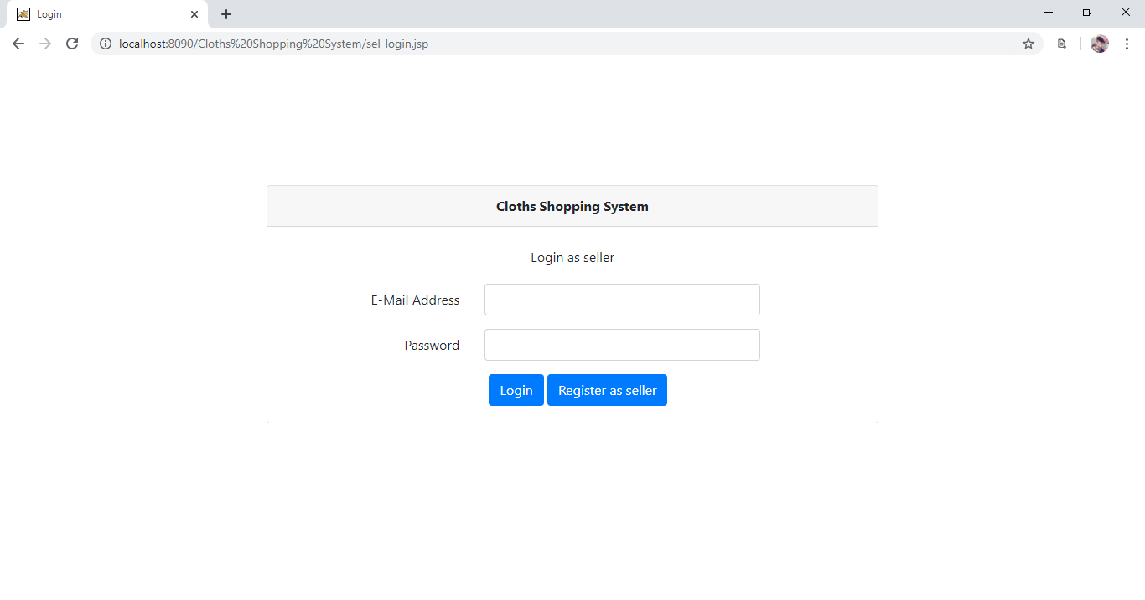

**Login.jsp:**

<%@page import="java.sql.*" %>

<!DOCTYPE html>

<html>

<head>

<link rel="stylesheet" href="res\bootstrap-4.4.1-dist\css\bootstrap.min.css"/>

<link rel="stylesheet" href="res\style.css"/>

<link rel="stylesheet" href="res\bootstrap-4.4.1-dist\css\login.css"/>

<link rel="stylesheet" href="res\bootstrap-4.4.1-dist\css\cover.css"/>

<title>Login </title>

</head>

<body>

<div class="container">

<%

try

{

Connection con=null;

String m = (String)request.getParameter("submit");

if(m != null)

{

String id = request.getParameter("email");

String pass = request.getParameter("pass");

Class.forName("com.mysql.jdbc.Driver");

con = DriverManager.getConnection("jdbc:mysql://localhost:3306/css","root","");

String sql = "select id from customer where email='"+id+"' and password ='"+pass+"'";

Statement st = con.createStatement();

ResultSet rs =st.executeQuery(sql);

if(rs.next())

{

session.setAttribute("user",rs.getInt("id"));

request.getRequestDispatcher("dashboard.jsp").forward(request, response);

}

else

{

session.setAttribute("lgnErr","Invalid email id or password.");

request.getRequestDispatcher("login.jsp").forward(request, response);

}

}

}

catch(Exception e)

{

}

%>

<main class="login-form" style="margin-top: 150px;">

<div class="cotainer">

<div class="row justify-content-center">

<div class="col-md-8">

<div class="card">

<%

String msg = (String)session.getAttribute("lgnErr");

if(msg != null)

{%>

<center>

<div class="alert alert-success">

<strong> <% out.println(msg);%></strong>

</div></center>

<%

session.removeAttribute("lgnErr");

}

%>

<div class="card-header"><center><strong>Cloths Shopping System</strong></center></div>

<br><div><center>Login as customer</center></div>

<div class="card-body">

<form action="#" method="post" class="needs-validation" novalidate="">

<div class="form-group row">

<label for="email_address" class="col-md-4 col-form-label text-md-right">E-Mail Address</label>

<div class="col-md-6">

<input type="email" id="email_address" class="form-control" name="email" required autofocus>

<div class="invalid-feedback">

Email address is not valid.

</div>

</div>

</div>

<div class="form-group row">

<label for="password" class="col-md-4 col-form-label text-md-right">Password</label>

<div class="col-md-6">

<input type="password" id="password" class="form-control" name="pass" required>

<div class="invalid-feedback">

Password cannot be left blank.

</div>

</div>

</div>

<div class="col-md-6 offset-md-4">

<button type="submit" value="submit" name="submit" class="btn btn-primary">

Login

</button>

<a href="customerregistration.jsp" class="btn btn-primary btn-link">

<font style="color:white;">Register as customer</font>

</a>

</div>

</div>

</form>

</div>

</div>

</div>

</div>

</div>

</main>

</div>

<script src="res/bootstrap-4.4.1-dist/js/form-validation.js"></script>

<script src="res/bootstrap-4.4.1-dist/js/login.js"></script>

</body>

</html>

**Design:**

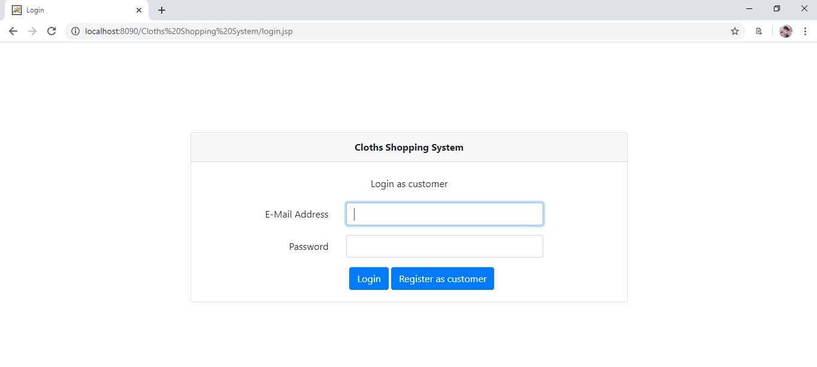

**Checklogin.jsp:**

<%@page import="java.sql.*" %>

<%

try

{

int c = (Integer)session.getAttribute("user");

if(session.getAttribute("user") != null)

{

if(request.getParameter("ac").equals("atc"))

{

try

{

Connection con=null;

String pid = request.getParameter("p_id");

Class.forName("com.mysql.jdbc.Driver");

con = DriverManager.getConnection("jdbc:mysql://localhost:3306/css","root","");

String sql = "insert into cart(cust_id, p_id) values ("+c+","+pid+");";

Statement st = con.createStatement();

int j= st.executeUpdate(sql);

RequestDispatcher rd=request.getRequestDispatcher("mycart.jsp");

rd.include(request, response);

}

catch(Exception e)

{

out.println(e.toString());

}

}

else if(request.getParameter("ac").equals("bn"))

{

session.setAttribute("buy","Order has been successfully placed.");

RequestDispatcher rd=request.getRequestDispatcher("dashboard.jsp");

rd.forward(request, response);

}

else

{

out.println("not atc and bn");

}

}

else

{

request.getRequestDispatcher("login.jsp").forward(request, response);

}

}

catch(Exception e)

{

request.getRequestDispatcher("login.jsp").forward(request, response);

}

%>

**Sellerregistration.jsp:**

<!DOCTYPE html>

<html>

<head>

<meta charset="utf-8">

<title>Clothes Shopping System | Seller Registration</title>

<link rel="stylesheet" href="res\bootstrap-4.4.1-dist\css\bootstrap.min.css"/>

<link rel="stylesheet" href="res\style.css"/>

<link rel="stylesheet" href="res\bootstrap-4.4.1-dist\css\cover.css"/>

</head>

<body>

<div class="container-fluide">

<nav class="navbar navbar-expand-lg navbar-light bg-light">

<%

String name = (String)application.getAttribute("pName");

%>

<a class="navbar-brand" href="#"><%=name%></a>

<button class="navbar-toggler" type="button" data-toggle="collapse" data-target="#navbarSupportedContent" aria-controls="navbarSupportedContent" aria-expanded="false" aria-label="Toggle navigation">

<span class="navbar-toggler-icon"></span>

</button>

</nav>

</div>

<jsp:include page="connection.jsp"/>

<div class="container-fluid text-dark pt-2 pb-2 header">

<h4 class="mb-3" style="margin-left: 555px;">Seller Registration</h4>

<form class="needs-validation" novalidate="" action="save_seller.jsp">

<div class="col-md-1 mb-3"></div>

<div class="col-md-10 mb-3" style="margin-left: 100px">

<div class="row">

<div class="col-md-6 mb-3">

<label for="businessOwner">Business Owner</label>

<input type="text" class="form-control" name="sellername" placeholder="" value="" required="">

<div class="invalid-feedback">

Valid name is required.

</div>

</div>

<div class="col-md-6 mb-3">

<label for="businessName">Business name</label>

<input type="text" class="form-control" name="businessname" placeholder="" value="" required="">

<div class="invalid-feedback">

Valid Business name is required.

</div>

</div>

</div>

<div class="row">

<div class="col-md-6 mb-3">

<label for="email">Email </label>

<input type="email" class="form-control" name="email" value="" placeholder="you@example.com" required="">

<div class="invalid-feedback">

Please enter a valid email address for shipping updates.

</div>

</div>

<div class="col-md-6 mb-3">

<label for="address">Address</label>

<input type="text" class="form-control" name="address" placeholder="" required="">

<div class="invalid-feedback">

Please enter your proper address.

</div>

</div>

</div>

<div class="row">

<div class="col-md-6 mb-3">

<label for="city">State </label>

<select name="state" class="form-control" required="">

<option selected value="">Choose</option>

<option value="Gujarat">Gujarat</option>

</select>

<div class="invalid-feedback">

Please choose a city for shipping.

</div>

</div>

<div class="col-md-6 mb-3">

<label for="state">City</label>

<select name="city" class="form-control" required="">

<option selected value="">Choose</option>

<option value="Surat">Surat</option>

</select>

<div class="invalid-feedback">

Please choose a state for shipping.

</div>

</div>

</div>

<div class="row">

<div class="col-md-6 mb-3">

<label for="city">Mobile Number </label>

<input type="text" class="form-control" name="mobile" placeholder="" required="">

<div class="invalid-feedback">

Please enter proper mobile number.

</div>

</div>

<div class="col-md-6 mb-3">

<label for="state">Password</label>

<input type="password" class="form-control" name="password" placeholder="" required="">

<div class="invalid-feedback">

Please enter proper password.

</div>

</div>

</div>

<div class="row">

<div class="col-md-6 mb-3">

<label for="state">Type Of Products</label>

<select name="category" class="form-control" required="">

<option selected value="">Choose</option>

<option>Formals</option>

<option>Casuals</option>

<option>Summer</option>

<option>Woollen</option>

<option>Footwear</option>

</select>

<div class="invalid-feedback">

Please choose a category.

</div>

</div>

</div>

<hr class="mb-4">

<div class="row">

<div class="col-sm-3"><button class="btn btn-primary btn-lg btn-block" type="submit">Register</button></div>

<div class="col-sm-3">

<a href="sel_login.jsp" class="btn btn-primary btn-lg btn-block btn-link">

<font style="color:white;">Login as seller</font>

</a></div>

</div>

</form>

</div>

</div>

<div class="col-md-1 mb-3"></div>

<script src="res\bootstrap-4.4.1-dist/js/form-validation.js"></script>

</body>

</html>

**Design:**

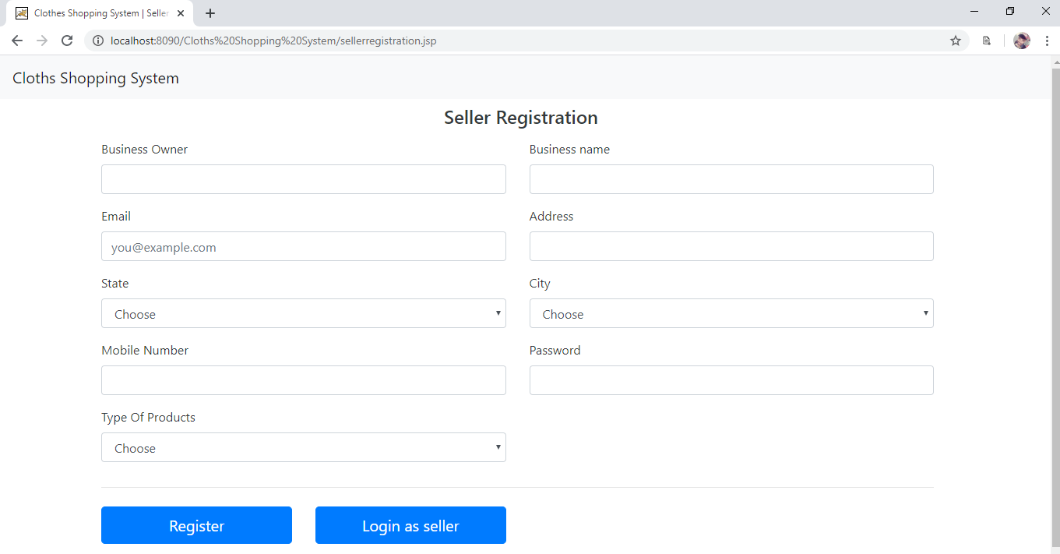

**Save_seller.jsp:**

<%@page import="java.sql.*" %>

<%

Connection con = null;

try

{

Class.forName("com.mysql.jdbc.Driver");

con = DriverManager.getConnection("jdbc:mysql://localhost:3306/css","root","");

}

catch(Exception e)

{

out.println(e.toString());

}

String seller_name = request.getParameter("sellername");

String businessname = request.getParameter("businessname");

String email = request.getParameter("email");

String address = request.getParameter("address");

String state = request.getParameter("state");

String city = request.getParameter("city");

String mobile = request.getParameter("mobile");

String category = request.getParameter("category");

String password = request.getParameter("password");

String sql = "insert into seller (seller_name,business_name,email,address,state,city,product_category,mobile_no,password) values ('"+seller_name+"','"+businessname+"','"+email+"','"+address+"','"+state+"','"+city+"','"+category+"','"+mobile+"','"+password+"')";

Statement st = con.createStatement();

int i=st.executeUpdate(sql);

if(i!=0)

{

session.setAttribute("srs","Seller account is successfully created.");

}

else

{

session.setAttribute("srs","Seller account is not successfully created.");

}

request.getRequestDispatcher("sel_login.jsp").forward(request, response);

%>

**Customerregistration.jsp:**

<!DOCTYPE html>

<html>

<head>

<meta charset="utf-8">

<title>Clothes Shopping System | Customer Registration</title>

<link rel="stylesheet" href="res\bootstrap-4.4.1-dist\css\bootstrap.min.css"/>

<link rel="stylesheet" href="res\style.css"/>

<link rel="stylesheet" href="res\bootstrap-4.4.1-dist\css\cover.css"/>

</head>

<body>

<div class="container-fluide">

<nav class="navbar navbar-expand-lg navbar-light bg-light">

<%

String name = (String)application.getAttribute("pName");

%>

<a class="navbar-brand" href="#"><%=name%></a>

<button class="navbar-toggler" type="button" data-toggle="collapse" data-target="#navbarSupportedContent" aria-controls="navbarSupportedContent" aria-expanded="false" aria-label="Toggle navigation">

<span class="navbar-toggler-icon"></span>

</button>

</nav>

</div>

<div class="container-fluid text-dark pt-2 pb-2 header">

<%

String msg = (String)session.getAttribute("msgCRS");

if(msg != null)

{%>

<center>

<div class="alert alert-success">

<strong>Success!</strong> <% out.println(msg);%>

</div></center>

<%

session.removeAttribute("msgCRS");

}

String msg1 = (String)session.getAttribute("msgCRE");

if(msg1!=null)

{

%>

<center>

<div class="alert alert-success">

<strong>Success!</strong> <% out.println(msg1);%>

</div></center>

<%

session.removeAttribute("msgCRE");

}

%>

<h4 class="mb-3" style="margin-left: 555px;">Customer Registration</h4>

<form class="needs-validation" novalidate="" method="post" action="save_customer.jsp">

<div class="col-md-1 mb-3"></div>

<div class="col-md-10 mb-3" style="margin-left: 100px">

<div class="row">

<div class="col-md-6 mb-3">

<label for="Username">User Name</label>

<input type="text" class="form-control" name="username" placeholder="" value="" required="">

<div class="invalid-feedback">

Valid name is required.

</div>

</div>

<div class="col-md-6 mb-3">

<label for="email">Email </label>

<input type="email" class="form-control" name="email" value="" placeholder="you@example.com" required="">

</div>

<div class="invalid-feedback">

Please enter a valid email address for shipping updates.

</div>

</div>

<div class="row">

<div class="col-md-6 mb-3">

<label for="address">Address</label>

<input type="text" class="form-control" name="address" placeholder="" required="">

<div class="invalid-feedback">

Please enter your proper address.

</div>

</div>

<div class="col-md-6 mb-3">

<label for="mobile">Mobile Number </label>

<input type="text" class="form-control" name="mobile" placeholder="" required="">

<div class="invalid-feedback">

Please enter proper mobile number.

</div>

</div>

</div>

<div class="row">

<div class="col-md-6 mb-3">

<label for="State">State </label>

<select name="state" class="form-control" required="">

<option selected value="">Choose</option>

<option value="Gujarat">Gujarat</option>

</select>

<div class="invalid-feedback">

Please choose a state for shipping.

</div>

</div>

<div class="col-md-6 mb-3">

<label for="city">City</label>

<select name="city" class="form-control" required="">

<option selected value="">Choose</option>

<option value="Surat">Surat</option>

</select>

<div class="invalid-feedback">

Please choose a city for shipping.

</div>

</div>

</div>

<div class="row">

<div class="col-md-6 mb-3" >

<label for="gender">Gender</label>

<select name="gender" class="form-control" required="">

<option selected value="">Choose</option>

<option value="Male">Male</option>

<option value="Female">Female</option>

</select>

<div class="invalid-feedback">

Please choose Gender.

</div>

</div>

<div class="col-md-6 mb-3">

<label for="password">Password</label>

<input type="password" class="form-control" name="password" placeholder="" required="">

<div class="invalid-feedback">

Please enter proper password.

</div>

</div>

</div>

<hr class="mb-4">

<div class="row">

<div class="col-sm-3"><button class="btn btn-primary btn-lg btn-block" type="submit">Register</button></div>

<div class="col-sm-3">

<a href="login.jsp" class="btn btn-primary btn-lg btn-block btn-link">

<font style="color:white;">Login as customer</font>

</a></div>

</div>

</form>

</div>

<div class="col-md-1 mb-3"></div>

</div>

<script src="res\bootstrap-4.4.1-dist/js/form-validation.js"></script>

</body>

</html>

**Design:**

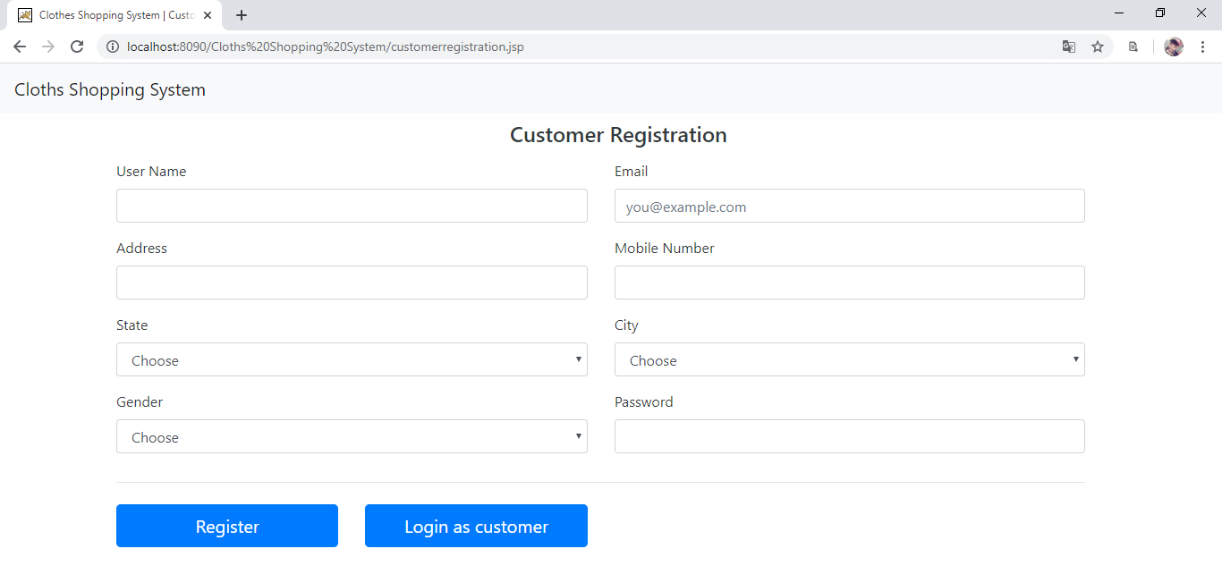

**Save_customer.jsp:**

<%@page import="java.sql.*" %>

<%

Connection con=null;

try

{

Class.forName("com.mysql.jdbc.Driver");

con = DriverManager.getConnection("jdbc:mysql://localhost:3306/css","root","");

}

catch(Exception e)

{

out.println(e.toString());

}

String username = request.getParameter("username");

String email = request.getParameter("email");

String address = request.getParameter("address");

String mobile = request.getParameter("mobile");

String state = request.getParameter("state");

String city = request.getParameter("city");

String gender = request.getParameter("gender");

String password = request.getParameter("password");

String sql = "insert into customer (customer_name,email,address,mobile,state,city,gender,password) values ('"+username+"','"+email+"','"+address+"','"+ mobile +"','"+state+"','"+city+"','"+gender+"','"+password+"')";

Statement st = con.createStatement();

int i=st.executeUpdate(sql);

if(i!=0)

{

session.setAttribute("msgCRS","Data is successfully inserted!");

}

else

{

session.setAttribute("msgCRE","Data is not successfully inserted!");

}

request.getRequestDispatcher("customerregistration.jsp").forward(request, response);

%>

**addProduct.jsp:**

<!DOCTYPE html>

<html>

<head>

<title></title>

<link rel="stylesheet" href="res\bootstrap-4.4.1-dist\css\bootstrap.min.css"/>

<link rel="stylesheet" href="res\style.css"/>

<link rel="stylesheet" href="res\bootstrap-4.4.1-dist\css\cover.css"/>

</head>

<body>

<div class="container-fluide">

<nav class="navbar navbar-expand-lg navbar-light bg-light">

<%

String name = (String)application.getAttribute("pName");

%>

<a class="navbar-brand" href="#"><%=name%></a>

<button class="navbar-toggler" type="button" data-toggle="collapse" data-target="#navbarSupportedContent" aria-controls="navbarSupportedContent" aria-expanded="false" aria-label="Toggle navigation">

<span class="navbar-toggler-icon"></span>

</button>

<div class="collapse navbar-collapse" id="navbarSupportedContent">

<ul class="navbar-nav mr-auto">

<li class="nav-item active">

<a class="nav-link" href="addProduct.jsp">Add Product</a>

</li>

</ul>

<form class="form-inline my-2 my-lg-0" action="logouts.jsp">

<button class="btn btn-outline-success my-2 my-sm-0" type="submit">Logout</button>

</form>

</div>

</nav>

</div>

<%

String msg = (String)session.getAttribute("mes");

if(msg != null)

{%>

<center>

<div class="alert alert-success">

<strong>Success!</strong> <% out.println(msg);%>

</div></center>

<%

session.setAttribute("mes",null);

}

%>

<div class="container-fluid text-dark pt-2 pb-2 header">

<h4 class="mb-3" style="margin-left: 560px;">Add Product</h4>

<form class="needs-validation" novalidate="" action="saveProduct" method="post" enctype="multipart/form-data">

<div class="col-md-1 mb-3"></div>

<div class="col-md-10 mb-3" style="margin-left: 100px">

<div class="row">

<div class="col-md-6 mb-3">

<label for="ProductName">Product Name</label>

<input type="text" class="form-control" name="productname" placeholder="" value="" required="">

<div class="invalid-feedback">

Valid name is required.

</div>

</div>

<div class="col-md-6 mb-3">

<label for="ProductPrice">Product Price</label>

<input type="number" class="form-control" name="productprice" value="" required="">

</div>

<div class="invalid-feedback">

Please enter a price for the product.

</div>

</div>

<div class="row">

<div class="col-md-6 mb-3">

<label for="ProductCategory">Product Category</label>

<select name="category" class="form-control" required="">

<option selected value="">Choose category</option>

<option>Formals</option>

<option>Footwear</option>

<option>Casual</option>

<option>Woolen</option>

</select>

<div class="invalid-feedback">

Category cannot be left blank.

</div>

</div>

<div class="col-md-6 mb-3">

<label for="Description">Description</label>

<input type="text-area" class="form-control" name="description" required="">

</div>

<div class="invalid-feedback">

</div>

</div>

<div class="row">

<div class="col-md-6 mb-3">

<label for="ProductName">Product Image</label>

<input type="file" class="form-control" name="p_image" placeholder="" required="">

<div class="invalid-feedback">

Please Choose A File.

</div>

</div>

<div class="col-md-6 mb-3">

<label for="Quantity">Quantity</label>

<input type="number" class="form-control" name="qty" value="" required="">

</div>

<div class="invalid-feedback">

Please enter a quantity of product.

</div>

</div>

<hr class="mb-4">

<button class="btn btn-primary btn-lg btn-block" value="submit" type="submit" name="submit">Register</button>

</form>

</div>

<div class="col-md-5 mb-3"></div>

</div>

<script src="res\bootstrap-4.4.1-dist/js/form-validation.js"></script>

</body>

</html>

**Design:**

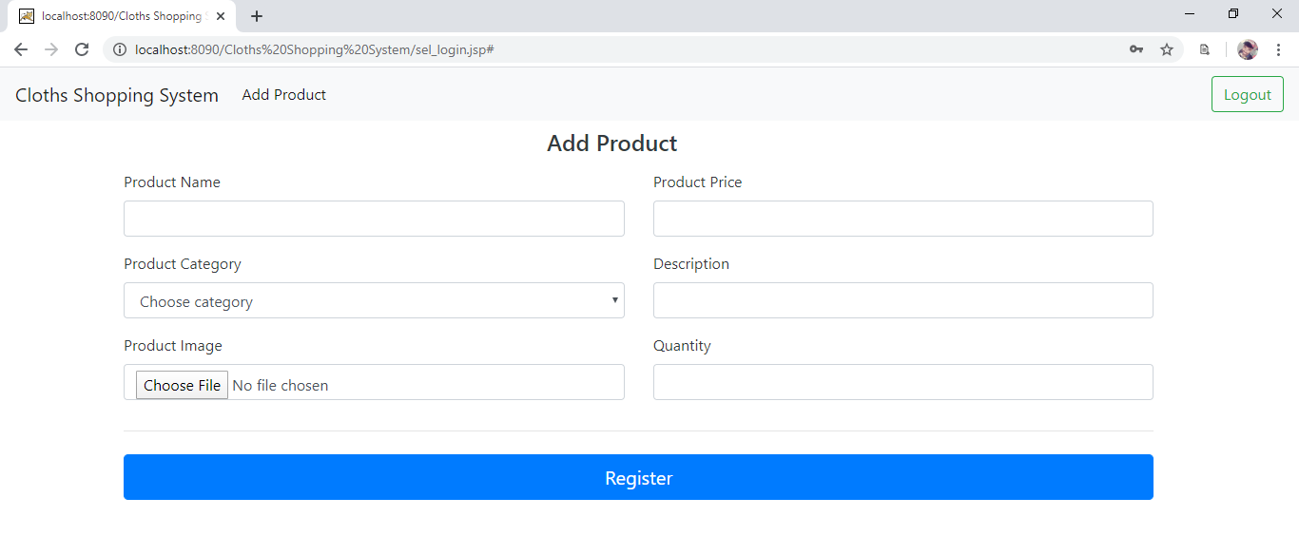

**saveProduct.java:**

import java.io.File;

import java.io.*;

import javax.servlet.*;

import javax.servlet.http.*;

import java.io.IOException;

import java.util.List;

import java.sql.*;

import javax.servlet.ServletException;

import javax.servlet.http.HttpServlet;

import javax.servlet.http.HttpServletRequest;

import javax.servlet.http.HttpServletResponse;

import org.apache.commons.fileupload.FileItem;

import org.apache.commons.fileupload.disk.DiskFileItemFactory;

import org.apache.commons.fileupload.servlet.ServletFileUpload;

import com.oreilly.servlet.MultipartRequest;

public class saveProduct extends HttpServlet {

private final String UPLOAD_DIRECTORY = "C:/xampp/tomcat/webapps/Cloths Shopping System/upload";

@Override

protected void doPost(HttpServletRequest request, HttpServletResponse response)

throws ServletException, IOException

{

try

{

PrintWriter out = response.getWriter();

MultipartRequest mr = new MultipartRequest(request,UPLOAD_DIRECTORY);

response.setContentType("text/html");

String name="";

String temp = "";

HttpSession session=request.getSession();

if(ServletFileUpload.isMultipartContent(request))

{

try

{

//out.println("Name : "+nm);

String p_name=mr.getParameter("productname");

String p_price = mr.getParameter("productprice");

String p_image = mr.getFilesystemName("p_image");

String p_category=mr.getParameter("category");

String description=mr.getParameter("description");

String qty=mr.getParameter("qty");

int j;

try

{

Connection con;

PreparedStatement pst ;

ResultSet rs ;

Class.forName("com.mysql.jdbc.Driver");

con=DriverManager.getConnection("jdbc:mysql://localhost:3306/css","root","");

//out.println(pst.toString());

if(true)

{

List<FileItem> multiparts = new ServletFileUpload(

new DiskFileItemFactory()).parseRequest(request);

for(FileItem item : multiparts){

if(!item.isFormField()){

name = new File(item.getName()).getName();

temp = new File(UPLOAD_DIRECTORY + File.separator + name).toString();

item.write( new File(UPLOAD_DIRECTORY + File.separator + name));

}

}

session.setAttribute("mes", "Product inserted Successfully");

pst=con.prepareStatement("insert into products(p_name, p_price, p_category, description, p_image, qty) VALUES (?,?,?,?,?,?)");

pst.setString(1,p_name);

pst.setString(2,p_price);

pst.setString(3,p_category);

pst.setString(4,description);

pst.setString(5,p_image);

pst.setInt(6,Integer.parseInt(qty));

j=pst.executeUpdate();

}

else{

out.println("<script>alert('some problem');</script>");

}

}

catch (Exception ex) {

out.println(ex.toString());

session.setAttribute("mes", "Product not inserted Successfully");

}

}

catch (Exception ex) {

out.println(ex.toString());

request.setAttribute("message", "Connection " + ex);

}

}

else

{

request.setAttribute("mes", "Product is not inserted Successfully");

request.setAttribute("mes","Sorry this Servlet only handles file upload request");

}

request.getRequestDispatcher("addProduct.jsp").forward(request, response);

}

catch(Exception e)

{

//out.println(e);

}

}

}

**Dashboard.jsp:**

<%@page import="java.sql.*" %>

<!DOCTYPE html>

<html>

<head>

<meta charset="utf-8">

<link rel="stylesheet" href="res\bootstrap-4.4.1-dist\css\bootstrap.min.css"/>

<link rel="stylesheet" href="res\style.css"/>

<link rel="stylesheet" href="res\bootstrap-4.4.1-dist\css\cover.css"/>

<script src="res\bootstrap-4.4.1-dist\js\bootstrap.min.js"></script>

</head>

<body>

<%

ResultSet rs = null;

try

{

Connection con=null;

Class.forName("com.mysql.jdbc.Driver");

con = DriverManager.getConnection("jdbc:mysql://localhost:3306/css","root","");

String sql = "select * from products";

Statement st = con.createStatement();

rs =st.executeQuery(sql);

}

catch(Exception e)

{

}

%>

<div class="container-fluide">

<nav class="navbar navbar-expand-lg navbar-light bg-light">

<%

application.setAttribute("pName","Cloths Shopping System");

String name = (String)application.getAttribute("pName");

%>

<a class="navbar-brand" href="#"><%=name%></a>

<button class="navbar-toggler" type="button" data-toggle="collapse" data-target="#navbarSupportedContent" aria-controls="navbarSupportedContent" aria-expanded="false" aria-label="Toggle navigation">

<span class="navbar-toggler-icon"></span>

</button>

<div class="collapse navbar-collapse" id="navbarSupportedContent">

<ul class="navbar-nav mr-auto">

<li class="nav-item active">

<a class="nav-link" href="dashboard.jsp">Home <span class="sr-only">(current)</span></a>

</li>

<li class="nav-item">

<a class="nav-link" href="mycart.jsp">My Cart</a>

</li>

</ul>

<form class="form-inline my-2 my-lg-0" action="logoutc.jsp">

<%

if(session.getAttribute("user") != null)

{%>

<button class="btn btn-outline-success my-2 my-sm-0" type="submit">Log out</button>

<%}

else

{%>

<button class="btn btn-outline-success my-2 my-sm-0" type="submit">Login</button>

<%}

%>

</form>

</div>

</nav>

</div>

<%

String msg = (String)session.getAttribute("buy");

if(msg != null)

{%>

<center>

<div class="alert alert-success">

<strong>Success!</strong> <% out.println(msg);%>

</div></center>

<%

session.removeAttribute("buy");

}

%>

<div class="container-fluid" style="height: 400px">

<%

while(rs.next())

{%>

<center>

<div class="card mb-3" style="max-width: 1000px;margin-top: 10px;">

<div class="row no-gutters">

<div class="col-md-3">

<img src="upload\<%=rs.getString("p_image") %>" height="200px" class="card-img" alt="...">

</div>

<div class="col-md-9">

<div class="card-body">

<h5 class="card-title"><% out.println(rs.getString("p_name")); %></h5>

<h5 class="card-text"><% out.println(rs.getString("description"));%></h5>

Price : <% out.println(rs.getInt("p_price"));%> Rs

<br><br>

<a href="checkLogin.jsp?p_id=<%=rs.getInt("pid") %>&ac=bn"><button class="btn btn-primary" >Buy Now</button></a>

<a href="checkLogin.jsp?p_id=<%=rs.getInt("pid") %>&ac=atc"><button class="btn btn-primary" >Add To Cart</button></a>

</div>

</div>

</div>

</div>

</center>

<%}

%>

</div>

<script >

$(document).ready(function(){

$('.col-3-md').hover();

});

/*

function(){

$(this).animate({

margin-top:"-=1%",

},100);

},

function(){

$(this).animate({

margin-top:"0%",

},100);

}

);

*/

</script>

</body>

</html>

**Design:**

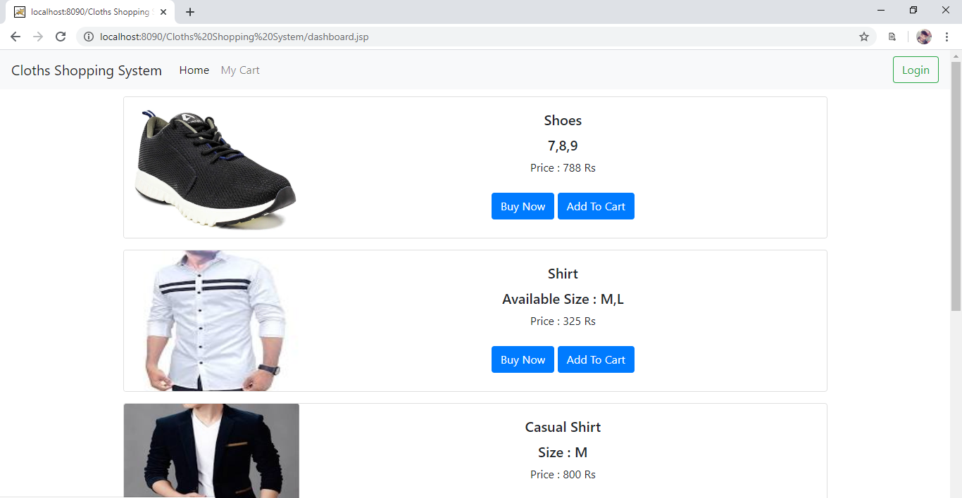

**Mycart.jsp:**

<%@page import="java.sql.*" %>

<%

if(session.getAttribute("user") != null)

{%>

<!DOCTYPE html>

<html>

<head>

<meta charset="utf-8">

<link rel="stylesheet" href="res\bootstrap-4.4.1-dist\css\bootstrap.min.css"/>

<link rel="stylesheet" href="res\style.css"/>

<link rel="stylesheet" href="res\bootstrap-4.4.1-dist\css\cover.css"/>

<script src="res\bootstrap-4.4.1-dist\js\bootstrap.min.js"></script>

</head>

<body>

<%

ResultSet rs = null;

try

{

Connection con=null;

int c = (Integer)session.getAttribute("user");

Class.forName("com.mysql.jdbc.Driver");

con = DriverManager.getConnection("jdbc:mysql://localhost:3306/css","root","");

String sql = "select * from products,cart where cart.cust_id="+c+" and products.pid=cart.p_id";

Statement st = con.createStatement();

rs =st.executeQuery(sql);

}

catch(Exception e)

{

}

%>

<div class="container-fluide">

<nav class="navbar navbar-expand-lg navbar-light bg-light">

<%

String name = (String)application.getAttribute("pName");

%>

<a class="navbar-brand" href="#"><%=name%></a>

<button class="navbar-toggler" type="button" data-toggle="collapse" data-target="#navbarSupportedContent" aria-controls="navbarSupportedContent" aria-expanded="false" aria-label="Toggle navigation">

<span class="navbar-toggler-icon"></span>

</button>

<div class="collapse navbar-collapse" id="navbarSupportedContent">

<ul class="navbar-nav mr-auto">

<li class="nav-item ">

<a class="nav-link" href="dashboard.jsp">Home <span class="sr-only">(current)</span></a>

</li>

<li class="nav-item active">

<a class="nav-link" href="mycart.jsp">My Cart</a>

</li>

</ul>

<form class="form-inline my-2 my-lg-0" action="logoutc.jsp">

<%

if(session.getAttribute("user") != null)

{%>

<button class="btn btn-outline-success my-2 my-sm-0" type="submit">Log out</button>

<%}

else

{%>

<button class="btn btn-outline-success my-2 my-sm-0" type="submit">Login</button>

<%}

%>

</form>

</div>

</nav>

</div>

<div class="container-fluid" style="height: 400px">

<%

while(rs.next())

{%>

<center>

<div class="card mb-3" style="max-width: 1000px;margin-top: 10px;">

<div class="row no-gutters">

<div class="col-md-3">

<img src="upload\<%=rs.getString("p_image") %>" height="200px" class="card-img" alt="...">

</div>

<div class="col-md-9">

<div class="card-body">

<h5 class="card-title"><% out.println(rs.getString("p_name")); %></h5>

<h5 class="card-text"><% out.println(rs.getString("description"));%></h5>

Price : <% out.println(rs.getInt("p_price"));%> Rs

<br><br>

<button class="btn btn-primary">Buy Now</button>

</div>

</div>

</div>

</div>

</center>

<%}

%>

</div>

<script >

$(document).ready(function(){

$('.col-3-md').hover();

});

/*

function(){

$(this).animate({

margin-top:"-=1%",

},100);

},

function(){

$(this).animate({

margin-top:"0%",

},100);

}

);

*/

</script>

</body>

</html>

<%}

else

{

RequestDispatcher rd=request.getRequestDispatcher("login.jsp");

rd.forward(request, response);

}%>

**Design:**

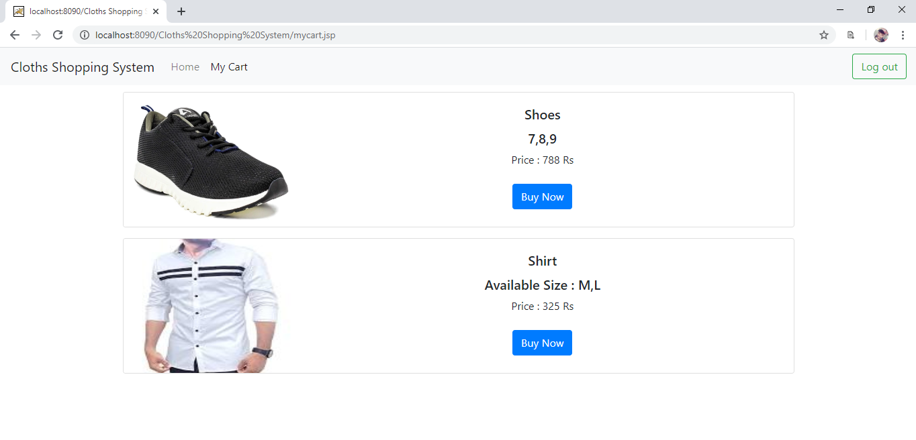

**Buynow.jsp:**

<%@page import="java.sql.*" %>

<%

String id = request.getParameter("pid");

try

{

Connection con=null;

Class.forName("com.mysql.jdbc.Driver");

con = DriverManager.getConnection("jdbc:mysql://localhost:3306/css","root","");

String sql = "delete from cart where p_id="+id;

Statement st = con.createStatement();

int j= st.executeUpdate(sql);

RequestDispatcher rd=request.getRequestDispatcher("mycart.jsp");

rd.forward(request, response);

}

catch(Exception e)

{

out.println(e.toString());

}

%>

**Logouts.jsp:**

<%

session.invalidate();

RequestDispatcher rd=request.getRequestDispatcher("sel_login.jsp");

rd.forward(request, response);

%>

**Logoutc.jsp:**

<%

session.invalidate();

RequestDispatcher rd=request.getRequestDispatcher("login.jsp");

rd.forward(request, response);

%>