1. Background
Fraser Health Authority (FHA) is one of British Columbia's largest publicly funded regional health authorities, serving a population of over 1.9 million residents across the Lower Mainland and Fraser Valley. FHA operates a comprehensive network of hospitals, community health centres, and specialized services, delivering care across a wide geographic and demographic spectrum. In recognition of evolving healthcare delivery models and growing demand for home-based and virtual care, Fraser Health identified a strategic opportunity in the acquisition and deployment of a Remote Patient Monitoring (RPM) service platform.
RPM technology allows healthcare providers to remotely monitor patients using connected medical devices and digital platforms, facilitating real-time data collection on vital signs, chronic conditions, and patient-reported outcomes. The evidence base for RPM is compelling: research demonstrates that such platforms reduce hospital readmission rates, improve chronic disease management outcomes, and enhance patient engagement in their own care (Keesara et al., 2020; Shah et al., 2018). However, the expansion of digital health infrastructure does not occur in a risk-free environment. Healthcare technology adoption introduces cybersecurity vulnerabilities, regulatory compliance obligations, operational integration challenges, and competitive dynamics that organizations must proactively evaluate and manage.
This Signature Assessment aggregates and synthesizes the full body of enterprise risk management (ERM) analysis conducted throughout the ALY6130 course term. The work spans five sequential modules, each building upon the last: Module 1 established a SWOT analysis identifying Fraser Health's internal strengths and weaknesses, and external opportunities and threats associated with RPM acquisition. Module 2 identified three focal risks, defined them using structured risk statements, and established early Key Risk Indicators (KRIs). Module 3 conducted quantitative risk scoring using a risk calculation sheet, risk register, and probability-impact heat map, supplemented by machine learning classification. Module 4 applied the Indicators and Warning (I&W) analytical technique for quantitative risk assessment, validated by Monte Carlo simulation and Random Forest classification. The final deliverable – this report – synthesizes all work into a comprehensive ERM report suitable for senior decision-makers.

The analytical framework applied throughout this assessment is grounded in the Committee of Sponsoring Organizations of the Treadway Commission (COSO, 2017) Enterprise Risk Management framework, which integrates risk management with organizational strategy and performance. This approach ensures that risks are evaluated not in isolation, but in the context of Fraser Health's mission, strategic objectives, and operational environment.
2. Identification of Risks
Risk identification for Fraser Health's RPM platform acquisition was conducted through a structured, multi-method approach. Beginning with the SWOT analysis in Module 1, the team evaluated internal capabilities and external environmental factors to surface potential risk domains. From this foundation, three focal risks were selected for detailed evaluation: two negative risks representing potential threats to the organization, and one positive risk representing a strategic opportunity that, if not actively pursued, constitutes an opportunity cost and competitive risk.
Each risk was articulated using the structured format: 'The risk of… caused by… resulting in…' to ensure clarity, specificity, and actionability in the risk statements. The Risk Register captures each risk's description, likelihood, impact, score, and assigned owner.
Figure 1: Risk Register Summary
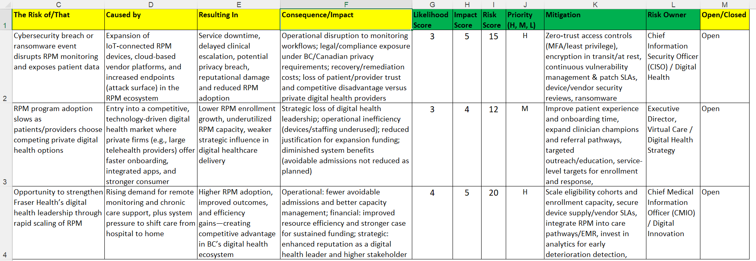
Risk 1: Cybersecurity Breach (Negative Risk – HIGH)
The risk of a cybersecurity breach or ransomware event disrupting RPM monitoring services and exposing patient data, caused by the expansion of IoT-connected RPM devices, cloud-based vendor platforms, and increased digital endpoints in the RPM ecosystem, resulting in service downtime, delayed clinical escalation, privacy breaches, reputational damage, and reduced RPM adoption.
Healthcare organizations are among the most targeted sectors for cyberattacks globally due to the high value of patient data and the pressure placed on health systems to resolve disruptions quickly to protect patient safety (Gordon et al., 2020). Expanding the RPM ecosystem significantly increases the attack surface available to malicious actors, introducing new vulnerabilities through connected devices, vendor platforms, and increased data transmission volumes. Fraser Health would face legal and regulatory consequences under the British Columbia Personal Information Protection Act (PIPA) and Canadian federal privacy legislation if patient data were exposed, in addition to significant financial recovery costs and reputational damage.
Risk 2: Competitive Pressure from Private Digital Health Providers (Negative Risk – MEDIUM)
The risk of RPM program adoption slowing as patients and healthcare providers choose competing private digital health services, caused by Fraser Health's entry into a competitive digital healthcare market where private firms offer faster onboarding, integrated digital applications, and a stronger consumer experience, resulting in lower RPM enrollment growth, underutilized monitoring capacity, and weaker strategic influence in digital healthcare delivery.
Private telehealth providers including Telus Health and other digital health companies operate in a consumer-oriented, technology-first environment that may be perceived as more responsive and technologically advanced than a publicly funded health authority's platform. If Fraser Health's RPM services fail to meet patient and provider expectations in terms of usability and responsiveness, adoption may slow, reducing the clinical and financial benefits justifying the program's investment and eroding Fraser Health's position in the digital health market.
Risk 3: Opportunity to Strengthen Digital Health Leadership (Positive Risk – HIGH)
The opportunity to strengthen Fraser Health's digital health leadership through rapid scaling of RPM services, caused by rising demand for remote monitoring and increasing system pressure to shift healthcare delivery from hospitals to home, resulting in higher RPM adoption, improved patient outcomes, and greater healthcare system efficiency.
This positive risk represents a strategic inflection point. Successful and rapid deployment of RPM services, supported by analytics-driven patient monitoring and integrated care pathways, could significantly enhance Fraser Health's reputation as a leader in digital health innovation. The financial case is equally compelling: reduced avoidable hospital admissions, improved capacity management, and stronger justification for sustained digital health investment funding from both provincial and federal sources (Government of British Columbia, 2023; WHO, 2021).
3. Qualitative Risk Assessment
Qualitative risk assessment was conducted using two primary analytics-based methodologies: Scenario Analytics and Industry Fusion Analytics. These techniques enabled the team to evaluate each risk's potential severity and likelihood of occurrence without requiring fully quantified data, providing a robust foundation for subsequent quantitative analysis.
3.1 Methodology: Scenario Analytics (Chapter 22)
Scenario Analytics was applied by constructing plausible future scenarios related to each risk, evaluating how different combinations of internal and external factors could interact to produce risk outcomes. For the Cybersecurity Breach risk, scenarios ranged from a targeted ransomware attack on RPM vendor infrastructure during peak usage, to an insider threat exploiting inadequate access controls post-deployment. For the Competitive Pressure risk, scenarios explored market conditions in which private telehealth providers reduced onboarding friction to 24-hour enrollment while Fraser Health's processes required weeks, and scenarios in which government policy changes enabled private providers to access publicly insured services.
3.2 Methodology: Industry Fusion Analytics (Chapter 17)
Industry Fusion Analytics was applied by drawing insights from analogous digital health implementations in comparable healthcare systems. Evidence from Canadian healthcare organizations and international health authorities revealed that cybersecurity incidents in healthcare settings have increased significantly in frequency and severity, with ransomware representing the dominant threat vector (Cyber Security Centre of Canada, 2024). Competitive dynamics in the digital health market were assessed by examining how health systems in Ontario and Alberta managed similar competitive pressures from private virtual care providers. This cross-industry analysis informed the likelihood and impact ratings applied to each risk.
3.3 Risk Calculation and Heat Map Results
Following qualitative scenario analysis, each risk was evaluated using numerical likelihood and impact scores applied to the Risk Calculation Sheet. The scoring matrix uses a scale where likelihood is rated as: Very Unlikely (1), Somewhat Unlikely (3), 50-50 Possibility (5), Somewhat Likely (7), and Very Likely (9), and impact across financial, operational, competitive, reputational, technical, and legal/compliance dimensions.
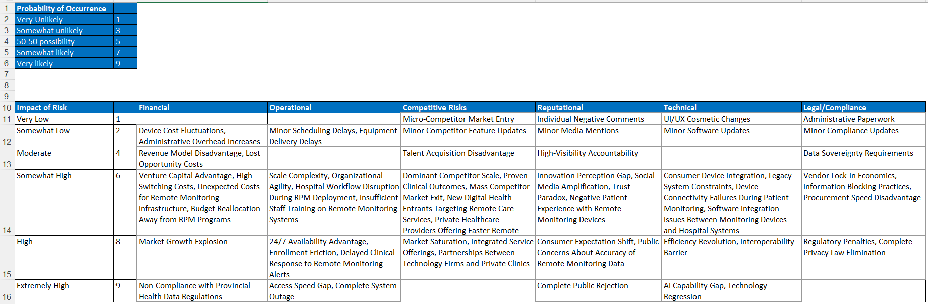
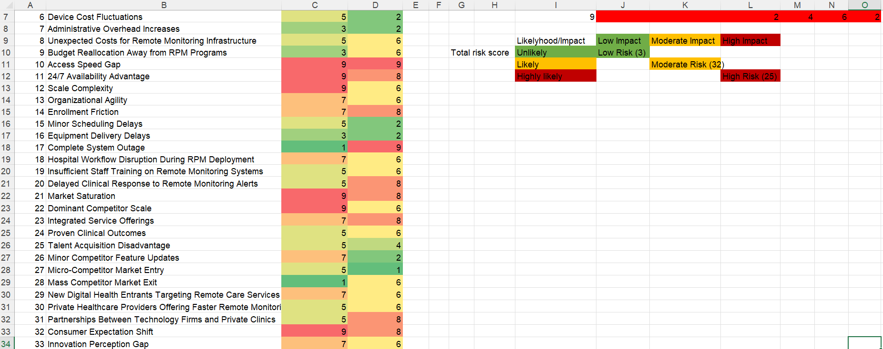
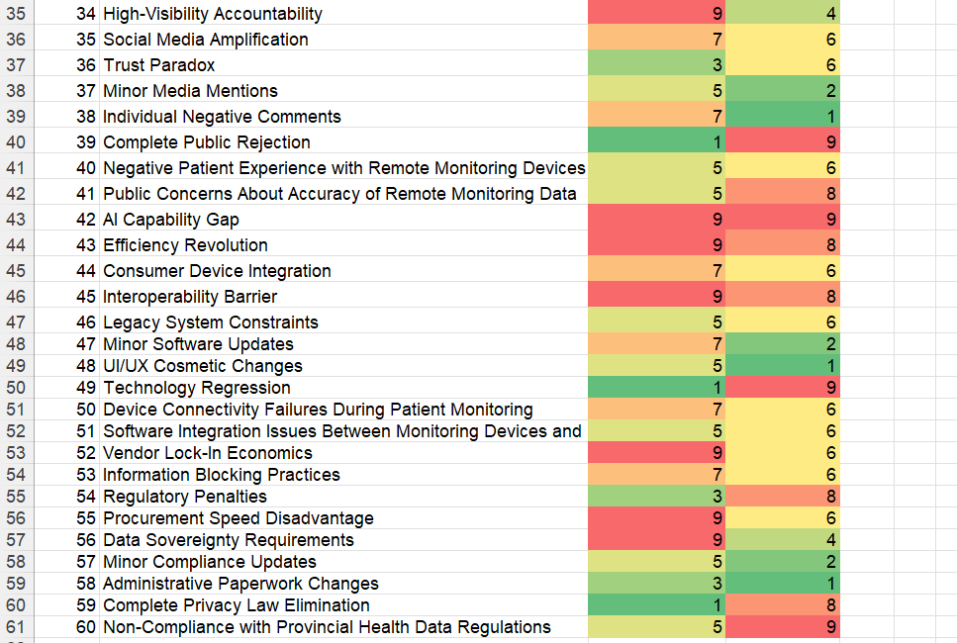
The Probability-Impact Heat Map (Figure 4.1 from Module 3) visualized risk severity across all 60 identified risk factors. The most critical risks – including Market Growth Explosion (R-1), Access Speed Gap (R-10), AI Capability Gap (R-42), and 24/7 Availability Advantage (R-11) – clustered in the upper-right quadrant (likelihood 9, impact 8–9), indicating high-severity areas requiring immediate management attention. Cybersecurity-related risks, system integration concerns, and regulatory compliance risks consistently appeared in the moderate-to-high severity regions of the heat map.
The cross-validated confusion matrix produced by the Random Forest classification model confirmed high accuracy in distinguishing risk severity levels, with 12 correctly classified Low-risk observations, 3 Medium-risk, and 44 High-risk observations, with only one misclassification across the full dataset. This validated the qualitative scoring methodology.

3.4 Qualitative Assessment Conclusions by Risk
Risk 1 – Cybersecurity Breach: Qualitative analysis confirmed this risk as HIGH priority. The expansion of IoT endpoints and cloud-based vendor integration creates systemic vulnerability that scenario analysis identified as likely to materialize within 18–24 months of full deployment without robust controls. This risk was identified as a candidate for further quantitative analysis using I&W techniques.
Risk 2 – Competitive Pressure: Qualitative assessment rated this risk as MEDIUM. While the competitive threat is real and growing, Fraser Health's public mandate and integrated care infrastructure provide meaningful competitive insulation. This risk is monitored qualitatively through enrollment KRIs.
Risk 3 – Digital Health Leadership Opportunity: Scenario analysis highlighted this opportunity as HIGH probability and HIGH impact. Failure to exploit this opportunity is itself a strategic risk. This positive risk was elevated to immediate pursuit priority.

4. Quantitative Risk Assessment
The quantitative risk assessment was conducted using the Indicators and Warning (I&W) analysis technique, supplemented by Monte Carlo simulation for financial impact modeling and Random Forest machine learning for independent severity classification. These complementary methods transformed the qualitative risk evaluation into a continuous, data-driven monitoring framework with clear early warning signals.
4.1 Indicators and Warning (I&W) Analysis
The I&W technique provides a structured, data-driven approach to risk quantification by identifying observable indicators for each risk, establishing measurable warning thresholds, and evaluating current operational values against those thresholds. Three risks were assessed quantitatively: Cybersecurity Breach of Patient Data, System Integration Failure with Existing Healthcare Systems, and Regulatory Non-Compliance with Data Privacy Laws.
Table 1: I&W Risk Classification Results – Fraser Health RPM Platform
The I&W analysis revealed that 7 of 9 indicators across the three risk areas fell in the HIGH category, with only 2 indicators (Data Encryption coverage at 90% and Staff Training coverage at 88%) rated as Moderate. This data provides compelling quantitative evidence that all three risk areas require immediate remediation action before full RPM platform deployment. Composite I&W scores were: Cybersecurity Breach (2.67/3.0), System Integration Failure (3.0/3.0), and Regulatory Non-Compliance (2.67/3.0), all classified as High risk with Immediate Action priority.

4.2 Monte Carlo Simulation – Financial Impact Modeling
Monte Carlo simulation was applied across 10,000 scenarios to model the financial impact uncertainty of each risk, generating probability distributions of potential losses in Canadian dollars. This technique accounted for the inherent uncertainty in risk outcomes and provided a range of possible financial impacts rather than single-point estimates.
Risk | Mean Impact (CAD M) | P95 Impact (CAD M) | Std Dev (CAD M) | P(>$10M) %
Cybersecurity Breach | $7.78M | $12.07M | $2.40M | 20.0%
System Integration Failure | $6.13M | $9.37M | $1.86M | 2.3%
Regulatory Non-Compliance | $4.91M | $8.40M | $2.08M | 0.7%
Table 2: Monte Carlo Simulation Results – Financial Impact in CAD Millions
The Monte Carlo results are particularly significant for the Cybersecurity Breach risk, where the mean financial impact of $7.78M CAD and 95th percentile impact of $12.07M CAD – with a 20% probability of exceeding $10M CAD – represent substantial financial exposure for a publicly funded health authority. System Integration Failure carries a mean impact of $6.13M CAD, representing costs associated with remediation, care continuity disruptions, and vendor contract penalties. Regulatory Non-Compliance, with a mean impact of $4.91M CAD, reflects potential regulatory penalties, legal costs, and reputational remediation expenses.
4.3 Random Forest Machine Learning Classification
A Random Forest classifier with 5-fold cross-validation was applied to independently validate the I&W severity classifications. The model analyzed patterns in indicator data and predicted risk severity levels with the following results: Cybersecurity Breach was classified as High severity with 81.9% confidence; System Integration Failure as Medium severity with 80.7% confidence; and Regulatory Non-Compliance as Medium severity with 63.5% confidence.
The convergence between I&W composite scores (all classified as High/Immediate Action) and the ML predictions (High and Medium) is noteworthy. The moderate ML confidence scores for System Integration and Regulatory risks reflect the greater uncertainty in those risk domains – precisely the areas where the Monte Carlo distribution shows wider variance. This convergence strengthens confidence in the overall risk assessment outcomes and supports the recommendation for immediate management action across all three quantitatively assessed risks.

