What is C Sharp?

General-Purpose object-oriented language

Created by Microsoft

Part of the many languages used with .NET

Relatively easy to learn

What is .NET?

Framework for building windows applications (and web apps)

Not limited to C sharp

Others include VB..net, F#, C++/CLI and much more

Consists of CLR (Common Language Runtime) & Class Library

CLR: Common Language Runtime

Virtual Machine Component

Manage Execution of .NET programs

JIT (Just in Time) converts compiled code into machine instructions

Also Includes things like memory and thread management

All .NET programs are executed by CLR

Using an IDE

An IDE is Integrated Development environment

TEXT/Code Editor on steroids

We will be using Visual Studio Community

The app name is userapp

This is the default app.

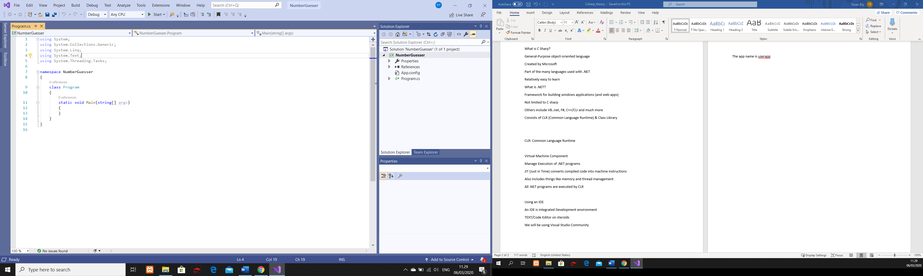

Now start coding

Namespace is basically the container for classes and functions.

//Single Line comment

Console.WriteLine(“Hello World”); // It prints and move the cursor to next line.

Console.Write(“HEI YOU”); // The cursor remains at the end of the printed content.

CTRL F5 to run the program.

Use Camel Case naming convention