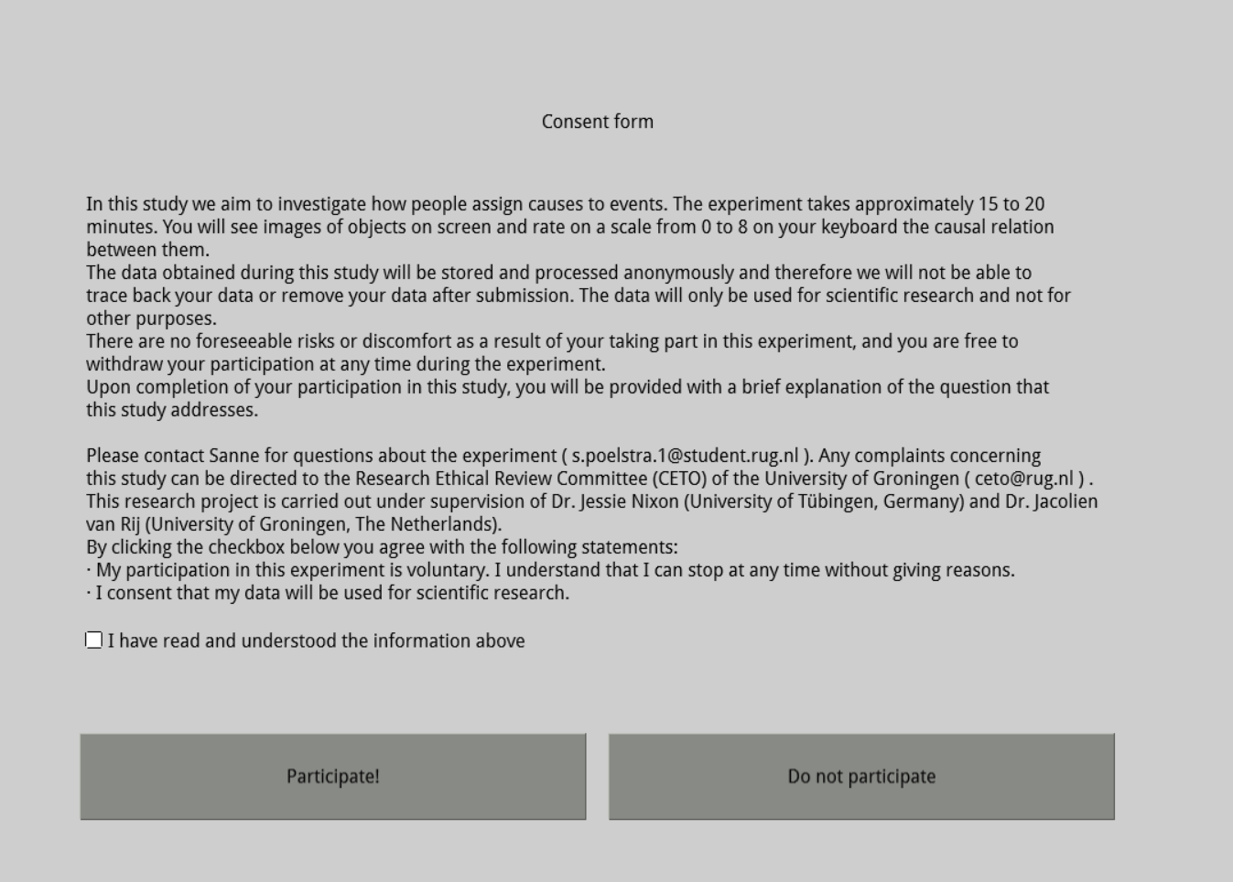This text will be shown in OpenSesame, the program we use to run the experiment. I’ve attached a picture of what exactly the participants will see, and underneath it I typed out the exact text.

In this study we aim to investigate how people assign causes to events. The experiment takes approximately 15 to 20 minutes. You will see images of objects on screen and rate on a scale from 0 to 8 on your keyboard the causal relation between them.  
The data obtained during this study will be stored and processed anonymously and therefore we will not be able to trace back your data or remove your data after submission. The data will only be used for scientific research and not for other purposes.  
There are no foreseeable risks or discomfort as a result of your taking part in this experiment, and you are free to withdraw your participation at any time during the experiment.  
Upon completion of your participation in this study, you will be provided with a brief explanation of the question that this study addresses.

Please contact Sanne for questions about the experiment ( [s.poelstra.1@student.rug.nl](mailto:s.poelstra.1@student.rug.nl) ). Any complaints concerning this study can be directed to the Research Ethical Review Committee (CETO) of the University of Groningen ( [ceto@rug.nl](mailto:ceto@rug.nl) ). This research project is carries out under supervision of Dr. Jessie Nixon (University of Tübingen, Germany) and Dr. Jacolien van Rij (University of Groningen, The Netherlands).  
By clicking the checkbox below you agree with the following statements:  
· My participation in this experiment is voluntary. I understand that I can stop at any time without giving reasons.  
· I consent that my data will be used for scientific research.

If a participant clicks “Do no participate” or clicks “Participate!” without first ticking the box, they will see the message “You need to accept the consent form to participate”, after which the same screen comes back and they can tick the box and participate, or just close the web browser tab if they decide that they do not want to participate.