**Assignment 4**

1. Create a table Customer with columns cid and cname. cid should be a primary key in the table and cname should be NOT NULL.
2. Insert three customer data into the table.

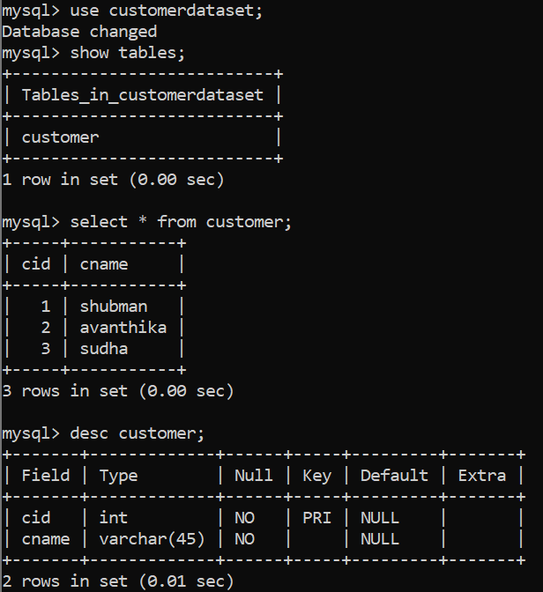

1. Add columns age, city and phnum. Age > 20, city default value should be ‘Bangalore’  and phnum should be unique.

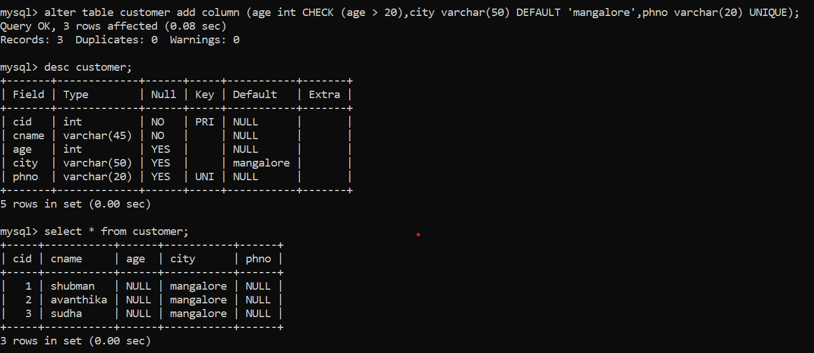

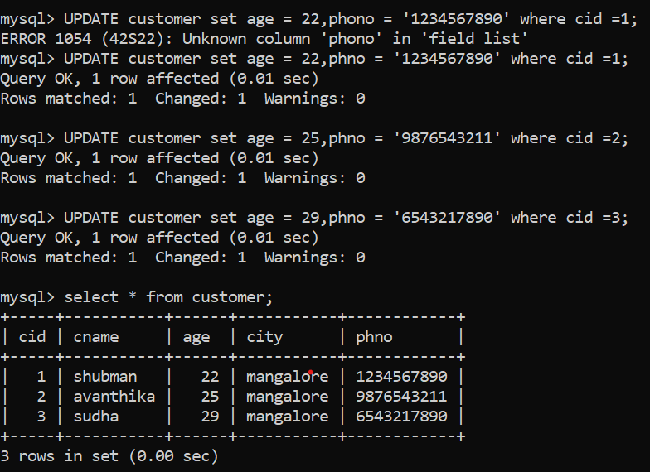

1. Turn on the transaction on.

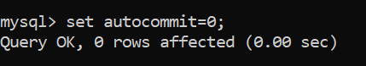

1. Insert another two customer data into the table without city value.



1. Display data from the table.

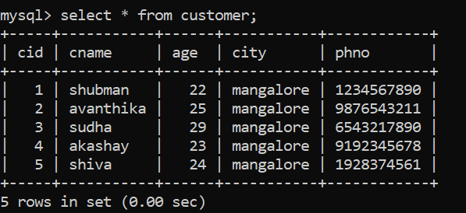

1. Create a savepoint ‘ins’.

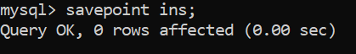

1. Update the first age of all the customers.
2. Display data from the table.
3. Create savepoint ‘up1’;

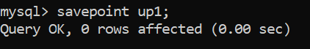

1. Update all the customer’s city of the first three customers.

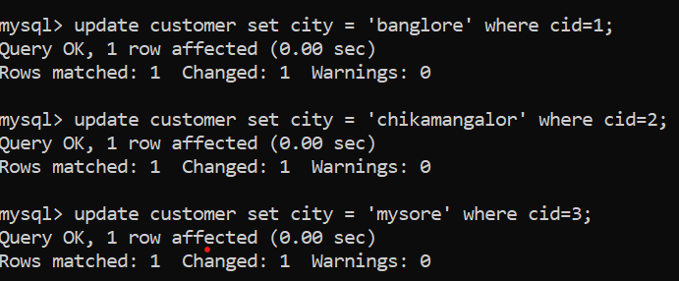

1. Display data from the table.

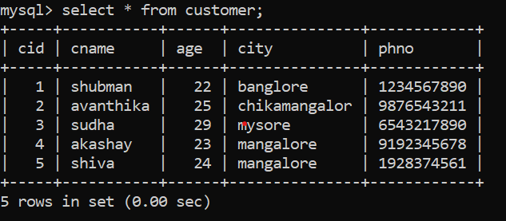

1. Create savepoint ‘up2’.

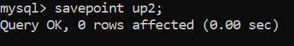

1. Roll back to up1.



1. Display data from the table.

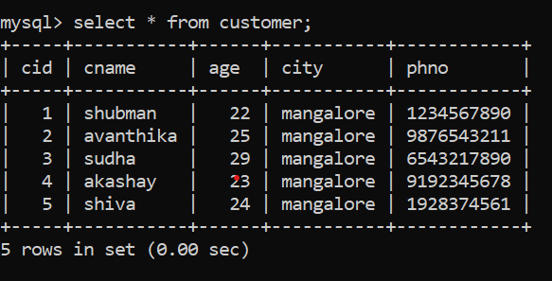

1. Commit.

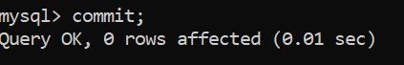

1. Display data from the table.

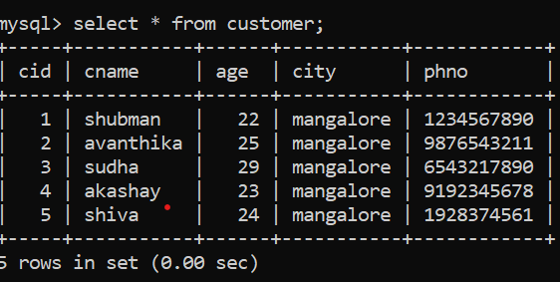

1. Turn off the transactions.

