Bookstore Microservice – AWS & MongoDB Pricing Integration Document

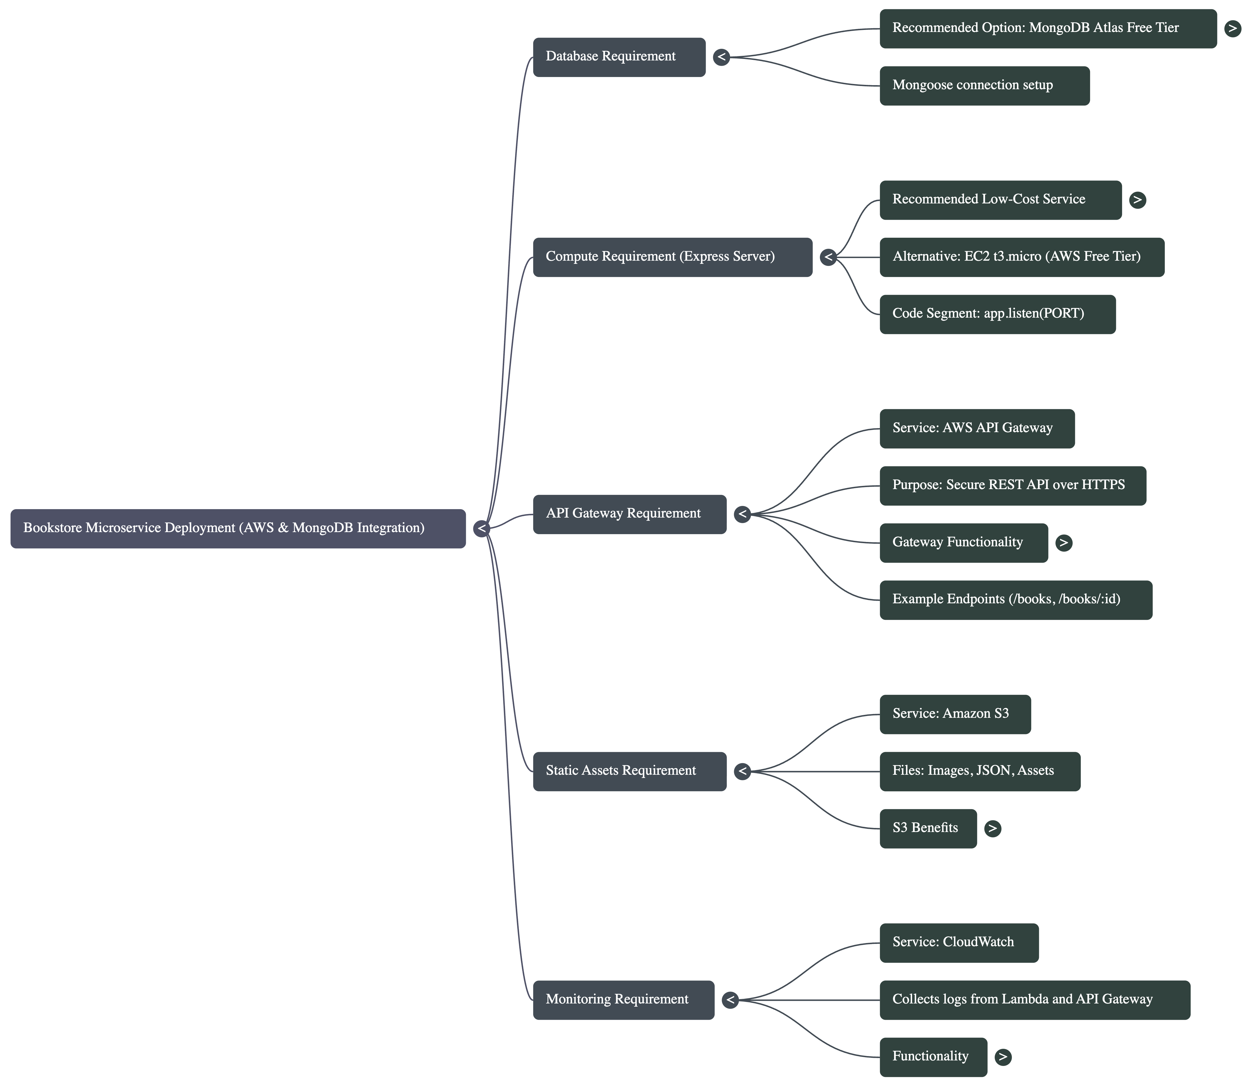

1. mongoose.connect() – Database Requirement
The MongoDB Atlas Free Tier provides 512 MB of storage, which is more than sufficient for a microservice serving approximately 100 users. Typical book documents (title, author, price fields) average between 0.2 KB and 1 KB in size. Even in an inflated scenario where each user adds 100–500 books, total storage usage remains between 10 MB and 150 MB. This represents less than 30% of the free tier limit. Therefore, the Free Tier comfortably supports academic and low-traffic workloads without risk of capacity issues.
Code Segment:
mongoose.connect('mongodb://localhost:27017/bookstore', {
useNewUrlParser: true,
useUnifiedTopology: true
});
Explanation:
This part of the code establishes a connection to MongoDB. For cloud deployment we require a managed MongoDB database. The recommended option for students and low‑traffic environments is MongoDB Atlas Free Tier.
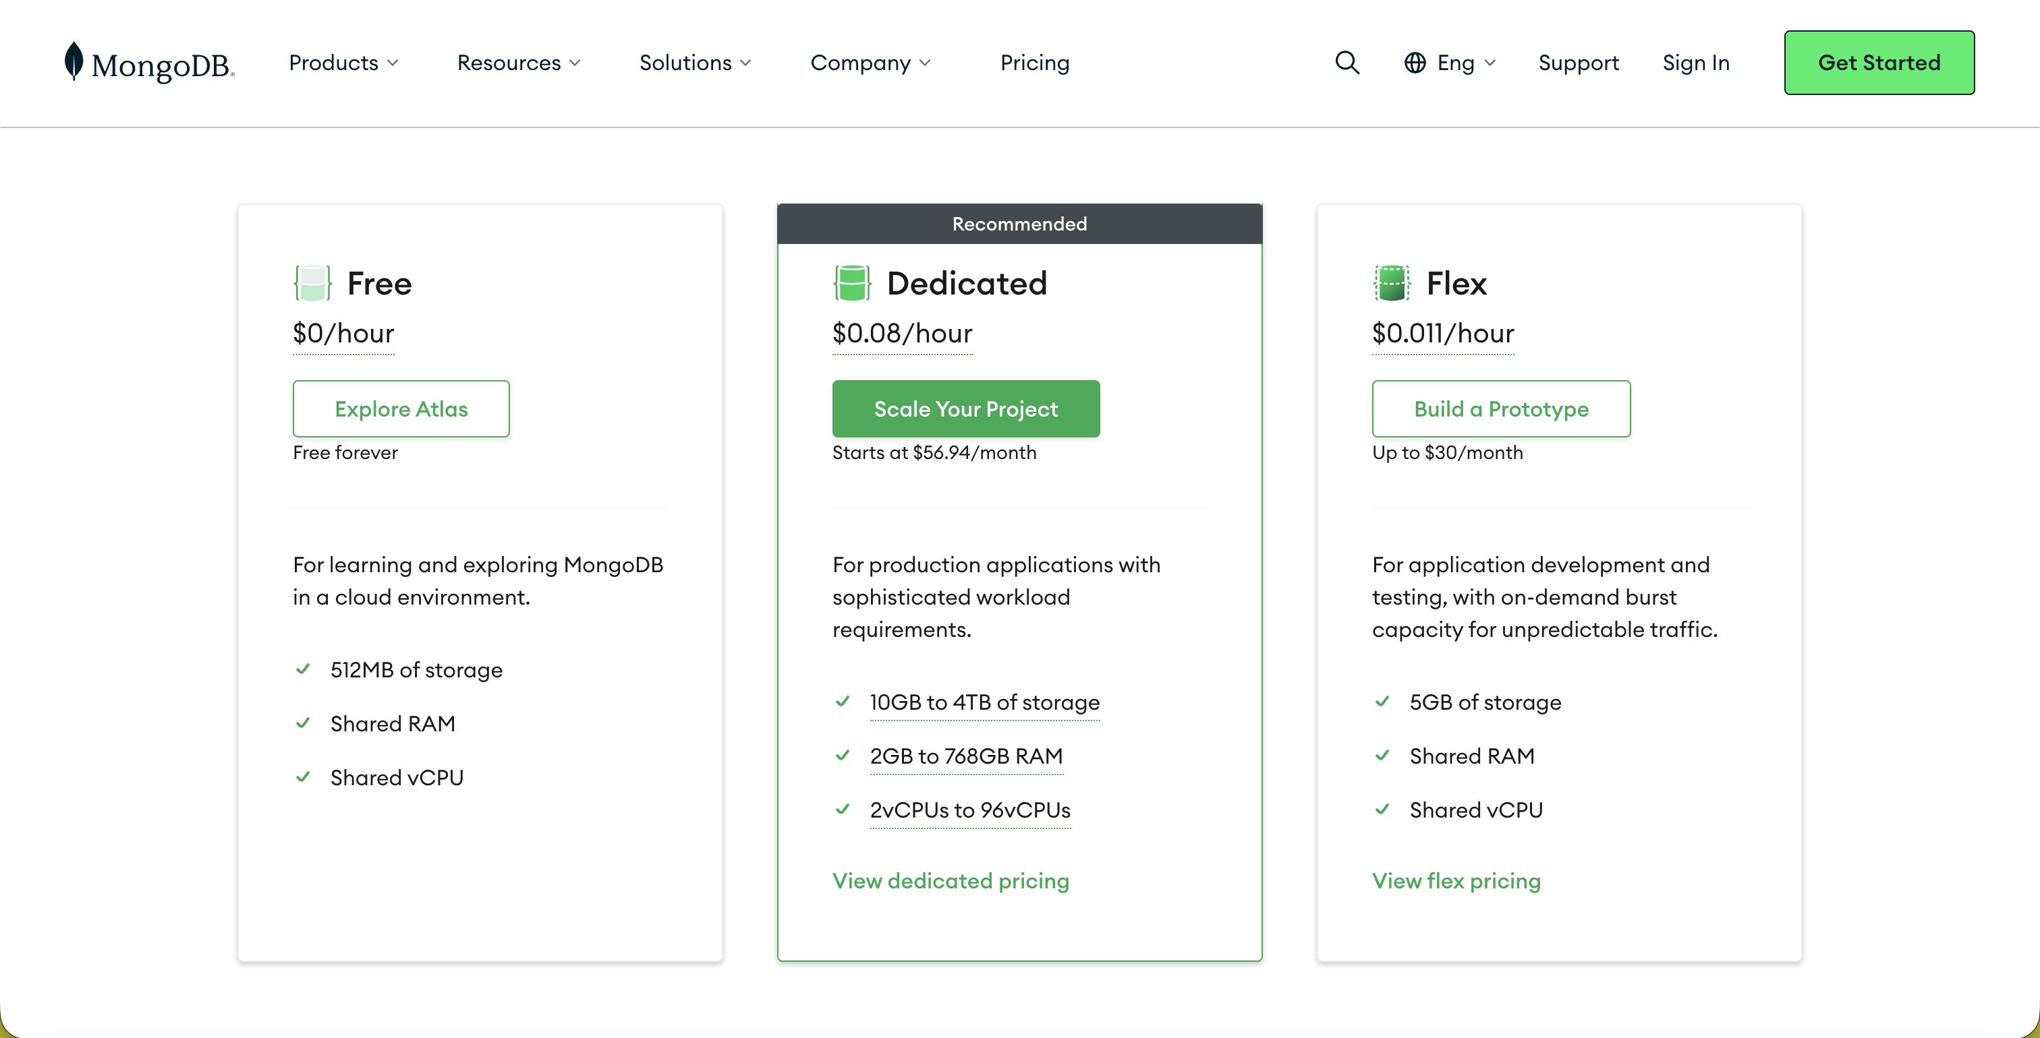

2. Express Server (app.listen) – Compute Requirement
Code Segment:
app.listen(PORT, () => {
console.log(`Bookstore service running on port ${PORT}`);
});
Explanation:
Running an Express application requires compute resources. Instead of running locally, the application can be hosted on AWS compute. The recommended low‑cost service is AWS Lambda (serverless). Alternatively, EC2 t3.micro is available in the AWS Free Tier.
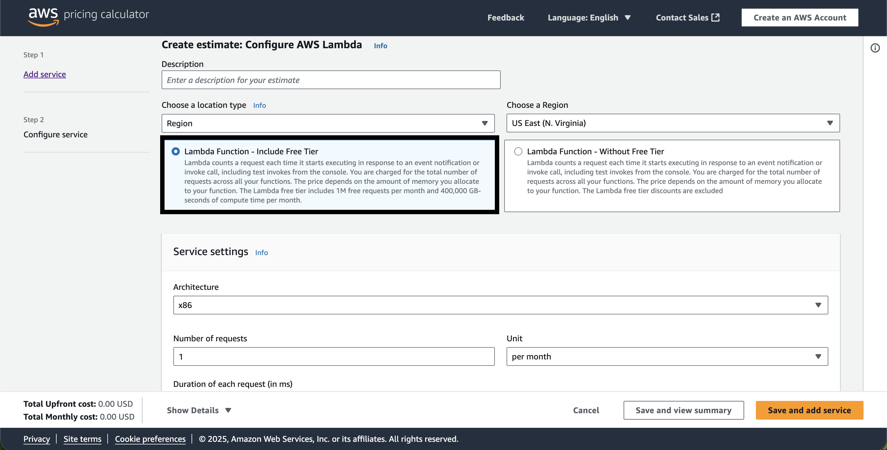

3. API Endpoints – API Gateway Requirement
Code Segment:
/books (GET, POST), /books/:id (PUT, DELETE)
Explanation:
To expose REST API endpoints securely over HTTPS, AWS API Gateway is used. It integrates directly with Lambda and provides request routing, security, rate limiting, and monitoring.
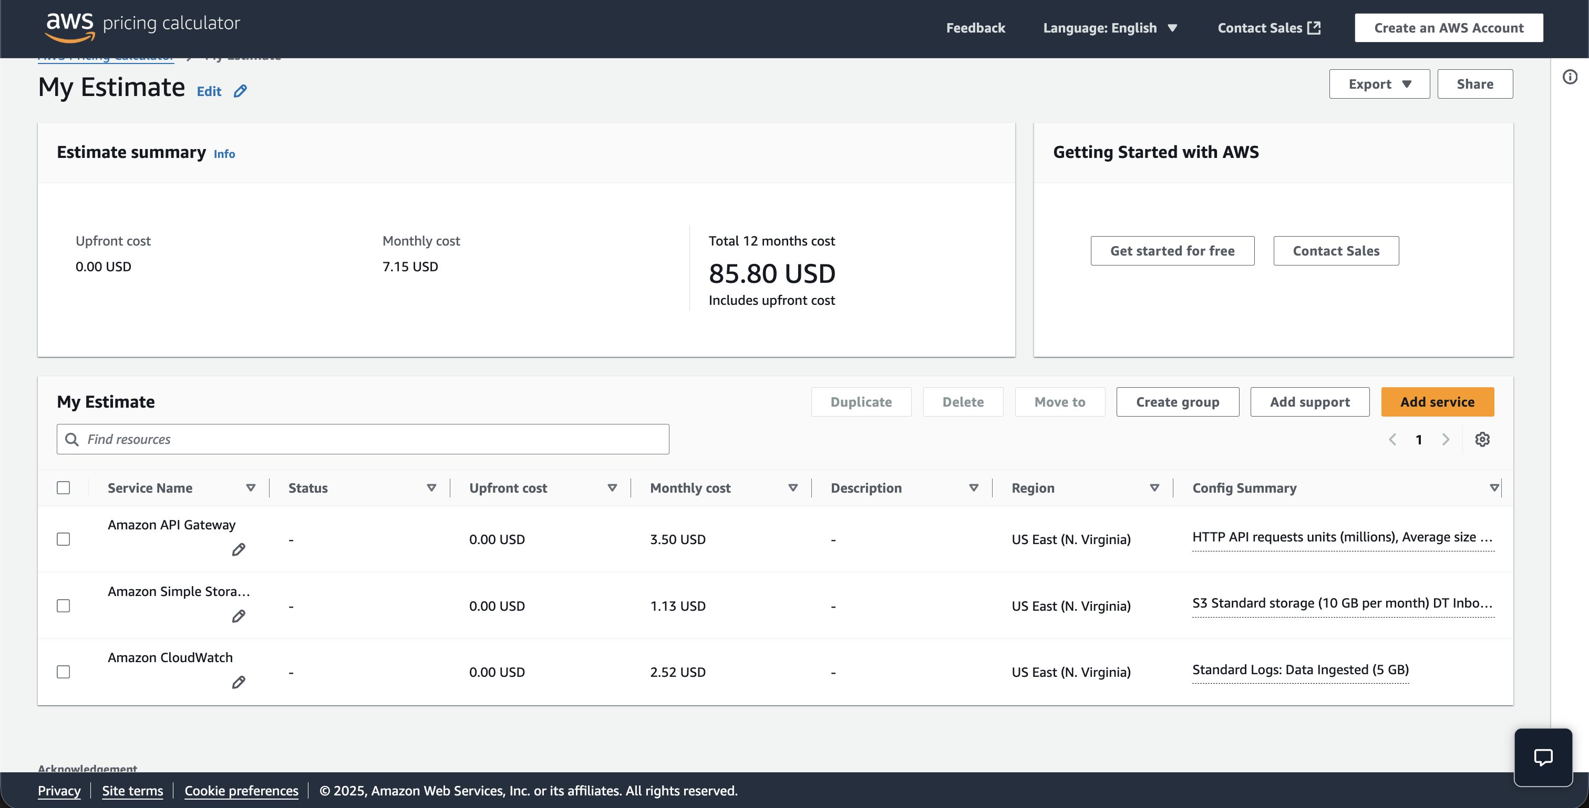

4. Static Assets – Amazon S3 Requirement
Code Segment:
N/A (Static files such as images, JSON, assets)
Explanation:
Static assets like images or JSON files can be offloaded to Amazon S3. S3 provides durable, highly available object storage with low monthly cost.

5. Monitoring – CloudWatch Requirement
Code Segment:
N/A (Lambda + API Gateway auto-generate logs)
Explanation:
CloudWatch collects logs from Lambda and API Gateway, enabling observability, error tracking, and metrics dashboards.

