**OUTPUTS**

**1602-18-737-104**

**DDL COMMANDS**

1.USERS

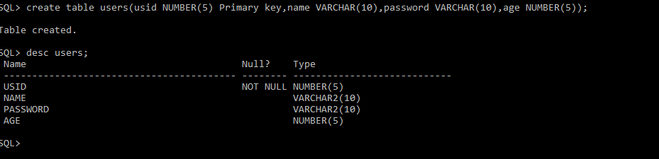

2.VIDEOS

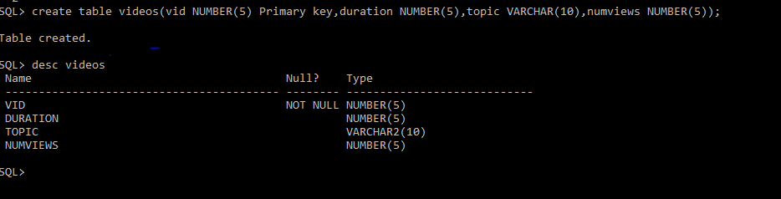

3.ADMIN

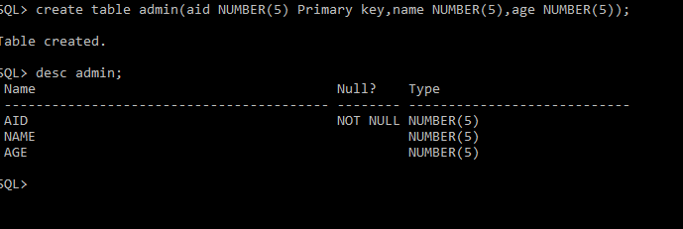

4.VIEWS

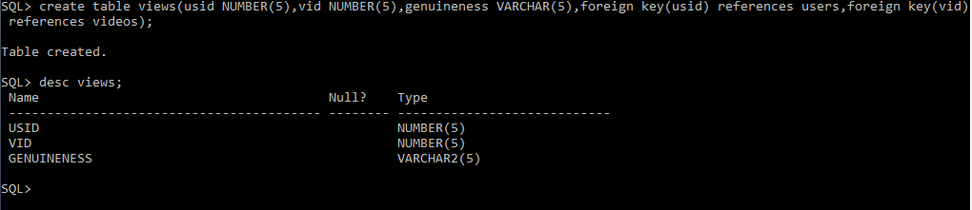

5.UPLOADS

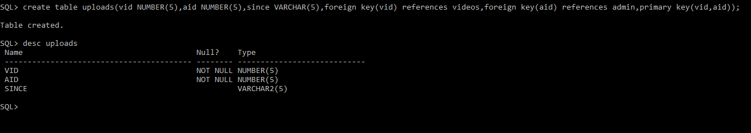

**DML COMMANDS**

1.USERS

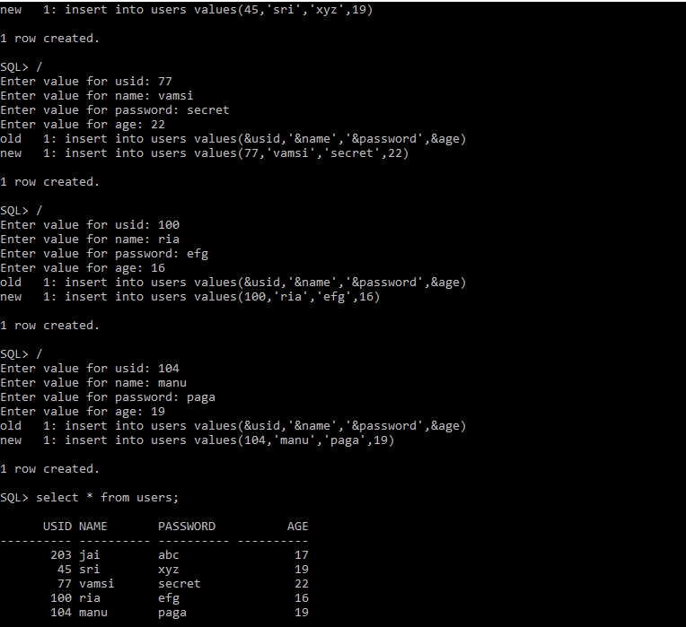

2.VIDEOS

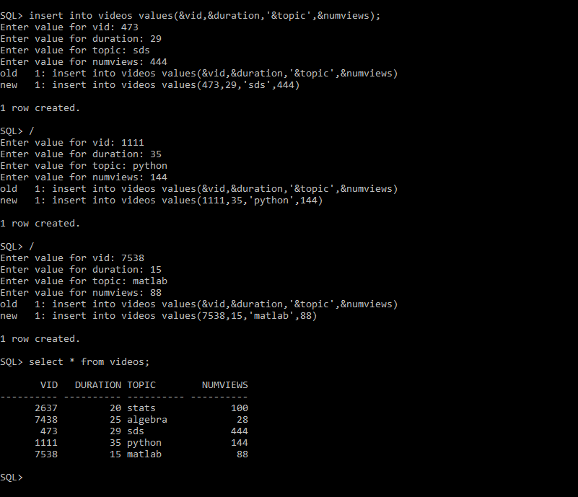

3.ADMIN

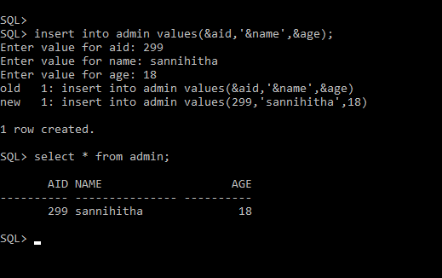

4.VIEWS

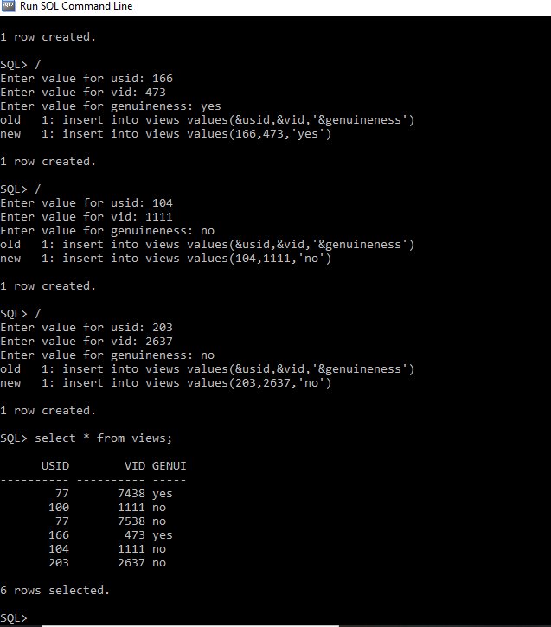

5.UPLOADS

