**EMPLOYMENT MANAGEMENT SYSTEM**

**Using HTML, CSS & BOOTSTRAP**

**LOGIN PAGE**

User has to login with username and password.

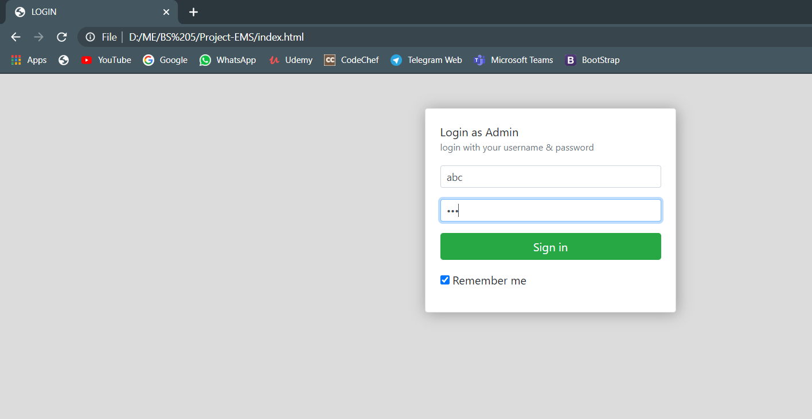

**HOME PAGE**

Home page displays the total count of employees and jobs.

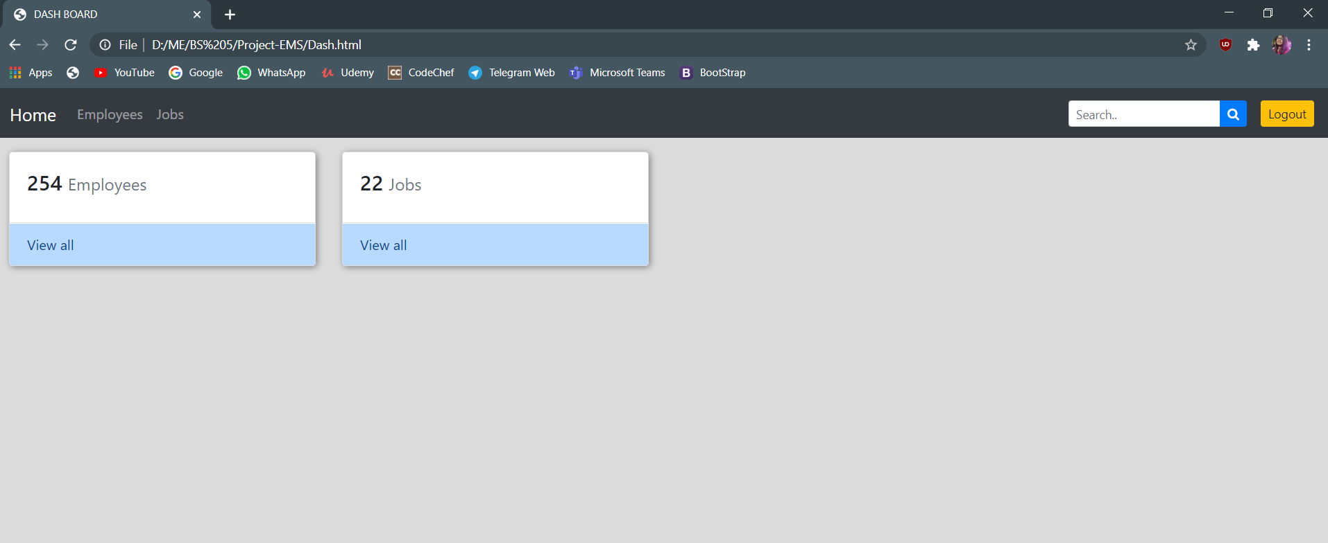

**EMPLOYEE PAGE**

Employee page displays all the employees and allows to add, edit and delete the Employee’s data (Back-end hasn’t been done).

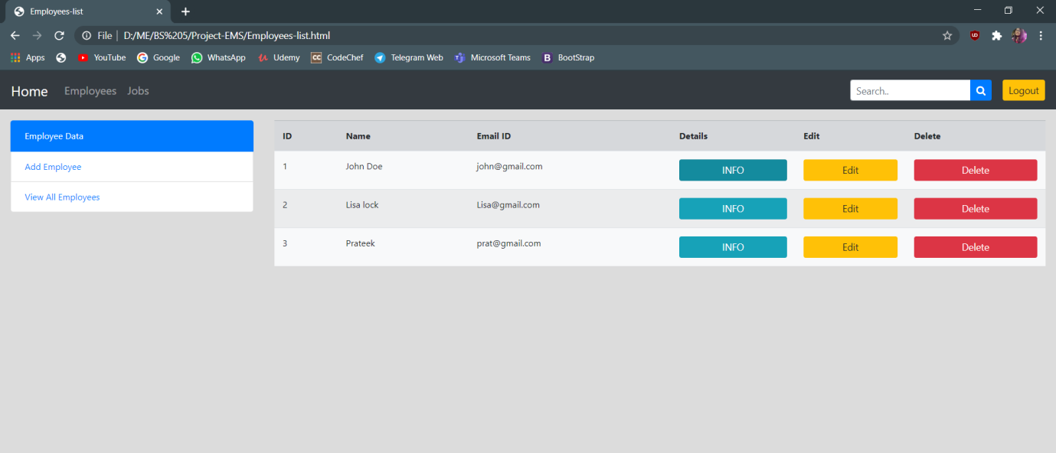

**ADD EMPLOYEE**

It allows adding new Employee’s data.

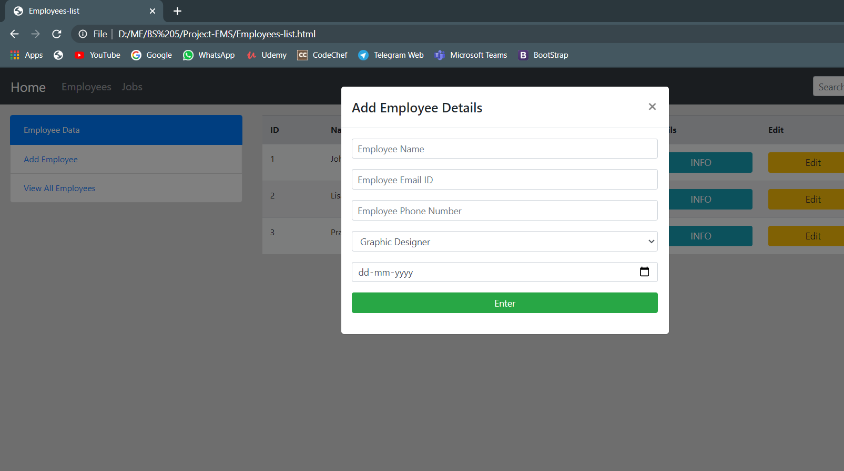

**Employee INFO**

INFO will show the details of the Employee.

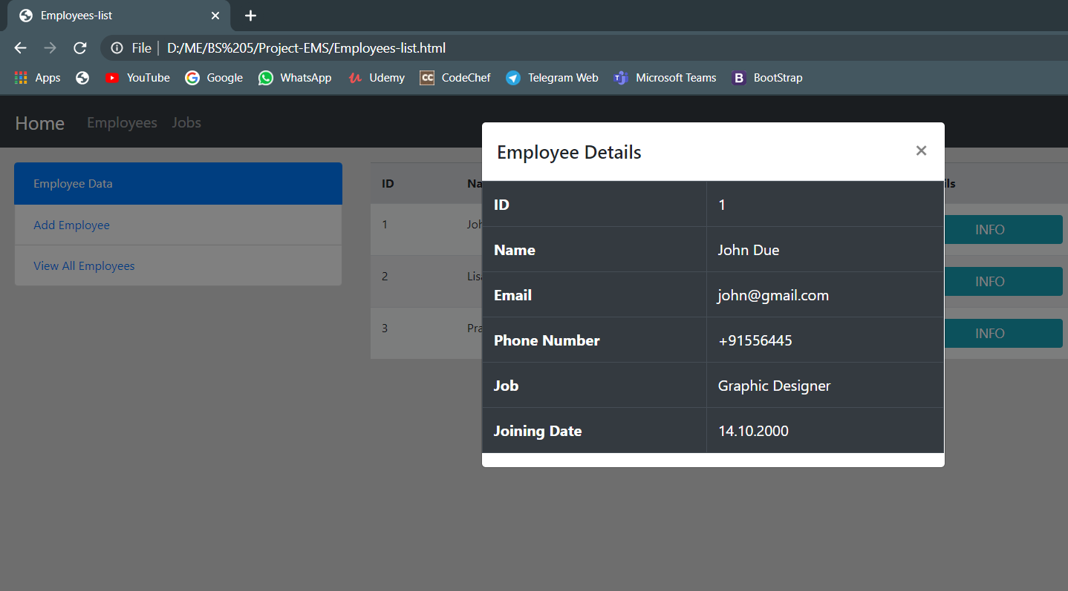

**Editing the Employee INFO**

It allows editing the Employee details.

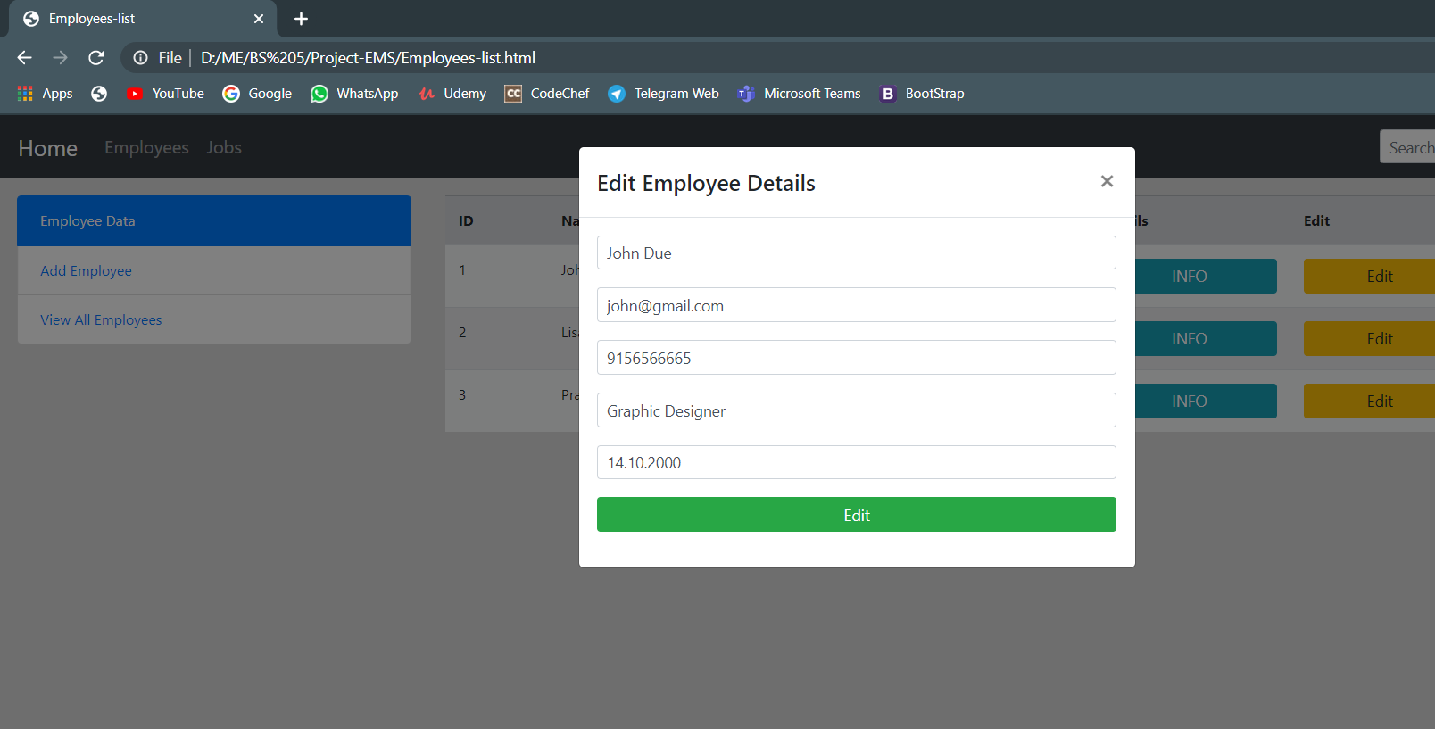

**Deleting the Employee INFO**

It confirms before deleting the records.

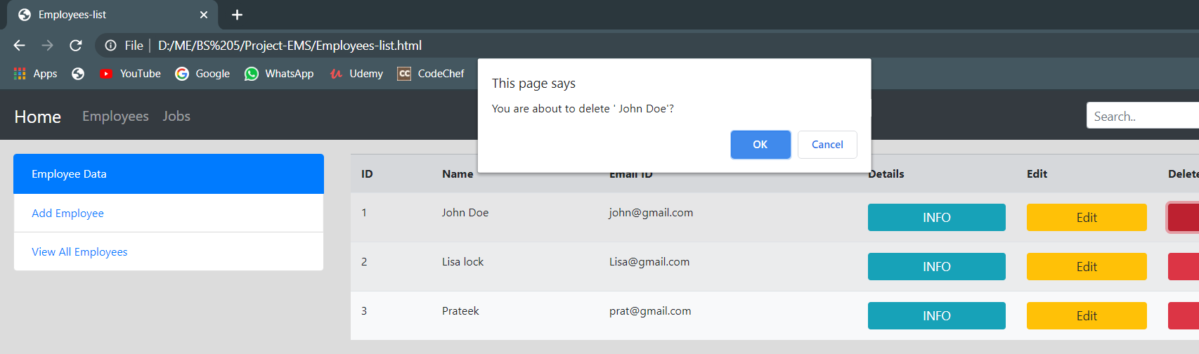

**JOBS PAGE**

Employee page displays all the jobs and allows to add, edit and delete the job’s data (Back-end hasn’t been done).

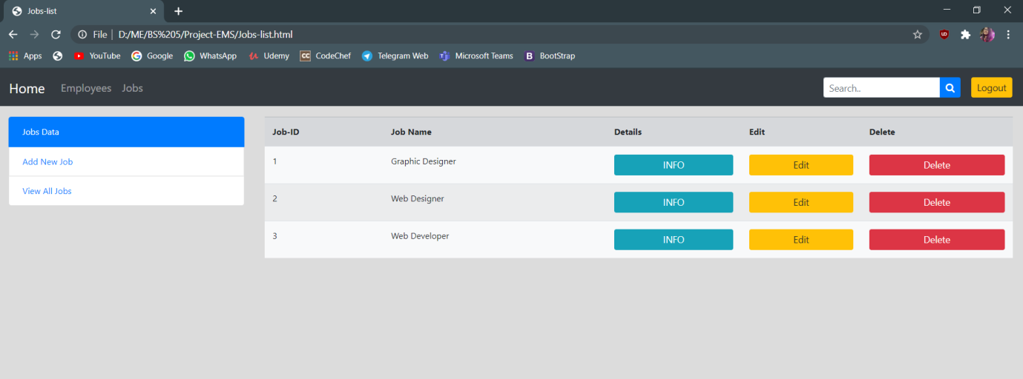

**JOBS INFO**

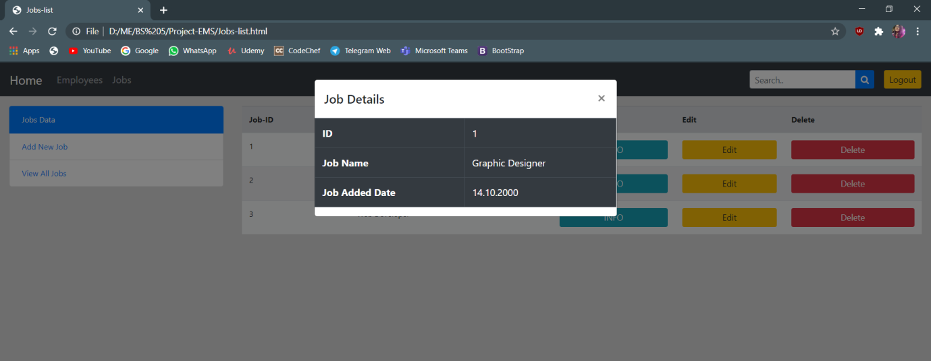

**Editing JOB INFO**

It allows editing the Job details.

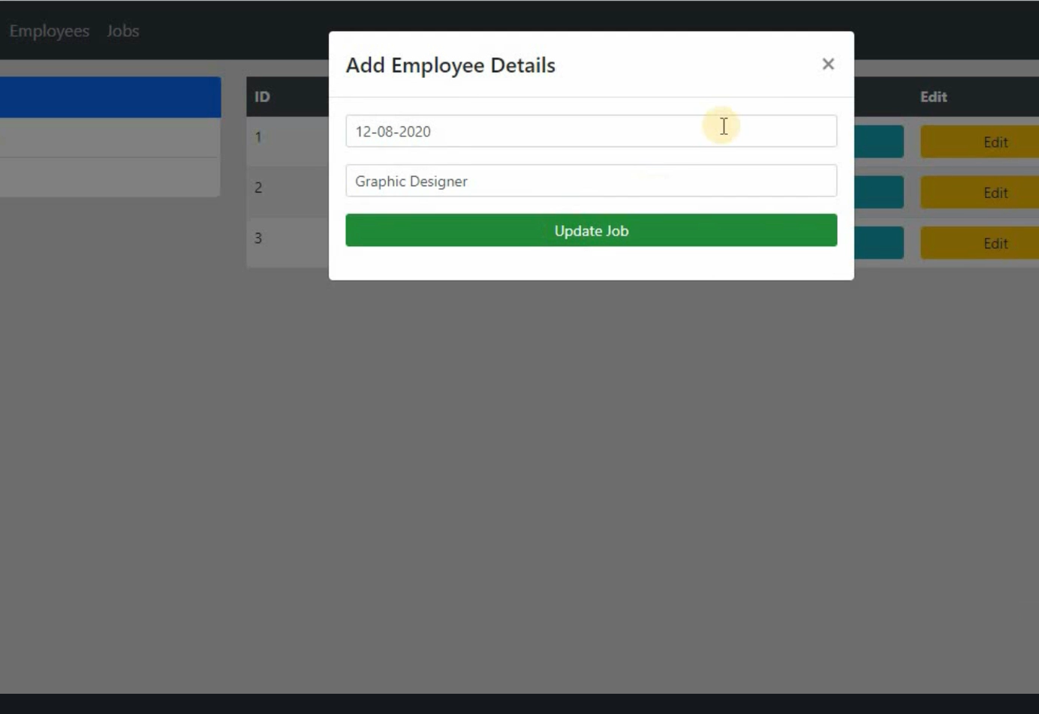

**Deleting JOB INFO**

It confirms before deleting the records.

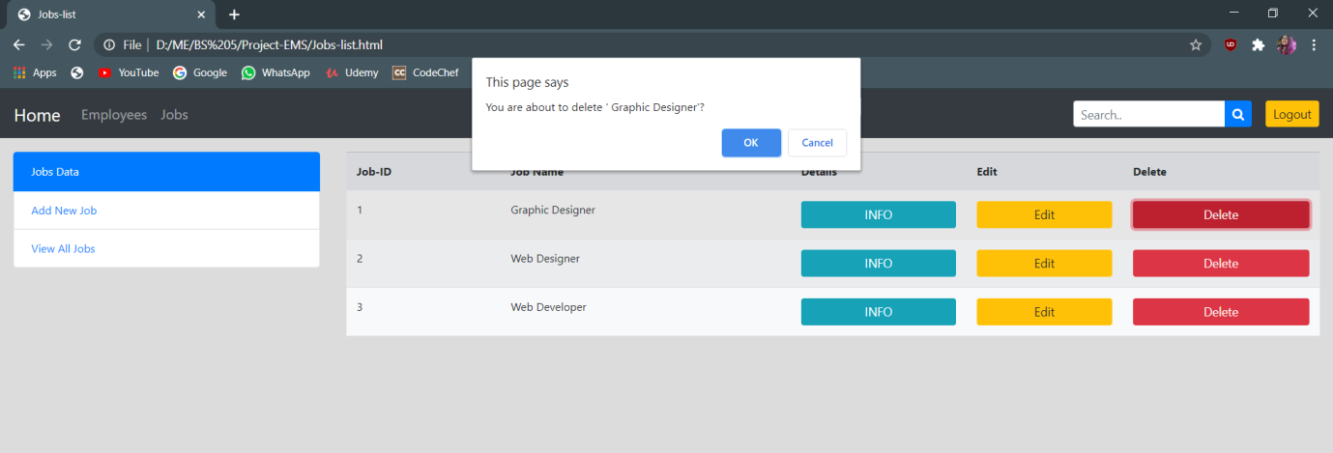

**AFTER LOG OUT**

It returns to the dashboard after clicking log out.