LABORATORY REPORT

Algorithm Laboratory (CS-39001)
B.Tech Program in ECSc
Submitted By
Name:- SANNIDHI DEB
Roll No: 2330044


Kalinga Institute of Industrial Technology

(Deemed to be University) Bhubaneswar, India
Autumn, 2025

Table of Contents
# | Title |  | Date of Experiment | Date of Submission | Remarks
1. | Revision of Data Structures |  | 24/07/2025 | 06/08/2025
2. | Design and Analysis of Fundamental Algorithms |  | 07/08/2025 | 20/08/2025
3. | Divide and Conquer Method |  | 14/08/2025 | 20/08/2025
Experiment Number |  | 3.1
Experiment Title |  | Aim of the program: Write a menu program to sort list of array elements using Merge Sort technique and calculate the execution time only to sort the elements. Count the number of comparisons.
Date of Experiment |  | 14/08/2025
Date of Submission |  | 20/08/2025

- Algorithm:-

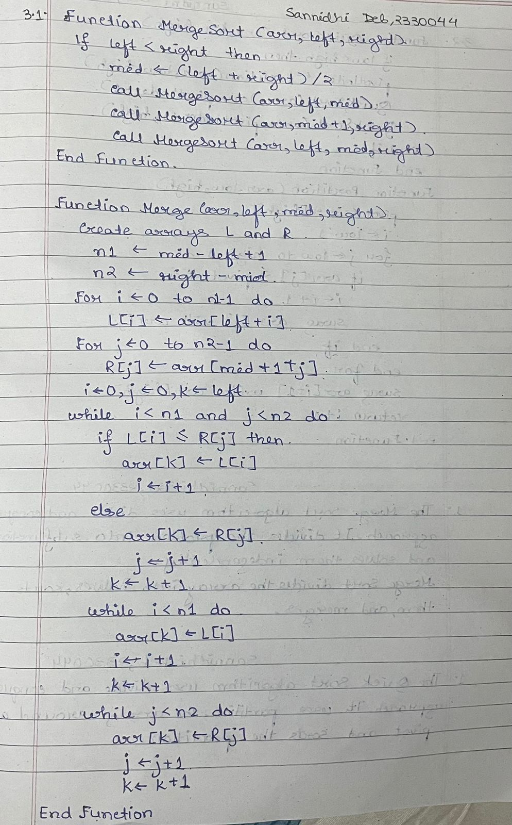

2. Code:-

#include <stdio.h>
#define MAX 500

void merge(int arr[], int l, int m, int r) {
int L[MAX], R[MAX];
int n1 = m - l + 1;
int n2 = r - m;

for (int i = 0; i < n1; i++)
L[i] = arr[l + i];
for (int j = 0; j < n2; j++)
R[j] = arr[m + 1 + j];

int i = 0, j = 0, k = l;

while (i < n1 && j < n2) {
if (L[i] <= R[j])
arr[k++] = L[i++];
else
arr[k++] = R[j++];
}

while (i < n1)
arr[k++] = L[i++];
while (j < n2)
arr[k++] = R[j++];
}

void mergeSort(int arr[], int l, int r) {
if (l < r) {
int m = l + (r - l) / 2;
mergeSort(arr, l, m);
mergeSort(arr, m + 1, r);
merge(arr, l, m, r);
}
}

int main(void) {
int arr[MAX], n;
printf("\nSannidhi Deb\n 2330044\n\n");
printf("Enter number of elements: \n");
scanf("%d", &n);

printf("\nEnter %d elements:\n", n);
for (int i = 0; i < n; i++)
scanf("%d", &arr[i]);

mergeSort(arr, 0, n - 1);

printf("\nSorted array:\n");
for (int i = 0; i < n; i++)
printf("%d ", arr[i]);
printf("\n");

return 0;
}

3.Results/Output:- Entire Screen Shot including Date & Time:-
Best Case :-
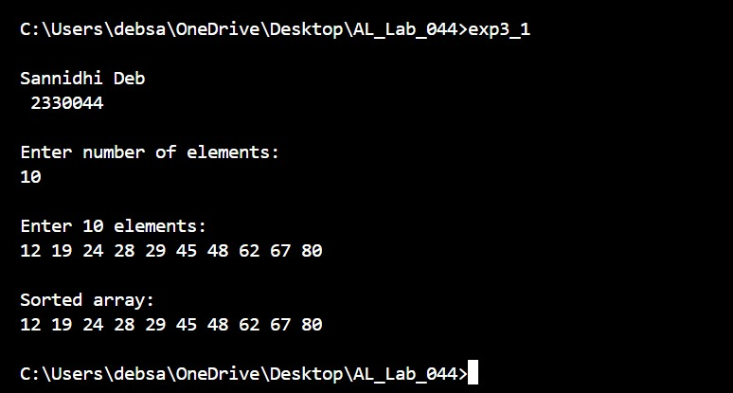

Average Case :-
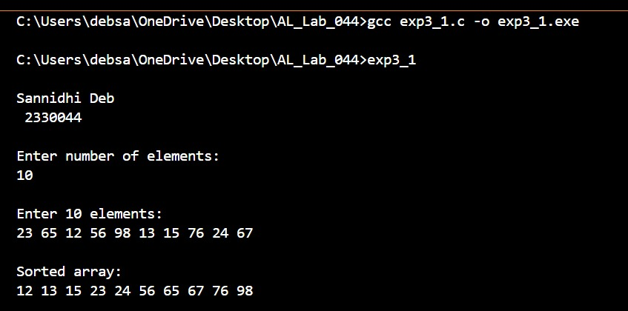

Worst Case :-
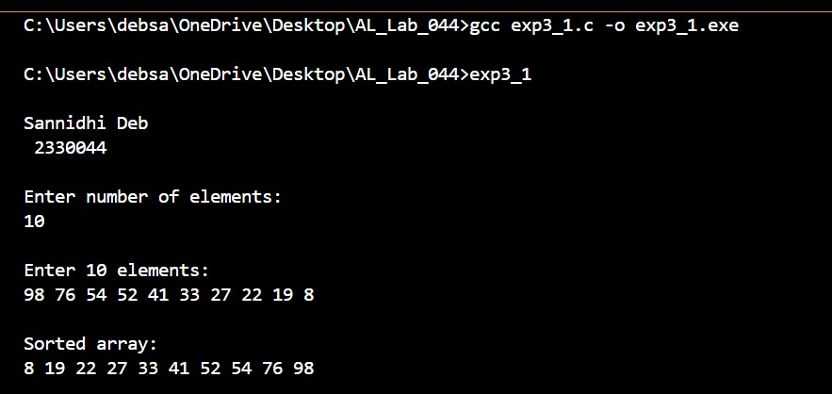

4. Remarks:-
- What type of algorithm is used?
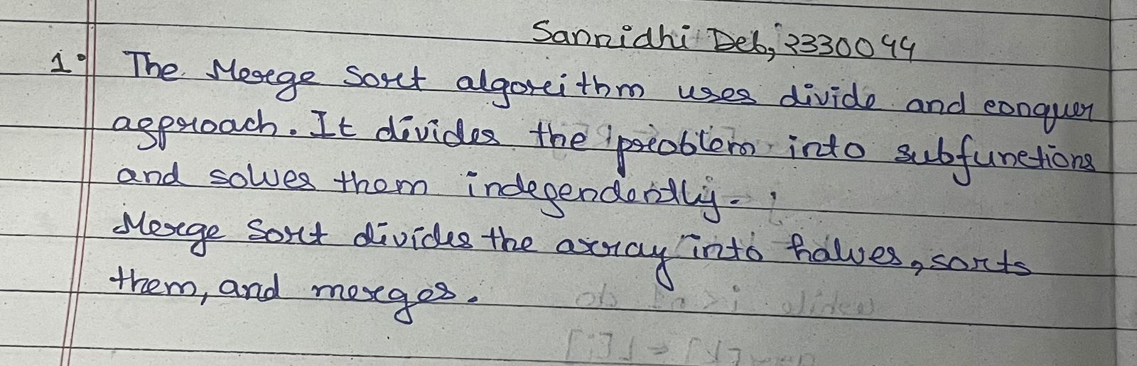
- Analyze the complexity of your algorithm.
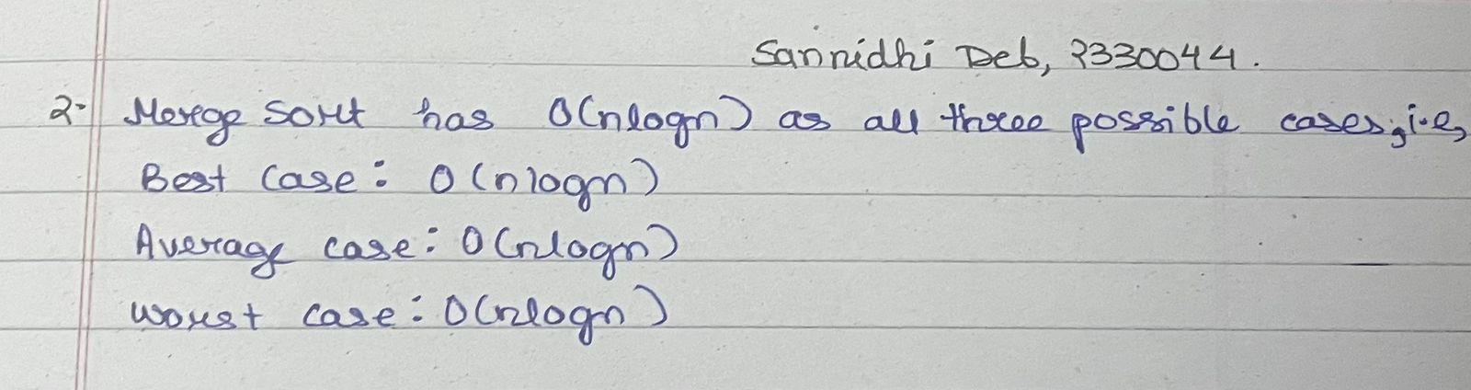

3.Any other observations?
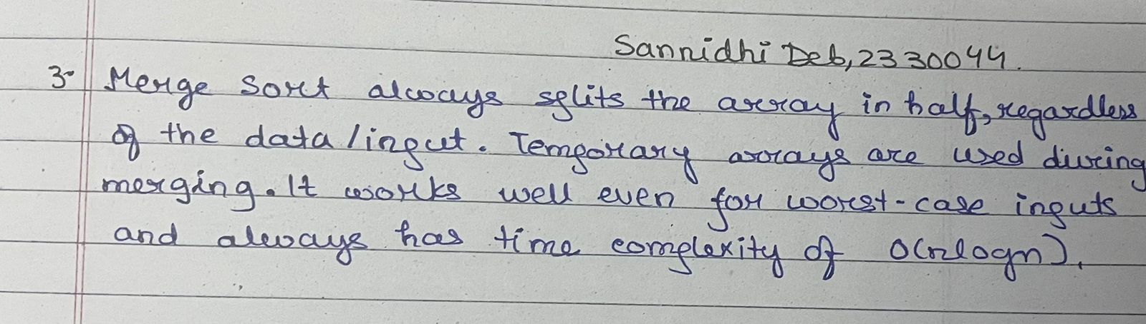

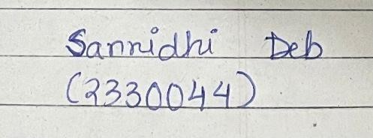 Signature of the FIC
____________________ | _________________________________
Sannidhi Deb | (Name of the FIC)
Experiment Number | 3.2
Experiment Title | Aim of the program: Write a menu driven program to sort a list of elements in ascending order using Quick Sort technique. After sorting display the content of the output. Based on the partitioning position for each recursive call, conclude the input scenario is either best-case partitioning or worst-case partitioning.
Date of Experiment | 14/08/2025
Date of Submission | 20/08/2025

1. Algorithm:-

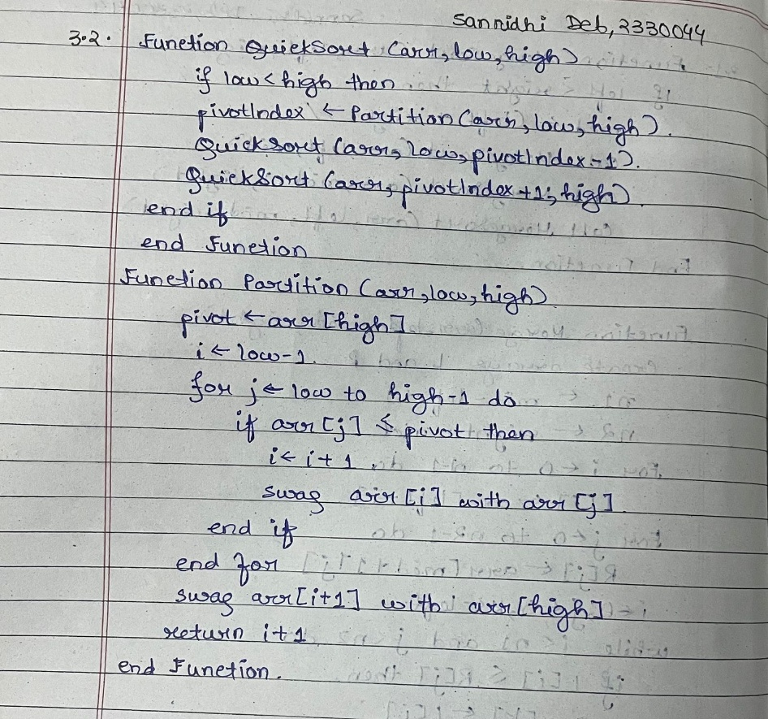

2. Code:-

#include <stdio.h>
#define MAX 500

void swap(int *a, int *b) {
int temp = *a;
*a = *b;
*b = temp;
}

int partition(int arr[], int low, int high) {
int pivot = arr[high];
int i = low - 1;

for (int j = low; j < high; j++) {
if (arr[j] <= pivot) {
i++;
swap(&arr[i], &arr[j]);
}
}
swap(&arr[i + 1], &arr[high]);
return (i + 1);
}

void quickSort(int arr[], int low, int high) {
if (low < high) {
int pi = partition(arr, low, high);

quickSort(arr, low, pi - 1);
quickSort(arr, pi + 1, high);
}
}

int main(void) {
int arr[MAX], n;
printf("\nSannidhi Deb\n 2330044\n\n");
printf("Enter number of elements: \n");
scanf("%d", &n);

printf("\nEnter %d elements:\n", n);
for (int i = 0; i < n; i++)
scanf("%d", &arr[i]);

quickSort(arr, 0, n - 1);

printf("\nSorted array:\n");
for (int i = 0; i < n; i++)
printf("%d ", arr[i]);
printf("\n");

return 0;
}

Results/Output:- Entire Screen Shot including Date & Time:-
Best Case :-
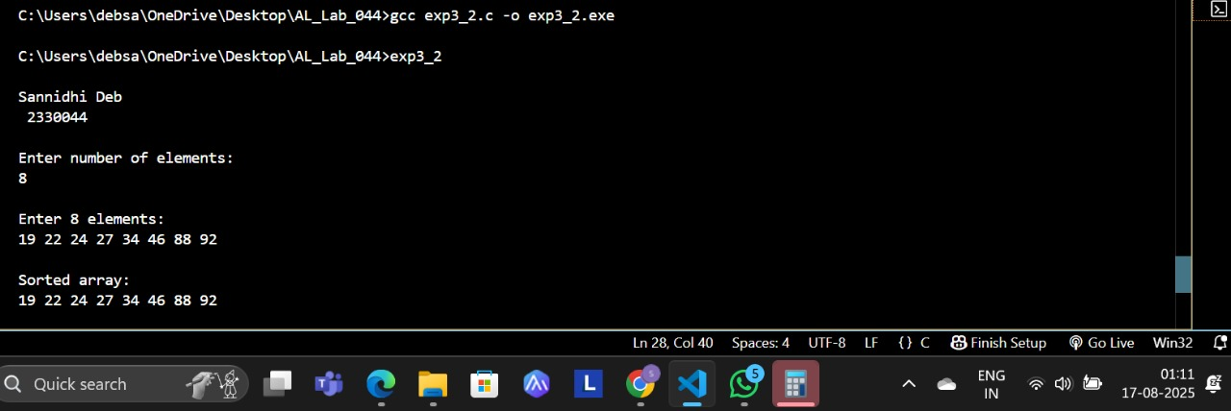

Average Case :-
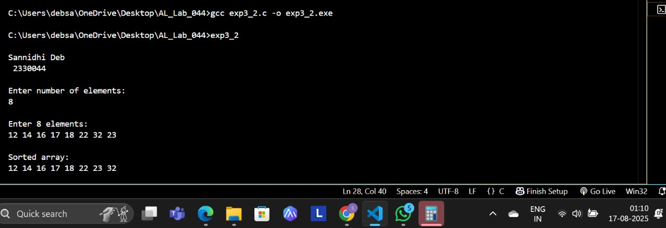

Worst Case :-
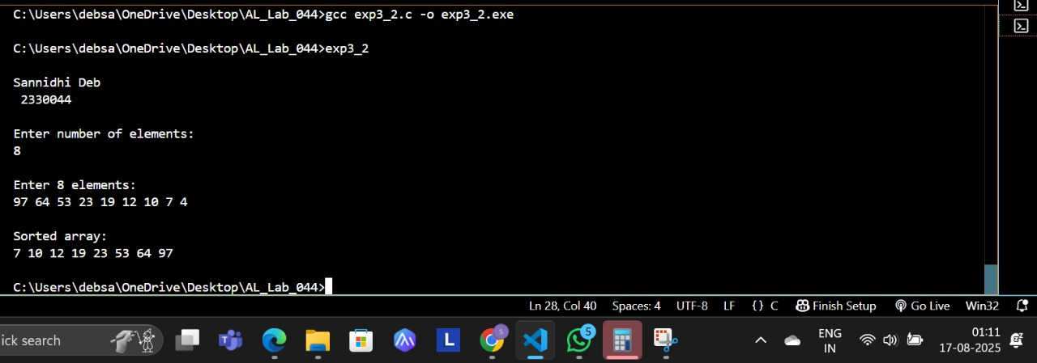

4. Remarks:-
- What type of algorithm is used?
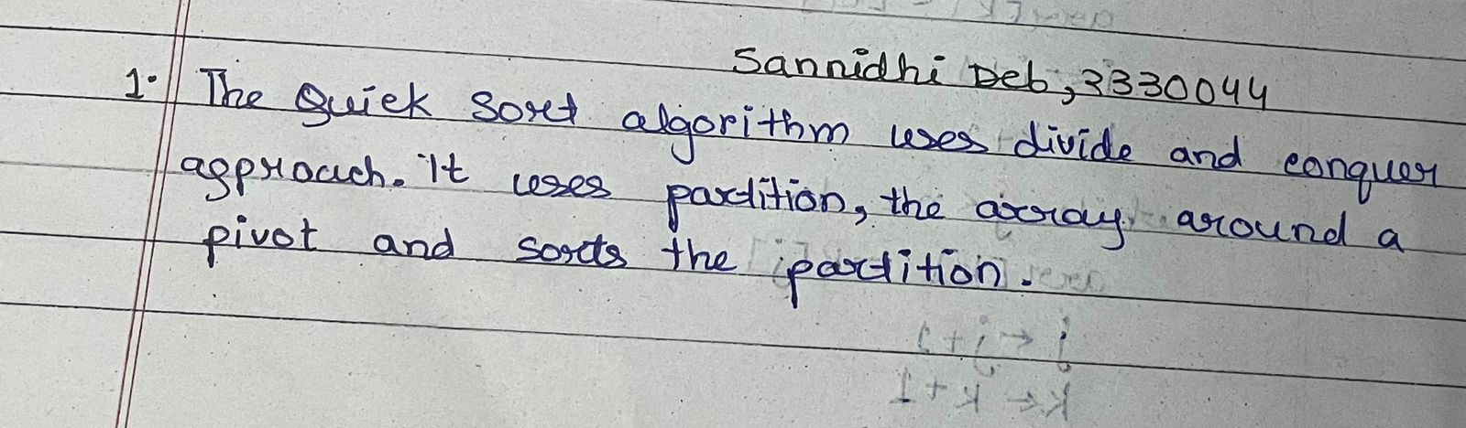

- Analyze the complexity of your algorithm.
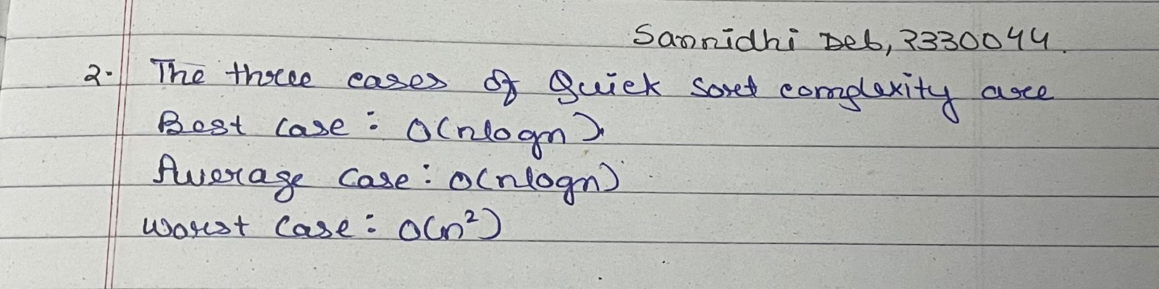

3.Any other observations?
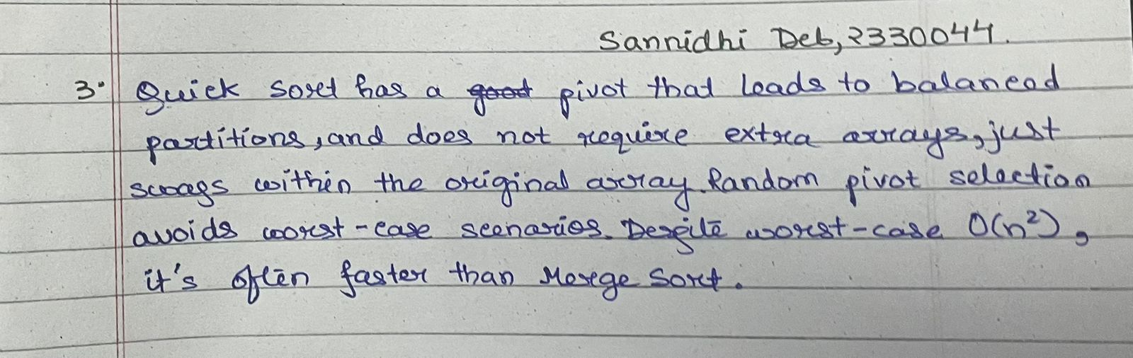

Signature of the FIC
____________________ | _________________________________
Sannidhi Deb | (Name of the FIC)

- Conclusion:-
Merge Sort and Quick Sort are both fast sorting methods. Merge Sort is steady and works well with large data but uses more memory. Quick Sort is usually faster and uses less memory, but can slow down with bad input. Choosing between them depends on speed, memory, and data type.

Merge Sort and Quick Sort both use the divide and conquer method. They break the problem into smaller parts, solve them, and combine the results. Merge Sort is stable but uses more memory. Quick Sort is faster and uses less memory, but can slow down with bad pivot choices.

Signature of the FIC
____________________ _________________________________
Sannidhi Deb (Name of the FIC)

