LABORATORY REPORT

Algorithm Laboratory (CS-39001)
B.Tech Program in ECSc
Submitted By
Name:- SANNIDHI DEB
Roll No: 2330044


Kalinga Institute of Industrial Technology

(Deemed to be University) Bhubaneswar, India
Autumn, 2025

Table of Contents
# | Title |  | Date of Experiment | Date of Submission | Remarks
1. | Revision of Data Structures |  | 24/07/2025 | 06/08/2025
2. | Design and Analysis of Fundamental Algorithms |  | 07/08/2025 | 20/08/2025
3. | Divide and Conquer Method |  | 14/08/2025 | 20/08/2025
4. | Heap Sort |  | 21/08/2025 | 27/08/2025
Experiment Number |  | 4.1
Experiment Title |  | 4.1 Aim of the program:  Define a struct person as follows:  struct person  {  int id;  char *name;  int age;  int height;  int weight;  };  Write a menu driven program to read the data of ‘n’ students. Implement the min-heap or max-heap and its operations based on the menu options.  Sample Input/Output:  MAIN MENU (HEAP)  1. Read Data  2. Create a Min-heap based on the age  3. Create a Max-heap based on the weight  4. Display weight of the youngest person  5. Insert a new person into the Min-heap  6. Delete the oldest person  7. Exit
Date of Experiment |  | 21/08/2025
Date of Submission |  | 27/08/2025

1.Algorithm:-
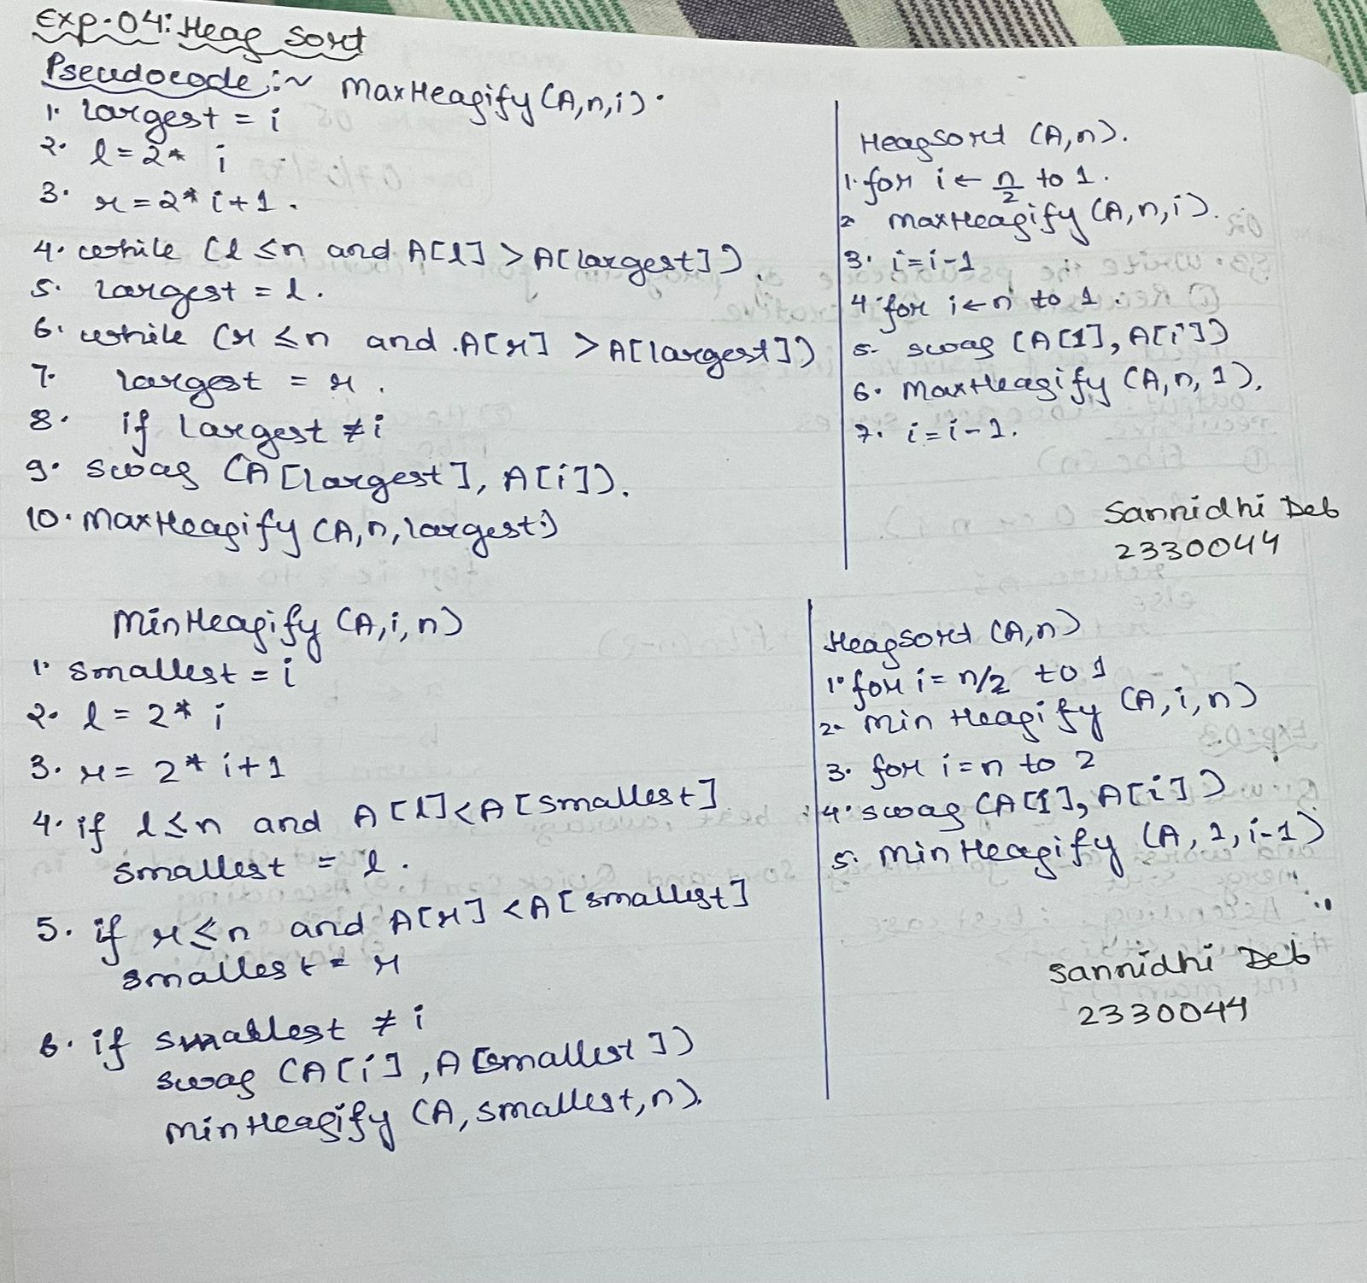

2. Code:-
#include <stdio.h>
#include <stdlib.h>
#include <string.h>

struct person {
int id;
char name[50];
int age;
int height;
int weight;
};

struct person *arr = NULL; // dynamic array of persons
int n = 0; // number of persons

// --------- Heap Helper Functions ---------
void swap(struct person *a, struct person *b) {
struct person temp = *a;
*a = *b;
*b = temp;
}

// Min-Heapify based on Age
void minHeapify(struct person arr[], int size, int i) {
int smallest = i;
int l = 2*i + 1;
int r = 2*i + 2;

if (l < size && arr[l].age < arr[smallest].age)
smallest = l;
if (r < size && arr[r].age < arr[smallest].age)
smallest = r;

if (smallest != i) {
swap(&arr[i], &arr[smallest]);
minHeapify(arr, size, smallest);
}
}

// Max-Heapify based on Weight
void maxHeapify(struct person arr[], int size, int i) {
int largest = i;
int l = 2*i + 1;
int r = 2*i + 2;

if (l < size && arr[l].weight > arr[largest].weight)
largest = l;
if (r < size && arr[r].weight > arr[largest].weight)
largest = r;

if (largest != i) {
swap(&arr[i], &arr[largest]);
maxHeapify(arr, size, largest);
}
}

void buildMinHeap(struct person arr[], int size) {
for (int i = size/2 - 1; i >= 0; i--)
minHeapify(arr, size, i);
}

void buildMaxHeap(struct person arr[], int size) {
for (int i = size/2 - 1; i >= 0; i--)
maxHeapify(arr, size, i);
}

// Insert into Min-Heap (based on Age)
void insertMinHeap(struct person p) {
n++;
arr = realloc(arr, n * sizeof(struct person));
arr[n-1] = p;

int i = n - 1;
while (i > 0 && arr[(i-1)/2].age > arr[i].age) {
swap(&arr[i], &arr[(i-1)/2]);
i = (i-1)/2;
}
}

// Delete the oldest person (max age) from Min-Heap
void deleteOldest() {
if (n == 0) {
printf("Heap is empty!\n");
return;
}

int maxAgeIdx = 0;
for (int i = 1; i < n; i++) {
if (arr[i].age > arr[maxAgeIdx].age)
maxAgeIdx = i;
}

printf("Deleted oldest person: %s (Age %d)\n", arr[maxAgeIdx].name, arr[maxAgeIdx].age);

arr[maxAgeIdx] = arr[n-1];
n--;
arr = realloc(arr, n * sizeof(struct person));
buildMinHeap(arr, n);
}

// --------- Menu Functions ---------
void readData() {
printf("Enter number of persons: ");
scanf("%d", &n);

arr = malloc(n * sizeof(struct person));

for (int i = 0; i < n; i++) {
arr[i].id = i;
printf("Enter Name, Age, Height, Weight for person %d:\n", i);
scanf("%s %d %d %d", arr[i].name, &arr[i].age, &arr[i].height, &arr[i].weight);
}
}

void displayPersons() {
printf("\nId\tName\tAge\tHeight\tWeight\n");
for (int i = 0; i < n; i++)
printf("%d\t%s\t%d\t%d\t%d\n", arr[i].id, arr[i].name, arr[i].age, arr[i].height, arr[i].weight);
}

void displayYoungestWeight() {
if (n == 0) {
printf("No persons available.\n");
return;
}

int minAgeIdx = 0;
for (int i = 1; i < n; i++) {
if (arr[i].age < arr[minAgeIdx].age)
minAgeIdx = i;
}

printf("Weight of youngest person (%s, Age %d): %.2f kg\n",
arr[minAgeIdx].name, arr[minAgeIdx].age, arr[minAgeIdx].weight * 0.453592);
}

// --------- Main ---------
int main(void) {
int choice;
do {
printf("\nSannidhi Deb\n 2330044\n\n\nMAIN MENU (HEAP)\n");
printf("1. Read Data\n");
printf("2. Create a Min-heap based on the age\n");
printf("3. Create a Max-heap based on the weight\n");
printf("4. Display weight of the youngest person\n");
printf("5. Insert a new person into the Min-heap\n");
printf("6. Delete the oldest person\n");
printf("7. Exit\n");
printf("Enter option: ");
scanf("%d", &choice);

switch(choice) {
case 1:
readData();
displayPersons();
break;
case 2:
buildMinHeap(arr, n);
printf("Min-heap (Age) created.\n");
displayPersons();
break;
case 3:
buildMaxHeap(arr, n);
printf("Max-heap (Weight) created.\n");
displayPersons();
break;
case 4:
displayYoungestWeight();
break;
case 5: {
struct person p;
p.id = n;
printf("Enter Name, Age, Height, Weight for new person:\n");
scanf("%s %d %d %d", p.name, &p.age, &p.height, &p.weight);
insertMinHeap(p);
printf("Person inserted into Min-heap.\n");
displayPersons();
break;
}
case 6:
deleteOldest();
displayPersons();
break;
case 7:
printf("Exiting program...\n");
break;
default:
printf("Invalid option!\n");
}
} while(choice != 7);

free(arr);
return 0;
}

3.Results/Output:- Entire Screen Shot including Date & Time:-

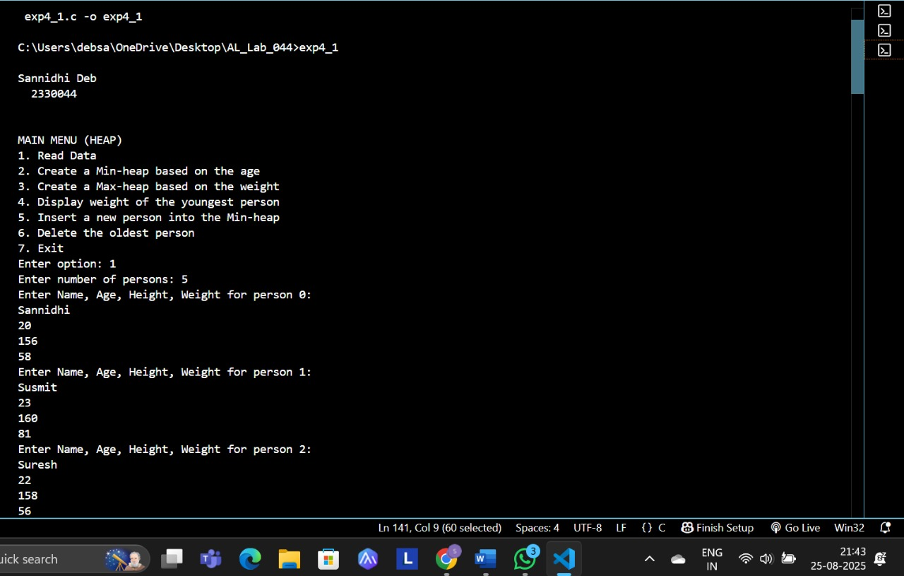

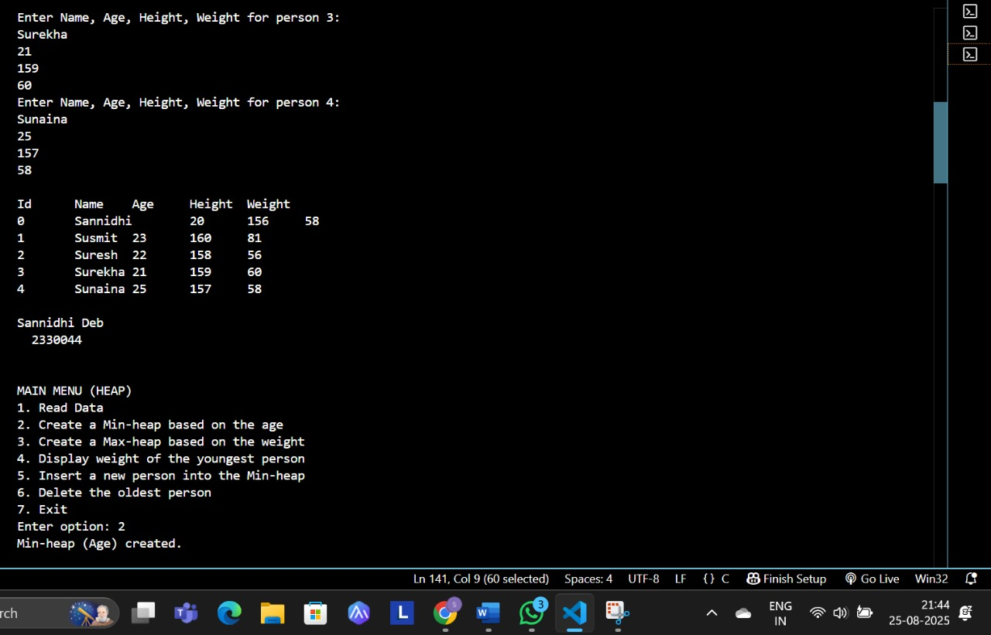
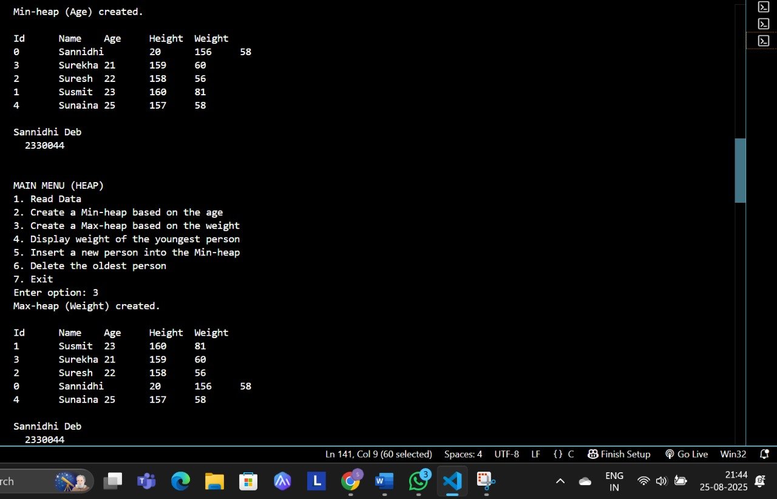
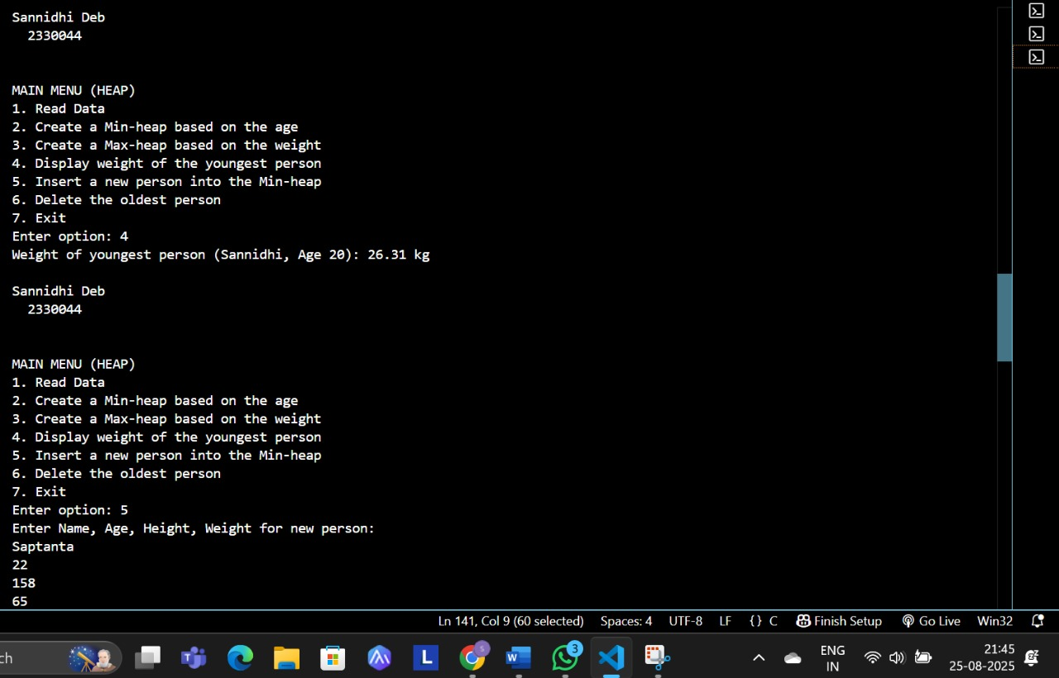
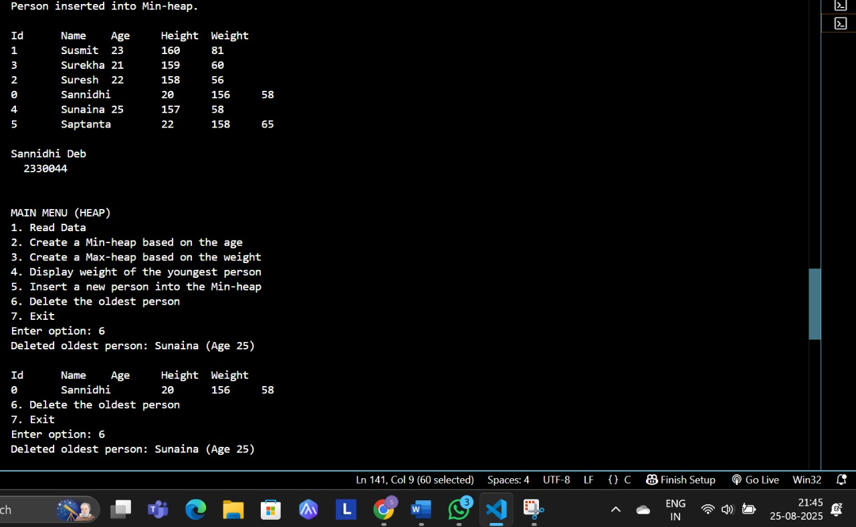
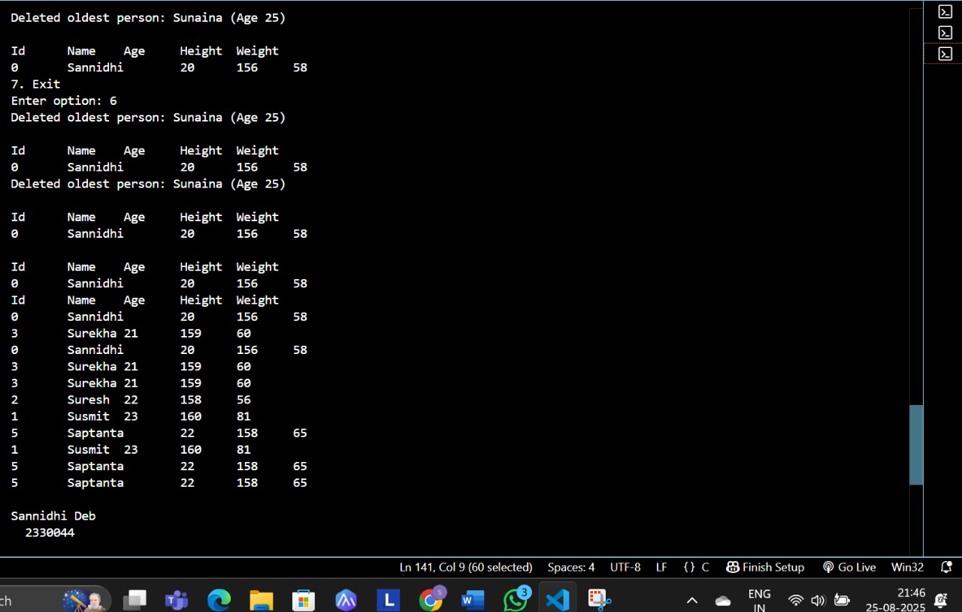
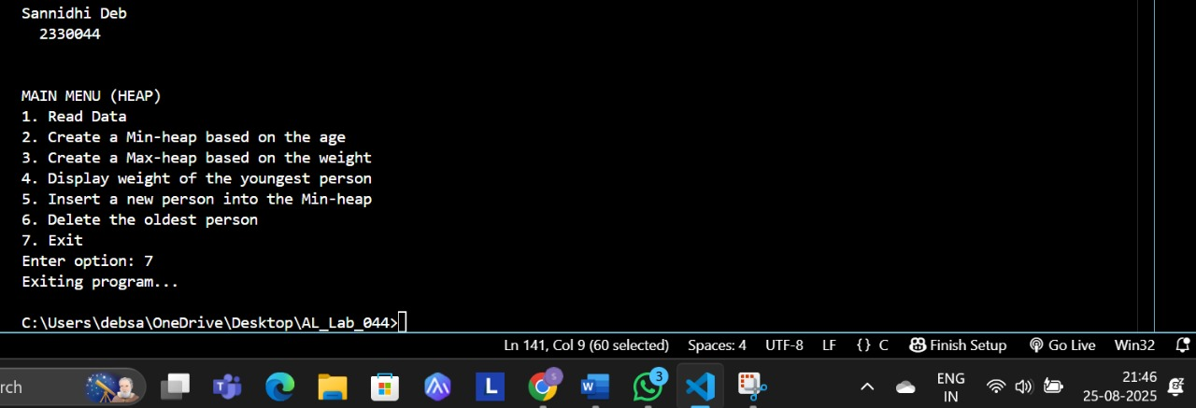

4. Remarks:-
- What type of algorithm is used?
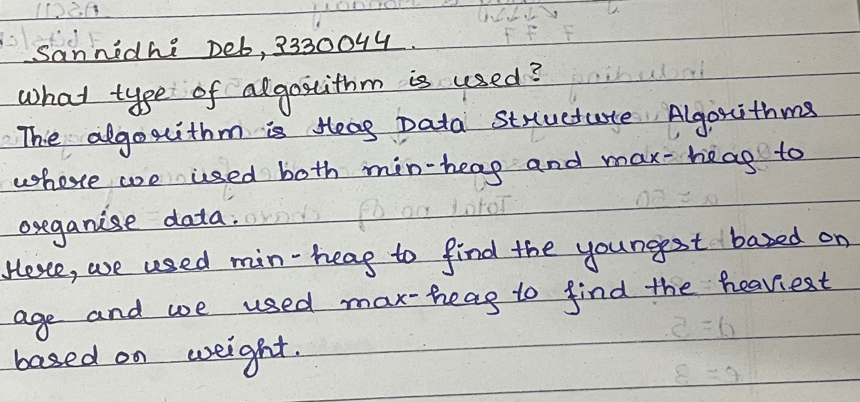

- Analyze the complexity of your algorithm.

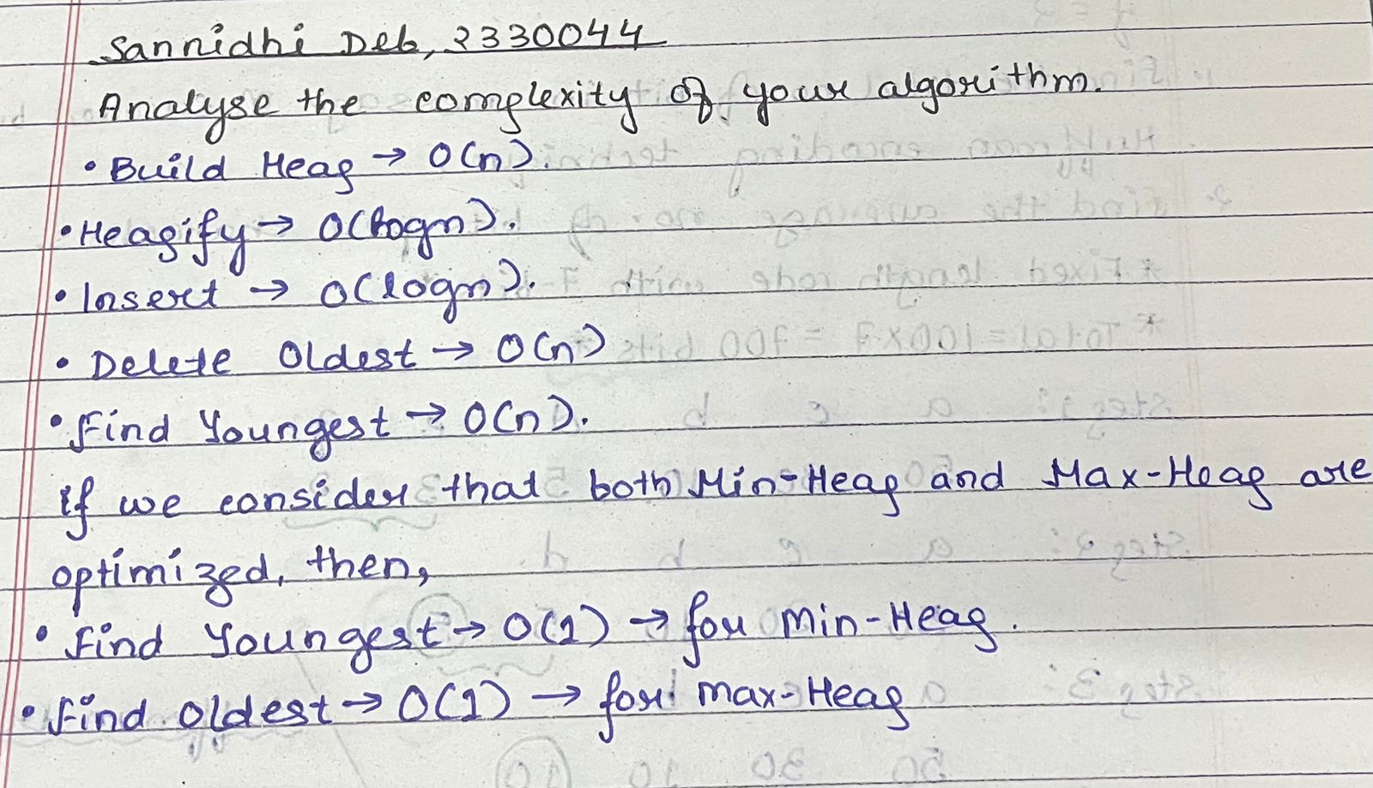

3.Any other observations?
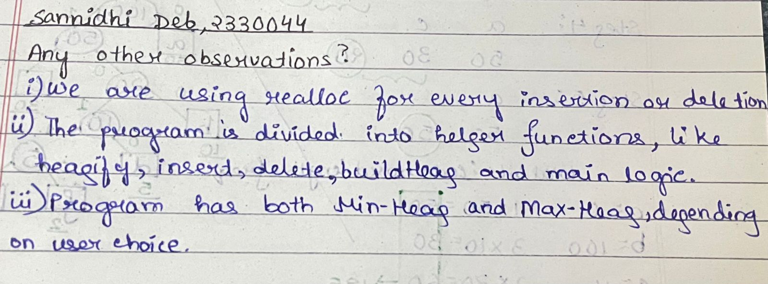

- Conclusion:-

The program helped in understanding how heaps can be used for priority-based operations. Using min-heap and max-heap on student data made it easier to insert, delete, and quickly access required information like youngest or heaviest person.

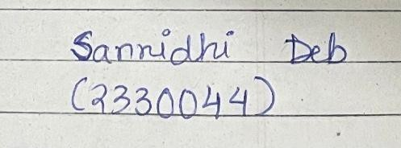 Signature of the FIC
____________________ _________________________________
Sannidhi Deb (Name of the FIC)

