LABORATORY REPORT

Algorithm Laboratory (CS-39001)
B.Tech Program in ECSc
Submitted By
Name:- SANNIDHI DEB
Roll No: 2330044


Kalinga Institute of Industrial Technology

(Deemed to be University) Bhubaneswar, India
Autumn, 2025

Table of Contents
# | Title |  | Date of Experiment | Date of Submission | Remarks
1. | Revision of Data Structures |  | 24/07/2025 | 06/08/2025
2. | Design and Analysis of Fundamental Algorithms |  | 07/08/2025 | 20/08/2025
3. | Divide and Conquer Method |  | 14/08/2025 | 20/08/2025
4. | Heap Sort |  | 21/08/2025 | 27/08/2025
5. | Greedy Algorithm |  | 18/09/2025 | 24/09/2025
Experiment Number |  | 5.1
Experiment Title |  | Write an algorithm and a C program to find the maximum profit nearest to but not exceeding the given knapsack capacity using the Fractional Knapsack algorithm.  Input:  Number of items: 3  Weights of items, {w1, w2, w3} = {18, 15, 10}  Profits of items, {P1, P2, P3} = {25, 24, 15}  Maximum capacity of knapsack, m =20
Date of Experiment |  | 18/09/2025
Date of Submission |  | 24/09/2025

1.Algorithm:-
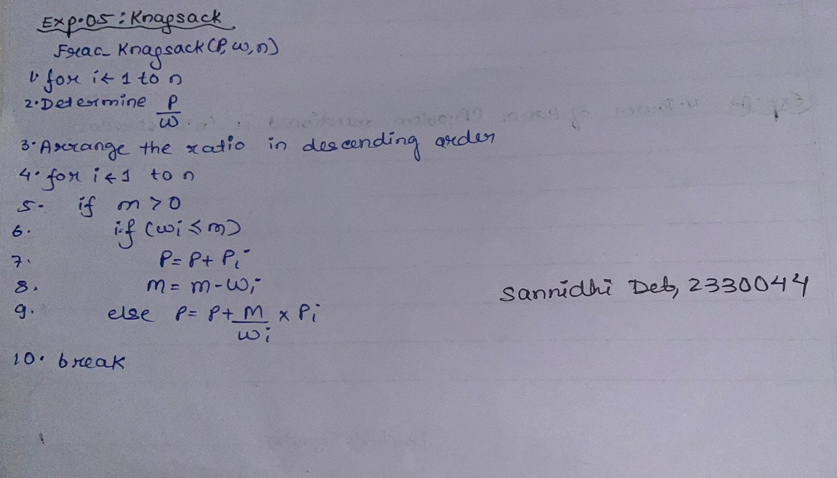
2. Code:-
#include <stdio.h>

typedef struct {
int weight;
int profit;
float ratio;
} Item;

void sortItems(Item items[], int n) {
for (int i = 0; i < n - 1; i++) {
for (int j = i + 1; j < n; j++) {
if (items[i].ratio < items[j].ratio) {
Item temp = items[i];
items[i] = items[j];
items[j] = temp;
}
}
}
}

int main() {
int n = 3;
int m = 20;
int weights[] = {18, 15, 10};
int profits[] = {25, 24, 15};

Item items[n];

for (int i = 0; i < n; i++) {
items[i].weight = weights[i];
items[i].profit = profits[i];
items[i].ratio = (float)profits[i] / weights[i];
}

sortItems(items, n);

int remaining_capacity = m;
float total_profit = 0.0;

for (int i = 0; i < n; i++) {
if (items[i].weight <= remaining_capacity) {

total_profit += items[i].profit;
remaining_capacity -= items[i].weight;
} else {

total_profit += items[i].profit * ((float)remaining_capacity / items[i].weight);
remaining_capacity = 0;
break;
}
}
printf("\nSannidhi Deb\n 2330044\n\n");
printf("Maximum Profit = %.2f\n", total_profit);

return 0;
}

3.Results/Output:- Entire Screen Shot including Date & Time:-

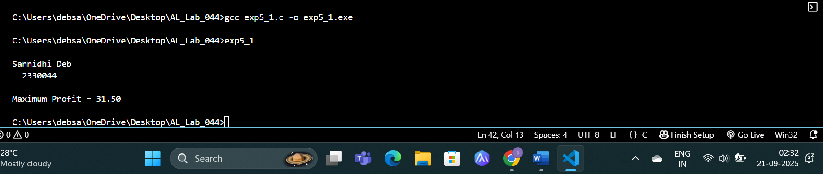

4. Remarks:-
- What type of algorithm is used?
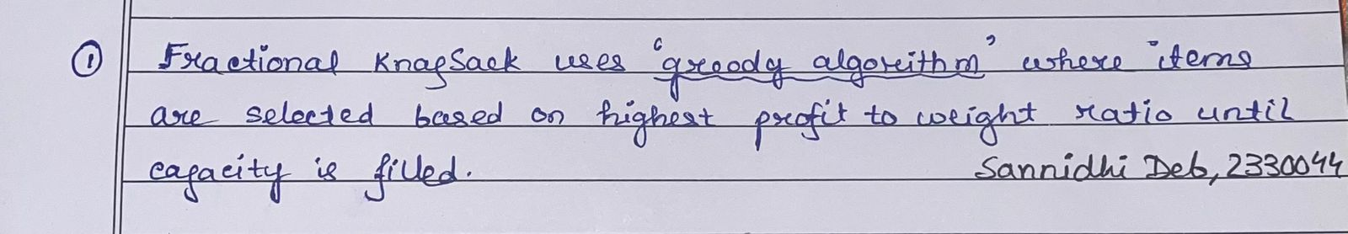

- Analyze the complexity of your algorithm.
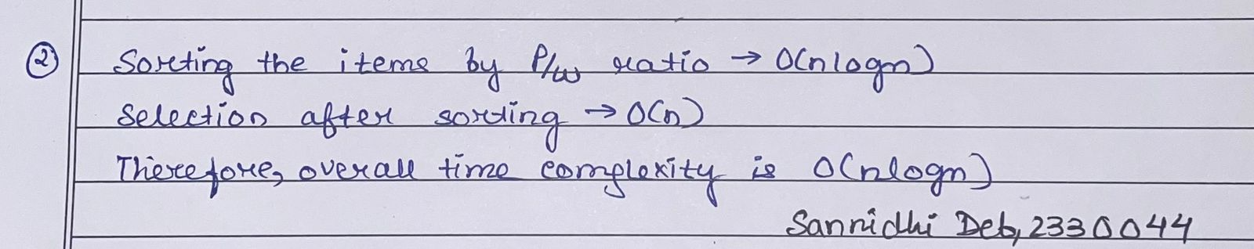

3.Any other observations?
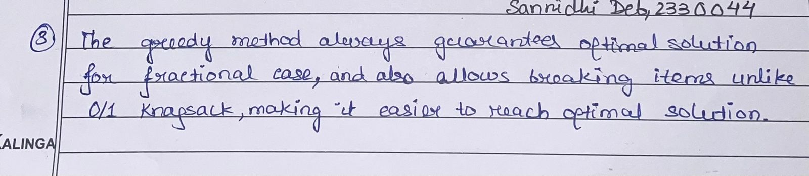

- Conclusion:-
The fractional knapsack experiment successfully demonstrated how greedy optimization can be applied to maximize profit without exceeding the capacity constraint. By prioritizing items based on profit-to-weight ratio and allowing fractional selection, the algorithm achieved an optimal solution efficiently, highlighting its effectiveness in resource allocation problems

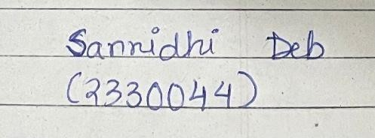 Signature of the FIC
____________________ _________________________________
Sannidhi Deb (Name of the FIC)

