LABORATORY REPORT

Algorithm Laboratory (CS-39001)
B.Tech Program in ECSc
Submitted By
Name:- SANNIDHI DEB
Roll No: 2330044


Kalinga Institute of Industrial Technology

(Deemed to be University) Bhubaneswar, India
Autumn, 2025

Table of Contents
# | Title |  | Date of Experiment | Date of Submission | Remarks
1. | Revision of Data Structures |  | 24/07/2025 | 06/08/2025
2. | Design and Analysis of Fundamental Algorithms |  | 07/08/2025 | 20/08/2025
3. | Divide and Conquer Method |  | 14/08/2025 | 20/08/2025
4. | Heap Sort |  | 21/08/2025 | 27/08/2025
5. | Greedy Algorithm |  | 18/09/2025 | 24/09/2025
6. | Huffman Coding |  | 01/10/2025 | 10/10/2025
7. | Minimum Spanning Tree |  | 01/10/2025 | 10/10/2025
Experiment Number |  | 7.1
Experiment Title |  | Given an undirected weighted connected graph G(V, E) and starring vertex ‘s’. Maintain a Min-Priority Queue ‘Q’ from the vertex set V and apply Prim’s algorithm to :  ● find the minimum spanning tree T(V, E’), and display the cost adjacency matrix of ‘T’, and  ● display the total cost of the minimum spanning tree T.  Given :  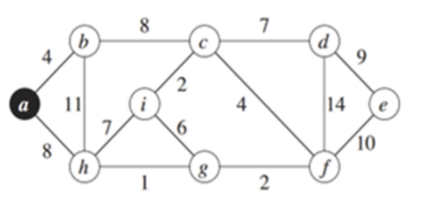  Input:  Enter the Number of Vertices: 9  Enter the Starting Vertex: 1 (that is, a)
Date of Experiment |  | 01/10/2025
Date of Submission |  | 10/10/2025

1.Algorithm:-
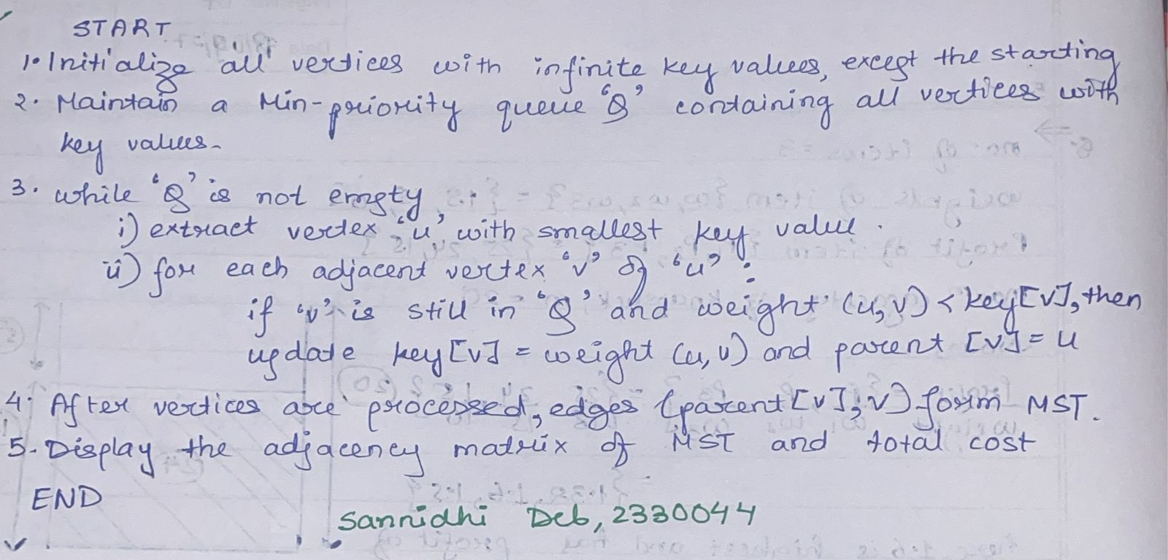
2. Code:-
#include <stdio.h>
#include <limits.h>
#define V 9
int minKey(int key[], int mstSet[]) {
int min = INT_MAX, min_index;
for (int v = 0; v < V; v++)
if (mstSet[v] == 0 && key[v] < min)
min = key[v], min_index = v;
return min_index;
}
void printMST(int parent[], int graph[V][V]) {
int totalCost = 0;
printf("\nEdge \tWeight\n");
for (int i = 1; i < V; i++) {
printf("%c - %c \t%d \n", parent[i] + 'a', i + 'a', graph[i][parent[i]]);
totalCost += graph[i][parent[i]];
}
printf("\nTotal cost of MST = %d\n", totalCost);
}
void primMST(int graph[V][V]) {
int parent[V];
int key[V];
int mstSet[V];
for (int i = 0; i < V; i++)
key[i] = INT_MAX, mstSet[i] = 0;
key[0] = 0;
parent[0] = -1;
for (int count = 0; count < V - 1; count++) {
int u = minKey(key, mstSet);
mstSet[u] = 1;
for (int v = 0; v < V; v++)
if (graph[u][v] && mstSet[v] == 0 && graph[u][v] < key[v])
parent[v] = u, key[v] = graph[u][v];
}printMST(parent, graph);
}
int main() {
int graph[V][V] = {
{0,4,0,0,0,0,8,11,0},
{4,0,8,0,0,0,0,0,0},
{0,8,0,7,0,4,0,2,0},
{0,0,7,0,9,14,0,0,0},
{0,0,0,9,0,10,0,0,0},
{0,0,4,14,10,0,2,0,0},
{8,0,0,0,0,2,0,1,6},
{11,0,2,0,0,0,1,0,7},
{0,0,0,0,0,0,6,7,0}
};
printf("\nSannidhi Deb\n 2330044\n\n");
printf("Prim’s Minimum Spanning Tree:\n");
primMST(graph);
return 0;
}
3.Results/Output:- Entire Screen Shot including Date & Time:-


4. Remarks:-
- What type of algorithm is used?

- Analyze the complexity of your algorithm.


3.Any other observations?


Experiment Number | 7.2
Experiment Title | For the same graph, apply Krushkal’s algorithm to  ● find the minimum spanning tree T(V, E’), and display the selected edges, and  ● display the total cost of the minimum spanning tree T.
Date of Experiment | 01/10/2025
Date of Submission | 10/10/2025

1.Algorithm:-


2. Code:-
#include <stdio.h>
#include <stdlib.h>
#define V 9
#define E 14
struct Edge {
int src, dest, weight;
};
struct subset {
int parent, rank;
};
int find(struct subset subsets[], int i) {
if (subsets[i].parent != i)
subsets[i].parent = find(subsets, subsets[i].parent);
return subsets[i].parent;
}
void Union(struct subset subsets[], int x, int y) {
int xroot = find(subsets, x);
int yroot = find(subsets, y);
if (subsets[xroot].rank < subsets[yroot].rank)
subsets[xroot].parent = yroot;
else if (subsets[xroot].rank > subsets[yroot].rank)
subsets[yroot].parent = xroot;
else {
subsets[yroot].parent = xroot;
subsets[xroot].rank++;
}
}
int compareEdges(const void* a, const void* b) {
struct Edge* a1 = (struct Edge*)a;
struct Edge* b1 = (struct Edge*)b;
return a1->weight > b1->weight;
}
void KruskalMST(struct Edge edges[]) {
struct subset subsets[V];
struct Edge result[V];
int e = 0; // index for result[]
int i = 0; // index for sorted edges
qsort(edges, E, sizeof(edges[0]), compareEdges);
for (int v = 0; v < V; v++) {
subsets[v].parent = v;
subsets[v].rank = 0;
}
while (e < V - 1 && i < E) {
struct Edge next_edge = edges[i++];
int x = find(subsets, next_edge.src);
int y = find(subsets, next_edge.dest);
if (x != y) {
result[e++] = next_edge;
Union(subsets, x, y);
}
}
printf("\nEdges in the Minimum Spanning Tree:\n");
int totalCost = 0;
for (i = 0; i < e; i++) {
printf("%c - %c \t%d\n", result[i].src + 'a', result[i].dest + 'a', result[i].weight);
totalCost += result[i].weight;
}
printf("\nSannidhi Deb\n 2330044\n\n");
printf("\nTotal cost of MST with Kruskal's Algo = %d\n", totalCost);
}
int main() {
struct Edge edges[E] = {
{0,1,4}, {0,7,8}, {1,2,8}, {2,3,7}, {3,4,9}, {4,5,10},
{3,5,14}, {2,5,4}, {2,8,2}, {7,8,7}, {7,6,1}, {6,5,2},
{6,8,6}, {1,7,11}
};
KruskalMST(edges);
return 0;
}
3.Results/Output:- Entire Screen Shot including Date & Time:-
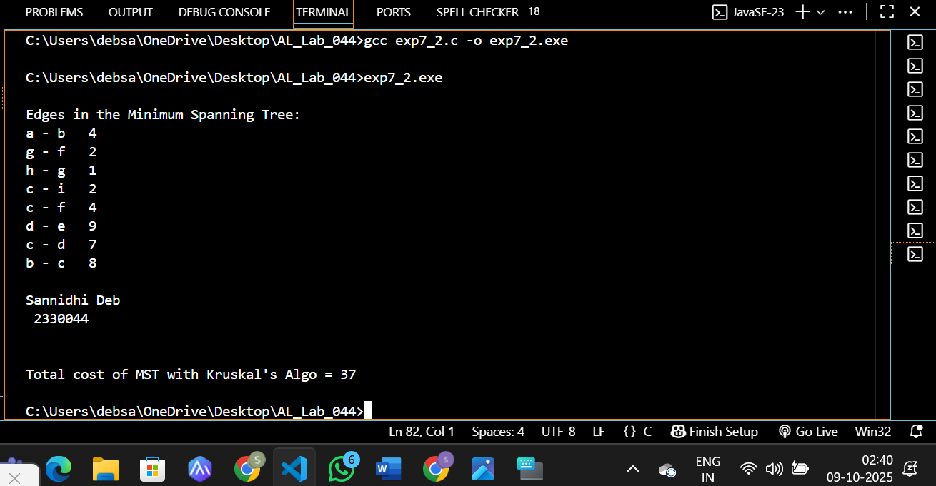

4. Remarks:-
- What type of algorithm is used?


- Analyze the complexity of your algorithm.


3.Any other observations?



5. Conclusion:-
Both Prim’s and Kruskal’s algorithms were successfully implemented to find the Minimum Spanning Tree (MST) of a connected weighted graph.The experiments demonstrated how both algorithms use greedy approaches to minimize the total edge cost while connecting all vertices without forming cycles.
Prim’s algorithm grows the MST from a starting vertex using a priority queue, Kruskal’s algorithm builds it by selecting the smallest edges and applying union–find to avoid cycles. In both cases, the resulting MST had the same total cost, confirming the correctness of the implementations.

 Signature of the FIC
____________________ _________________________________
Sannidhi Deb (Name of the FIC)

