LABORATORY REPORT

Algorithm Laboratory (CS-39001)
B.Tech Program in ECSc
Submitted By
Name:- SANNIDHI DEB
Roll No: 2330044


Kalinga Institute of Industrial Technology

(Deemed to be University) Bhubaneswar, India
Autumn, 2025

Table of Contents
# | Title |  | Date of Experiment | Date of Submission | Remarks
1. | Revision of Data Structures |  | 24/07/2025 | 06/08/2025
2. | Design and Analysis of Fundamental Algorithms |  | 07/08/2025 | 20/08/2025
3. | Divide and Conquer Method |  | 14/08/2025 | 20/08/2025
4. | Heap Sort |  | 21/08/2025 | 27/08/2025
5. | Greedy Algorithm |  | 18/09/2025 | 24/09/2025
6. | Huffman Coding |  | 01/10/2025 | 10/10/2025
7. | Minimum Spanning Tree |  | 01/10/2025 | 10/10/2025
8. | Single Source Shortest Path |  | 09/10/2025 | 15/10/2025
Experiment Number |  | 8.1
Experiment Title |  | Given a directed graph G (V, E) and a starting vertex ‘s’.  ● Determine the lengths of the shortest paths from the starting vertex ‘s’ to all other vertices in the graph G using Dijkstra’s Algorithm.  ● Display the shortest path from the given source ‘s’ to all other vertices.  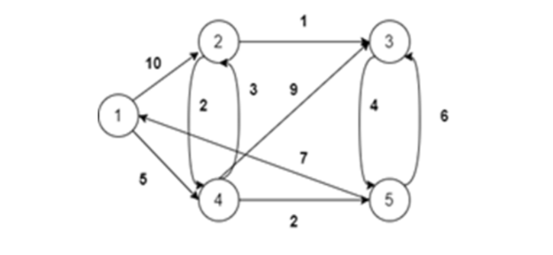  Input:  Enter the Number of Vertices: 5  Enter the Source Vertex: 1  Output:  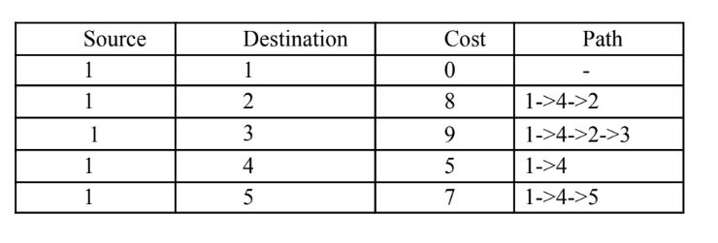
Date of Experiment |  | 09/10/2025
Date of Submission |  | 15/10/2025
1.Algorithm:-
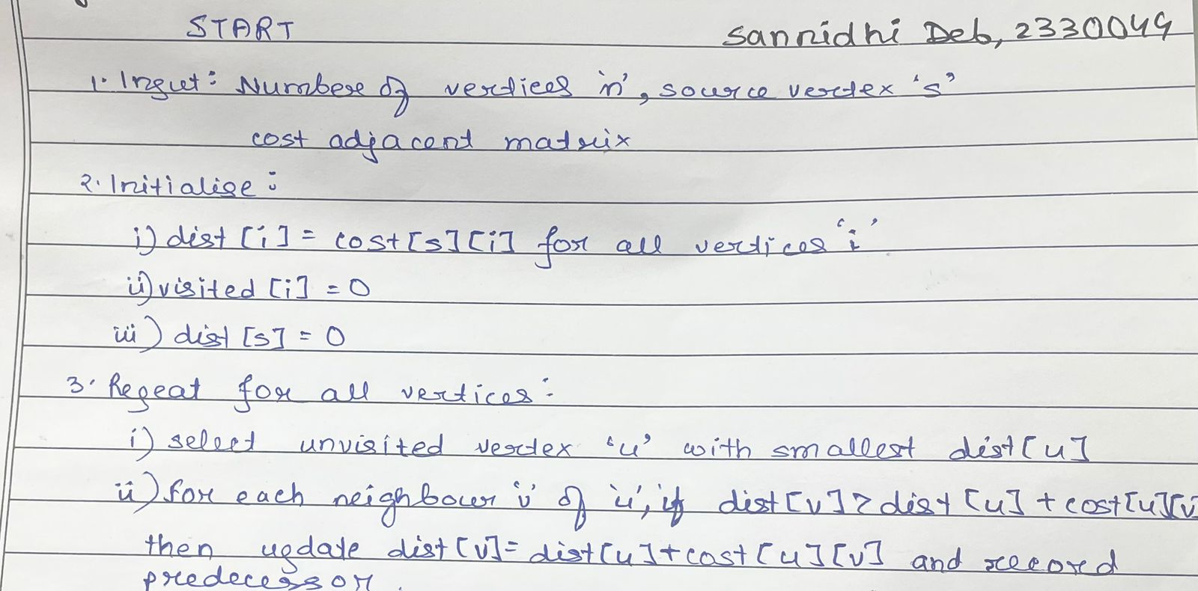
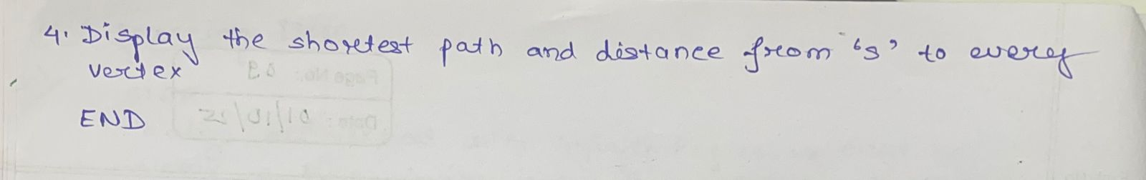
2. Code:-
#include <stdio.h>
#define INF 999
void dijkstra(int n, int cost[10][10], int source) {
int dist[10], visited[10], parent[10];
int count, mindist, nextnode, i, j;
for (i = 1; i <= n; i++) {
dist[i] = cost[source][i];
visited[i] = 0;
parent[i] = source;
}

dist[source] = 0;
visited[source] = 1;
count = 1;
while (count < n - 1) {
mindist = INF;
for (i = 1; i <= n; i++)
if (dist[i] < mindist && !visited[i]) {
mindist = dist[i];
nextnode = i;
}
visited[nextnode] = 1;
for (i = 1; i <= n; i++)
if (!visited[i])
if (mindist + cost[nextnode][i] < dist[i]) {
dist[i] = mindist + cost[nextnode][i];
parent[i] = nextnode;
}
count++;
}
printf("\nSannidhi Deb\n 2330044\n\n");
printf("\nSource\tDestination\tCost\tPath");
for (i = 1; i <= n; i++) {
if (i != source) {
printf("\n%d\t%d\t\t%d\t%d", source, i, dist[i], i);
j = i;
while (j != source) {
j = parent[j];
printf("<-%d", j);
}
}
}
printf("\n");
}
int main() {
int n = 5, source = 1;
int cost[10][10] = {
{0,0,0,0,0,0},
{0,0,10,INF,5,INF},
{0,INF,0,1,2,INF},
{0,INF,INF,0,INF,4},
{0,INF,3,9,0,2},
{0,INF,INF,6,INF,0}
};
dijkstra(n, cost, source);
return 0;
}

3.Results/Output:- Entire Screen Shot including Date & Time:-
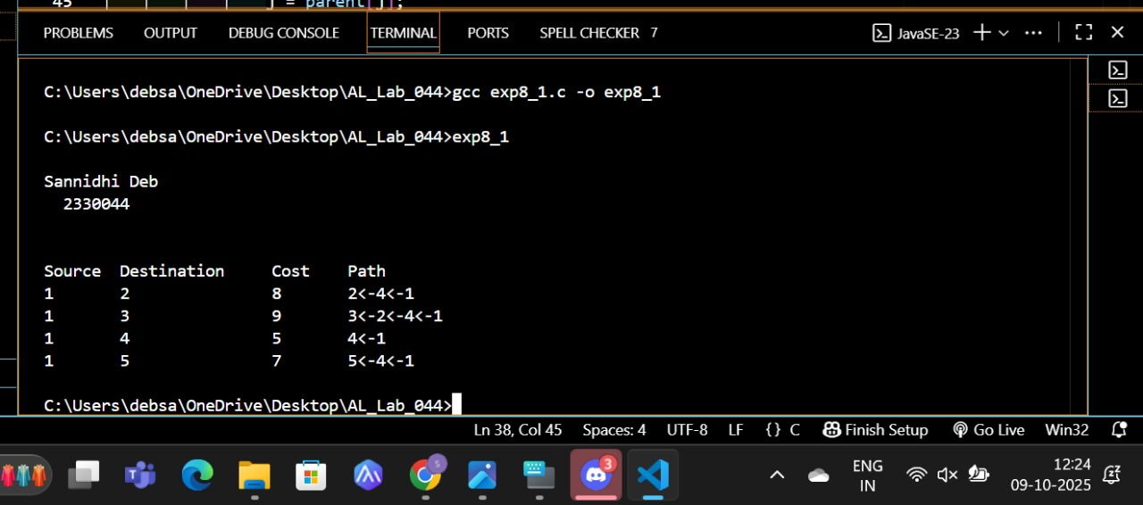

4. Remarks:-
- What type of algorithm is used?
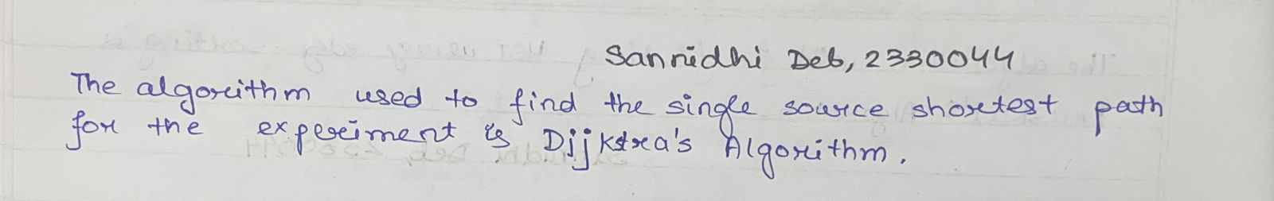

- Analyze the complexity of your algorithm.

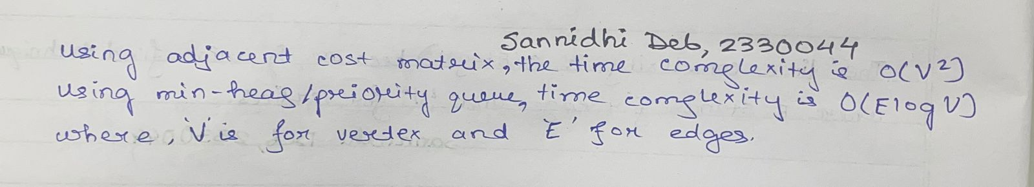

3.Any other observations?

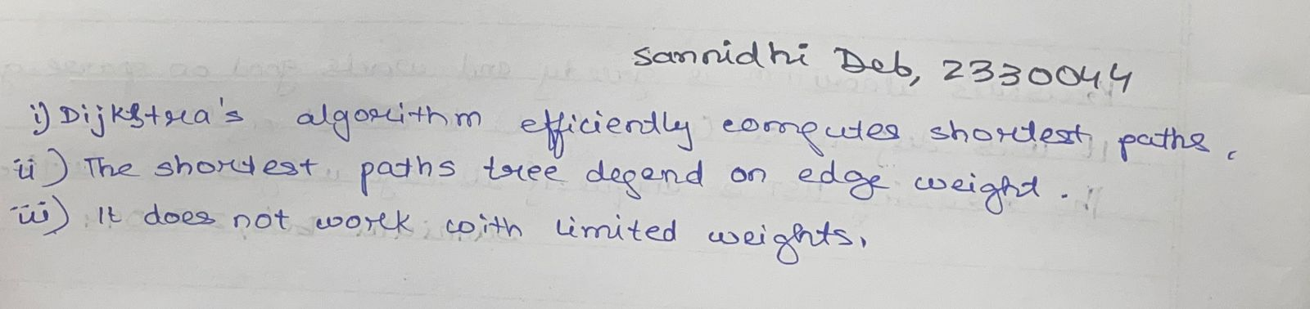

5. Conclusion:- Dijkstra’s Algorithm successfully determines the shortest path and cost from a given source vertex to all other vertices in a directed weighted graph.
It is one of the most efficient algorithms for single-source shortest path problems with non-negative edge weights.

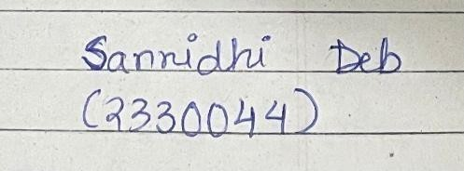 Signature of the FIC
____________________ _________________________________
Sannidhi Deb (Name of the FIC)

