LABORATORY REPORT

Algorithm Laboratory (CS-39001)
B.Tech Program in ECSc
Submitted By
Name:- SANNIDHI DEB
Roll No: 2330044


Kalinga Institute of Industrial Technology

(Deemed to be University) Bhubaneswar, India
Autumn, 2025

Table of Contents
# | Title |  | Date of Experiment | Date of Submission | Remarks
1. | Revision of Data Structures |  | 24/07/2025 | 06/08/2025
2. | Design and Analysis of Fundamental Algorithms |  | 07/08/2025 | 20/08/2025
3. | Divide and Conquer Method |  | 14/08/2025 | 20/08/2025
4. | Heap Sort |  | 21/08/2025 | 27/08/2025
5. | Greedy Algorithm |  | 18/09/2025 | 24/09/2025
6. | Huffman Coding |  | 01/10/2025 | 10/10/2025
7. | Minimum Spanning Tree |  | 01/10/2025 | 10/10/2025
8. | Single Source Shortest Path |  | 09/10/2025 | 15/10/2025
9. | Matrix Chain Multiplication (MCM) and  Longest Common Subsequence (LCS) |  | 16/10/2025 | 22/10/25
Experiment Number |  | 9.1
Experiment Title |  | Write a C program to implement matrix chain multiplication (A1.A2.A3.A4.A5.A6) using a dynamic programming approach.  Input (for example): matrix dimensions,  {d0, d1, d2, d3, d4, d5, d6} = {30, 35, 15, 5, 10, 20, 25}  Output: Parenthesized product: ((A1.(A2.A3))((A4.A5).A6))  Number of scalar multiplications: 15125
Date of Experiment |  | 16/10/2025
Date of Submission |  | 22/10/2025
1.Algorithm:- 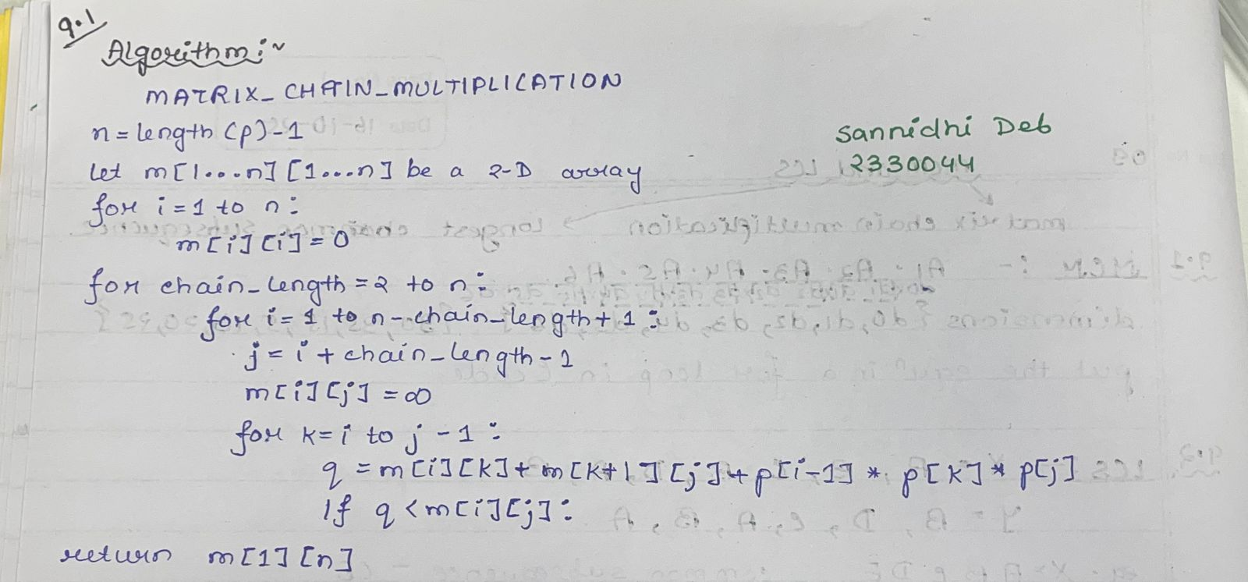

2. Code:-
#include <stdio.h>
#include <limits.h>

void printOptimalParens(int i, int j, int n, int bracket[n][n]) {
if (i == j) {
printf("A%d", i);
return;
}
printf("(");
printOptimalParens(i, bracket[i][j], n, bracket);
printOptimalParens(bracket[i][j] + 1, j, n, bracket);
printf(")");
}

void matrixChainOrder(int p[], int n) {
int m[n][n];
int bracket[n][n];
int i, j, k, L, q;

for (i = 1; i < n; i++)
m[i][i] = 0;

for (L = 2; L < n; L++) {
for (i = 1; i < n - L + 1; i++) {
j = i + L - 1;
m[i][j] = INT_MAX;
for (k = i; k <= j - 1; k++) {
q = m[i][k] + m[k + 1][j] + p[i - 1] * p[k] * p[j];
if (q < m[i][j]) {
m[i][j] = q;
bracket[i][j] = k;
}
}
}
}
printf("\nSannidhi Deb\n2330044\n\n");
printf("Optimal Parenthesization: ");
printOptimalParens(1, n - 1, n, bracket);
printf("\nMinimum number of scalar multiplications: %d\n", m[1][n - 1]);
}

int main() {
int p[] = {30, 35, 15, 5, 10, 20, 25};
int n = sizeof(p) / sizeof(p[0]);

matrixChainOrder(p, n);

return 0;
}

3.Results/Output:- Entire Screen Shot including Date & Time:-
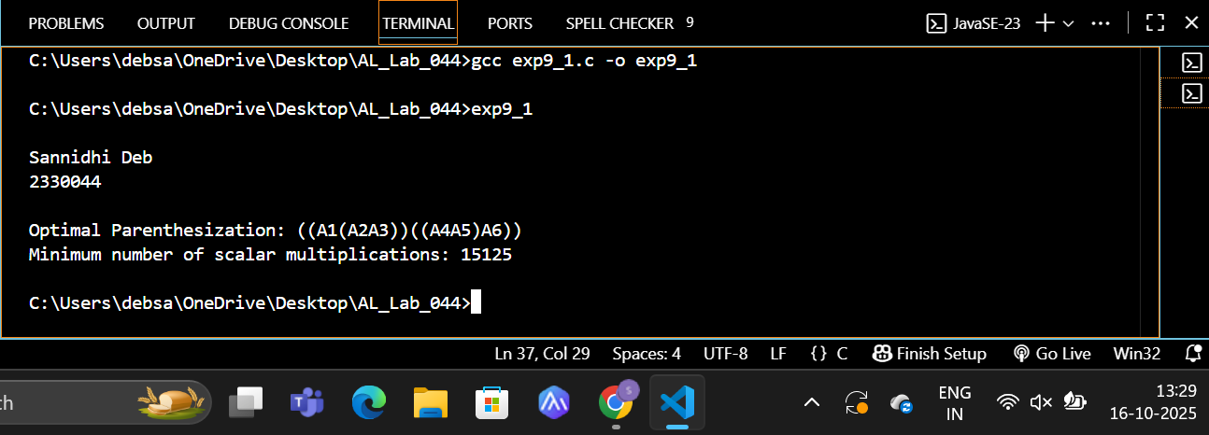

4. Remarks:-
- What type of algorithm is used?

- Analyze the complexity of your algorithm.
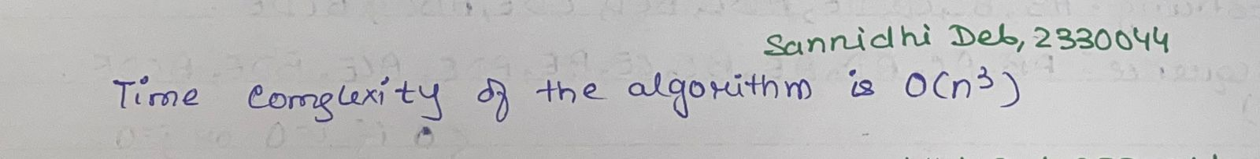

3.Any other observations?
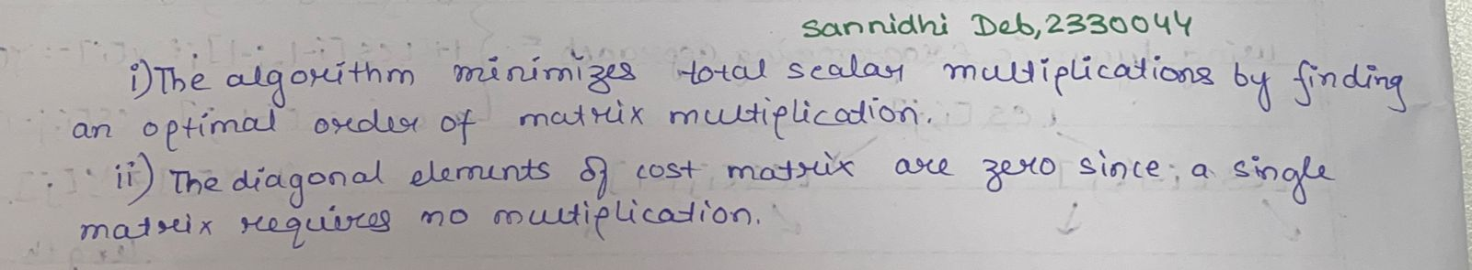

Experiment Number | 9.2
Experiment Title | Write a C program to find the longest common subsequence in a given two sequences using a dynamic programming approach.  Input (for example): Sequence X = A, B, C, B, D, A, B  Sequence Y = B, D, C, A, B, A  Output: Longest common subsequence: B,C,B,A  Length of longest common subsequence: 4
Date of Experiment | 16/10/2025
Date of Submission | 22/10/2025

1.Algorithm:-
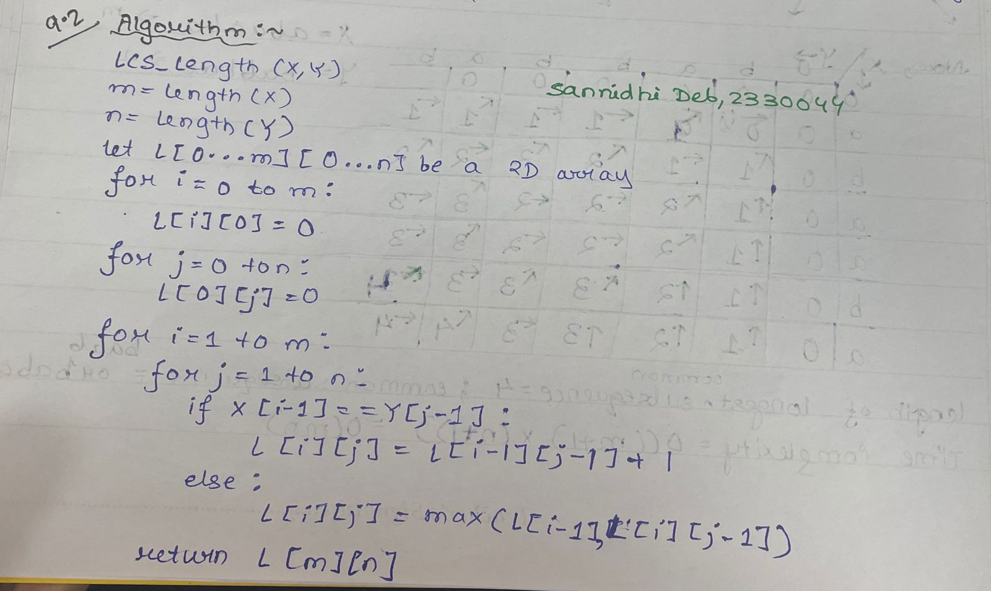
2. Code:-
#include <stdio.h>
#include <string.h>
int max(int a, int b) {
return (a > b) ? a : b;
}

void LCS(char X[], char Y[], int m, int n) {
int L[m + 1][n + 1];
for (int i = 0; i <= m; i++) {
for (int j = 0; j <= n; j++) {
if (i == 0 || j == 0)
L[i][j] = 0;
else if (X[i - 1] == Y[j - 1])
L[i][j] = L[i - 1][j - 1] + 1;
else
L[i][j] = max(L[i - 1][j], L[i][j - 1]);
}
}
int index = L[m][n];
char lcs[index + 1];
lcs[index] = '\0';

int i = m, j = n;
while (i > 0 && j > 0) {
if (X[i - 1] == Y[j - 1]) {
lcs[index - 1] = X[i - 1];
i--;
j--;
index--;
} else if (L[i - 1][j] > L[i][j - 1])
i--;
else
j--;
}
printf("\nSannidhi Deb\n2330044\n\n");
printf("Longest Common Subsequence: ");
for (int k = 0; lcs[k] != '\0'; k++) {
printf("%c", lcs[k]);
if (lcs[k + 1] != '\0')
printf(",");
}
printf("\nLength of Longest Common Subsequence: %d\n", L[m][n]);
}

int main() {
char X[] = {'A', 'B', 'C', 'B', 'D', 'A', 'B'};
char Y[] = {'B', 'D', 'C', 'A', 'B', 'A'};

int m = sizeof(X) / sizeof(X[0]);
int n = sizeof(Y) / sizeof(Y[0]);
LCS(X, Y, m, n);
return 0;
}

3.Results/Output:- Entire Screen Shot including Date & Time:-
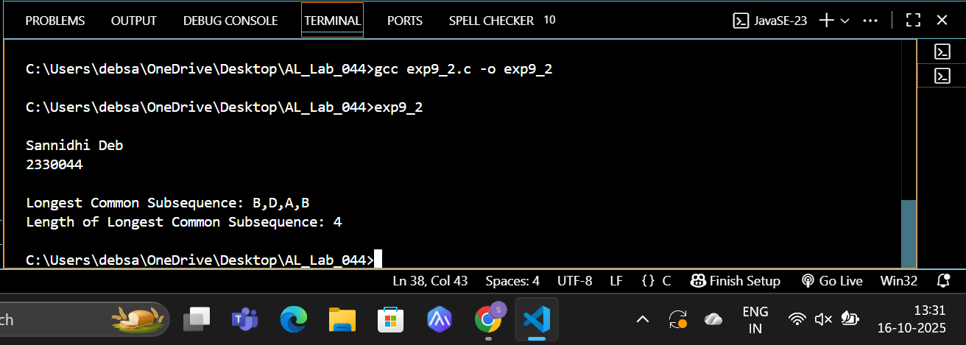

4. Remarks:-
- What type of algorithm is used?

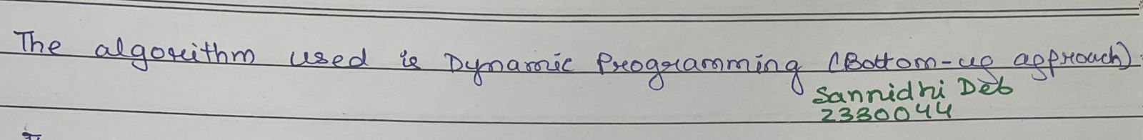

- Analyze the complexity of your algorithm.
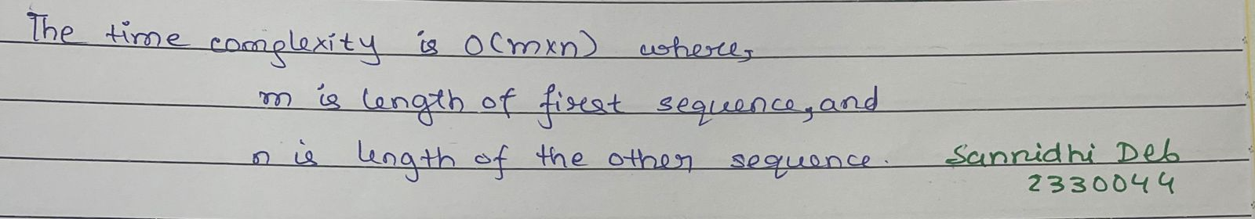

3.Any other observations?
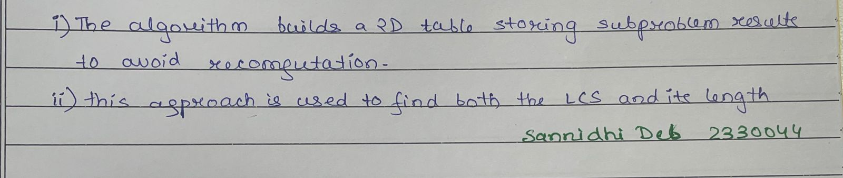

5. Conclusion:- Both the Matrix Chain Multiplication (MCM) and Longest Common Subsequence (LCS) problems were efficiently solved using dynamic programming, demonstrating its power in optimizing recursive problems by storing intermediate results. These experiments highlight how dynamic programming minimizes computation time and provides optimal solutions for complex problems involving overlapping subproblems and optimal substructure.

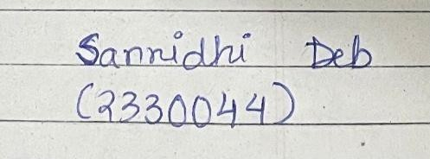 Signature of the FIC
____________________ _________________________________
Sannidhi Deb (Name of the FIC)

