LABORATORY REPORT

Algorithm Laboratory (CS-39001)
B.Tech Program in ECSc
Submitted By
Name:- SANNIDHI DEB
Roll No: 2330044


Kalinga Institute of Industrial Technology

(Deemed to be University) Bhubaneswar, India
Autumn, 2025

Table of Contents
# | Title |  | Date of Experiment | Date of Submission | Remarks
1. | Revision of Data Structures |  | 24/07/2025 | 06/08/2025
2. | Design and Analysis of Fundamental Algorithms |  | 07/08/2025 | 20/08/2025
3. | Divide and Conquer Method |  | 14/08/2025 | 20/08/2025
4. | Heap Sort |  | 21/08/2025 | 27/08/2025
5. | Greedy Algorithm |  | 18/09/2025 | 24/09/2025
6. | Huffman Coding |  | 01/10/2025 | 10/10/2025
7. | Minimum Spanning Tree |  | 01/10/2025 | 10/10/2025
8. | Single Source Shortest Path |  | 09/10/2025 | 15/10/2025
9. | Matrix Chain Multiplication (MCM) and  Longest Common Subsequence (LCS) |  | 16/10/2025 | 22/10/2025
10. | Open Ended Experiment : Restaurant Auto Scheduling System |  | 23/10/2025 | 30/10/2025
Experiment Number |  | 10 (Open Ended Experiment)
Experiment Title |  | To design and implement a Greedy algorithm that schedules restaurant orders to achieve maximum total profit, ensuring that all accepted orders are completed before their deadlines.  Number of orders: 5
  Order | 1 | 2 | 3 | 4 | 5
  Deadline | 2 | 1 | 2 | 1 | 3
  Profit | 100 | 19 | 27 | 25 | 15
Date of Experiment |  | 23/10/2025
Date of Submission |  | 30/10/2025
1.Algorithm:-
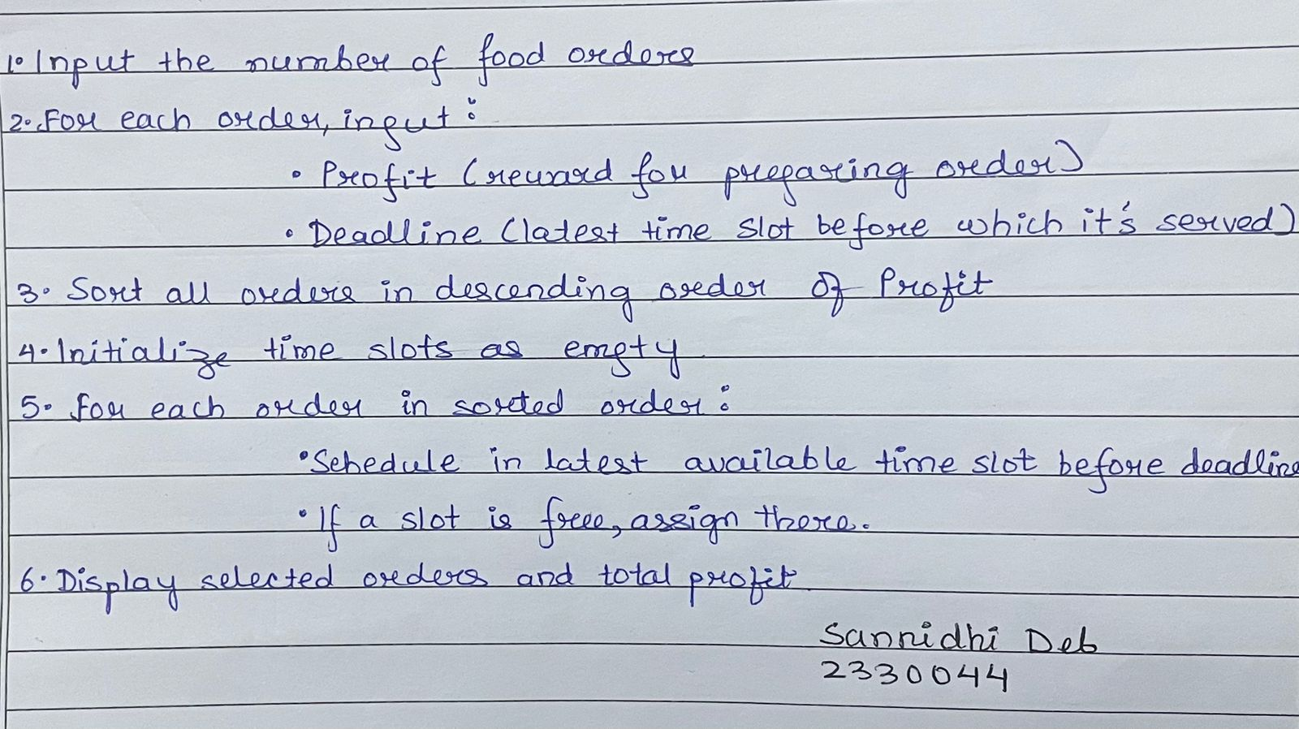
2. Code:-
#include <stdio.h>

struct Order {
int id;
int deadline;
int profit;
};

void sortOrders(struct Order orders[], int n) {
struct Order temp;
for (int i = 0; i < n - 1; i++) {
for (int j = 0; j < n - i - 1; j++) {
if (orders[j].profit < orders[j + 1].profit) {
temp = orders[j];
orders[j] = orders[j + 1];
orders[j + 1] = temp;
}
}
}
}
int findMaxDeadline(struct Order orders[], int n) {
int max = orders[0].deadline;
for (int i = 1; i < n; i++) {
if (orders[i].deadline > max)
max = orders[i].deadline;
}
return max;
}

void scheduleOrders(struct Order orders[], int n) {
int maxDeadline = findMaxDeadline(orders, n);
int slots[maxDeadline + 1];
for (int i = 0; i <= maxDeadline; i++)
slots[i] = -1;

int totalProfit = 0;

for (int i = 0; i < n; i++) {
for (int j = orders[i].deadline; j > 0; j--) {
if (slots[j] == -1) {
slots[j] = i;
totalProfit += orders[i].profit;
break;
}
}
}
printf("\nSannidhi Deb\n 2330044\n\n");
printf("\nScheduled Orders (within deadlines):\n");
for (int i = 1; i <= maxDeadline; i++) {
if (slots[i] != -1) {
int idx = slots[i];
printf("Order %d (Deadline: %d, Profit: %d)\n",
orders[idx].id, orders[idx].deadline, orders[idx].profit);
}
}
printf("\nTotal Profit: %d\n", totalProfit);
}

int main() {
int n;
printf("Enter number of orders: ");
scanf("%d", &n);

struct Order orders[n];
for (int i = 0; i < n; i++) {
orders[i].id = i + 1;
printf("Enter Deadline and Profit for Order %d: ", i + 1);
scanf("%d %d", &orders[i].deadline, &orders[i].profit);
}

sortOrders(orders, n);
scheduleOrders(orders, n);
return 0;
}

3.Results/Output:- Entire Screen Shot including Date & Time:-
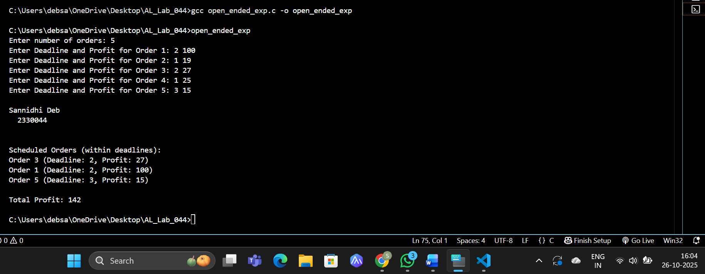

4. Remarks:-
- What type of algorithm is used?
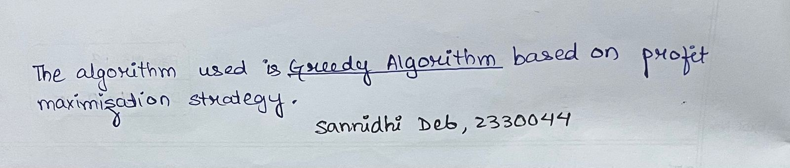

- Analyze the complexity of your algorithm.
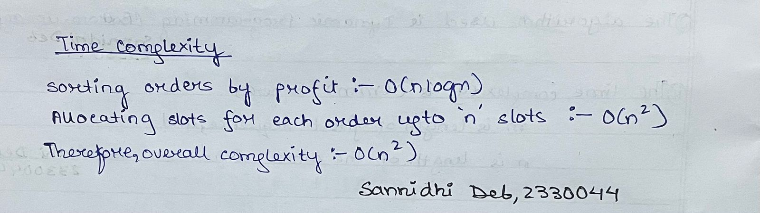

3.Any other observations?
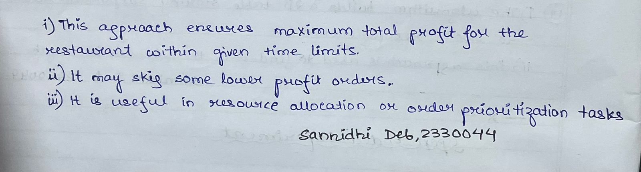

5. Conclusion:- The Restaurant Auto Scheduling System implemented using the Job Sequencing with Deadlines (Greedy Algorithm) approach efficiently schedules restaurant orders to maximize total profit while ensuring deadlines are met. This experiment demonstrates how greedy strategies can be applied to real-world restaurant operations and other scheduling tasks involving limited time and high-profit optimization.

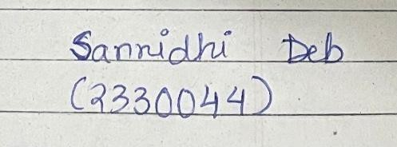 Signature of the FIC
____________________ _________________________________
Sannidhi Deb (Name of the FIC)

