1. Common to every page

HEADER:

|  |  |  |  |  |  |
| --- | --- | --- | --- | --- | --- |
| LOGO | HOME | ABOUT | TRAVEL DESTINATIONS | CONTACT | SEARCH |
| CONTENT: This will differ from page to page | | | | | |

FOOTER:

|  |  |  |  |  |  |
| --- | --- | --- | --- | --- | --- |
| Contact Information | Copyrights | All Rights Reserved | Terms & Conditions | Policy | Language |

1. a. Rough Sketch of Home Page

Header:

|  |  |  |  |  |  |
| --- | --- | --- | --- | --- | --- |
| LOGO | HOME | ABOUT | TRAVEL DESTINATIONS | CONTACT US | SEARCH |

WELCOME TO GET SET GO!

An Ultimate Travel Guide for Budget Travellers



Footer:

|  |  |  |  |  |  |
| --- | --- | --- | --- | --- | --- |
| Contact Information | Copyrights | All Rights Reserved | Terms & Conditions | Policy | Language |

2 b) About Page

Header:

|  |  |  |  |  |  |
| --- | --- | --- | --- | --- | --- |
| LOGO | HOME | ABOUT | TRAVEL DESTINATIONS | CONTACT US | SEARCH |



ABOUT US

Hi! We are students from Turku, Finland. We have travelled a lot: 13 countries in Europe, Asia and the United States. Hence, we wanted to share our experience and other travel tips and tricks that can be handy for other budget travellers or student travellers like us.

Footer:

|  |  |  |  |  |  |
| --- | --- | --- | --- | --- | --- |
| Contact Information | Copyrights | All Rights Reserved | Terms & Conditions | Policy | Language |

2c) BARCELONA

Header:

|  |  |  |  |  |  |
| --- | --- | --- | --- | --- | --- |
| LOGO | HOME | ABOUT | TRAVEL DESTINATIONS | CONTACT US | SEARCH |

GUIDE TO BARCELONA, SPAIN

Information to Barcelona. Why is it famous? And so on.

ACCOMMODATION:

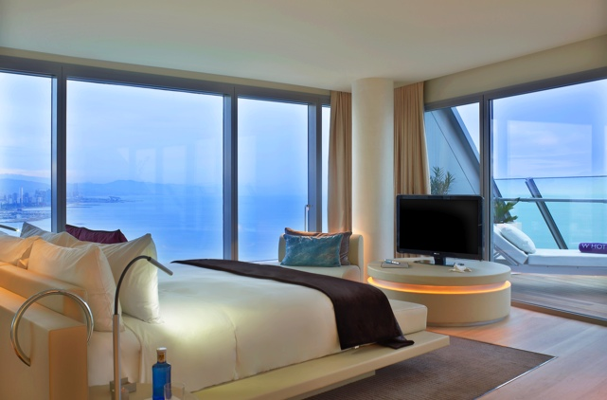 SOME ACCOMMODATION TIPS AND GUIDE

TRANSPORTATION:

Picture SOME Transportation Tips

THINGS TO DO

Picture TIPs on Things to Do

Footer:

|  |  |  |  |  |  |
| --- | --- | --- | --- | --- | --- |
| Contact Information | Copyrights | All Rights Reserved | Terms & Conditions | Policy | Language |

2d) PAGE: CONTACT US

Header:

|  |  |  |  |  |  |
| --- | --- | --- | --- | --- | --- |
| LOGO | HOME | ABOUT | TRAVEL DESTINATIONS | CONTACT US | SEARCH |

Your Opinion Always Matter!

Help US Improve!

First Name:

Last Name:

Email Address:

Confirm Email:

LEAVE FEEDBACK:

|  |
| --- |
| SUBMIT |

Footer:

|  |  |  |  |  |  |
| --- | --- | --- | --- | --- | --- |
| Contact Information | Copyrights | All Rights Reserved | Terms & Conditions | Policy | Language |

2e) Contact Information Page

Header:

|  |  |  |  |  |  |
| --- | --- | --- | --- | --- | --- |
| LOGO | HOME | ABOUT | TRAVEL DESTINATIONS | CONTACT US | SEARCH |

Contact US AT:

PICTURE ADDRESS Phone Number Email Address

Picture

Footer:

|  |  |  |  |  |  |
| --- | --- | --- | --- | --- | --- |
| Contact Information | Copyrights | All Rights Reserved | Terms & Conditions | Policy | Language |

2f) TERMS & CONDITION PAGE

Header:

|  |  |  |  |  |  |
| --- | --- | --- | --- | --- | --- |
| LOGO | HOME | ABOUT | TRAVEL DESTINATIONS | CONTACT US | SEARCH |

1. Accepting Terms

CONTENT

1. Eligibility

CONTENT

1. Registration

CONTENT

1. Content Availability & Restriction

CONTENT

1. Rules Of Service

CONTENT

1. Third Party Service

CONTENT

1. Termination

CONTENT

Footer:

|  |  |  |  |  |  |
| --- | --- | --- | --- | --- | --- |
| Contact Information | Copyrights | All Rights Reserved | Terms & Conditions | Policy | Language |

2 g) Privacy Policy Page:

Header:

|  |  |  |  |  |  |
| --- | --- | --- | --- | --- | --- |
| LOGO | HOME | ABOUT | TRAVEL DESTINATIONS | CONTACT US | SEARCH |

What information does GET SET GO Collect?

How and to whom is the information shared?

What happens when there are changes in the Privacy policy?

What to do if I have questions or concerns?

Effective Date:

Footer:

|  |  |  |  |  |  |
| --- | --- | --- | --- | --- | --- |
| Contact Information | Copyrights | All Rights Reserved | Terms & Conditions | Policy | Language |

1. Travel Destinations (Search Results)

Transportation

Accommodation

Things to Do (Tourist attractions, Eateries)

Currency

Guide to save money

Languages spoken in the place (some basic words and phrases)

Most common basics

WARNINGS

1. Search Results:

|  |  |  |
| --- | --- | --- |
| ACCOMMODATION | TRANSPORTATION | THINGS TO DO |
| Hotels | Bus | Tourist Attractions |
| Hostels | Flights | Eateries |
| Airbnb | Train | Free- walking tours |
| Couchsurfing | Taxi or Uber | Shopping Malls |
|  | On foot | Beaches |
|  | Bike | Theatres |

Country

|  |
| --- |
| Currency |
| Languages |
| Do’s and Don’ts |
| Guide to save money in that country |
| Warnings for travelling in that country |

1. Sketch of a Rough Site Map

