1)Each stage of Design and implementation was typified by a period of

-> Intellectual activity followed by a period of program reconstruction.(Answer)

-> Program structuring and implementation.

-> Intellectual activity and Bug-Fixing.

-> None of the above.

2)Small Design changes that are localised were described as

a) Tuning (Answer)

b) Simulation

c) Structuring

d) None of the above

3)Why does a system's design and implementation become slow as pointed out by Fraser?

-> Complexity of the system and Conceptual inadequacy about the basic system design. (Answer)

-> Frequent design changes and Feedback between External and internal design specifications.

-> Feedback between External and internal design specifications and Complexity of the system.

-> Frequent design changes and Complexity of the system.

4)Three major design changes were included in the design and implementation procedure as said by Fraser. Write in brief about the major design changes suggested by Fraser.

->First major design change was to improve the product to make it less expensive and superior based on the information that the creators of the product have acquired.

->Second major design change had its origin in the more usual combination of an inelegant system and a demanding environment.

->Third major design change arose out of observing the slow but steady escalation of complexity in one area of the system.

5)Explain how mutual feedback is necessary for the external and internal design.

->External specifications at any level describe the software product in terms of the items controlled by and available to the user.

->The internal design describes the software product in terms of the program structures which realize the external specifications.

->For a realistic and effective implementation process, mutual feedback between external and internal specifications is mandatory. Feedback helps the implementers to analyse the external design specifications and build structures that are needed. They can avoid building unnecessary products/structures through feedback, which makes the design and implementation process of a product more efficient.

->Furthermore, this interaction must begin at the earliest stage of establishing the objectives, and continue until completion of the

Product.

From the image, guess the order of a,b,c and d

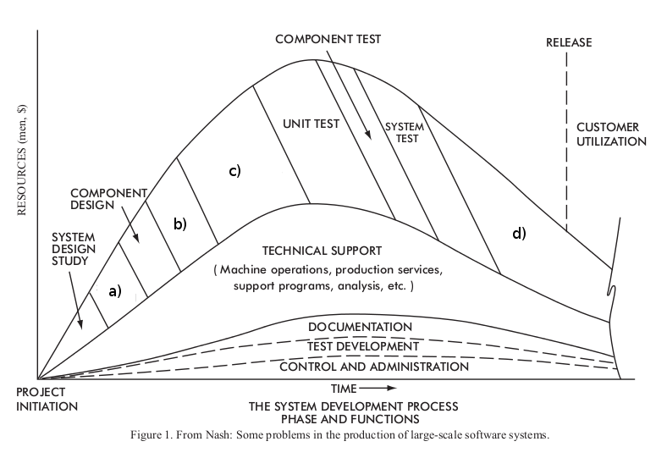

-> System Design, Unit Design, Unit Development, Maintenance and follow up(Answer)

-> System Design, Unit Development , Unit Design, Maintenance and follow up

-> Unit Development,Unit Design, Maintenance and follow up, System Design

->System Design, Unit Development ,Maintenance and follow up,Unit Design