AMATEUR SATELLITE FREQUENCY COORDINATION REQUEST

(Make a separate request for each space station to be operated in the amateur-satellite service.)

Have you read the instructions? Here is the link
http://www.iaru.org/uploads/1/3/0/7/13073366/instructions_iaru_amateur_satellite_coordination_request.doc
Please do NOT submit the request before it is 100% filled and signed.

Administrative information:
0 | DOCUMENT CONTROL
0a | Date submitted | 26-05-2020
0b | Document revision number | 3
1 | SPACECRAFT (published)
1a | Name | SanoSat-1 (Project name)  AM9NPQ (requested callsign)
1b | Notifying administration | Spanish Ministry of Economy & Business
1c | API/A number | Pending
2 | LICENSEE OF THE SPACE STATION (published) or responsible amateur in case of educational mission
2a1 | First (given) name | FELIX
2b1 | Last (family) name | PAEZ PAVON
2c1 | Amateur Radio Call sign | EA4GQS
2c11 | licensed since | 01-10-2014
2d1 | Postal address | P.O BOX 74.001  28080 MADRID  SPAIN
2e1 | Telephone number (including country code) | +34 679-21-81-32
2f1 | E-mail address (licensee will be IARU’s point of contact and receive all correspondence) | felix.paez at amsat-ea dot org
2g1 | Licensee’s position in any organisation referenced in item 3. | AMSAT EA President

 | LICENSEE OF THE SPACE STATION (published) or responsible amateur in case of educational mission
2a2 | First (given) name | SAURAV
2b2 | Last (family) name | PAUDEL
2c2 | Amateur Radio Call sign | 9N1PO
2c21 | licensed since | May 2017
2d2 | Postal address | Kaushaltar, Bhaktapur, 44800, Nepal
2e2 | Telephone number (including country code) | +9779844782525
2f2 | E-mail address (licensee will be IARU’s point of contact and receive all correspondence) | 9n1po at amsat-np dot org  paudelsaurav50 at gmail dot com
2g2 | Licensee’s position in any organisation referenced in item 3. | Secretary, AMSAT NEPAL

3 | ORGANISATIONS (published) — complete this section for EACH participating organization
3a1 | Name of organization and/or educational institution | AMSAT EA
3b1 | Postal address | La Nave  Contenedor 11  Calle Cifuentes, 5  E28021 Madrid  SPAIN
3c1 | Telephone number (including country code) | +34 679-21-81-32
3d1 | E-mail address | contacto at amsat-ea dot org
3e1 | Web site URL | https://www.amsat-ea.org/
3f1 | National Amateur Radio Society (including contact information) | Unión de Radioaficionados Españoles  Avda. Monte Igueldo, 102  E28053-Madrid  +34 914 771 413  ure@ure.es
3g1 | Does your National Amateur Satellite organization and/or National Amateur Radio Society endorse this request? | National AMSAT Organization  X yes ☐no  National Amateur Radio Society  X yes ☐no
3h1 | Name and email address(es) of the person(s) you’ve contacted in the National AMSAT Organisation or National Amateur Radio Society | Felix Paez EA4GQS  Felipe Baena EA7KAN  contacto at amsat-ea.org
3i1 | Will any person or organisation involved with the project be, directly or indirectly, financially compensated for operating the satellite and ground station(s) | ☐yes, see 3j1  X no
3j1 | If you’ve answered yes in 3i1, please explain.

 | ORGANISATIONS (published) — complete this section for EACH participating organization
3a2 | Name of organization and/or educational institution | AMSAT Nepal
3b2 | Postal address | Naxal-5, Kathmandu, Nepal
3c2 | Telephone number (including country code) | +9779801039635
3d2 | E-mail address | contact at amsat-np dot org  amsatnepal at gmail dot com
3e2 | Web site URL | http://amsat-np.org
3f2 | National Amateur Radio Society (including contact information) | AMSAT Nepal
3g2 | Does your National Amateur Satellite organization and/or National Amateur Radio Society endorse this request? | National AMSAT Organization  X Yes  Nepal Amateur Radio Operator’s Society  X Yes
3h2 | Name and email address(es) of the person(s) you’ve contacted in the National AMSAT Organization or National Amateur Radio Society | Saurav Paudel 9N1PO  9n1po at amsat-np dot org  paudelsaurav50 at gmail dot com  Satish Krishna Kharel 9N1AA  9n1aa.sk@gmail.com
3i2 | Will any person or organisation involved with the project be, directly or indirectly, financially compensated for operating the satellite and ground station(s) | ☐yes, see 3j2  X no
3j2 | If you’ve answered yes in 3i2, please explain.

Space station information:
4 | SPACE STATION (published)
4a | Type of mission  Tick applicable box(es) | ☐Amateur  X Amateur combined with Educational
4a3 | If mission type in 4a is Amateur combined with other missions, will the transmitters or receivers operating in the amateur radio frequencies be used to control, or retrieve data (telemetry, payload, etc.) from, the non-amateur mission sub-systems? | ☐ yes, see 4a4  X no
4a4 | If you’ve answered yes in 4a3, please explain.
4b | Mission(s):  List and describe in clear text the project mission(s) | SanoSat-1 satellite has the following three missions and objectives.  PRIMARY MISSION is a DIGITAL REPEATER.  SanoSat-1 will act now as a digital amateur radio repeater. Amateur operators will be able to upload a message to the satellite and it will transmit it to the ground once. This functionality could be used to develop on-ground L2 protocols like APRS or AX25 digipeaters. The frame format will be published on the website.  SECONDARY MISSION is CW BEACON Transmission.  The satellite will send a Morse Code identification. This will help amateur radio operators to 1) detect the presence of the satellite and 2) measure basic properties of the signals: strength, fading (spin), doppler (speed), etc. The message will be similar to VVV DE AM9NPQ AM9NPQ at 20 WPM. (AM9NPQ provisional callsign to be confirmed with Spanish Administration).  TERTIARY MISSION is SATELLITE SUBSYSTEMS TELEMETRY.  A low-cost PicoSatellite is a promising technology for amateur radio use. The telemetry data containing information: battery charging rates, in-orbit environmental radiation measurements, temperature, charging voltages and antenna deployment status are transmitted by the satellite. Telemetries will be received by amateur ground station networks, like, SatNOGS and it will be published on our homepage. The frame format will be published here:  htttp://amsat-np.org/sanosat1-frame-format.html  Since Nepal has only a few active amateur operators, with this satellite, we try to promote amateur radio in the country and encourage new HAMs to try to do QSOs through the satellite, and receive its CW beacon and telemetry.  We also aim to promote amateur radio and satellite technology to encourage the students in the field of science and technology around the globe, which will be followed by organizing workshops about building pico-satellite, and ground-station, and making open-source of the satellite design.  We will give them the opportunity to build an affordable open-source ground station (SatNOGS) and a dedicated GFSK receiver ground-station to receive data from our satellite.
4b1 | Amateur Satellite Bands used: | ☐144-146 MHz  X 435-438 MHz  ☐1260-1270 MHz  ☐2400-2450 MHz  ☐3400-3410 MHz  ☐5650-5670 MHz and/or 5830-5850 MHz  ☐10.450-10.500 GHz  ☐24.000-24.050 GHz  ☐Other (please describe)
4c | Planned duration of each part of the mission. | The planned mission length is less than 12 months.
4d | Proposed space station transmitting frequency plan.
4d1 | List all the frequencies (or frequency bands) requested and describe the function of each | 435MHz-438MHz, the same frequency will be used for uplink & downlink and will operate in half-duplex mode.
4d2 | Frequency tuning range (in MHz) of transmitter and tuning step increment (in Hz or kHz) | 420MHz-520MHz Range & 14.3 Hz Step Increment
4d3 | EIRP (in dBm) | 22.2 dBm
4d4 | List all ITU emission designator  For each transmitter | 1st Transmission type: 500H A1A  2nd transmission type: 515H F1B  3rd transmission type: 2K00 F1D
4d5 | Common description of the emission including modulation type AND data rate | 500H A1A: CW Morse at 20 wpm.  515H F1B: RTTY FSK at 45 Baud.  2K00 F1D: GFSK at 500 bps.
4d6 | Type of antenna, antenna gain and pattern | Dipole antenna at 437.497 MHz -> 2.16dBi  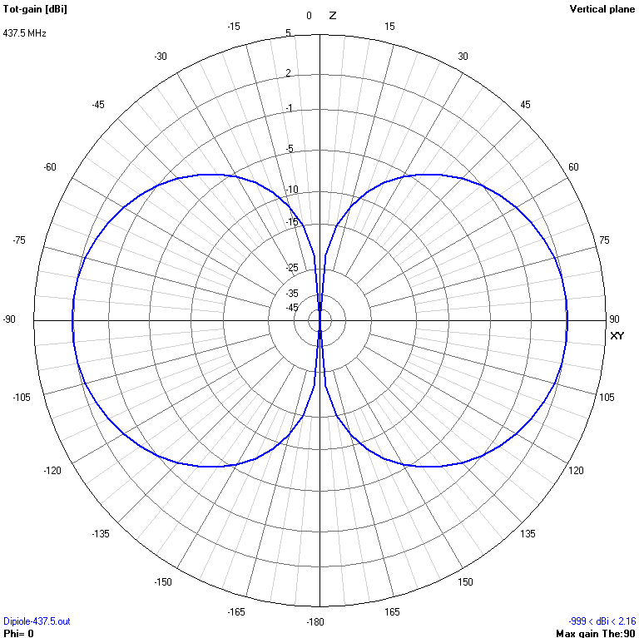
4d7 | Attitude stabilization, if used | Passive Attitude Stabilization with permanent magnets and Hysteresis sheets.
4d8 | Service Area | Worldwide
4e | Proposed space station receiving frequency plan.  List for each frequency or frequency range:
4e1 | Requested frequency and function | Same as 4d1
4e2 | Frequency tuning range (in MHz) of receiver and tuning step increment (in Hz or kHz) | 420MHz-520MHz Range & 14.3 Hz Step Increment
4e3 | ITU emission designator for each transmitter and emission type | 500H A1A  515H F1B  2K00 F1D
4e4 | Common description of the emission including modulation type AND data rate for each transmitter and emission type | 500H A1A: CW Morse at 20 wpm, +20dBm.  515H F1B: RTTY FSK at 425 Hz Shift and 45 Baud in ASCII-8 Mode, +20dBm.  2K00 F1D: GFSK at 500bps and 1kHz Deviation, +20dBm.
4e5 | Noise temperature for each receiver onboard the satellite | 900K
4e6 | Associated antenna gain and pattern for each receiver onboard the satellite | Same as 4d6
4f | Physical structure, including dimension and mass: | The satellite has a mass of approximately 250 gm and has a dimension of 5 cm X 5 cm X 5 cm.  The satellite consists of an outer structure of aluminum alloy (Al-6061-T6). The outer structure is divided into three parts. They are Battery Casing at the bottom, Structure to hold solar cells and a Top Casing to hold magnets at the top. The solar cells are attached to the PCB and the PCB is connected to the structure by M2 HEX screw.  The internal structure contains PCBs for different subsystems connected to each other by harness headers on two sides and standoffs on four edges of PCBs.  The satellite is inserted into the Deployer with the help of Base Plate acting as a rail. PCB of FR4 and thickness of 1.4mm is used as a Base Plate.  Five out of six faces of satellite contain solar cells whereas one contains the thermal knife, Payload, Deployment sensing system and an antenna.  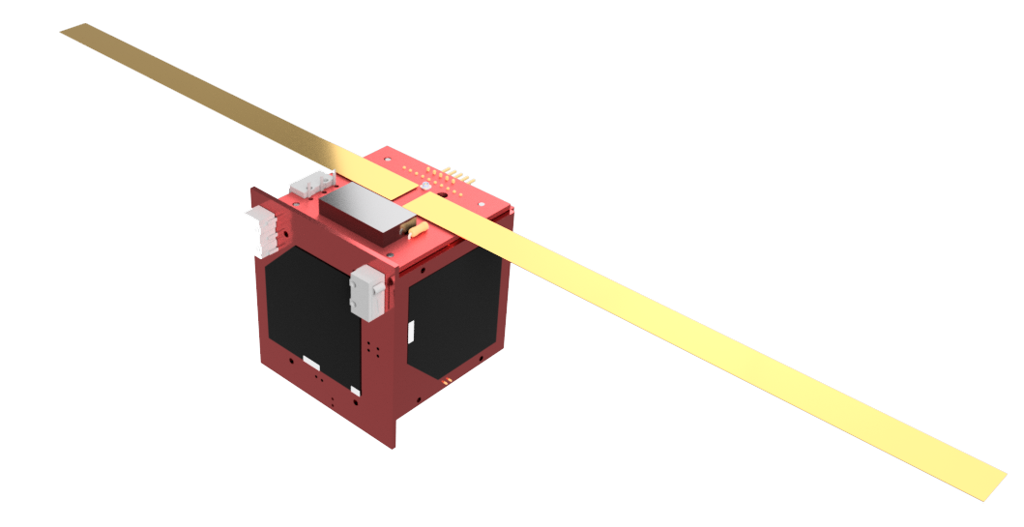  Assembled View  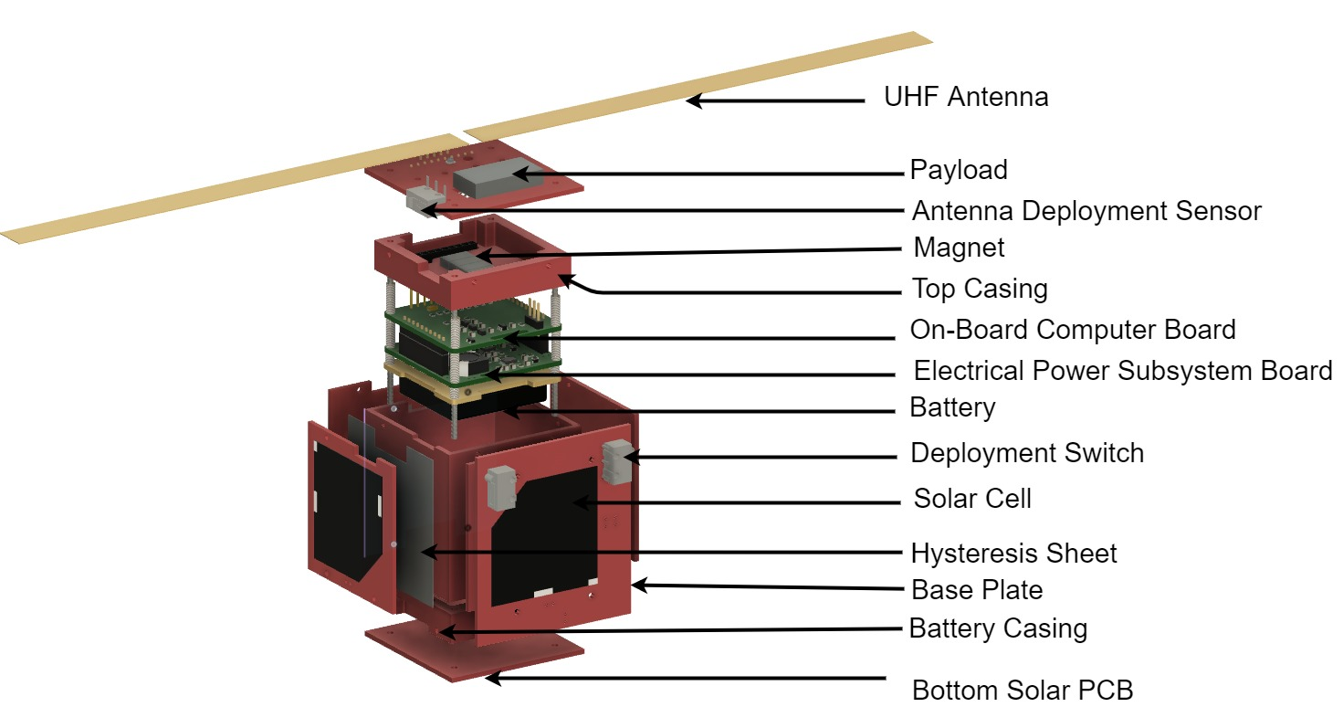  Exploded View

4g | Functional Description of each satellite sub-system, including non-amateur payloads | The satellite’s subsystems are composed of:  - Onboard Computer / Processing unit composed of Atmega328p based microcontroller with Watchdog for SEU protection and Current protection circuitry for SEL protection.  - Electronic Subsystem consists of Battery, Maximum Power Point Tracking (MPPT) based chargers, Solar cells, Low Dropout Regulators, Power monitoring devices and Current limiters. Five faces of the satellite contain triple-junction solar cells from Azurspace (3G30C) cut into half in order to fit into the side of PocketQube.  - The payload: BG51 Radiation sensor based on PIN diodes capable of detecting beta radiation (electrons), gamma radiation (photons) and x-rays.  - The amateur radio payload: Si4463 based RFM26W transceiver is being used along with UHF tape measure antenna and will transmit in CW Morse Beacon, RTTY-FSK and GFSK.
4h | Electrical Power budget.  (average power consumption and power generation in Watts) | The average power generation is around 550mW at any given time when the satellite is not in the eclipse period of the orbit. The system consumes around 450mW while transmitting and 220mW in idle mode. Transmission is done in a periodic basis so as to reduce power consumption.
encryption
4i | Will all transmissions (telemetry formats and equations, payload data, etc.) from the satellite have descriptions of modulations, protocols, formats, etc., published and publicly available on the project web site? | X yes  ☐no, see 4j
4j | If you’ve answered no in 4i, please explain.
5 | TELECOMMAND (NOT published)
5a | Telecommand frequency plan.
5a1 | Proposed space station telecommand frequencies | Same as 4d1
5a2 | List all ITU emission designators for each transmitter | 1st Transmission type: 2K00 F1D
5a3 | Common description of the emission including modulation type AND data rate | 2K00 F1D: GFSK at 500bps data.
5a4 | Radio Link budget(s) | Orbital Altitude: 500km  The distance at 35 Degree elevation: 815 km  Frequency: 437.5 MHz  Free Space Path Loss: 143.472 dB  Uplink Transmit Power: 11.5 dBW  Transmit Antenna Gain: 8 dBi  Antenna Transmission Line Loss: 2 dB  Atmospheric Loss: 2 dB  Miscellaneous Loss: 2 dB  Receive Antenna Gain: 2.2 dBi  Receive Sensitivity: -140 dBW  Link Margin: 15 dB
5a5 | A general description of any cipher system | The telecommand won’t be encrypted but it requires a specific message to be transmitted in order to send the telecommand.
5b | Positive space station transmitter control.  Explain how telecommand stations will turn off the space station transmitter(s) immediately, even in the presence of user traffic and/or space station computer system failure | In case of any CPU failure, the satellite won’t transmit the data until it is restarted. The restart can also be done by the uplink command.  In the case of user traffic, the transmitter can be easily turned off by the uplink command.  The satellite is designed in such a way that all three transmissions can be turned off individually in case of a problem with any transmission.
5c | Telecommand stations. List telecommand station(s)
5c1  5c2 | Amateur Radio Callsign | - 9N1AA  - EA4URE
 | Physical location (this is where the antennas are) lat/lon | - 27.700172, 85.349105  - Madrid N40°24'59.4" O3°42'9.22"
5d | Optional: Give the complete space station turn off procedure. | TBA
6 | Telemetry (published)
6a | Telemetry frequencies
6a1 | All amateur telemetry frequencies or frequency bands | Same as 4d1
6a2 | ITU emission designator | 1st Transmission type: 500H A1A  2nd transmission type: 515H F1B  3RD transmission type: 2K00 F1D
6a3 | Common description of the emission including modulation type AND data rate | 500H A1A: CW Morse at 20 wpm, +20dBm.  515H F1B: RTTY FSK at 425 Hz Shift and 45 Baud in ASCII-8 Mode, +20dBm.  2K00 F1D: GFSK at 500bps and 1kHz Deviation, +20dBm.
6a4 | Radio Link budgets | Same as 5a4
6b | Transmission formats | TBA and will be published online:  http://amsat-np.org/sanosat-1/  http://amsat-np.org/sanosat1-protocols/
7 | Launch plans (published)
7a | Launch agency | Alba Orbital
7b | Launch location | TBA
7c | Expected launch date | Q4 2020
7d | Planned orbit.
7d1 | planned orbit apogee | 400-500 km
7d2 | planned orbit perigee | 400-500 km
7d3 | planned orbit inclination | TBA
7d4 | planned orbit period | TBA
7e | List other amateur satellites expected to share the same launch. | EASAT-2, Hades and others in Alba Orbital cluster 3 launch

Earth station information:
8 | Typical Earth station — transmitting
8a | Describe the hardware and software of a typical Earth station used to transmit signals to the planned satellite | A Si4463 based RFM26W breakout board along with an external PA and atmega328p based microcontroller can be used to communicate with the satellite. Si4463’s inbuilt protocol in GFSK modulation can be used to communicate with the satellite. The transmission format will be as in 6b.
8b | Radio Link budget.  Show complete link budgets for all Earth station transmitting frequencies, except telecommand. | Orbital Altitude: 500km  The distance at 35 Degree elevation: 815 km  Frequency: 437.5 MHz  Free Space Path Loss: 143.472 dB  Uplink Transmit Power: 11.5 dBW  Transmit Antenna Gain: 3 dBi  Antenna Transmission Line Loss: 2 dB  Atmospheric Loss: 2 dB  Miscellaneous Loss: 2 dB  Receive Antenna Gain: 2.2 dBi  Receive Sensitivity: -140 dBW  Link Margin: 10 dB
9 | Typical Earth station — receiving
9a | Describe the hardware and software of a typical Earth station to receive signals from the planned satellite. | The receiving system consists of a helical antenna along with the rotator, LNA, a portable SDR, and a PC.  CW and RTTY FSK can be received by any amateur operators using a simple handheld radio and a simple Yagi antenna.
9b | Radio Link budget.  Show complete link budgets for all Earth station receiving frequencies. | Frequency: 437.5 MHz  Orbital Altitude 500 km  Elevation Angle 35 Deg  Distance: 815.089 km  -10 dBW  Spacecraft Antenna Gain 2.2 dBi  Spacecraft Line Loss 1 dB  EIRP -8.8  GFSK(2K00F1D) CW Morse (500H A1A) RTTY FSK (515H F1B)  Free Space Path Loss: 143.4737 143.4737 143.4737 dB  Antenna Pointing Loss: 1 1 1 dB  Antenna Polarization Loss: 1 1 1 dB  Atmospheric Loss: 2 2 2 dB  Ionospheric Loss: 1 1 1 dB  Rain Loss: 0 0 0 dB  Isotropic Signal Level at GS -157.274 -157.274 -157.274 dB  GS Antenna Pointing Loss 0.2 0.2 0.2 dB  GS Antenna Gain 14 14 14 dB  GS Transmission Loss 2 2 2 dB  Ground Station Effective Noise Temperature: 635 635 635 K  Ground Station Figure of Merrit (G/T): -16.2277 -16.2277 -16.2277 dB/K  Signal Power at Input of LNA -145.474 -145.474 -145.474 dBW  Boltzman's Constant -228.6 -228.6 -228.6 dbW/K/Hz  Receiver Bandwidth 2000 500 515 Hz  Receiver Noise Power -167.562 -173.583 -173.454 dBW  SNR at Receiver 22.0883 28.1089 27.98053 dB  Required SNR 12.8 10 10 dB  Link Margin 9.288301 18.1089 17.9805 dB
Additional information:
Do not attach large files. Indicate the URL where the information is available.

10 | Please, supply any additional information that may assist the Satellite Advisor to coordinate your request(s).  NA

Certification:
11* | [x]The licensee of the planned space station has reviewed all relevant laws, rules, and regulations, and certifies that this request complies with all requirements as understood by IARU to the best of his/her knowledge and confirms to meet the requirements of RR 1.56 and RR 1.57 in that the proposed satellite will operate without pecuniary interest.  Please list any commercial interests. If none, please state none.
 | [x]The licensee of the planned space station has reviewed all relevant laws, rules, and regulations and disagrees with IARU interpretations of Treaty requirements. The IARU Satellite Advisor is asked to consider the following interpretation. Explanation follows.
Please tick ONE appropriate box.

Signature:
12 | (REQUIRED!)    __FELIX PAEZ________ ________________ ___26/MAY/2020____  Signature of space station licensee. Date submitted for coordination.

