Lab no.: 4 Date: March 25th, 2025
Write a Program to encrypt and decrypt the user input message and rails using
Rail-fence cipher.

Theory
The Rail Fence Cipher is a form of transposition cipher that encrypts a message by rearranging its characters in a zigzag (rail fence) pattern across multiple rows. It is one of the simplest transposition ciphers used in classical cryptography.
Encryption Algorithm:
- A transposition cipher that arranges text in a zigzag pattern.
- The message is written diagonally downward across multiple rails.
- Once the bottom rail is reached, the direction reverses upward.
- This process continues until the entire message is placed in the pattern.
- The encrypted text is formed by reading each row sequentially.
Decryption Algorithm :
- The matrix size is determined based on the cipher text length and the number of rails.
- The zigzag pattern from encryption is recreated to mark character positions.
- The cipher text is placed row-wise into the marked positions.
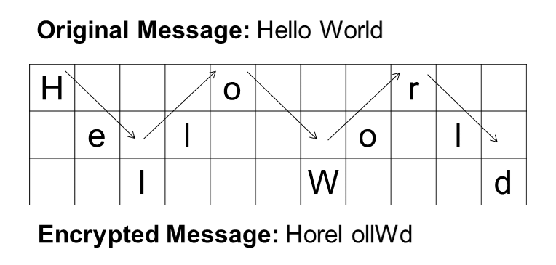
- Finally, the message is reconstructed by reading in the original zigzag pattern.

Programming Language: C
IDE: Microsoft Visual Code
Source code:

#include <stdio.h>
#include <string.h>
#define MAX 100

// Function to create Rail Fence pattern
void createRailFence(char *text, int rails, char rail[][MAX]) {
int len = strlen(text);
int row = 0, dir_down = 0;

// Initialize the matrix
for (int i = 0; i < rails; i++)
for (int j = 0; j < len; j++)
rail[i][j] = ' ';

// Build the zig-zag pattern
for (int i = 0; i < len; i++) {
rail[row][i] = text[i];
if (row == 0)
dir_down = 1;
else if (row == rails - 1)
dir_down = 0;

row += dir_down ? 1 : -1;
}
}

// Function to print the Rail Fence matrix with box graphics
void printRailFence(char rail[][MAX], int rails, int len) {
printf("\n========== Rail Fence Cipher ==========\n");

// Print top horizontal border
for (int j = 0; j < len; j++)
printf("*---");
printf("+\n");

// Print characters row by row with vertical lines
for (int i = 0; i < rails; i++) {
for (int j = 0; j < len; j++) {
printf("| %c ", rail[i][j]);
}
printf("|\n");

// Print horizontal border after each row
for (int j = 0; j < len; j++)
printf("*---");
printf("*\n");
}
}

// Function to perform Encryption
void encrypt(char *text, int rails) {
char rail[rails][MAX];
createRailFence(text, rails, rail);
int len = strlen(text);

// Print the rail fence pattern
printRailFence(rail, rails, len);

// Read the rail row-wise to get the ciphertext
printf("\n Encrypted Message: ");
for (int i = 0; i < rails; i++)
for (int j = 0; j < len; j++)
if (rail[i][j] != ' ')
printf("%c", rail[i][j]);
printf("\n");
}

// Function to perform Decryption
void decrypt(char *cipher, int rails) {
int len = strlen(cipher);
char rail[rails][MAX];
int i, j, index = 0;

// Initialize the rail matrix
for (i = 0; i < rails; i++)
for (j = 0; j < len; j++)
rail[i][j] = ' ';

// Mark the zig-zag positions with '*'
int row = 0, dir_down;
for (i = 0; i < len; i++) {
if (row == 0)
dir_down = 1;
if (row == rails - 1)
dir_down = 0;
rail[row][i] = '*';
row += dir_down ? 1 : -1;
}

// Fill the cipher text into the marked positions
for (i = 0; i < rails; i++)
for (j = 0; j < len; j++)
if (rail[i][j] == '*' && index < len)
rail[i][j] = cipher[index++];

// Print the rail fence pattern
printRailFence(rail, rails, len);

// Read the matrix in zig-zag order to decrypt
printf("\n Decrypted Message: ");
row = 0;
for (i = 0; i < len; i++) {
if (row == 0)
dir_down = 1;
if (row == rails - 1)
dir_down = 0;
if (rail[row][i] != ' ')
printf("%c", rail[row][i]);
row += dir_down ? 1 : -1;
}
printf("\n");
}

// Main Function
int main() {
char text[MAX], cipher[MAX];
int rails;
printf("\t****NISHAN DHAKAL****\n*****Rail-Fence Cipher*****\n\n");
printf(" Enter the message : ");
scanf("%s", text);

printf(" Enter the number of rails: ");
scanf("%d", &rails);

// Perform encryption
encrypt(text, rails);

printf("\n Enter the cipher text for decryption: ");
scanf("%s", cipher);

// Perform decryption
decrypt(cipher, rails);

return 0;
}

// Function to perform Encryption
void encrypt(char *text, int rails) {
char rail[rails][MAX];
createRailFence(text, rails, rail);
int len = strlen(text);

// Print the rail fence pattern
printRailFence(rail, rails, len);

// Read the rail row-wise to get the ciphertext
printf("\n Encrypted Message: ");
for (int i = 0; i < rails; i++)
for (int j = 0; j < len; j++)
if (rail[i][j] != ' ')
printf("%c", rail[i][j]);
printf("\n");
}
// Function to perform Decryption
void decrypt(char *cipher, int rails) {
int len = strlen(cipher);
char rail[rails][MAX];
int i, j, index = 0;
for (i = 0; i < rails; i++)
for (j = 0; j < len; j++)
rail[i][j] = ' ';
int row = 0, dir_down;
for (i = 0; i < len; i++) {
if (row == 0)
dir_down = 1;
if (row == rails - 1)
dir_down = 0;
rail[row][i] = '*';
row += dir_down ? 1 : -1;
}

// Fill the cipher text into the marked positions
for (i = 0; i < rails; i++)
for (j = 0; j < len; j++)
if (rail[i][j] == '*' && index < len)
rail[i][j] = cipher[index++];
printRailFence(rail, rails, len);
printf("\n Decrypted Message: ");
row = 0;
for (i = 0; i < len; i++) {
if (row == 0)
dir_down = 1;
if (row == rails - 1)
dir_down = 0;
if (rail[row][i] != ' ')
printf("%c", rail[row][i]);
row += dir_down ? 1 : -1;
}
printf("\n");
}

// Main Function
int main() {
char text[MAX], cipher[MAX];
int rails;
printf("\t****NISHAN DHAKAL****\n*****Rail-Fence Cipher*****\n\n");
printf(" Enter the message : ");
scanf("%s", text);

printf(" Enter the number of rails: ");
scanf("%d", &rails);

// Perform encryption
encrypt(text, rails);

printf("\n Enter the cipher text for decryption: ");
scanf("%s", cipher);

// Perform decryption
decrypt(cipher, rails);

return 0;
}

printf("\n");
}

// Main Function
int main() {
char text[MAX], cipher[MAX];
int rails;
printf("\t****NISHAN DHAKAL****\n*****Rail-Fence Cipher*****\n\n");
printf(" Enter the message : ");
scanf("%s", text);

printf(" Enter the number of rails: ");
scanf("%d", &rails);

// Perform encryption
encrypt(text, rails);

printf("\n Enter the cipher text for decryption: ");
scanf("%s", cipher);

// Perform decryption
decrypt(cipher, rails);

return 0;
}

Output:
ss
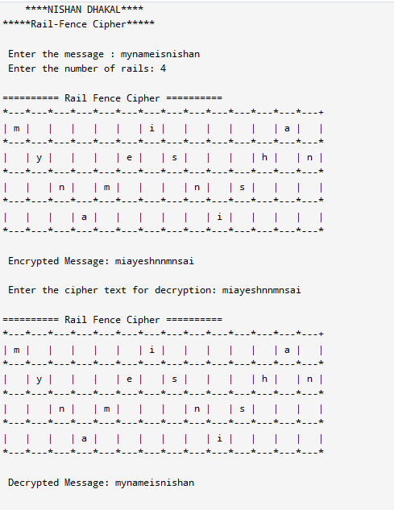

Conclusion:

