Exp1:

6 aspects follow the same trend, distribution of positive of reviews becoming bigger along with time.

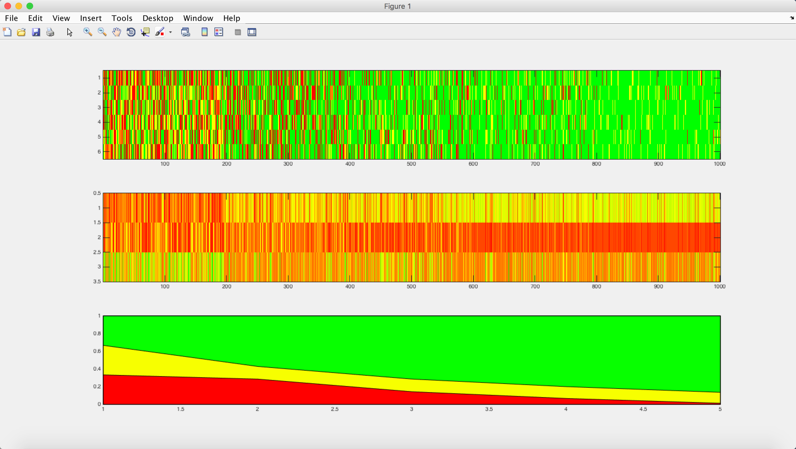

Exp2:

6 aspects follow the same trend, distribution of positive of reviews becoming bigger along with time.

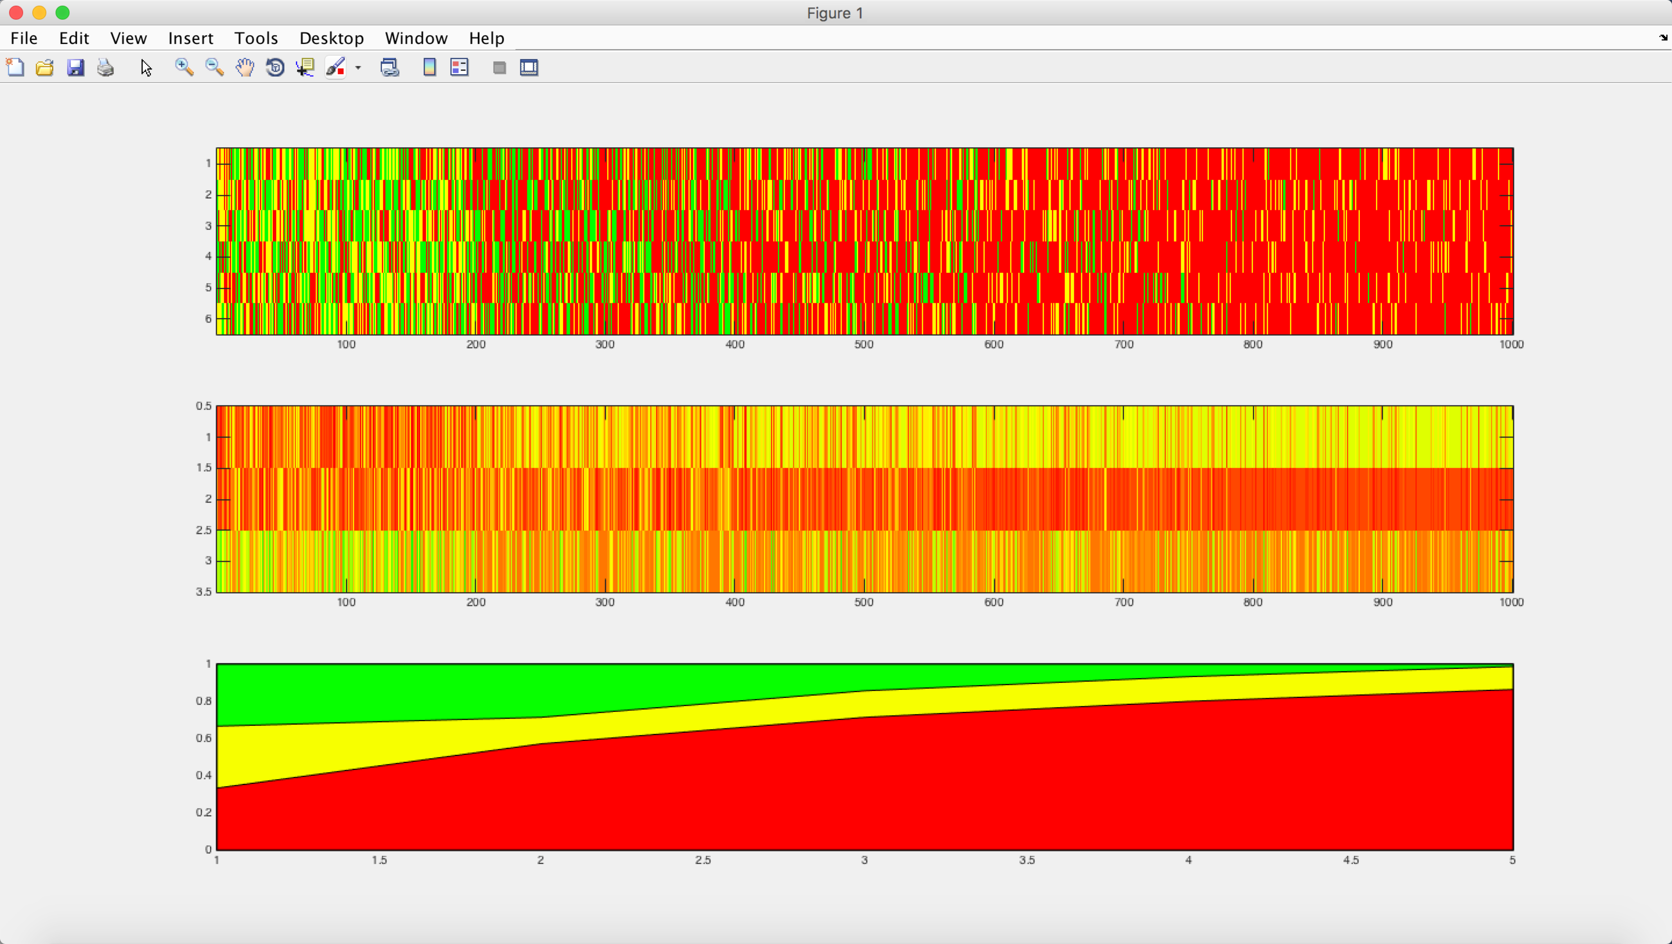

Exp3:

3 aspects follow one trend, the other 3 aspects follow another trend.

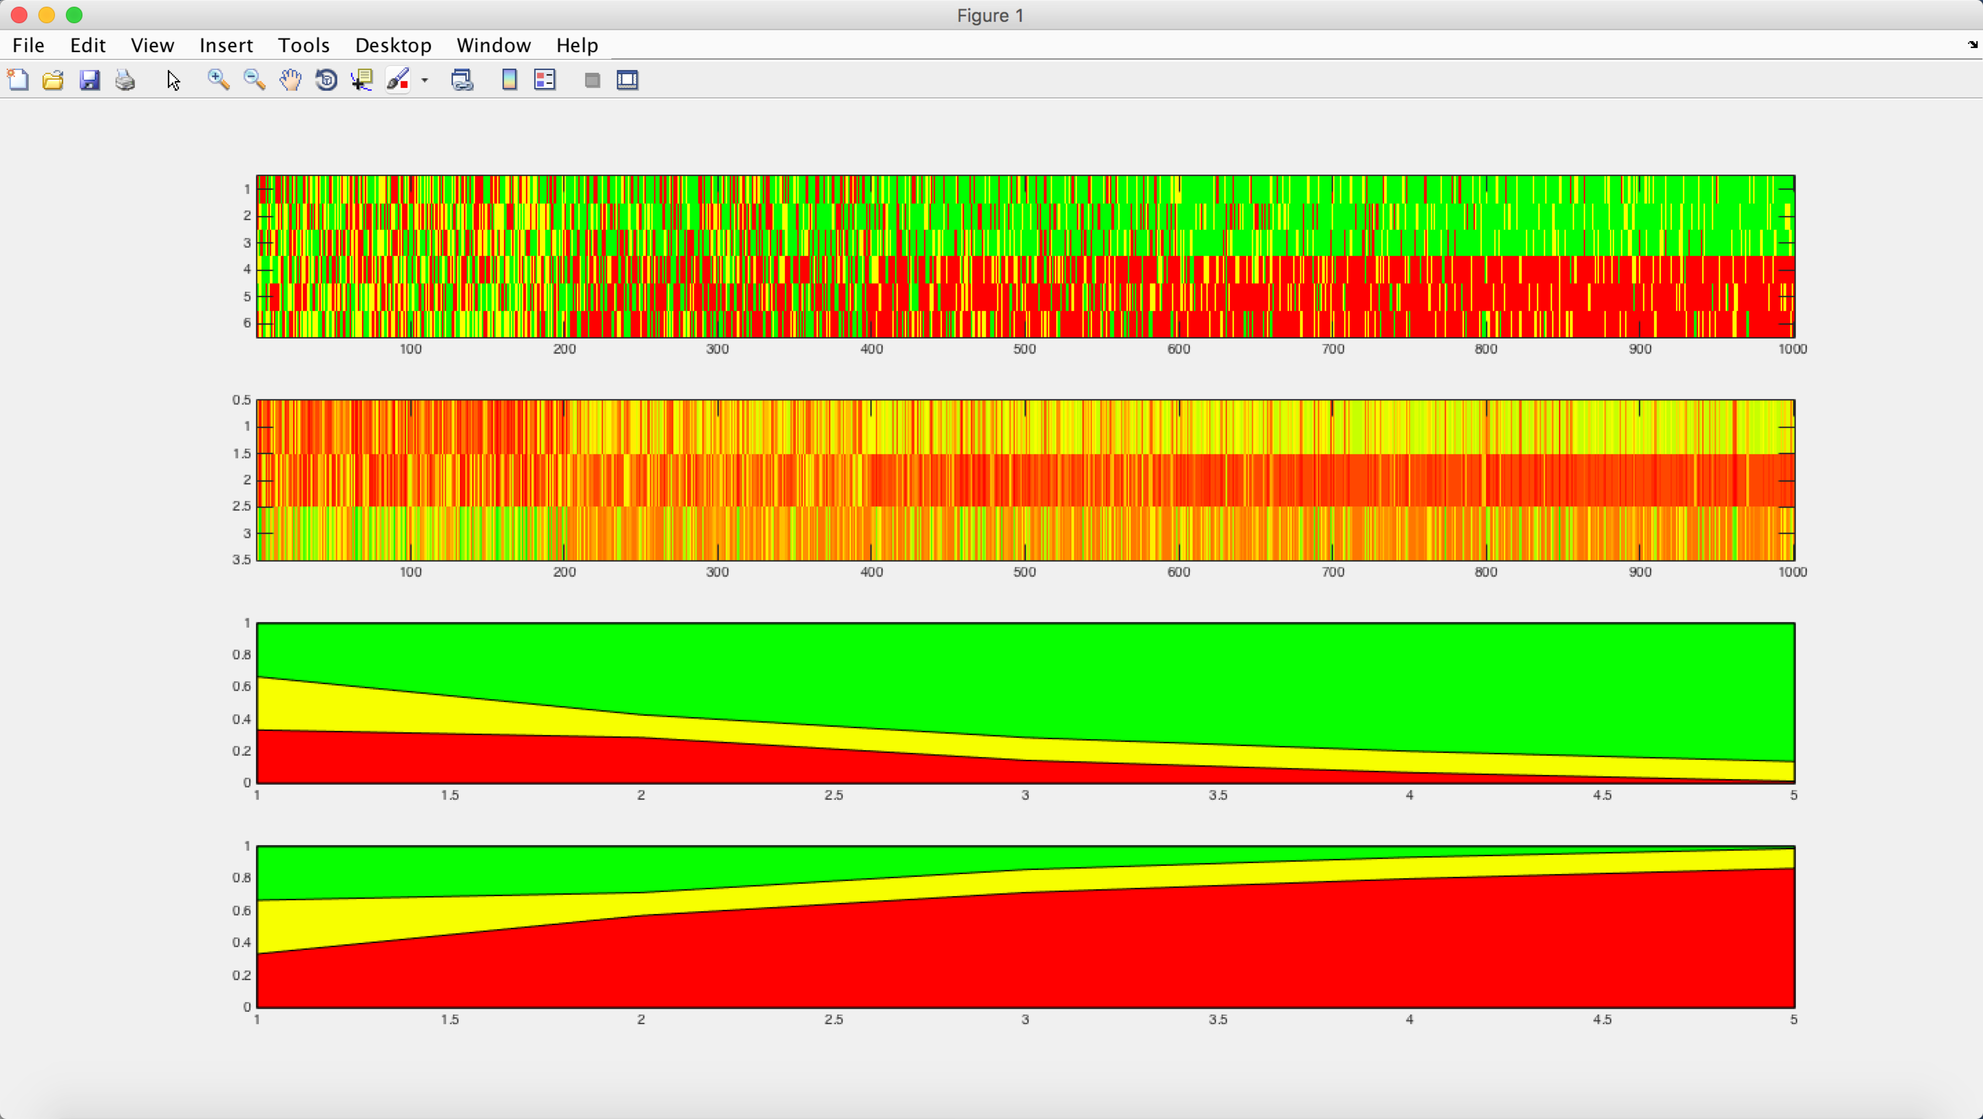

Exp4

3 aspects follow one trend, the other 3 aspects follow another trend.

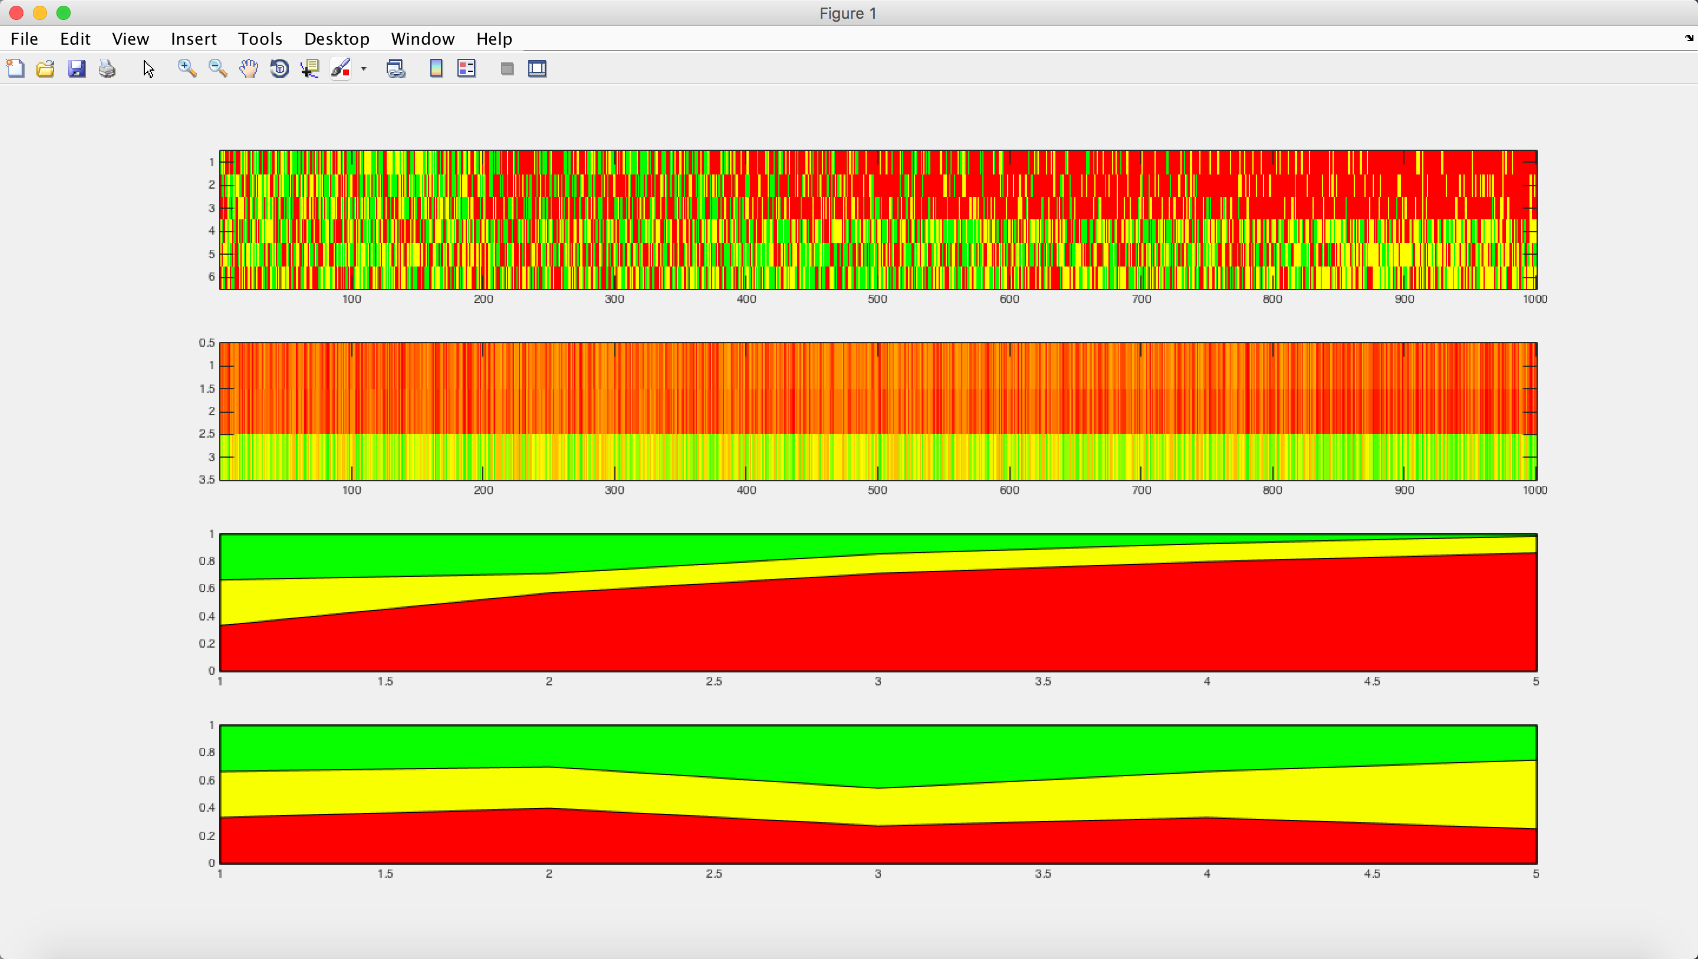

Exp5:

Five aspects follow the same trend, but the trend is roughly flat.

