bac2food — score column derivation
Bottom-up derivation of the per-(bacterium, food) score

This document derives the score column in differential.tsv, perFood.tsv and community.tsv. It starts from the smallest atomic variables (a single nutrient amount, a single bacterium, a single food) and builds upward one layer at a time. At every layer, the inputs and outputs are named explicitly so a reader can stop anywhere and still know where they are.
The final score (Layer 12) and the differential comp_score (Layer 13) are exactly the values bac2food_predict.py writes to disk.

Layer 0 — Atomic variables
Inputs: the raw FoodDB tables and the user-supplied MAG → EC TSV
Output: four primitive objects we manipulate from this point on
Everything downstream is built from four atomic objects. Nothing in this layer is computed; the predictor just reads them off disk.
• n — a single nutrient ID (an integer in the FDC namespace, extended into the 200001–299999 block for the v2 ingesters).
• F — a single canonical food. Many FDC rows usually map to the same canon (variants, cultivars, prep states); F is the representative chosen by build_static_food_meta.
• B — a single bacterium (a species label from the user's MAG TSV). It carries a set of EC numbers EC(B).
• a — the measured amount of nutrient n in food F, in the FoodDB row schema (fdc_id, nutrient_id, amount). Units are normalised per 100 g of edible portion downstream.
Notation used throughout the document:
• cur[n] — the running amount of nutrient n already accumulated by previously picked foods (greedy path only).
• targs(B) — the set of nutrients B can metabolise (see Layer 1).
• measured(F) — the set of nutrients with a non-zero row for F.

Layer 1 — Bacterium → target nutrients targs(B)
Inputs: B's EC set EC(B); the nutrient-to-EC table 0_building/3_nutrient_to_ec.tsv
Output: targs(B), the set of nutrients B can in principle metabolise
Each EC number is a chemical reaction. The nutrient→EC table lists, for each nutrient n, the ECs that produce or transform n. A bacterium can metabolise n if it carries any of those ECs.
Two filters are then applied:
• the blocked nutrient set (junk panel entries like "Energy", "Ash", "Specific gravity") is removed.
• with --specialty_mode, targs(B) is restricted to B's top-K nutrients by bacterial-IDF specificity (Layer 4). This is what makes Faecalibacterium ignore polyphenol breadth and concentrate on inulin / FOS.

Layer 2 — Per-nutrient threshold τ(n)
Inputs: the reference amount ref(n) (a quantile of n's values across foods) and the unit class of n
Output: τ(n) — the amount of n at which one helping moves the log-gain by one nat
τ(n) is the saturation point of the per-nutrient log-gain in Layer 3. Without τ, foods rich in one micronutrient (selenium, vitamin B12) would dominate every score; with τ proportional to ref(n), each nutrient contributes on a unit-free scale.
Step 1 — Reference amount:
Step 2 — Quantile scaling. TAU_Q = 0.05 normally; 0.01 for rare nutrients (ndf(n) < 50 000 rows):
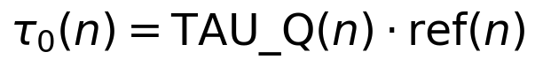
Step 3 — Floor and cap (unit-class aware). For gram-scale nutrients (carbohydrate, protein) the floor is 0.1 g and the cap is 500 g; for mg-scale nutrients the floor is 0.01 mg and the cap is 50 mg:
Worked example — pentosan (n = 1019) across the wheat-bran rows: ref ≈ 25 g per 100 g, TAU_Q = 0.05 → τ_0 = 1.25 g; floor 0.1 g and cap 500 g both pass; final τ(1019) ≈ 1.25 g.

Layer 3 — Per-nutrient log-gain dg(n)
Inputs: the threshold τ(n) (Layer 2), the measured amount a, and the running cur[n]
Output: dg(n) — the marginal benefit of adding amount a of nutrient n
log1p(x) = ln(1+x) is the saturating function: small amounts grow linearly, large amounts grow logarithmically. Picking the same nutrient twice yields diminishing returns — which is how the predictor avoids stacking ten high-fiber foods on top of each other.
Greedy path (used inside the per-bacterium greedy shortlist):
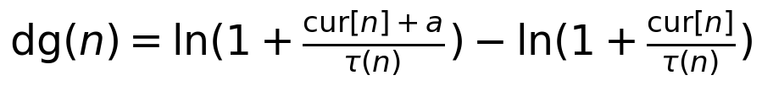
Clean-slate path (used for differential, perFood, community — every food scored independently, so cur[n] = 0):
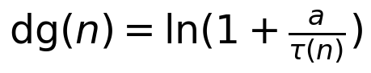
Interpretation: if a = τ(n), then dg(n) = ln(2) ≈ 0.69 — "one unit of saturation". If a = 9·τ(n), dg(n) = ln(10) ≈ 2.30 — ten times the amount only triples the gain.

Layer 4 — Per-nutrient weight w(n)
Inputs: the nutrient name (for fiber detection), per-nutrient manual multipliers, ndf(n) (food document frequency) and bf(n) (bacterial frequency)
Output: w(n) — a positive scalar that re-weights dg(n) by the nutrient's biological and statistical importance
w(n) is the product of four independent factors. Each factor is ≥ 1 (so weighting never zeroes out a nutrient) and each captures a different axis of importance.
(a) Fiber boost — fiber-family nutrients (fiber, starch, oligosaccharide, inulin, pectin, glucan, hemicellulose, cellulose, pentosan) carry the bacterial-substrate signal most strongly:
(b) Manual multiplier — a per-nutrient dial in DYNAMIC_STATE.nmult (defaults to 1.0; used for curation overrides):

(c) Food-IDF — down-weights nutrients present in every food. N is total foods, ndf(n) is the number of foods that contain n:
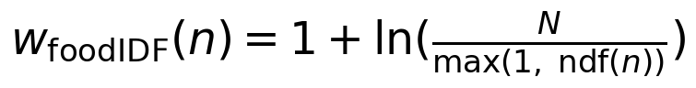
(d) Bacterial-IDF — Phase 9 specificity. B_total is the total bacteria in the input pool, bf(n) is the number of bacteria whose targs include n, α = spec_alpha is the sharpness knob:
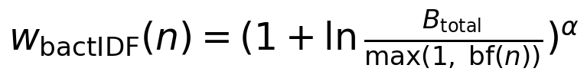
Final weight — product of the four factors:
At α = 2, a nutrient targeted by 1 of 600 bacteria gets ≈ 55× the weight of a nutrient targeted by 300 of 600. That is what tips the differential output from generalist plant foods toward bacterium-specific substrates.

Layer 5 — Per-nutrient contribution cg(n)
Inputs: dg(n) from Layer 3 and w(n) from Layer 4
Output: cg(n) — the signed contribution of nutrient n to the food's gain
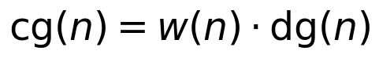
cg(n) is what gets summed across n to produce the food-level gain G in the next layer. A nutrient with high specificity (large w) and a meaningful amount (positive dg) contributes a large cg; a nutrient found in every food (small w) or present in trace amounts (small dg) contributes near zero.

Layer 6 — Food gain G(B, F)
Inputs: the per-nutrient contributions cg(n) and the contribution-floor filter
Output: G(B, F) — the total weighted log-gain B realises by eating one helping of F, and ni(B, F) — the count of nutrients that materially contributed
Two filters keep the sum honest:
• per-nutrient floor — the amount a must clear τ(n) · MIN_CONTRIB_FRAC (0.01 in general, 0.0001 for fiber, 0.001 for rare nutrients). Special oligosaccharide and isoflavone floors (10 mg and 1 mg) override.
• minimum hit count ni_min — a food must improve at least a small number of nutrients; trace-only hits are dropped to suppress single-nutrient outliers.
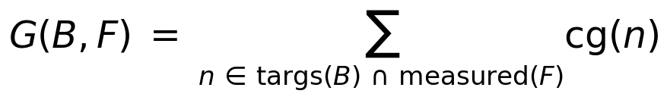

Layer 7 — Effective gain geff(B, F)
Inputs: G(B, F) and ni(B, F) from Layer 6
Output: geff — gain after log compression and breadth gating
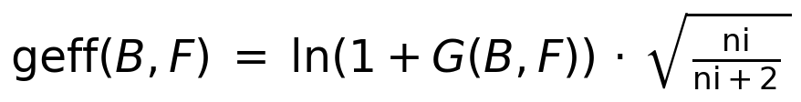
Two pieces:
• ln(1 + G) — compresses raw G into a comparable range. Doubling G no longer doubles the score.
• √(ni / (ni + 2)) — the breadth gate. A food with ni = 1 gets factor √(1/3) ≈ 0.58; with ni = 5 it gets √(5/7) ≈ 0.85; with ni → ∞ it approaches 1. Many-nutrient foods get nearly their full ln(1+G); single-nutrient outliers get penalised.

Layer 8 — Food-level metadata
Inputs: food_category, description, data_type (FDC / source DB)
Output: five scalar attributes used by Layer 11
These are properties of the food itself, not of the (bacterium, food) pairing. They are precomputed once in build_static_food_meta and cached in food_stats.
• p — category penalty from CAT_PENALTY (1.0 for fruits and vegetables; 1.5–2.0 for sweets, snacks, alcoholic beverages; boosted further by NF-yield / powder / processed / junk regex hits).
• bc = PROC_BASE_W · p — a flat per-food base cost.
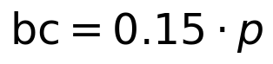
• art ∈ {0, 1} — "artifact" flag, set when p ≥ 1.5. Triggers the ART_W penalty for almost certainly synthetic / heavily-processed entries.
• tb — type-confidence bonus. tp is the database-quality tier (foundation_food = 600, sr_legacy = 500, branded = 200…), TYPE_W = 0.25:
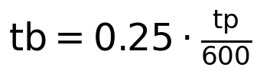
• pl — plant / processed factor (≥ 1.0 for non-plant or heavily-processed foods; used to penalise the amount-cost in Layer 11).

Layer 9 — Breadth–purity ratio prm(B, F)
Inputs: ni(B, F) from Layer 6 and mc(F) = total nutrients measured for F
Output: prm ∈ [0, 1] — what fraction of F's nutrient panel B actually uses
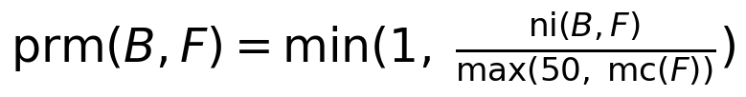
A food with mc(F) = 200 measured nutrients where B improves only 5 has prm = 5/200 = 0.025 — B uses 2.5% of F's panel. A food with mc(F) = 50 and ni = 25 has prm = 25/50 = 0.5 — B uses half. The max(50, ·) in the denominator stops sparsely-measured foods from looking artificially specialised.

Layer 10 — Food baseline cost
Inputs: bc and art from Layer 8, plus the global constant LAMBDA_FOOD = 0.08
Output: food_baseline — a flat per-food cost charged regardless of B
Concrete numbers: LAMBDA_FOOD = 0.08 is the universal regulariser; bc scales with category penalty (0.15 for vegetables, 0.30 for sweets); ART_W = 8.0 puts a heavy cost on artifact-flagged entries — those have to clear a very high gain bar to make the cut.

Layer 11 — Amount-scaled cost
Inputs: pl from Layer 8, prm from Layer 9, G from Layer 6
Output: amount_cost — a cost that grows with how much gain we are claiming
Concrete numbers: PROC_W = BROAD_W = 0.20, BROAD_Q = 2.
Two summed components, both multiplied by the same ln(1 + G) envelope so the cost scales with the magnitude of the claim:
• PROC_W · pl — processing cost. A plant food with pl = 1 contributes 0.20; a deep-fried or branded food with pl = 2 contributes 0.40.
• BROAD_W · (1 − prm)² — breadth cost. If B uses all of F's panel (prm = 1), this term is 0. If B uses 10% of the panel (prm = 0.1), this term is 0.20 · 0.81 = 0.162. The exponent (BROAD_Q = 2) makes mid-range breadth cheap and very-broad breadth expensive.

Layer 12 — Final clean-slate score score(B, F)
Inputs: geff (Layer 7), tb (Layer 8), food_baseline (Layer 10), amount_cost (Layer 11)
Output: score(B, F) — the number written into the score column of every output TSV
This is the formula that produces the score column in differential.tsv, perFood.tsv and community.tsv:
Term-by-term reading:
• geff · (1 + tb) — the positive side. Effective log-gain, scaled up by the database-quality bonus.
• − food_baseline — flat per-food cost (regulariser + base cost + artifact penalty).
• − amount_cost — gain-scaled cost (processing penalty + breadth penalty).
Greedy-path extension. The per-bacterium greedy shortlist (emitted only for the absolute-mode --max_foods output, which the current 3-file output structure does not write) subtracts two additional greedy-state terms:
where red is the cosine similarity to previously picked foods' nutrient contribution vectors (OVERLAP_W = 0.60) and cat_pen = 0.20 · (count of already-picked foods in the same category). Neither term affects the clean-slate score in Layer 12.

Layer 13 — Differential comp_score comp(B, F)
Inputs: the score(B, F) matrix from Layer 12, computed for every (B, F) pair in the input pool
Output: comp_score — how much B beats the median peer on food F
The differential output answers a comparative question: "which foods does B do better than its peers?" Layer 12 gives the absolute score; subtracting the per-food peer median converts it into a peer-relative score.
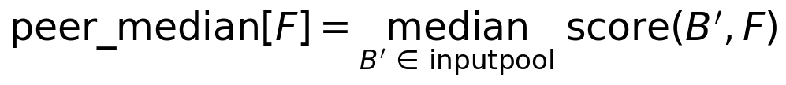
Median, not mean — a handful of specialists scoring very high on one food would lift the mean enough to drown out the comparative signal. Median gives "this bacterium beats half its peers" semantics.

Layer 14 — Output filtering
Inputs: the (bacterium, food, score) long frame and the comp_score column
Output: the rows that survive into community.tsv / differential.tsv / perFood.tsv
Phase 10 rule — drop net-negative recommendations:
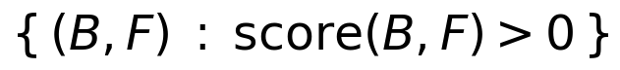
A row with score(B, F) ≤ 0 means the food's costs (baseline + amount cost) exceed B's effective gain — eating F actively does not benefit B. Printing such rows is misleading, so they are filtered out before per-bacterium / per-food top-K truncation. If a bacterium has fewer than max_foods positive-score rows, its block in differential.tsv is shorter than max_foods — not padded with negative-score noise.
The --keep_negative_scores flag disables this filter (useful for debugging which foods penalise a bacterium hardest).

Layer 15 — End-to-end worked example
Inputs: one concrete (B, F) pair traced through every layer
Output: a numeric score we can compare to differential.tsv
Take B = Roseburia, F = "bran, wheat, raw". Pick three nutrients in targs(B) ∩ measured(F) for the walkthrough — pentosan, arabinoxylan, β-glucan — with the values the predictor actually loads.
Layer 2 — τ for each nutrient:
Layer 3 — dg for each nutrient (clean-slate, cur = 0):
Layer 4 — weight w(n). All three nutrients match the fiber regex (w_fiber = 2.0), are common across foods (small w_foodIDF ≈ 2), and are bacterially specific (rough w_bactIDF ≈ 3 at α = 2). Combined w ≈ 12 each:
Layer 5 — cg(n) = w · dg:
Layer 6 — sum to gain (other nutrients in targs ∩ measured add another ≈ 11 from minor hits; ni = 5):
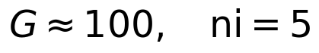
Layer 7 — effective gain:
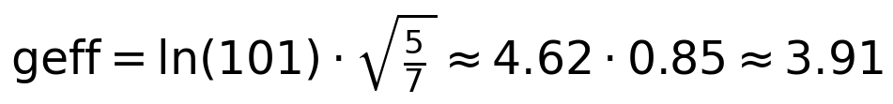
Layer 8 — food metadata. "bran, wheat, raw" is in the Cereal Grains and Pasta category (p = 1.0, bc = 0.15), no artifact (art = 0), high data-quality tier (tp = 600, tb = 0.25), plant food (pl = 1.0).
Layer 9 — breadth ratio. Wheat bran has mc ≈ 80 measured nutrients; ni = 5; prm = 5/80 ≈ 0.063.
Layer 10 — food baseline:
Layer 11 — amount cost:
Layer 12 — final score:
Layer 13 — peer-median for wheat bran across all bacteria in the input pool is ≈ 1.0 (most bacteria don't have arabinoxylan-degrading ECs), so comp_score ≈ 2.92 − 1.0 ≈ 1.92. Wheat bran appears near the top of Roseburia's differential.tsv block.
Layer 14 — score > 0, so the row survives the negative-score filter and is written to disk.

Layer 16 — Constants reference
Every named constant used in the derivation, with its current value and the layer that introduces it.
Constant | Value | Introduced in
TAU_Q | 0.05 (0.01 if ndf(n) < 50 000) | Layer 2 — τ scaling
MIN_CONTRIB_FRAC | 0.01 (0.0001 for fiber, 0.001 for rare) | Layer 6 — per-nutrient floor
OLIGO_FLOOR_MG | 10 mg | Layer 6 — oligosaccharide floor
ISOFLAVONE_FLOOR_MG | 1 mg | Layer 6 — isoflavone floor
GAIN_MIN | 0.001 | Layer 6 — min food gain
FIBER_WEIGHT | 2.0 | Layer 4 — fiber boost
spec_alpha (α) | 2.0 (tunable) | Layer 4 — bacterial-IDF sharpness
PROC_BASE_W | 0.15 | Layer 8 — base cost coefficient
ART_W | 8.0 | Layer 10 — artifact penalty weight
LAMBDA_FOOD | 0.08 | Layer 10 — flat regulariser
PROC_W | 0.20 | Layer 11 — processing cost weight
BROAD_W | 0.20 | Layer 11 — breadth cost weight
BROAD_Q | 2 | Layer 11 — breadth cost exponent
TYPE_W | 0.25 | Layer 8 — type-confidence weight
OVERLAP_W | 0.60 | Layer 12 (greedy) — redundancy cost
SCORE_MIN | −2.0 | Layer 12 — score cutoff before output filter

Layer 17 — One-page summary
All the formulas from Layer 0 to Layer 14, collapsed.
Inputs: bacterium B with EC set, food F with nutrient row (n, a), global constants from Layer 16.

1. targs(B) = nutrients reachable from EC(B).
2. τ(n) — adaptive saturation:
3. dg(n) — log-gain (clean-slate form):
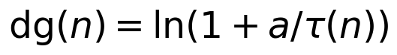
4. w(n) — fiber × manual × food-IDF × bacterial-IDF^α.
5. cg(n) = w(n) · dg(n).
6. G = Σ cg(n); ni = count of positive cg.
7. geff = ln(1 + G) · √(ni / (ni + 2)).
8. food_baseline = LAMBDA_FOOD + bc + ART_W · art.
9. prm = min(1, ni / max(50, mc(F))).
10. amount_cost = (PROC_W · pl + BROAD_W · (1−prm)^BROAD_Q) · ln(1 + G).
11. score = geff · (1 + tb) − food_baseline − amount_cost.
12. comp_score = score − peer_median[F].
13. Output filter: keep rows with score > 0.

