**Secondary Technical School of Electrical Engineering**

**Information technology**

Ječná 517, 120 00 Nové Město

**Pong**

Arcade Game

**Oleg Goshovskyy**

Information technology

2024

Table of contents

1 Project goal 3

2 Software 3

3 Game description 3

3.1 Mechanics 3

4 Manual 4

5 Conclusion 4

Table of Figures

Figure 1: Method for drawing score and “PAUSED” on screen 3

Figure 2: Method for running the game 4

# Project goal

The goal was to program a classic arcade game Pong where players control a paddle to deflect a ball at his enemy. The game can be played in two players where both control paddle on different sides, or alone where player plays against a computer which can have 3 different difficulty options.

# Software

The game was made in IntelliJ IDEA 2023.2.2 (Ultimate Edition), using Java SE Development Kit 16.0.2. No external libraries were used.

# Game description

This game is about paddles deflecting ball. The game runs in a window.

## Mechanics

The Ball object has a parameter leftScore and rightScore which allow to display score. Whenever the game is in pauseState, we draw grey ”PAUSED” on top of everything.

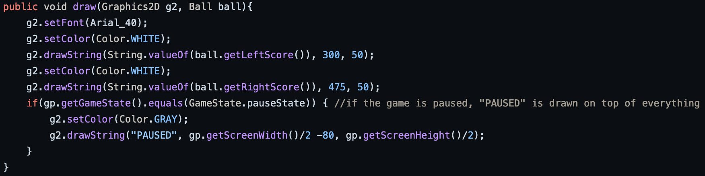Figure 1: Method for drawing score and “PAUSED” on screen

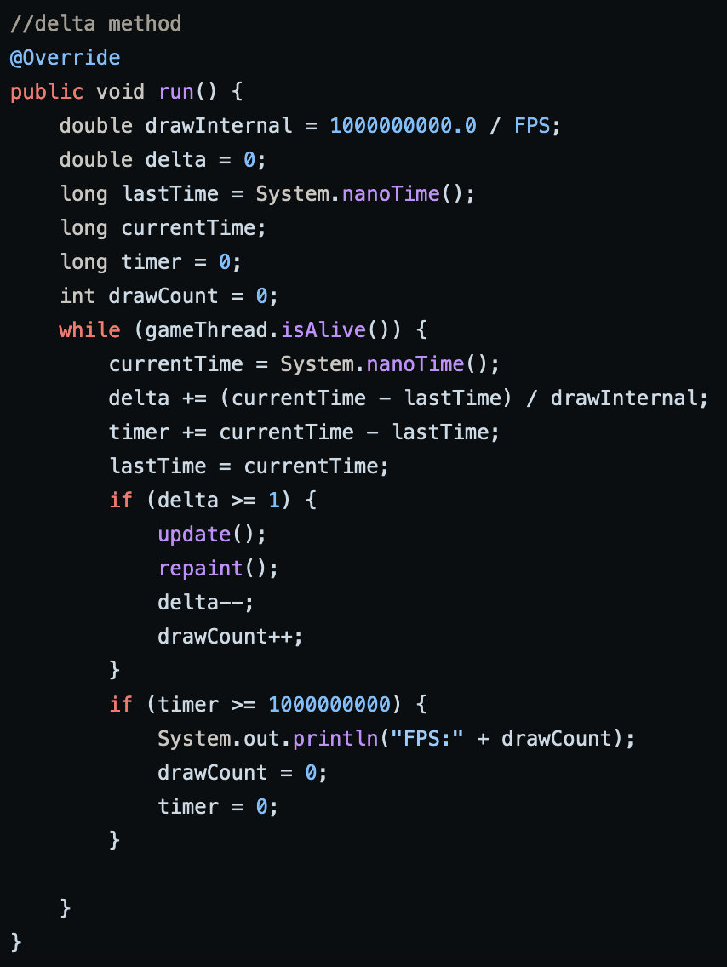Figure 2: Method for running the game

This method checks how much time has passed, divides that by drawInterval and adds that to delta. If delta is bigger or equal to 1 then the game updates and repaints, delta is subtracted and loop repeats. Timer and drawCount are used to display FPS.

# Manual

The player on the left side can control the left paddle with keys “W” and “S”, and player on the right controls his paddle with arrow up “↑” and arrow down “↓”. Game can be paused anytime by pressing “P”.

# Conclusion