# Assignment 1 Individual (redo)

## Topics: Implementing and Using List ADT

Date release : 23 March 2022

Date due : 4 April 2022

## Instruction

Submit the solution by attaching the solution file (or inform the link to solution) in the reply message on Schoology by due time.

## Description of the Problem

### Part ONE

Create a simple C++ program for storing, adding and selling laptop. This program has the functionality below:

* 1. Add Laptop
  2. Display Laptop stock
  3. Sell Laptop
  4. Search Laptop
  5. Exit

The functional requirements is as follows:

* If *user* choose menu ***Add Laptop*** (key press ‘**1**’), then:
  + - The program asks *user* to input **laptop stock**, you have to validate **the allowed stock is beetwen 1 to 100 items**. (otherwise, it wouldn’t fit into your warehouse or store)
* If *user* choose menu ***Display Laptop*** stock (keypress ‘**2**’), then:
  + - The program displays all the available laptop in the stock.
* If *user* choose menu ***Sell Laptop*** (keypress ‘**3**’), then:
  + - The program asks *user* to input **how many laptop** is going to be sold, please validate the allowed **sold laptop is between 1 and whatever remains in the *stock***.
* If *user* choose menu ***Search Laptop*** (keypress ‘**4**’), then:
  + - The program asks *user* to input **laptop model**, and if this is found, the laptop details is displayed on screen.
* Jika *user* memilih menu ***Exit*** (tekan tombol ‘**5**’), maka program akan berakhir.

The non-functional requirements is as follows:

1. Use List Abstract Data Type
   1. You can use the example provided by the Textbook (see google drive below) or adopt code from internet or develop your own ADT
   2. You are not allowed to use any STL container such as vector, or list
2. Do not use file input output, instead just store the data in the computer memory.

Here is an example of the CLI (command-line interface):

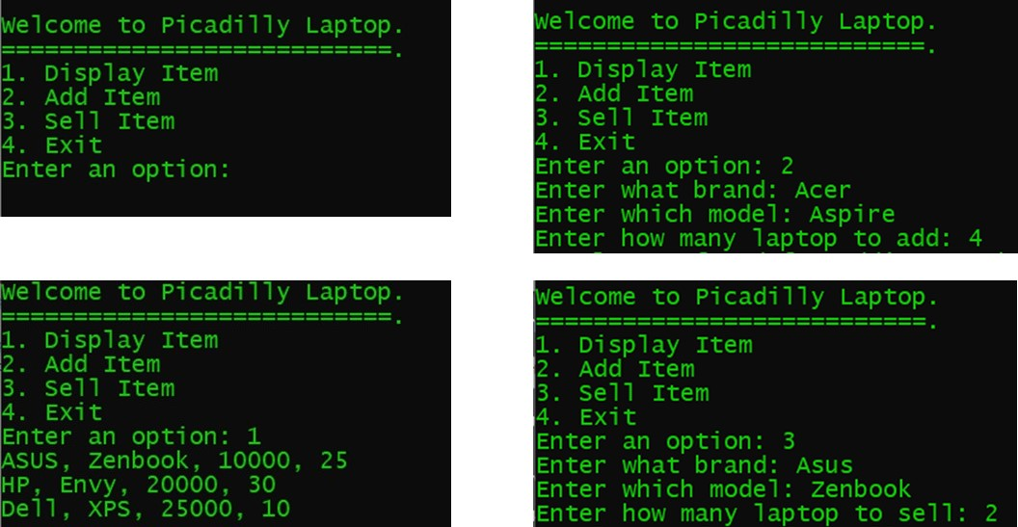

Here is a sample code for the class that contains the main function:

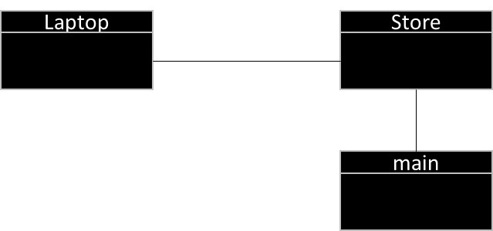

### Part TWO

What is the complexity or efficiency of the following functions in Big-Oh notation? Explain your reasons.

* 1. Add Laptop
  2. Display Laptop stock
  3. Sell Laptop

## Scoring Rubrics

Please use this rubric to assess how good is your Program.

|  |  |  |  |  |  |  |  |
| --- | --- | --- | --- | --- | --- | --- | --- |
| Component | Weight | Criteria | Score | Poor | Fair | Good | Excellent |
| Laptop Store Application | 60% | Functionality | 20 | Only one of the functionalities of add, delete, display, search and exit works | Two of the functionalities of add, delete, display, search and exit works | Three of the functionalities of add, delete, display, search and exit works | Implements the functionalities of add, delete, display, search and exit successfully |
| Correctness | 20 | Program cannot compile | Program compiled but does not meet the requirements and contain logical errors | Program compiled but does not meet the requirements even though it's free of logical errors | Program compiled, meet the requirements and bug-free |
| Efficiency | 20 | All the functions are inefficient | Search function is efficient | Add and Search function are efficient | Add and Search function are correct and efficient |
| List ADT | 40% | Operations | 30 | Major operations are not implemented | Not all major operations have been implemented and they still contain logical errors | All major operations have been implemented even though they still contain logical errors | All major operations have been implemented correctly |
| Efficiency | 10 | No trade-off among the operations has been attempted | Trade-off among the operations has been attempted, even though it resulted in efficient operations | Trade-off among the operations has been attempted and resulted in efficient operations | Trade-off among the operations has been attempted and resulted in efficient operations based on the choice of data structure |
|  | 100% |  | 100 |  |  |  |  |

## Resources that may help you

Please, check out this link to get some examples that can help you to finish this assignment well.

<https://drive.google.com/drive/folders/1bmKWc4i7mXq8sRotVdXKO7G84UsSPNFK?usp=sharing>

## Submission Guide

You must submit two kinds of solutions:

1. Your answer to the complexity questions – 10 points
2. Your program – 90 points. You can submit the code listing in MS Word or Text file format in Schoology or simple specify the link to your Github or other online repository.

--end of assignment 1--