DEPARTMENT OF COMPUTER SCIENCE &ENGINEERING

KATHMANDU UNIVERSITY

**COMP 102: Project on Telephone Directory**

Submitted by:

Shishir Kafle, Harichandra Khatri, Saloon Gautam, Sanskar Karki

Department of Computer Science

School of Science, Kathmandu University

Submitted to:

Manish Joshi / Pratit Raj Giri

Lecturer

Department of Computer Science and Engineering

School of Engineering, Kathmandu University

Date:17/08/2021

# Table of Content

Table of Content 2

Introduction 3

Case Study of Similar Application 4

1. Student Management System. 4

2. Bank Management System 5

3. Customer Data Management System 6

Library used 7

Flowchart and Algorithm 9

1. Algorithm: 9

2. Flowchart: 11

Features 16

Conclusion with future enhancement 18

Code Architecture 19

Source Code 20

1. Main.c 20

2. Login.h 23

3. Phonebook.h 26

Output Snippets 35

Refrence 47

# Introduction

C is a procedural programming language. It was initially developed by Dennis Ritchie in the 1972. It was mainly developed as a system programming language to write an operating system. The main features of the C language include low-level memory access, a simple set a keyword, and a clean style, these features make C language suitable for system programming like an operating system or compiler development.

We've covered several aspects of the C programming language so far, and we're ready to develop and run simple programs. However, before attempting to create sophisticated programs, it is worthwhile to explore some programming principles that will assist in the creation of efficient and error-free programs.

Program design, program coding, and program testing are all significant steps in the development process. All three stages are necessary for a high-quality program to be produced.

We did system design, source coding, program testing, and many other aspects in “TELEPHONE DIRECTORY” to provide the greatest user experience possible. We've offered the user the ability to enter the person's information, as well as the ability to save, sort, append, delete and more… that information, among other things.

We can improve the efficiency of the system and thereby overcome the shortcomings of the current system. Some of the benefits of utilizing C in our project include:

* Less human mistake is possible
* Manual labor strength and strain can be decreased
* High security;
* Data consistency
* Easy handling;
* Easy data updating;
* Easy record keeping;
* Backup data can be quickly generated.

# Case Study of Similar Application

## Student Management System.

We discovered the similar technique in the student management system after being asked to sort the names of the telephone entries. The students' names, for example, are sorted by first name, last name, or roll number. In a similar way, our program allows the user to do the same thing. The user has the option of sorting the list by first or last name. Additionally, the user has the option of sorting the numbers in ascending order.

We're all aware that sorting makes finding any form of data a breeze. This may be handy if a user wants to find out how many people have the initial name "A" because he can access them directly.



The one we attempted to replicate

## Bank Management System

One of the most important features that every user desire is the security of their work. It might be found in their financial system or in their phone book. None of the users wants their saved phone numbers to be stolen or shared with others. As a result, we sought to incorporate the login notion into our software "TELEPHONE DIRECTORY" after extracting an idea from the bank administration system. Users must first register in the database, which is a text file in this case, and then log in to gain access to the whole telephone directory. In comparison to our telephone directory, the bank management system gives higher security. Furthermore, our program lacks double authentication, although the bank management system does. As a result, we will be able to develop this feature into our program in the future.

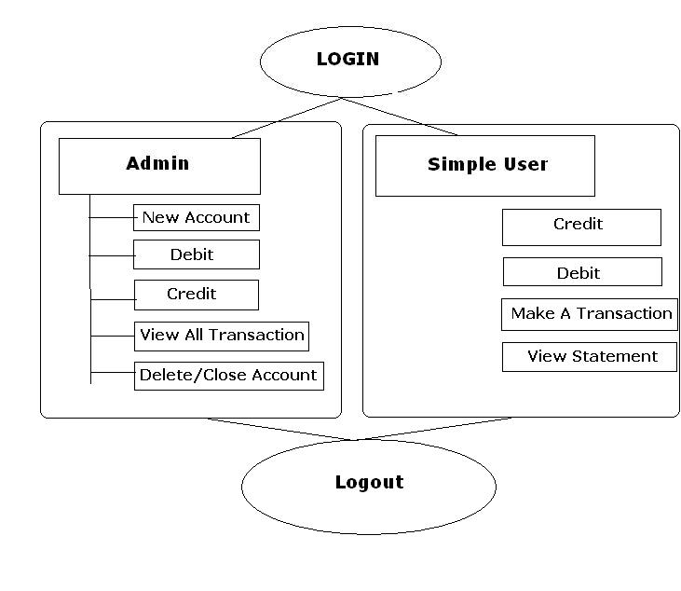

## Customer Data Management System

Take, for example, any Nepalese insurance company. One of that company's customers has a ten-year accident life insurance policy, and the service given to that customer will be unavailable. As a result, the company's admin interface may not require that Customer's details so, the organization now deletes obsolete data from its database. In a similar way, our “TELEPHONE DIRECTORY” allows the registered user (in this example, admin) to delete data that is no longer needed. We can also append fresh data to our database, much like an insurance company does with newly enrolled customers' information.

Let's look at another scenario,

One of the pre-registered customers visits the Insurance Company for another policy, and when the name is submitted, the outcome displays pre-registered user. As a result, in this instance, the Insurance Company adds the customer's desired insurance to the same previous information. Our application "TELEPHONE DIRECTORY" performs something similar. It will tell you whether or not the number exists. However, when looking at the case of an insurance company adding another policy to the same individual, we notice that we are missing the ability to add multiple contact numbers for the same person, which will be addressed in the near future.

Observing the idea of a Database and repurposing it



# Library used

While coding the "TELEPHONE DIRECTORY," we employed a number of header files and Datatypes, such as:

* #include <stdio.h>

{

<Stdio.h> is a header file in C, it is the file which contains C declaration and Macro definition to be shared between several files. stdio.h means standard input/output function which contains:

* printf ()
* Scanf ()
* getc ()
* putc ()
* fopen ()
* fclose ()
* fprintf ()
* fscanf ()

}

* #include<stdlib.h>

{

<stdlib.h> header file stands for Standard Library. It has the information of memory allocation/freeing functions Some predefined function that we used are:

* malloc ()
* exit ()

}

* #include<string.h>

{

<string.h> is the header in the C standard library which contains macro definitions, constants and declarations of functions and types used not only for string handling but also various memory handling functions, some function used under the <string.h> header file are:

* [strcat ()](https://www.programiz.com/c-programming/library-function/string.h/strcat)
* [strcmp ()](https://www.programiz.com/c-programming/library-function/string.h/strcmp)
* [strcpy ()](https://www.programiz.com/c-programming/library-function/string.h/strcpy)
* [strlen ()](https://www.programiz.com/c-programming/library-function/string.h/strlen)

}

* #include<ctype.h>

{

<ctype.h> header file of the C Standard Library declares several functions that are useful for testing and mapping characters. All the functions accept int as a parameter, whose value must be EOF or representable as an unsigned char. All the functions return non-zero (true) if the argument c satisfies the condition described, and zero(false) if not. Some pre-defined functions used under <ctype.h> header file is:

* isalpha ()
* tolower ()
* toupper ()

}

* #include<windows.h>

{

<windows.h>is a Windows-specific header file for the C programming languages which contains declarations for all of the functions in the Windows API, all the common macros used by Windows programmers, and all the data types used by the various functions and subsystems.

* Sleep ()

}

# Flowchart and Algorithm

## Algorithm:

Step 1: Start.

Step 2: Display the login options on the screen.

Step 3: Read username, password and save to .txt file.

Step 4: If login info matches then

* Print “Hello, username Welcome to the Program”

Step 5: Prints “Welcome to our telephone directory”

* Print phone records
* Add records
* Retrieve records
* Delete records
* Load file
* Save to file
* Sort
* Exit

Step 6: Now for printRec ()

* Prints First Name, Last Name, Phone Number from the Records.txt file.

Step 7: Now for addRecord ()

* Reads First Name, Last Name, Phone Number and saves to Record.txt file

Step 8: Now for rectrieveRec(),

* Reads First Name or Last Name or Phone number to search and stores in *attr
* If( Strcmp(fname, attr)==0 || strcmp(lname, attr)==0 ||strcmp(pnum, attr)==0)
* Prints “First Name, Last Name, Phone Number”

Step 9: Now for deleteRec(),

* Reads First Name or Last Name or Phone number to delete and stores in *attr
* If( Strcmp(fname, attr)==0 || strcmp(lname, attr)==0 ||strcmp(pnum, attr)==0)
* Deletes the record.

Step 10: for loadRec()

* Loads the files data to the console.

Step 11: Now for saveRec (), saves the entered data to file,

* File *wFile = fopen(“Records.txt”, “w”);
* Fprintf (“First Name, Last name, Phone number”);

Step 12: Now for sortRec()

* If ‘f’ sorts by first name
* If ‘l’, sorts by last name
* If ‘p’ sorts by phone number

Step 13: For Exit(),

* Prints “Do you want to save data?”
* If ‘y’, saves and exit.
* If ‘n’, exits without saving changes.

## Flowchart:

N

Displays Login Options

Reads the Input from the User

1

2

Choice

Choice

Login: Read Username and Password

Register: Stores the Input to the file User_Input.txt

Displays the Menu for Telephone Directory

Case 0:

Case6:

Case 5:

Case 4:

Case 3:

Case 2:

Case 1:

Case7:

Reads Last name

Reads First name

Prints First name

Prints Phone number

Prints last name

Reads Phone Number

Reads the Input

(Strcmp (firstCap(attr), pr->phoneRec[i]->fName) == 0 strcmp(firstCap(attr), pr->phoneRec[i]->lName) == 0 strcmp (attr, pr->phoneRec[i]->pNum) == 0)

If ==0

Yes

No

Print “Record not Found”

Print Output

Reads the Input

(Strcmp (firstCap(attr), pr->phoneRec[i]->fName) == 0 strcmp(firstCap(attr), pr->phoneRec[i]->lName) == 0 strcmp (attr, pr->phoneRec[i]->pNum) == 0)

Yes

No

If ==0

Prints “No match found in record to delete”

Prints “” Deleted Successfully”

Opens File in Read Mode

Reads and stores Data from the file

Closes the file

Opens File in Write Mode

Stores the Data entry in the Database

Closes the File

Reads as char arr

sortRec ()

Sort by Phone Number

Sort by Last Name

Sort by First Name

Reads char in;

n

y

If char in=’y’

saveRec ()

Print” Exited Successfully!!”

# Features

* Secured:

For the security of the telephone records, we have a separate login page where a user must first register their name and password, and only if those usernames and passwords match the data in the database during the login procedure will that user be granted access to the telephone directory.

* Print Records

Output

This feature displays the data that are stored in the Telephone directory Database. The data is tabulated in a way that distinguishes between first and last names, as well as phone numbers.

* Append

This lets us to append/add the First name, Last name and Telephone number in our existing Database.

* Search

This feature allows user to search any specific telephone number of a person by entering first name or last name of the person. Both names are presented on the output screen if there are two different entries with the same name.

* Delete

This feature allows the user to remove any person's record from the directory. This can be done by typing the user's username or last name, or by entering the number of the order in which it is sorted if there are many users with the same name.

* Load

The load is performed after any modifications to the file have been saved, because if it is performed before saving, the garbage value from the empty file may provide undesirable results.

* Save

After appending, deleting, and sorting data, this function of the application is used to store the record in the Database. This should be done right after some modification is done.

* Sort

This feature allows the user to sort the directory's records. The data can be sorted by first name, last name, and phone number.

* Exit

This function aids the user in exiting the program. The user is asked if he or she wants to keep the changes made while exploring the program before departing it.

# Conclusion with future enhancement

Using experimental scenarios and the language C, the application software was successfully implemented. Other functions of this application include making it simple to search, remove, update, and remember our information. examining other management systems that we described in the reference cases Our project necessitates crucial upgrades, which can be incorporated in the future or, to put it another way, future enhancements. Our program lacks double authentication, which could be a security flaw that will be rectified in future releases.

We were also unable to add several contacts to the same individual, but since everyone in today's society has many phone numbers, we planned to provide this capability in the future. We deal with "TELEPHONE DIRECTORY" in various forms in our daily lives. For example, we use the contact application on our phones. We can search, save, remove, adjust, and sort all of the data in the contact application on our phones, and our software does the same, so we can argue that our application, with a good user interface and other lacking functionalities as mentioned above, can be a replication of the contact application.

# Code Architecture

The project comprises of a Main.c file, which has all of the primary modules, as well as two main header files, “phonebook.h” and “login.h,” which contain all of the functions required for the program to execute. Additionally, the login.h header file contains User Input.txt as its Database txt file, and the phonebook.h header file contains Records.txt as its Record tracking txt file/Database.

# Source Code

## 1. Main.c

This is the source code for our main file, Main.c, which contains two key header files, namely "login.h" and "phonebook.h."

*// _____________________________Header Files________________________________*

#include "login.h"

#include "phonebook.h"

*// First Create a Blank User_Input.txt and Records.txt File in the same application Directory*

*// This system can store up to 20 number of users Data.*

int main()

{

    system("color e");

    printf("\n\nLoading");

    for (int i = 0; i < 8; i++)

    {

        printf(".");

        Sleep(370);

    }

*FILE* *fp = fopen(filename, "r");

    int i = 0, Num, Num1;

*User* u;

    if (NULL == fp)

    {

        printf("\nFILE NOT FOUND");

        exit(1);

    }

    for (i = 0; i < USER_MAX; i++)

    {

        char User_Name[100];

        char User_Password[10];

        fscanf(fp, "%s%s", User_Name, User_Password);

        strcpy(list[i].name, User_Name);

        strcpy(list[i].password, User_Password);

    }

    int choice = Start_Options();

    switch (choice)

    {

*// This Case is for login*

    case 1:

        system("cls");

        u = login ();

        if (1 == exist(u))

        {

*// More Main Codes to include.*

            printf ("\n\n Loading");

            for (int i = 0; i < 8; i++)

            {

                printf (".");

                Sleep (370);

            }

            system("cls");

            printf ("\n\n\n\n\t\t\t\t\t\tHello

, %s Welcome to the Program.", Confirmed_User.name);

            printf ("\n\n Loading");

            for (int i = 0; i < 8; i++)

            {

                printf (".");

                Sleep (250);

            }

            system("cls");

*PhoneRec* pr = initPhoneRec ();

            loadRec(pr);

            printf ("Welcome to Our TELEPHONE DIRECTORY\n\n");

            mainMenu(pr);

        }

        else

        {

            Printf ("\nWRONG USERNAME OR PASS\n");

            printf ("\n 1 ==> Retry \n 0 ==> Exit\n\n   ==> ");

            scanf ("%d", &Num);

            switch (Num)

            {

            case 1:

                system("cls");

                main ();

                break;

            case 0:

                exit(0);

                break;

            default:

                printf("\nWrong Input Do you Want to Try again");

                printf("\n 1 ==> Retry \n 0 ==> Exit\n\n   ==> ");

                scanf("%d", &Num1);

                switch (Num1)

                {

                case 1:

                    system("cls");

                    main();

                    break;

                case 0:

                    exit(0);

                    break;

                default:

                    system("cls");

                    printf("\n\nAgain, the input is Wrong........");

                    main();

                    break;

                }

            }

        }

        break;

*// This Case is for Registration*

    case 2:

        system("cls");

        registerUser();

        main ();

        break;

*// This Case is to Exit*

    case 0:

        exit (0);

        break;

*// This Case is for the Default if any wrong key is Pressed except*

*0, 1 and 2*

    default:

        printf ("\n Wrong Input Do You Want to Try again");

        printf ("\n 1 ==> Retry \n 0 ==> Exit\n\n   ==> ");

        scanf ("%d", &Num);

        switch (Num)

        {

        case 1:

            system("cls");

            main ();

            break;

        case 0:

            exit (0);

            break;

        default:

            system("cls");

            printf ("\n\n Again, the input is Wrong..........");

            main ();

            break;

        }

    }

}

## Login.h

This is the source code for the “login.h” header file, which contains the terminal login function. It is the first component of the application, in which a user must register by name before being able to login and access the "TELEPHONE DIRECTORY" services.

*//______________________________ Header Files _______________________________*

#include <stdio.h>

#include <stdlib.h>

#include <string.h>

#include <windows.h>

#define USER_MAX 20

*// Declaration of Global Variable*

char User_Name[100];

*//Defining Structure having Name and Password as its Member*

typedef struct

{

    char name[100];

    char password[10];

} *User*;

*// define a global array, type User, size is USER_MAX*

*User* list[USER_MAX];

*User* Confirmed_User;

*// user.txt needs to br created your application directory before Running the prgram*

char *filename = "User_Input.txt";

*//______________________________Function Starts______________________________*

*// Login Function*

*User* login()

{

    char name[100];

    char password[10];

    printf("\nEnter name:");

    scanf("%s", name);

    strcpy(Confirmed_User.name, name);

    printf("\nEnter password:");

    scanf("%s", password);

    strcpy(Confirmed_User.password, password);

    return Confirmed_User;

}

*// Funcitn for Appending the name and Password of the user*

void writeToFile(*User* u)

{

*FILE* *fw = fopen(filename, "a+");

    fprintf(fw, u.name);

    fprintf(fw, "\t\t");

    fprintf(fw, u.password);

    fprintf(fw, "\n");

    fclose(fw);

}

*// Funciton to determine whether the user exists*

int exist(*User* u)

{

    int i;

    for (i = 0; i < USER_MAX; i++)

    {

        if (0 == strcmp(list[i].name, u.name) && 0 == strcmp

(list[i].password, u.password))

        {

            return 1;

        }

    }

    return -1;

}

*//Funciton to Register the user*

void registerUser()

{

    char name[100];

    char password[10];

*User* user;

    int i;

    printf("\nEnter your name:");

    scanf("%s", name);

    strcpy(user.name, name);

*// determine whether there has been a registered user*

    for (i = 0; i < USER_MAX; i++)

    {

        if (strcmp(list[i].name, name) == 0)

        {

            printf("\nUserName Already Taken.\n");

            printf("\nRegistration Failed :(\n");

            return;

        }

    }

    printf("\nEnter your password:");

    scanf("%s", password);

    printf("\nRegistration Successful :)\n");

    strcpy(user.password, password);

    writeToFile(user);

}

*// Function for Showing the Options at First*

int Start_Options()

{

    system("cls");

    int choice;

    printf("\n1==> Login\n");

    printf("2==> Register\n");

    printf("0==> Exit\n");

    printf("\nEnter your Choice: ");

    scanf("%d", &choice);

    return choice;

}

## 3. Phonebook.h

The “phonebook.h” header file contains all of the directory's major functionalities, such as sorting, appending, displaying, removing, and searching.

#include <ctype.h>

#define MaxR 5000

#define MaxNL 20

*// ____________________________________STRUCTS________________________________________*

typedef struct

{

    char fName[MaxNL + 1];

    char lName[MaxNL + 1];

    char pNum[11];

} *RType*, *\*Record*;

typedef struct

{

*Record* phoneRec[MaxR];

    int recIndex;

} *PRType*, *\*PhoneRec*;

void mainMenu();

void sort(*PhoneRec* pr);

void addRecord(*PhoneRec* pr);

void load(*PhoneRec* pr);

*// ___________________________________FUNCTIONS______________________________________*

*// creates an empty collection of records*

*PhoneRec* initPhoneRec(void)

{

*PhoneRec* pr = (*PhoneRec*)malloc(sizeof(*PRType*));

    pr->recIndex = 0;

    return pr;

}

*//Goes through array and return 1 if phone number found and 0 if not.*

int checkDupNum(*PhoneRec* pr, char *\**input)

{

    for (int i = 0; i < pr->recIndex; i++)

    {

        if (strcmp(input, pr->phoneRec[i]->pNum) == 0)

        {

            return 1;

        }

    }

    return 0;

}

*// sort: display all records in ascending order based on a particular field*

void swap(*Record* list[], int i, int j)

{

*//swap list[i] and list[j]*

*Record* hold = list[i];

    list[i] = list[j];

    list[j] = hold;

}*//end swap*

*//splitting part of quicksort*

int partition(*Record* A[], int lo, int hi, char ans)

{

*//partition A[lo] to A[hi] using A[lo] as the pivot*

*Record* pivot = A[lo];

    int lastSmall = lo;

    int cmp = 0;

    for (int h = lo + 1; h <= hi; h++)

    {

        if (ans == 'f')

            cmp = strcmp(A[h]->fName, pivot->fName);

        else if (ans == 'l')

            cmp = strcmp(A[h]->lName, pivot->lName);

        else

            cmp = strcmp(A[h]->pNum, pivot->pNum);

        if (cmp < 0)

        {

            ++lastSmall;

            swap(A, lastSmall, h);

        }

    }

    swap(A, lo, lastSmall);

    return lastSmall;*//return the division point*

}*//end partition*

*//Divide and conquer, recursive algorithm, which calls partition*

void quicksort(*Record* A[], int lo, int hi, char ans)

{

*//sorts A[lo] to A[hi] in ascending order*

    if (lo < hi)

    {

        int dp = partition(A, lo, hi, ans);

        quicksort(A, lo, dp - 1, ans);

        quicksort(A, dp + 1, hi, ans);

    }

}*//end quicksort*

*// capitalize first word*

char *\**firstCap(char *\**s)

{

    int length = strlen(s);

    for (int i = 0; i < length; i++)

    {

        if (isalpha(s[0]))

        {

            s[0] = toupper(s[0]);

        }

        if (isalpha(s[i]) && i != 0)

        {

            s[i] = tolower(s[i]);

        }

    }

    return s;

}

*// print all records in phone book*

int cleanInput(void)

{

    while (getchar() != '\n')

        ;

    return 1;

}

void printRec(*PhoneRec* pr)

{

    printf("  NO.          FIRST NAME          LAST NAME          PHONE NUMBER\n");

    printf("____________________________________________________________________\n\n");

    for (int i = 0; i < pr->recIndex; i++)

    {

        printf("%4d.%20s%19s%22s\n", i + 1, pr->phoneRec[i]->fName,

 pr->phoneRec[i]->lName,

        pr->phoneRec[i]->pNum);

    }

    printf("\n");

}

*// add a new record*

void addRec(*PhoneRec* pr, *Record* r)

{

    if (!checkDupNum(pr, r->pNum))

    {

        pr->phoneRec[pr->recIndex] = r;

        pr->recIndex++;

    }

}

*// creates an empty record and returns the record struct*

*Record* initRec(char *\**fName, char *\**lName, char *\**pNum)

{

*Record* r = (*Record*)malloc(sizeof(*RType*));

    strncpy(r->fName, fName, MaxNL);

    r->fName[MaxNL] = '\0';

    strncpy(r->lName, lName, MaxNL);

    r->lName[MaxNL] = '\0';

    strncpy(r->pNum, pNum, 10);

    r->pNum[MaxNL] = '\0';

    return r;

}

*// retrieve: display a record that contains a particular attribute value*

void retrieveRec(*PhoneRec* pr)

{

    char *attr = (char *)malloc(MaxNL + 1);

    int found = 0;

    int count = 1;

    printf("\nEnter first name, last name, or phone number to look for:\n");

    scanf("%s", attr);

    printf("  NO.          FIRST NAME          LAST NAME          PHONE NUMBER\n");

    printf("____________________________________________________________________\n\n");

    for (int i = 0; i < pr->recIndex; i++)

    {

        if (strcmp(firstCap(attr), pr->phoneRec[i]->fName) == 0 ||

            strcmp(firstCap(attr), pr->phoneRec[i]->lName) == 0 ||

            strcmp(attr, pr->phoneRec[i]->pNum) == 0)

        {

            printf("%4d.%20s%19s%22s\n", count, pr->phoneRec[i]->fName,

pr->phoneRec[i]->lName,

            pr->phoneRec[i]->pNum);

            count++;

            found = 1;

        }

    }

    if (found == 0)

    {

        printf("\nRecord not found\n");

    }

    printf("\n");

}

*// delete: delete an existing record given a specific attribute of that record*

void deleteRec(*PhoneRec* pr)

{

    int found = 0;

    char *attr = (char *)malloc(MaxNL + 1);

    int count = 0;

    printf("\nEnter first name, last name, or phone number to delete:\n");

    scanf("%s", attr);

    printf("\n");

    printf("  NO.          FIRST NAME          LAST NAME          PHONE NUMBER\n");

    printf("____________________________________________________________________\n\n");

    for (int i = 0; i < pr->recIndex; i++)

    {

        if (strcmp(firstCap(attr), pr->phoneRec[i]->fName) == 0 ||

            strcmp(firstCap(attr), pr->phoneRec[i]->lName) == 0 ||

            strcmp(attr, pr->phoneRec[i]->pNum) == 0)

        {

            printf("%4d.%20s%19s%22s\n", count + 1, pr->phoneRec[i]->fName,

pr->phoneRec[i]->lName,

            pr->phoneRec[i]->pNum);

            count++;

        }

    }

    int recNum = 1;

    char newLine;

    if (count > 1)

    {

        do

        {

            printf("\nWhich record do you want to to delete from the above list?\n");

        } while (((scanf("%d%c", &recNum, &newLine) != 2 || newLine != '\n') &&

                  cleanInput()) ||

                 recNum < 1 || recNum > count);

    }

    for (int i = 0; i < pr->recIndex; i++)

    {

        if (strcmp(attr, pr->phoneRec[i]->fName) == 0 ||

            strcmp(attr, pr->phoneRec[i]->lName) == 0 ||

            strcmp(attr, pr->phoneRec[i]->pNum) == 0)

        {

            found = 1;

            if (recNum == 1)

            {

*// move all elements right of index to left by one position*

                for (int j = i; j < pr->recIndex - 1; j++)

                {

                    pr->phoneRec[j] = pr->phoneRec[j + 1];

                }

                pr->recIndex--;

                printf("\nThis record was successfully deleted.\n\n");

            }

            else

                recNum--;

        }

    }

    if (found == 0)

        printf("\nNo record match found to delete.\n\n");

*//printRec(pr);*

}

*// load: read data from a file which contains data of the phone book*

void loadRec(*PhoneRec* pr)

{

    char fName[MaxNL + 1];

    char lName[MaxNL + 1];

    char pNum[11];

*FILE* *rFile = fopen("Records.txt", "r");*// opens a file for reading*

    if (rFile == NULL)*// file does not exist*

        printf("File not found.\n\n");

    else

    {

        while (!feof(rFile))

        {

            fscanf(rFile, "%s %s %s", fName, lName, pNum);

            if (feof(rFile))

            {

                break;

            }

            else

            {

*Record* r = initRec(fName, lName, pNum);

                addRec(pr, r);

            }

        }

    }

    printf("\n");

    quicksort(pr->phoneRec, 0, pr->recIndex - 1, 'f');

    fclose(rFile);

}

*// save: write data of phone book to a file*

void saveRec(*PhoneRec* pr)

{

*FILE* *wFile = fopen("Records.txt", "w");*// opens a new file for writing*

    if (wFile == NULL)

    {

        printf("File not found.\n\n");

    }

    for (int i = 0; i < pr->recIndex; i++)

    {

        fprintf(wFile, "%s %s %s\n", pr->phoneRec[i]->fName, pr->phoneRec[i]->lName, pr->phoneRec[i]->pNum);

    }

    fclose(wFile);

}

*//Function for checking if string contains anything other than characters*

int isChar(char *\**input)

{

    int len = strlen(input);

    for (int i = 0; i < len; i++)

    {

        if (!isalpha(input[i]))

        {

            printf("Must be characters only\n");

            return 0;

        }

    }

    return 1;

}

*//Function for checking if string contains anything other than numbers*

int isNum(char *\**input)

{

    int len = strlen(input);

    for (int i = 0; i < len; i++)

    {

        if (isalpha(input[i]))

        {

            return 0;

        }

    }

    return 1;

}

void mainMenu(*PhoneRec* pr)

{

    int input;

    printf("0. Print Phone Records\n");

    printf("1. Add Record\n");

    printf("2. Retrieve Record\n");

    printf("3. Delete Record\n");

    printf("4. Load File\n");

    printf("5. Save To File\n");

    printf("6. Sort\n");

    printf("7. Exit\n\n");

    do

    {

        printf("Choose an option: \n");

        scanf("%d", &input);

    } while ((input < 0 || input > 7) && cleanInput());

    if (input == 0)

    {

        printf("\n\n\n\nLoading");

        for (int i = 0; i < 8; i++)

        {

            printf("\n.");

            Sleep(150);

        }

        printf("\n\n\n");

        printRec(pr);

        mainMenu(pr);

    }

    else if (input == 1)

    {

        addRecord(pr);

        mainMenu(pr);

    }

    else if (input == 2)

    {

        retrieveRec(pr);

        mainMenu(pr);

    }

    else if (input == 3)

    {

        printf("\n");

        deleteRec(pr);

        mainMenu(pr);

    }

    else if (input == 4)

    {

        load(pr);

        mainMenu(pr);

    }

    else if (input == 5)

    {

        saveRec(pr);

        printf("\nState saved!\n\n");

        mainMenu(pr);

    }

    else if (input == 6)

    {

        sort(pr);

        printf("\n\n");

        mainMenu(pr);

    }

    else if (input == 7)

    {

        char in;

        do

        {

            printf("\nDo you want to save current state(y/n): ");

            scanf("%s", &in);

            if (in == 'y')

            {

                saveRec(pr);

                printf("State saved!\n");

                exit(0);

            }

            else if (in == 'n')

            {

                printf("\n Exicted Successfully !!! \n");

                exit(0);

            }

            else

                printf("Invalid Input!\n");

        } while (in);

    }

}

*//Adds user input into records which is added to the PhoneRec array.*

void addRecord(*PhoneRec* pr)

{

    char first[MaxNL + 1];

    char last[MaxNL + 1];

    char pnum[11];

    char in = 'y';

    while (in != 'n')

    {

        do

        {

            printf("\nEnter First Name: ");

            scanf("%s", first);

        } while (!isChar(first));

        do

        {

            printf("Enter Last Name: ");

            scanf("%s", last);

        } while (!isChar(last));

        do

        {

            printf("Enter Phone Number: ");

            scanf("%s", pnum);

            if (!isNum(pnum))

                printf("\nMust be Numbers only\n\n");

            else if (strlen(pnum) != 10)

                printf("\nPhone number must be 10 numbers long.\n\n");

            else if (checkDupNum(pr, pnum))

                printf("\nPhone number already exists.\n\n");

        } while (checkDupNum(pr, pnum) || !isNum(pnum) || strlen(pnum) != 10);

*Record* r = initRec(firstCap(first), firstCap(last), pnum);

        addRec(pr, r);

        quicksort(pr->phoneRec, 0, pr->recIndex - 1, 'f');

        do

        {

            printf("\nDo you want to add another record? (y/n)");

            scanf("%s", &in);

            if (in == 'y')

                break;

            else if (in == 'n')

            {

                printf("\n");

                mainMenu(pr);

            }

            else

                printf("Enter valid input\n\n");

        } while (in);

    }

}

*//Prompts user to choose a sort criteria. Calls quicksort accordingly.*

void sort(*PhoneRec* pr)

{

    char in[11];

    do

    {

        printf("\nSort by First Name(f), Last Name(l), or Phone Number(p)?\n");

        scanf("%s", in);

        printf("\n");

        firstCap(in);

        if (!strcmp(in, "F"))

        {

            quicksort(pr->phoneRec, 0, pr->recIndex - 1, 'f');

            printf("\n\nLoading");

            for (int i = 0; i < 8; i++)

            {

                printf("\n.");

                Sleep(150);

            }

            printf("\n\n");

            printRec(pr);

            printf("Sorted by First Name\n\n");

            mainMenu(pr);

        }

        else if (!strcmp(in, "L"))

        {

            quicksort(pr->phoneRec, 0, pr->recIndex - 1, 'l');

            printf("\n\nLoading");

            for (int i = 0; i < 8; i++)

            {

                printf("\n.");

                Sleep(150);

            }

            printf("\n\n");

            printRec(pr);

            printf("Sorted by Last Name\n\n");

            mainMenu(pr);

        }

        else if (!strcmp(in, "P"))

        {

            quicksort(pr->phoneRec, 0, pr->recIndex - 1, 'p');

            printf("\n\nLoading");

            for (int i = 0; i < 8; i++)

            {

                printf("\n.");

                Sleep(150);

            }

            printf("\n\n");

            printRec(pr);

            printf("Sorted by Phone Number\n\n");

            mainMenu(pr);

        }

        else

        {

            printf("Invalid input\n");

        }

    } while ((strcmp(in, "F") || strcmp(in, "L") || strcmp(in, "P")));

}

*//Calls loadRec and prints success statement.*

void load(*PhoneRec* pr)

{

    loadRec(pr);

    printf("Load Successful\n\n");

}

# Output Snippets

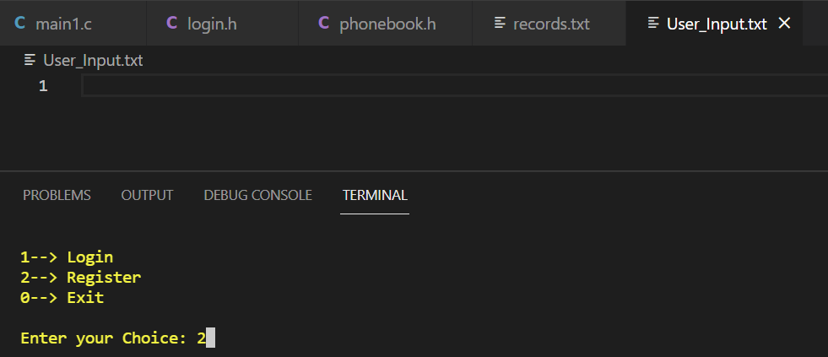To begin, the application displays three alternatives for you to choose from: login, register, or exit the program. Because you haven't registered your user name yet, choose option 2 and register your username and password.

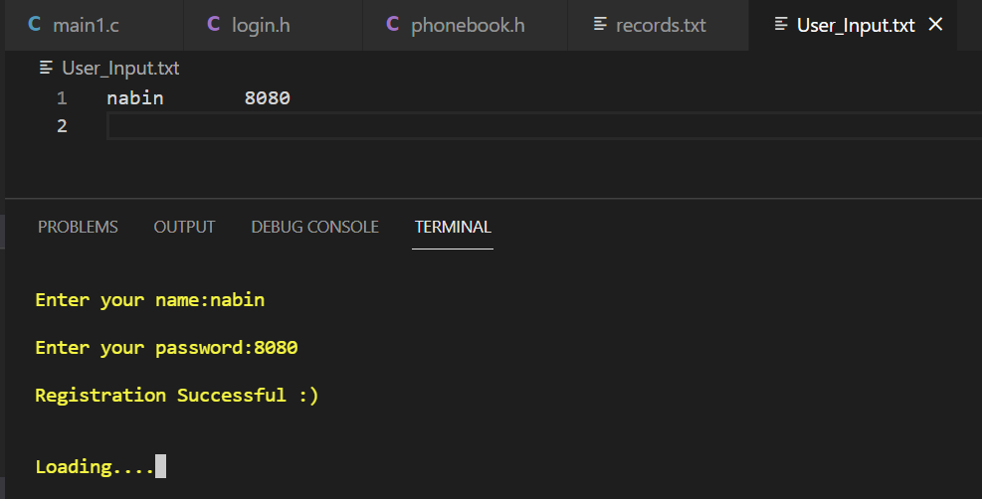You'll now be led to option ‘2', where you'll be requested to enter your name and password, as well as a valid input, and the program will save the data you've entered in the login system's database.

Since the system's database has your identity. You can now select option 1 and proceed to the login page, where you will input the same username and password, allowing you to continue with the program.

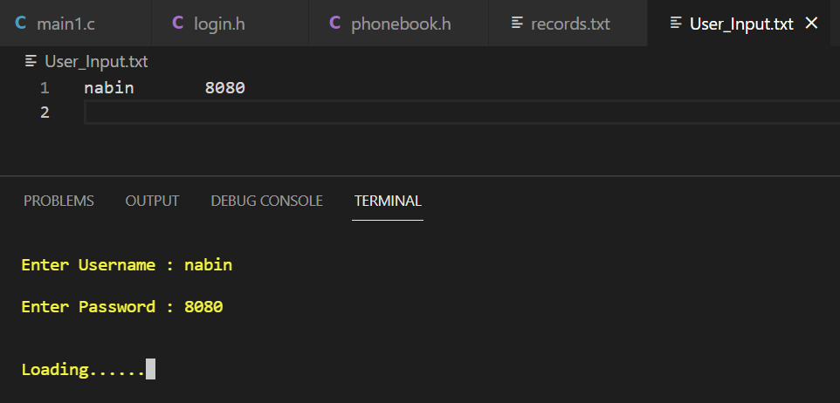

The system now double-checks the user name entered by the user to see if it exists in the database. If the user's name is found in the database, he or she is granted access to the "TELEPHONE DIRECTORY".

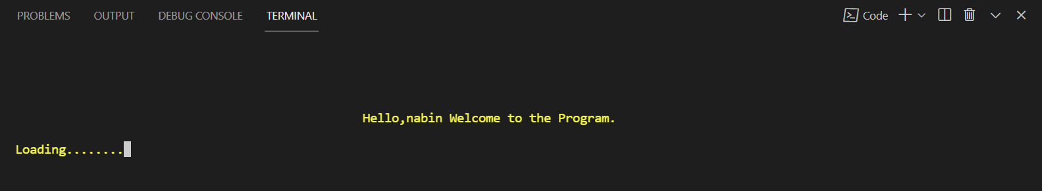

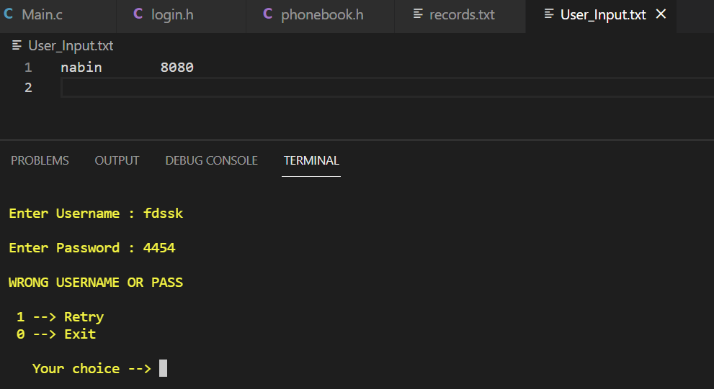If, instead of entering the same username and password as in the database, the user enters the wrong user name and password, an error notice appears with the choice to retry or exit.

Now that the login process has been completed, the main part of the Program will begin, which will allow the user to enjoy the various functions of the program.

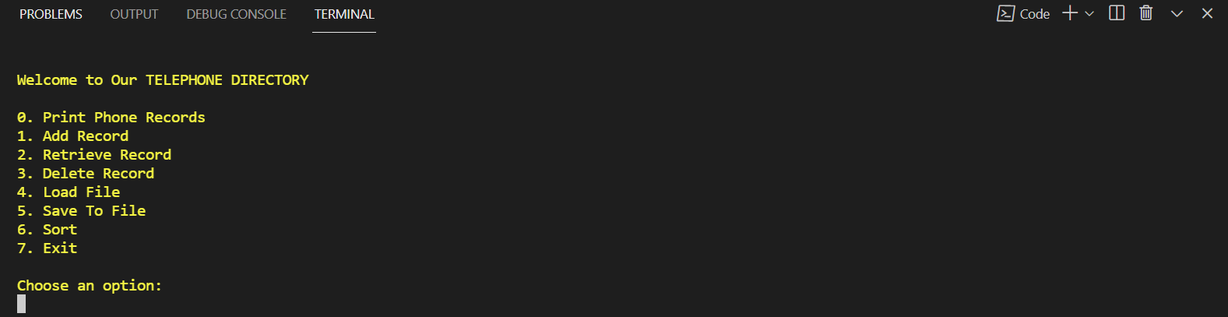 After completing the login part and gaining access to the telephone directory, the user is presented with a variety of options from which to choose.

Now, because the file is empty initially, if the user selects option 0 to print the record, nothing will appear because the file is blank.

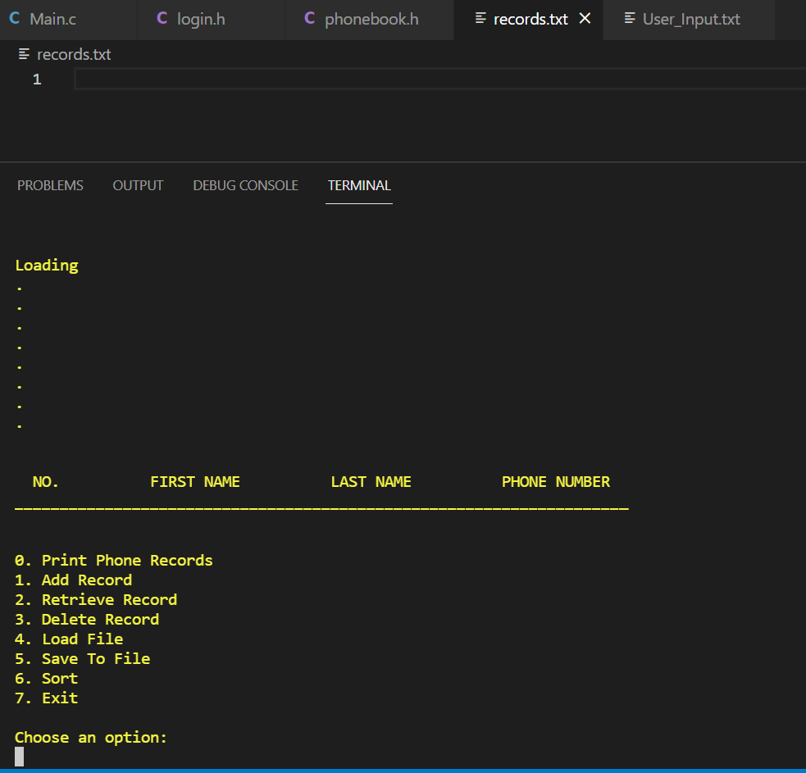

Now, a user can add data to the file by selecting the add option, which prompts the user to provide their first, last, and phone numbers.

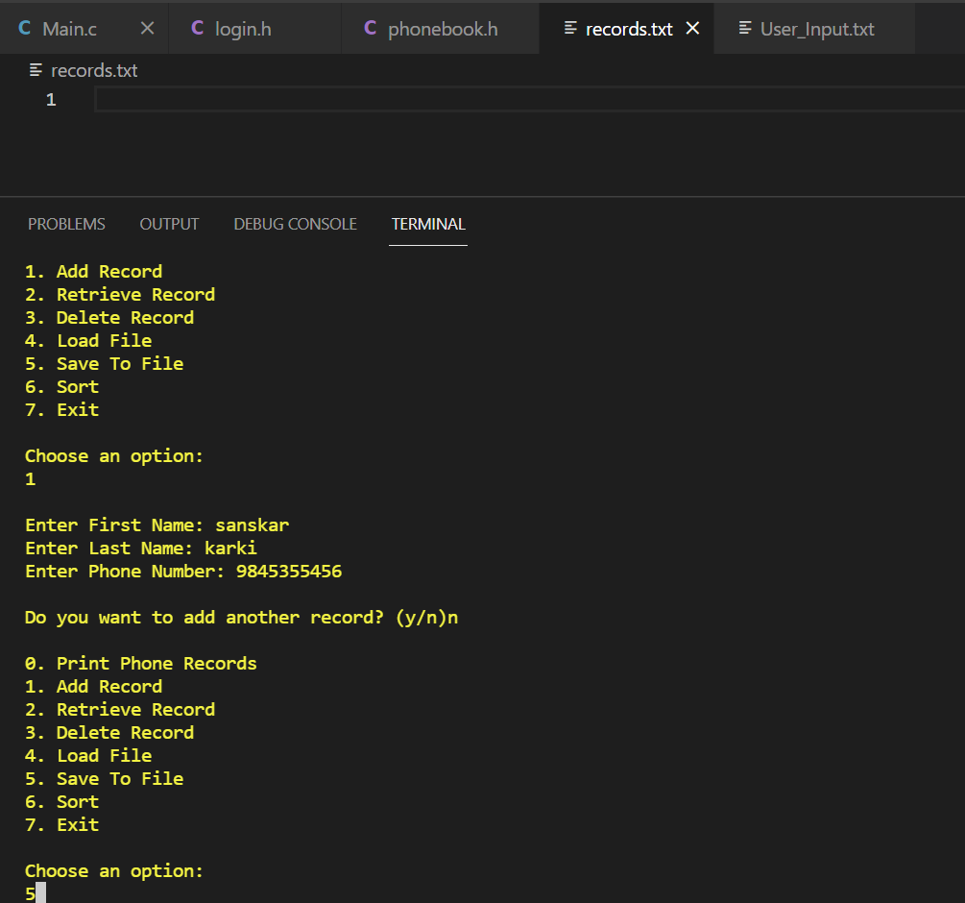

To save the data that the user has entered, the user should save it to a file using the save to file option, which pushes the data to the database and stores it.

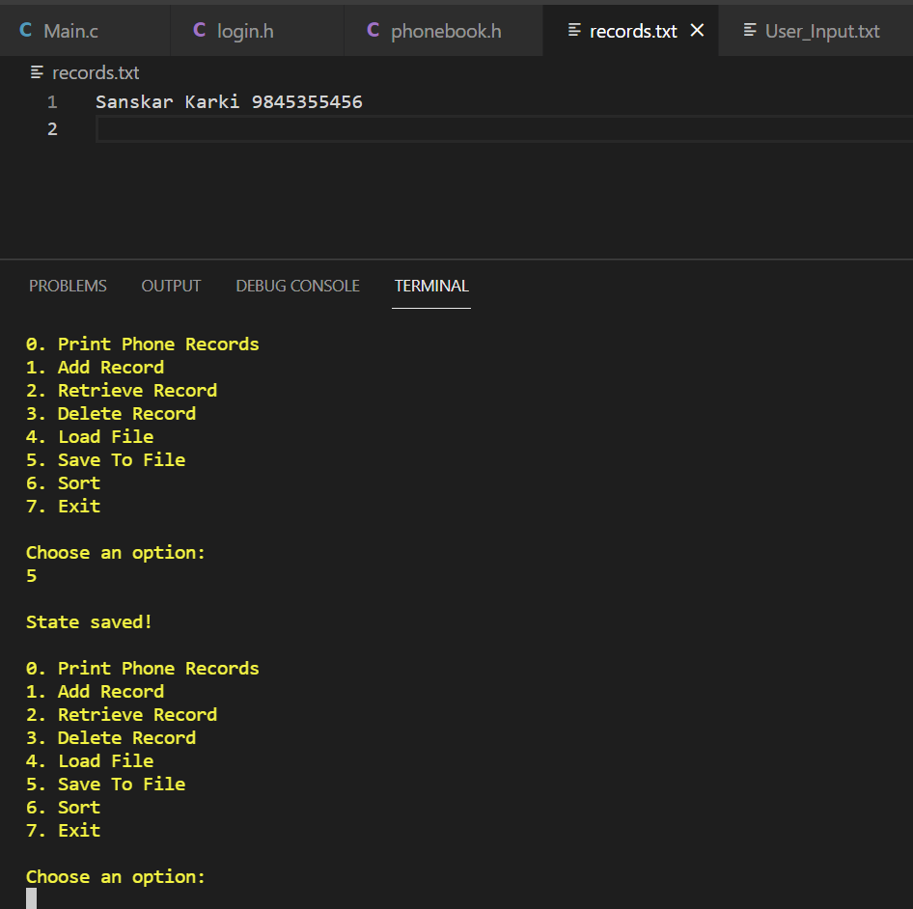

Following a series of multiple data entries. If a user wants to access some specific information, he or she can do so by selecting the search option and searching by first name, last name, or phone number.

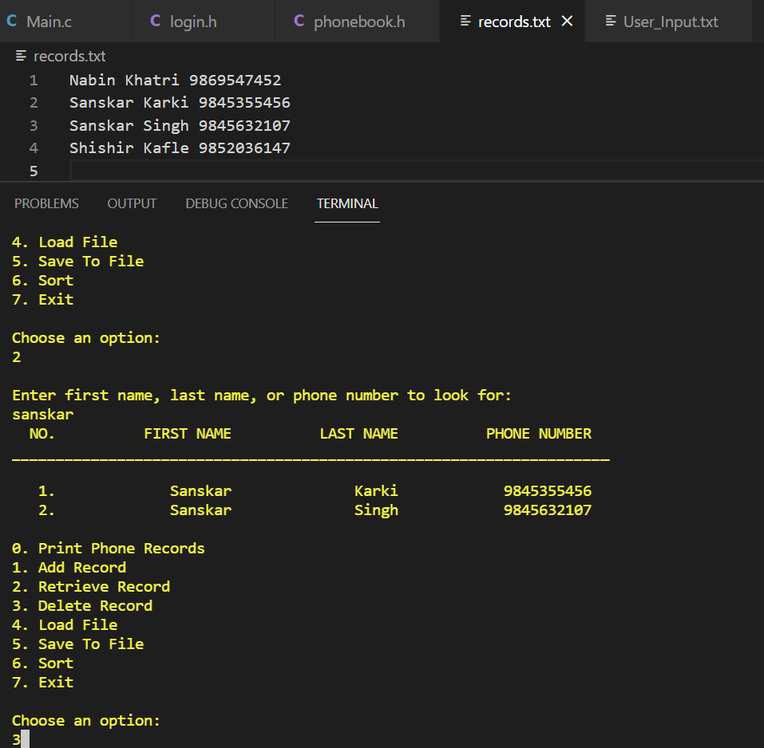

If the user wants to erase the data, he or she can do so now. The user must select the option to delete the record. Here, too the search feature is used and the user is asked to enter the first name, last name, or phone number of the data we want to remove.

When you search for data by first name or last name, if there are two people with the same name, it displays both of their records and asks which one you wish to delete. And the user can simply erase data by inputting the number in which it exists.

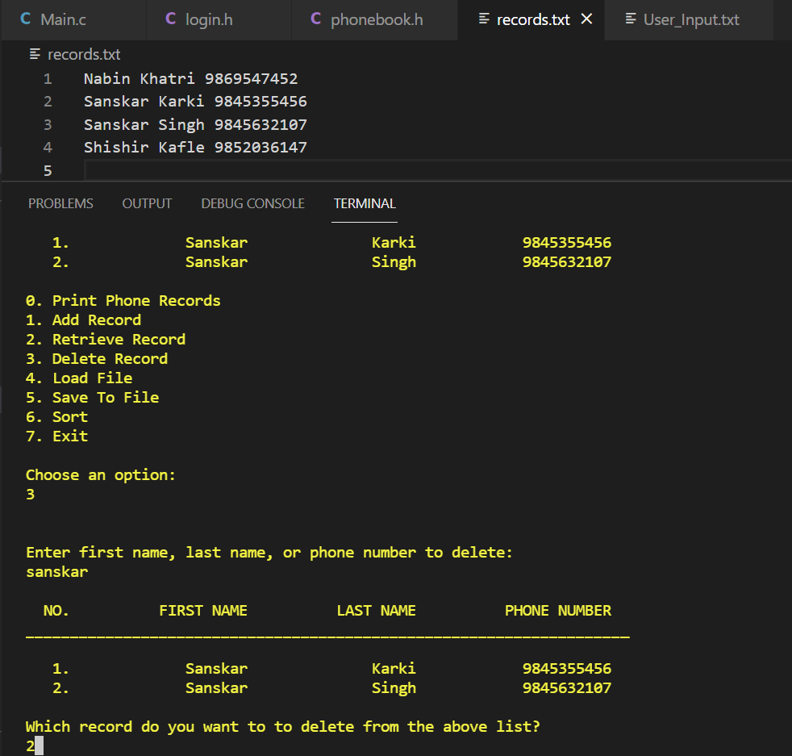

After the data has been deleted, the user can utilize the save to file feature to update the data in the database.

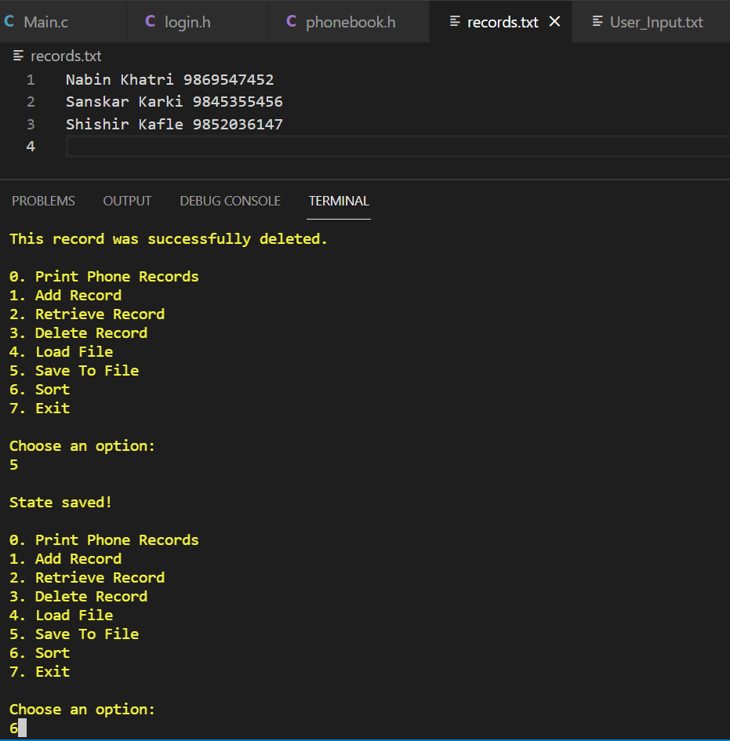

Another important aspect of the program is the user's ability to sort the data in the datable. The data can be sorted using three distinct methods: first name, last name, and phone number.

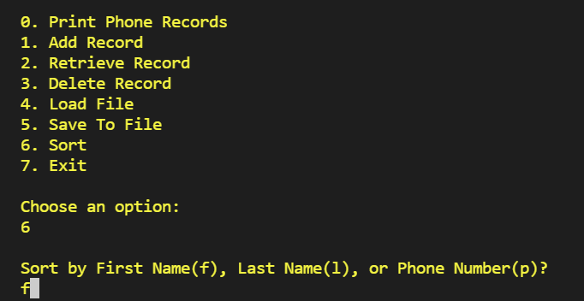

The following is how the data would be sorted if it were sorted by first name:

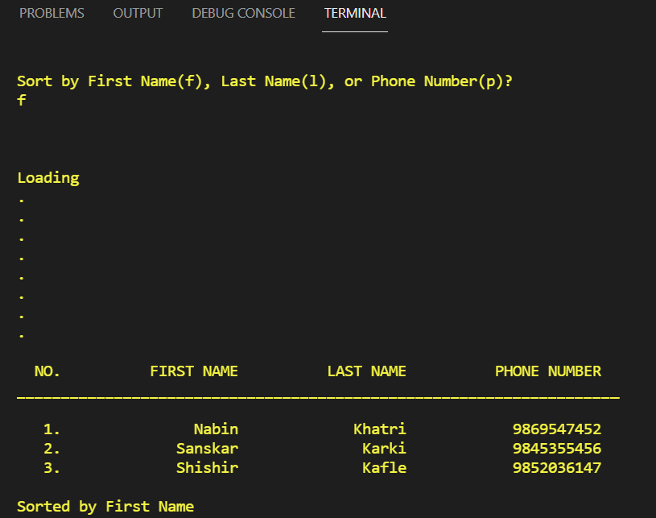

The following is how the data would be sorted if it were sorted by last name:

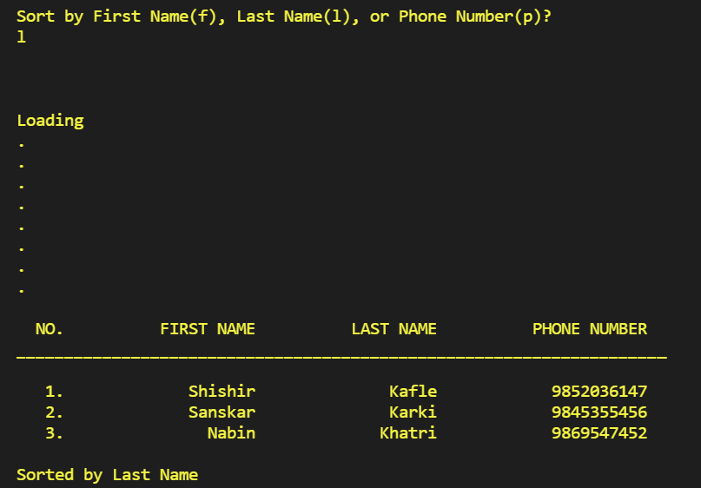

The following is how the data would be sorted if it were sorted by number:

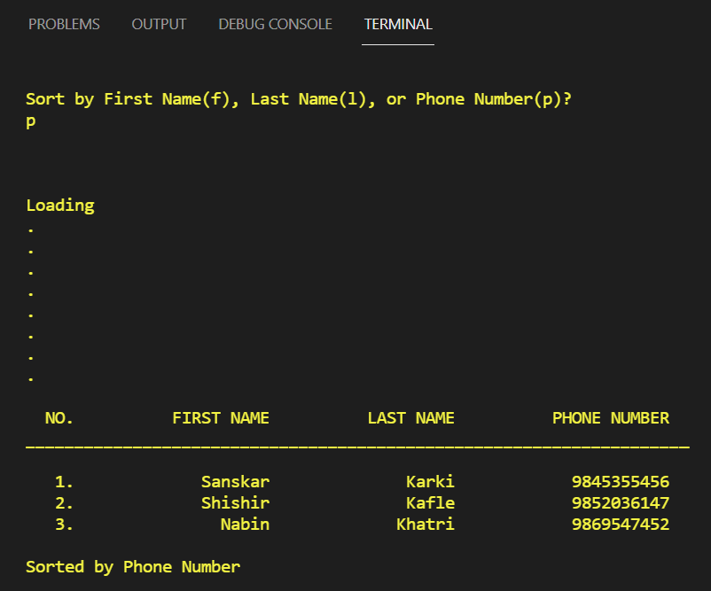

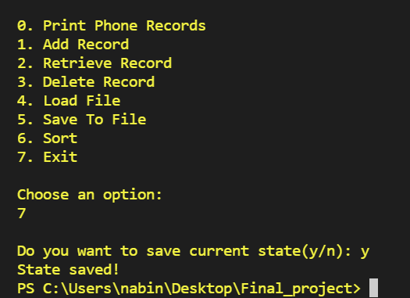Finally, if the user wants to exit the program, he or she can do so by selecting the exit option, which asks whether the user wants to save the last data or not. If the user selects ‘y’, the data is saved; if the user selects ‘n’, the modification made while the user was using the program is not saved.

# Refrence

[1] <https://stackoverflow.com/>

[2] <https://www.w3schools.com/>

[3] <https://www.javatpoint.com/c-string-functions>

[4] <https://www.quora.com/>

[5] <https://www.programiz.com/c-programming/c-structures-pointers>

[6] <https://www.flaticon.com/>