DEPARTMENT OF COMPUTER SCIENCE & ENGINEERING

KATHMANDU UNIVERSITY

ENGG 111: MINI-PROJECT



Department of Computer Science School of Science,

Kathmandu University

STATICS - Engineering Mechanics

Submitted to: Saroj Gautam

ENGG 111, Lecturer

Kathmandu University

Submitted by: Sanskar Karki

Roll No: 25

Group: CS (1’st Semester)

Date:10/07/2021

Table of Content

Table of Content 2

ABSTRACT 3

INTRODUCTION 4

OBJECTIVES 4

Reference case: 6

Solution of three Cases 7

* Case I: 7
* Case II: 9
* CASE III: 12
* Condition I: 13
* Condition II: 13

FLOWCHART AND ALGORITHM: 15

EXPECTED OUTCOME: 20

REFERENCE: 21

# ABSTRACT

Hydraulic crane is a of heavy-duty equipment, used for raising or transferring heavy loads. Cranes do play the most vital role in the manufacturing industries. This project explores different force components and mechanism acting on the crane. Here, we consider the crane to be in static equilibrium state so that we can apply the fundamental equilibrium equations to solve the force components. Different conditions are taken to solve desired unknown forces or inclination of the crane. The problems are solved, manually and also by making a c program. In both instances the solution to the condition found to be similar. In implication, when we take less inclination the radius of the crane increases due to which the load capacity of the crane decreases. And we take more inclination the radius of the crane decreases due to which the load capacity of the crane increases. This explains the physics behind the change in load capacity due to change in reaction force of the Hydraulic Cylinder and the radius of the boom.

# INTRODUCTION

A hydraulic crane is a type of heavy-duty equipment used for lifting and hoisting. Unlike smaller cranes, which rely on electric or diesel-powered motors, hydraulic cranes include an internal hydraulic system that allows the crane to lift heavier loads. The purpose of hydraulic cranes is to stay stable whilst lifting heavy weights. Although cranes have been used throughout the history of construction engineering, hydraulic cranes use a more technical design.

Source: https://pngwing.com

It depends on three separate parts when lifting incredibly heavy loads: the hydraulic cylinder, the pulley and the lever. The latter is a horizontal beam that takes on the task of the fulcrum. When a heavy object is loaded, an amount of force is applied at the other end, and in the other direction.

Known also as the jib, the pulley is a strut tilted to support a pulley block. The fixed block is wrapped with several layers of cable that is then pulled by machine or by hand. This can then create a force that is equal to the weight of the load. The hydraulic cylinder is then used to lift the load.

This paper studies a numerical problem of Statics from Engineering Mechanics which deals the application of hydraulic crane on lifting load and use of hydraulic cylinder in the process.

# OBJECTIVES

* To determine the reaction force of hydraulic cylinder which withstands and maintains inclination of boom of the crane.
* To determine the reaction force of the crane body.
* To compare the different reaction force of hydraulic cylinder while changing the inclination of the Boom of the crane
* To make a c-program that lets the user to generate different conditions possible for the numerical.
* To compare the calculated solutions with the solutions that c program provides.

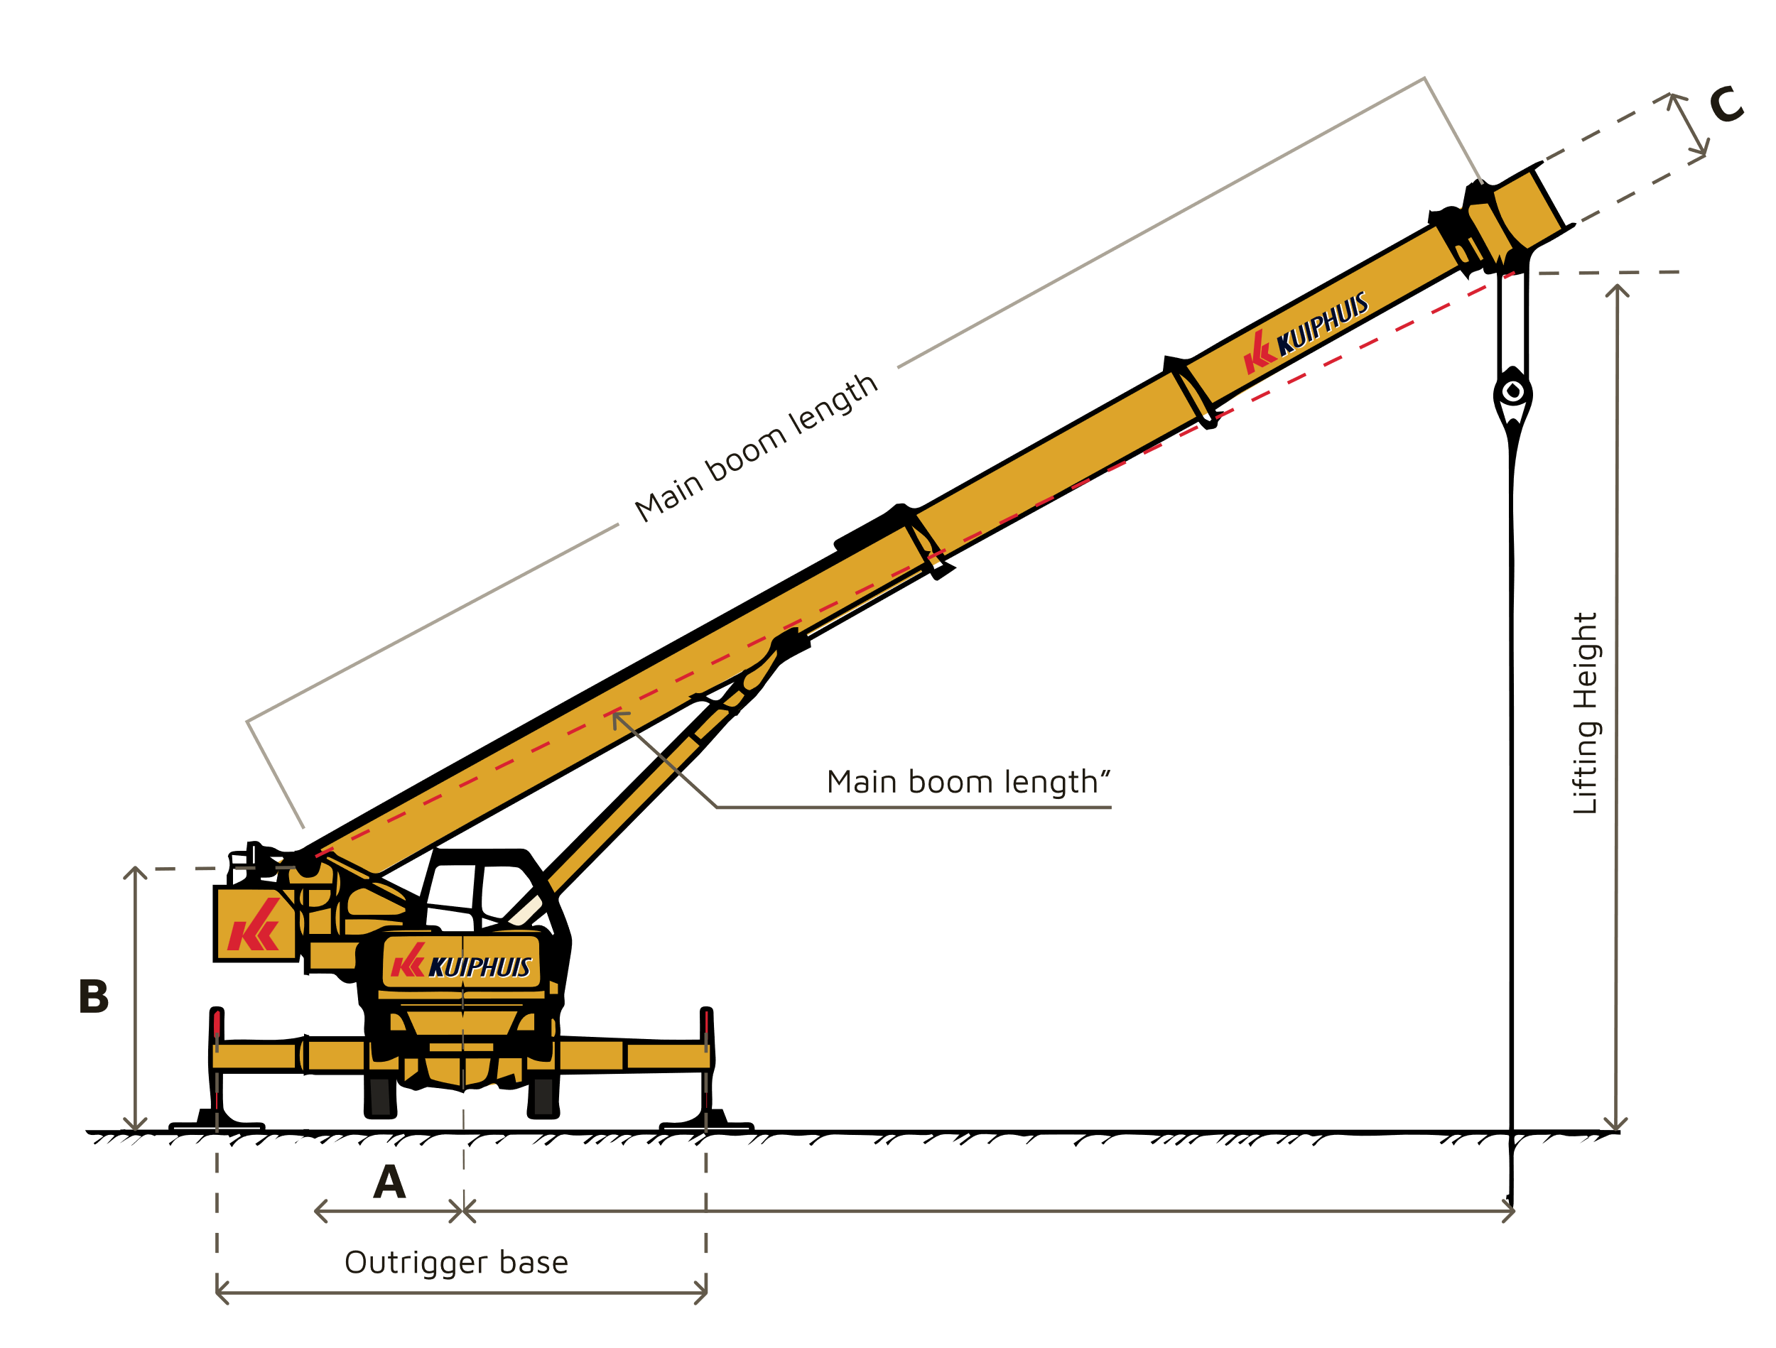

Source: https://www.cleanpng.com/

BOOM OF CRANE

LOAD

**P**

**N**

**S**

**MAJOR TERMS TO KNOW:**

PIVOT OF BOOM

RADIUS OF BOOM

HYDRAULIC CYLINDER

The point which I have marked with yellow boxes are important to know before solving the numerical.

*NOTE: All the numerical that I will be doing, I will only take 4 digits after the decimal. So that there will be some difference in calculation doing it manually and doing it in c-program, I will Take all the decimal digits while performing from c program and will observe the difference in answer*.

# Reference case:

In the given figure of Boom (SN) of the crane. The reaction force of the hydraulic cylinder is unknown. Using the information given in the figure. Find the reaction of the hydraulic cylinder FR. Assume $α$ to be between (20-25) $θ$ to be 45‘.

**N**

FLCos $θ$

$$θ$$

FLSin $θ$

DL=35ft

FL

500kg

**B**

FBCos $θ$

$$θ$$

DA=1.5ft

DB=16ft

20,000 N

FBSin $θ$

DH=10ft

FB

FHCos $(90-α-θ)$

FHSin $(90-α-θ)$

$$90-α-θ$$

X

Y

$$θ$$

$α$

\

**S**

**P**

FH

Radius of Boom

# Solution of three Cases

## Case I:

For Case I, I will be taking the same case given in the Original Question.

Solution:

Given Data in the Figure,

Let us consider,

Point ‘B ’to be Center of gravity of the Boom (SN) and,

Point ‘P’ to be the pivot Where the body of the crane give the reaction force.

$$θ be the Angle between horizontal and the Boom.$$

$α be the angle between Fh and the axis perpendicular to the hozontal surface$.

FH be the reaction force of the hydraulic cylinder to the boom.

FL be the force of the given load.

FB be the Center of gravity of Boom.

Here,

FLCos $θ and$ FLSin $θ$ are the vertical and horizontal components of the load FL.

FBCos $θ and$ FBSin $θ$ are the vertical and horizontal components of Center of gravity of Boom FB.

FHSin $(90-α-θ)$ and FHCos $(90-α-θ)$ are the vertical and horizontal components of the force of Hydraulic Cylinder.

Also,

DL=35ft=10.6688m, DB=16ft=4.8768m, DH=10ft= 3.0488m, DA=1.5ft =0.4572m

FL=mass*g=500kg*10=5,000N

$θ={45}^{'}$

$α=22'$

Here, the main thing to notice is that the component FLCos $θ$ and FBCos $θ$ accts downward resulting a clockwise torque which means it gives negative torque but the component FHSin $(90-α-θ)$ and FHCos $(90-α-θ)$ give anticlockwise torque which means it gives positive torque.

Also, one thing to know is that the FHCos $(90-α-θ)$ component is producing torque only because it is 1.5ft apart from the axis of boom had it been at the axis of the beam it would not have produced any kind of torque

Now, since the system is in Equilibrium, we can use balance Equation.

So, the net Torque i.e., $∑$ τ=0,

Then,

$∑$ τ=0

Or, -FLCos $θ$*DL-FBCos $θ$*DB+FHSin $(90-α-θ)$*DH+FHCos $(90-α-θ)$*DA=0

Or, -5000*cos (45’) *10.6688-20,000*cos (45’) *4.8768+FHSin (90-22-45) *3.0488+ FHCos (90-22-45) *0.4572=0

Or, -37719.9041-68968.3670+FH 1.1912+ FH 0.4208=0

Or,106688.2711= FH1.6120

Or, FH=106688.2711/1.6120

Or, FH=66183.7910N

Therefore, The Reaction force on the Hydraulic is found to be 66183.7910N or 66.1837KN.

Now, we have come up with a formula though which we can directly find FH .

FH=

## Case II:

Here, we try to find reaction that the base of the crane gives to the pivot(P) of the Boom (SN) while it is at angle of, assume $θ={60}^{'},α=15'$.

**N**

FLCos $θ$

$$θ$$

FLSin $θ$

DL=35ft

FL

500kg

**B**

FBCos $θ$

$$θ$$

DA=1.5ft

DB=16ft

20,000 N

FBSin $θ$

DH=10ft

FB

FHCos $(90-α-θ)$

FRy

FHSin $(90-α-θ)$

$$90-α-θ$$

X

Y

$$θ$$

**S**

$α$

\

FR

**P**

FH

=60’

Radius of Boom

FRx

Now, to find reaction force of hydraulic cylinder in this case we can directly apply our formula that we found in case I.

FR be the reaction force of the crane’s body to pivot joint.

We Know,

FH=

FH=

FH=

FH=

FH=

Therefore, the reaction force given by the Hydraulic cylinder in this case is $61303.4292N$ or $61.3034KN$.

Now let’s see the forces that are acting in x-components. Also let’s take FRx to be positive and later on we can see whether the direction that we have assumed is right or wrong.

So,

$∑$ x=0

Or, FRx+ FHCos $(90-α-θ)$- $FbSin\left(θ \right)$- $FL\operatorname{Sin}\left(θ \right)$ =0

Or, FRx+*Cos (15)-20,000Sin (60)-5000*Sin (60) =0

Or, FRx+59214.5655-17320.5080-4340.1270=0

Or, FRx=-37553.9305N

Therefore, the x-component of the reaction force of the crane body to the Boom is -37553.9305N.

This shows that the direction that we have taken is wrong and we need to point the FRx towards negative x-axis while assuming to get the positive value. But it doesn’t cause any change in the magnitude of FRx.

Now let’s see the forces that are acting in y-components. Also let’s take FRy to be positive and later on we can see whether the direction that we have assumed is right or wrong.

So,

$∑$ y=0

Or, FRy+ FHSin $(90-α-θ)$- $FbCos\left(θ \right)$- $FL\operatorname{Cos}\left(θ \right)$ =0

Or, FRy=20,000 $Cos\left(60\right)$*+5000*Cos (60) - $61303.4292*$ Sin (15)

Or, FRy=10000+2500+15866.49501

Or, FRy=-3366.4950N

Therefore, the y-component of the reaction force of the crane body to the Boom is -3366.4950N or -3.3664KN.

This shows that the direction that we have taken is wrong and we need to point the FRy towards negative y-axis while assuming to get the positive value. But it doesn’t cause any change in the magnitude of FRy.

Now by using Pythagoras’s theorem,

B

FR

FR=

FRx=37553.9305N

A

FR=2

FRy=3366.4950N

FR=37704.5250N

C

Therefore, the reaction force that the body of the crane give to the pivot of Boom is 37704.5250N or 37.7045KN

## CASE III:

Here, we find how reaction force of hydraulic cylinder changes while the crane lifting the

same Load changes the inclination from angle 70’ to angle15’.

Solution:

Given,

Load to lift is FL= 6500N.

Here, FB=22,500N

First Condition: $θ=15'$, $α=60'$

Now, we can use the equilibrium condition formula to find FH,

FH=

FH=

FH=

FH=

FH=132185.9996N

Second Condition: $θ=70'$, $α=5'$

Now, while the crane is at angle 75’ the FH becomes,

FH=

FH=

FH=

FH=44494.4707N

So,

Difference of Force in two conditions is,

F= FH at angle 15’- FH at angle 75’

F= 132185.9996-44494.4707

F=87691.5289N.

What did I find taking these two conditions?

### Condition I:

While the boom of the crane is at angle 15’ the radius of the crane is more, also at 15’ the reaction force to the hydraulic cylinder is very larger that is to say if we increase more load the force on hydraulics increases and at some point, it can’t handle it and the hydraulic cylinder failure can be seen for that crane can’t lift heavy loads at this inclination.

So, when we take less inclination the radius of the crane increases due to which the load capacity of the crane decreases.

### Condition II:

While the boom of the crane is at angle 70’ the radius of the crane is less in comparison to while it was in 15’ inclination, and also at 70’ the reaction force to the hydraulic cylinder is comparatively less which says that we can lift heavy load at this angle without having failure in the hydraulic system of the crane.

Here what we can conclude is that when we take more inclination the radius of the crane decreases due to which the load capacity of the crane increases.

This is exactly seen in the load chart of the crane which proves that we are going through a right approach.

*Also, Load Chart is shown in next page though which we can see the change in load capacity of the crane while the inclination of the crane changes.*

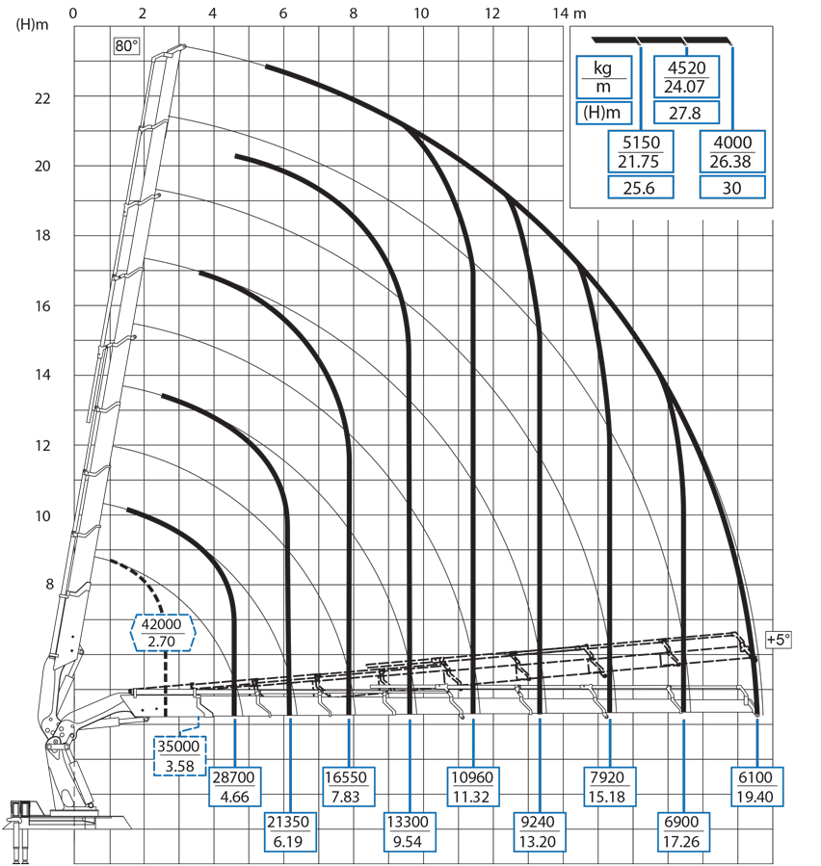

LOAD CHART

Source: https://giuffre.com/

RADIUS OF BOOM

Thus, when inclination increases the radius of Boom decreases, resulting the increase in Load Capacity.

# FLOWCHART AND ALGORITHM:

Note*: I have included 1main flowchart with 3 separate flowchart and algorithm for 3 different cases which will be programmed and complied in a single file in my final C-program file.*

Calculate FH, FR, FRx, FRy

Again?

Yes

No

CASE I:

This is the reference case where the reaction force of the hydraulic cylinder is found.

FH=

ALGORITHM:

*Step 1: Start.*

*Step 2: Enter Angles, Forces and Distance.*

*Step 3: Calculate DB*FB Cos (θ), DL*FL Sin (θ), DA*Cos(90-α-θ), DH*Sin(90-α-θ).*

*Step 4: Calculate FH=*

*Step 5: Print FH.*

*Step 6: Stop.*

CASE II:

Here, in this case, we find the reaction force of the crane body to the pivot of the boom.

FH=

FRy+ FHSin $(90-α-θ)$- $FbCos\left(θ \right)$- $FL\operatorname{Cos}\left(θ \right)$ =0

FRx+ FHCos $(90-α-θ)$- $FbSin\left(θ \right)$- $FL\operatorname{Sin}\left(θ \right)$ =0

FR=

ALGORITHM:

*Step 1: Start.*

*Step 2: Enter Angles, Forces and Distance.*

*Step 3: Calculate DB*FB Cos (θ), DL*FL Sin (θ), DA*Cos(90-α-θ), DH*Sin(90-α-θ).*

*Step 4: Calculate FH=*

*Step 5: Calculate FRx+ FHCos $(90-α-θ)$- $FbSin\left(θ \right)$- $FL\operatorname{Sin}\left(θ \right)$ =0.*

*Step 6: Calculate FRy+ FHSin $(90-α-θ)$- $FbCos\left(θ \right)$- $FL\operatorname{Cos}\left(θ \right)$ =0.*

*Step 7: Calculate FR=.*

*Step 8: STOP.*

CASE III:

NOTE: Similar to case I we find the FH i.e., reaction force on hydraulic cylinder but here, we Find two or more different values of FH by changing the inclination of the boom of the crane ($α and θ$) so that we can compare the difference of FH while changing inclination.

INPUT

DB*FB Cos (θ)

DA*Cos(90-α-θ)

DL*FL Sin (θ)

DH*Sin(90-α-θ)

FH=

**AGAIN?**

YES

NO

ALGORITHM:

*Step 1: Start.*

*Step 2: Enter Angles, Forces and Distance.*

*Step 3: Calculate DB*FB Cos (θ), DL*FL Sin (θ), DA*Cos(90-α-θ), DH*Sin(90-α-θ).*

*Step 4: Calculate FH=*

*Step 5: Print FH.*

*Step 6: Go to Step 2:*

*Step 7: Compare Different values of FH.*

*Step 8: Stop.*

Here, we obtain different values of FH by giving multiple inputs of the inclination of the boom of the crane. Then, we compare the forces and observes the changing behavior of the force while the angle changes.

# EXPECTED OUTCOME:

The project was carried out to determine the reaction force of the hydraulic cylinder, reaction force of the crane body and to compare the different reaction force of hydraulic cylinder while changing the inclination of the boom of the crane.

Initially, what I had expected was, for a particular load a crane could easily lift till some inclination but hardly increase the inclination further. In fact, it was observed that the crane lifts heavier load when the inclination of the crane increase, this was due to the increase in radius of the Boom of the crane and decrease in Reaction Force of the Hydraulic Cylinder.

Later, I came to know the physics behind the change of load capacity is caused due to change in reaction force of the Hydraulic Cylinder and the radius of the boom.

# REFERENCE:

[1] [Fundamentals of Crane Hydraulics | CD Industrial Group Inc. (cdiginc.com)](https://www.cdiginc.com/courses/fundamentals-of-crane-hydraulics)

[2] https://science.howstuffworks.com/transport/engines-equipment/hydraulic-crane.htm

[3]<https://youtu.be/CSpcAdPF-E4>