* + 1. **Demonstrate a neural network using Phyton to solve problem of image classification**

An image transmission system (coded by 45 bits) sends images via a communication link. When arriving at the reception system, the information is decoded in order to recover, accurately, the image previously sent. The four images (information) transmitted are represented in the following Fig.1.

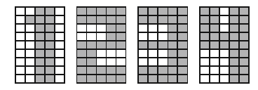

|  |  |  |  |  |
| --- | --- | --- | --- | --- |
| -1 | -1 | 1 | 1 | -1 |
| -1 | 1 | 1 | 1 | -1 |
| -1 | -1 | 1 | 1 | -1 |
| -1 | -1 | 1 | 1 | -1 |
| -1 | -1 | 1 | 1 | -1 |
| -1 | -1 | 1 | 1 | -1 |
| -1 | -1 | 1 | 1 | -1 |
| -1 | -1 | 1 | 1 | -1 |
| -1 | -1 | 1 | 1 | -1 |

|  |  |  |  |  |
| --- | --- | --- | --- | --- |
| 1 | 1 | 1 | 1 | 1 |
| 1 | 1 | 1 | 1 | 1 |
| -1 | -1 | -1 | 1 | 1 |
| -1 | -1 | -1 | 1 | 1 |
| 1 | 1 | 1 | 1 | 1 |
| -1 | -1 | -1 | 1 | 1 |
| -1 | -1 | -1 | 1 | 1 |
| 1 | 1 | 1 | 1 | 1 |
| 1 | 1 | 1 | 1 | 1 |

|  |  |  |  |  |
| --- | --- | --- | --- | --- |
| 1 | 1 | 1 | 1 | 1 |
| 1 | 1 | 1 | 1 | 1 |
| -1 | -1 | -1 | 1 | 1 |
| -1 | -1 | -1 | 1 | 1 |
| 1 | 1 | 1 | 1 | 1 |
| 1 | 1 | -1 | -1 | -1 |
| 1 | 1 | -1 | -1 | -1 |
| 1 | 1 | 1 | 1 | 1 |
| 1 | 1 | 1 | 1 | 1 |

|  |  |  |  |  |
| --- | --- | --- | --- | --- |
| 1 | 1 | -1 | 1 | 1 |
| 1 | 1 | -1 | 1 | 1 |
| 1 | 1 | -1 | 1 | 1 |
| 1 | 1 | 1 | 1 | 1 |
| 1 | 1 | 1 | 1 | 1 |
| -1 | -1 | -1 | 1 | 1 |
| -1 | -1 | -1 | 1 | 1 |
| -1 | -1 | -1 | 1 | 1 |
| -1 | -1 | -1 | 1 | 1 |

Fig.1 Image by the transmitter

During the transmission over the communication link, the images are corrupted by noise, and when decoded by the reception system, become incomplete or distorted representations of the image. To solve this problem, an associative memory is implemented through a Hopfield network, which consists of 45 neurons, to store and recover the images (patterns) defined in Fig. 1. Therefore, consider the following conventions:

* + White pixel is encoded with value −1.
  + Dark pixel is encoded with value +1.
  + About 20 % of the pixels are randomly corrupted during transmission, i.e., some values −1 becomes +1 and vice versa.
  + The weight matrix W is defined by the outer product method.

The activation function used in all neurons is the signal function, or the hyperbolic tangent function, with the slope parameter {b} equal to 100. After the computational implementation of the Hopfield network is finished, do the following exercises.

1. Simulate 12 transmission situations (3 for each pattern) as the illustrative scheme shown in Fig. 2.

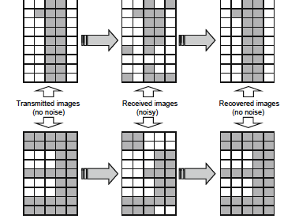

Fig. 2: Illustrative scheme of the transmitted, received and recovered images

2. Show the distorted image and the recovered clean image in every situation.

3. Explain what happens when the noise level is increased in an extreme way.