USER MANUAL

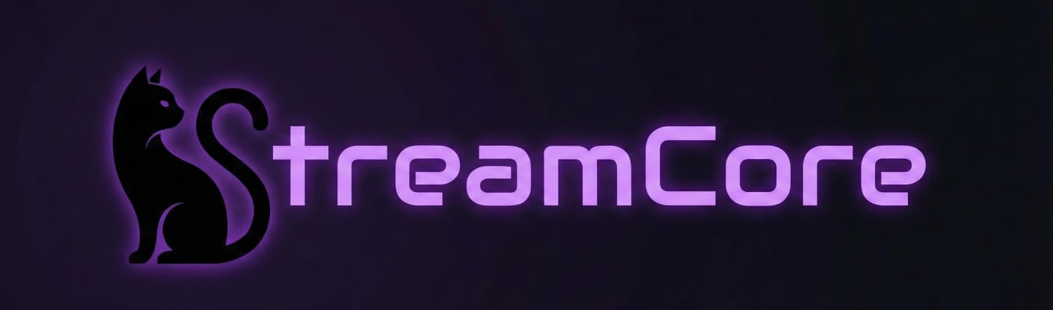

ENGLISH
ÍNDICE

GET STARTED 3
CONNECTIONS 4
DASHBOARD 8
COMMANDS 9
TEXT-TO-SPEECH 11
ASSISTANCES 12

GET STARTED
StreamCore is a desktop solution designed specifically for growing content creators seeking an efficient, lightweight, and centralized tool to manage audience interaction in real-time. Its goal is to simplify chat management without consuming unnecessary system resources.
StreamCore stands out for its absolute commitment to user privacy. Under a "Zero Data" philosophy, the application operates 100% locally on your machine:
- No Telemetry: We do not collect usage data or hidden statistics.
- No External Servers: We do not rely on a cloud database; all your configuration is stored locally on your own computer.
- Secure Authentication: We utilize official protocols (OAuth) for Twitch and Kick, ensuring that your credentials are never exposed or shared.
The program adapts its functionality based on the connected platforms, offering three main tools to enhance your stream:
- Chat Commands: Allows you to create and manage custom commands (e.g., !socials, !discord) with dynamic responses. It includes advanced features such as death/win counters, automatic timers, and permission restrictions based on roles (VIP, Moderator, Subscriber).
- Text-to-Speech (TTS): A real-time voice message reading system. It runs in the background triggered by a command (for example, !s), featuring speed control, profanity filters, and a smart queue to ensure no message is ever missed.
- Attendance Control: An automated tool designed to build audience loyalty. It allows users to register their daily presence via a command (e.g., !present), saving a local history that the streamer can view, edit, and export to Excel/CSV for analysis or giveaways.

CONNECTIONS
To start using StreamCore, it is necessary to link your streaming platform accounts (Twitch and/or Kick). The application uses the standard OAuth protocol, ensuring a secure connection without the need to store your passwords locally.
- Navigate to the Configuration section in the sidebar menu.
- In the "Platform Connections" panel, select the "Access" button for the desired platform.
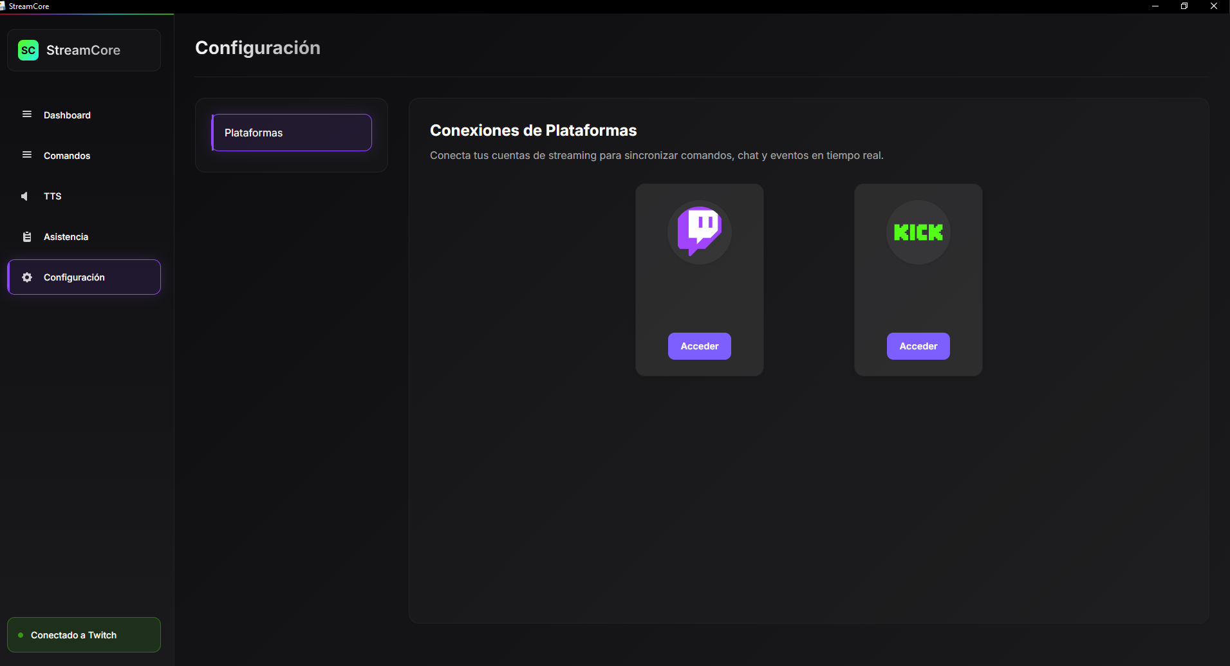

Security Note: When connecting for the first time, Windows Firewall may request network permissions for streamcore.exe. It is essential to allow access so the application can communicate with chat and event servers.
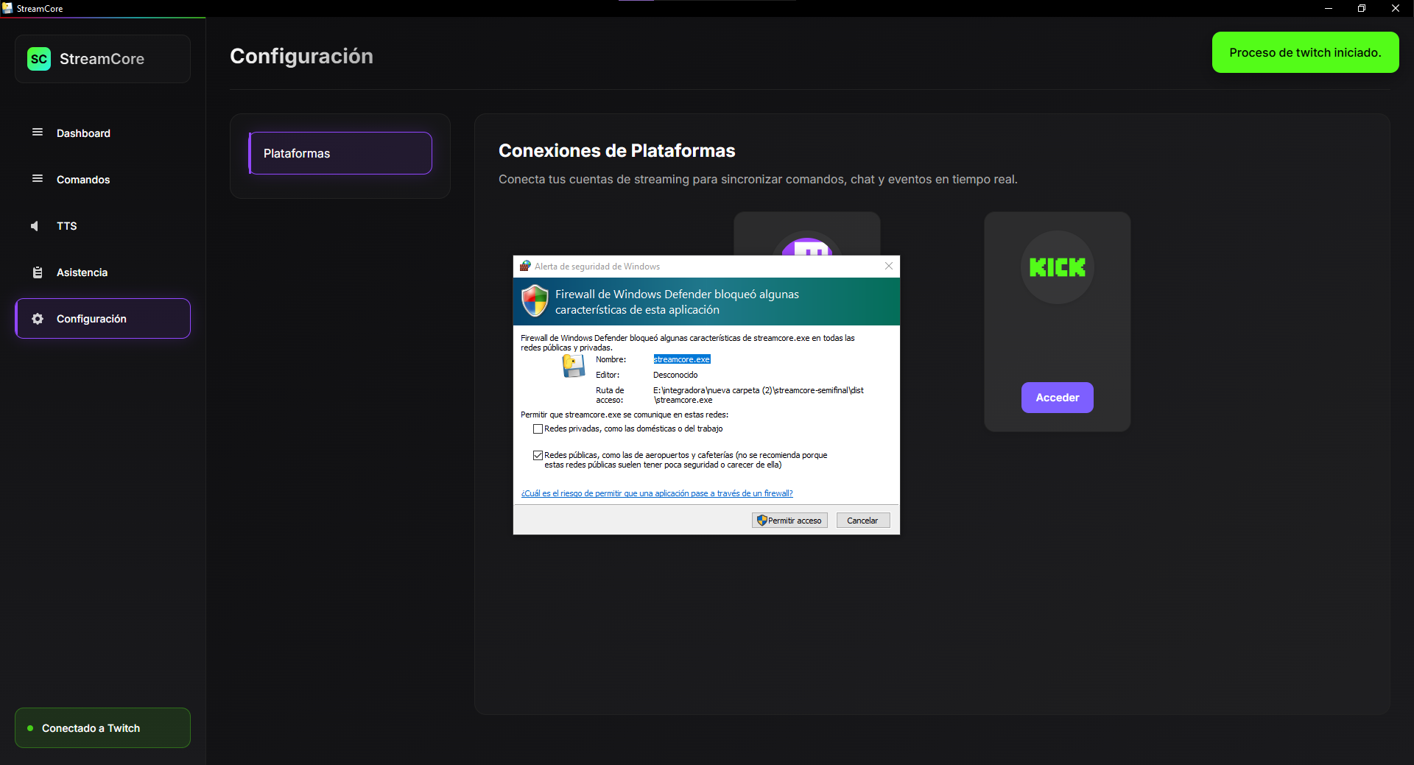

Authorization: A window will open in your default browser requesting the necessary permissions to read chat and send messages. Click "Authorize" or "Allow access" to complete the linking process.
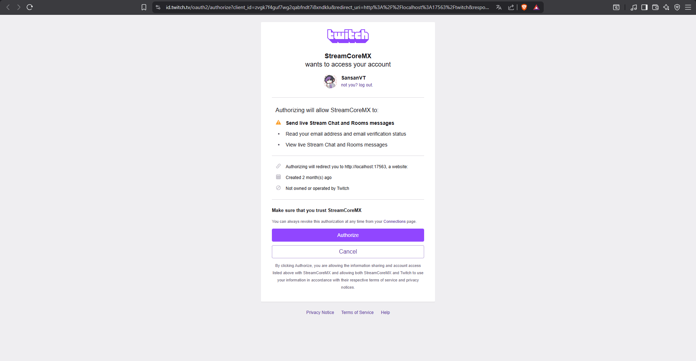
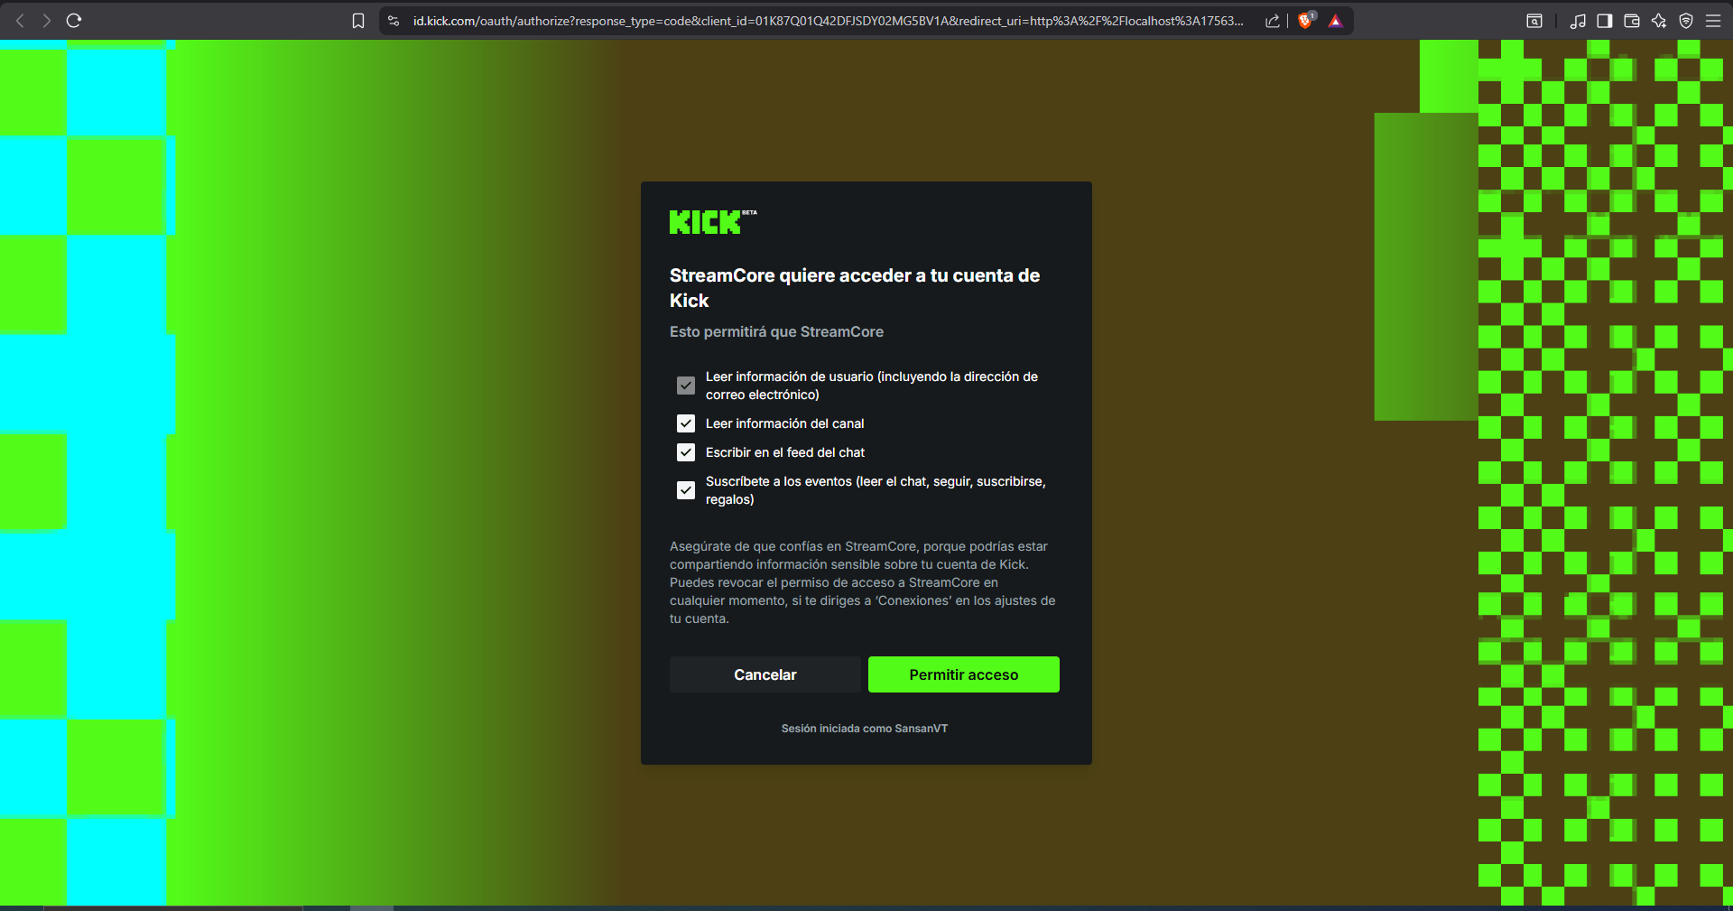

Once linked, the panel will display your active profile. If you wish to log out or switch accounts, you can do so securely using the "Log Out" button.
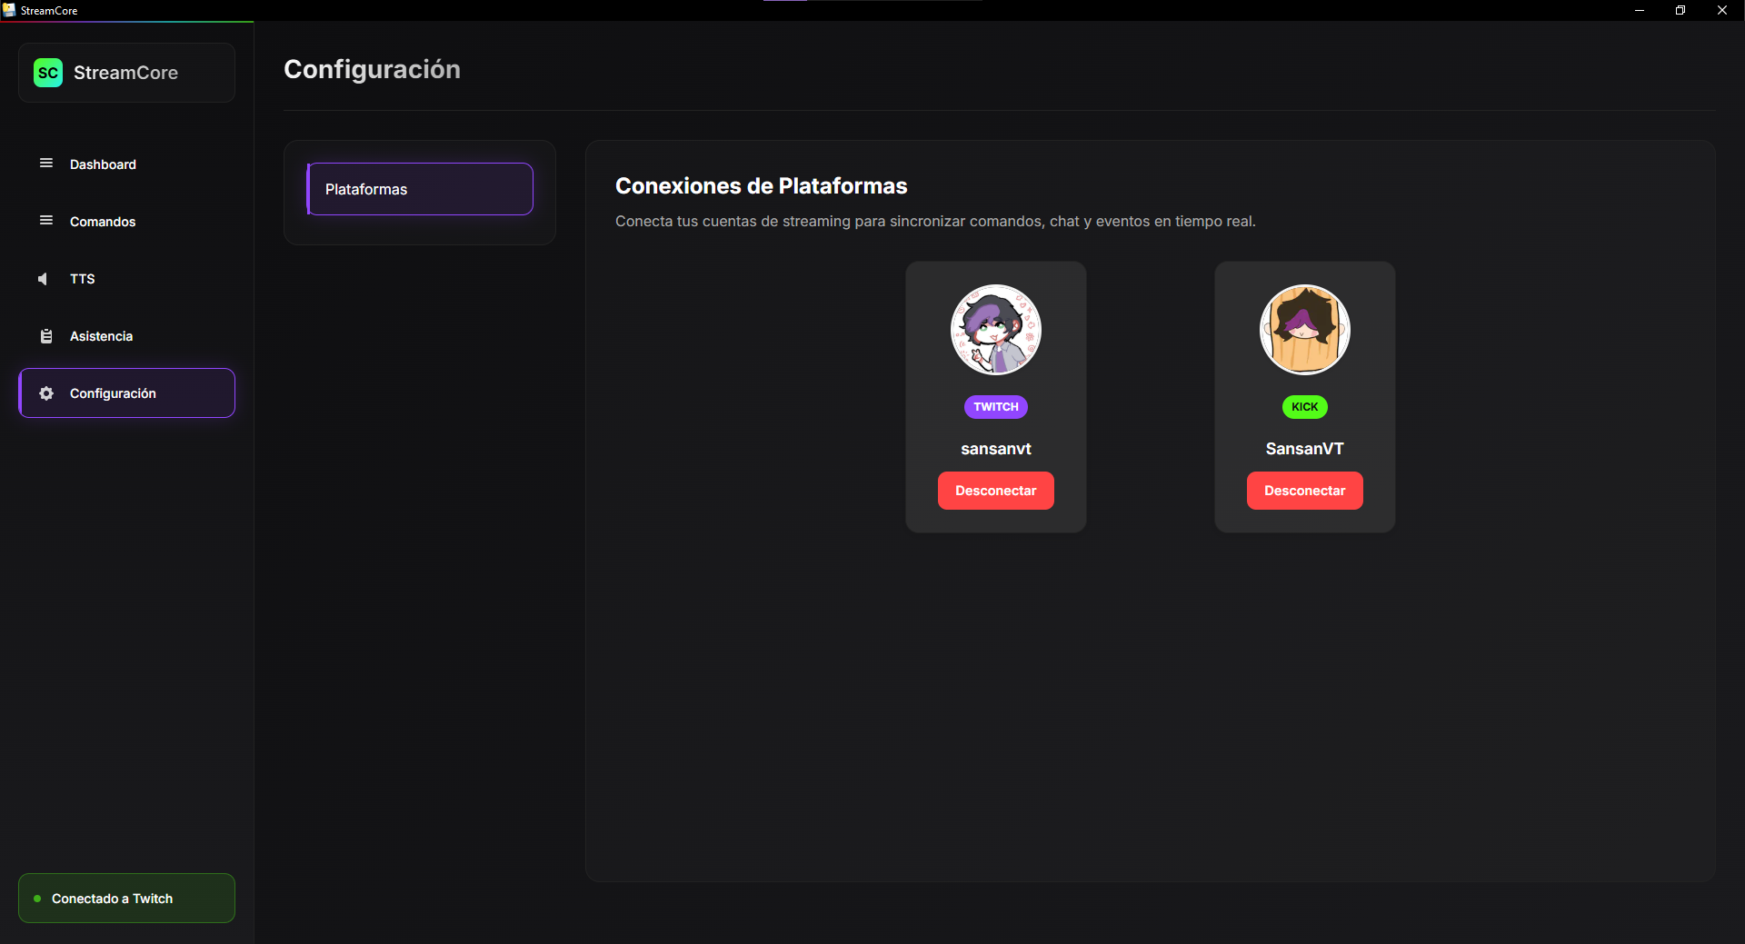

DASHBOARD
The Dashboard serves as the central control hub for StreamCore. Here you will find an overview of the application status and a Modular Control panel.
This panel allows you to enable or disable entire modules (TTS, Commands, Assistance) using toggle switches. When a module is disabled, its functions stop immediately to conserve system resources, but your configuration remains preserved for when you decide to reactivate it.
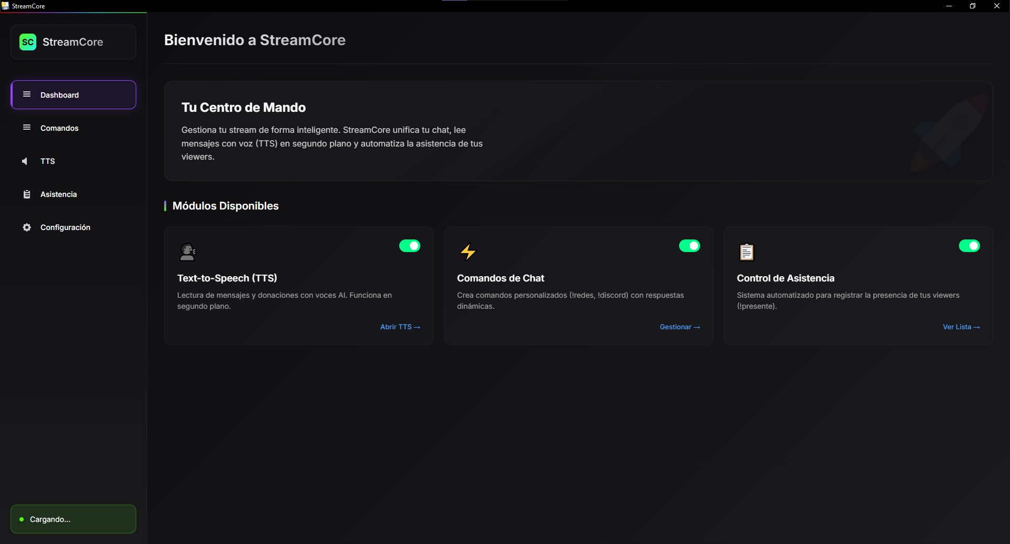

COMMANDS
This module allows for the automation of chat responses. The interface is organized by tabs, enabling the management of Twitch and Kick commands either independently or jointly.
Panel Features:
- Metrics: Visualize how many active commands you have and the total usage count.
- Filters: Search for specific commands or sort them by status (active/inactive).
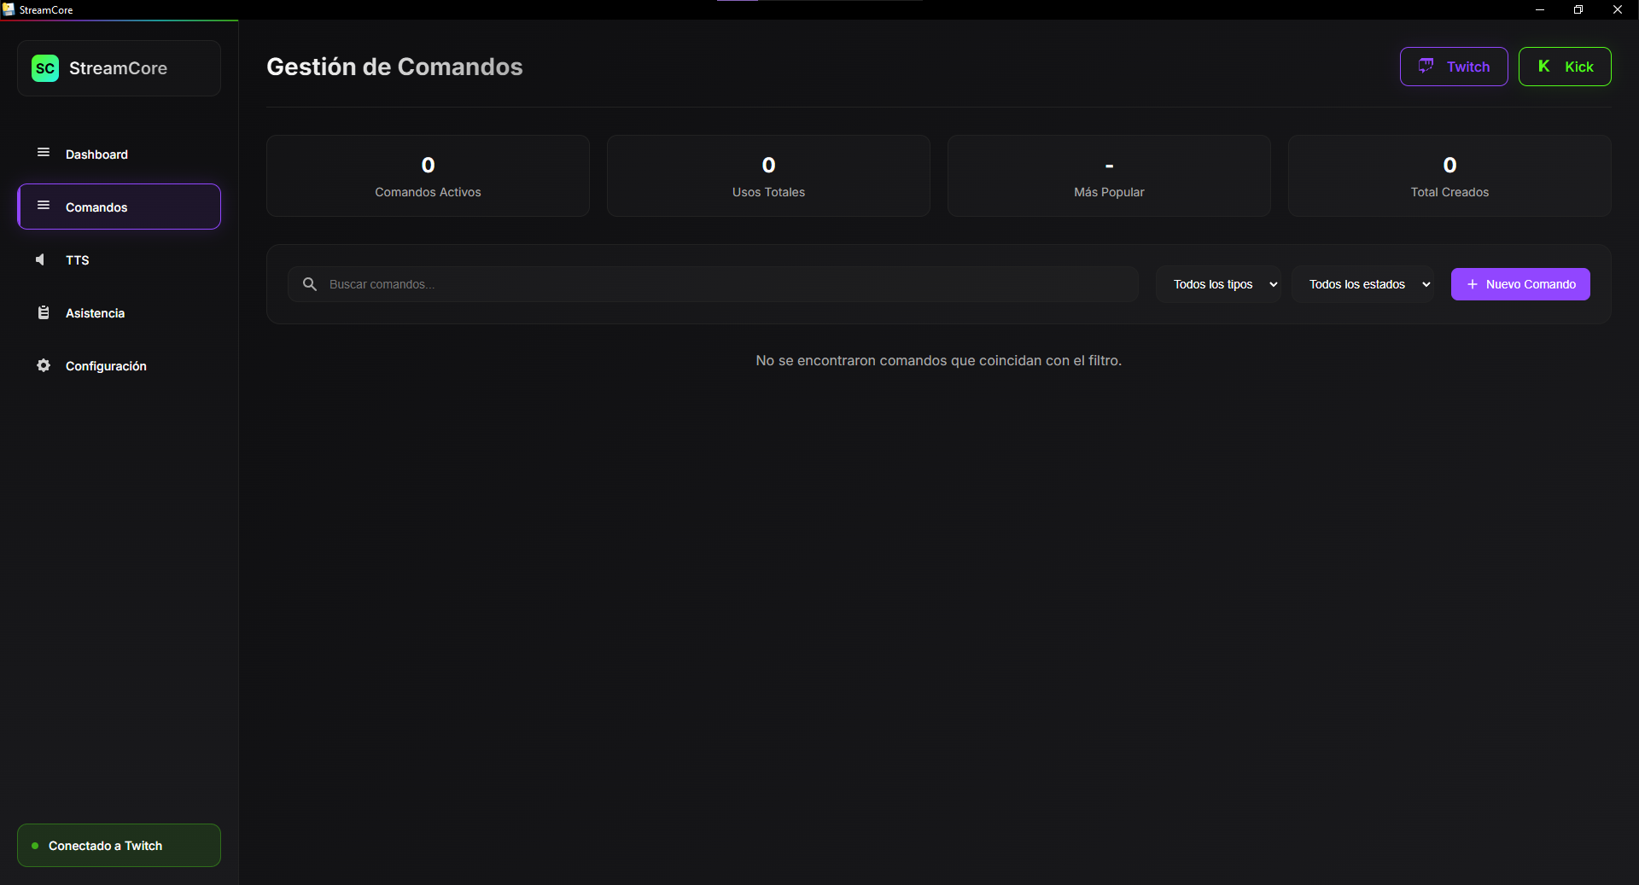

Creation and Editing: When creating a new command, you can define advanced parameters:
- Name: The trigger (e.g., !socials).
- Command Type: Select between simple text, counter, or timer.
- Response: The text the bot will send. It supports dynamic variables such as {user} (username), {count} (counter), and {time} (current time).
- Cooldown: Waiting time between uses to prevent spam.
- Permissions: Restrict who can execute the command (Everyone, Subscribers, Moderators).
- Platform: Determine whether the command operates on a single platform or both simultaneously.
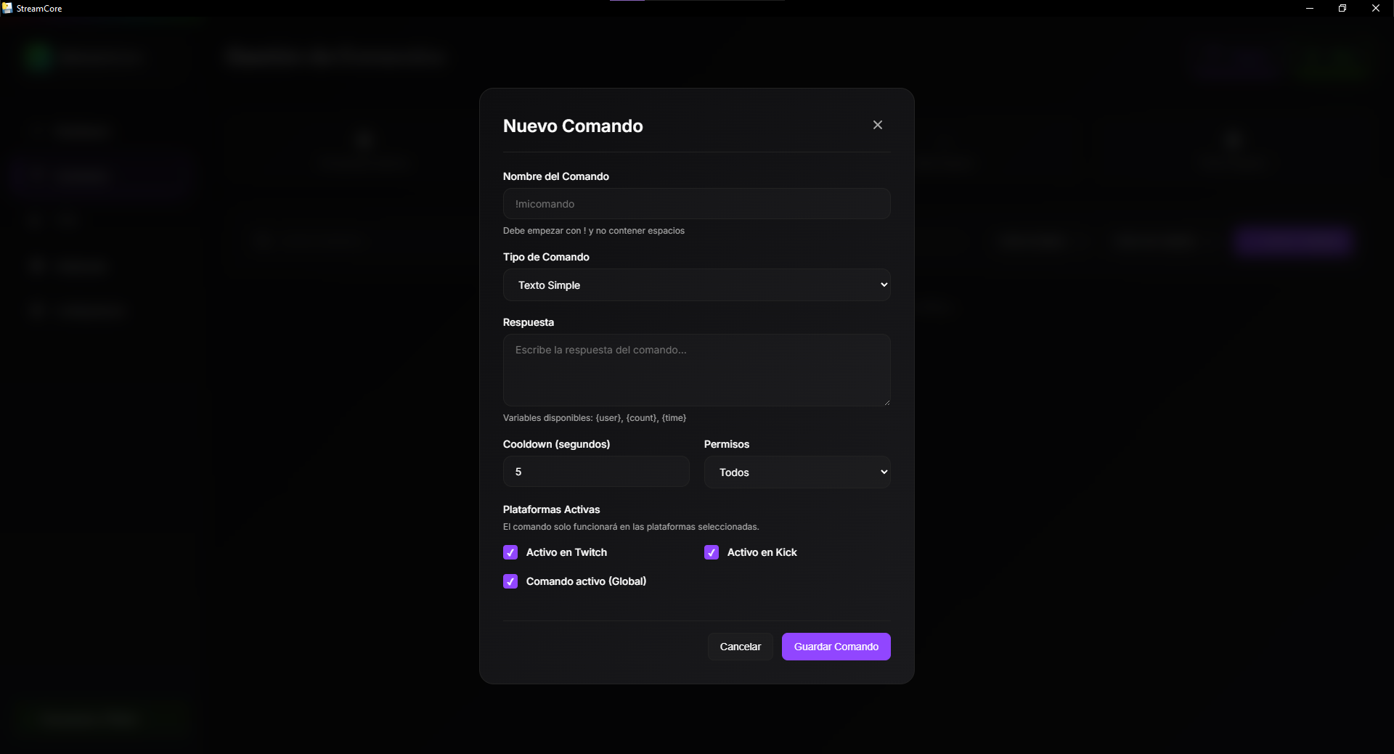

TEXT-TO-SPEECH
The Text-to-Speech system allows chat messages to be read aloud, making it ideal for maintaining interaction while gaming or performing other activities.
Key Features:
- Voice Engine: Voice selection and precise speed adjustments.
- Queue Control: Buttons to pause reading or instantly clear the pending message queue.
- Security: Profanity filter and usage restriction by role (e.g., subscribers only).
- Audio Test: Area to test how the voice will sound before starting the stream.
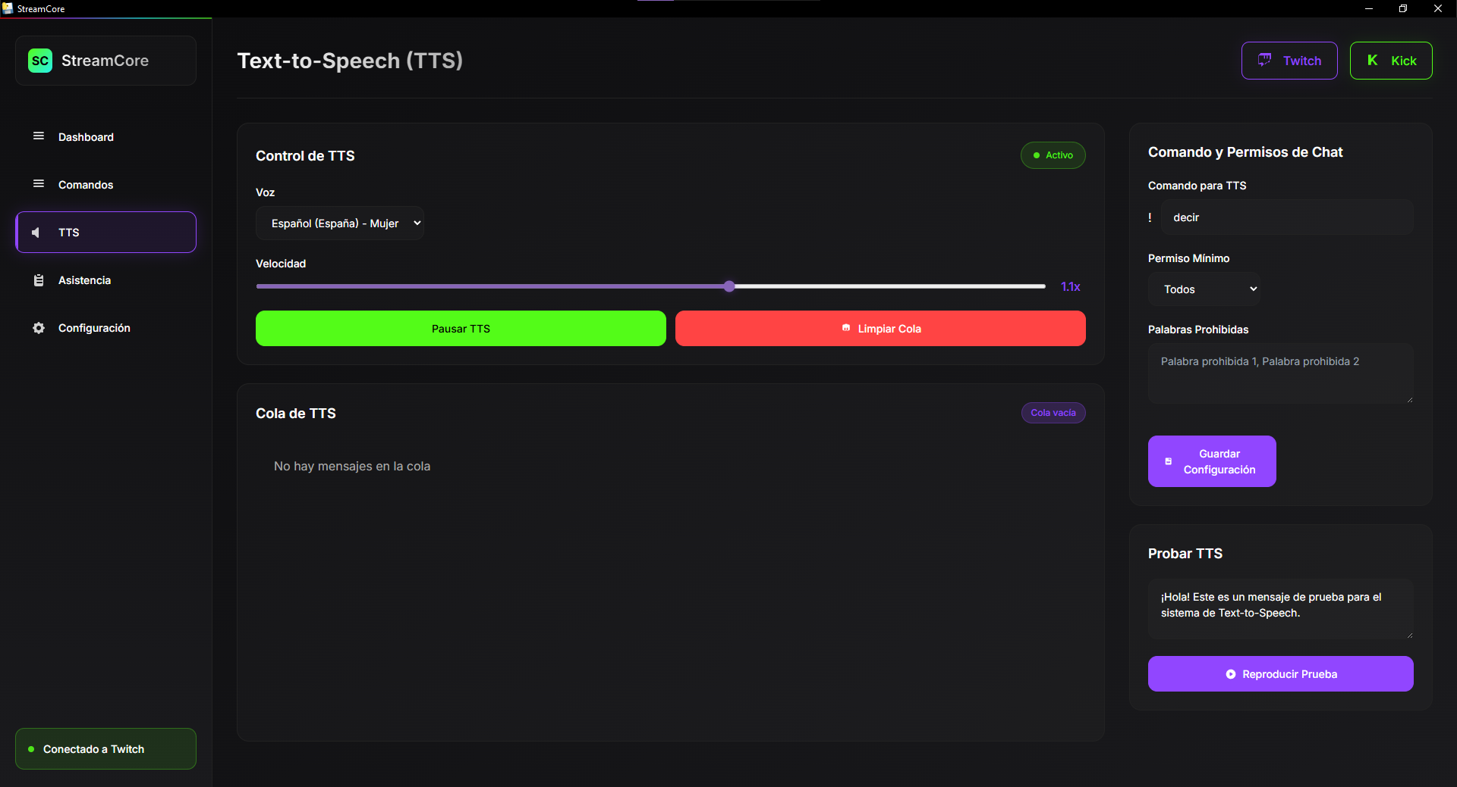

ASSISTANCES
This module is designed to build audience loyalty by registering your viewers' presence using a specific command (default !assistance).
Assistance List: Displays a detailed table of users who have registered their attendance, allowing you to filter by name and sort by the number of registrations.
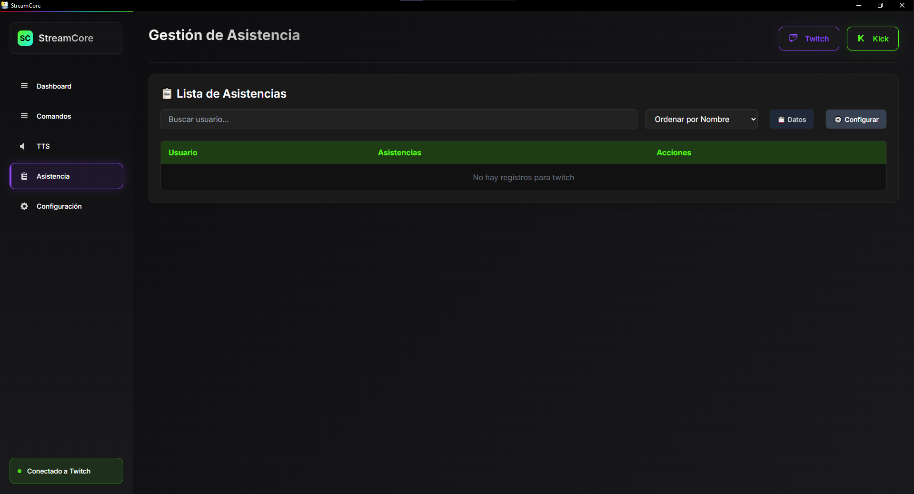

Module Configuration: From the "Configure" button, you can customize the user experience:
- Command and Cooldown: Define exactly what users must type and the required time interval between uses.
- Reset List (Session): Allows you to "open" a new attendance session within the same stream without deleting the accumulated history.
- Feedback: Configure custom success or error messages and enable an optional sound effect upon registration.
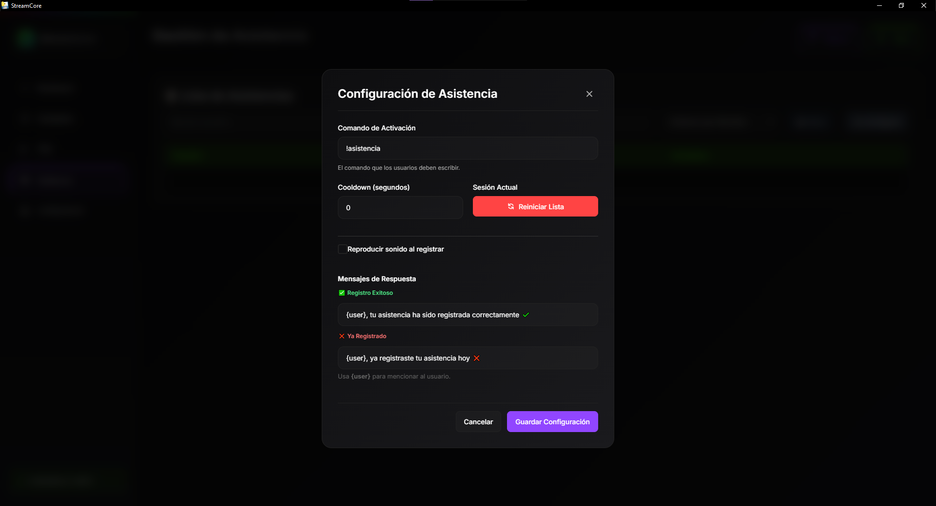

Data Management and Reports: The "Data" button provides administrative tools:
- Generate CSV Report: Exports the full list to an Excel-compatible file, ideal for conducting giveaways or performing audience analysis.
- Delete Records: Allows you to clear the database for the selected platform. This action includes a double security confirmation to prevent accidental deletions.

