**PRACTICAL – 01**

**Aim :** Introduction to Oracle 11g database and demonstrate Data Definition Language [DDL] command for the creation of tables.

**Problem Definition :**

***Q1 ) Table creation.***

***Batch D1***

Create the following tables. Give names to all the constraints (except NULL constraints). The properties of the tables are defined as follows:

MEMEBERS table

- CardNo - 5 characters, primary key,

- Surname - up to 15 characters,

- Name – as above,

- Address –up to 150 characters,

- Name, Surname, Birthday_date – not null,

- Gender - 1 char: M or F letter,

- Phone_No – up to 15 characters, unique.

EMPLOYEES table

- emp_id - primery key,

- Surname, Name and Birthday_date are not null,

- Emp_Hire_Date date not null,

- birthday date must be earlier than date of employment (Emp_Hire_Date),

Publishers table

- pub_id is a primary key,

- Name, City, - not null, up to 50 characters,

- Phone_No - up to 15 charakters,

Books table

- BookID - primary key, 5 characters,

- Pub_ID - foreign key related to Publishers,

- Type - charaters, must contain one of the following values: novel, historical, for kids, poems, crime story, science fiction, science

- Price numeric with precision 7 and scale 2, not null,

- Title - up to 40 characters, not null,

BOOK_LOANS table

- LoanID - integer, primary key,

- CardNo, BookID and emp_id are foreign keys related to Members, Books and Employees,

- DateOut must be earlier than DueDate,

- Penalty can't contain negative values, default is set to 0 (zero)

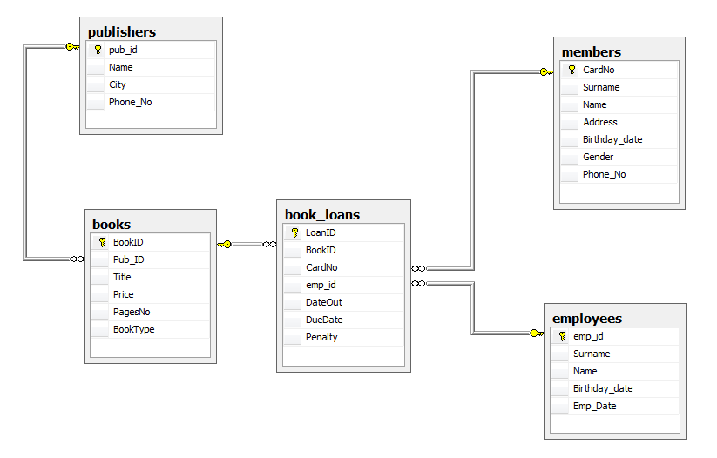

***Batch D4***

Create tables and add the following constraints:

* tblCustomers table:  Country – default to Canada
* tblOrderDetails:  Quantity –   > 0
* tblShippers: CompanyName must be unique.
* tblOrders: ShippedDate must be greater than order date.
* tblOrderDetails : UnitPrice must have a value greate than 0
* tblCustomers : CustomerID values lie between 101 to 500

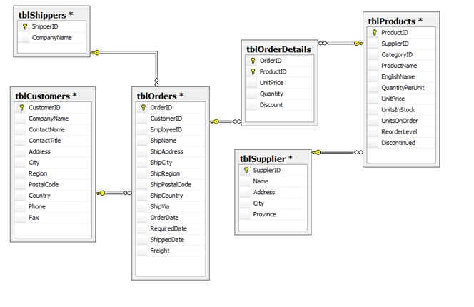

***Q2) Create a table COLLEGE with following columns and constraints :***

CNAME varchar2(15) not null,

LOCATION varchar2(50) with default value Nagpur

Demonstrate the use of ALTER TABLE statement to:

* Add a new column
* Modify an existing column definition
* Define a default value for the new column
* Drop a column
* Rename a table / column
* Add constraints

Q3) Using tables SUPPLIERS and PRODUCTS, demonstrate the following Foreign Key constraints :

ON DELETE CASCADE

ON DELETE SET NULL

Also demonstrate dropping of foreign key, enabling and disabling of foreign key.