PRACTICAL – 04

Aim : Execution of various types of joins operations on multiple tables in a database
Tasks-01: Use HE schema
- Write a query for the HR department to produce the addresses of all the departments. Use the LOCATIONS and COUNTRIES tables. Show the location ID, street address, city, state or province, and country in the output. Use a NATURAL JOIN to produce the results.
- The HR department needs a report of all employees. Write a query to display the last name, department number, and department name for all the employees.
- The HR department needs a report of employees in Toronto. Display the last name, job, department number, and the department name for all employees who work in Toronto.
- Create a report to display employees’ last name and employee number along with their manager’s last name and manager number. Label the columns Employee, Emp#, Manager, and Mgr#, respectively. Save your SQL statement as lab_04_04.sql. Run the query.
- Modify lab_04_04.sql to display all employees including King, who has no manager. Order the results by the employee number. Save your SQL statement as lab_04_05.sql. Run the query in lab_04_05.sql
- Create a report for the HR department that displays employee last names, department numbers, and all the employees who work in the same department as a given employee. Give each column an appropriate label.
- The HR department needs a report on job grades and salaries. To familiarize yourself with the JOB_GRADES table, first show the structure of the JOB_GRADES table. Then create a query that displays the name, job, department name, salary, and grade for all employees.
- The HR department wants to determine the names of all the employees who were hired after Davies. Create a query to display the name and hire date of any employee hired after employee Davies.
- The HR department needs to find the names and hire dates of all the employees who were hired before their managers, along with their managers’ names and hire dates.

Task 02 : Execute the sailor.sql script to create the required tables. Populate the tables as follows:
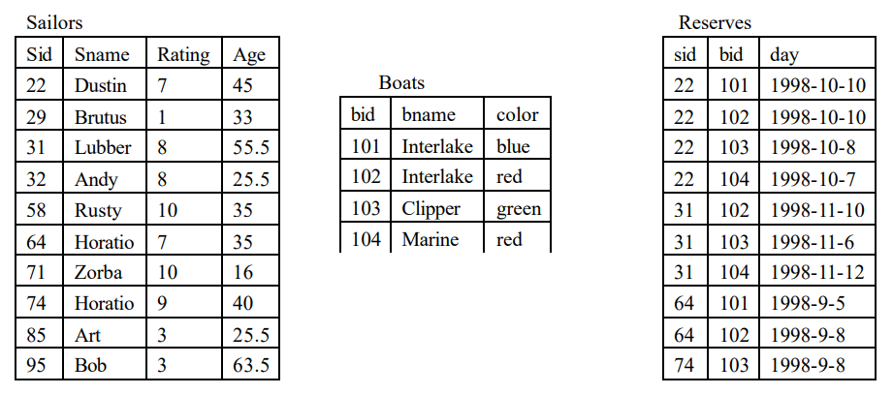
- CREATE VIEW SAILOR1 with SID [22, 29, 31, 32, 58, 95]
- CREATE VIEW SAILOR2 with SID [31, 32, 64, 71, 74]
- CREATE VIEW SAILOR3 with SID [22, 32, 85, 74]
- CREATE VIEW RESERVE1 with SID [22,64]
- CREATE VIEW RESERVE1 with SID [31,74]
- Display the content of above views
- Perform Inner Join Sailor and Reserve table and display all the attributes.
- Perform Inner Join Sailor and Reserve table and display only Sid and Sname from sailors table and Bid and Rday from Reserve table.
- Perform Equi Join Sailor and Reserve table and display only Sid and Sname from sailors table and Bid and Rday from Reserve table. The reservation month should be November and SID should be 74.
- Perform Theta join Sailor, Reserve and Boat. The reservation month should be August and BID should not be 101.
- Perform Left Outer Join on Sailor1 and Sailor2 and tuples to be ordered by SID of sailor1 and sailor2.
- Perform Right Outer Join on Sailor1 and Sailor2 and tuples to be ordered by SID of sailor1 and sailor2.
- Perform Full Outer Join on Sailor1 and Sailor2 and tuples to be ordered by SID of sailor1 and sailor2.
- Execute Natural Join on Sailor and Reserve
- Perform Cross Join on Sailor3 and Reserve2
- Find the names of sailors who have reserved boat 103. [Perform using Natural Join and Inner Join]
- Find the names of sailors who have reserved a red boat. [Perform using Natural Join and Inner Join]
- Find the colors of boats reserved by Lubber
- Find the colors of boats reserved by Dustin
- Find the names of sailors who have reserved at least one boat.
- Find the names of sailors who have reserved either a red or a green boat.
- Find the names of sailors who have reserved a red and a green boat.
- Find all sailor id’s of sailors who have a rating of at least 8 or reserved boat 103.
- Find the names of sailors who have reserved a boat whose name contains ‘U’ and Order the names in ascending order.
- Find the sailor id’s and name of sailors with age over 20 who have reserved a boat whose name includes the string “lake”.
- Find the sailor id’s of sailors whose rating is better than some sailor called Bob
- For each boat which was reserved by at least 5 sailors with age >= 40, find the boat id and the average age of such sailors.

