
PROJECT REPORT
TITLE: Design and Implementation of a Database Management System for Car Rental Reservation and Vehicle Return Management System

NAME: Sansita.M
ROLL NO. : 25WU0102244
COURSE NAME: Database Management Systems
FACULTY NAME: Dr Kiran Mayee Adavala
ACADEMIC YEAR: 2025-2029
B. TECH AI ML Whales

ABSTRACT
The Car Rental Management System is a web-based database application developed to manage the major activities involved in a car rental process. The system is designed to store and organize customer details, vehicle information, reservations, rental transactions, vehicle returns and payment records in a centralized MySQL database.
The main purpose of the project is to reduce the difficulties associated with maintaining car rental records manually. In a traditional system, customer information, vehicle availability, reservations, rental details and payment information may be maintained separately, which can result in duplication, inconsistency and difficulty in retrieving information. The proposed system provides a structured solution by using a relational database and a user-friendly web interface.
The application is developed using HTML and CSS for the frontend and Python Flask for the backend. MySQL is used as the database management system, while MySQL Connector/Python is used to establish communication between the Flask application and the database. The system provides CRUD operations such as inserting, viewing, updating and deleting records.
The database consists of six main tables: Customer, Vehicle, Reservation, Rental, Vehicle Return and Payment. Primary keys and foreign keys are used to maintain relationships between the tables and preserve referential integrity.
The project demonstrates how database concepts such as relational schema design, normalization, constraints, SQL commands, CRUD operations and foreign key relationships can be implemented in a practical web-based application.

INTRODUCTION
Car rental services involve managing different types of information such as customer details, vehicle information, reservations, rental transactions, vehicle returns, and payments. Managing all these records manually can become difficult as the number of customers and vehicles increases. It may also lead to errors, duplicate records, and difficulty in finding or updating information.
A Database Management System (DBMS) provides an organized solution for managing this information. In the proposed Car Rental Management System, related data is stored in separate tables and connected using relationships. Primary keys and foreign keys are used to maintain the connection between customers, vehicles, reservations, rentals, returns, and payments. This helps maintain data consistency and reduces unnecessary duplication.
The system is designed to manage the complete car rental process, starting from customer registration and vehicle selection to reservation, rental, vehicle return, and payment recording. Vehicle availability can also be maintained based on rental and return information.
A web interface is provided to make the system easier to use. Users can perform basic database operations such as adding, viewing, updating, and deleting records without directly entering SQL commands every time. This makes the system more convenient and demonstrates the practical use of DBMS concepts in a real-world car rental application.
Overall, the proposed system aims to provide a simple, organized, and efficient way to manage car rental records while reducing manual work and improving data accuracy.

PROBLEM STATEMENT
Managing car rental records manually can become difficult when the number of customers, vehicles, and rental transactions increases. Maintaining customer details, vehicle information, reservations, rental records, return details, and payment information separately can lead to confusion and errors.
One of the major challenges is tracking vehicle availability. Without a proper system, it may be difficult to know whether a vehicle is available, reserved, currently rented, or already returned. Reservation and rental details may also become disorganized, making it harder to identify the correct customer or vehicle associated with a transaction.
Another problem is maintaining consistency between related records. For example, a payment should be connected to the correct rental, and a return should be associated with the corresponding rental transaction. Manual management can also result in duplicate data, outdated information, and difficulties while searching, updating, or deleting records.
Therefore, a centralized database system is required to organize all car rental information in one place. The proposed Car Rental Management System addresses these problems by storing related information in structured tables and maintaining relationships between them. A web interface is also provided to make common database operations such as adding, viewing, updating, and deleting records easier for users.
The system aims to reduce manual work, improve data accuracy, maintain consistency between related records, and make car rental information easier to manage and access.

OBJECTIVES
The major objectives of the proposed Car Rental Management System are:
- To manage customer information efficiently by storing and organizing customer details in a structured manner, making the information easy to access and update whenever required.
- To maintain vehicle details and availability by storing information about vehicles and their current status, helping users identify which vehicles are available, reserved, or rented.
- To manage customer reservations by recording reservation details and maintaining a proper connection between customers and the vehicles they wish to rent.
- To maintain rental transaction records by storing details of each rental and linking the transaction with the corresponding customer and vehicle.
- To record vehicle return details and late fees by maintaining information about returned vehicles and recording additional charges when a vehicle is returned late.
- To maintain payment information by recording the payment details related to each rental transaction and keeping the financial records organized.
- To provide CRUD operations through a web interface so that users can easily create, view, update, and delete database records without having to enter SQL commands for every operation.
- To reduce manual work and data duplication by storing information in a centralized relational database and avoiding unnecessary repetition of records.
- To maintain relationships between different database tables using primary keys and foreign keys so that related customer, vehicle, reservation, rental, return, and payment information remains consistent.
- To provide centralized access to rental information by bringing all important car rental records together in one system, making the overall rental management process simple, organized, and efficient.

SCOPE OF THE PROJECT
The scope of the proposed Car Rental Management System covers the major activities involved in managing customers, vehicles, reservations, rental transactions, vehicle returns, and payments. The system provides a centralized database where rental information can be stored, maintained, and accessed through a simple web interface.
Customer Management
The system stores important customer details such as Customer ID, name, phone number, email address, and driving license number. These records can be added, viewed, updated, and deleted whenever required. Customer information can also be connected with their reservations and rental transactions.
Vehicle Management
The system maintains vehicle details including Vehicle ID, brand, model, vehicle type, rent per day, and availability status. The vehicle status helps identify whether a vehicle is available, reserved, or rented, making vehicle management easier.
Reservation and Rental Management
The system records customer reservations using Reservation ID, Customer ID, Vehicle ID, start date, end date, and reservation status. It also maintains rental transactions using Rental ID, reservation details, rent date, due date, and total amount. This helps maintain a clear connection between customers, vehicles, reservations, and rentals.
Vehicle Return Management
The system records vehicle return details such as Return ID, Rental ID, return date, vehicle condition, and late fee. This information helps maintain proper return records and supports updating the vehicle's availability after it is returned.
Payment Management
The system maintains payment information related to rental transactions. Payment ID, Rental ID, payment date, amount, and payment method are stored to provide an organized record of customer payments.
Database Operations and Web Interface
The project provides basic CRUD operations such as creating, viewing, updating, and deleting records through a web-based interface. This reduces the need to manually enter SQL commands for common database operations and makes the system easier to use.
Database Relationships
Primary keys and foreign keys are used to establish relationships between customers, vehicles, reservations, rentals, returns, and payments. This helps maintain data consistency, reduce duplication, and preserve data integrity.
Overall, the project provides a centralized and organized solution for managing the main activities of a car rental service. It demonstrates the practical application of DBMS concepts such as relational tables, keys, relationships, CRUD operations, and data management in a real-world system.

SOFTWARE AND HARDWARE REQUIREMENTS
The Car Rental Management System requires a basic computer system with suitable software tools for developing the web application, managing the relational database, and executing the system. The project can be developed and executed using the following software and hardware configuration.
Software Requirements
- Operating System: Windows 10/11 or equivalent operating system
- Visual Studio Code: Used for writing, editing, and managing the source code of the web application.
- Python: Used for developing the backend of the application and implementing the server-side functionality.
- Flask: A Python web framework used for developing the backend server and connecting the web interface with the database.
- MySQL: A relational database management system used for storing and managing customer, vehicle, reservation, rental, return, and payment information.
- HTML5: Used for creating the basic structure and content of the web-based user interface.
- CSS3: Used for designing and formatting the web interface and improving its overall appearance and usability.
- JavaScript: Used for implementing interactive features and handling client-side functionality in the web application.
- MySQL Connector/Python: Used to establish a connection between the Python Flask application and the MySQL database.
- Web Browser: Google Chrome, Microsoft Edge, or any other modern web browser can be used to access and run the web application.
- Internet Connection: Required for installing software packages, accessing development resources, and performing database-related operations when required.
Hardware Requirements
- Processor: Intel Core i3 or equivalent and above
- RAM: Minimum 4 GB, preferably 8 GB for smooth development and execution.
- Storage: At least 10 GB of available storage for the application, database, development tools, and project files.
- Display: Standard laptop or desktop display suitable for developing and accessing the web application.
- Keyboard and Mouse: Required for coding, database management, and system interaction.
- Internet Connectivity: Required for downloading required packages, accessing online resources, and performing necessary development activities.
Overall, the Car Rental Management System can be developed and executed using a standard laptop or desktop computer with a modern web browser, Python and Flask development environment, and MySQL database. The required hardware and software are commonly available, making the system suitable for development and demonstration in a normal academic environment.

ER DIAGRAM
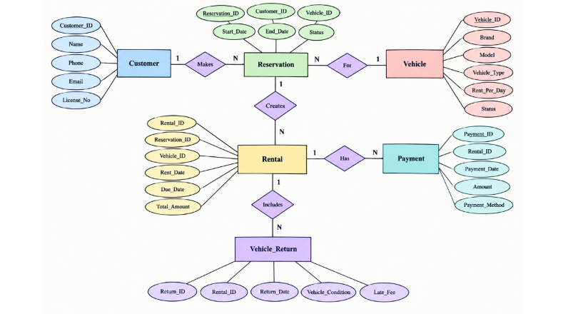

RELATIONAL SCHEMA AND NORMALIZATION

Relational Schema
The relational schema defines the structure of the database by specifying the tables, attributes, primary keys, and foreign keys used in the Car Rental Management System. The database consists of six main relations: CUSTOMER, VEHICLE, RESERVATION, RENTAL, VEHICLE_RETURN, and PAYMENT.
CUSTOMER
The CUSTOMER table stores customer details. Customer_ID uniquely identifies each customer, while License_No is kept unique.
CUSTOMER(
Customer_ID PK,
Name,
Phone,
Email,
License_No UNIQUE
)
VEHICLE
The VEHICLE table stores vehicle details such as brand, model, type, daily rent, and availability status.
VEHICLE(
Vehicle_ID PK,
Brand,
Model,
Vehicle_Type,
Rent_Per_Day,
Status
)
RESERVATION
The RESERVATION table records customer reservations and connects customers and vehicles using foreign keys.
RESERVATION(
Reservation_ID PK,
Customer_ID FK,
Vehicle_ID FK,
Start_Date,
End_Date,
Status
)
RENTAL
The RENTAL table stores rental transaction details, including the rental date, due date, and total amount.
RENTAL(
Rental_ID PK,
Reservation_ID FK,
Vehicle_ID FK,
Rent_Date,
Due_Date,
Total_Amount
)
VEHICLE_RETURN
The VEHICLE_RETURN table stores vehicle return details, including return date, vehicle condition, and late fee.
VEHICLE_RETURN(
Return_ID PK,
Rental_ID FK,
Return_Date,
Vehicle_Condition,
Late_Fee
)
PAYMENT
The PAYMENT table stores payment details associated with rental transactions.
PAYMENT(
Payment_ID PK,
Rental_ID FK,
Payment_Date,
Amount,
Payment_Method
)
Normalization
Normalization is the process of organizing data to reduce data redundancy and improve data consistency. The database in this project is structured using normalized relations.
- First Normal Form — 1NF
A table is in 1NF when all attributes contain atomic values and there are no repeating groups. In this project, each field stores a single value and every record has a unique primary key. Therefore, the tables satisfy 1NF.
- Second Normal Form — 2NF
A table is in 2NF when it is already in 1NF and all non-key attributes depend on the complete primary key. In this project, each table uses a separate primary key such as Customer_ID, Vehicle_ID, Reservation_ID, and Rental_ID. Therefore, the relations satisfy 2NF.
- Third Normal Form — 3NF
A table is in 3NF when it is in 2NF and non-key attributes do not depend on other non-key attributes. In this project, customer details are stored only in the CUSTOMER table and vehicle details are stored only in the VEHICLE table. Other tables use foreign keys to refer to them instead of duplicating the information. Therefore, the database satisfies 3NF.
Normalization helps the project reduce duplication, improve consistency, simplify updates, and maintain data integrity between the related tables.

DATA DICTIONARY
The data dictionary describes the structure of the database tables used in the Car Rental Management System. It includes the field names, data types, and constraints such as primary keys, foreign keys, and unique values

Table | Field | Data Type | Constraint
CUSTOMER | Customer_ID | INT | Primary Key, Auto Increment
 | Name | VARCHAR(100) | NOT NULL
 | Phone | VARCHAR(15) | NOT NULL
 | Email | VARCHAR(100) | NOT NULL
 | License_No | VARCHAR(30) | UNIQUE

VEHICLE | Vehicle_ID | INT | Primary Key, Auto Increment
 | Brand | VARCHAR(50) | NOT NULL
 | Model | VARCHAR(50) | NOT NULL
 | Vehicle_Type | VARCHAR(30) | NOT NULL
 | Rent_Per_Day | DECIMAL(10,2) | NOT NULL
 | Status | VARCHAR(20) | NOT NULL

RESERVATION | Reservation_ID | INT | Primary Key, Auto Increment
 | Customer_ID | INT | Foreign Key
 | Vehicle_ID | INT | Foreign Key
 | Start_Date | DATE | NOT NULL
 | End_Date | DATE | NOT NULL
 | Status | VARCHAR(20) | NOT NULL

RENTAL | Rental_ID | INT | Primary Key, Auto Increment
 | Reservation_ID | INT | Foreign Key
 | Vehicle_ID | INT | Foreign Key
 | Rent_Date | DATE | NOT NULL
 | Due_Date | DATE | NOT NULL
 | Total_Amount | DECIMAL(10,2) | NOT NULL

VEHICLE_RETURN | Return_ID | INT | Primary Key, Auto Increment
 | Rental_ID | INT | Foreign Key
 | Return_Date | DATE | NOT NULL
 | Vehicle_Condition | VARCHAR(100) | Optional
 | Late_Fee | DECIMAL(10,2) | Default 0.00

PAYMENT | Payment_ID | INT | Primary Key, Auto Increment
 | Rental_ID | INT | Foreign Key
 | Payment_Date | DATE | NOT NULL
 | Amount | DECIMAL(10,2) | NOT NULL
 | Payment_Method | VARCHAR(30) | NOT NULL

SOL COMMANDS
DDL COMMAND
DDL (Data Definition Language) commands are used to create and define the structure of the database and its tables. In this project, DDL is used for creating the Car Rental database and the tables required to store customer, vehicle, reservation, rental, return, and payment information.
CODE:
mysql> CREATE TABLE Customer (
Customer_ID INT PRIMARY KEY,
Name VARCHAR(50), Phone VARCHAR(15),
Email VARCHAR(50),
License_No VARCHAR(20) UNIQUE );
OUTPUT:
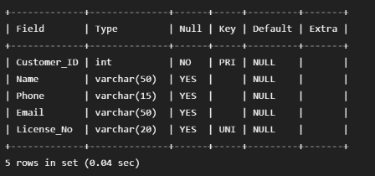

DQL COMMAND
DML (Data Manipulation Language) commands are used to manage the records stored in these tables. In this project, DML is used to add and modify customer and rental-related information.
CODE:
mysql> UPDATE Vehicle SET Status = 'Rented' WHERE Vehicle_ID = 1;

OUTPUT:
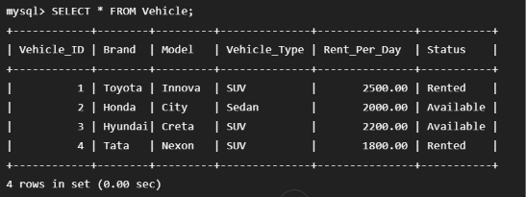

QUERIES WITH OUTPUTS

