SANSKAAR PATNI
180905134 IT LAB 1- JQUERY
CSE C-23

1. CODE
<html>
<head>
<title></title>
<script src="https://ajax.googleapis.com/ajax/libs/jquery/3.5.1/jquery.min.js"></script>
<script type="text/javascript">
$(document).ready(function () {
$('#btnSubmit').click(function () {
$('div').animate({marginLeft:'0'});
});

});
</script>
<style>
tr:nth-child(even) {
background-color: #dddddd;
}
</style>
</head>
<body style="font-family:Arial;">
<div style="margin-left: 60%;">
<table>
<tr>
<td>Island Trading</td>
<td>Helen Bennett</td>
<td>UK</td>
</tr>
<tr>
<td>Laughing Bacchus Winecellars</td>
<td>Yoshi Tannamuri</td>
<td>Canada</td>
</tr>
<tr>
<td>Magazzini Alimentari Riuniti</td>
<td>Giovanni Rovelli</td>
<td>Italy</td>
</tr>
</table>
<img src="tree.jpg" style="height: 300px;width: 400px;">
</div>
<input id="btnSubmit" type="submit" value="Submit" />
</body>
</html>

SCREENSHOTS

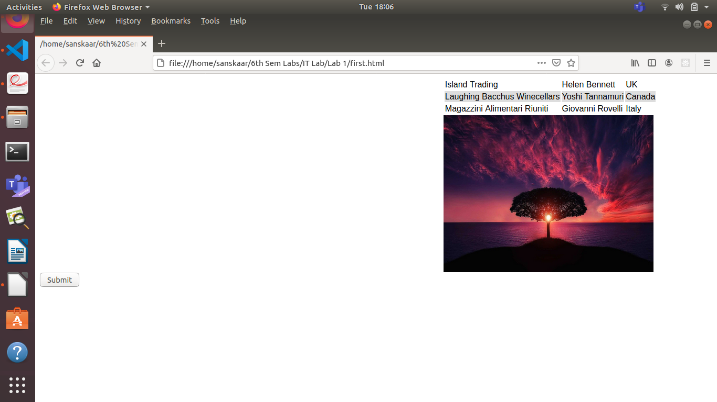
After Clicking the Button

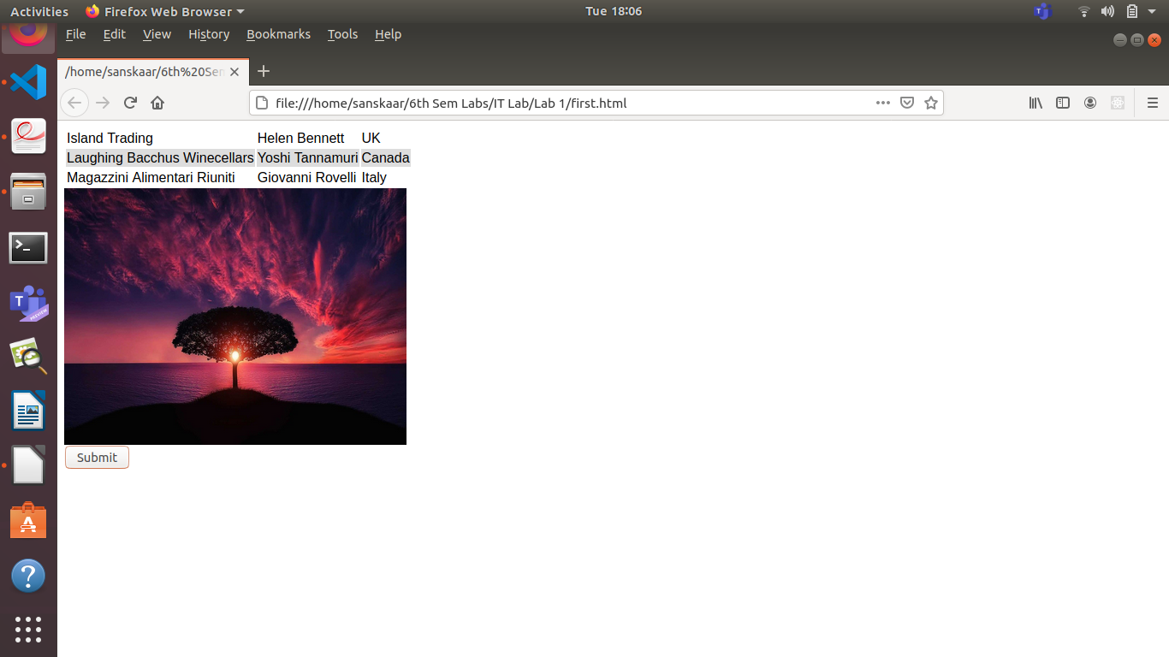
2. CODE
<html>
<head>
<title></title>
<script src="https://ajax.googleapis.com/ajax/libs/jquery/3.5.1/jquery.min.js"></script>
<script type="text/javascript">
$(document).ready(function () {
$('button').click(function () {
var total = $('textarea').val($('textarea').val() +$(this).val());
});
$('#btnSubmit').click(function () {
$('textarea').val(eval($('textarea').val()));
});
});
</script>
<style>
tr:nth-child(even) {
background-color: #dddddd;
}
</style>
</head>
<body style="font-family:Arial;">
<textarea class="#input" value="" rows="2" cols="20"></textarea>
<table>
<tr>
<td><button value="1">1</button></td>
<td><button value="2">2</button></td>
<td><button value="3">3</button></td>
</tr>
<tr>
<td><button value="4">4</button></td>
<td><button value="5">5</button></td>
<td><button value="6">6</button></td>
</tr>
<tr>
<td><button value="7">7</button></td>
<td><button value="8">8</button></td>
<td><button value="9">9</button></td>
</tr>
<tr>
<td><button value="+" id="add">+</button></td>
<td><button value="0">0</button></td>
<td><button value="-" id="sub">-</button></td>
</tr>
<tr>
<td><button value="/" id="div">/</button></td>
<td><button value="*" id="mul">*</button></td>
<td><button value="%" id="mod">%</button></td>
</tr>
</table>
<input id="btnSubmit" type="submit" value="Calculate" />
</body>
</html>

SCREENSHOTS
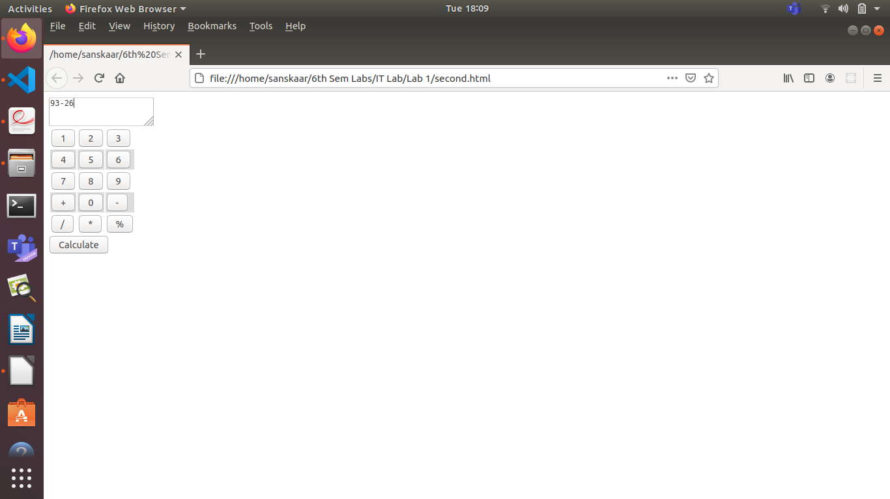
After clicking Calculate Button
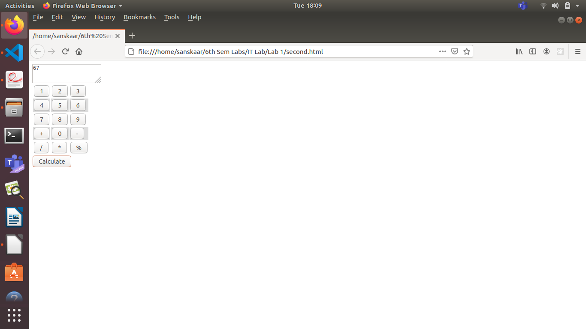

3. CODE
<!DOCTYPE html>
<html>
<script src="https://ajax.googleapis.com/ajax/libs/jquery/3.5.1/jquery.min.js"></script>
<script>
$(document).ready(function(){
$('input[type="checkbox"]').on('change', function() {
$('input[type="checkbox"]').not(this).prop('checked', false);
});
$("button").click(function(){
$("div").css("background-color",$("#bgcolor").val());
$("#targetText").css("font-family",$("#fonttype").val());
$("#targetText").css("font-size",parseFloat($("#text1").val()));
$("div").css("border",$('input[type="radio"]:checked').val());
$("#textarea1").keyup(function(){
var currentText = $(this).val();
$("#targetText").text(currentText);
});
//$("#checkbox1").attr('checked',true).
var result = $('input[type="checkbox"]:checked');
if(result.length>0){
$("img").show();
}else{
$("img").hide();
}
});
});
</script>
<body>
<div style="position: absolute; width: 400px;background-color: yellow; height: 500px;border: double; right:100px">
<p1 id="targetText"style="text-align: center;">Happy Birthday, and many more</p1>
<img src="tree.jpg" style="height: 200px;margin-top: 200px;margin-left: 50px;"; ></img><br>
</div>
<p1>Choose a background color</p1>
<select id="bgcolor">
<option value="Yellow">Yellow</option>
<option value="Blue">Blue</option>
</select>
<br>
<p1>Choose a font</p1>
<select id="fonttype">
<option value="Verdana">Verdana</option>
<option value="Times New Roman">TNR</option>
</select>
<br></br>
<p1>Choose a font size</p1><input type="number" id="text1" value="16">px
<br></br>
<p>Choose a border Style</p>
<input type="radio" value="None" name="borderStyle">
<label for="None">None</label><br>
<input type="radio" value="Double" name="borderStyle" checked>
<label for="Double">Double</label><br>
<input type="radio" value="Solid" name="borderStyle">
<label for="Solid">Solid</label>
<br>
<br>
<p1>Add default Picture</p1>
<input type="checkbox" id="checkbox1" checked>
<br>
<br>
<p1>Enter greeting text below</p1><br><br>
<textarea rows="5" cols="100" id="textarea1" placeholder="Happy Birthday, and many more"></textarea>
<br>
<button id="btnSubmit" type="submit">Update</button>
</body>
</html>

SCREENSHOTS

Initially

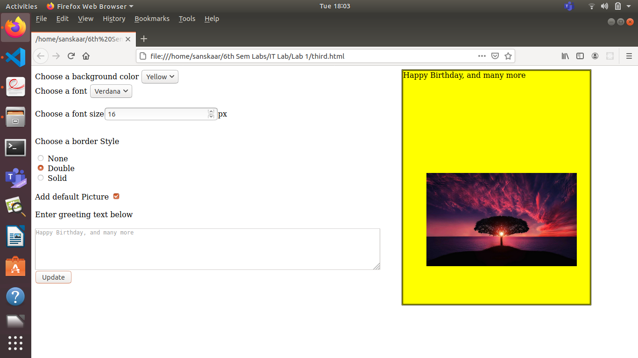
After changing some inputs and clicking update
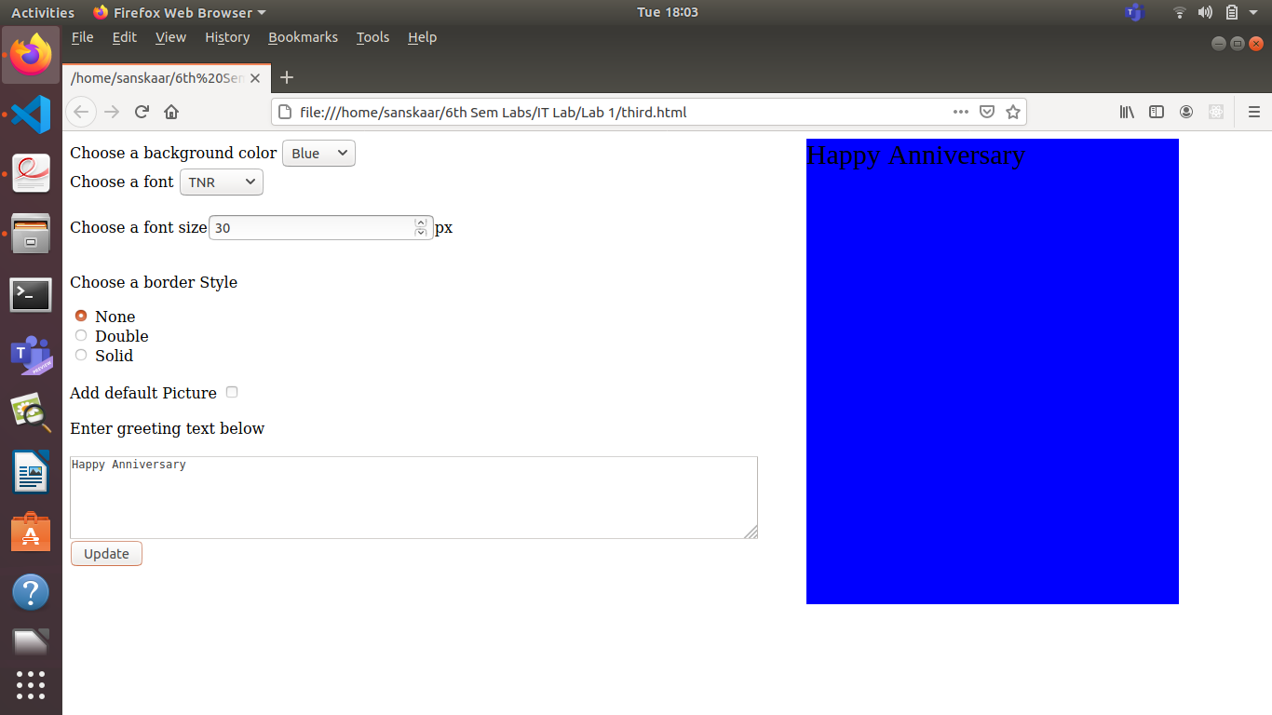
4. CODE
<!DOCTYPE html>
<html>
<head>
<script type="text/javascript" src="https://code.jquery.com/jquery-3.5.1.min.js"></script>
<script type="text/javascript">
$(document).ready(function(){
$("#text1").click(function(){
if($("#text1").prop("checked")==true)$("#quantity1").prop("disabled",false);
else $("#quantity1").prop("disabled",true);
});
$("#text2").click(function(){
if($("#text2").prop("checked")==true)$("#quantity2").prop("disabled",false);
else $("#quantity2").prop("disabled",true);
});
$("#btnSubmit").click(function(){
var sum=0;
if($("#dropdown").val()=="HP"){
if($("#text1").prop("checked")==true){
sum=sum+parseInt($("#quantity1").val())*1;
}
if($("#text2").prop("checked")==true){
sum=sum+parseInt($("#quantity2").val())*2;
}
}
else if($("select").val()=="Nokia"){
if($("#text1").prop("checked")==true){
sum=sum+parseInt($("#quantity1").val())*2;
}
if($("#text2").prop("checked")==true){
sum=sum+parseInt($("#quantity2").val())*3;
}
}
else if($("select").val()=="Samsung"){
if($("#text1").prop("checked")==true){
sum=sum+parseInt($("#quantity1").val())*3;
}
if($("#text2").prop("checked")==true){
sum=sum+parseInt($("#quantity2").val())*4;
}
}
else if($("select").val()=="Motorola"){
if($("#text1").prop("checked")==true){
sum=sum+parseInt($("#quantity1").val())*4;
}
if($("#text2").prop("checked")==true){
sum=sum+parseInt($("#quantity2").val())*5;
}
}
else if($("select").val()=="Apple"){
if($("#text1").prop("checked")==true){
sum=sum+parseInt($("#quantity1").val())*5;
}
if($("#text2").prop("checked")==true){
sum=sum+parseInt($("#quantity2").val())*6;
}
}
alert("Total cost"+ sum+" K");
});
});
</script>
</head>
<body>
<table>
<tr>
<th>Company</th>
<th>Laptop Cost(in K)</th>
<th>Mobile Cost(in K)</th>
</tr>
<tr>
<td>HP</td>
<td>1</td>
<td>2</td>
</tr>
<tr>
<td>Nokia</td>
<td>2</td>
<td>3</td>
</tr>
<tr>
<td>Samsung</td>
<td>3</td>
<td>4</td>
</tr>
<tr>
<td>Motorola</td>
<td>4</td>
<td>5</td>
</tr>
<tr>
<td>Apple</td>
<td>5</td>
<td>6</td>
</tr>
</table>
<select id="dropdown">
<option value = "HP" selected>HP</option>
<option value = "Nokia">Nokia</option>
<option value = "Samsung">Samsung</option>
<option value = "Motorola">Motorola</option>
<option value = "Apple">Apple</option>
</select>
<br>
<input type="checkbox" id="text1" value="Mobile">Mobile<br>
<input type="checkbox" id="text2" value="Laptop">Laptop<br>
Quantity of Mobiles: <input type="number" id="quantity1" disabled value="0">
Quantity of Laptops: <input type="number" id="quantity2" disabled value="0">
<input type="submit" id="btnSubmit" value="Produce Bill">
</body>
</html>

SCREENSHOTS

initially quantity is disabled becomes visible if respective checkbox toggled
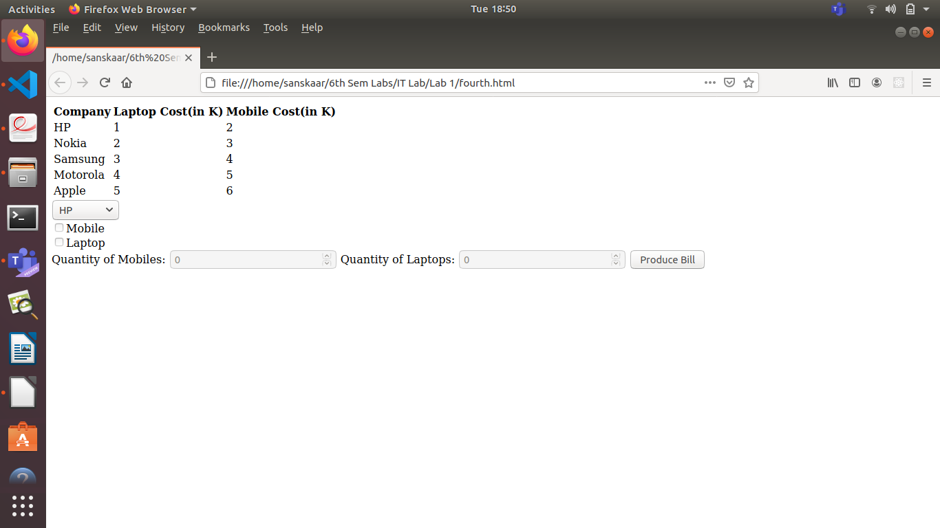
Inputing some values
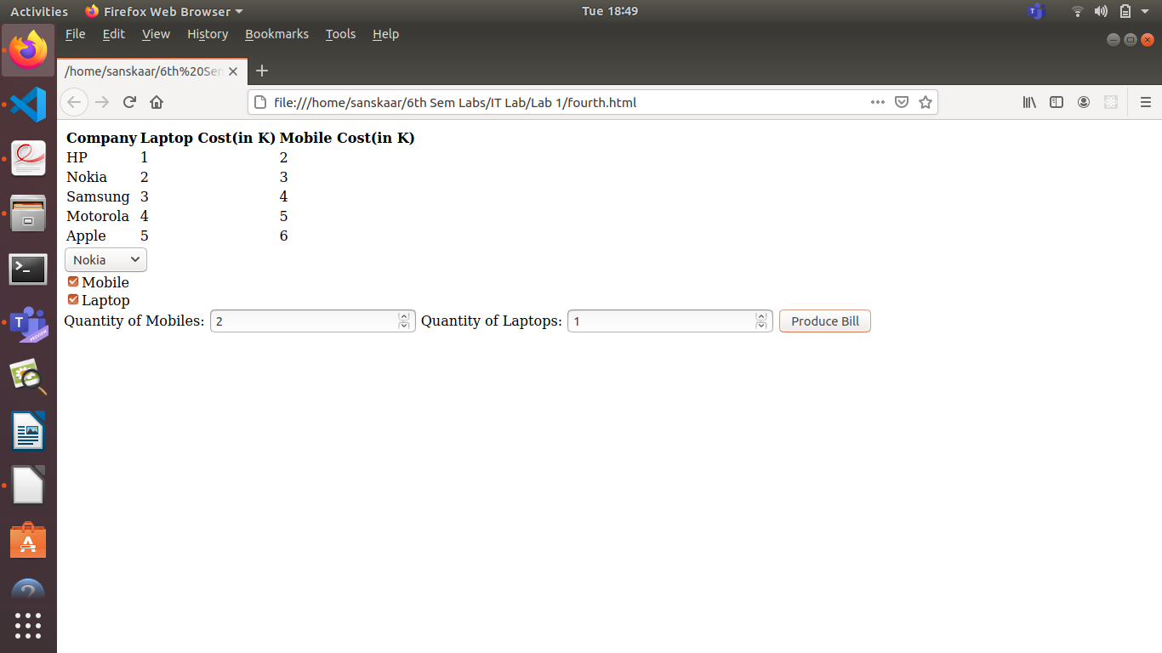
After clicking produce bill button: Alert is displayed containing the total amount

