SANSKAAR PATNI
180905134 CSE -C 23
IT LAB 2

1.CODE
<!DOCTYPE html>
<html lang="en">
<head>
<meta charset="UTF-8">
<meta http-equiv="X-UA-Compatible" content="IE=edge">
<meta name="viewport" content="width=device-width, initial-scale=1.0">
<link rel="stylesheet" href="https://maxcdn.bootstrapcdn.com/bootstrap/4.0.0/css/bootstrap.min.css" integrity="sha384-Gn5384xqQ1aoWXA+058RXPxPg6fy4IWvTNh0E263XmFcJlSAwiGgFAW/dAiS6JXm" crossorigin="anonymous">
<script src="https://maxcdn.bootstrapcdn.com/bootstrap/4.0.0/js/bootstrap.min.js" integrity="sha384-JZR6Spejh4U02d8jOt6vLEHfe/JQGiRRSQQxSfFWpi1MquVdAyjUar5+76PVCmYl" crossorigin="anonymous"></script>
<title>First Question</title>
</head>
<body>
<div class="container">
<h1>Student Bio Data Form</h1>
</div>
<form>
<table class="table">
<tr>
<div class="form-group">
<td><label for="exampleInputEmail1">Registration number</label></td>
<td><input type="email" class="form-control" id="exampleInputEmail1" aria-describedby="emailHelp" placeholder="Enter registration number"></td>
</div>
</tr>
<tr>
<td>
<label>Hobbies</label>
</td>
<td>
<div class="form-group">
<div class="form-check">
<input class="form-check-input" type="checkbox" id="gridCheck">
<label class="form-check-label" for="gridCheck">
Cricket
</label>
</div>
</div>
<div class="form-group">
<div class="form-check">
<input class="form-check-input" type="checkbox" id="gridCheck">
<label class="form-check-label" for="gridCheck">
Football
</label>
</div>
</div>
</td>
</tr>
<tr>
<td>Gender</td>
<td><div class="form-check">
<input class="form-check-input" type="radio" name="exampleRadios" id="exampleRadios1" value="option1" checked>
<label class="form-check-label" for="exampleRadios1">
Male
</label>
</div>
<div class="form-check">
<input class="form-check-input" type="radio" name="exampleRadios" id="exampleRadios2" value="option2">
<label class="form-check-label" for="exampleRadios2">
Female
</label>
</div>
<div class="form-check disabled">
<input class="form-check-input" type="radio" name="exampleRadios" id="exampleRadios3" value="option3" disabled>
<label class="form-check-label" for="exampleRadios3">
Others
</label>
</div></td>
</tr>
<tr>
<td>
Queries
</td>
<td>
<div class="form-group">
<label for="exampleFormControlTextarea1">Example textarea</label>
<textarea class="form-control" id="exampleFormControlTextarea1" rows="3"></textarea>
</div>
</td>
</tr>
<tr>
<td><button type="button" class="btn btn-danger">Submit</button></td>
</tr>
</table>
</form>
</body>
</html>

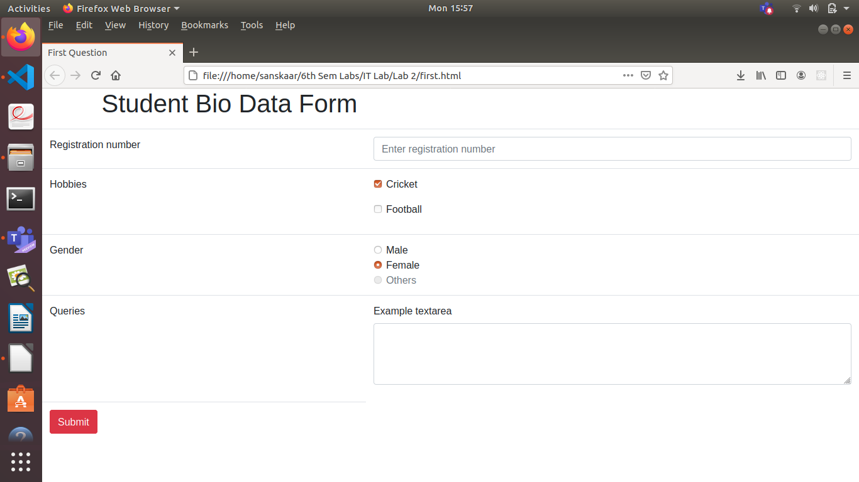
2.CODE
<!DOCTYPE html>
<html lang="en">
<head>
<meta charset="utf-8">
<meta http-equiv="X-UA-Compatible" content="IE=edge">
<meta name="viewport" content="width=device-width, initial-scale=1">
<title>Second Question</title>
<link rel="stylesheet" href="https://fonts.googleapis.com/css?family=Roboto|Varela+Round|Open+Sans">
<link rel="stylesheet" href="https://fonts.googleapis.com/icon?family=Material+Icons">
<link rel="stylesheet" href="https://maxcdn.bootstrapcdn.com/font-awesome/4.7.0/css/font-awesome.min.css">
<link rel="stylesheet" href="https://maxcdn.bootstrapcdn.com/bootstrap/3.3.7/css/bootstrap.min.css">
<script src="https://ajax.googleapis.com/ajax/libs/jquery/1.12.4/jquery.min.js"></script>
<script src="https://maxcdn.bootstrapcdn.com/bootstrap/3.3.7/js/bootstrap.min.js"></script>
<script>
$(document).ready(function(){
$('[data-toggle="tooltip"]').tooltip();
var actions = $("table td:last-child").html();
// Append table with add row form on add new button click
$(".add-new").click(function(){
$(this).attr("disabled", "disabled");
var index = $("table tbody tr:last-child").index();
var row = '<tr>' +
'<td><input type="text" class="form-control" name="name" id="name"></td>' +
'<td><input type="text" class="form-control" name="department" id="department"></td>' +
'<td><input type="text" class="form-control" name="phone" id="phone"></td>' +
'<td>' + actions + '</td>' +
'</tr>';
$("table").append(row);
$("table tbody tr").eq(index + 1).find(".add, .edit").toggle();
$('[data-toggle="tooltip"]').tooltip();
});
// Add row on add button click
$(document).on("click", ".add", function(){
var empty = false;
var input = $(this).parents("tr").find('input[type="text"]');
input.each(function(){
if(!$(this).val()){
$(this).addClass("error");
empty = true;
} else{
$(this).removeClass("error");
}
});
$(this).parents("tr").find(".error").first().focus();
if(!empty){
input.each(function(){
$(this).parent("td").html($(this).val());
});
$(this).parents("tr").find(".add, .edit").toggle();
$(".add-new").removeAttr("disabled");
}
});
// Edit row on edit button click
$(document).on("click", ".edit", function(){
$(this).parents("tr").find("td:not(:last-child)").each(function(){
$(this).html('<input type="text" class="form-control" value="' + $(this).text() + '">');
});
$(this).parents("tr").find(".add, .edit").toggle();
$(".add-new").attr("disabled", "disabled");
});
// Delete row on delete button click
$(document).on("click", ".delete", function(){
$(this).parents("tr").remove();
$(".add-new").removeAttr("disabled");
});
});
</script>
</head>
<body>
<div class="container">
<div class="table-wrapper">
<div class="table-title">
<div class="row">
<div class="col-sm-8"><h2>Employee <b>Details</b></h2></div>
<div class="col-sm-4">
<span class="align-middle"><button type="button" class="btn btn-info add-new"><i class="fa fa-plus "></i> Add New</button>
</span></div>
</div>
</div>
<table class="table table-bordered">
<thead>
<tr>
<th>Name</th>
<th>Department</th>
<th>Phone</th>
<th>Actions</th>
</tr>
</thead>
<tbody>
<tr>
<td>Sanskaar Patni</td>
<td>Administration</td>
<td>(+91) 88888 88888</td>
<td>
<a class="add" title="Add" data-toggle="tooltip"></a>
<a class="edit" title="Edit" data-toggle="tooltip">Edit</a>
<a class="delete" title="Delete" data-toggle="tooltip">Delete</a>
</td>
</tr>
<tr>
<td>Harsh Vardhan Rathore</td>
<td>Customer Service</td>
<td>(+91) 99999 99999</td>
<td>
<a class="add" title="Add" data-toggle="tooltip"></a>
<a class="edit" title="Edit" data-toggle="tooltip">Edit</a>
<a class="delete" title="Delete" data-toggle="tooltip">Delete</a>
</td>
</tr>
<tr>
<td>Neeraja</td>
<td>Human Resources</td>
<td>(+91) 55555 55555</td>
<td>
<a class="add" title="Add" data-toggle="tooltip"></a>
<a class="edit" title="Edit" data-toggle="tooltip">Edit</a>
<a class="delete" title="Delete" data-toggle="tooltip">Delete</a>
</td>
</tr>
</tbody>
</table>
</div>
</div>
</body>
</html>
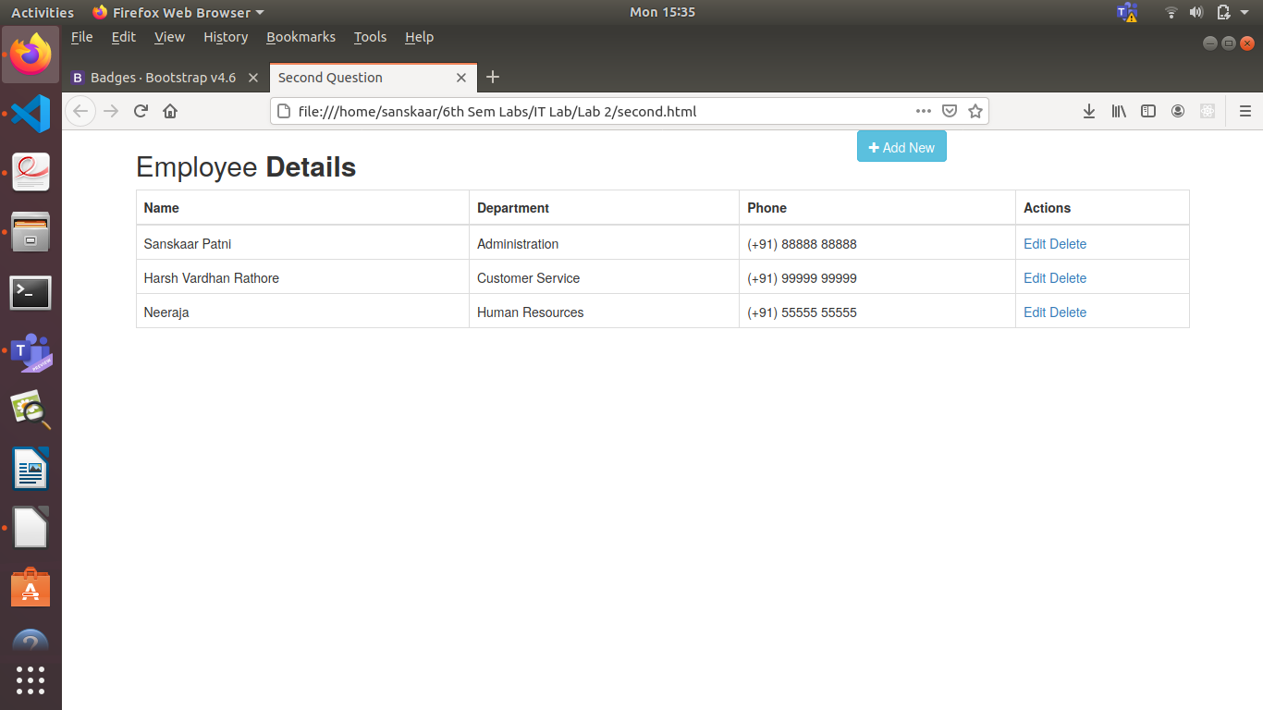

3.CODE
<html lang="en">
<head>
<meta charset="UTF-8" />
<meta http-equiv="X-UA-Compatible" content="IE=edge" />
<meta name="viewport" content="width=device-width, initial-scale=1.0" />
<link
href="https://maxcdn.bootstrapcdn.com/bootstrap/4.4.1/css/bootstrap.min.css"
rel="stylesheet"
/>
<script src="https://ajax.googleapis.com/ajax/libs/jquery/3.4.1/jquery.min.js"></script>
<script src="https://cdnjs.cloudflare.com/ajax/libs/popper.js/1.16.0/umd/popper.min.js"></script>
<script src="https://maxcdn.bootstrapcdn.com/bootstrap/4.4.1/js/bootstrap.min.js"></script>

<title>Third Question</title>
</head>
<body>
<div class="container-fluid">
<div class="row" style="background-color:yellow;height: 50vh;">
<div class="col-sm-12">
<h1 class="text-center">Login</h1>
<input type="email" class="form-control" placeholder="Enter email" id="email" style="margin-bottom: 2%;margin-top: 2%;">
<input type="password" class="form-control" placeholder="Enter password" id="pwd" style="margin-bottom: 2%;margin-top: 2%;">
</div>
</div>
<div class="row">
<div class="col-sm-4">
<form action="/action_page.php">
<div class="form-check">
<label class="form-check-label" for="check1" style="margin-bottom: 2%;margin-top: 2%;">
<input type="checkbox" class="form-check-input" id="check1" name="option1" value="something" checked>Student
</label>
</div>
<div class="form-check">
<label class="form-check-label" for="check2">
<input type="checkbox" class="form-check-input" id="check2" name="option2" value="something">Phd
</label>
</div>
<div class="form-check">
<label class="form-check-label">
<input type="checkbox" class="form-check-input" disabled>Admin
</label>
</div>
</form>
<button type="button" class="btn btn-primary">
Notifications <span class="badge badge-light">4</span>
</button>
</div>
<div class="col-sm-4" style="background-color: green;width: 100%;height: 50vh;">
<p style="font-size:130%;font-weight:bold">Upload ID</p>
<form action="/action_page.php">
<input type="file" id="myFile" name="filename">
</form>
</div>
<div class="col-sm-4" style="background-color: blueviolet;width: 100%;height: 50vh;">
<div class="btn-group" role="group" aria-label="Basic example" style="padding: 40% 0;">
<button type="button" class="btn btn-primary">Register</button>
<button type="button" class="btn btn-secondary">Sign Out</button>
<button type="button" class="btn btn-success">Contact us</button>
</div>
</div>
</div>
</div>
</body>
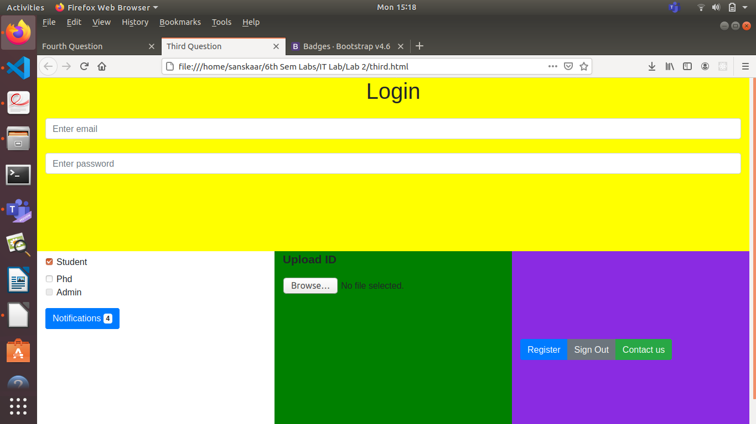

4.CODE
<!DOCTYPE html>
<html lang="en">

<head>
<title>Fourth Question</title>
<meta charset="utf-8">
<meta name="viewport" content="width=device-width, initial-scale=1">
<link rel="stylesheet" href="https://maxcdn.bootstrapcdn.com/bootstrap/4.5.2/css/bootstrap.min.css">
<script src="https://ajax.googleapis.com/ajax/libs/jquery/3.5.1/jquery.min.js"></script>
<script src="https://cdnjs.cloudflare.com/ajax/libs/popper.js/1.16.0/umd/popper.min.js"></script>
<script src="https://maxcdn.bootstrapcdn.com/bootstrap/4.5.2/js/bootstrap.min.js"></script>
</head>

<body>
<br>
<div id="myCarousel" class="carousel slide">
<ul class="carousel-indicators">
<li class="item1 active"></li>
<li class="item2"></li>
</ul>
<div class="carousel-inner">
<div class="carousel-item active center">
<div class="container">
<h4>ONLINE CLASS TIME-TABLE</h4>
<br>
<table class="table table-light table-striped table-bordered">
<thead>
<tr>
<th>DAY</th>
<th>8:00-9:30</th>
<th>10:00-11:30</th>
<th>2:00-3:30</th>
<th>4:00-5:30</th>
</tr>
</thead>
<tbody>
<tr>
<td>Monday</td>
<td></td>
<td></td>
<td>EEFM</td>
<td>DS</td>
</tr>
<tr>
<td>Tuesday</td>
<td>PCAP</td>
<td>PE-I</td>
<td></td>
<td></td>
</tr>
<tr>
<td>Wednesday</td>
<td></td>
<td></td>
<td>PE-II</td>
<td>OE-III</td>
</tr>
<tr>
<td>Thursday</td>
<td>EEFM</td>
<td>DS</td>
<td></td>
<td></td>
</tr>
<tr>
<td>Friday</td>
<td></td>
<td></td>
<td>PCAP</td>
<td>PE-I</td>
</tr>
<tr>
<td>Saturday</td>
<td>PE-II</td>
<td>OE-III</td>
<td></td>
<td></td>
</tr>
<tr>
<td></td>
<td></td>
<td></td>
<td></td>
<td></td>
</tr>
</tbody>
</table>
</div>
</div>
<div class="carousel-item">
<div class="container">
<h4>LAB TIME-TABLE</h4>
<br>
<table class="table table-dark table-striped table-bordered">
<thead>
<tr>
<th>DAY</th>
<th>Software Engineering Lab- 8:00-10:00</th>
<th>DATABASE LAB- 11:00-1:00</th>
<th>PG LAB- 1:00-3:00</th>
</tr>
</thead>
<tbody>
<tr>
<td>Monday</td>
<td></td>
<td>IT LAB</td>
<td></td>
</tr>
<tr>
<td>Tuesday</td>
<td></td>
<td></td>
<td>DS LAB</td>
</tr>
<tr>
<td>Wednesday</td>
<td></td>
<td></td>
<td></td>
</tr>
<tr>
<td>Thursday</td>
<td></td>
<td></td>
<td></td>
</tr>
<tr>
<td>Friday</td>
<td>PCAP LAB</td>
<td></td>
<td></td>
</tr>
<tr>
<td>Saturday</td>
<td></td>
<td></td>
<td></td>
</tr>
<tr>
<td></td>
<td></td>
<td></td>
<td></td>
</tr>
</tbody>
</table>
</div>
</div>
</div>
<a class="carousel-control-prev" href="#myCarousel">
<span class="carousel-control-prev-icon"></span>
</a>
<a class="carousel-control-next" href="#myCarousel">
<span class="carousel-control-next-icon"></span>
</a>
</div>
</div>
<script>
$(document).ready(function() {
// Activate Carousel
$("#myCarousel").carousel();

// Enable Carousel Indicators
$(".item1").click(function() {
$("#myCarousel").carousel(0);
});
$(".item2").click(function() {
$("#myCarousel").carousel(1);
});

// Enable Carousel Controls
$(".carousel-control-prev").click(function() {
$("#myCarousel").carousel("prev");
});
$(".carousel-control-next").click(function() {
$("#myCarousel").carousel("next");
});
});
</script>
</body>

</html>
