1.
// SERVER CODE
#include <stdio.h>
#include <strings.h>
#include <sys/types.h>
#include <arpa/inet.h>
#include <sys/socket.h>
#include <netinet/in.h>
#include <unistd.h>
#define PORT 5000
#define MAXLINE 1000

int main()
{
printf("Server code running\n");
char buffer[100];
int servsockfd, len, n;
struct sockaddr_in servaddr, cliaddr;
bzero(&servaddr, sizeof(servaddr));

// Create a UDP Socket
servsockfd = socket(AF_INET, SOCK_DGRAM, 0);
servaddr.sin_addr.s_addr = htonl(INADDR_ANY);
servaddr.sin_port = htons(PORT);
servaddr.sin_family = AF_INET;
// bind server address to socket descriptor
bind(servsockfd, (struct sockaddr *)&servaddr, sizeof(servaddr));
// infinite loop for chat
for (;;)
{
bzero(buffer, 80);
len = sizeof(cliaddr);
n = recvfrom(servsockfd, buffer, sizeof(buffer), 0, (struct sockaddr *)&cliaddr, &len);
// buffer[n] = '\0';
if ((strncmp(buffer, "exit", 4)) == 0)
{
printf("Client Exit...\n");
break;
}
puts(buffer);
}
// close the descriptor
close(servsockfd);
}

//CLIENT CODE

#include <stdio.h>
#include <strings.h>
#include <sys/types.h>
#include <arpa/inet.h>
#include <sys/socket.h>
#include <netinet/in.h>
#include <unistd.h>
#include <stdlib.h>

#define PORT 5000
#define MAXLINE 1000

// Driver code
int main()
{
char buffer[100];
//char *message = "";
int sockfd, n, len;
struct sockaddr_in servaddr, cliaddr;

// clear servaddr
bzero(&servaddr, sizeof(servaddr));
servaddr.sin_addr.s_addr = htonl(INADDR_ANY);
servaddr.sin_port = htons(PORT);
servaddr.sin_family = AF_INET;

// create datagram socket
sockfd = socket(AF_INET, SOCK_DGRAM, 0);
char buff[100];
for (;;)
{
bzero(buff, sizeof(buff));
printf("Enter matrix row : ");
n = 0;
while ((buff[n++] = getchar()) != '\n')
;
// buff[n] = '\n';
sendto(sockfd, &buff, MAXLINE, 0, (struct sockaddr *)&servaddr, sizeof(servaddr));
if (strncmp(buff, "exit", 4) == 0)
{
printf("Closing..");
break;
}
bzero(buff, sizeof(buff));
len = sizeof(cliaddr);
}

// close the descriptor
close(sockfd);
}
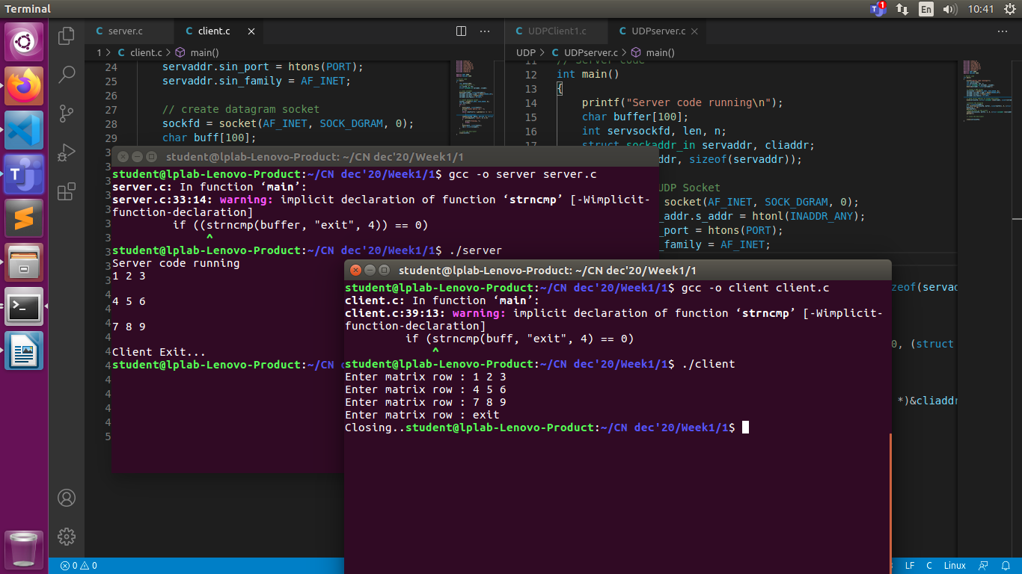

2.
//SERVER CODE

#include <stdio.h>
#include <netdb.h>
#include <netinet/in.h>
#include <stdlib.h>
#include <string.h>
#include <sys/socket.h>
#include <sys/types.h>
#include <ctype.h>
#define MAX 80
#define PORT 8080
#define SA struct sockaddr

// Function designed for chat between client and server.
void servfunc(int sockfd)
{
char buff[MAX];
int n;
// infinite loop for chat
for (;;)
{
bzero(buff, MAX);

// read the message from client and copy it in buffer
read(sockfd, buff, sizeof(buff));
// print buffer which contains the client contents
printf("From client: %s ", buff);

// bzero(buff, sizeof(buff));
// Read server message from keyboard in the buffer
// and send that buffer to client
char ch;
int j = 0;
while (buff[j])
{
ch = buff[j];
buff[j] = toupper(ch);
j++;
}
write(sockfd, buff, sizeof(buff));

// if msg contains "Exit" then server exit and session ended.
if (strncmp("exit", buff, 4) == 0)
{
printf("Server Exit...\n");
break;
}
}
}

// Driver function
int main()
{
int sockfd, connfd, len;
struct sockaddr_in servaddr, cli;

// socket create and verification
sockfd = socket(AF_INET, SOCK_STREAM, 0);
if (sockfd == -1)
{
printf("socket creation failed...\n");
exit(0);
}
else
printf("Socket successfully created..\n");
bzero(&servaddr, sizeof(servaddr));

// assign IP, PORT
servaddr.sin_family = AF_INET;
servaddr.sin_addr.s_addr = htonl(INADDR_ANY);
servaddr.sin_port = htons(PORT);

// Binding newly created socket to given IP and verification
if ((bind(sockfd, (SA *)&servaddr, sizeof(servaddr))) != 0)
{
printf("socket bind failed...\n");
exit(0);
}
else
printf("Socket successfully binded..\n");

// Now server is ready to listen and verification
if ((listen(sockfd, 5)) != 0)
{
printf("Listen failed...\n");
exit(0);
}
else
printf("Server listening..\n");
len = sizeof(cli);

// Accept the data packet from client and verification
connfd = accept(sockfd, (SA *)&cli, &len);
if (connfd < 0)
{
printf("server acccept failed...\n");
exit(0);
}
else
printf("server acccept the client...\n");

// Function for chatting between client and server
servfunc(connfd);

// After sending exit message close the socket
close(sockfd);
}

//CLIENT CODE
#include <netdb.h>
#include <stdio.h>
#include <stdlib.h>
#include <string.h>
#include <sys/socket.h>
#define MAX 80
#define PORT 8080
#define SA struct sockaddr
void clifunc(int sockfd)
{
char buff[MAX];
int n;
int first = 1;
for (;;)
{
bzero(buff, sizeof(buff));
printf("Enter the string : ");
n = 0;
while ((buff[n++] = getchar()) != '\n')
;
// if (first == 1)
// {
// int port = ntohl(sockfd);
// first = 2;
// }
write(sockfd, buff, sizeof(buff));
if ((strncmp(buff, "quit", 4)) == 0)
{
printf("CLOSING..");
break;
}
bzero(buff, sizeof(buff));
read(sockfd, buff, sizeof(buff));
printf("From Server : %s", buff);
}
}

int main()
{
int sockfd, connfd;
struct sockaddr_in servaddr, cli;
// socket create and verification
sockfd = socket(AF_INET, SOCK_STREAM, 0);
if (sockfd == -1)
{
printf("socket creation failed...\n");
exit(0);
}
else
printf("Socket successfully created..\n");
bzero(&servaddr, sizeof(servaddr));

// assign IP, PORT
servaddr.sin_family = AF_INET;
servaddr.sin_addr.s_addr = inet_addr("127.0.0.1");
servaddr.sin_port = htons(PORT);

// connect the client socket to server socket
if (connect(sockfd, (SA *)&servaddr, sizeof(servaddr)) != 0)
{
printf("connection with the server failed...\n");
exit(0);
}
else
printf("connected to the server..\n");

// function for client
clifunc(sockfd);

// close the socket
close(sockfd);
}
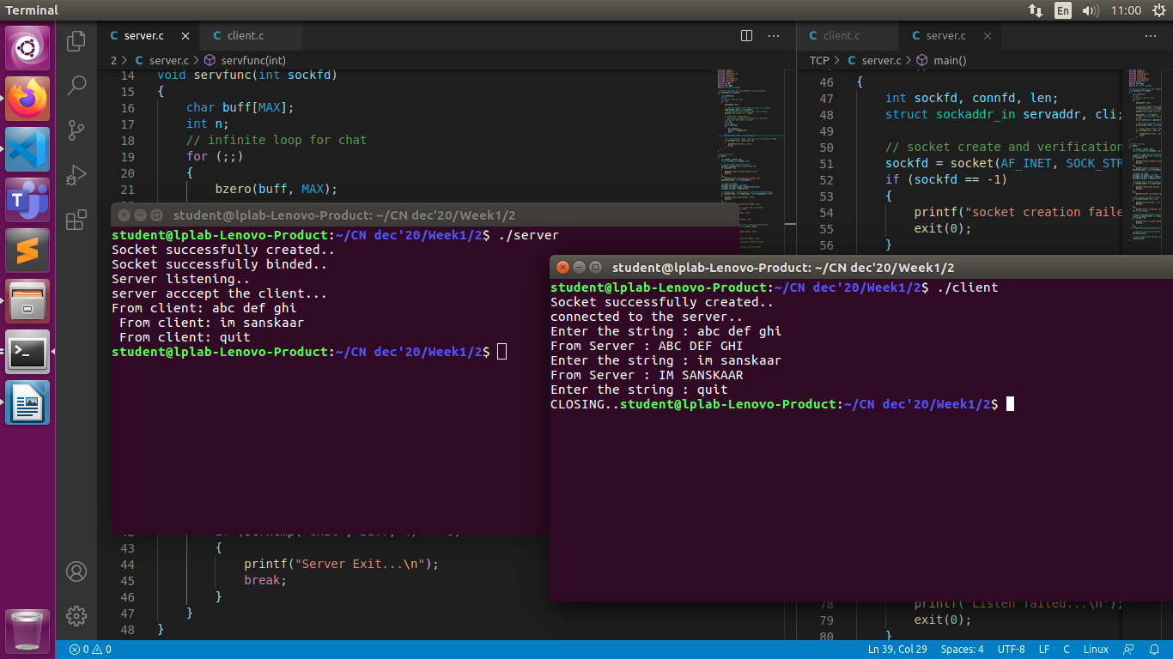

3.
//SERVER CODE

#include <stdio.h>
#include <netdb.h>
#include <netinet/in.h>
#include <stdlib.h>
#include <string.h>
#include <sys/socket.h>
#include <sys/types.h>
#define MAX 80
#define PORT 8080
#define SA struct sockaddr

// Function designed for chat between client and server.
void servfunc(int sockfd)
{
char buff[MAX];
int n;
int num1 = 0;
int num2 = 0;
char op;
int ans = 0;
// infinite loop for chat
for (int i = 0; i <= 2; i++)
{
bzero(buff, MAX);

// read the message from client and copy it in buffer
read(sockfd, buff, sizeof(buff));
// print buffer which contains the client contents
if (i == 0)
{
// for (i = 0; buff[i] != '\0'; i++)
// num1 = 10 * num1 + buff[i] - '0';
sscanf(buff, "%d", &num1);
}
else if (i == 1)
{
op = buff[0];
}
else
{
sscanf(buff, "%d", &num2);
}

bzero(buff, sizeof(buff));
// and send that buffer to client
if (i == 2)
{
if (op == '+')
{
ans = num1 + num2;
}
else if (op == '-')
{
ans = num1 - num2;
}
else if (op == '*')
{
ans = num1 * num2;
}
else if (op == '/')
{
ans = num1 / num2;
}
sprintf(buff, "%ld", ans);
write(sockfd, buff, sizeof(buff));
}
}
}

// Driver function
int main()
{
int sockfd, connfd, len;
struct sockaddr_in servaddr, cli;

// socket create and verification
sockfd = socket(AF_INET, SOCK_STREAM, 0);
if (sockfd == -1)
{
printf("socket creation failed...\n");
exit(0);
}
else
printf("Socket successfully created..\n");
bzero(&servaddr, sizeof(servaddr));

// assign IP, PORT
servaddr.sin_family = AF_INET;
servaddr.sin_addr.s_addr = htonl(INADDR_ANY);
servaddr.sin_port = htons(PORT);

// Binding newly created socket to given IP and verification
if ((bind(sockfd, (SA *)&servaddr, sizeof(servaddr))) != 0)
{
printf("socket bind failed...\n");
exit(0);
}
else
printf("Socket successfully binded..\n");

// Now server is ready to listen and verification
if ((listen(sockfd, 5)) != 0)
{
printf("Listen failed...\n");
exit(0);
}
else
printf("Server listening..\n");
len = sizeof(cli);

// Accept the data packet from client and verification
connfd = accept(sockfd, (SA *)&cli, &len);
if (connfd < 0)
{
printf("server acccept failed...\n");
exit(0);
}
else
printf("server acccept the client...\n");

// Function for chatting between client and server
servfunc(connfd);

// After sending exit message close the socket
close(sockfd);
}

//CLIENT CODE
#include <netdb.h>
#include <stdio.h>
#include <stdlib.h>
#include <string.h>
#include <sys/socket.h>
#define MAX 80
#define PORT 8080
#define SA struct sockaddr
void clifunc(int sockfd)
{
char buff[MAX];
int n;
for (int i = 0; i < 3; i++)
{
bzero(buff, sizeof(buff));
if (i == 0 || i == 2)
printf("Enter the number : ");
else
printf("Enter the operator: ");
n = 0;
while ((buff[n++] = getchar()) != '\n')
;
write(sockfd, buff, sizeof(buff));
bzero(buff, sizeof(buff));
if (i == 2)
{
read(sockfd, buff, sizeof(buff));
printf("Answer from Server : %s", buff);
}
}
}

int main()
{
int sockfd, connfd;
struct sockaddr_in servaddr, cli;
// socket create and verification
sockfd = socket(AF_INET, SOCK_STREAM, 0);
if (sockfd == -1)
{
printf("socket creation failed...\n");
exit(0);
}
else
printf("Socket successfully created..\n");
bzero(&servaddr, sizeof(servaddr));

// assign IP, PORT
servaddr.sin_family = AF_INET;
servaddr.sin_addr.s_addr = inet_addr("127.0.0.1");
servaddr.sin_port = htons(PORT);

// connect the client socket to server socket
if (connect(sockfd, (SA *)&servaddr, sizeof(servaddr)) != 0)
{
printf("connection with the server failed...\n");
exit(0);
}
else
printf("connected to the server..\n");

// function for client
clifunc(sockfd);

// close the socket
close(sockfd);
}
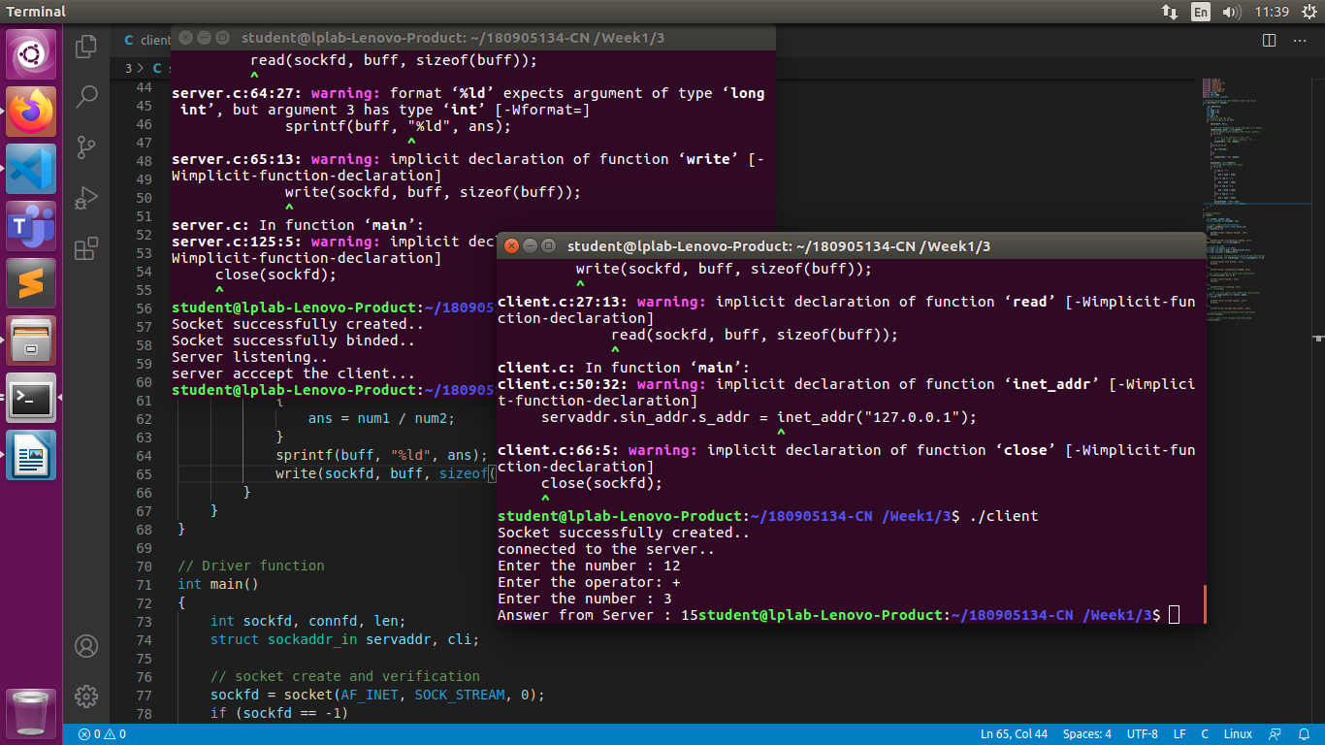

4.
//SERVER CODE
#include <stdio.h>
#include <netdb.h>
#include <netinet/in.h>
#include <stdlib.h>
#include <string.h>
#include <sys/socket.h>
#include <sys/types.h>
#include <time.h>
#define MAX 80
#define PORT 8080
#define SA struct sockaddr

// Function designed for chat between client and server.
void servfunc(int sockfd)
{
char buff[MAX];
int n;
int i = 0;
for (;;)
{
bzero(buff, MAX);
// read the message from client and copy it in buffer
read(sockfd, buff, sizeof(buff));
if (strncmp("time", buff, 4) == 0)
{
printf("Server Exit...\n");
break;
}
bzero(buff, sizeof(buff));

// Read server message from keyboard in the buffer
// n = 0;
// while ((buff[n++] = getchar()) != '\n')
// ;
// and send that buffer to client
time_t rawtime;
struct tm *info;
time(&rawtime);
info = localtime(&rawtime);
// printf("Current local time and date: %s", asctime(info));
write(sockfd, asctime(info), sizeof(asctime(info)));
i++;
}
}

// Driver function
int main()
{
int sockfd, connfd, len;
struct sockaddr_in servaddr, cli;

// socket create and verification
sockfd = socket(AF_INET, SOCK_STREAM, 0);
if (sockfd == -1)
{
printf("socket creation failed...\n");
exit(0);
}
else
printf("Socket successfully created..\n");
bzero(&servaddr, sizeof(servaddr));

// assign IP, PORT
servaddr.sin_family = AF_INET;
servaddr.sin_addr.s_addr = htonl(INADDR_ANY);
servaddr.sin_port = htons(PORT);

// Binding newly created socket to given IP and verification
if ((bind(sockfd, (SA *)&servaddr, sizeof(servaddr))) != 0)
{
printf("socket bind failed...\n");
exit(0);
}
else
printf("Socket successfully binded..\n");

// Now server is ready to listen and verification
if ((listen(sockfd, 5)) != 0)
{
printf("Listen failed...\n");
exit(0);
}
else
printf("Server listening..\n");
len = sizeof(cli);

// Accept the data packet from client and verification
connfd = accept(sockfd, (SA *)&cli, &len);
if (connfd < 0)
{
printf("server acccept failed...\n");
exit(0);
}
else
printf("server acccept the client...\n");

// Function for chatting between client and server
servfunc(connfd);

// After sending exit message close the socket
close(sockfd);
}

//CLIENT CODE
#include <netdb.h>
#include <stdio.h>
#include <stdlib.h>
#include <string.h>
#include <sys/socket.h>
#define MAX 80
#define PORT 8080
#define SA struct sockaddr
void clifunc(int sockfd)
{
char buff[MAX];
int n;
for (;;)
{
bzero(buff, sizeof(buff));
printf("Enter the string : ");
n = 0;
while ((buff[n++] = getchar()) != '\n')
;
write(sockfd, buff, sizeof(buff));
if ((strncmp(buff, "exit", 4)) == 0)
{
printf("Client Exit...\n");
break;
}
bzero(buff, sizeof(buff));
read(sockfd, buff, sizeof(buff));
printf("From Server : %s", buff);
}
}

int main()
{
int sockfd, connfd;
struct sockaddr_in servaddr, cli;
// socket create and verification
sockfd = socket(AF_INET, SOCK_STREAM, 0);
if (sockfd == -1)
{
printf("socket creation failed...\n");
exit(0);
}
else
printf("Socket successfully created..\n");
bzero(&servaddr, sizeof(servaddr));

// assign IP, PORT
servaddr.sin_family = AF_INET;
servaddr.sin_addr.s_addr = inet_addr("127.0.0.1");
servaddr.sin_port = htons(PORT);

// connect the client socket to server socket
if (connect(sockfd, (SA *)&servaddr, sizeof(servaddr)) != 0)
{
printf("connection with the server failed...\n");
exit(0);
}
else
printf("connected to the server..\n");

// function for client
clifunc(sockfd);

// close the socket
close(sockfd);
}

