SANSKAAR PATNI 180905134 C-23

LAB 1:

1. GREP
#include <stdio.h> // for printf and all
#include <stdlib.h> //for exit
// #include <unistd.h>
#include <fcntl.h> // for file functions
// #include <sys/stat.h>
#include <string.h> //for string functions

int main(int argc, char *argv[])
{
if (argc < 3)
{
write(2, "Command requires 3 arguments\n", 30);
exit(1);
}
int fd = open(argv[2], O_RDONLY);
if (fd == -1)
{
write(2, "Source file does not exist\n", 27);
exit(1);
}
char line[100] = "";
char c;
int no_of_lines = 0;
while (read(fd, &c, 1) == 1)
{
if (c != '\n')
{
strncat(line, &c, 1); //Appends one character to line string
}
else
{
no_of_lines++;
if (strstr(line, argv[1]) != NULL)
{
printf("Line %d: %s\n", no_of_lines, line);
}
line[0] = '\0';
}
}
close(fd);
return 0;
}
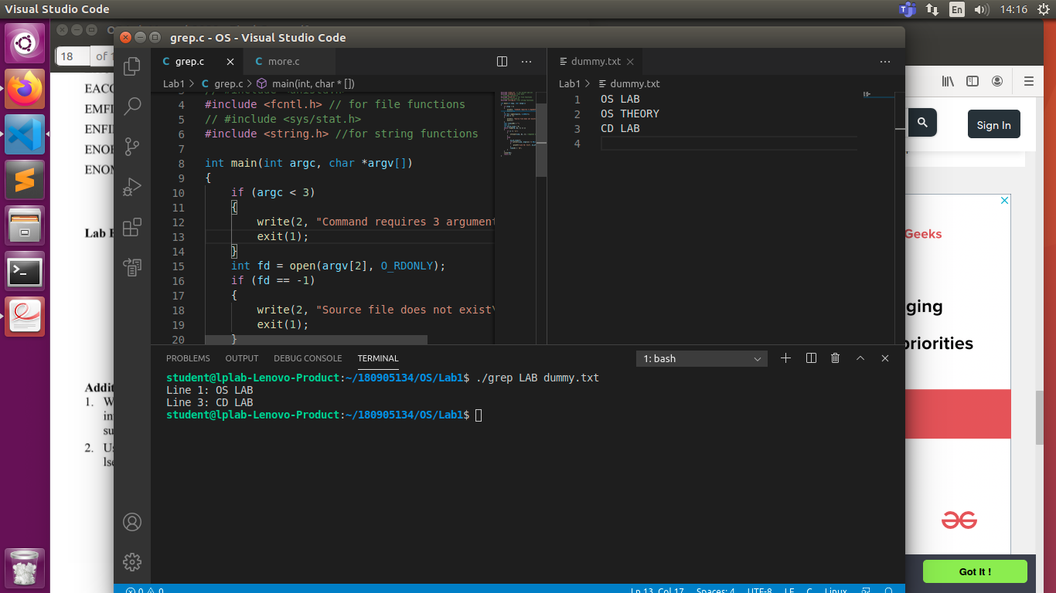

2. MORE

#include <stdio.h> // for printf and all
#include <stdlib.h> //for exit
#include <fcntl.h> // for file functions
#include <string.h> //for string functions

int main(int argc, char *argv[])
{
if (argc < 2)
{
write(2, "Command requires atleast 1 filename and a line stop count", 100);
exit(1);
}
int stopCount = atoi(argv[1]);
int line_count = 0; //for comparing it with stopCount
for (int i = 2; i < argc; i++)
{
int fd = open(argv[i], O_RDONLY);
if (fd == -1)
{
write(2, "Source file does not exist\n", 27);
continue;
}
int line_number = 0; //Line number
char line[100] = "";
char c;
while (read(fd, &c, 1) == 1)
{
if (c != '\n')
{
strncat(line, &c, 1); //Appends one character to line string
}
else
{
line_count++;
line_number++;
printf("Line %d: %s\n", line_number, line);
line[0] = '\0';
if (line_count == stopCount)
{
line_count = 0;
printf("Press Any Key to continue....");
scanf("%c", &c);
}
}
}
close(fd);
}
exit(0);
}

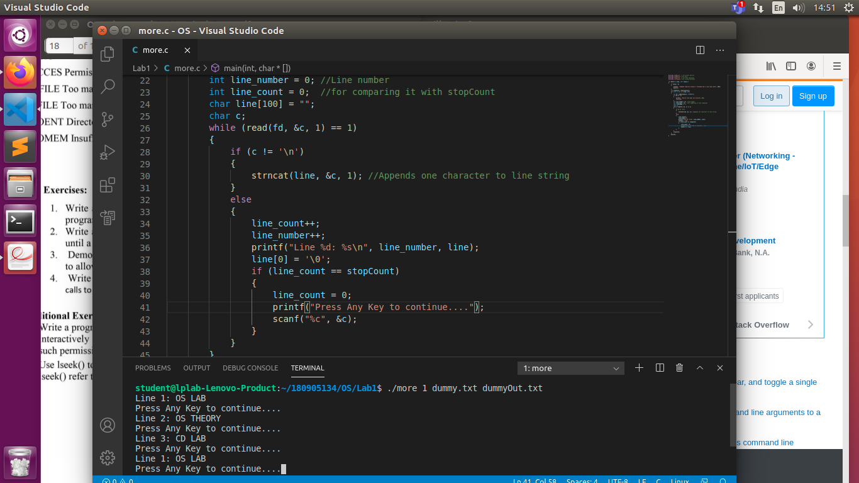
3. CONVERSION SPECIFIERS
#include <stdio.h>
#include <errno.h>
int main(int argc, char const *argv[])
{
int x = -23;
unsigned int y = 23;
float z = 23.23;
double d = 2323.23;
char c = 'x';
char str[] = "Hello world!";
errno = EPERM;
printf("Integer: %d\n", x);
printf("unsigned Integer %u\n", y);
printf("Hexadecimal versionsof both: %#x %#x\n", x, y);
printf("float: %f\n", z);
printf("double %3.3lf\n", d);
printf("STRING %s\n", str);
printf("CHAR %c\n", c);
printf("ERR %m\n");
return 0;
}
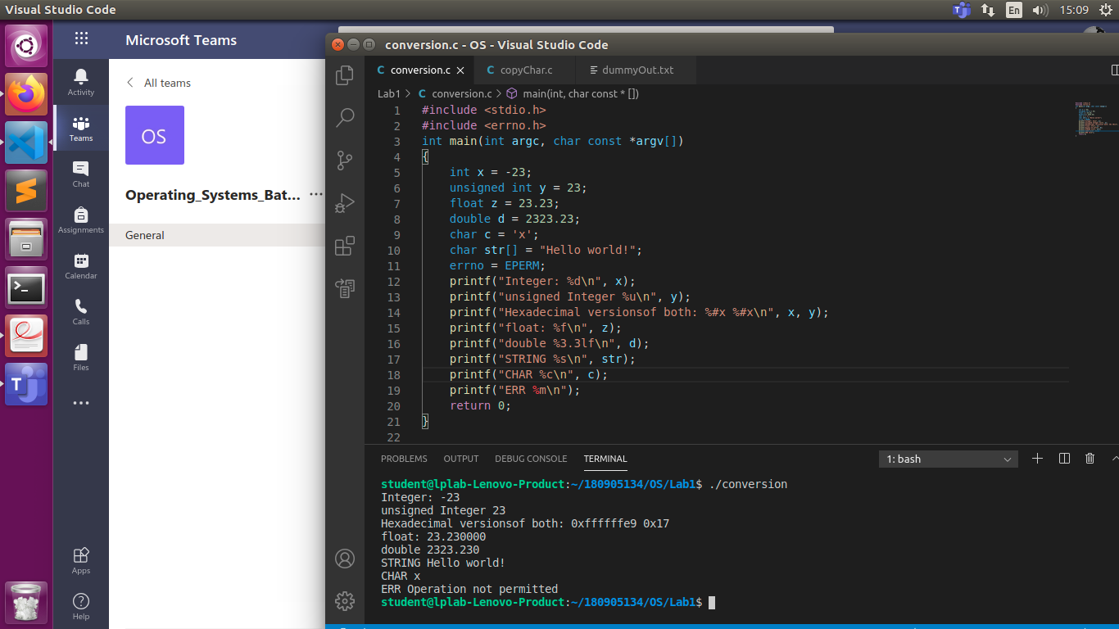
4.COPY CHAR USING stdio.h
#include <unistd.h>
#include <sys/stat.h>
#include <fcntl.h>
#include <stdlib.h>
#include <stdio.h>

int main(int argc, char const *argv[])
{
if (argc != 3)
{
printf("Provide 2 files names\n");
exit(1);
}
FILE *in, *out; // file descriptors
in = (FILE *)fopen(argv[1], "r");
out = (FILE *)fopen(argv[2], "w+");
while (1)
{
if (feof(in))
break;
fputc(fgetc(in), out);
}
fclose(in);
fclose(out);
return 0;
}
