SANSKAAR PATNI
180905134 C-23
OS LAB2

1. ls -l
#include <unistd.h>
#include <stdio.h> // for printf and all
#include <dirent.h> // for directory functions
#include <stdlib.h> //for exit
#include <sys/stat.h>
#include <string.h> //for string functions

void printdir(char *dir)
{
DIR *dp;
struct dirent *entry;
struct stat statbuf;
if ((dp = opendir(dir)) == NULL)
{
fprintf(stderr, "cannot open directory:%s\n", dir);
return;
}
chdir(dir);
while ((entry = readdir(dp)) != NULL)
{
if (strcmp(".", entry->d_name) == 0 || strcmp("..", entry->d_name) == 0)
continue;
lstat(entry->d_name, &statbuf);
printf((S_ISDIR(statbuf.st_mode)) ? "d" : "-");
printf((statbuf.st_mode & S_IRUSR) ? "r" : "-");
printf((statbuf.st_mode & S_IWUSR) ? "w" : "-");
printf((statbuf.st_mode & S_IXUSR) ? "x" : "-");
printf((statbuf.st_mode & S_IRGRP) ? "r" : "-");
printf((statbuf.st_mode & S_IWGRP) ? "w" : "-");
printf((statbuf.st_mode & S_IXGRP) ? "x" : "-");
printf((statbuf.st_mode & S_IROTH) ? "r" : "-");
printf((statbuf.st_mode & S_IWOTH) ? "w" : "-");
printf((statbuf.st_mode & S_IXOTH) ? "x" : "-");
printf("\t%s\n", entry->d_name);
}
chdir("..");
closedir(dp);
}

int main()
{
printdir("/home/sanskaar/180905134-OS");
}
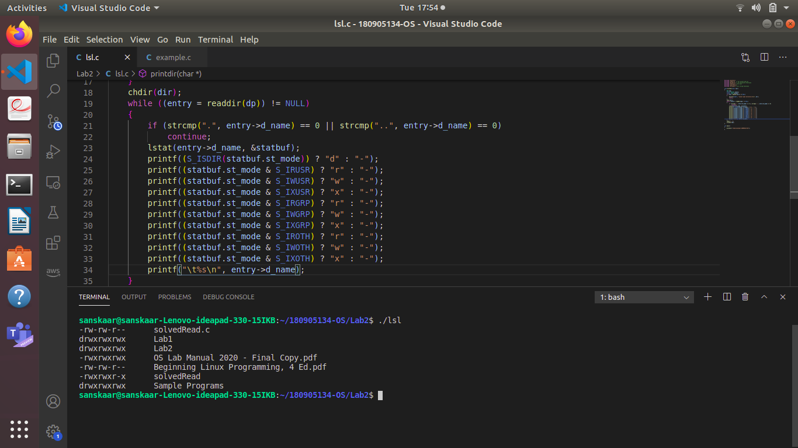
2.Simulate file tree

#include <unistd.h>
#include <sys/stat.h>
#include <stdlib.h>
#include <stdio.h>
#include <string.h>
#include <dirent.h>
void printdir(char *dir, int depth)
{
DIR *dp;
struct dirent *entry;
struct stat statbuf;
if ((dp = opendir(dir)) == NULL)
{
fprintf(stderr, "cannot open directory: %s\n", dir);
return;
}
chdir(dir);
while ((entry = readdir(dp)) != NULL)
{
lstat(entry->d_name, &statbuf);
if (S_ISDIR(statbuf.st_mode))
{
if (strcmp(".", entry->d_name) == 0 || strcmp("..", entry->d_name) == 0)
continue;
printf("%*s%s/\n", depth, " ", entry->d_name);
printdir(entry->d_name, depth + 4);
}
else
printf("%*s%s/\n", depth, " ", entry->d_name);
}
chdir("..");
closedir(dp);
}

int main(int argc, char const *argv[])
{
if (argc == 2)
{
char *dir = (char *)argv[1];
printdir(dir, 0);
}
else
printdir("/home", 0);
exit(0);
}
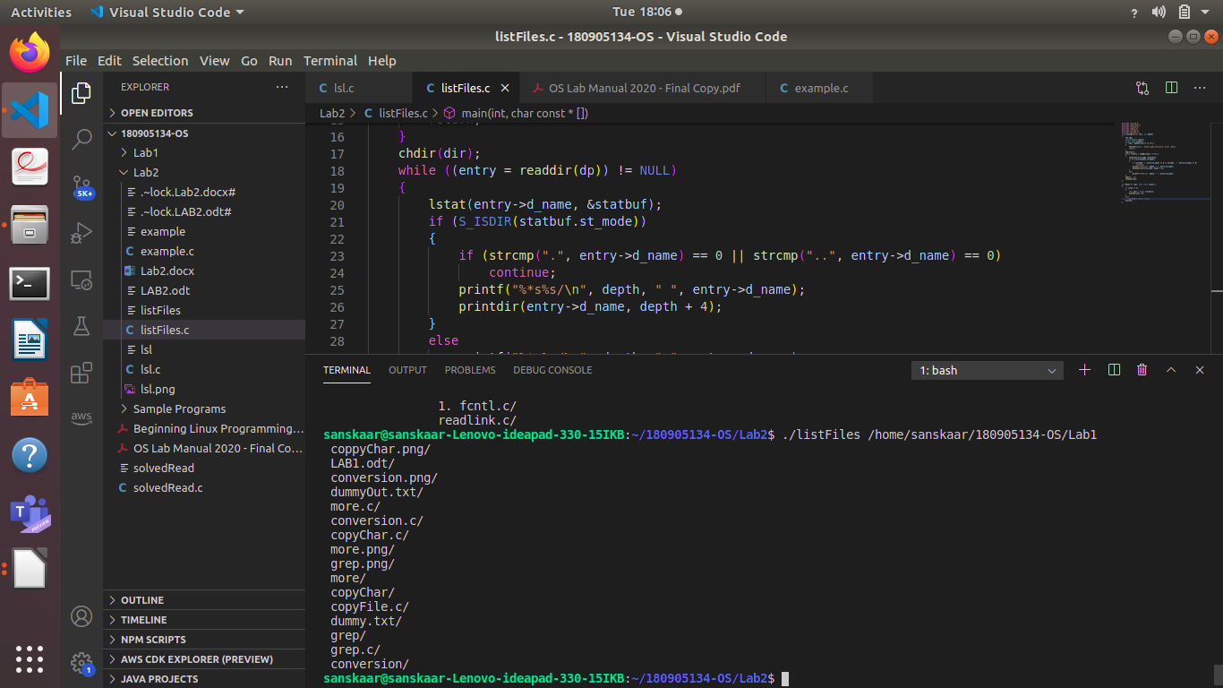
3.LIST ALL INSTALLED PACKAGES
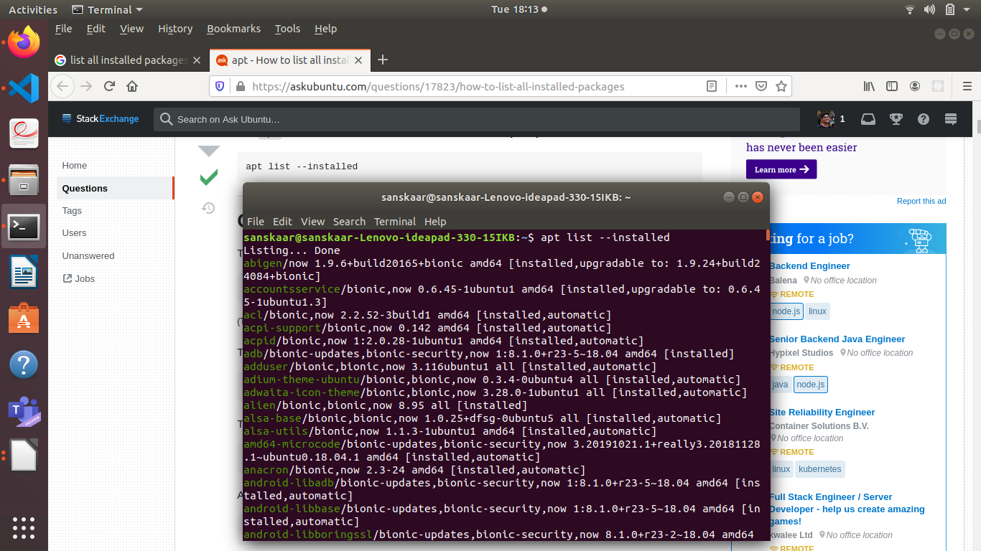
apt list –installed

4.LIST ALL INSTALLED RPM PACKAGES
rpm -qa
o/p No RPM PACKAGES INSTALLED
