Abhinav Bhat
180905087
Roll No: 17
CSE C 5th semester

LAB 07

Question 1:
//run using gcc -o pc pc.c -lpthread
#include <stdio.h>
#include <pthread.h>
#include <semaphore.h>
#include <unistd.h>

int buf[10],f,r;
sem_t mutex,full,empty;

void *produce(void *arg)
{
int i;
for(i=0;i<10;i++)
{
sem_wait(&empty);
sem_wait(&mutex);
printf("Produced: %d\n",i);
buf[(++r)%10]=i;
sleep(1);
sem_post(&mutex);
sem_post(&full);
}
}

void *consume(void *arg)
{
int item,i;
for(i=0;i<10;i++)
{
sem_wait(&full);
sem_wait(&mutex);
item = buf[(++f)%10];
printf("Consumed: %d\n",item);
sleep(2);
sem_post(&mutex);
sem_post(&empty);
}
}

int main()
{
pthread_t tid1,tid2;
sem_init(&mutex,0,1);
sem_init(&full,0,10);
sem_init(&empty,0,10);
pthread_create(&tid1,NULL,produce,NULL);
pthread_create(&tid2,NULL,consume,NULL);
pthread_join(tid1,NULL);
pthread_join(tid1,NULL);
}

OUTPUT:-

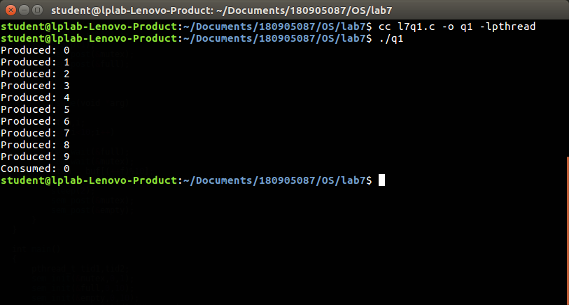

Question 2:-

//run using gcc -o rw rw.c -lpthread
#include <pthread.h>
#include <semaphore.h>
#include <stdio.h>

sem_t wrt;
pthread_mutex_t mutex;
int cnt = 1;
int numreader = 0;

void *writer(void *wno)
{
sem_wait(&wrt);
cnt = cnt*2;
printf("Writer %d modified cnt to %d\n",(*((int *)wno)),cnt);
sem_post(&wrt);

}
void *reader(void *rno)
{
pthread_mutex_lock(&mutex);
numreader++;
if(numreader == 1) {
sem_wait(&wrt);
}
pthread_mutex_unlock(&mutex);
printf("Reader %d: read cnt as %d\n",*((int *)rno),cnt);
pthread_mutex_lock(&mutex);
numreader--;
if(numreader == 0) {
sem_post(&wrt);
}
pthread_mutex_unlock(&mutex);
}

int main()
{
pthread_t read[10],write[5];
pthread_mutex_init(&mutex, NULL);
sem_init(&wrt,0,1);
int a[10] = {1,2,3,4,5,6,7,8,9,10};
for(int i = 0; i < 10; i++) {
pthread_create(&read[i], NULL, (void *)reader, (void *)&a[i]);
}
for(int i = 0; i < 5; i++) {
pthread_create(&write[i], NULL, (void *)writer, (void *)&a[i]);
}
for(int i = 0; i < 10; i++) {
pthread_join(read[i], NULL);
}
for(int i = 0; i < 5; i++) {
pthread_join(write[i], NULL);
}
pthread_mutex_destroy(&mutex);
sem_destroy(&wrt);
return 0;
}

OUTPUT:-

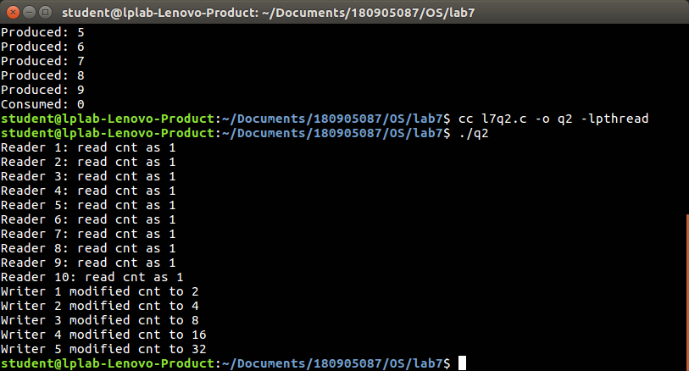

Question 3:-

//run using gcc -o dl dl.c -lpthread
#include <stdio.h>
#include <unistd.h>
#include <pthread.h>
#include <sys/sem.h>
#define PERMS 0660

int semId;
int initSem(int semId, int semNum, int initValue)
{
return semctl(semId, semNum, SETVAL, initValue);
}

int P(int semId, int semNum)
{
struct sembuf operationList[1];
operationList[0].sem_num = semNum;
operationList[0].sem_op = -1;
operationList[0].sem_flg = 0;
return semop(semId, operationList, 1);
}

int V(int semId, int semNum)
{
struct sembuf operationList[1];
operationList[0].sem_num = semNum;
operationList[0].sem_op = 1;
operationList[0].sem_flg = 0;
return semop(semId, operationList, 1);
}

void* funcA(void* nothing)
{
printf("Thread A try to lock 0...\n");
P(semId, 0);
printf("Thread A locked 0.\n");
usleep(50*1000);
printf("Thread A try to lock 1...\n");
P(semId, 1);
printf("Thread A locked 1.\n");
V(semId, 0);
V(semId, 1);
return NULL;
}

void* funcB(void* nothing)
{
printf("Thread B try to lock 1...\n");
P(semId, 1);
printf("Thread B locked 1.\n");
usleep(5*1000);
printf("Thread B try to lock 0...\n");
P(semId, 0);
printf("Thread B locked 0.\n");
V(semId, 0);
V(semId, 1);
return NULL;
}

int main(int argc, char* argv[])
{
int i;
semId = semget(ftok(argv[0], 'A'), 2, IPC_CREAT | PERMS);
initSem(semId, 0, 1);
initSem(semId, 1, 1);
pthread_t thread[2];
pthread_create(&thread[0], NULL, funcA, NULL);
pthread_create(&thread[1], NULL, funcB, NULL);
for (i = 0 ; i < 2 ; i++)
{
pthread_join(thread[i], NULL);
}
printf("This is not printed in case of deadlock\n");
semctl(semId, 0, IPC_RMID, 0);
semctl(semId, 1, IPC_RMID, 0);
return 0;
}
OUTPUT:-

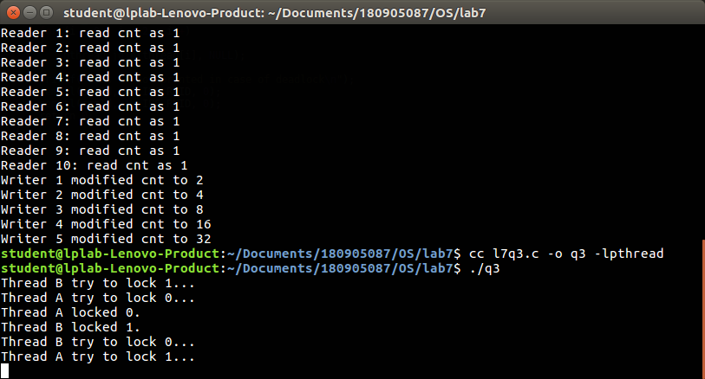

Question 4:-

//run using gcc -o sb sb.c -lpthread
#define MAX 20
#include <stdio.h>
#include <unistd.h>
#include <stdlib.h>
#include <pthread.h>
#include <semaphore.h>

void *client(void *param);
void *barber(void *param);

sem_t chairs_mutex;
sem_t sem_client;
sem_t sem_barber;
int num_chairs;
int clientWait;
int main(int argc, char *argv[]) {
pthread_t barberid;
pthread_t clientids[MAX];
printf("Main thread beginning\n");
int runTime,clients,i;
if (argc != 5){
printf("Please enter 4 arguments: <Program run time> <Number of clients>\n");
printf("<Number of chairs> <Client wait time>\n");
exit(0);
}
runTime = atoi(argv[1]);
clients = atoi(argv[2]);
num_chairs = atoi(argv[3]);
clientWait = atoi(argv[4]);
sem_init(&chairs_mutex,0,1);
sem_init(&sem_client,0,0);
sem_init(&sem_barber,0,0);
pthread_create(&barberid, NULL, barber, NULL);
printf("Creating barber thread with id %lu\n",barberid);
for (i = 0; i < clients; i++){
pthread_create(&clientids[i], NULL, client, NULL);
printf("Creating client thread with id %lu\n",clientids[i]);
}
printf("Main thread sleeping for %d seconds\n", runTime);
sleep(runTime);
printf("Main thread exiting\n");
exit(0);
}

void *barber(void *param) {
int worktime;

while(1) {
sem_wait(&sem_client);
sem_wait(&chairs_mutex);
num_chairs += 1;
printf("Barber: Taking a client. Number of chairs available = %d\n",num_chairs);
sem_post(&sem_barber);
sem_post(&chairs_mutex);
worktime = (rand() % 4) + 1;
printf("Barber: Cutting hair for %d seconds\n", worktime);
sleep(worktime);
}
}

void *client(void *param) {
int waittime;

while(1) {
sem_wait(&chairs_mutex);
if(num_chairs <= 0){
printf("Client: Thread %u leaving with no haircut\n", (unsigned int)pthread_self());
sem_post(&chairs_mutex);
}
else{
num_chairs -= 1;
printf("Client: Thread %u Sitting to wait. Number of chairs left = %d\n",(unsigned int)pthread_self(),num_chairs);
sem_post(&sem_client);
sem_post(&chairs_mutex);
sem_wait(&sem_barber);
printf("Client: Thread %u getting a haircut\n",(unsigned int)pthread_self());
}
waittime = (rand() % clientWait) + 1;
printf("Client: Thread %u waiting %d seconds before attempting next haircut\n",(unsigned int)pthread_self(),waittime);
sleep(waittime);
}
}
OUTPUT:-

