OS Lab 7
Q1
Code :
#include<stdio.h>
#include<pthread.h>
#include<stdlib.h>
#include <string.h>

void *thread_code(void *param)
{
int n = (int)param;
printf("%d \n",n);
int first = 1;
int second = 1;
int arr[n];
arr[0] = first;
arr[1] = second;
for(int i=2;i<n;i++)
{
int sum = first+second;
first = second;
second = sum;
arr[i] = sum;
}
int *soln = (int *)malloc(n*sizeof(int));
memcpy(soln, arr, sizeof(int) * n);
return soln;
}

int main(int argc, char const *argv[])
{
pthread_t thread;
int n = argv[1][0]-'0';
void * arr;

printf("N in main %d\n",n );
pthread_create(&thread,0,&thread_code,(void *)n);
printf("Thread created\n");
pthread_join(thread,&arr);
int *arr2 = arr;
for(int i=0;i<n;i++)
{
printf("%d ",(int)arr2[i]);
}
return 0;
}
SS :
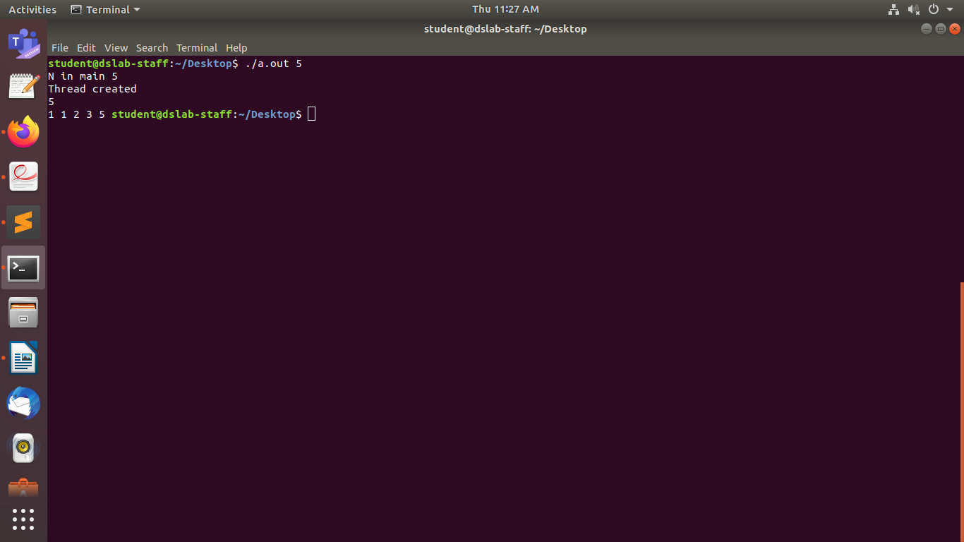

Q2
#include<stdio.h>
#include<pthread.h>

void *thread_code(void *arr)
{
int sum = 0;
int n = (int)arr;

for(int i=1;i<=n;i++)
{
sum += i;
}

return (void *)sum;
}

int main()
{
pthread_t thread;
printf("Enter the number of elements \n");
int n,ans;
void *ans2;
scanf("%d",&n);

pthread_create(&thread,0,&thread_code,(void *)n);
printf("Thread created successfully\n");
pthread_join(thread,(void **)&ans);

printf("The result is %d\n",(int)ans );
}
SS :
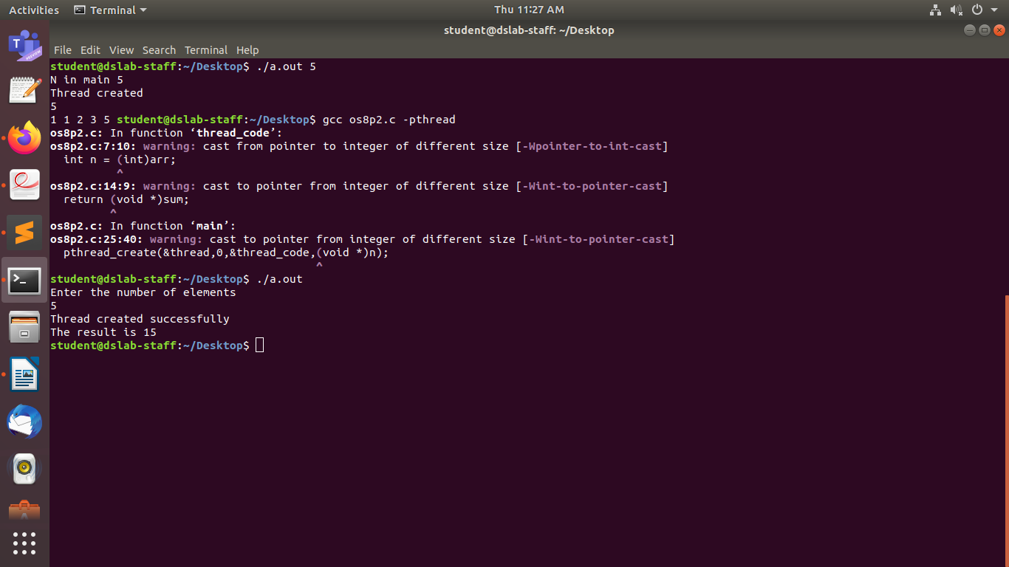

Q3:

#include<stdio.h>
#include<pthread.h>
#include<stdlib.h>
#include <string.h>

void *func(void **arr2)
{
int * arr = (int *)arr2;
int l = arr[0];
int h = arr[1];
for(int i=l;i<=h;i++)
{
int flag = 0;
for(int j=2;j<=i/2;j++)
{
if((i%j)==0)
{
flag = 1;
break;
}
}
if(flag == 0)
{
printf("%d ",i);
}
}
return;
}

int main()
{
int l,h;
pthread_t thread;
printf("Enter the limits \n");
scanf("%d%d",&l,&h);

int arr[2];
arr[0] = l;
arr[1] = h;

pthread_create(&thread,0,&func,(void **)arr);
pthread_join(thread,NULL);
}

SS :
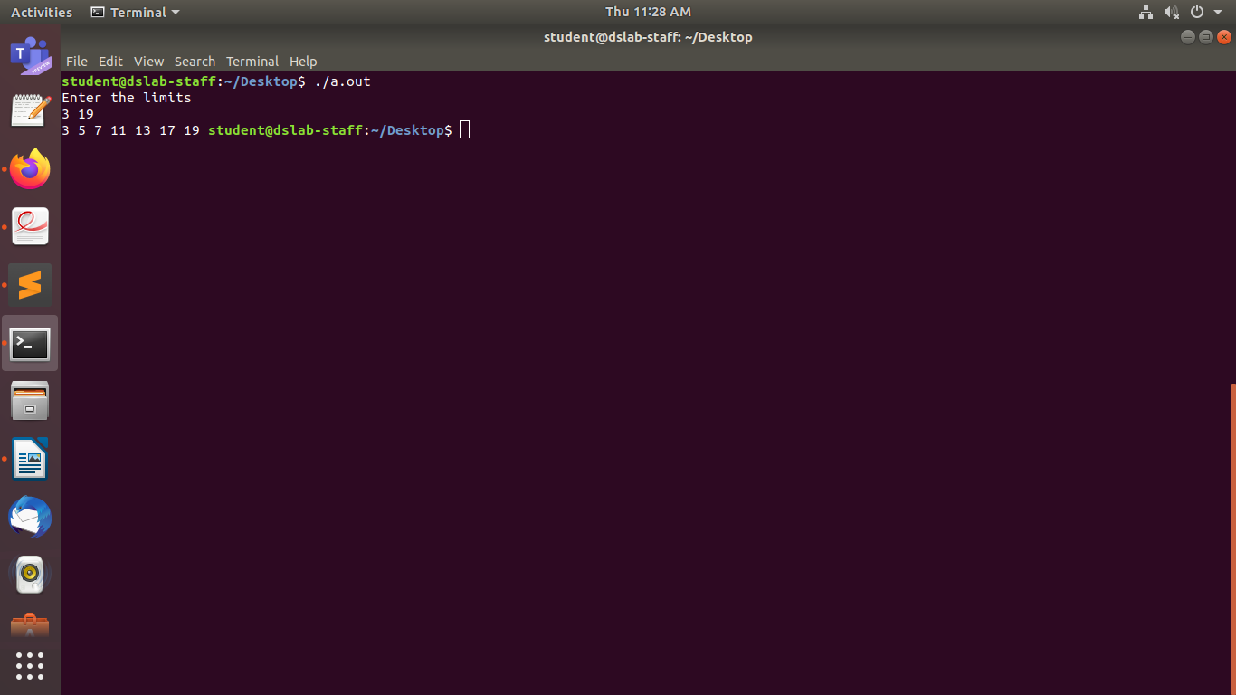

Q4 :
#include<stdio.h>
#include<pthread.h>
#include<stdlib.h>
#include <string.h>

void *evenF(void **arr2)
{

int *arr = (int *)arr2;
int n = arr[0];
printf("n = %d\n", n);
int sum = 0;
for(int i=1;i<=n;i++)
{
if(arr[i]%2==0)
sum+=arr[i];
}
return (void *)sum;
}

void *oddF(void **arr2)
{
int *arr = (int *)arr2;
int n = arr[0];
int sum = 0;
for(int i=1;i<=n;i++)
{
if(arr[i]%2==1)
sum+=arr[i];
}
return (void *)sum;
}

int main()
{
pthread_t thread1,thread2;
int n,even,odd;
printf("Enter number of elements \n");
scanf("%d",&n);
printf("Enter the elements \n");
int arr[n+1];
arr[0] = n;
for(int i=1;i<=n;i++)
scanf("%d",&arr[i]);
pthread_create(&thread1,0,&evenF,(void **)arr);
pthread_create(&thread2,0,&oddF,(void **)arr);

pthread_join(thread1,(void **)&even);
pthread_join(thread2,(void **)&odd);
printf("Sum of even numbers is %d \n", (int)even);
printf("Sum of odd numbers is %d \n", (int)odd);
}

SS :
