SANSKAAR PATNI
DS LAB 2
180905134 CSE C -23

1.CODE
import pandas as pd
import numpy as np
s=pd.Series([3,9,-2,10,5])
print("Total Sum: ",s.sum())
print("Minimum: ",s.min())
print("Maximum: ",s.max())

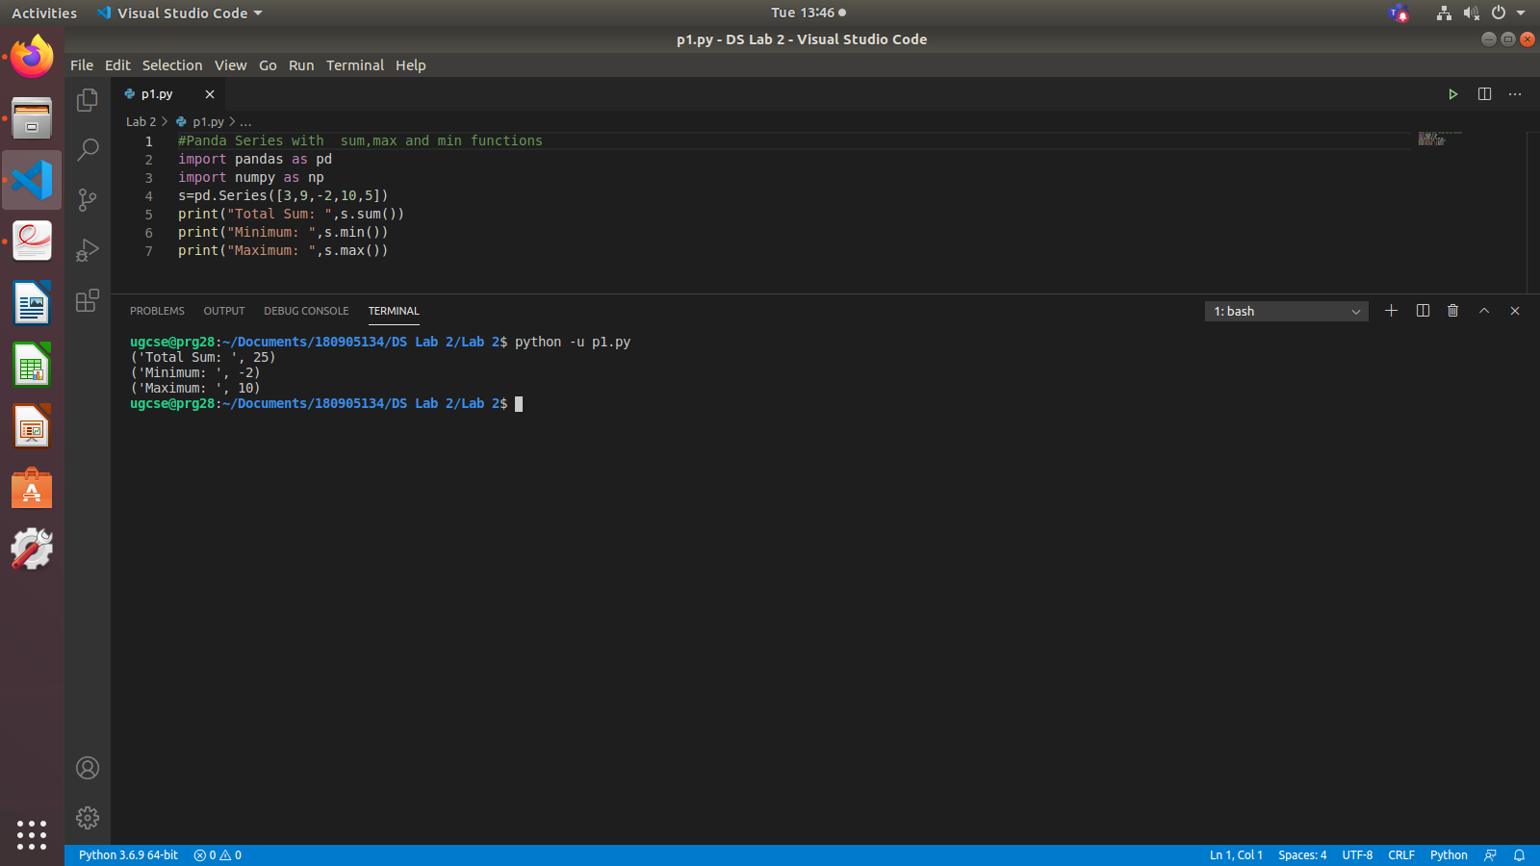
2.CODE

import pandas as pd
data=[['Dinesh',10],['Nithya',12],['Raji',13]]
df=pd.DataFrame(data,columns=['Name','Age'])
print("Normal Dataframe")
print(df)

print("\nIndexed Data Frame")
data = {'Name':['Kavitha', 'Sudha', 'Raju','Vignesh'],'Age':[28,34,29,42]}
df = pd.DataFrame(data, index=['rank-1','rank-2','rank-3','rank-4'])
print(df)

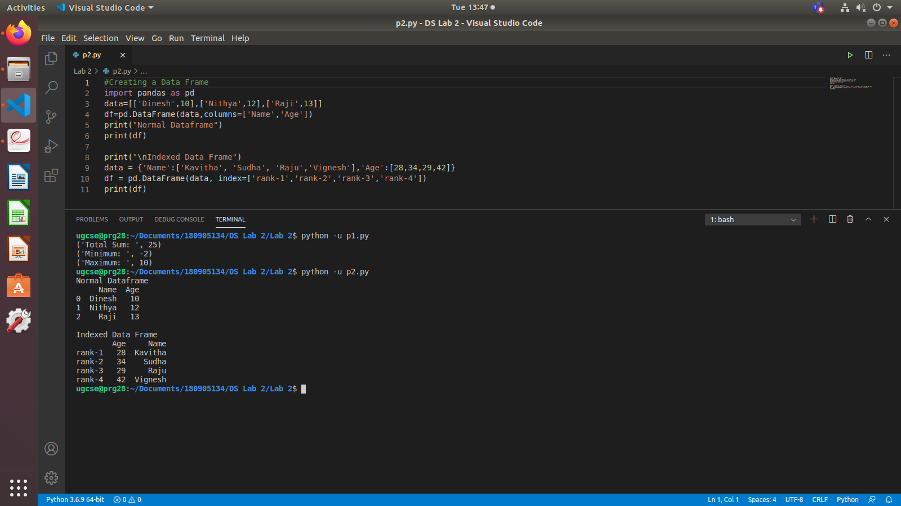
3.CODE
import pandas as pd
import numpy as np
df1=pd.DataFrame({
'A':pd.Timestamp('20130102'),
'B':np.array([3,2,1,3]),
'C':pd.Categorical(['Male','Female','Male','Female'])
})
print(df1)
print("Number of Rows and Columns in data frame using shape tuple: ",df1.shape)
print("Display first five records: head()")
print(df1.head())
print("Display last five records: tail()")
print(df1.tail())
print(df1.dtypes)
print(df1.describe())

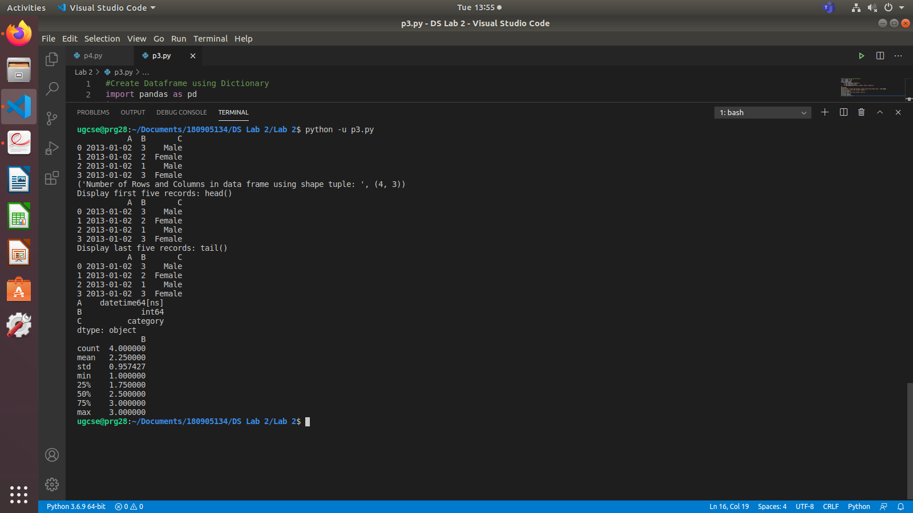
4.CODE
#Creating Dataframe using randomn values
import pandas as pd
import numpy as np
#generates 100 randomn days
dates=pd.date_range('20130101',periods=10)
print(dates)
df=pd.DataFrame(np.random.randn(10,4),index=dates,columns=list('ABCD'))
print(df)
print("First five records of data frame: head()")
print(df.head())
print("Last five records of data frame: tail()")
print(df.tail())
print("To print the list of index: index tuple object")
print(df.index)
print("To view column names: columns tuple")
print(df.columns)
print("Sorting by Axis: ")
print(df.sort_index(axis=1,ascending=False))
print("Slicing the rows: Displaying first 3 rows")
print(df[0:3])
print("Slicing the rows with index range: 2013-01-05 TO 2013-01-10")
print(df['20130105':'20130110'])
print("Slicing with row and Column Index: df.iloc[0]- fetches first row")
print("Third row with df.iloc[2]\n",df.iloc[2])
print('Selecting a single column of A,B,C D: "A"\n',df['A'])
print('Selecting more than one column of A,B,C D: "A" & "B"\n',df[['A','B']])
print("Selecting 2 or more columns with fixed number of rows\n",df[['A','B','C']][:5])

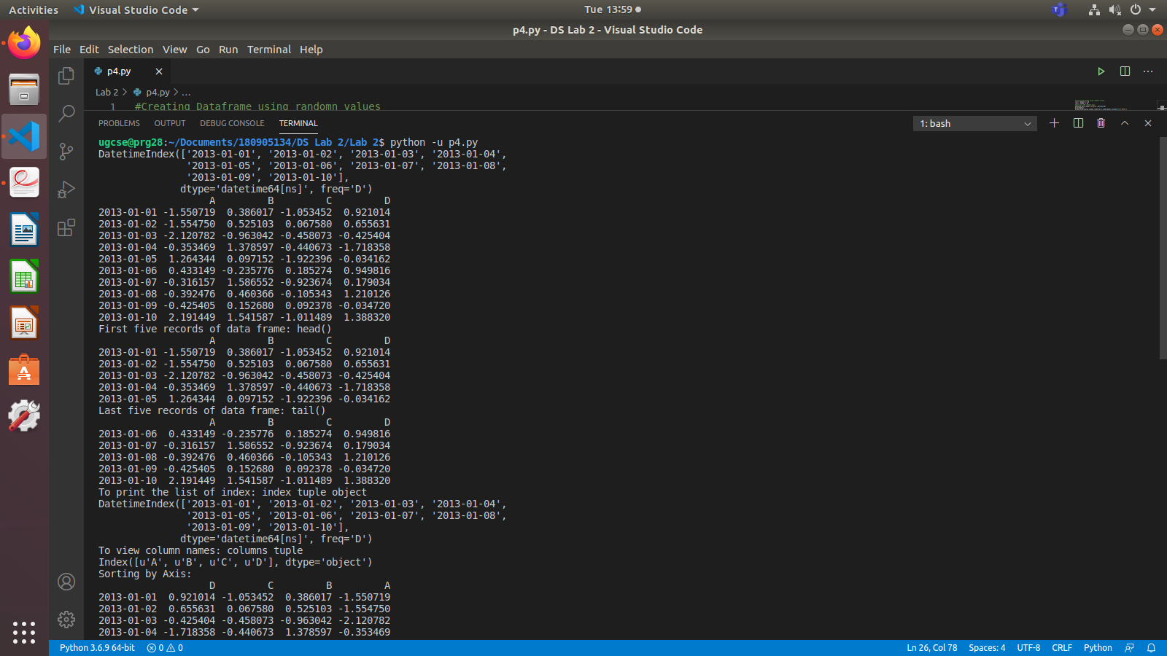
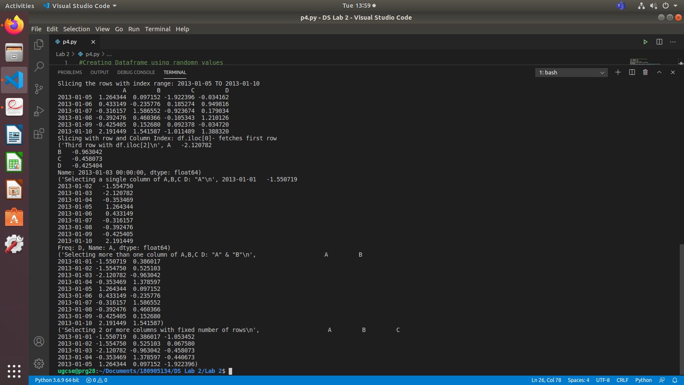
5.CODE
#Boolean Indexing of Dataframes
import pandas as pd
import numpy as np
dates=pd.date_range('20210301',periods=10)
df=pd.DataFrame(np.random.randn(10,5),index=dates,columns=list('ABCDE'))
print"All Records with Value in column A as positive:\n",df[df.A>0]
print("Adding a sixth column:")
df['F']=['Male','Female','Male','Female','Male','Female','Male','Female','Male','Female']
print(df)
print("Replacing all values in a given column:\n")
df.loc[:,'D']=np.array([5]*len(df))
print("Replaced COLUMN 'D' with all 5\n")
print(df)
print"sorting the values by Column B:\n",df.sort_values(by='B')

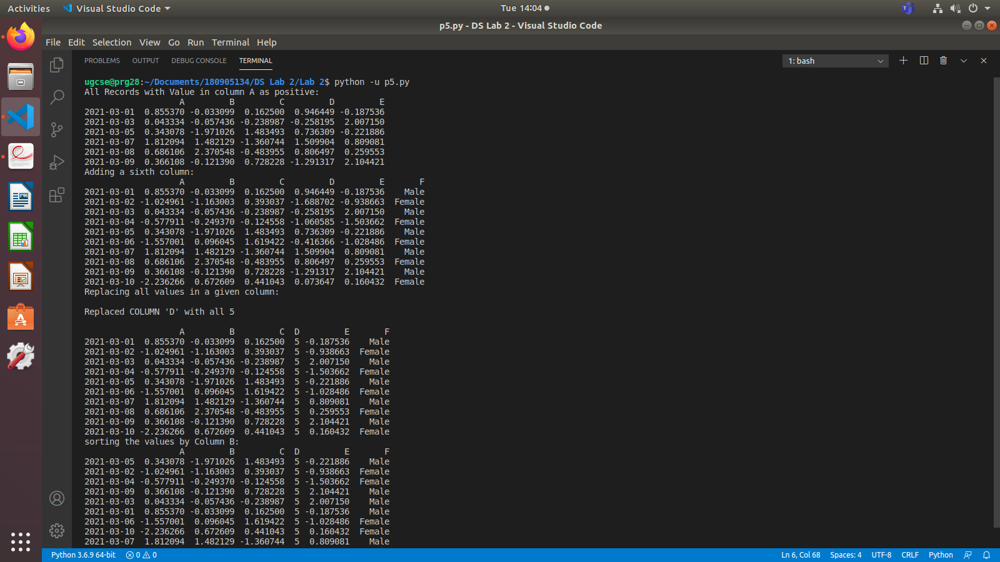
6.CODE
import pandas as pd
import numpy as np
df=pd.DataFrame(np.random.randn(10,3),index=list('abcdefghij'),columns=list('ABC'))
print"Original Dataframe:\n",df
df.drop('A',axis=1,inplace=True)
print"Dropping column A:\n",df
df.drop('e',axis=0,inplace=True)
print'Dropping 5th row: using index- "e"\n',df

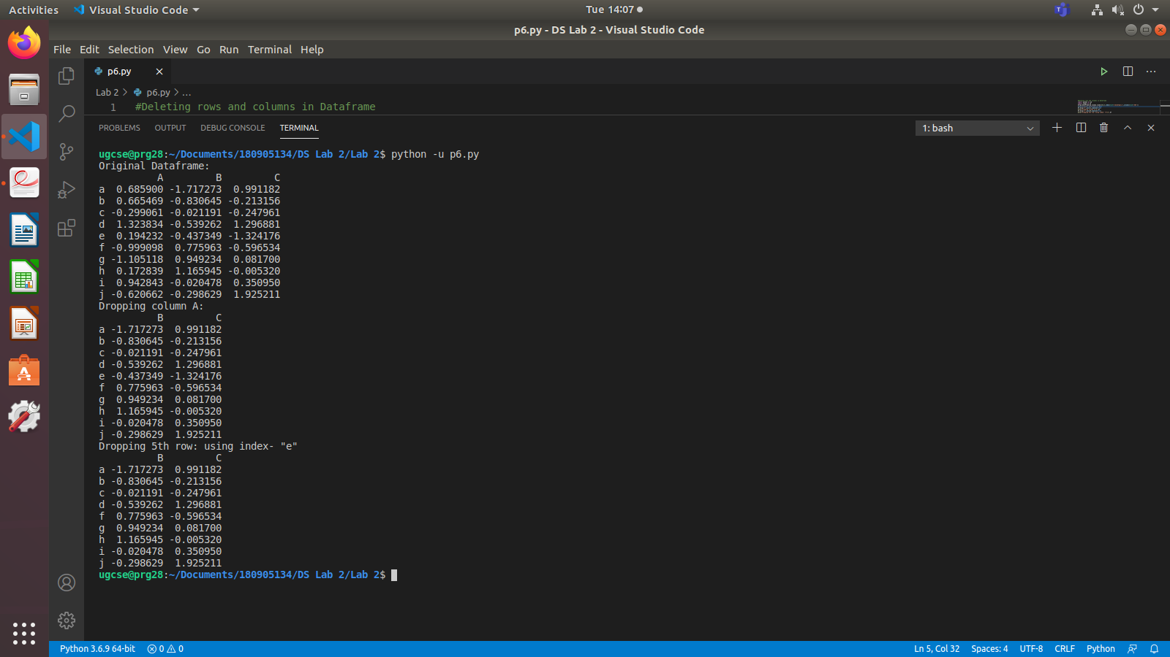

7.CODE
#Data frame concatenation
import pandas as pd
import numpy as np
df1=pd.DataFrame(np.random.randn(10,5),index=list('abcdefghij'),columns=list('ABCDE'))
df2=pd.DataFrame(np.random.randn(10,3),index=list('abcdefghij'),columns=list('ABC'))
print("Data Frame 1: ",df1.shape)
print("Data Frame 2: ",df2.shape)
print("Horizontal Concatenation:")
df_new=pd.concat([df1,df2],axis=1)
print'Dimensions of new Horizontal Data Frame: ',df_new.shape
print("\nVertical Concatenation")
df_vert=pd.concat([df1,df2],axis=0)
print'Dimensions of new Vertical Data Frame: ',df_vert.shape
print"Absent values substituted by NaN:\n",df_vert
