SANSKAAR PATNI
180905134 CSE-C 23
DS LAB 3

1.CODE
num=int(input("Enter a number whose factors are to be found "))
factors=[1]

for i in range(2,num):
if num%i ==0:
factors.append(i)
factors.append(num)
print("Factors of %d are " %(num))
print(factors)

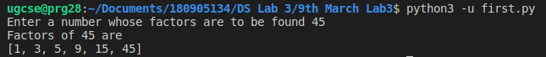

2.CODE
import numpy as np
a=np.arange(15).reshape(3,5)
print("array is ")
print(a)
print("Sum of each column: ",a.sum(axis=0))
print("Sum of each row: ",a.sum(axis=1))

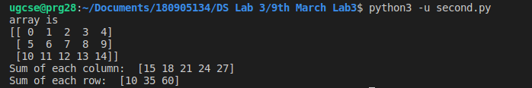
3.CODE
import numpy as np
A=np.array([2.3,5.65,10])
print ("a)")
print("Floating NumPy Array 'A': ",A)

my_tuple = ([8, 4, 6], [1, 2, 3])
print ("b)")
print("Tuple to array: ")
print(np.array(my_tuple))
print ("c)")
print("Only Zeroes 3*4 array:\n",np.zeros((3,4)))
print ("d)")
print("5 step intervals from 0 to 20: ",np.arange(0,20,5))
print ("e)")
a=np.arange(12).reshape(3,4)
print("Shape of a ",a.shape)
a=a.reshape(2,2,3)
print("Shape of a ",a.shape)
print ("f)")
a=np.arange(12).reshape(3,4)
print("Matrix is ",a)
print("Max of each column: ",a.max(axis=0))
print("Max of each row: ",a.max(axis=1))
print("Min of each column: ",a.min(axis=0))
print("Min of each row: ",a.min(axis=1))
print("Sum of each column: ",a.sum(axis=0))
print("Sum of each row: ",a.sum(axis=1))

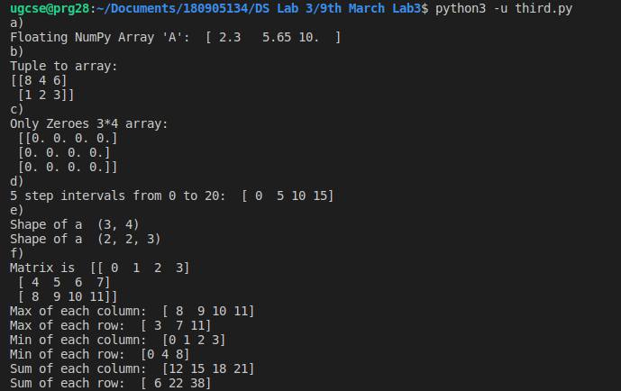

4.CODE
import numpy as np
a=np.arange(12).reshape(3,4)
print("Matrix is ")
print(a)
print("Transpose of a is")
print(a.T)
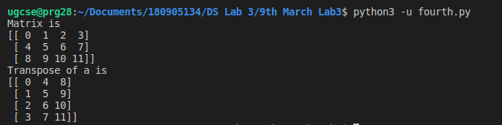

5.CODE
import numpy as np
a=np.arange(12).reshape(3,4)
print("Matrix a is ")
print(a)
print("Matrix b is ")
b=np.ones((3, 4),dtype=int)
print(b)
print("Adding a and b")
print(a+b)
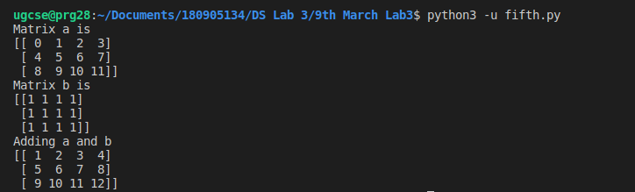

6.CODE
import numpy as np
A= np.array([[1,2],[3,4]])
B= np.array([[2,0],[0,1]])
print("A:\n",A)
print("B:\n",B)
print("Element Wise Product: A*B\n",A*B)

