SANSKAAR PATNI
180905134 CSE-C 23
DS LAB 4

PRACTISE PROBLEMS
1.
SERVER CODE
import socket
HOST = '127.0.0.1'
PORT = 2054
with socket.socket(socket.AF_INET, socket.SOCK_STREAM) as s:
s.bind((HOST, PORT))
s.listen()
conn, addr = s.accept()
with conn:
print('Connected by', addr)
while True:
data = conn.recv(1024)
if data:
print("Client: ",data.decode())
data = input("Enter message to client:");
if not data:
break;
conn.sendall(bytearray(data, 'utf-8'));
conn.close()
CLIENT CODE
import socket
HOST = '127.0.0.1'
PORT = 2054

with socket.socket(socket.AF_INET, socket.SOCK_STREAM) as s:
s=socket.socket()
s.connect((HOST,PORT))
s.sendall(b'Hello World!')
data=s.recv(1024)
print("Recieved Connection")
print('Server:',data.decode())
SCREENSHOT
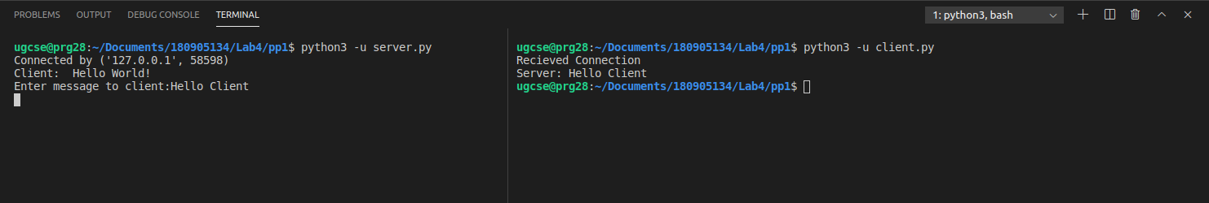

2.
SERVER CODE
import socket
import time
serversocket = socket.socket(socket.AF_INET, socket.SOCK_STREAM)
host = socket.gethostname()
port = 9991
serversocket.bind((host, port))
serversocket.listen(5)
while True:
clientsocket,addr = serversocket.accept()
print("Got a connection from %s" % str(addr))
currentTime = time.ctime(time.time()) + "\r\n"
clientsocket.send(currentTime.encode('ascii'))
clientsocket.close()
CLIENT CODE
import socket
s = socket.socket(socket.AF_INET, socket.SOCK_STREAM)
host = socket.gethostname()
port = 9991
s.connect((host, port))
tm = s.recv(1024)
print('Current time from Sever :', tm.decode())
s.close()
SCREENSHOT
3.
SERVER CODE
import socket
HOST = '127.0.0.1'
PORT = 31621
s = socket.socket()
s.bind((HOST, PORT))
s.listen()
print("\nWaiting for incoming connections...\n")
conn, addr = s.accept()
print("Received connection from ", addr[0], "(", addr[1], ")\n")
s_name = conn.recv(1024)
s_name = s_name.decode()
print(s_name, "has connected to the chat room\n Later use Enter [e] to exit chat room\n")
name = input(str("Enter your name: "))
conn.send(name.encode())
while True:
message = input(str("Me : "))
if message == "[e]":
message = "Left chat room!"
conn.send(message.encode())
print("\n")
break
conn.send(message.encode())
message = conn.recv(1024)
message = message.decode()
print(s_name, ":", message)
CLIENT CODE
import socket
HOST = '127.0.0.1'
PORT = 31621
s = socket.socket()
name=input(str("\nEnter your name:"))
print("\nTrying to connect to ",HOST,"(",PORT,")\n")
s.connect((HOST,PORT))
print("Connected..\n")
s.send(name.encode())
s_name = s.recv(1024)
s_name = s_name.decode()
print(s_name, "has joined the chat room\n Later use Enter [e] to exit chat room\n")
while True:
message = s.recv(1024)
message = message.decode()
print(s_name, ":", message)
message = input(str("Me : "))
if message == "[e]":
message = "Left chat room!"
s.send(message.encode())
print("\n")
break
s.send(message.encode())

SCREENSHOT
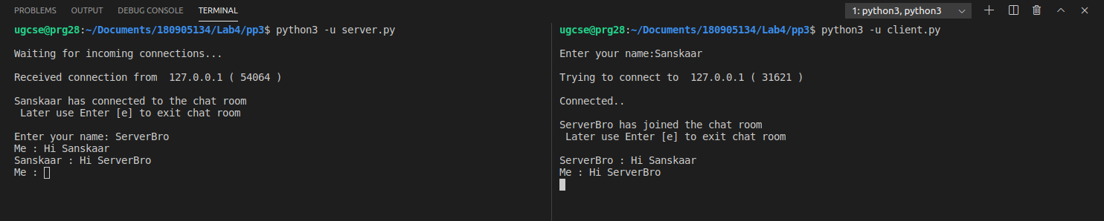
4.
SERVER CODE
import socket
import os
from _thread import *
ServerSocket = socket.socket()
host = '127.0.0.1'
port = 11599
ThreadCount = 0
try:
ServerSocket.bind((host, port))
except socket.error as e:
print(str(e))
print('Waitiing for a Connection..')
ServerSocket.listen(5)
def threaded_client(connection):
connection.send(str.encode('Welcome to the Server'))
while True:
data = connection.recv(2048)
print('Received from client ' + str(ThreadCount)+": " +data.decode())
Inputs = input('Server Says: ')
if not data:
break
connection.sendall(Inputs.encode())
connection.close()
while True:
Client, address = ServerSocket.accept()
print('Connected to: ' + address[0] + ':' + str(address[1]))
start_new_thread(threaded_client(Client))
ThreadCount += 1
print('Thread Number: ' + str(ThreadCount))
ServerSocket.close()

CLIENT CODE
import socket
ClientSocket = socket.socket()
host = '127.0.0.1'
port = 11599
print('Waiting for connection')
try:
ClientSocket.connect((host, port))
except socket.error as e:
print(str(e))
Response = ClientSocket.recv(1024)
while True:
Input = input('Client Say Something: ')
ClientSocket.send(str.encode(Input))
Response = ClientSocket.recv(1024)
print('From Server : ' + Response.decode())
ClientSocket.close()

SCREENSHOT
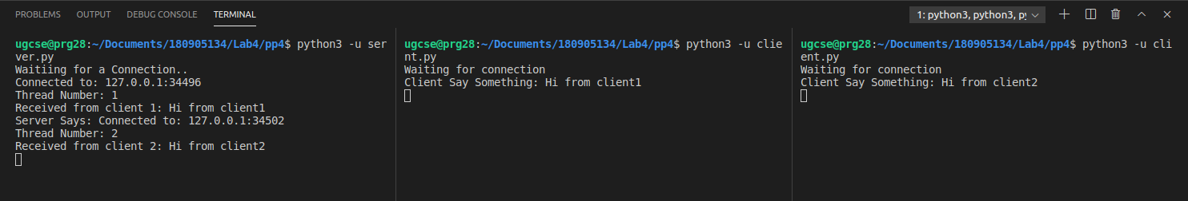
EXERCISE QSNS

1.
SERVER CODE
import socket
import time

sock = socket.socket(socket.AF_INET, socket.SOCK_DGRAM)

udp_host = socket.gethostname()
udp_port = 12345

sock.bind((udp_host, udp_port))

while True:
print("Waiting for client . . .")
data, addr = sock.recvfrom(1024)

print("Got a connection from %s" % str(addr))
currentTime = time.ctime(time.time())

sock.sendto(currentTime.encode('ascii'),addr)
print("Done!\n")

CLIENT CODE
import socket

sock = socket.socket(socket.AF_INET, socket.SOCK_DGRAM)

host = socket.gethostname()
client_port = 12346
server_port = 12345

sock.bind((host, client_port))

print("Requesting server..")
sock.sendto("".encode(), (host, server_port))

data, _ = sock.recvfrom(1024)

print("Server: %s" % data.decode())

SCREENSHOT
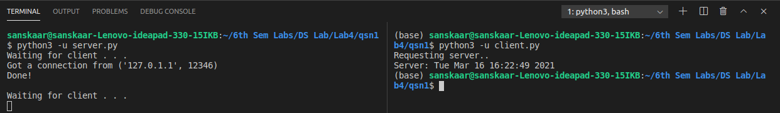

2.
SERVER CODE
import socket

sock = socket.socket(socket.AF_INET, socket.SOCK_DGRAM)

udp_host = socket.gethostname()
udp_port = 12345

sock.bind((udp_host, udp_port))

print("Do Ctrl+C to exit the program!!")

while True:
print("####### Server is listening #######")
data, addr = sock.recvfrom(1024)

print("2. Server received: %s" % data.decode())
msg = input("Type some text to send => ")

sock.sendto(msg.encode(),addr)
print("1. Server sent: %s" % msg)
CLIENT CODE
import socket

sock = socket.socket(socket.AF_INET, socket.SOCK_DGRAM)

host = socket.gethostname()
client_port = 12346
server_port = 12345

sock.bind((host, client_port))

print("Do Ctrl+C to exit the program!!")

while True:
msg = input("Type some text to send => ")
print("1. Client sent: %s" % msg)
sock.sendto(msg.encode(), (host, server_port))

data, _ = sock.recvfrom(1024)
print("2. Client received: %s" % data.decode())

SCREENSHOT
3.
SERVER CODE
import socket

sock = socket.socket(socket.AF_INET, socket.SOCK_STREAM)

host = socket.gethostname()
port = 12345

sock.bind((host, port))

sock.listen()

print("Hostname: ", socket.gethostbyname(host), "Port: ", port)
print("Waiting for incoming connections...\n")
conn, addr = sock.accept()

print("Received connection from ", addr[0], "(", addr[1], ")\n")
s_name = conn.recv(1024)
s_name = s_name.decode()

print(s_name, "has connected to the chat room\nEnter [e] to exit chat room\n")

name = input(str("Enter your name: "))
conn.send(name.encode())

print()

while True:
message = input(str("YOU : "))

if message == "[e]":
message = "Left chat room!"
conn.send(message.encode())
print("\n")
sock.close()
break

conn.send(message.encode())
message = conn.recv(1024)
message = message.decode()
print(s_name, ":", message)

CLIENT CODE
import socket

host, port = input("Enter IP and port of the server: ").split()
port = int(port)

sock = socket.socket()
name = input(str("\nEnter your name: "))
print("\nTrying to connect to ", host, ":", port)

sock.connect((host, port))
print("Connected...\n")

sock.send(name.encode())
sock_name = sock.recv(1024)
sock_name = sock_name.decode()

print(sock_name, "has joined the chat room\nEnter [e] to exit chat room\n")

while True:
message = sock.recv(1024)
message = message.decode()
print(sock_name, ":", message)
message = input(str("YOU : "))

if message == "[e]":
message = "Left chat room!"
sock.send(message.encode())
print("\n")
sock.close()
break

sock.send(message.encode())

SCREENSHOT

1.Server Screenshot
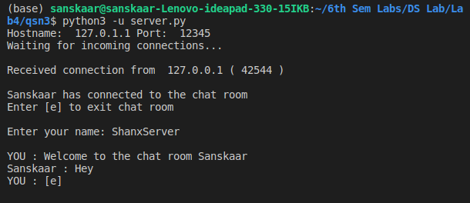
2.Client Screenshot

