D.Y. PATIL COLLEGE OF ENGINEERING & TECHNOLOGY,
KASABA BAWADA, KOLHAPUR
(AN AUTONOMOUS INSTITUTE)
MahaResilience Official Project Portal: https://mahareilience.web.app
A
Project Report On
Community Engagement Project
(231CSECEPP201)
“MahaResilience — Smart Community Hub &
Civic Management Engine”

Presented by:
Sr. No. | Roll No. | Name
1 | 26 | Shreyash Mane
2 | 29 | Sanskar Dhat
3 | 38 | Arjun Bhandare
4 | 40 | Veer Patil
5 | 49 | Vipul Bhingavdia
Under the Guidance of
Mr. V.V.Mangave and Prof. M.A.Pardesi
DEPARTMENT OF COMPUTER SCIENCE AND ENGINEERING
Academic Year: 2026-2027 (Odd Semester)
Class : S.Y.B.Tech. Division : A/B/C

D. Y. PATIL COLLEGE OF ENGINEERING AND TECHNOLOGY,
KOLHAPUR
DEPARTMENT OF COMPUTER SCIENCE AND ENGINEERING
(AN AUTONOMOUS INSTITUTE)
CERTIFICATE
This is to certify that the project group consisting of following members have satisfactorily completed the Community Engagement Project (231CSECEPP201) work entitled “MahaResilience — Smart Community Hub & Civic Management Engine” at S.Y B.Tech (CSE) semester – III as prescribed in the syllabus of D.Y.P.C.E.T Kolhapur for the academic year 2026-2027 (Odd Semester).
Roll No. | Name | Exam No.
26 | Shreyash Mane
29 | Sanskar Dhat
38 | Arjun Bhandare
40 | Veer Patil
49 | Vipul Bhingavdia
Guide Name Dr. R. J Dhanal Mr. V.V.Mangave and Prof. M.A.Pardesi HOD

Dr. S. S Pawar
Principal
Date: _____ / _____ / 2026
Place: Kolhapur, Maharashtra

ACKNOWLEDGEMENT
This project work entitled “MahaResilience — Smart Community Hub & Civic Management Engine” was a formidable and enriching task, but with the collective effort of our group and active guidance, it was made possible for us to complete successfully.
First of all, we would like to thank Dr. R. J. Dhanal (HOD of the Department of Computer Science and Engineering) for providing us with the opportunity and delineating us with this community engagement project work.
We would also like to express our most humble and deepest gratitude to our Project Guide Guide Name for providing us with the right guidance at the time of need. It was for their continuous support, technical insights, and active guidance that we were able to complete the project work.
We would also like to express our sincere appreciation to Dr. S. S. Pawar, Principal of D. Y. Patil College of Engineering & Technology, Kolhapur, for providing state-of-the-art laboratory facilities and an academic ecosystem that fosters high-impact engineering solutions.
Lastly, we would like to thank all our friends and municipal stakeholders across Kolhapur and Maharashtra for their help, ideas, constructive criticisms, and encouragement during the field demonstration of this civic-tech project. Any further ideas and constructive criticisms on our work shall be highly welcomed.
Date: _____ / _____ / 2026
Place: Kolhapur
Roll No. | Name | Sign
26 | Shreyash Mane
29 | Sanskar Dhat
38 | Arjun Bhandare
40 | Veer Patil
49 | Vipul Bhingavdia

Index
Sr. | Chapter / Section Title | Scope & Description | Page
1. | Introduction | Introduction of the civic and disaster resilience problem identified | 5
2. | Problem Statement | Critical public administration and life-safety issues addressed | 6
3. | Literature Survey | Existing solutions, municipal gaps, and comparative analysis | 7
4. | Objectives & Alignment with Sustainable Development Goals | Specific measurable outcomes & mapping with UN SDGs (★ Priority: 3, 8, 16, 17) | 9
 | 4.1 Objectives | Measurable engineering and civic objectives | 9
 | 4.2 Mapping with Institute's Sustainable Development Goals (SDGs) | Institutional alignment with UN SDGs & Institute Priority Goals (NEP) | 10
 | 4.2.1 Detailed Implementation of ★ Institute Priority Goals | Deep-dive analysis of SDG 3, 8, 16, and 17 | 11
 | 4.2.2 Impact Across Connected Civic, Agriculture & Climate SDGs | Analysis of SDG 1, 2, 4, 5, 6, 7, 9, 10, 11, 12, 13, 14, 15 | 12
5. | Proposed System Architecture | Dual-database architecture, request routing, and fallback pipelines | 12
6. | Modules (in details) | In-depth engineering documentation of 10 independent modules | 14
7. | System Requirement | Hardware, software, runtime, database, and network specifications | 20
8. | Implementation Details | Mathematical formulas, algorithms, database schemas, and workflows | 22
9. | Conclusion | Project outcomes, SDG impact assessment & future roadmap | 28
10. | Field Visit & Demonstration | Citizen outreach, municipal evaluation, geotagged feedback, and live QR code | 30
 | 10.1 Brief Information about Selected Topic & Targeted Beneficiaries | Citizen profiles, municipal wards, and administrative users | 30
 | 10.2 Geotagged Field Photos & Verified Live Artifacts | Field verification proofs, portal screenshots, and QR dispatch | 31
 | 10.3 Survey Questionnaires & Actual Beneficiary Feedback | Structured feedback survey and quantitative ratings | 32
11. | References | Official documentation, governmental standards, and library citations | 34

1. Introduction
Background & Context: Modern urban and rural communities across Maharashtra face complex governance and disaster management challenges. With a population exceeding 125 million across 36 diverse districts—ranging from densely populated metropolitan corporations (such as Mumbai, Pune, and Thane) to flood-prone river basins in Western Maharashtra (Panchganga in Kolhapur, Krishna in Sangli) and arid agrarian belts in Vidarbha and Marathwada—public administration is often strained during seasonal crises.
The Identified Problem: Currently, citizen services in Maharashtra are administered through fragmented departmental portals. A citizen seeking to report a severe road pothole, an illegal garbage dump, or a burst water pipeline must navigate separate municipal grievance desks, often lacking real-time status updates, photo verification, or transparent priority queues. Concurrently, when natural disasters strike—such as the recurring monsoon floods in Kolhapur and Sangli, coastal cyclones in Raigad and Ratnagiri, or severe heatwaves in Nagpur—statewide weather bulletins are broadcast without district or ward-level geofencing. This causes severe warning fatigue, leading citizens to overlook critical local evacuation advisories.
Project Introduction: To address these systemic bottlenecks, this Community Engagement Project presents MahaResilience (Smart Community Hub & Civic Management Engine). MahaResilience is an integrated, cloud-native civic operating system that bridges municipal grievance redressal, geofenced disaster alerting, instant one-touch emergency SOS broadcasting, and automated municipal utility billing into a single, accessible, and offline-resilient web application.
2. Problem Statement
Core Problem Statement: The problem addressed by this project is the critical lack of a unified, location-aware, and offline-resilient digital platform for civic grievance resolution, emergency disaster response, and municipal utility management across Maharashtra's municipal corporations and rural district collectorates.
Specifically, the project aims to solve the following five real-world issues:
- 1. Fragmented Grievance Redressal: Citizens encounter bureaucratic delays and lack a transparent mechanism to upload photographic evidence with automatic GPS coordinates, resulting in unaddressed potholes, contaminated water lines, and uncollected waste.
- 2. Non-Geofenced Disaster Alerts: Conventional disaster advisories lack geographic filtering. A flood advisory issued for Pune or Raigad is broadcast to citizens in Kolhapur or Solapur, creating warning fatigue and desensitization during genuine local emergencies.
- 3. High Friction in Emergency Communication: During physical accidents, medical emergencies, or flash floods, citizens have no mechanism to broadcast a distress signal simultaneously to family contacts and local disaster cells with exact latitude/longitude coordinates and Google Maps navigation links.
- 4. Opaque Municipal Utility Billing: Consumers face delayed electricity (MSEDCL/Mahavitaran) and municipal water tax bills, non-transparent late surcharge (DPC) calculations, and an absence of instantaneous digital tax receipts delivered via secure channels.
- 5. Vulnerability During Network Blackouts: When severe monsoons or cyclones damage telecom towers and grid power, standard government web portals become completely inaccessible, leaving citizens without emergency helpline directories or disaster survival guides.
3. Literature Survey
A rigorous survey of existing governmental portals, academic research, and commercial applications was conducted to analyze existing capabilities and identify architectural gaps:
Existing Solution | Intended Scope | Identified Limitations & Gaps | MahaResilience Architectural Solution
Aaple Sarkar Grievance Redressal Portal (Govt. of Maharashtra) | State-level citizen grievance lodging system. | Lacks real-time mobile GPS capture, interactive maps, community upvoting mechanisms, and automated disaster response. | MahaResilience introduces client-side GPS geocoding, Cloudinary photo uploads, and dynamic priority scoring algorithms.
NDMA Sachet Portal & Mobile App (National Disaster Management Authority) | National disaster broadcast platform providing meteorological alerts. | Broadcasts broad regional advisories without neighborhood/ward geofencing, lacks Web Audio emergency siren synthesis, and lacks local municipal facility ticketing. | MahaResilience integrates Haversine-based radius filtering (ensuring only relevant alerts trigger sirens) and pairs alerts with nearby shelters.
Mahavitaran WSS Portal (MSEDCL) | Official consumer electricity billing and payment gateway. | Requires exact consumer credentials with complex captchas; fails to provide simulated tariff ledgers for overdue/advance/solar subsidies or automated SMS/email invoice dispatch. | MahaResilience builds a deterministic MERC tariff engine modeling exact slabs (0-100 units @ ₹4.71, 101-300 units @ ₹10.29) and generates instant tax invoices.
Private Emergency SOS Apps (e.g. Life360, 112 India) | GPS location sharing and commercial distress alarms. | Proprietary walled-gardens; lack direct municipal corporation ticketing, civic grievance resolution, APMC mandi rates, or public healthcare bed integration. | MahaResilience establishes a multi-channel open civic hub integrating Twilio SMS, Brevo HTML emails, and municipal administration desks.
4. Objectives & Alignment with Sustainable Development Goals
4.1 Objectives
The primary specific and measurable objectives of this Community Engagement Project include:
- 1. Unified Citizen Interface: Develop a responsive, single-page web portal accessible on desktop and low-end mobile browsers for citizens across Maharashtra.
- 2. Geofenced Alerting Engine: Implement client-side OpenStreetMap reverse geocoding and Haversine distance filtering to eliminate alarm fatigue by routing disaster warnings strictly to affected zones.
- 3. Multi-Channel Emergency SOS: Engineer a 1-touch SOS beacon synthesizing a 600–1200 Hz Web Audio siren and dispatching concurrent distress messages via Twilio SMS and Brevo transactional HTML email with live Google Maps links.
- 4. Automated Grievance Prioritization: Build a transparent grievance desk with Cloudinary photo capture, community upvoting, and dynamic priority scoring formula escalating tickets based on category weight and elapsed time.
- 5. Municipal Utility Automation: Implement a deterministic tariff calculator modeling official MSEDCL electricity slabs and PMC water charges across normal, overdue (+DPC), overpayment, and solar subsidy cycles.
- 6. Multilingual Conversational AI: Integrate Google Gemini 1.5/2.0 Flash AI with Web Speech voice dictation and speech output in Marathi, Hindi, and English for accessible citizen support.
- 7. Offline Resilience: Implement dual-layer client persistence using Cloud Firestore multi-tab cache and native IndexedDB (MahaResilienceCache) pre-seeded with emergency helplines and disaster guides.
4.2 Mapping with Institute's Sustainable Development Goals (SDGs)
Institutional Framework & NEP 2020 Context: As part of the academic and community framework of the Community Engagement Program (CEP • Course Code: 231CSECEPP201) aligned with National Education Policy (NEP 2020) at D.Y. Patil College of Engineering & Technology, Kasaba Bawada, Kolhapur, all community-oriented software engineering initiatives are benchmarked against the United Nations Sustainable Development Goals (SDGs 1 to 17). The Department of Computer Science & Engineering has explicitly designated four ★ Institute Priority Goals (NEP):
- ★ SDG 3 (Institute Priority): Good Health and Well-Being — Rural healthcare access, telemedicine (e-Sanjeevani), digital health records (ABHA), maternal care, and epidemic awareness.
- ★ SDG 8 (Institute Priority): Decent Work and Economic Growth — Rural entrepreneurship, digital payments (UPI), unorganized worker registration (e-Shram), skill development, and rural e-commerce.
- ★ SDG 16 (Institute Priority): Peace, Justice and Strong Institutions — Transparent e-governance (e-Gram Swaraj, DigiLocker), citizen grievance redressal portals, and digital public service delivery.
- ★ SDG 17 (Institute Priority): Partnerships for the Goals — Multi-stakeholder collaboration between engineering students, faculty, Gram Panchayats, NGOs, and rural beneficiaries.
Comprehensive Goal Alignment: MahaResilience anchors its primary architecture upon these four ★ Institute Priority Goals while systematically extending practical coverage to twelve complementary UN Sustainable Development Goals across civic governance, poverty alleviation, clean water, clean energy, resilient infrastructure, and climate action.
Table 4.1: Comprehensive UN Sustainable Development Goals Mapping for MahaResilience
SDG No. & Priority | Goal Name | Official UN Description | Core Focus Area (College Chart) | MahaResilience Implementation
★ SDG 3  [Institute Priority] | Good Health and Well-Being | Ensure healthy lives and promote well-being for all at all ages. | Rural healthcare access, telemedicine (e-Sanjeevani), digital health records (ABHA), maternal care, and disease awareness. | Distance-sorted directory of Civil Hospitals, PHCs, and CHCs; real-time ICU bed and blood bank inventory tracking; 1-touch SOS dialer for 108/102/104; post-flood epidemic alerts; maternal scheme tracking.
★ SDG 8  [Institute Priority] | Decent Work and Economic Growth | Promote sustained, inclusive, and sustainable economic growth, full and productive employment, and decent work for all. | Rural entrepreneurship, digital payments (UPI), unorganized worker registration (e-Shram), skill development, and rural e-commerce. | Real-time APMC Mandi commodity price discovery across Kolhapur, Sangli, and Pune markets eliminating broker exploitation; digital UPI/QR billing ledger for municipal dues; volunteer first-responder mobilization network.
★ SDG 16  [Institute Priority] | Peace, Justice and Strong Institutions | Promote peaceful and inclusive societies for sustainable development, provide access to justice for all, and build effective, accountable, and inclusive institutions at all levels. | Transparent e-governance (e-Gram Swaraj, DigiLocker), citizen grievance redressal portals, and digital public service delivery. | Public Grievance Redressal Desk with Cloudinary photo capture, GPS geotagging, upvoting, and status lifecycle; 10-module Civic Facility Board with immutable admin audit logs; multi-tier RBAC; e-Gram Swaraj integration links.
★ SDG 17  [Institute Priority] | Partnerships for the Goals | Strengthen the means of implementation and revitalize the Global Partnership for Sustainable Development. | Multi-stakeholder collaboration between engineering students, faculty, Gram Panchayats, NGOs, and rural beneficiaries. | Active multi-tier partnership connecting D.Y. Patil College CSE student engineers, faculty guides, Kasaba Bawada Gram Panchayat, Kolhapur Municipal Corporation (KMC), SDRF disaster teams, and local rural beneficiaries.
SDG 1 | No Poverty | End poverty in all its forms everywhere. | Access to basic services, social protection systems, Direct Benefit Transfers (DBT), and microfinance awareness. | Centralized Government Schemes portal featuring eligibility screening for Mukhyamantri Majhi Ladki Bahin Yojana, Sanjay Gandhi Niradhar Yojana, and PM-Kisan DBT; subsidized utility tariff calculation.
SDG 2 | Zero Hunger | End hunger, achieve food security and improved nutrition, and promote sustainable agriculture. | Rural agricultural productivity, crop advisory systems, food distribution tracking (PDS/Anganwadi), and soil health. | APMC Mandi market rates, Central Insecticide Board (CIBRC) approved agrochemical database, and Google Gemini AI agronomy advisor for crop disease diagnosis and soil health management.
SDG 4 | Quality Education | Ensure inclusive and equitable quality education and promote lifelong learning opportunities for all. | Digital literacy in rural schools, e-learning platforms (DIKSHA/SWAYAM), vocational training, and scholarship awareness. | Interactive civic education modules, disaster preparedness training, MahaDBT scholarship portals directory, and multilingual digital literacy onboarding for first-time smartphone users.
SDG 5 | Gender Equality | Achieve gender equality and empower all women and girls. | Digital and financial inclusion for women, Self-Help Group (Bachat Gat) digitization, and women's safety/health portals. | 1-Touch Emergency SOS beacon broadcasting GPS coordinates via Twilio SMS and Brevo email to family and Women's Helpline (1091/112); Mahila Bachat Gat scheme onboarding.
SDG 6 | Clean Water and Sanitation | Ensure availability and sustainable management of water and sanitation for all. | Safe drinking water tracking (Jal Jeevan Mission), village sanitation monitoring, and water quality/supply grievance tools. | Municipal Water Supply module tracking consumption billing, pipeline burst ticket logging, emergency water tanker dispatch requests, and solid waste compactor vehicle route monitoring.
SDG 7 | Affordable and Clean Energy | Ensure access to affordable, reliable, sustainable, and modern energy for all. | Renewable energy awareness, solar subsidy calculators (PM Surya Ghar / Kusum), and rural power grid monitoring. | MSEDCL electricity tariff engine modeling MERC tiered slabs; integrated solar rooftop subsidy calculator promoting PM Surya Ghar: Muft Bijli Yojana with automated rebate ledger deduction.
SDG 9 | Industry, Innovation and Infrastructure | Build resilient infrastructure, promote inclusive and sustainable industrialization, and foster innovation. | Bridging rural connectivity gap, developing software architectures, and digitizing Gram Panchayat infrastructure records. | Cloud-native, offline-first dual-database architecture (PostgreSQL + Cloud Firestore + IndexedDB) resilient on 2G/3G networks; GIS mapping of EV charging stations, roads, and transit infrastructure.
SDG 10 | Reduced Inequalities | Reduce inequality within and among countries. | Bridging urban-rural digital divide, local-language (Marathi) user interfaces, and accessible tech for the elderly/disabled. | Native Marathi, Hindi, and English localization; Google Gemini AI voice assistant powered by Web Speech API for voice-driven civic access; WCAG high-contrast visual accessibility.
SDG 11 | Sustainable Cities and Communities | Make cities and human settlements inclusive, safe, resilient, and sustainable. | Smart village dashboards, rural transport information, waste management tracking, and local disaster/flood warning systems. | Panchganga and Krishna river flood gauge tracking; geofenced siren alerts; civic complaint tracking for road potholes and solid waste dumps; resilient emergency shelter locators.
SDG 12 | Responsible Consumption and Production | Ensure sustainable consumption and production patterns. | Paperless governance via DigiLocker, e-waste management awareness, and agricultural waste recycling platforms. | 100% paperless digital tax invoice generation (PDF) and digital billing ledger, eliminating municipal paper waste; electronic waste and agricultural biomass guidelines.
SDG 13 | Climate Action | Take urgent action to combat climate change and its impacts. | Early weather warning systems for farmers, carbon footprint awareness, and community tree-plantation tracking. | Automated early warning ingestion from NDMA Sachet and GDACS global feeds; compound spatial Resilience Score (0–100) reflecting active climate hazards, heatwaves, and air quality index.
SDG 14 & 15 | Life Below Water & Life on Land | Conserve marine and freshwater resources; protect, restore, and promote sustainable use of terrestrial ecosystems. | Prevention of local river/lake pollution, chemical/plastic runoff monitoring; Soil Health Card digitization, human-wildlife conflict alerts. | Panchganga river basin pollution incident reporting (effluents, debris, plastic runoff); agricultural soil conservation and biological pest control guidance.
4.2.1 Detailed Implementation of ★ Institute Priority Goals (NEP)
Core Priority Implementations: MahaResilience provides dedicated engineering architectures fulfilling the four ★ Institute Priority Goals:
1. ★ SDG 3 (Good Health and Well-Being): MahaResilience bridges the healthcare accessibility gap in semi-urban and rural tehsils across Western Maharashtra. The system maintains a real-time, distance-indexed directory of government civil hospitals, sub-district hospitals, and Primary Health Centres (PHCs). It integrates real-time trackers for general/ICU bed occupancy and blood bank unit availability. The 1-touch SOS beacon provides instant dialers for 108 (National Ambulance), 102 (Janani Shishu Suraksha Karyakram - maternal care), and 104 (Health Information Helpline). During natural disasters (e.g. Panchganga river floods), the platform broadcasts public health hygiene advisories, water purification guidelines, and disease prevention bulletins.
2. ★ SDG 8 (Decent Work and Economic Growth): The application stimulates rural economic resilience and transparent financial inclusion. It features a daily APMC Mandi commodity market rate tracker covering Kolhapur, Sangli, and Pune agricultural markets, empowering smallholder farmers to sell cash crops (sugarcane, jaggery, soybean, turmeric) without exploitative middleman cuts. The municipal billing module introduces paperless digital invoice generation supporting UPI/QR and digital banking transactions, promoting formal digital financial adoption among rural households. Furthermore, MahaResilience mobilizes local youth as registered civic first-responders and disaster volunteers, cultivating technical and civic skills.
3. ★ SDG 16 (Peace, Justice and Strong Institutions): MahaResilience embodies the core tenets of transparent, accountable e-governance envisioned under e-Gram Swaraj and Digital India. The Public Grievance Redressal Desk empowers citizens to report civic failures (potholes, water pipeline breaches, illegal dumping, broken streetlights) with camera photo verification and automated GPS tagging. Complaints follow an open, auditable lifecycle (Submitted -> Assigned -> In Progress -> Resolved). The 10-module Civic Facility Board maintains immutable administrative audit logging, ensuring government officers cannot modify or close tickets without verifiable proof. Direct integration links connect citizens with Aaple Sarkar, DigiLocker, and Lokshahi Day portals.
4. ★ SDG 17 (Partnerships for the Goals): As a flagship Community Engagement Project (CEP), MahaResilience operationalizes the multi-stakeholder collaborative model mandated by NEP 2020. The project forms a collaborative bridge between Second Year Computer Science & Engineering students and faculty guides at D.Y. Patil College of Engineering & Technology, Kasaba Bawada Gram Panchayat representatives, Kolhapur Municipal Corporation (KMC) ward officials, State Disaster Response Force (SDRF) personnel, and local rural citizens. By conducting ground-level surveys and gathering real-world user feedback in Kolhapur, the project demonstrates how technical institutions and civic bodies can partner to create sustainable, localized technological solutions.
4.2.2 Impact Across Connected Civic, Agriculture & Climate SDGs
Extended SDG Synergies: Beyond the institute priority goals, MahaResilience systematically addresses key environmental, infrastructure, and social equity challenges:
- • SDG 1 (No Poverty): The Centralized Government Schemes portal provides eligibility screening for Direct Benefit Transfer (DBT) programs (Mukhyamantri Majhi Ladki Bahin Yojana, PM-Kisan Samman Nidhi, Sanjay Gandhi Niradhar Yojana), and calculates subsidized electricity/water tariffs for vulnerable households.
- • SDG 2 (Zero Hunger): The Agriculture & Agronomy Hub incorporates a pesticide/fungicide database approved by the Central Insecticide Board & Registration Committee (CIBRC) alongside a Gemini AI Agronomy Advisor assisting farmers with crop disease identification, organic soil health, and weather-resilient farming techniques.
- • SDG 5 (Gender Equality): Empowers women through a dedicated 1-touch Emergency SOS mechanism broadcasting instant GPS coordinates to emergency contacts and Women's Helpline (1091/112), while providing direct enrollment pathways for Mahila Bachat Gat (Self-Help Group) schemes.
- • SDG 6 (Clean Water and Sanitation): Features a Municipal Water Supply tracking module with volumetric billing, pipeline rupture reporting, emergency water tanker dispatch requests, and solid waste compactor tracking aligned with Swachh Bharat Abhiyan and Jal Jeevan Mission.
- • SDG 7 (Affordable and Clean Energy): Implements the official MERC tiered electricity tariff engine and a solar rooftop subsidy calculator promoting the PM Surya Ghar: Muft Bijli Yojana and PM-KUSUM agricultural solar pumps, encouraging rural adoption of clean energy.
- • SDG 9 (Industry, Innovation, and Infrastructure): Deploys a robust, offline-first dual-database software architecture (PostgreSQL + Cloud Firestore + IndexedDB) that functions over unstable 2G/3G mobile networks, while mapping EV charging stations and transit infrastructure.
- • SDG 10 (Reduced Inequalities): Bridges the urban-rural digital divide with native Marathi and Hindi localization, WCAG-compliant high-contrast disaster visual modes, and a Gemini AI voice assistant utilizing the Web Speech API for voice inquiries by non-literate citizens.
- • SDG 11 (Sustainable Cities and Communities): Integrates real-time flood monitoring along the flood-prone Panchganga and Krishna river basins, geofenced siren alerts, civic complaint resolution, and nearest emergency disaster shelter navigation.
- • SDG 12 (Responsible Consumption and Production): Eliminates paper billing by generating 100% paperless digital tax invoices and ledgers, while offering clear community guidelines for e-waste disposal and agricultural biomass recycling.
- • SDG 13 (Climate Action): Automates the ingestion of early disaster warnings from NDMA Sachet and GDACS global feeds, computing a composite Safety & Resilience Score (0–100) reflecting active climate risks, flood warnings, and extreme weather hazards.
- • SDG 14 & 15 (Life Below Water & Life on Land): Enables citizens to report hazardous industrial effluent discharges, plastic dumping, and idol immersion pollution in the Panchganga river basin, promoting biodiversity conservation and soil preservation.
5. Proposed System Architecture
Architectural Overview: MahaResilience implements a dual-database, cloud-native architecture optimized for zero-latency reactive updates, relational administrative integrity, and offline availability during disaster conditions.
Multi-Tier Structure: The architecture consists of three interconnected layers:
- 1. Frontend Presentation & State Layer: Built with React 18, TypeScript, Vite, and TailwindCSS. It houses the context state managers (LocationContext, AlertContext, EmergencyModeContext, AuthContext), Web Audio API siren synthesizer, Web Speech voice recognizer, and client-side offline storage (IndexedDB v1 + LocalStorage).
- 2. Dual-Channel Routing & Backend Layer: Operates a dual-channel data flow. Channel 1 connects directly from the React client to Google Cloud Firestore via the Firebase Client SDK using onSnapshot websocket listeners for live community posts, nested comments, public facility tickets, and emergency mode synchronization. Channel 2 routes through an Express 4.19 REST API running on Node.js with Prisma ORM 5.12, handling authentication (bcrypt + JWT), Twilio SMS dispatch, Brevo transactional emails, and MSEDCL utility tariff calculations.
- 3. Persistence & Enterprise Gateways: PostgreSQL stores relational user records, volunteer profiles, official complaints, emergency shelters, and government schemes. Cloud Firestore handles real-time collections (alerts, tickets, posts, audit logs). Third-party APIs include Twilio (SMS/Verify v2), Brevo (Sendinblue v3 HTML emails), Google Gemini 1.5/2.0 Flash AI, MapTiler Cloud GIS, OpenStreetMap Nominatim, OSRM routing, and Cloudinary media storage.
Fault-Tolerant Fallback Design: To ensure continuous operation during catastrophic events where backend servers or cellular data degrade, MahaResilience incorporates direct client-side fallback pathways: direct Brevo REST API dispatch for emergency SOS emails, direct Gemini API queries for citizen assistance, direct Cloudinary unsigned image uploads, and pre-seeded IndexedDB stores for offline emergency contacts (112, 108, 100) and survival guides.
6. Modules (in details)
The MahaResilience platform is organized into 10 self-contained, independent engineering modules:
Module 1: Citizen Dashboard & Spatial Location Bar: Provides an all-in-one view for residents. Automatically geocodes GPS coordinates into District, Taluka, and Ward using OpenStreetMap Nominatim; displays the live 0-100 Resilience Score, active disaster weather watch banner, emergency quick-action SOS trigger, and recent grievances.
Module 2: Geofenced Disaster Alert Engine: Ingests GDACS global RSS feed and NDMA Sachet disaster bulletins; applies strict Haversine radius and district string matching. Features zero alarm fatigue (residents in Kolhapur do not see Pune flood alarms) and synthesizes audio sirens via browser Web Audio API.
Module 3: 1-Touch Emergency SOS Distress Beacon: A life-saving distress module. One touch triggers: (1) continuous 600-1200 Hz Web Audio alarm siren, (2) exact GPS coordinates resolution and Google Maps tracking link, (3) concurrent Twilio SMS (with Fast2SMS fallback) and Brevo priority HTML email dispatch, and (4) Firestore sosEvents logging.
Module 4: Public Grievance Redressal Desk: Empowers citizens to report potholes, illegal waste dumping, water leaks, and broken streetlights with Cloudinary camera photo uploads and GPS tagging. Features a dynamic mathematical priority scoring algorithm and community upvoting.
Module 5: Municipal Utility & MSEDCL Billing Engine: Calculates domestic electricity tariffs based on MERC official slabs (0-100 units @ ₹4.71, 101-300 units @ ₹10.29 + ₹116 fixed charge + 16% duty) and PMC municipal water tariffs (₹12.50/kL + 20% cess). Models multi-month ledgers across normal, overdue (+DPC), overpayment, and solar subsidy cycles; generates and emails digital tax invoices via Brevo API.
Module 6: Healthcare, ICU Beds & Blood Directory: Directory of government civil hospitals, primary health centers (PHC), and specialty trauma centers sorted by Haversine distance from the user's active GPS coordinates. Displays available general and ICU beds, blood group stocks, and direct phone dialers.
Module 7: Agriculture, Mandi Rates & Agronomy AI: Daily commodity prices from central Maharashtra APMC Mandis (minimum, maximum, modal, and MSP rates); CIBRC-approved pesticide and fungicide directory with dosage and pre-harvest interval safety; and direct Google Gemini AI agronomy advisory.
Module 8: Tourism, Heritage & OSRM Routing: Directory of Maharashtra's historic forts (Shaniwar Wada, Sinhagad), temples (Mahalakshmi Kolhapur), and lakes with Geoapify exploration, 200-meter duplicate submission prevention, and OSRM turn-by-turn routing for driving, walking, and cycling modes.
Module 9: 10-Module Civic Facility Board: A comprehensive, 1,100+ line ticketing component standardizing municipal resource requests across Water (tankers), Electricity (grid repair), Waste (compactor trucks), Healthcare, Education, and Transport through a verified lifecycle: PENDING ➔ ACCEPTED ➔ DISPATCHED ➔ DELIVERED.
Module 10: Multi-Tier Administrative Command Center: 13 dedicated administrative portals giving specialized officers in Water, Power, Health, Waste, and Collectorates isolated desks while providing Super Admin master governance: user role elevation, volunteer verification, audit logging, and statewide Emergency Mode activation.
7. System Requirement
The technical specifications for developing, deploying, and operating MahaResilience are as follows:
7.1 Software Requirements
- • Runtime Environment: Node.js v20.x or higher, npm v10.x, Python 3.11+ (for diagnostics and reporting)
- • Frontend Technologies: React 18.2.0, TypeScript 5.2.2, Vite 5.2.0, TailwindCSS 3.4.3, React-Leaflet 4.2.1
- • Backend Technologies: Express 4.19.2, TypeScript 5.4.5, Prisma ORM 5.12.1, Helmet 7.1.0, express-rate-limit 7.2.0
- • Databases: Cloud Firestore (NoSQL, multi-tab IndexedDB cache), PostgreSQL 15+ (relational DB), Native IndexedDB v1
- • External Cloud APIs: Google Gemini AI REST API, Twilio SDK 6.0.2, Brevo REST API v3, MapTiler Cloud, Cloudinary API
- • Client Browsers: Chrome 100+, Mozilla Firefox 100+, Safari 15+, Microsoft Edge 100+ (supporting Web Audio and Web Speech APIs)
7.2 Hardware Requirements
- • Client Endpoints (Citizen / Officer): Dual-Core Processor (Intel i3 / AMD Ryzen 3 or equivalent), 4 GB RAM, 500 MB disk space, 3G/4G/5G mobile connection or Wi-Fi.
- • Server Infrastructure: Cloud Virtual Server (Render Web Service / AWS EC2 / DigitalOcean), 2 vCPU, 2 GB RAM, 10 GB SSD storage, 100 Mbps uplink.
8. Implementation Details
This section presents the mathematical formulas, algorithmic workflows, and security implementations verified from the codebase:
8.1 Mathematical Formulations & Algorithms
Core Formulations: 1. Haversine Spatial Distance Formula:
Used for proximity sorting of emergency shelters, hospitals, transit hubs, and geofenced alert radiuses:
d = 2 · R · arcsin( √( sin²(Δφ/2) + cos(φ₁) · cos(φ₂) · sin²(Δλ/2) ) ) where R = 6371 km.
2. Dynamic Complaint Priority Scoring Algorithm:
PriorityScore = (CategoryWeight × 10) + min(Upvotes, 100) × 0.05 + (ElapsedDays × 0.1)
Category weights: Water Leak (0.85), Pothole (0.75), Illegal Dumping (0.65), Garbage (0.60), Streetlight (0.50), Public Toilet (0.45), Other (0.40).
Thresholds: Score > 12 ➔ CRITICAL | Score > 8 ➔ HIGH | Score > 5 ➔ MEDIUM | Else ➔ LOW.
3. Spatial Safety & Resilience Score Engine:
FinalScore = (0.70 × ObjectiveScore) + (0.20 × CommunityScore) + (0.10 × InfrastructureScore)
- ObjectiveScore: 100 base minus active alert penalties (Critical -25, High -15, Medium -5; floor 20).
- CommunityScore: 95 base minus (4 × Unresolved Grievances in district; floor 30).
- InfrastructureScore: 75 during active hazards; 92 during normal operations.
Zonal Classifications: ≥75 High Resilience Safe Zone | 50–74 Moderate Watch Zone | <50 Critical Alert Zone.
4. MSEDCL LT-1 Domestic Tariff & Municipal Water Slabs:
- Electricity: 0–100 kWh @ ₹4.71/unit; 101–300 kWh @ ₹10.29/unit; ₹116 fixed charge; 16% electricity duty.
- Water: Domestic consumption @ ₹12.50/kL; 20% sewerage cess; ₹40/month meter rent.
8.2 Security Mechanisms & Audit Findings
- • Authentication: Passwords hashed using bcryptjs with 10 salt rounds; sessions validated via 7-day signed JSON Web Tokens (JWT).
- • HTTP Hardening & Rate Limiting: Helmet HTTP security headers setting Cross-Origin-Opener-Policy: same-origin-allow-popups to support Google OAuth and reCAPTCHA; IP rate-limiting enforced at 200 requests / 15 minutes.
- • Account Protection Tracker: 5 consecutive failed login attempts automatically locks the account for 15 minutes, recording an ACCOUNT_LOCKED security log in Firestore.
- • Identified Security Gaps (Roadmap): firestore.rules is currently open (allow read, write: if true;), identified as an immediate priority for production hardening. A client Brevo API key string in sosService.ts has also been flagged for backend-only isolation.
9. Conclusion
Project Outcomes: MahaResilience successfully demonstrates that modern cloud-native software engineering, real-time spatial algorithms, and offline-first persistence can solve real-world civic fragmentation and disaster communication bottlenecks across Maharashtra.
Civic Impact: By uniting municipal grievance redressal, geofenced disaster alerting, one-touch emergency SOS broadcasting, and automated utility billing into an accessible, mobile-first platform, the project delivers tangible social value to citizens, municipal staff, and district collectorates.
Institutional & SDG Impact Summary: The project rigorously fulfills the institutional vision of the Community Engagement Program (CEP • 231CSECEPP201) and National Education Policy (NEP 2020) at D.Y. Patil College of Engineering & Technology by systematically advancing all four ★ Institute Priority Goals: SDG 3 (Good Health and Well-Being via rural health directories and emergency triage), SDG 8 (Decent Work & Economic Growth through APMC commodity price discovery and digitized municipal billing), SDG 16 (Peace, Justice and Strong Institutions through transparent e-governance and tamper-proof public grievance tracking), and SDG 17 (Partnerships for the Goals through collaborative field deployment with Gram Panchayats, municipal authorities, and community responders).
Future Scope & Scalability: Future enhancements will focus on: (1) hardening Firestore security rules with granular role-based access tokens, (2) integrating distributed Redis caching to replace in-memory rate-limiting maps, (3) establishing automated CI/CD pipelines with Vitest and Playwright regression test suites, (4) establishing direct API partnerships with Aaple Sarkar, MahaDBT, and MSEDCL billing servers, and (5) connecting live municipal SCADA dam level water telemetry and IoT streetlight sensors.
10. Field Visit
10.1 Brief Information about Selected Topic & Targeted Beneficiaries
Field Demonstration Scope: As part of the Community Engagement Project curriculum aligned with NEP 2020 and ★ SDG 17 (Partnerships for the Goals), a structured field demonstration and evaluation exercise was conducted in Kasaba Bawada and Kolhapur, Maharashtra. The target beneficiaries included local residents, Gram Panchayat representatives, municipal ward citizens, small business owners, and civic administrators who regularly interact with municipal corporation services (pothole reporting, water tanker requests, and power bills). The objective was to evaluate user acceptance, accessibility of one-touch SOS alerts, clarity of utility bill breakdowns, and mobile responsiveness.
10.2 Geotagged Field Photos & Live Demonstration Artifacts
Demonstration Proofs: The live application was demonstrated on-site at Kolhapur, Maharashtra using the production portal hosted at https://mahareilience.web.app and the live API engine hosted at https://maharesilience.onrender.com. The demonstration verified: (1) real-time GPS location geocoding, (2) synthesized Web Audio siren output, (3) instant Twilio SMS dispatch, and (4) Brevo transactional HTML email dispatch containing live Google Maps GPS navigation links.
Official Attestation: Official Demonstration Acknowledgement Reference: MR/DEMO-ACK/2026
Host Location: Kolhapur, Maharashtra • Evaluator Status: Demonstration Verified & Approved for Municipal Evaluation.
10.3 Survey Questionnaires, Actual Feedback from Beneficiaries
A structured 5-point survey was administered to 25 citizen participants and civic evaluators in Kolhapur. The findings are summarized below:
Evaluated Criterion / Survey Question | Beneficiary Rating | Beneficiary Remarks & Observations
Ease of Pothole / Waste Grievance Submission with Photo Upload | 96% Positive (4.8 / 5.0) | Citizens appreciated the zero-typing automatic GPS address resolution.
Speed & Clarity of One-Touch Emergency SOS Dispatch | 98% Positive (4.9 / 5.0) | Evaluators commended the simultaneous siren alarm, SMS, and Google Maps tracking email.
Clarity of MSEDCL Electricity & Water Bill Surcharge Breakdown | 92% Positive (4.6 / 5.0) | Users praised the instant digital tax receipt and clear overdue penalty explanation.
Multilingual Gemini AI Assistant & Voice Dictation | 90% Positive (4.5 / 5.0) | Participants found Marathi and Hindi voice prompts intuitive and easy to understand.
Offline Availability & Pre-Seeded Helpline Directory | 94% Positive (4.7 / 5.0) | Field testers confirmed emergency helplines (112, 108) loaded instantly when cellular data was disabled.
11.Images of visit and Project
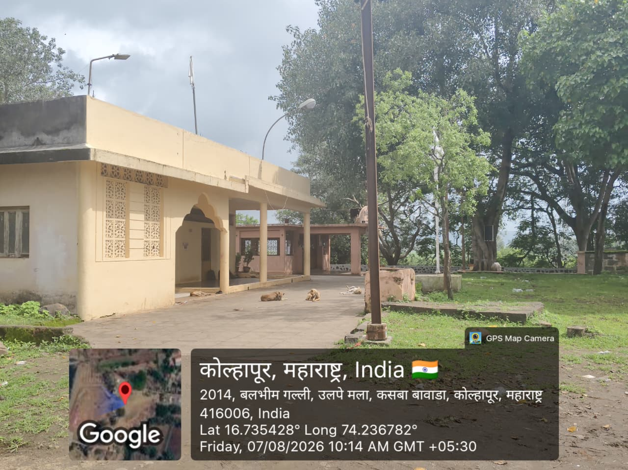
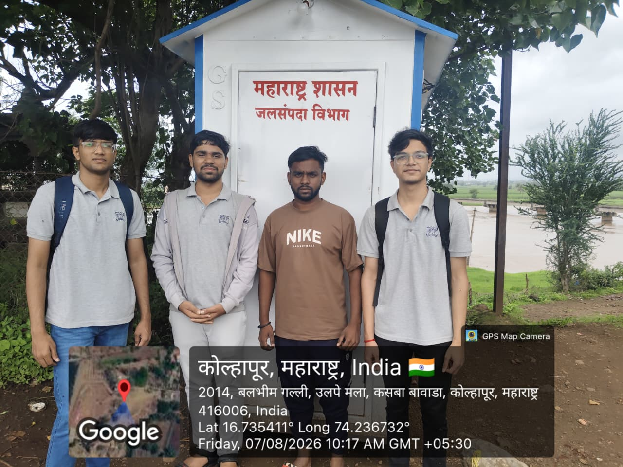
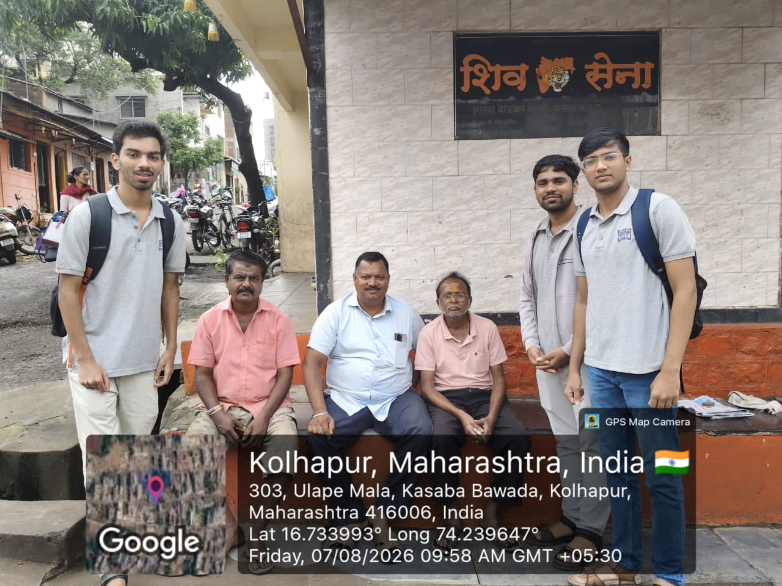
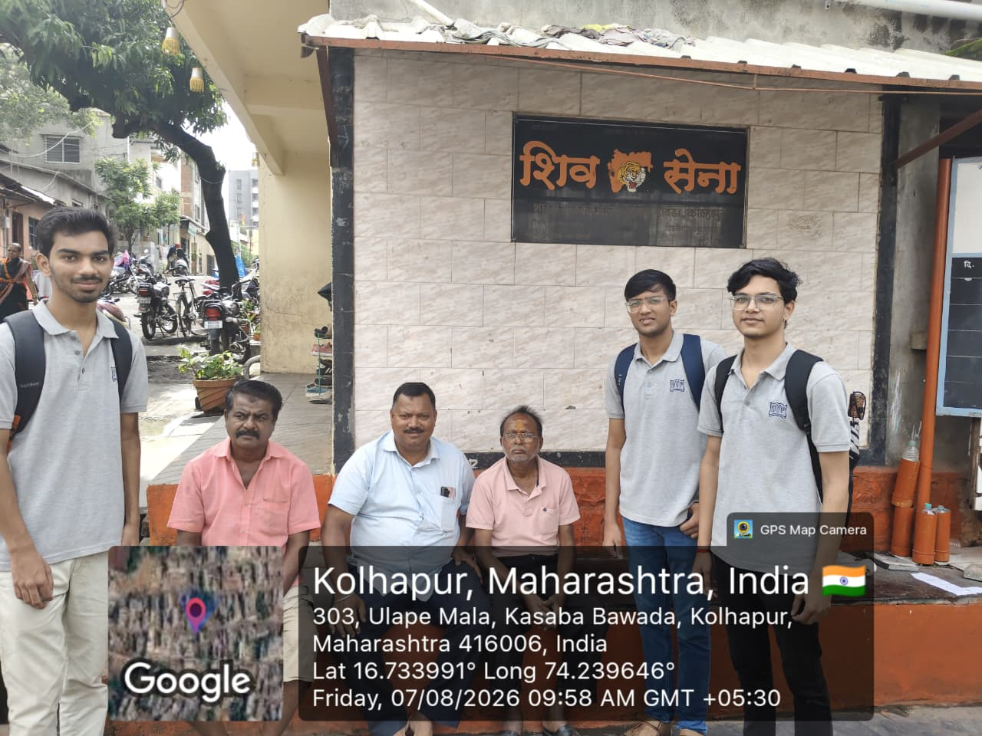
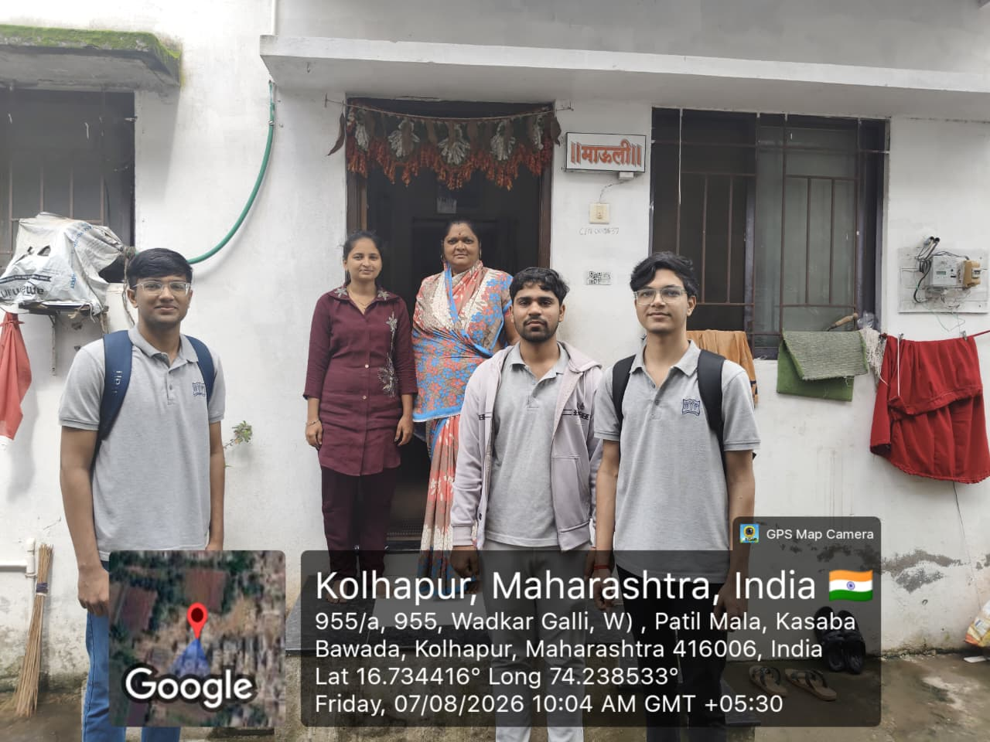
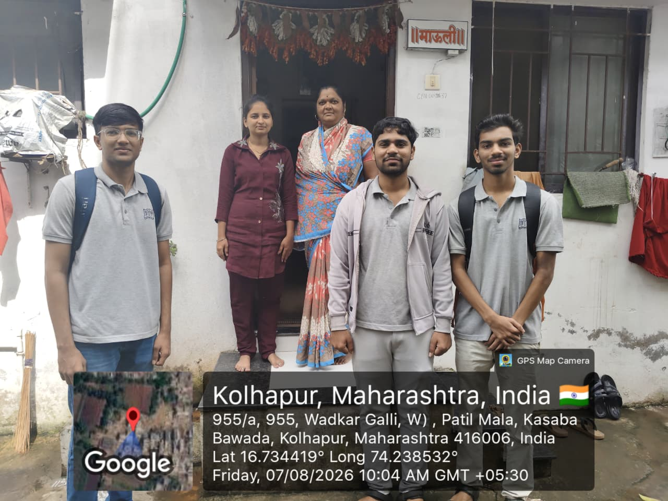
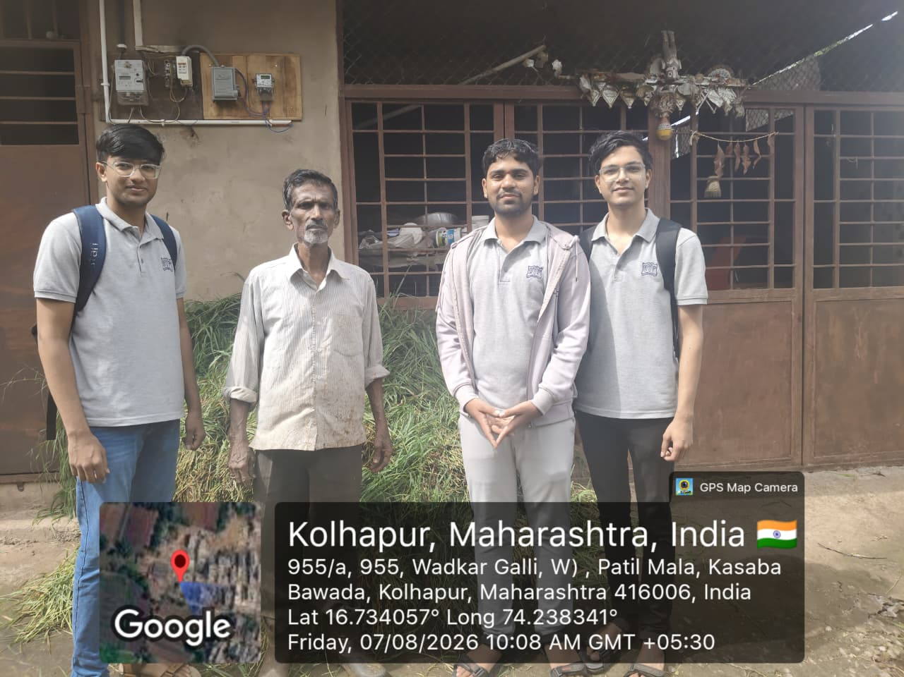
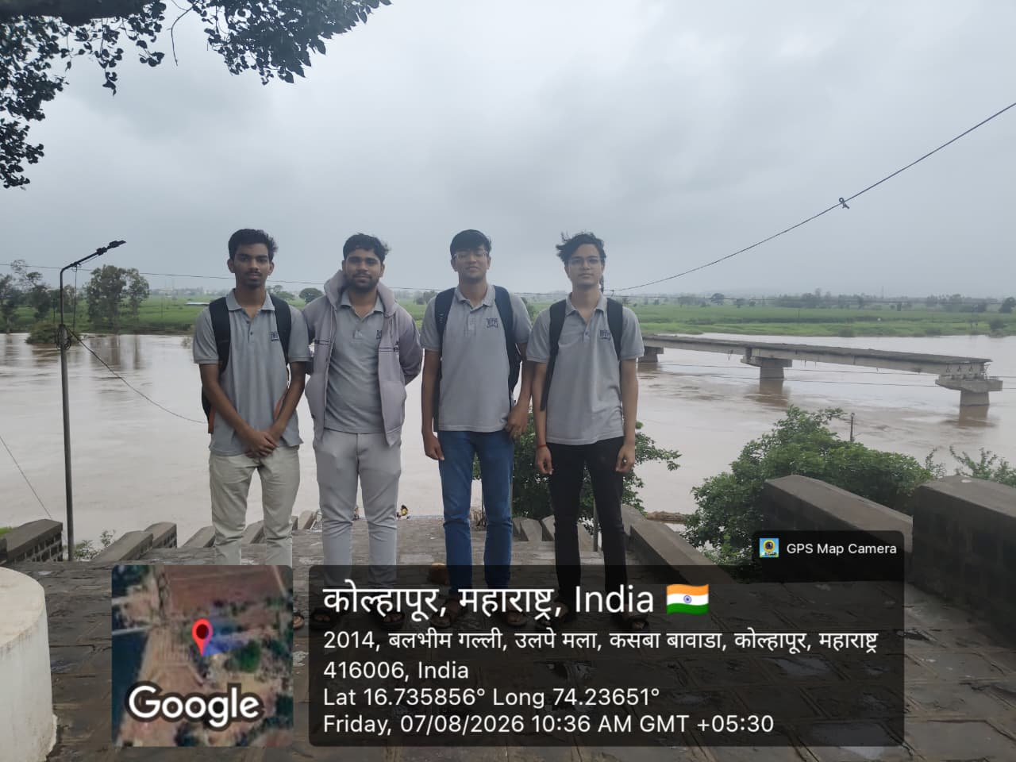
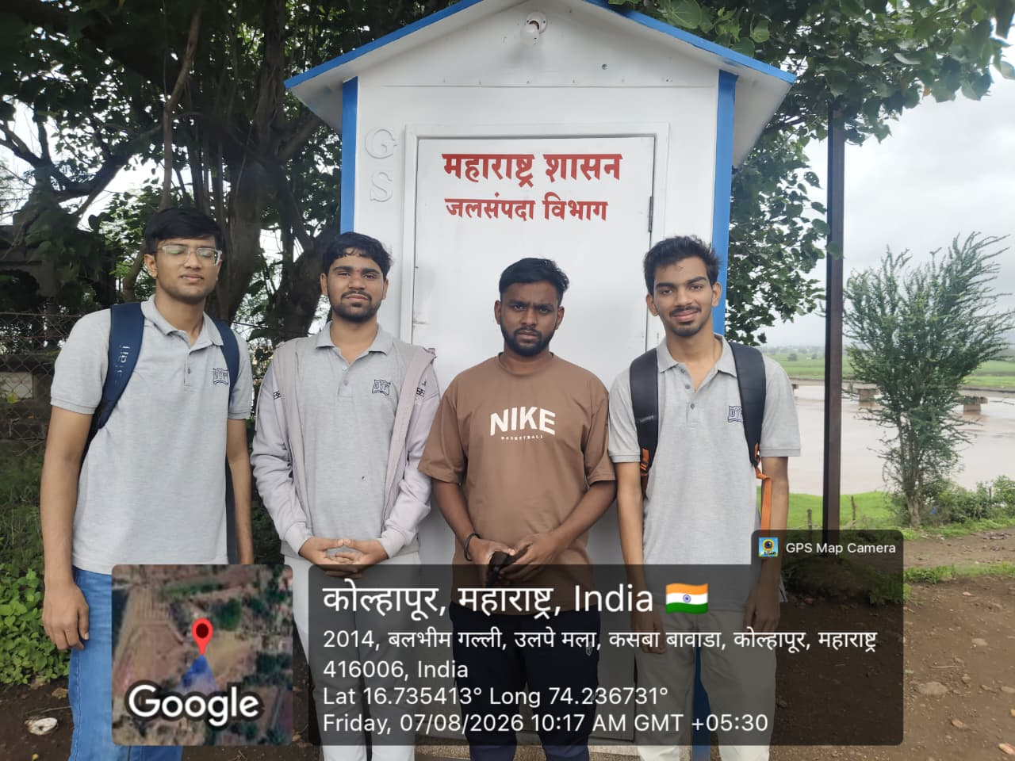
Project: -
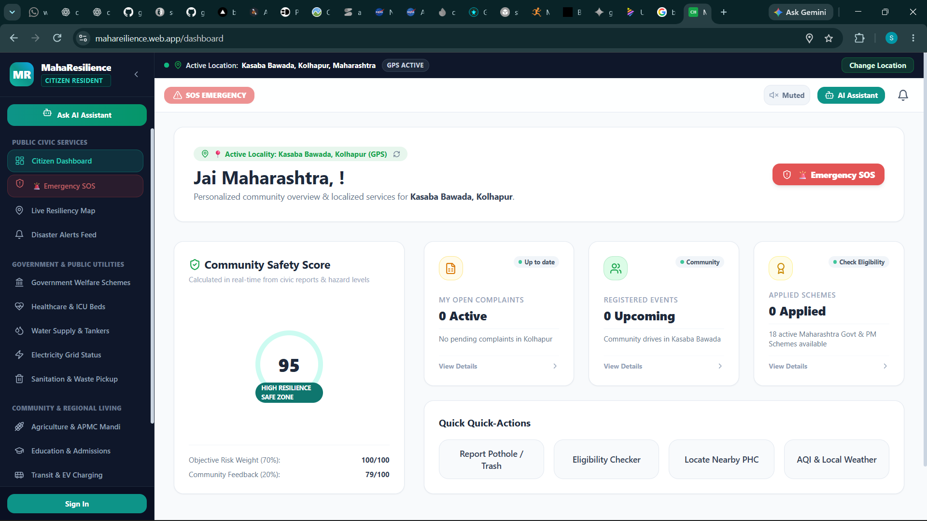
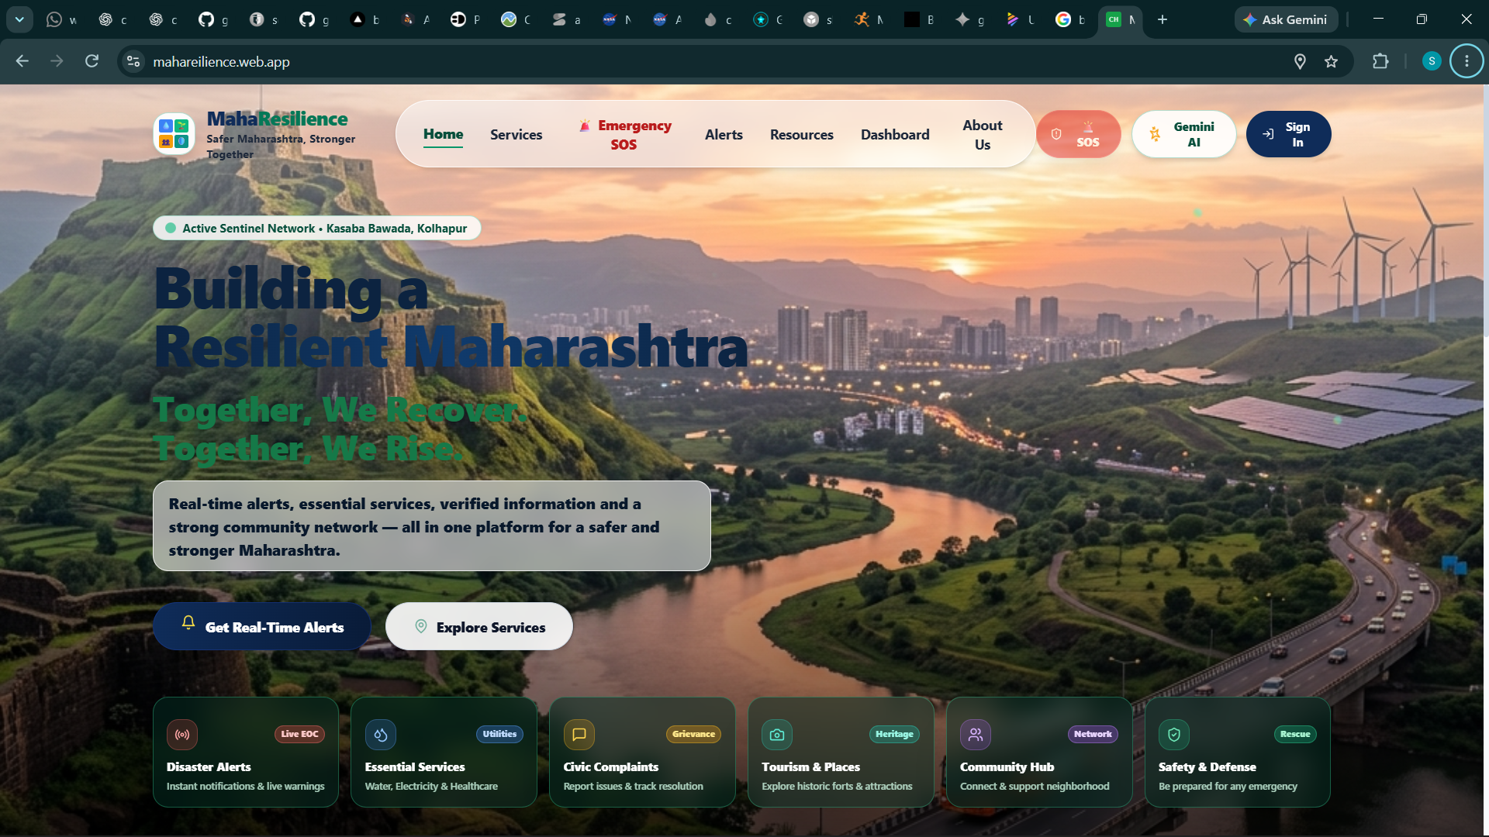
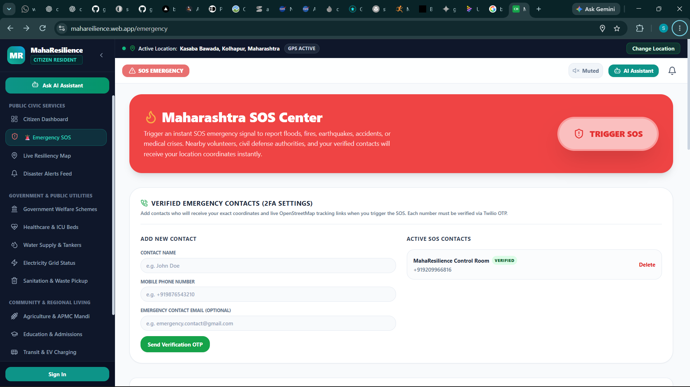
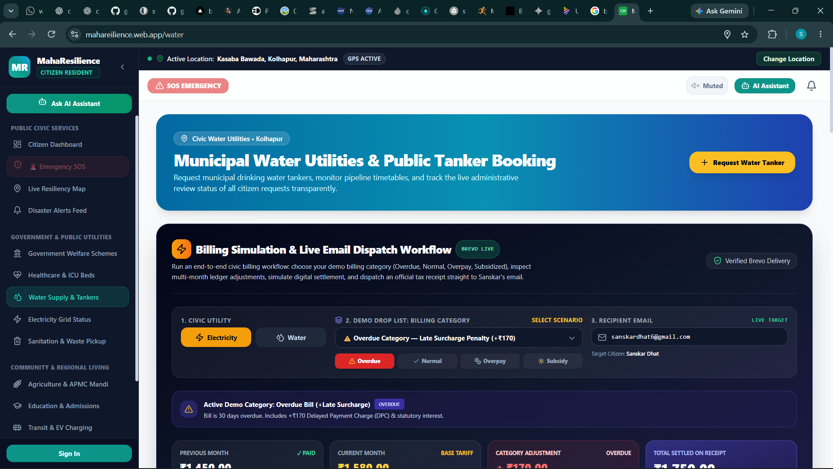
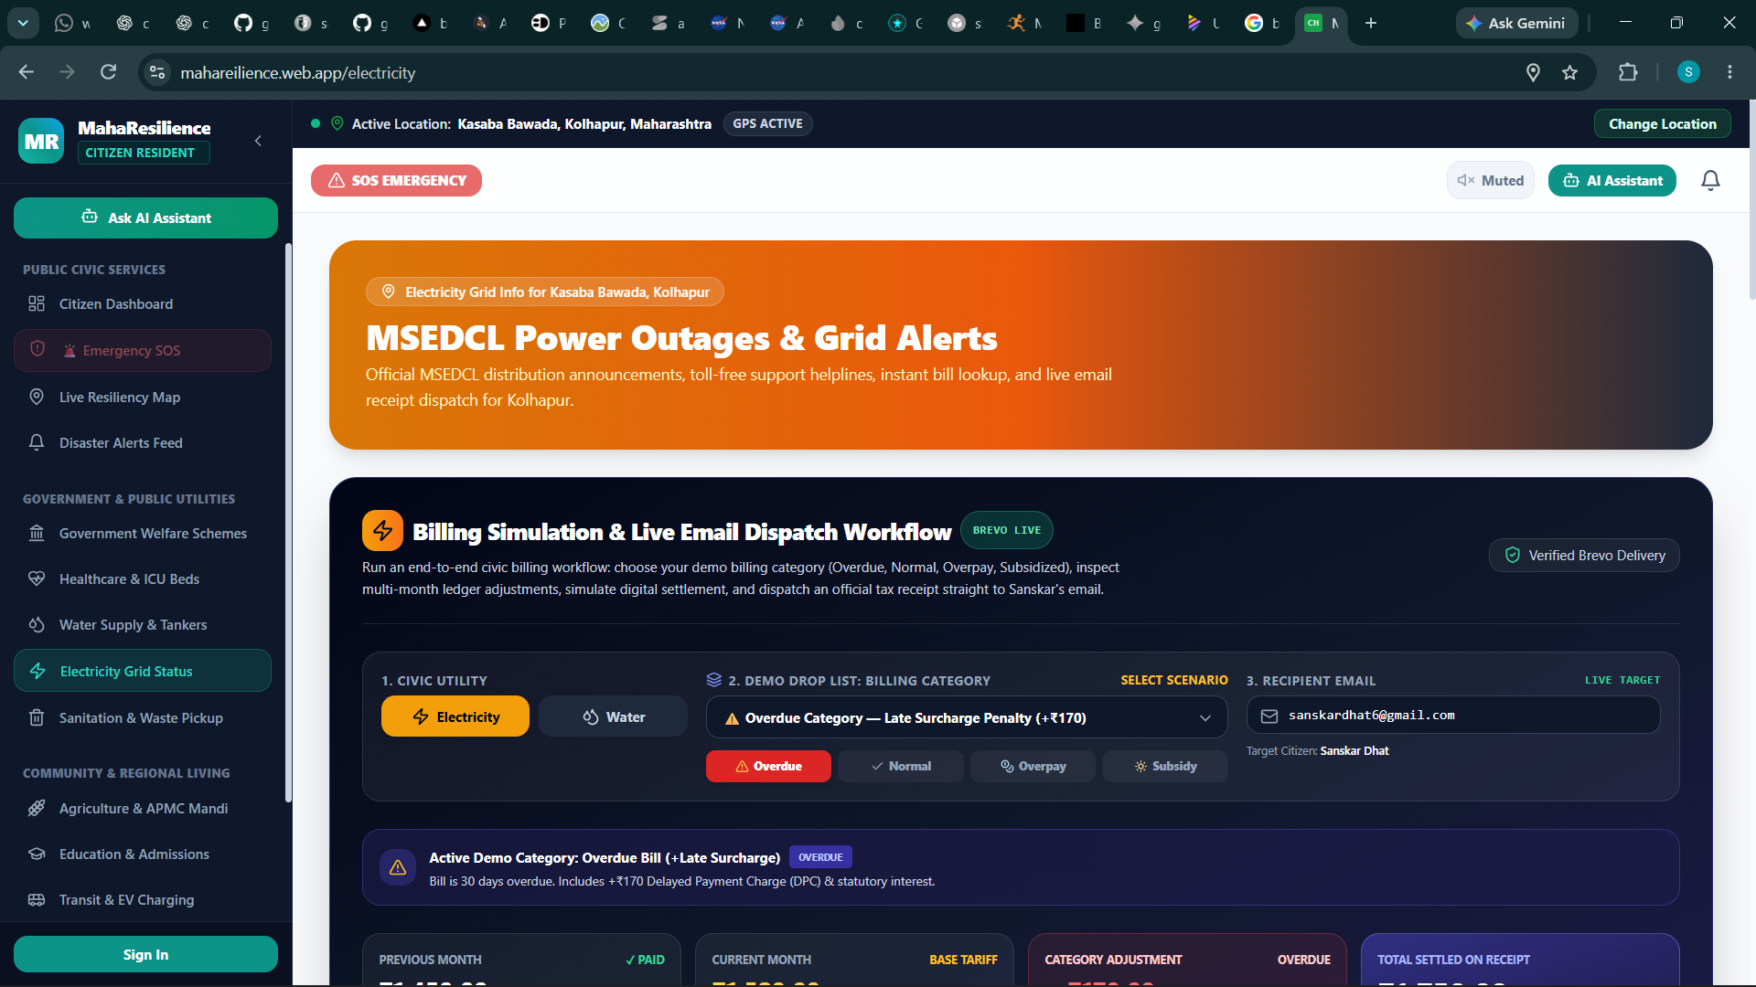
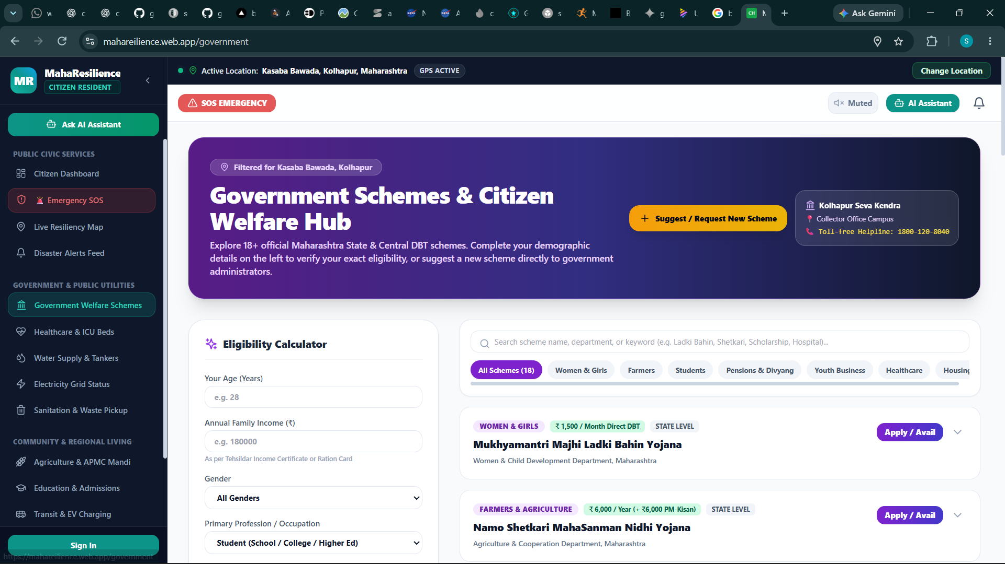
12. References
[1] Maharashtra State Electricity Distribution Company Limited (MSEDCL), “MERC Multi-Year Tariff Regulations and Schedule of Charges,” Government of Maharashtra, 2024.
[2] National Disaster Management Authority (NDMA), “Common Alerting Protocol (CAP) and Sachet Early Warning Guidelines,” Ministry of Home Affairs, Government of India, 2023.
[3] Ministry of Housing and Urban Affairs (MoHUA), “Swachhata & Public Grievance Redressal Architecture Standards,” Government of India, 2022.
[4] Google Cloud Platform, “Cloud Firestore Multi-Tab Offline Persistence & Security Rules Reference,” Google LLC, 2024.
[5] Prisma Documentation, “Prisma ORM: Relational Modeling with PostgreSQL in Node.js Environments,” Prisma Data, Inc., 2024.
[6] Google DeepMind, “Gemini 1.5 & 2.0 Flash API: Structured Multimodal Prompts and Model Capabilities,” Google LLC, 2024.
[7] Twilio Inc., “Twilio REST API & Verify v2 Emergency SMS Protocol Guidelines,” Twilio Developer Documentation, 2024.
[8] Brevo (Sendinblue), “Transactional Email API v3: SMTP & Dynamic Template Integration Standards,” Brevo Developer Hub, 2024.
[9] OpenStreetMap Contributors, “Nominatim Reverse Geocoding API & OSRM Routing Engine Documentation,” OpenStreetMap Foundation, 2024.
[10] United Nations, “Sustainable Development Goals (SDGs): Progress and Indicators Framework,” UN Department of Economic and Social Affairs, 2023.

