part-3.R

sansk

2022-03-29

source('part-2.R')

## [1] "hey this is part 1"

## Loading required package: Hmisc

## Loading required package: lattice

## Loading required package: survival

## Loading required package: Formula

## Loading required package: ggplot2

##   
## Attaching package: 'Hmisc'

## The following objects are masked from 'package:base':  
##   
## format.pval, units

## funModeling v.1.9.4 :)  
## Examples and tutorials at livebook.datascienceheroes.com  
## / Now in Spanish: librovivodecienciadedatos.ai

## 'data.frame': 1460 obs. of 51 variables:  
## $ Id : int 1 2 3 4 5 6 7 8 9 10 ...  
## $ LotFrontage : int 65 80 68 60 84 85 75 NA 51 50 ...  
## $ LotArea : int 8450 9600 11250 9550 14260 14115 10084 10382 6120 7420 ...  
## $ Street : chr "Pave" "Pave" "Pave" "Pave" ...  
## $ Alley : chr NA NA NA NA ...  
## $ Utilities : chr "AllPub" "AllPub" "AllPub" "AllPub" ...  
## $ LotConfig : chr "Inside" "FR2" "Inside" "Corner" ...  
## $ Neighborhood : chr "CollgCr" "Veenker" "CollgCr" "Crawfor" ...  
## $ Condition1 : chr "Norm" "Feedr" "Norm" "Norm" ...  
## $ Condition2 : chr "Norm" "Norm" "Norm" "Norm" ...  
## $ BldgType : chr "1Fam" "1Fam" "1Fam" "1Fam" ...  
## $ HouseStyle : chr "2Story" "1Story" "2Story" "2Story" ...  
## $ OverallQual : int 7 6 7 7 8 5 8 7 7 5 ...  
## $ OverallCond : int 5 8 5 5 5 5 5 6 5 6 ...  
## $ YearBuilt : int 2003 1976 2001 1915 2000 1993 2004 1973 1931 1939 ...  
## $ RoofStyle : chr "Gable" "Gable" "Gable" "Gable" ...  
## $ RoofMatl : chr "CompShg" "CompShg" "CompShg" "CompShg" ...  
## $ Exterior1st : chr "VinylSd" "MetalSd" "VinylSd" "Wd Sdng" ...  
## $ MasVnrArea : int 196 0 162 0 350 0 186 240 0 0 ...  
## $ ExterQual : chr "Gd" "TA" "Gd" "TA" ...  
## $ ExterCond : chr "TA" "TA" "TA" "TA" ...  
## $ Foundation : chr "PConc" "CBlock" "PConc" "BrkTil" ...  
## $ BsmtQual : chr "Gd" "Gd" "Gd" "TA" ...  
## $ BsmtCond : chr "TA" "TA" "TA" "Gd" ...  
## $ TotalBsmtSF : int 856 1262 920 756 1145 796 1686 1107 952 991 ...  
## $ Heating : chr "GasA" "GasA" "GasA" "GasA" ...  
## $ X1stFlrSF : int 856 1262 920 961 1145 796 1694 1107 1022 1077 ...  
## $ X2ndFlrSF : int 854 0 866 756 1053 566 0 983 752 0 ...  
## $ LowQualFinSF : int 0 0 0 0 0 0 0 0 0 0 ...  
## $ GrLivArea : int 1710 1262 1786 1717 2198 1362 1694 2090 1774 1077 ...  
## $ FullBath : int 2 2 2 1 2 1 2 2 2 1 ...  
## $ BedroomAbvGr : int 3 3 3 3 4 1 3 3 2 2 ...  
## $ KitchenAbvGr : int 1 1 1 1 1 1 1 1 2 2 ...  
## $ KitchenQual : chr "Gd" "TA" "Gd" "Gd" ...  
## $ TotRmsAbvGrd : int 8 6 6 7 9 5 7 7 8 5 ...  
## $ Functional : chr "Typ" "Typ" "Typ" "Typ" ...  
## $ Fireplaces : int 0 1 1 1 1 0 1 2 2 2 ...  
## $ GarageType : chr "Attchd" "Attchd" "Attchd" "Detchd" ...  
## $ GarageArea : int 548 460 608 642 836 480 636 484 468 205 ...  
## $ GarageCond : chr "TA" "TA" "TA" "TA" ...  
## $ PavedDrive : chr "Y" "Y" "Y" "Y" ...  
## $ PoolArea : int 0 0 0 0 0 0 0 0 0 0 ...  
## $ PoolQC : chr NA NA NA NA ...  
## $ Fence : chr NA NA NA NA ...  
## $ MiscFeature : chr NA NA NA NA ...  
## $ MiscVal : int 0 0 0 0 0 700 0 350 0 0 ...  
## $ MoSold : int 2 5 9 2 12 10 8 11 4 1 ...  
## $ YrSold : int 2008 2007 2008 2006 2008 2009 2007 2009 2008 2008 ...  
## $ SaleType : chr "WD" "WD" "WD" "WD" ...  
## $ SaleCondition: chr "Normal" "Normal" "Normal" "Abnorml" ...  
## $ SalePrice : int 208500 181500 223500 140000 250000 143000 307000 200000 129900 118000 ...

## Warning: `guides(<scale> = FALSE)` is deprecated. Please use `guides(<scale> = "none")` instead.  
## `guides(<scale> = FALSE)` is deprecated. Please use `guides(<scale> = "none")` instead.

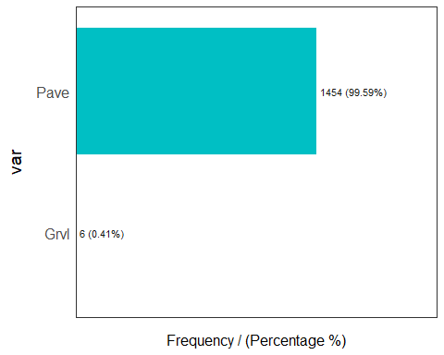

## Warning: `guides(<scale> = FALSE)` is deprecated. Please use `guides(<scale> =  
## "none")` instead.

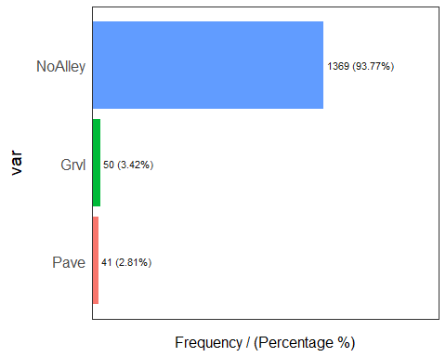

## Warning: `guides(<scale> = FALSE)` is deprecated. Please use `guides(<scale> =  
## "none")` instead.

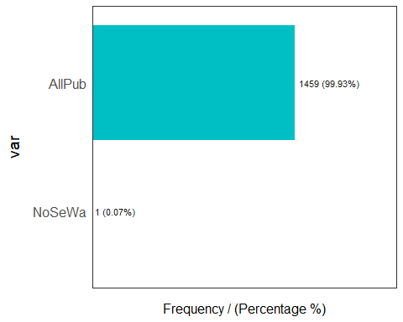

## Warning: `guides(<scale> = FALSE)` is deprecated. Please use `guides(<scale> =  
## "none")` instead.

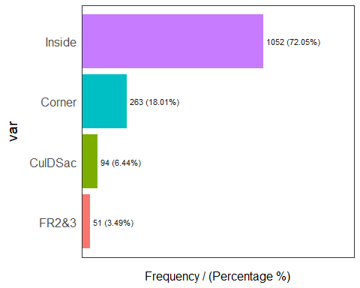

## Warning: `guides(<scale> = FALSE)` is deprecated. Please use `guides(<scale> =  
## "none")` instead.

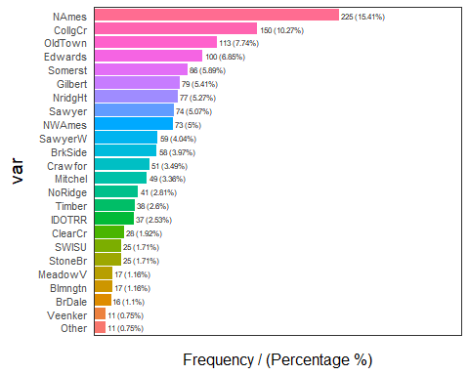

## Warning: `guides(<scale> = FALSE)` is deprecated. Please use `guides(<scale> =  
## "none")` instead.

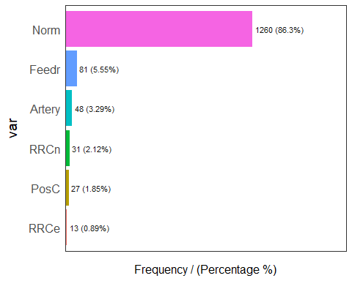

## Warning: `guides(<scale> = FALSE)` is deprecated. Please use `guides(<scale> =  
## "none")` instead.

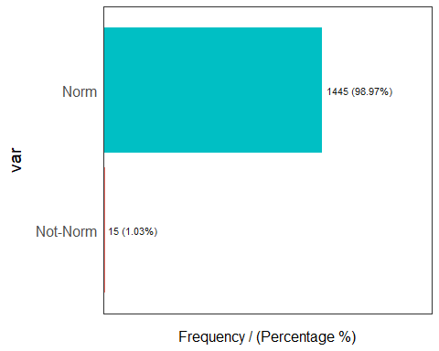

## Warning: `guides(<scale> = FALSE)` is deprecated. Please use `guides(<scale> =  
## "none")` instead.

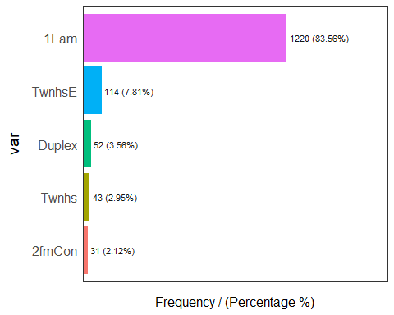

## Warning: `guides(<scale> = FALSE)` is deprecated. Please use `guides(<scale> =  
## "none")` instead.

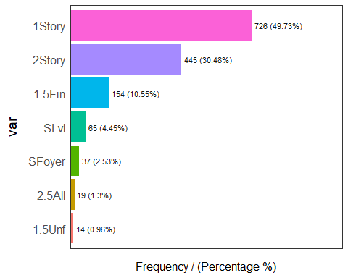

## Warning: `guides(<scale> = FALSE)` is deprecated. Please use `guides(<scale> =  
## "none")` instead.

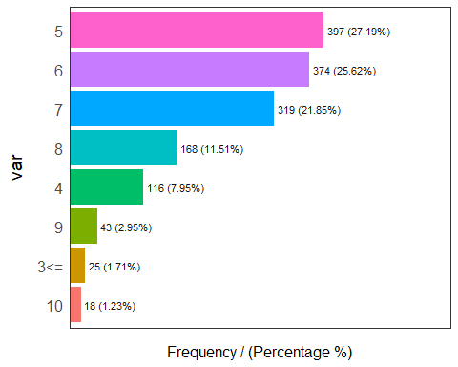

## Warning: `guides(<scale> = FALSE)` is deprecated. Please use `guides(<scale> =  
## "none")` instead.

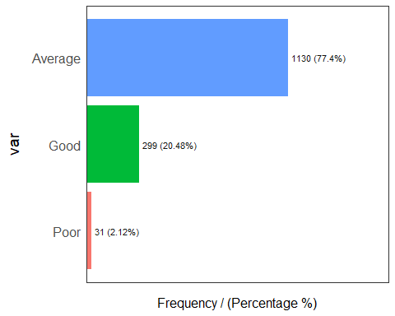

## Warning: `guides(<scale> = FALSE)` is deprecated. Please use `guides(<scale> =  
## "none")` instead.

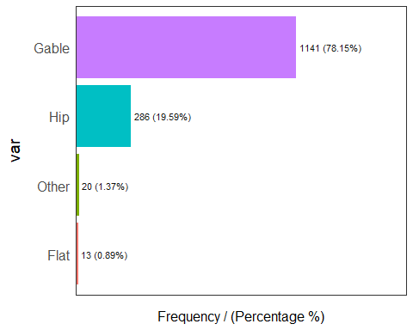

## Warning: `guides(<scale> = FALSE)` is deprecated. Please use `guides(<scale> =  
## "none")` instead.

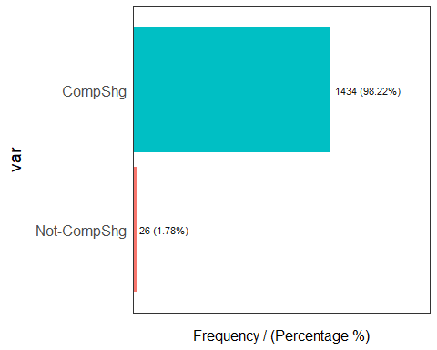

## Warning: `guides(<scale> = FALSE)` is deprecated. Please use `guides(<scale> =  
## "none")` instead.

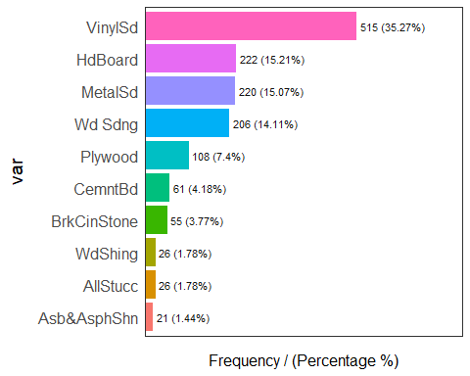

## Warning: `guides(<scale> = FALSE)` is deprecated. Please use `guides(<scale> =  
## "none")` instead.

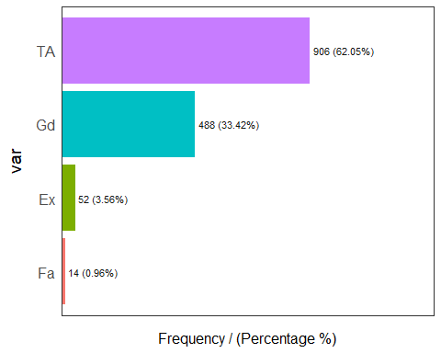

## Warning: `guides(<scale> = FALSE)` is deprecated. Please use `guides(<scale> =  
## "none")` instead.

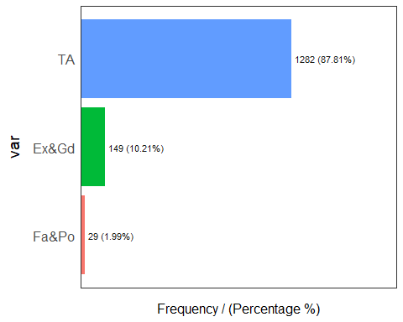

## Warning: `guides(<scale> = FALSE)` is deprecated. Please use `guides(<scale> =  
## "none")` instead.

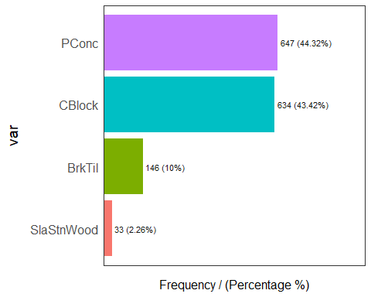

## Warning: `guides(<scale> = FALSE)` is deprecated. Please use `guides(<scale> =  
## "none")` instead.

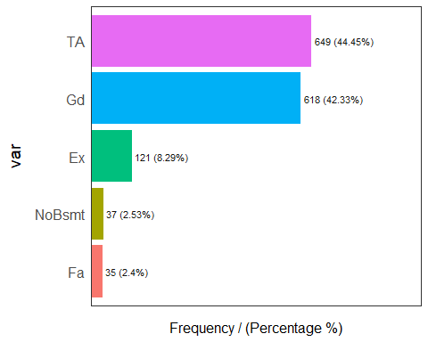

## Warning: `guides(<scale> = FALSE)` is deprecated. Please use `guides(<scale> =  
## "none")` instead.

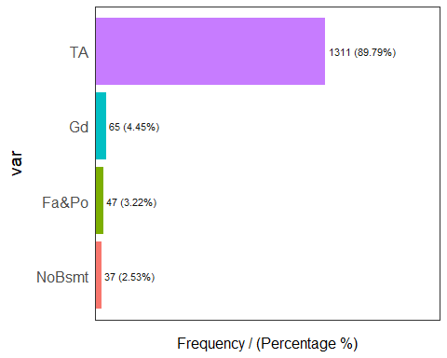

## Warning: `guides(<scale> = FALSE)` is deprecated. Please use `guides(<scale> =  
## "none")` instead.

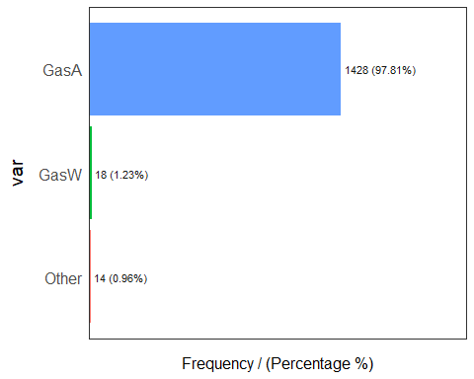

## Warning: `guides(<scale> = FALSE)` is deprecated. Please use `guides(<scale> =  
## "none")` instead.

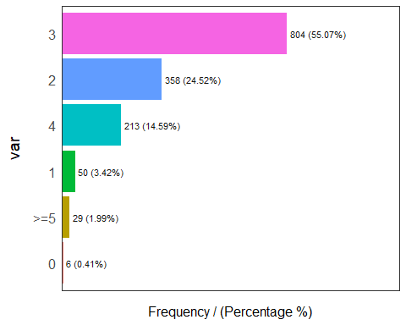

## Warning: `guides(<scale> = FALSE)` is deprecated. Please use `guides(<scale> =  
## "none")` instead.

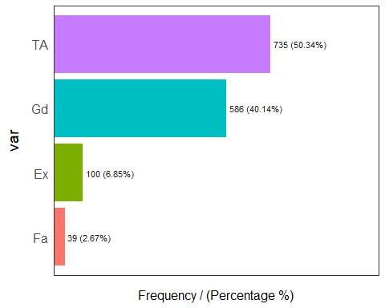

## Warning: `guides(<scale> = FALSE)` is deprecated. Please use `guides(<scale> =  
## "none")` instead.

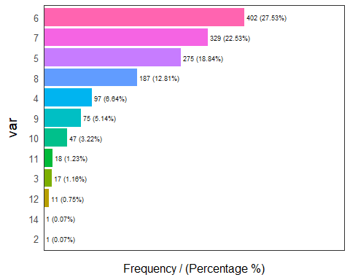

## Warning: `guides(<scale> = FALSE)` is deprecated. Please use `guides(<scale> =  
## "none")` instead.

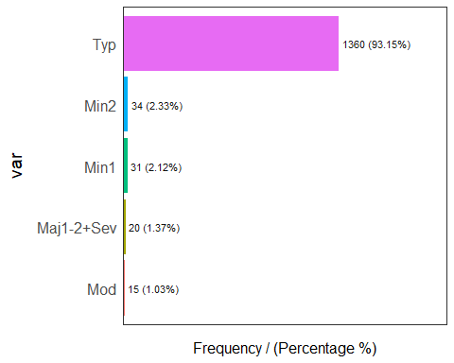

## Warning: `guides(<scale> = FALSE)` is deprecated. Please use `guides(<scale> =  
## "none")` instead.

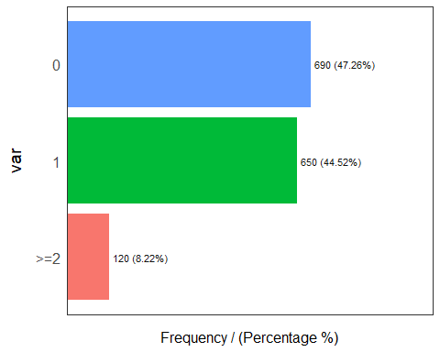

## Warning: `guides(<scale> = FALSE)` is deprecated. Please use `guides(<scale> =  
## "none")` instead.

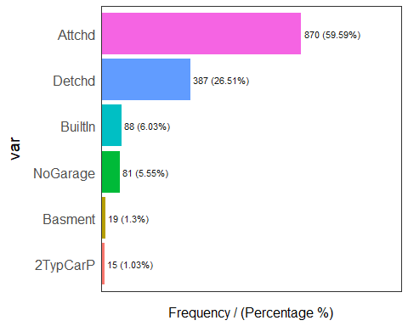

## Warning: `guides(<scale> = FALSE)` is deprecated. Please use `guides(<scale> =  
## "none")` instead.

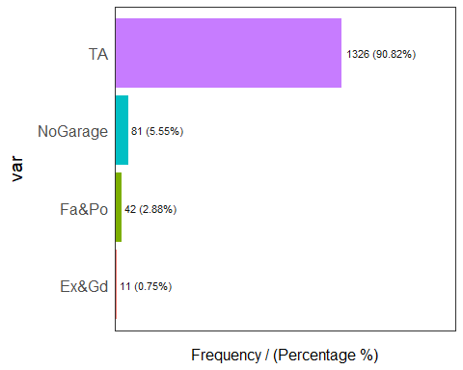

## Warning: `guides(<scale> = FALSE)` is deprecated. Please use `guides(<scale> =  
## "none")` instead.

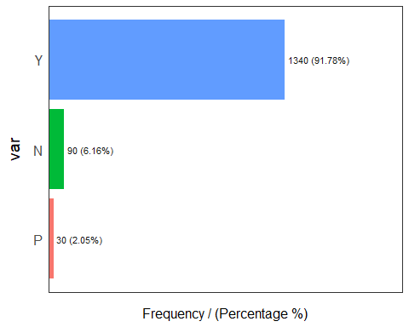

## Warning: `guides(<scale> = FALSE)` is deprecated. Please use `guides(<scale> =  
## "none")` instead.

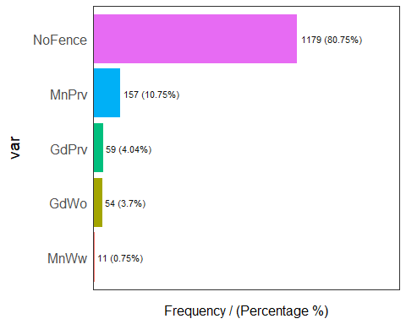

## Warning: `guides(<scale> = FALSE)` is deprecated. Please use `guides(<scale> =  
## "none")` instead.

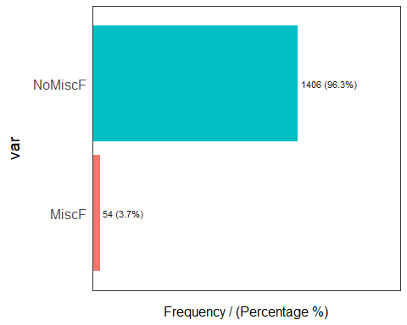

## Warning: `guides(<scale> = FALSE)` is deprecated. Please use `guides(<scale> =  
## "none")` instead.

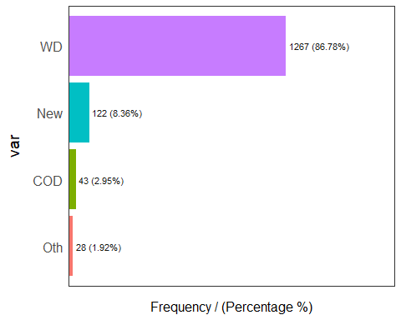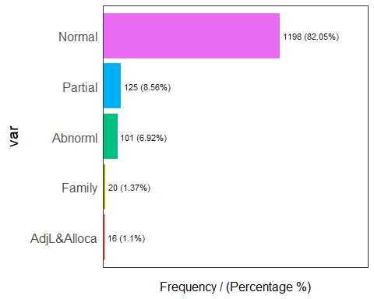

## [1] "yo wassup, this part two"

##   
## Attaching package: 'dplyr'

## The following objects are masked from 'package:Hmisc':  
##   
## src, summarize

## The following objects are masked from 'package:stats':  
##   
## filter, lag

## The following objects are masked from 'package:base':  
##   
## intersect, setdiff, setequal, union

##   
## Attaching package: 'caret'

## The following object is masked from 'package:survival':  
##   
## cluster

## randomForest 4.7-1

## Type rfNews() to see new features/changes/bug fixes.

##   
## Attaching package: 'randomForest'

## The following object is masked from 'package:dplyr':  
##   
## combine

## The following object is masked from 'package:ggplot2':  
##   
## margin

## For binary classification, the first factor level is assumed to be the event.  
## Use the argument `event_level = "second"` to alter this as needed.

##   
## Attaching package: 'yardstick'

## The following objects are masked from 'package:caret':  
##   
## precision, recall, sensitivity, specificity

## The following object is masked from 'package:readr':  
##   
## spec

## # weights: 42 (26 variable)  
## initial value 1284.277765   
## iter 10 value 609.446760  
## iter 20 value 603.876680  
## iter 30 value 603.764077  
## final value 603.763392   
## converged  
## # weights: 402 (266 variable)  
## initial value 1284.277765   
## iter 10 value 534.153613  
## iter 20 value 338.183216  
## iter 30 value 298.317505  
## iter 40 value 283.312614  
## iter 50 value 275.331318  
## iter 60 value 271.121151  
## iter 70 value 268.363024  
## iter 80 value 266.696211  
## iter 90 value 265.485806  
## iter 100 value 264.639428  
## final value 264.639428   
## stopped after 100 iterations

## Warning in sqrt(diag(vc)): NaNs produced

## Warning in sqrt(diag(vc)): NaNs produced

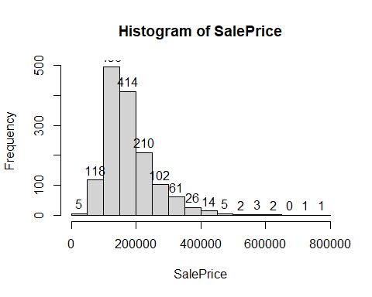

##   
## Call:  
## randomForest(x = xtrain, y = ytrain, importance = T, method = "class")   
## Type of random forest: classification  
## Number of trees: 500  
## No. of variables tried at each split: 6  
##   
## OOB estimate of error rate: 19.42%  
## Confusion matrix:  
## Average Good Poor class.error  
## Average 854 50 0 0.05530973  
## Good 154 86 0 0.64166667  
## Poor 21 2 2 0.92000000

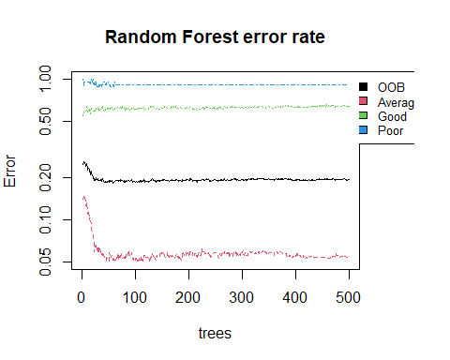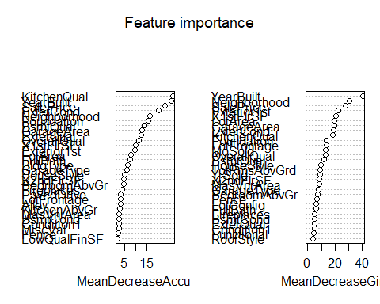

library(tidyverse)

## -- Attaching packages --------------------------------------- tidyverse 1.3.1 --

## v tibble 3.1.6 v stringr 1.4.0  
## v purrr 0.3.4 v forcats 0.5.1

## -- Conflicts ------------------------------------------ tidyverse_conflicts() --  
## x randomForest::combine() masks dplyr::combine()  
## x dplyr::filter() masks stats::filter()  
## x dplyr::lag() masks stats::lag()  
## x purrr::lift() masks caret::lift()  
## x randomForest::margin() masks ggplot2::margin()  
## x yardstick::spec() masks readr::spec()  
## x dplyr::src() masks Hmisc::src()  
## x dplyr::summarize() masks Hmisc::summarize()

library(ggplot2)  
library(caret)  
library(randomForest)  
library(broom)  
  
summary(house.data)

## LotFrontage LotArea Alley LotConfig   
## Min. :-1.6623 Min. :-0.9234 Grvl : 50 Corner : 263   
## 1st Qu.:-0.4507 1st Qu.:-0.2969 NoAlley:1369 CulDSac: 94   
## Median : 0.1551 Median :-0.1040 Pave : 41 FR2&3 : 51   
## Mean : 0.0000 Mean : 0.0000 Inside :1052   
## 3rd Qu.: 0.6167 3rd Qu.: 0.1087   
## Max. : 7.3671 Max. :20.5112   
##   
## Neighborhood Condition1 Condition2 BldgType HouseStyle   
## NAmes :225 Artery: 48 Not-Norm: 15 1Fam :1220 1.5Fin:154   
## CollgCr:150 Feedr : 81 Norm :1445 2fmCon: 31 1.5Unf: 14   
## OldTown:113 Norm :1260 Duplex: 52 1Story:726   
## Edwards:100 PosC : 27 Twnhs : 43 2.5All: 19   
## Somerst: 86 RRCe : 13 TwnhsE: 114 2Story:445   
## Gilbert: 79 RRCn : 31 SFoyer: 37   
## (Other):707 SLvl : 65   
## OverallQual OverallCond YearBuilt RoofStyle   
## 5 :397 Average:1130 Min. :-3.28670 Flat : 13   
## 6 :374 Good : 299 1st Qu.:-0.57173 Gable:1141   
## 7 :319 Poor : 31 Median : 0.05735 Other: 20   
## 8 :168 Mean : 0.00000 Hip : 286   
## 4 :116 3rd Qu.: 0.95131   
## 9 : 43 Max. : 1.28240   
## (Other): 43   
## RoofMatl Exterior1st MasVnrArea ExterQual ExterCond   
## Not-CompShg: 26 VinylSd:515 Min. :-0.5706 Ex: 52 Ex&Gd: 149   
## CompShg :1434 HdBoard:222 1st Qu.:-0.5706 Fa: 14 Fa&Po: 29   
## MetalSd:220 Median :-0.5706 Gd:488 TA :1282   
## Wd Sdng:206 Mean : 0.0000 TA:906   
## Plywood:108 3rd Qu.: 0.3383   
## CemntBd: 61 Max. : 8.2824   
## (Other):128   
## Foundation BsmtQual BsmtCond Heating X1stFlrSF   
## BrkTil :146 Ex :121 Fa&Po : 47 Other: 14 Min. :-2.1434   
## CBlock :634 Fa : 35 Gd : 65 GasA :1428 1st Qu.:-0.7259   
## PConc :647 Gd :618 NoBsmt: 37 GasW : 18 Median :-0.1956   
## SlaStnWood: 33 NoBsmt: 37 TA :1311 Mean : 0.0000   
## TA :649 3rd Qu.: 0.5914   
## Max. : 9.1296   
##   
## X2ndFlrSF LowQualFinSF FullBath BedroomAbvGr  
## Min. :-0.7949 Min. :-0.1202 Min. :-2.8408 0 : 6   
## 1st Qu.:-0.7949 1st Qu.:-0.1202 1st Qu.:-1.0257 1 : 50   
## Median :-0.7949 Median :-0.1202 Median : 0.7895 2 :358   
## Mean : 0.0000 Mean : 0.0000 Mean : 0.0000 3 :804   
## 3rd Qu.: 0.8728 3rd Qu.:-0.1202 3rd Qu.: 0.7895 4 :213   
## Max. : 3.9356 Max. :11.6438 Max. : 2.6046 >=5: 29   
##   
## KitchenAbvGr KitchenQual TotRmsAbvGrd Functional Fireplaces  
## Min. :-4.7499 Ex:100 Min. :-2.7795 Maj1-2+Sev: 20 0 :690   
## 1st Qu.:-0.2114 Fa: 39 1st Qu.:-0.9338 Min1 : 31 1 :650   
## Median :-0.2114 Gd:586 Median :-0.3186 Min2 : 34 >=2:120   
## Mean : 0.0000 TA:735 Mean : 0.0000 Mod : 15   
## 3rd Qu.:-0.2114 3rd Qu.: 0.2967 Typ :1360   
## Max. : 8.8656 Max. : 4.6033   
##   
## GarageType GarageArea GarageCond PavedDrive Fence   
## 2TypCarP: 15 Min. :-2.21220 Ex&Gd : 11 N: 90 GdPrv : 59   
## Attchd :870 1st Qu.:-0.64769 Fa&Po : 42 P: 30 GdWo : 54   
## Basment : 19 Median : 0.03283 NoGarage: 81 Y:1340 MnPrv : 157   
## BuiltIn : 88 Mean : 0.00000 TA :1326 MnWw : 11   
## Detchd :387 3rd Qu.: 0.48184 NoFence:1179   
## NoGarage: 81 Max. : 4.42001   
##   
## MiscFeature MiscVal MoSold YrSold   
## MiscF : 54 Min. :-0.08766 Min. :-1.9684 Min. :-1.3672   
## NoMiscF:1406 1st Qu.:-0.08766 1st Qu.:-0.4889 1st Qu.:-0.6142   
## Median :-0.08766 Median :-0.1191 Median : 0.1387   
## Mean : 0.00000 Mean : 0.0000 Mean : 0.0000   
## 3rd Qu.:-0.08766 3rd Qu.: 0.6207 3rd Qu.: 0.8917   
## Max. :31.15459 Max. : 2.1002 Max. : 1.6446   
##   
## SaleType SaleCondition SalePrice   
## COD: 43 Abnorml : 101 Min. :-1.8381   
## Oth: 28 AdjL&Alloca: 16 1st Qu.:-0.6413   
## New: 122 Family : 20 Median :-0.2256   
## WD :1267 Normal :1198 Mean : 0.0000   
## Partial : 125 3rd Qu.: 0.4164   
## Max. : 7.2263   
##

# partitioning the model for training and testing set (80/20 split)  
samp <- createDataPartition(house.data$SalePrice, p = 0.8, list = FALSE)  
training <- house.data[samp,]  
testing <- house.data[-samp,]  
x_test <- testing[,1:43]  
y_test <- testing[,44]  
  
set.seed(16)  
  
# linear regression model using all the variables (regression based)  
lm_full_model <- train(SalePrice~., data = training, method = "lm")

## Warning in predict.lm(modelFit, newdata): prediction from a rank-deficient fit  
## may be misleading

## Warning in predict.lm(modelFit, newdata): prediction from a rank-deficient fit  
## may be misleading  
  
## Warning in predict.lm(modelFit, newdata): prediction from a rank-deficient fit  
## may be misleading  
  
## Warning in predict.lm(modelFit, newdata): prediction from a rank-deficient fit  
## may be misleading  
  
## Warning in predict.lm(modelFit, newdata): prediction from a rank-deficient fit  
## may be misleading  
  
## Warning in predict.lm(modelFit, newdata): prediction from a rank-deficient fit  
## may be misleading  
  
## Warning in predict.lm(modelFit, newdata): prediction from a rank-deficient fit  
## may be misleading  
  
## Warning in predict.lm(modelFit, newdata): prediction from a rank-deficient fit  
## may be misleading  
  
## Warning in predict.lm(modelFit, newdata): prediction from a rank-deficient fit  
## may be misleading  
  
## Warning in predict.lm(modelFit, newdata): prediction from a rank-deficient fit  
## may be misleading  
  
## Warning in predict.lm(modelFit, newdata): prediction from a rank-deficient fit  
## may be misleading  
  
## Warning in predict.lm(modelFit, newdata): prediction from a rank-deficient fit  
## may be misleading  
  
## Warning in predict.lm(modelFit, newdata): prediction from a rank-deficient fit  
## may be misleading  
  
## Warning in predict.lm(modelFit, newdata): prediction from a rank-deficient fit  
## may be misleading  
  
## Warning in predict.lm(modelFit, newdata): prediction from a rank-deficient fit  
## may be misleading  
  
## Warning in predict.lm(modelFit, newdata): prediction from a rank-deficient fit  
## may be misleading  
  
## Warning in predict.lm(modelFit, newdata): prediction from a rank-deficient fit  
## may be misleading  
  
## Warning in predict.lm(modelFit, newdata): prediction from a rank-deficient fit  
## may be misleading  
  
## Warning in predict.lm(modelFit, newdata): prediction from a rank-deficient fit  
## may be misleading  
  
## Warning in predict.lm(modelFit, newdata): prediction from a rank-deficient fit  
## may be misleading  
  
## Warning in predict.lm(modelFit, newdata): prediction from a rank-deficient fit  
## may be misleading  
  
## Warning in predict.lm(modelFit, newdata): prediction from a rank-deficient fit  
## may be misleading  
  
## Warning in predict.lm(modelFit, newdata): prediction from a rank-deficient fit  
## may be misleading  
  
## Warning in predict.lm(modelFit, newdata): prediction from a rank-deficient fit  
## may be misleading  
  
## Warning in predict.lm(modelFit, newdata): prediction from a rank-deficient fit  
## may be misleading

# random forest model using all the variables (tree based)  
rf_full_model <- train(SalePrice~., data = training, method = "rf")  
  
# checking most important variables for the linear regression model  
lm_imp<- varImp(lm_full_model, xlim = c(50, 100))  
ggplot(lm_imp)

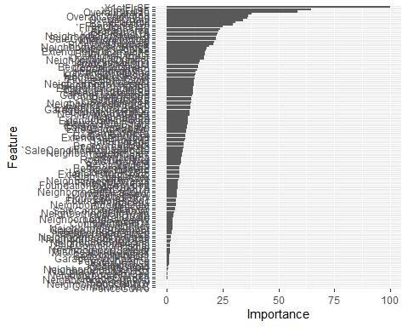

plot(lm_imp, top = 10)

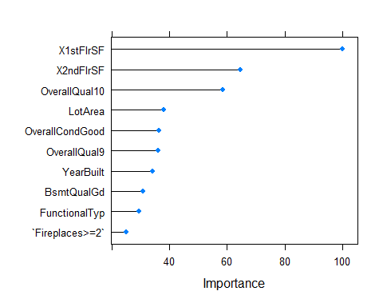

lm_imp

## lm variable importance  
##   
## only 20 most important variables shown (out of 131)  
##   
## Overall  
## X1stFlrSF 100.00  
## X2ndFlrSF 64.53  
## OverallQual10 58.50  
## LotArea 37.98  
## OverallCondGood 36.51  
## OverallQual9 36.12  
## YearBuilt 34.24  
## BsmtQualGd 30.89  
## FunctionalTyp 29.45  
## `Fireplaces>=2` 24.97  
## GarageArea 24.02  
## BsmtQualTA 23.20  
## KitchenQualTA 22.75  
## NeighborhoodStoneBr 22.44  
## SaleConditionNormal 22.14  
## KitchenQualGd 22.07  
## OverallQual8 21.16  
## BldgTypeTwnhsE 20.67  
## NeighborhoodNoRidge 19.08  
## KitchenQualFa 17.70

# checking most important variables for the random forest model  
rf_imp <- varImp(rf_full_model, xlim = c(20,100))  
ggplot(rf_imp)

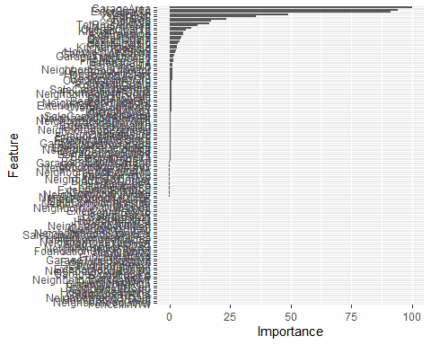

plot(rf_imp, top = 10)

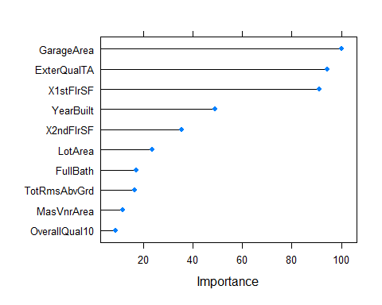

rf_imp

## rf variable importance  
##   
## only 20 most important variables shown (out of 133)  
##   
## Overall  
## GarageArea 100.000  
## ExterQualTA 94.248  
## X1stFlrSF 91.282  
## YearBuilt 48.931  
## X2ndFlrSF 35.664  
## LotArea 23.625  
## FullBath 17.161  
## TotRmsAbvGrd 16.537  
## MasVnrArea 11.770  
## OverallQual10 9.052  
## KitchenQualTA 6.892  
## LotFrontage 5.897  
## ExterQualGd 5.810  
## OverallQual8 5.096  
## OverallQual7 4.591  
## BsmtQualGd 4.336  
## OverallQual9 3.377  
## KitchenQualGd 3.259  
## MoSold 3.018  
## HouseStyle2Story 2.711

# Now that we know what the most important variables are with respect to the dataset,  
# we can model accordingly to get the most accurate model using both, a refression   
# model and a tree based model.  
  
# linear regression model using the most important variables out of all of them (regression based)  
lm_selected_model <- train(SalePrice~OverallQual+X2ndFlrSF+OverallCond+X1stFlrSF+Fireplaces+BsmtQual+KitchenQual+Neighborhood+BldgType,   
 data = training, method = "lm")  
  
# random forest model using the most important variables out of all of them (tree based)  
rf_selected_model <- train(SalePrice~OverallQual+X2ndFlrSF+OverallCond+X1stFlrSF+Fireplaces+BsmtQual+KitchenQual+Neighborhood,  
 data = training, method = "rf")  
  
# getting the insight about the model  
lm_full_model$finalModel

##   
## Call:  
## lm(formula = .outcome ~ ., data = dat)  
##   
## Coefficients:  
## (Intercept) LotFrontage   
## -1.0756864 0.0153552   
## LotArea AlleyNoAlley   
## 0.0886103 -0.0282978   
## AlleyPave LotConfigCulDSac   
## 0.0863652 0.1072903   
## `LotConfigFR2&3` LotConfigInside   
## -0.0565867 0.0062295   
## NeighborhoodOther NeighborhoodBrDale   
## 0.2816249 0.1031370   
## NeighborhoodBrkSide NeighborhoodClearCr   
## 0.1504605 0.1211713   
## NeighborhoodCollgCr NeighborhoodCrawfor   
## 0.0018864 0.3395720   
## NeighborhoodEdwards NeighborhoodGilbert   
## -0.0333434 -0.0451761   
## NeighborhoodIDOTRR NeighborhoodMeadowV   
## -0.0172552 -0.1196621   
## NeighborhoodMitchel NeighborhoodNAmes   
## -0.0332177 0.0072154   
## NeighborhoodNoRidge NeighborhoodNridgHt   
## 0.3866488 0.1942477   
## NeighborhoodNWAmes NeighborhoodOldTown   
## -0.0350189 -0.0693635   
## NeighborhoodSawyer NeighborhoodSawyerW   
## 0.0304457 0.0531730   
## NeighborhoodSomerst NeighborhoodStoneBr   
## -0.0041897 0.4683259   
## NeighborhoodSWISU NeighborhoodTimber   
## 0.0120209 -0.0488130   
## NeighborhoodVeenker Condition1Feedr   
## 0.3193864 0.0583605   
## Condition1Norm Condition1PosC   
## 0.1199457 -0.0011934   
## Condition1RRCe Condition1RRCn   
## -0.0604030 0.1638443   
## Condition2Norm BldgType2fmCon   
## 0.2612612 0.0082351   
## BldgTypeDuplex BldgTypeTwnhs   
## -0.0880595 -0.2402344   
## BldgTypeTwnhsE HouseStyle1.5Unf   
## -0.1985892 0.1749238   
## HouseStyle1Story HouseStyle2.5All   
## 0.1218396 -0.0309541   
## HouseStyle2Story HouseStyleSFoyer   
## 0.0364307 0.1863216   
## HouseStyleSLvl OverallQual4   
## 0.1648459 -0.0120780   
## OverallQual5 OverallQual6   
## 0.0476522 0.0478927   
## OverallQual7 OverallQual8   
## 0.1131251 0.3703949   
## OverallQual9 OverallQual10   
## 0.7940862 1.5601441   
## OverallCondGood OverallCondPoor   
## 0.1857577 -0.2292345   
## YearBuilt RoofStyleGable   
## 0.1765387 0.1297719   
## RoofStyleOther RoofStyleHip   
## 0.1869068 0.1467736   
## RoofMatlCompShg Exterior1stBrkCinStone   
## -0.2138212 0.3023592   
## Exterior1stCemntBd Exterior1stHdBoard   
## 0.2220435 0.1528011   
## Exterior1stAllStucc Exterior1stMetalSd   
## 0.1872625 0.1835556   
## Exterior1stPlywood Exterior1stVinylSd   
## 0.1396672 0.1680389   
## `Exterior1stWd Sdng` Exterior1stWdShing   
## 0.1667142 0.1083198   
## MasVnrArea ExterQualFa   
## 0.0212408 -0.1751994   
## ExterQualGd ExterQualTA   
## -0.0150297 -0.0712017   
## `ExterCondFa&Po` ExterCondTA   
## 0.1509851 0.0301496   
## FoundationCBlock FoundationPConc   
## -0.0167573 0.0373874   
## FoundationSlaStnWood BsmtQualFa   
## -0.0849404 -0.1875111   
## BsmtQualGd BsmtQualNoBsmt   
## -0.2655883 -0.2771031   
## BsmtQualTA BsmtCondGd   
## -0.2428472 0.0837852   
## BsmtCondNoBsmt BsmtCondTA   
## NA 0.0947539   
## HeatingGasA HeatingGasW   
## -0.0207251 -0.0666124   
## X1stFlrSF X2ndFlrSF   
## 0.4029046 0.3882671   
## LowQualFinSF FullBath   
## 0.0216076 0.0220647   
## BedroomAbvGr1 BedroomAbvGr2   
## -0.0404122 -0.1876817   
## BedroomAbvGr3 BedroomAbvGr4   
## -0.2485698 -0.2770207   
## `BedroomAbvGr>=5` KitchenAbvGr   
## -0.5041930 -0.0522207   
## KitchenQualFa KitchenQualGd   
## -0.2825729 -0.2057238   
## KitchenQualTA TotRmsAbvGrd   
## -0.2326936 -0.0292018   
## FunctionalMin1 FunctionalMin2   
## 0.3067338 0.2888030   
## FunctionalMod FunctionalTyp   
## 0.2492319 0.5277140   
## Fireplaces1 `Fireplaces>=2`   
## 0.0190270 0.1919106   
## GarageTypeAttchd GarageTypeBasment   
## 0.2176155 0.0594469   
## GarageTypeBuiltIn GarageTypeDetchd   
## 0.1873305 0.2150889   
## GarageTypeNoGarage GarageArea   
## 0.2953481 0.0691614   
## `GarageCondFa&Po` GarageCondNoGarage   
## -0.0253264 NA   
## GarageCondTA PavedDriveP   
## 0.0061046 -0.1245109   
## PavedDriveY FenceGdWo   
## -0.0341927 -0.0008382   
## FenceMnPrv FenceMnWw   
## 0.0470944 0.0024378   
## FenceNoFence MiscFeatureNoMiscF   
## 0.0105150 0.0179886   
## MiscVal MoSold   
## 0.0140057 -0.0107385   
## YrSold SaleTypeOth   
## -0.0028115 0.1956765   
## SaleTypeNew SaleTypeWD   
## 0.3722281 0.0852728   
## `SaleConditionAdjL&Alloca` SaleConditionFamily   
## 0.1363768 0.0553005   
## SaleConditionNormal SaleConditionPartial   
## 0.1521872 0.0980828

lm_selected_model$finalModel

##   
## Call:  
## lm(formula = .outcome ~ ., data = dat)  
##   
## Coefficients:  
## (Intercept) OverallQual4 OverallQual5   
## 0.605501 -0.027427 0.011787   
## OverallQual6 OverallQual7 OverallQual8   
## 0.089599 0.241631 0.541637   
## OverallQual9 OverallQual10 X2ndFlrSF   
## 0.966814 1.843094 0.265418   
## OverallCondGood OverallCondPoor X1stFlrSF   
## 0.131174 -0.396244 0.374296   
## Fireplaces1 `Fireplaces>=2` BsmtQualFa   
## 0.027832 0.225429 -0.592385   
## BsmtQualGd BsmtQualNoBsmt BsmtQualTA   
## -0.399769 -0.653763 -0.540622   
## KitchenQualFa KitchenQualGd KitchenQualTA   
## -0.441229 -0.232698 -0.330460   
## NeighborhoodOther NeighborhoodBrDale NeighborhoodBrkSide   
## 0.044751 -0.007974 -0.251781   
## NeighborhoodClearCr NeighborhoodCollgCr NeighborhoodCrawfor   
## 0.084808 0.020723 0.040590   
## NeighborhoodEdwards NeighborhoodGilbert NeighborhoodIDOTRR   
## -0.258514 -0.022424 -0.404864   
## NeighborhoodMeadowV NeighborhoodMitchel NeighborhoodNAmes   
## -0.204438 -0.094940 -0.176168   
## NeighborhoodNoRidge NeighborhoodNridgHt NeighborhoodNWAmes   
## 0.514582 0.270066 -0.166230   
## NeighborhoodOldTown NeighborhoodSawyer NeighborhoodSawyerW   
## -0.496597 -0.145191 -0.057807   
## NeighborhoodSomerst NeighborhoodStoneBr NeighborhoodSWISU   
## 0.139254 0.512227 -0.408256   
## NeighborhoodTimber NeighborhoodVeenker BldgType2fmCon   
## -0.005654 0.373527 -0.142690   
## BldgTypeDuplex BldgTypeTwnhs BldgTypeTwnhsE   
## -0.304840 -0.362489 -0.218419

rf_full_model$finalModel

##   
## Call:  
## randomForest(x = x, y = y, mtry = min(param$mtry, ncol(x)))   
## Type of random forest: regression  
## Number of trees: 500  
## No. of variables tried at each split: 67  
##   
## Mean of squared residuals: 0.1428324  
## % Var explained: 86.15

rf_selected_model$finalModel

##   
## Call:  
## randomForest(x = x, y = y, mtry = min(param$mtry, ncol(x)))   
## Type of random forest: regression  
## Number of trees: 500  
## No. of variables tried at each split: 22  
##   
## Mean of squared residuals: 0.1438133  
## % Var explained: 86.05

# evaluating the model based just on the metrics  
lm_selected_model$results

## intercept RMSE Rsquared MAE RMSESD RsquaredSD MAESD  
## 1 TRUE 0.3604262 0.8731112 0.2477793 0.01711603 0.01343138 0.01028351

rf_selected_model$results

## mtry RMSE Rsquared MAE RMSESD RsquaredSD MAESD  
## 1 2 0.5079719 0.8171572 0.3338935 0.05174938 0.01375752 0.02238036  
## 2 22 0.3981829 0.8482190 0.2650656 0.03430726 0.01428344 0.01336203  
## 3 43 0.4207101 0.8289842 0.2780323 0.03253927 0.01747963 0.01262551

# listing models to compare them agaisnt each other  
model_list <- list(lm = lm_selected_model, rf = rf_selected_model)  
res <- resamples(model_list)  
summary(res)

##   
## Call:  
## summary.resamples(object = res)  
##   
## Models: lm, rf   
## Number of resamples: 25   
##   
## MAE   
## Min. 1st Qu. Median Mean 3rd Qu. Max. NA's  
## lm 0.2255518 0.2403104 0.247853 0.2477793 0.2579752 0.2666405 0  
## rf 0.2427198 0.2547127 0.267209 0.2650656 0.2722505 0.2930186 0  
##   
## RMSE   
## Min. 1st Qu. Median Mean 3rd Qu. Max. NA's  
## lm 0.3314462 0.3489387 0.3580303 0.3604262 0.3689908 0.4107310 0  
## rf 0.3540637 0.3754993 0.3909601 0.3981829 0.4160422 0.5112252 0  
##   
## Rsquared   
## Min. 1st Qu. Median Mean 3rd Qu. Max. NA's  
## lm 0.8392397 0.8674143 0.8720572 0.8731112 0.8818620 0.9014462 0  
## rf 0.8114172 0.8426254 0.8499553 0.8482190 0.8578693 0.8721466 0

compare_models(lm_selected_model, rf_selected_model)

##   
## One Sample t-test  
##   
## data: x  
## t = -4.9648, df = 24, p-value = 0.00004544  
## alternative hypothesis: true mean is not equal to 0  
## 95 percent confidence interval:  
## -0.05345221 -0.02206112  
## sample estimates:  
## mean of x   
## -0.03775667

# making predictions for SalePrice based on the train/test data  
pred_lm <- as.data.frame(predict(lm_selected_model, x_test))  
names(pred_lm)[1] = "fit"  
pred_lm$real = y_test  
pred_lm$error = pred_lm$fit - pred_lm$real  
mean(pred_lm$error^2)

## [1] 0.337847

# [1] 0.1344096  
  
pred_rf <- as.data.frame(predict(rf_selected_model, x_test))  
names(pred_rf)[1] = "fit"  
pred_rf$real = y_test  
pred_rf$error = pred_rf$fit - pred_rf$real  
mean(pred_rf$error^2)

## [1] 0.2593682

# [1] 0.1318999  
  
print("Section 3b")

## [1] "Section 3b"

#Leave-One-Out Cross-Validation  
  
#defines the cross-validation method  
cvmethod <- trainControl(method = 'LOOCV')  
  
#creates a linear regression model and performs the LOOCV method  
modelloocv1 <- train(SalePrice ~ Fireplaces+TotRmsAbvGrd+Foundation+X1stFlrSF, data=house.data, method= 'lm', trControl=cvmethod, na.action=na.exclude)  
modelloocv2 <- train(SalePrice ~., data=house.data, method= 'lm', trControl=cvmethod, na.action=na.exclude)

## Warning in predict.lm(modelFit, newdata): prediction from a rank-deficient fit  
## may be misleading  
  
## Warning in predict.lm(modelFit, newdata): prediction from a rank-deficient fit  
## may be misleading  
  
## Warning in predict.lm(modelFit, newdata): prediction from a rank-deficient fit  
## may be misleading  
  
## Warning in predict.lm(modelFit, newdata): prediction from a rank-deficient fit  
## may be misleading  
  
## Warning in predict.lm(modelFit, newdata): prediction from a rank-deficient fit  
## may be misleading  
  
## Warning in predict.lm(modelFit, newdata): prediction from a rank-deficient fit  
## may be misleading  
  
## Warning in predict.lm(modelFit, newdata): prediction from a rank-deficient fit  
## may be misleading  
  
## Warning in predict.lm(modelFit, newdata): prediction from a rank-deficient fit  
## may be misleading  
  
## Warning in predict.lm(modelFit, newdata): prediction from a rank-deficient fit  
## may be misleading  
  
## Warning in predict.lm(modelFit, newdata): prediction from a rank-deficient fit  
## may be misleading  
  
## Warning in predict.lm(modelFit, newdata): prediction from a rank-deficient fit  
## may be misleading  
  
## Warning in predict.lm(modelFit, newdata): prediction from a rank-deficient fit  
## may be misleading  
  
## Warning in predict.lm(modelFit, newdata): prediction from a rank-deficient fit  
## may be misleading  
  
## Warning in predict.lm(modelFit, newdata): prediction from a rank-deficient fit  
## may be misleading  
  
## Warning in predict.lm(modelFit, newdata): prediction from a rank-deficient fit  
## may be misleading  
  
## Warning in predict.lm(modelFit, newdata): prediction from a rank-deficient fit  
## may be misleading  
  
## Warning in predict.lm(modelFit, newdata): prediction from a rank-deficient fit  
## may be misleading  
  
## Warning in predict.lm(modelFit, newdata): prediction from a rank-deficient fit  
## may be misleading  
  
## Warning in predict.lm(modelFit, newdata): prediction from a rank-deficient fit  
## may be misleading  
  
## Warning in predict.lm(modelFit, newdata): prediction from a rank-deficient fit  
## may be misleading  
  
## Warning in predict.lm(modelFit, newdata): prediction from a rank-deficient fit  
## may be misleading  
  
## Warning in predict.lm(modelFit, newdata): prediction from a rank-deficient fit  
## may be misleading  
  
## Warning in predict.lm(modelFit, newdata): prediction from a rank-deficient fit  
## may be misleading  
  
## Warning in predict.lm(modelFit, newdata): prediction from a rank-deficient fit  
## may be misleading  
  
## Warning in predict.lm(modelFit, newdata): prediction from a rank-deficient fit  
## may be misleading  
  
## Warning in predict.lm(modelFit, newdata): prediction from a rank-deficient fit  
## may be misleading  
  
## Warning in predict.lm(modelFit, newdata): prediction from a rank-deficient fit  
## may be misleading  
  
## Warning in predict.lm(modelFit, newdata): prediction from a rank-deficient fit  
## may be misleading  
  
## Warning in predict.lm(modelFit, newdata): prediction from a rank-deficient fit  
## may be misleading  
  
## Warning in predict.lm(modelFit, newdata): prediction from a rank-deficient fit  
## may be misleading  
  
## Warning in predict.lm(modelFit, newdata): prediction from a rank-deficient fit  
## may be misleading  
  
## Warning in predict.lm(modelFit, newdata): prediction from a rank-deficient fit  
## may be misleading  
  
## Warning in predict.lm(modelFit, newdata): prediction from a rank-deficient fit  
## may be misleading  
  
## Warning in predict.lm(modelFit, newdata): prediction from a rank-deficient fit  
## may be misleading  
  
## Warning in predict.lm(modelFit, newdata): prediction from a rank-deficient fit  
## may be misleading  
  
## Warning in predict.lm(modelFit, newdata): prediction from a rank-deficient fit  
## may be misleading  
  
## Warning in predict.lm(modelFit, newdata): prediction from a rank-deficient fit  
## may be misleading  
  
## Warning in predict.lm(modelFit, newdata): prediction from a rank-deficient fit  
## may be misleading  
  
## Warning in predict.lm(modelFit, newdata): prediction from a rank-deficient fit  
## may be misleading  
  
## Warning in predict.lm(modelFit, newdata): prediction from a rank-deficient fit  
## may be misleading  
  
## Warning in predict.lm(modelFit, newdata): prediction from a rank-deficient fit  
## may be misleading  
  
## Warning in predict.lm(modelFit, newdata): prediction from a rank-deficient fit  
## may be misleading  
  
## Warning in predict.lm(modelFit, newdata): prediction from a rank-deficient fit  
## may be misleading  
  
## Warning in predict.lm(modelFit, newdata): prediction from a rank-deficient fit  
## may be misleading  
  
## Warning in predict.lm(modelFit, newdata): prediction from a rank-deficient fit  
## may be misleading  
  
## Warning in predict.lm(modelFit, newdata): prediction from a rank-deficient fit  
## may be misleading  
  
## Warning in predict.lm(modelFit, newdata): prediction from a rank-deficient fit  
## may be misleading  
  
## Warning in predict.lm(modelFit, newdata): prediction from a rank-deficient fit  
## may be misleading  
  
## Warning in predict.lm(modelFit, newdata): prediction from a rank-deficient fit  
## may be misleading  
  
## Warning in predict.lm(modelFit, newdata): prediction from a rank-deficient fit  
## may be misleading  
  
## Warning in predict.lm(modelFit, newdata): prediction from a rank-deficient fit  
## may be misleading  
  
## Warning in predict.lm(modelFit, newdata): prediction from a rank-deficient fit  
## may be misleading  
  
## Warning in predict.lm(modelFit, newdata): prediction from a rank-deficient fit  
## may be misleading  
  
## Warning in predict.lm(modelFit, newdata): prediction from a rank-deficient fit  
## may be misleading  
  
## Warning in predict.lm(modelFit, newdata): prediction from a rank-deficient fit  
## may be misleading  
  
## Warning in predict.lm(modelFit, newdata): prediction from a rank-deficient fit  
## may be misleading  
  
## Warning in predict.lm(modelFit, newdata): prediction from a rank-deficient fit  
## may be misleading  
  
## Warning in predict.lm(modelFit, newdata): prediction from a rank-deficient fit  
## may be misleading  
  
## Warning in predict.lm(modelFit, newdata): prediction from a rank-deficient fit  
## may be misleading  
  
## Warning in predict.lm(modelFit, newdata): prediction from a rank-deficient fit  
## may be misleading  
  
## Warning in predict.lm(modelFit, newdata): prediction from a rank-deficient fit  
## may be misleading  
  
## Warning in predict.lm(modelFit, newdata): prediction from a rank-deficient fit  
## may be misleading  
  
## Warning in predict.lm(modelFit, newdata): prediction from a rank-deficient fit  
## may be misleading  
  
## Warning in predict.lm(modelFit, newdata): prediction from a rank-deficient fit  
## may be misleading  
  
## Warning in predict.lm(modelFit, newdata): prediction from a rank-deficient fit  
## may be misleading  
  
## Warning in predict.lm(modelFit, newdata): prediction from a rank-deficient fit  
## may be misleading  
  
## Warning in predict.lm(modelFit, newdata): prediction from a rank-deficient fit  
## may be misleading  
  
## Warning in predict.lm(modelFit, newdata): prediction from a rank-deficient fit  
## may be misleading  
  
## Warning in predict.lm(modelFit, newdata): prediction from a rank-deficient fit  
## may be misleading  
  
## Warning in predict.lm(modelFit, newdata): prediction from a rank-deficient fit  
## may be misleading  
  
## Warning in predict.lm(modelFit, newdata): prediction from a rank-deficient fit  
## may be misleading  
  
## Warning in predict.lm(modelFit, newdata): prediction from a rank-deficient fit  
## may be misleading  
  
## Warning in predict.lm(modelFit, newdata): prediction from a rank-deficient fit  
## may be misleading  
  
## Warning in predict.lm(modelFit, newdata): prediction from a rank-deficient fit  
## may be misleading  
  
## Warning in predict.lm(modelFit, newdata): prediction from a rank-deficient fit  
## may be misleading  
  
## Warning in predict.lm(modelFit, newdata): prediction from a rank-deficient fit  
## may be misleading  
  
## Warning in predict.lm(modelFit, newdata): prediction from a rank-deficient fit  
## may be misleading  
  
## Warning in predict.lm(modelFit, newdata): prediction from a rank-deficient fit  
## may be misleading  
  
## Warning in predict.lm(modelFit, newdata): prediction from a rank-deficient fit  
## may be misleading  
  
## Warning in predict.lm(modelFit, newdata): prediction from a rank-deficient fit  
## may be misleading  
  
## Warning in predict.lm(modelFit, newdata): prediction from a rank-deficient fit  
## may be misleading  
  
## Warning in predict.lm(modelFit, newdata): prediction from a rank-deficient fit  
## may be misleading  
  
## Warning in predict.lm(modelFit, newdata): prediction from a rank-deficient fit  
## may be misleading  
  
## Warning in predict.lm(modelFit, newdata): prediction from a rank-deficient fit  
## may be misleading  
  
## Warning in predict.lm(modelFit, newdata): prediction from a rank-deficient fit  
## may be misleading  
  
## Warning in predict.lm(modelFit, newdata): prediction from a rank-deficient fit  
## may be misleading  
  
## Warning in predict.lm(modelFit, newdata): prediction from a rank-deficient fit  
## may be misleading  
  
## Warning in predict.lm(modelFit, newdata): prediction from a rank-deficient fit  
## may be misleading  
  
## Warning in predict.lm(modelFit, newdata): prediction from a rank-deficient fit  
## may be misleading  
  
## Warning in predict.lm(modelFit, newdata): prediction from a rank-deficient fit  
## may be misleading  
  
## Warning in predict.lm(modelFit, newdata): prediction from a rank-deficient fit  
## may be misleading  
  
## Warning in predict.lm(modelFit, newdata): prediction from a rank-deficient fit  
## may be misleading  
  
## Warning in predict.lm(modelFit, newdata): prediction from a rank-deficient fit  
## may be misleading  
  
## Warning in predict.lm(modelFit, newdata): prediction from a rank-deficient fit  
## may be misleading  
  
## Warning in predict.lm(modelFit, newdata): prediction from a rank-deficient fit  
## may be misleading  
  
## Warning in predict.lm(modelFit, newdata): prediction from a rank-deficient fit  
## may be misleading  
  
## Warning in predict.lm(modelFit, newdata): prediction from a rank-deficient fit  
## may be misleading  
  
## Warning in predict.lm(modelFit, newdata): prediction from a rank-deficient fit  
## may be misleading  
  
## Warning in predict.lm(modelFit, newdata): prediction from a rank-deficient fit  
## may be misleading  
  
## Warning in predict.lm(modelFit, newdata): prediction from a rank-deficient fit  
## may be misleading  
  
## Warning in predict.lm(modelFit, newdata): prediction from a rank-deficient fit  
## may be misleading  
  
## Warning in predict.lm(modelFit, newdata): prediction from a rank-deficient fit  
## may be misleading  
  
## Warning in predict.lm(modelFit, newdata): prediction from a rank-deficient fit  
## may be misleading  
  
## Warning in predict.lm(modelFit, newdata): prediction from a rank-deficient fit  
## may be misleading  
  
## Warning in predict.lm(modelFit, newdata): prediction from a rank-deficient fit  
## may be misleading  
  
## Warning in predict.lm(modelFit, newdata): prediction from a rank-deficient fit  
## may be misleading  
  
## Warning in predict.lm(modelFit, newdata): prediction from a rank-deficient fit  
## may be misleading  
  
## Warning in predict.lm(modelFit, newdata): prediction from a rank-deficient fit  
## may be misleading  
  
## Warning in predict.lm(modelFit, newdata): prediction from a rank-deficient fit  
## may be misleading  
  
## Warning in predict.lm(modelFit, newdata): prediction from a rank-deficient fit  
## may be misleading  
  
## Warning in predict.lm(modelFit, newdata): prediction from a rank-deficient fit  
## may be misleading  
  
## Warning in predict.lm(modelFit, newdata): prediction from a rank-deficient fit  
## may be misleading  
  
## Warning in predict.lm(modelFit, newdata): prediction from a rank-deficient fit  
## may be misleading  
  
## Warning in predict.lm(modelFit, newdata): prediction from a rank-deficient fit  
## may be misleading  
  
## Warning in predict.lm(modelFit, newdata): prediction from a rank-deficient fit  
## may be misleading  
  
## Warning in predict.lm(modelFit, newdata): prediction from a rank-deficient fit  
## may be misleading  
  
## Warning in predict.lm(modelFit, newdata): prediction from a rank-deficient fit  
## may be misleading  
  
## Warning in predict.lm(modelFit, newdata): prediction from a rank-deficient fit  
## may be misleading  
  
## Warning in predict.lm(modelFit, newdata): prediction from a rank-deficient fit  
## may be misleading  
  
## Warning in predict.lm(modelFit, newdata): prediction from a rank-deficient fit  
## may be misleading  
  
## Warning in predict.lm(modelFit, newdata): prediction from a rank-deficient fit  
## may be misleading  
  
## Warning in predict.lm(modelFit, newdata): prediction from a rank-deficient fit  
## may be misleading  
  
## Warning in predict.lm(modelFit, newdata): prediction from a rank-deficient fit  
## may be misleading  
  
## Warning in predict.lm(modelFit, newdata): prediction from a rank-deficient fit  
## may be misleading  
  
## Warning in predict.lm(modelFit, newdata): prediction from a rank-deficient fit  
## may be misleading  
  
## Warning in predict.lm(modelFit, newdata): prediction from a rank-deficient fit  
## may be misleading  
  
## Warning in predict.lm(modelFit, newdata): prediction from a rank-deficient fit  
## may be misleading  
  
## Warning in predict.lm(modelFit, newdata): prediction from a rank-deficient fit  
## may be misleading  
  
## Warning in predict.lm(modelFit, newdata): prediction from a rank-deficient fit  
## may be misleading  
  
## Warning in predict.lm(modelFit, newdata): prediction from a rank-deficient fit  
## may be misleading  
  
## Warning in predict.lm(modelFit, newdata): prediction from a rank-deficient fit  
## may be misleading  
  
## Warning in predict.lm(modelFit, newdata): prediction from a rank-deficient fit  
## may be misleading  
  
## Warning in predict.lm(modelFit, newdata): prediction from a rank-deficient fit  
## may be misleading  
  
## Warning in predict.lm(modelFit, newdata): prediction from a rank-deficient fit  
## may be misleading  
  
## Warning in predict.lm(modelFit, newdata): prediction from a rank-deficient fit  
## may be misleading  
  
## Warning in predict.lm(modelFit, newdata): prediction from a rank-deficient fit  
## may be misleading  
  
## Warning in predict.lm(modelFit, newdata): prediction from a rank-deficient fit  
## may be misleading  
  
## Warning in predict.lm(modelFit, newdata): prediction from a rank-deficient fit  
## may be misleading  
  
## Warning in predict.lm(modelFit, newdata): prediction from a rank-deficient fit  
## may be misleading  
  
## Warning in predict.lm(modelFit, newdata): prediction from a rank-deficient fit  
## may be misleading  
  
## Warning in predict.lm(modelFit, newdata): prediction from a rank-deficient fit  
## may be misleading  
  
## Warning in predict.lm(modelFit, newdata): prediction from a rank-deficient fit  
## may be misleading  
  
## Warning in predict.lm(modelFit, newdata): prediction from a rank-deficient fit  
## may be misleading  
  
## Warning in predict.lm(modelFit, newdata): prediction from a rank-deficient fit  
## may be misleading  
  
## Warning in predict.lm(modelFit, newdata): prediction from a rank-deficient fit  
## may be misleading  
  
## Warning in predict.lm(modelFit, newdata): prediction from a rank-deficient fit  
## may be misleading  
  
## Warning in predict.lm(modelFit, newdata): prediction from a rank-deficient fit  
## may be misleading  
  
## Warning in predict.lm(modelFit, newdata): prediction from a rank-deficient fit  
## may be misleading  
  
## Warning in predict.lm(modelFit, newdata): prediction from a rank-deficient fit  
## may be misleading  
  
## Warning in predict.lm(modelFit, newdata): prediction from a rank-deficient fit  
## may be misleading  
  
## Warning in predict.lm(modelFit, newdata): prediction from a rank-deficient fit  
## may be misleading  
  
## Warning in predict.lm(modelFit, newdata): prediction from a rank-deficient fit  
## may be misleading  
  
## Warning in predict.lm(modelFit, newdata): prediction from a rank-deficient fit  
## may be misleading  
  
## Warning in predict.lm(modelFit, newdata): prediction from a rank-deficient fit  
## may be misleading  
  
## Warning in predict.lm(modelFit, newdata): prediction from a rank-deficient fit  
## may be misleading  
  
## Warning in predict.lm(modelFit, newdata): prediction from a rank-deficient fit  
## may be misleading  
  
## Warning in predict.lm(modelFit, newdata): prediction from a rank-deficient fit  
## may be misleading  
  
## Warning in predict.lm(modelFit, newdata): prediction from a rank-deficient fit  
## may be misleading  
  
## Warning in predict.lm(modelFit, newdata): prediction from a rank-deficient fit  
## may be misleading  
  
## Warning in predict.lm(modelFit, newdata): prediction from a rank-deficient fit  
## may be misleading  
  
## Warning in predict.lm(modelFit, newdata): prediction from a rank-deficient fit  
## may be misleading  
  
## Warning in predict.lm(modelFit, newdata): prediction from a rank-deficient fit  
## may be misleading  
  
## Warning in predict.lm(modelFit, newdata): prediction from a rank-deficient fit  
## may be misleading  
  
## Warning in predict.lm(modelFit, newdata): prediction from a rank-deficient fit  
## may be misleading  
  
## Warning in predict.lm(modelFit, newdata): prediction from a rank-deficient fit  
## may be misleading  
  
## Warning in predict.lm(modelFit, newdata): prediction from a rank-deficient fit  
## may be misleading  
  
## Warning in predict.lm(modelFit, newdata): prediction from a rank-deficient fit  
## may be misleading  
  
## Warning in predict.lm(modelFit, newdata): prediction from a rank-deficient fit  
## may be misleading  
  
## Warning in predict.lm(modelFit, newdata): prediction from a rank-deficient fit  
## may be misleading  
  
## Warning in predict.lm(modelFit, newdata): prediction from a rank-deficient fit  
## may be misleading  
  
## Warning in predict.lm(modelFit, newdata): prediction from a rank-deficient fit  
## may be misleading  
  
## Warning in predict.lm(modelFit, newdata): prediction from a rank-deficient fit  
## may be misleading  
  
## Warning in predict.lm(modelFit, newdata): prediction from a rank-deficient fit  
## may be misleading  
  
## Warning in predict.lm(modelFit, newdata): prediction from a rank-deficient fit  
## may be misleading  
  
## Warning in predict.lm(modelFit, newdata): prediction from a rank-deficient fit  
## may be misleading  
  
## Warning in predict.lm(modelFit, newdata): prediction from a rank-deficient fit  
## may be misleading  
  
## Warning in predict.lm(modelFit, newdata): prediction from a rank-deficient fit  
## may be misleading  
  
## Warning in predict.lm(modelFit, newdata): prediction from a rank-deficient fit  
## may be misleading  
  
## Warning in predict.lm(modelFit, newdata): prediction from a rank-deficient fit  
## may be misleading  
  
## Warning in predict.lm(modelFit, newdata): prediction from a rank-deficient fit  
## may be misleading  
  
## Warning in predict.lm(modelFit, newdata): prediction from a rank-deficient fit  
## may be misleading  
  
## Warning in predict.lm(modelFit, newdata): prediction from a rank-deficient fit  
## may be misleading  
  
## Warning in predict.lm(modelFit, newdata): prediction from a rank-deficient fit  
## may be misleading  
  
## Warning in predict.lm(modelFit, newdata): prediction from a rank-deficient fit  
## may be misleading  
  
## Warning in predict.lm(modelFit, newdata): prediction from a rank-deficient fit  
## may be misleading  
  
## Warning in predict.lm(modelFit, newdata): prediction from a rank-deficient fit  
## may be misleading  
  
## Warning in predict.lm(modelFit, newdata): prediction from a rank-deficient fit  
## may be misleading  
  
## Warning in predict.lm(modelFit, newdata): prediction from a rank-deficient fit  
## may be misleading  
  
## Warning in predict.lm(modelFit, newdata): prediction from a rank-deficient fit  
## may be misleading  
  
## Warning in predict.lm(modelFit, newdata): prediction from a rank-deficient fit  
## may be misleading  
  
## Warning in predict.lm(modelFit, newdata): prediction from a rank-deficient fit  
## may be misleading  
  
## Warning in predict.lm(modelFit, newdata): prediction from a rank-deficient fit  
## may be misleading  
  
## Warning in predict.lm(modelFit, newdata): prediction from a rank-deficient fit  
## may be misleading  
  
## Warning in predict.lm(modelFit, newdata): prediction from a rank-deficient fit  
## may be misleading  
  
## Warning in predict.lm(modelFit, newdata): prediction from a rank-deficient fit  
## may be misleading  
  
## Warning in predict.lm(modelFit, newdata): prediction from a rank-deficient fit  
## may be misleading  
  
## Warning in predict.lm(modelFit, newdata): prediction from a rank-deficient fit  
## may be misleading  
  
## Warning in predict.lm(modelFit, newdata): prediction from a rank-deficient fit  
## may be misleading  
  
## Warning in predict.lm(modelFit, newdata): prediction from a rank-deficient fit  
## may be misleading  
  
## Warning in predict.lm(modelFit, newdata): prediction from a rank-deficient fit  
## may be misleading  
  
## Warning in predict.lm(modelFit, newdata): prediction from a rank-deficient fit  
## may be misleading  
  
## Warning in predict.lm(modelFit, newdata): prediction from a rank-deficient fit  
## may be misleading  
  
## Warning in predict.lm(modelFit, newdata): prediction from a rank-deficient fit  
## may be misleading  
  
## Warning in predict.lm(modelFit, newdata): prediction from a rank-deficient fit  
## may be misleading  
  
## Warning in predict.lm(modelFit, newdata): prediction from a rank-deficient fit  
## may be misleading  
  
## Warning in predict.lm(modelFit, newdata): prediction from a rank-deficient fit  
## may be misleading  
  
## Warning in predict.lm(modelFit, newdata): prediction from a rank-deficient fit  
## may be misleading  
  
## Warning in predict.lm(modelFit, newdata): prediction from a rank-deficient fit  
## may be misleading  
  
## Warning in predict.lm(modelFit, newdata): prediction from a rank-deficient fit  
## may be misleading  
  
## Warning in predict.lm(modelFit, newdata): prediction from a rank-deficient fit  
## may be misleading  
  
## Warning in predict.lm(modelFit, newdata): prediction from a rank-deficient fit  
## may be misleading  
  
## Warning in predict.lm(modelFit, newdata): prediction from a rank-deficient fit  
## may be misleading  
  
## Warning in predict.lm(modelFit, newdata): prediction from a rank-deficient fit  
## may be misleading  
  
## Warning in predict.lm(modelFit, newdata): prediction from a rank-deficient fit  
## may be misleading  
  
## Warning in predict.lm(modelFit, newdata): prediction from a rank-deficient fit  
## may be misleading  
  
## Warning in predict.lm(modelFit, newdata): prediction from a rank-deficient fit  
## may be misleading  
  
## Warning in predict.lm(modelFit, newdata): prediction from a rank-deficient fit  
## may be misleading  
  
## Warning in predict.lm(modelFit, newdata): prediction from a rank-deficient fit  
## may be misleading  
  
## Warning in predict.lm(modelFit, newdata): prediction from a rank-deficient fit  
## may be misleading  
  
## Warning in predict.lm(modelFit, newdata): prediction from a rank-deficient fit  
## may be misleading  
  
## Warning in predict.lm(modelFit, newdata): prediction from a rank-deficient fit  
## may be misleading  
  
## Warning in predict.lm(modelFit, newdata): prediction from a rank-deficient fit  
## may be misleading  
  
## Warning in predict.lm(modelFit, newdata): prediction from a rank-deficient fit  
## may be misleading  
  
## Warning in predict.lm(modelFit, newdata): prediction from a rank-deficient fit  
## may be misleading  
  
## Warning in predict.lm(modelFit, newdata): prediction from a rank-deficient fit  
## may be misleading  
  
## Warning in predict.lm(modelFit, newdata): prediction from a rank-deficient fit  
## may be misleading  
  
## Warning in predict.lm(modelFit, newdata): prediction from a rank-deficient fit  
## may be misleading  
  
## Warning in predict.lm(modelFit, newdata): prediction from a rank-deficient fit  
## may be misleading  
  
## Warning in predict.lm(modelFit, newdata): prediction from a rank-deficient fit  
## may be misleading  
  
## Warning in predict.lm(modelFit, newdata): prediction from a rank-deficient fit  
## may be misleading  
  
## Warning in predict.lm(modelFit, newdata): prediction from a rank-deficient fit  
## may be misleading  
  
## Warning in predict.lm(modelFit, newdata): prediction from a rank-deficient fit  
## may be misleading  
  
## Warning in predict.lm(modelFit, newdata): prediction from a rank-deficient fit  
## may be misleading  
  
## Warning in predict.lm(modelFit, newdata): prediction from a rank-deficient fit  
## may be misleading  
  
## Warning in predict.lm(modelFit, newdata): prediction from a rank-deficient fit  
## may be misleading  
  
## Warning in predict.lm(modelFit, newdata): prediction from a rank-deficient fit  
## may be misleading  
  
## Warning in predict.lm(modelFit, newdata): prediction from a rank-deficient fit  
## may be misleading  
  
## Warning in predict.lm(modelFit, newdata): prediction from a rank-deficient fit  
## may be misleading  
  
## Warning in predict.lm(modelFit, newdata): prediction from a rank-deficient fit  
## may be misleading  
  
## Warning in predict.lm(modelFit, newdata): prediction from a rank-deficient fit  
## may be misleading  
  
## Warning in predict.lm(modelFit, newdata): prediction from a rank-deficient fit  
## may be misleading  
  
## Warning in predict.lm(modelFit, newdata): prediction from a rank-deficient fit  
## may be misleading  
  
## Warning in predict.lm(modelFit, newdata): prediction from a rank-deficient fit  
## may be misleading  
  
## Warning in predict.lm(modelFit, newdata): prediction from a rank-deficient fit  
## may be misleading  
  
## Warning in predict.lm(modelFit, newdata): prediction from a rank-deficient fit  
## may be misleading  
  
## Warning in predict.lm(modelFit, newdata): prediction from a rank-deficient fit  
## may be misleading  
  
## Warning in predict.lm(modelFit, newdata): prediction from a rank-deficient fit  
## may be misleading  
  
## Warning in predict.lm(modelFit, newdata): prediction from a rank-deficient fit  
## may be misleading  
  
## Warning in predict.lm(modelFit, newdata): prediction from a rank-deficient fit  
## may be misleading  
  
## Warning in predict.lm(modelFit, newdata): prediction from a rank-deficient fit  
## may be misleading  
  
## Warning in predict.lm(modelFit, newdata): prediction from a rank-deficient fit  
## may be misleading  
  
## Warning in predict.lm(modelFit, newdata): prediction from a rank-deficient fit  
## may be misleading  
  
## Warning in predict.lm(modelFit, newdata): prediction from a rank-deficient fit  
## may be misleading  
  
## Warning in predict.lm(modelFit, newdata): prediction from a rank-deficient fit  
## may be misleading  
  
## Warning in predict.lm(modelFit, newdata): prediction from a rank-deficient fit  
## may be misleading  
  
## Warning in predict.lm(modelFit, newdata): prediction from a rank-deficient fit  
## may be misleading  
  
## Warning in predict.lm(modelFit, newdata): prediction from a rank-deficient fit  
## may be misleading  
  
## Warning in predict.lm(modelFit, newdata): prediction from a rank-deficient fit  
## may be misleading  
  
## Warning in predict.lm(modelFit, newdata): prediction from a rank-deficient fit  
## may be misleading  
  
## Warning in predict.lm(modelFit, newdata): prediction from a rank-deficient fit  
## may be misleading  
  
## Warning in predict.lm(modelFit, newdata): prediction from a rank-deficient fit  
## may be misleading  
  
## Warning in predict.lm(modelFit, newdata): prediction from a rank-deficient fit  
## may be misleading  
  
## Warning in predict.lm(modelFit, newdata): prediction from a rank-deficient fit  
## may be misleading  
  
## Warning in predict.lm(modelFit, newdata): prediction from a rank-deficient fit  
## may be misleading  
  
## Warning in predict.lm(modelFit, newdata): prediction from a rank-deficient fit  
## may be misleading  
  
## Warning in predict.lm(modelFit, newdata): prediction from a rank-deficient fit  
## may be misleading  
  
## Warning in predict.lm(modelFit, newdata): prediction from a rank-deficient fit  
## may be misleading  
  
## Warning in predict.lm(modelFit, newdata): prediction from a rank-deficient fit  
## may be misleading  
  
## Warning in predict.lm(modelFit, newdata): prediction from a rank-deficient fit  
## may be misleading  
  
## Warning in predict.lm(modelFit, newdata): prediction from a rank-deficient fit  
## may be misleading  
  
## Warning in predict.lm(modelFit, newdata): prediction from a rank-deficient fit  
## may be misleading  
  
## Warning in predict.lm(modelFit, newdata): prediction from a rank-deficient fit  
## may be misleading  
  
## Warning in predict.lm(modelFit, newdata): prediction from a rank-deficient fit  
## may be misleading  
  
## Warning in predict.lm(modelFit, newdata): prediction from a rank-deficient fit  
## may be misleading  
  
## Warning in predict.lm(modelFit, newdata): prediction from a rank-deficient fit  
## may be misleading  
  
## Warning in predict.lm(modelFit, newdata): prediction from a rank-deficient fit  
## may be misleading  
  
## Warning in predict.lm(modelFit, newdata): prediction from a rank-deficient fit  
## may be misleading  
  
## Warning in predict.lm(modelFit, newdata): prediction from a rank-deficient fit  
## may be misleading  
  
## Warning in predict.lm(modelFit, newdata): prediction from a rank-deficient fit  
## may be misleading  
  
## Warning in predict.lm(modelFit, newdata): prediction from a rank-deficient fit  
## may be misleading  
  
## Warning in predict.lm(modelFit, newdata): prediction from a rank-deficient fit  
## may be misleading  
  
## Warning in predict.lm(modelFit, newdata): prediction from a rank-deficient fit  
## may be misleading  
  
## Warning in predict.lm(modelFit, newdata): prediction from a rank-deficient fit  
## may be misleading  
  
## Warning in predict.lm(modelFit, newdata): prediction from a rank-deficient fit  
## may be misleading  
  
## Warning in predict.lm(modelFit, newdata): prediction from a rank-deficient fit  
## may be misleading  
  
## Warning in predict.lm(modelFit, newdata): prediction from a rank-deficient fit  
## may be misleading  
  
## Warning in predict.lm(modelFit, newdata): prediction from a rank-deficient fit  
## may be misleading  
  
## Warning in predict.lm(modelFit, newdata): prediction from a rank-deficient fit  
## may be misleading  
  
## Warning in predict.lm(modelFit, newdata): prediction from a rank-deficient fit  
## may be misleading  
  
## Warning in predict.lm(modelFit, newdata): prediction from a rank-deficient fit  
## may be misleading  
  
## Warning in predict.lm(modelFit, newdata): prediction from a rank-deficient fit  
## may be misleading  
  
## Warning in predict.lm(modelFit, newdata): prediction from a rank-deficient fit  
## may be misleading  
  
## Warning in predict.lm(modelFit, newdata): prediction from a rank-deficient fit  
## may be misleading  
  
## Warning in predict.lm(modelFit, newdata): prediction from a rank-deficient fit  
## may be misleading  
  
## Warning in predict.lm(modelFit, newdata): prediction from a rank-deficient fit  
## may be misleading  
  
## Warning in predict.lm(modelFit, newdata): prediction from a rank-deficient fit  
## may be misleading  
  
## Warning in predict.lm(modelFit, newdata): prediction from a rank-deficient fit  
## may be misleading  
  
## Warning in predict.lm(modelFit, newdata): prediction from a rank-deficient fit  
## may be misleading  
  
## Warning in predict.lm(modelFit, newdata): prediction from a rank-deficient fit  
## may be misleading  
  
## Warning in predict.lm(modelFit, newdata): prediction from a rank-deficient fit  
## may be misleading  
  
## Warning in predict.lm(modelFit, newdata): prediction from a rank-deficient fit  
## may be misleading  
  
## Warning in predict.lm(modelFit, newdata): prediction from a rank-deficient fit  
## may be misleading  
  
## Warning in predict.lm(modelFit, newdata): prediction from a rank-deficient fit  
## may be misleading  
  
## Warning in predict.lm(modelFit, newdata): prediction from a rank-deficient fit  
## may be misleading  
  
## Warning in predict.lm(modelFit, newdata): prediction from a rank-deficient fit  
## may be misleading  
  
## Warning in predict.lm(modelFit, newdata): prediction from a rank-deficient fit  
## may be misleading  
  
## Warning in predict.lm(modelFit, newdata): prediction from a rank-deficient fit  
## may be misleading  
  
## Warning in predict.lm(modelFit, newdata): prediction from a rank-deficient fit  
## may be misleading  
  
## Warning in predict.lm(modelFit, newdata): prediction from a rank-deficient fit  
## may be misleading  
  
## Warning in predict.lm(modelFit, newdata): prediction from a rank-deficient fit  
## may be misleading  
  
## Warning in predict.lm(modelFit, newdata): prediction from a rank-deficient fit  
## may be misleading  
  
## Warning in predict.lm(modelFit, newdata): prediction from a rank-deficient fit  
## may be misleading  
  
## Warning in predict.lm(modelFit, newdata): prediction from a rank-deficient fit  
## may be misleading  
  
## Warning in predict.lm(modelFit, newdata): prediction from a rank-deficient fit  
## may be misleading  
  
## Warning in predict.lm(modelFit, newdata): prediction from a rank-deficient fit  
## may be misleading  
  
## Warning in predict.lm(modelFit, newdata): prediction from a rank-deficient fit  
## may be misleading  
  
## Warning in predict.lm(modelFit, newdata): prediction from a rank-deficient fit  
## may be misleading  
  
## Warning in predict.lm(modelFit, newdata): prediction from a rank-deficient fit  
## may be misleading  
  
## Warning in predict.lm(modelFit, newdata): prediction from a rank-deficient fit  
## may be misleading  
  
## Warning in predict.lm(modelFit, newdata): prediction from a rank-deficient fit  
## may be misleading  
  
## Warning in predict.lm(modelFit, newdata): prediction from a rank-deficient fit  
## may be misleading  
  
## Warning in predict.lm(modelFit, newdata): prediction from a rank-deficient fit  
## may be misleading  
  
## Warning in predict.lm(modelFit, newdata): prediction from a rank-deficient fit  
## may be misleading  
  
## Warning in predict.lm(modelFit, newdata): prediction from a rank-deficient fit  
## may be misleading  
  
## Warning in predict.lm(modelFit, newdata): prediction from a rank-deficient fit  
## may be misleading  
  
## Warning in predict.lm(modelFit, newdata): prediction from a rank-deficient fit  
## may be misleading  
  
## Warning in predict.lm(modelFit, newdata): prediction from a rank-deficient fit  
## may be misleading  
  
## Warning in predict.lm(modelFit, newdata): prediction from a rank-deficient fit  
## may be misleading  
  
## Warning in predict.lm(modelFit, newdata): prediction from a rank-deficient fit  
## may be misleading  
  
## Warning in predict.lm(modelFit, newdata): prediction from a rank-deficient fit  
## may be misleading  
  
## Warning in predict.lm(modelFit, newdata): prediction from a rank-deficient fit  
## may be misleading  
  
## Warning in predict.lm(modelFit, newdata): prediction from a rank-deficient fit  
## may be misleading  
  
## Warning in predict.lm(modelFit, newdata): prediction from a rank-deficient fit  
## may be misleading  
  
## Warning in predict.lm(modelFit, newdata): prediction from a rank-deficient fit  
## may be misleading  
  
## Warning in predict.lm(modelFit, newdata): prediction from a rank-deficient fit  
## may be misleading  
  
## Warning in predict.lm(modelFit, newdata): prediction from a rank-deficient fit  
## may be misleading  
  
## Warning in predict.lm(modelFit, newdata): prediction from a rank-deficient fit  
## may be misleading  
  
## Warning in predict.lm(modelFit, newdata): prediction from a rank-deficient fit  
## may be misleading  
  
## Warning in predict.lm(modelFit, newdata): prediction from a rank-deficient fit  
## may be misleading  
  
## Warning in predict.lm(modelFit, newdata): prediction from a rank-deficient fit  
## may be misleading  
  
## Warning in predict.lm(modelFit, newdata): prediction from a rank-deficient fit  
## may be misleading  
  
## Warning in predict.lm(modelFit, newdata): prediction from a rank-deficient fit  
## may be misleading  
  
## Warning in predict.lm(modelFit, newdata): prediction from a rank-deficient fit  
## may be misleading  
  
## Warning in predict.lm(modelFit, newdata): prediction from a rank-deficient fit  
## may be misleading  
  
## Warning in predict.lm(modelFit, newdata): prediction from a rank-deficient fit  
## may be misleading  
  
## Warning in predict.lm(modelFit, newdata): prediction from a rank-deficient fit  
## may be misleading  
  
## Warning in predict.lm(modelFit, newdata): prediction from a rank-deficient fit  
## may be misleading  
  
## Warning in predict.lm(modelFit, newdata): prediction from a rank-deficient fit  
## may be misleading  
  
## Warning in predict.lm(modelFit, newdata): prediction from a rank-deficient fit  
## may be misleading  
  
## Warning in predict.lm(modelFit, newdata): prediction from a rank-deficient fit  
## may be misleading  
  
## Warning in predict.lm(modelFit, newdata): prediction from a rank-deficient fit  
## may be misleading  
  
## Warning in predict.lm(modelFit, newdata): prediction from a rank-deficient fit  
## may be misleading  
  
## Warning in predict.lm(modelFit, newdata): prediction from a rank-deficient fit  
## may be misleading  
  
## Warning in predict.lm(modelFit, newdata): prediction from a rank-deficient fit  
## may be misleading  
  
## Warning in predict.lm(modelFit, newdata): prediction from a rank-deficient fit  
## may be misleading  
  
## Warning in predict.lm(modelFit, newdata): prediction from a rank-deficient fit  
## may be misleading  
  
## Warning in predict.lm(modelFit, newdata): prediction from a rank-deficient fit  
## may be misleading  
  
## Warning in predict.lm(modelFit, newdata): prediction from a rank-deficient fit  
## may be misleading  
  
## Warning in predict.lm(modelFit, newdata): prediction from a rank-deficient fit  
## may be misleading  
  
## Warning in predict.lm(modelFit, newdata): prediction from a rank-deficient fit  
## may be misleading  
  
## Warning in predict.lm(modelFit, newdata): prediction from a rank-deficient fit  
## may be misleading  
  
## Warning in predict.lm(modelFit, newdata): prediction from a rank-deficient fit  
## may be misleading  
  
## Warning in predict.lm(modelFit, newdata): prediction from a rank-deficient fit  
## may be misleading  
  
## Warning in predict.lm(modelFit, newdata): prediction from a rank-deficient fit  
## may be misleading  
  
## Warning in predict.lm(modelFit, newdata): prediction from a rank-deficient fit  
## may be misleading  
  
## Warning in predict.lm(modelFit, newdata): prediction from a rank-deficient fit  
## may be misleading  
  
## Warning in predict.lm(modelFit, newdata): prediction from a rank-deficient fit  
## may be misleading  
  
## Warning in predict.lm(modelFit, newdata): prediction from a rank-deficient fit  
## may be misleading  
  
## Warning in predict.lm(modelFit, newdata): prediction from a rank-deficient fit  
## may be misleading  
  
## Warning in predict.lm(modelFit, newdata): prediction from a rank-deficient fit  
## may be misleading  
  
## Warning in predict.lm(modelFit, newdata): prediction from a rank-deficient fit  
## may be misleading  
  
## Warning in predict.lm(modelFit, newdata): prediction from a rank-deficient fit  
## may be misleading  
  
## Warning in predict.lm(modelFit, newdata): prediction from a rank-deficient fit  
## may be misleading  
  
## Warning in predict.lm(modelFit, newdata): prediction from a rank-deficient fit  
## may be misleading  
  
## Warning in predict.lm(modelFit, newdata): prediction from a rank-deficient fit  
## may be misleading  
  
## Warning in predict.lm(modelFit, newdata): prediction from a rank-deficient fit  
## may be misleading  
  
## Warning in predict.lm(modelFit, newdata): prediction from a rank-deficient fit  
## may be misleading  
  
## Warning in predict.lm(modelFit, newdata): prediction from a rank-deficient fit  
## may be misleading  
  
## Warning in predict.lm(modelFit, newdata): prediction from a rank-deficient fit  
## may be misleading  
  
## Warning in predict.lm(modelFit, newdata): prediction from a rank-deficient fit  
## may be misleading  
  
## Warning in predict.lm(modelFit, newdata): prediction from a rank-deficient fit  
## may be misleading  
  
## Warning in predict.lm(modelFit, newdata): prediction from a rank-deficient fit  
## may be misleading  
  
## Warning in predict.lm(modelFit, newdata): prediction from a rank-deficient fit  
## may be misleading  
  
## Warning in predict.lm(modelFit, newdata): prediction from a rank-deficient fit  
## may be misleading  
  
## Warning in predict.lm(modelFit, newdata): prediction from a rank-deficient fit  
## may be misleading  
  
## Warning in predict.lm(modelFit, newdata): prediction from a rank-deficient fit  
## may be misleading  
  
## Warning in predict.lm(modelFit, newdata): prediction from a rank-deficient fit  
## may be misleading  
  
## Warning in predict.lm(modelFit, newdata): prediction from a rank-deficient fit  
## may be misleading  
  
## Warning in predict.lm(modelFit, newdata): prediction from a rank-deficient fit  
## may be misleading  
  
## Warning in predict.lm(modelFit, newdata): prediction from a rank-deficient fit  
## may be misleading  
  
## Warning in predict.lm(modelFit, newdata): prediction from a rank-deficient fit  
## may be misleading  
  
## Warning in predict.lm(modelFit, newdata): prediction from a rank-deficient fit  
## may be misleading  
  
## Warning in predict.lm(modelFit, newdata): prediction from a rank-deficient fit  
## may be misleading  
  
## Warning in predict.lm(modelFit, newdata): prediction from a rank-deficient fit  
## may be misleading  
  
## Warning in predict.lm(modelFit, newdata): prediction from a rank-deficient fit  
## may be misleading  
  
## Warning in predict.lm(modelFit, newdata): prediction from a rank-deficient fit  
## may be misleading  
  
## Warning in predict.lm(modelFit, newdata): prediction from a rank-deficient fit  
## may be misleading  
  
## Warning in predict.lm(modelFit, newdata): prediction from a rank-deficient fit  
## may be misleading  
  
## Warning in predict.lm(modelFit, newdata): prediction from a rank-deficient fit  
## may be misleading  
  
## Warning in predict.lm(modelFit, newdata): prediction from a rank-deficient fit  
## may be misleading  
  
## Warning in predict.lm(modelFit, newdata): prediction from a rank-deficient fit  
## may be misleading  
  
## Warning in predict.lm(modelFit, newdata): prediction from a rank-deficient fit  
## may be misleading  
  
## Warning in predict.lm(modelFit, newdata): prediction from a rank-deficient fit  
## may be misleading  
  
## Warning in predict.lm(modelFit, newdata): prediction from a rank-deficient fit  
## may be misleading  
  
## Warning in predict.lm(modelFit, newdata): prediction from a rank-deficient fit  
## may be misleading  
  
## Warning in predict.lm(modelFit, newdata): prediction from a rank-deficient fit  
## may be misleading  
  
## Warning in predict.lm(modelFit, newdata): prediction from a rank-deficient fit  
## may be misleading  
  
## Warning in predict.lm(modelFit, newdata): prediction from a rank-deficient fit  
## may be misleading  
  
## Warning in predict.lm(modelFit, newdata): prediction from a rank-deficient fit  
## may be misleading  
  
## Warning in predict.lm(modelFit, newdata): prediction from a rank-deficient fit  
## may be misleading  
  
## Warning in predict.lm(modelFit, newdata): prediction from a rank-deficient fit  
## may be misleading  
  
## Warning in predict.lm(modelFit, newdata): prediction from a rank-deficient fit  
## may be misleading  
  
## Warning in predict.lm(modelFit, newdata): prediction from a rank-deficient fit  
## may be misleading  
  
## Warning in predict.lm(modelFit, newdata): prediction from a rank-deficient fit  
## may be misleading  
  
## Warning in predict.lm(modelFit, newdata): prediction from a rank-deficient fit  
## may be misleading  
  
## Warning in predict.lm(modelFit, newdata): prediction from a rank-deficient fit  
## may be misleading  
  
## Warning in predict.lm(modelFit, newdata): prediction from a rank-deficient fit  
## may be misleading  
  
## Warning in predict.lm(modelFit, newdata): prediction from a rank-deficient fit  
## may be misleading  
  
## Warning in predict.lm(modelFit, newdata): prediction from a rank-deficient fit  
## may be misleading  
  
## Warning in predict.lm(modelFit, newdata): prediction from a rank-deficient fit  
## may be misleading  
  
## Warning in predict.lm(modelFit, newdata): prediction from a rank-deficient fit  
## may be misleading  
  
## Warning in predict.lm(modelFit, newdata): prediction from a rank-deficient fit  
## may be misleading  
  
## Warning in predict.lm(modelFit, newdata): prediction from a rank-deficient fit  
## may be misleading  
  
## Warning in predict.lm(modelFit, newdata): prediction from a rank-deficient fit  
## may be misleading  
  
## Warning in predict.lm(modelFit, newdata): prediction from a rank-deficient fit  
## may be misleading  
  
## Warning in predict.lm(modelFit, newdata): prediction from a rank-deficient fit  
## may be misleading  
  
## Warning in predict.lm(modelFit, newdata): prediction from a rank-deficient fit  
## may be misleading  
  
## Warning in predict.lm(modelFit, newdata): prediction from a rank-deficient fit  
## may be misleading  
  
## Warning in predict.lm(modelFit, newdata): prediction from a rank-deficient fit  
## may be misleading  
  
## Warning in predict.lm(modelFit, newdata): prediction from a rank-deficient fit  
## may be misleading  
  
## Warning in predict.lm(modelFit, newdata): prediction from a rank-deficient fit  
## may be misleading  
  
## Warning in predict.lm(modelFit, newdata): prediction from a rank-deficient fit  
## may be misleading  
  
## Warning in predict.lm(modelFit, newdata): prediction from a rank-deficient fit  
## may be misleading  
  
## Warning in predict.lm(modelFit, newdata): prediction from a rank-deficient fit  
## may be misleading  
  
## Warning in predict.lm(modelFit, newdata): prediction from a rank-deficient fit  
## may be misleading  
  
## Warning in predict.lm(modelFit, newdata): prediction from a rank-deficient fit  
## may be misleading  
  
## Warning in predict.lm(modelFit, newdata): prediction from a rank-deficient fit  
## may be misleading  
  
## Warning in predict.lm(modelFit, newdata): prediction from a rank-deficient fit  
## may be misleading  
  
## Warning in predict.lm(modelFit, newdata): prediction from a rank-deficient fit  
## may be misleading  
  
## Warning in predict.lm(modelFit, newdata): prediction from a rank-deficient fit  
## may be misleading  
  
## Warning in predict.lm(modelFit, newdata): prediction from a rank-deficient fit  
## may be misleading  
  
## Warning in predict.lm(modelFit, newdata): prediction from a rank-deficient fit  
## may be misleading  
  
## Warning in predict.lm(modelFit, newdata): prediction from a rank-deficient fit  
## may be misleading  
  
## Warning in predict.lm(modelFit, newdata): prediction from a rank-deficient fit  
## may be misleading  
  
## Warning in predict.lm(modelFit, newdata): prediction from a rank-deficient fit  
## may be misleading  
  
## Warning in predict.lm(modelFit, newdata): prediction from a rank-deficient fit  
## may be misleading  
  
## Warning in predict.lm(modelFit, newdata): prediction from a rank-deficient fit  
## may be misleading  
  
## Warning in predict.lm(modelFit, newdata): prediction from a rank-deficient fit  
## may be misleading  
  
## Warning in predict.lm(modelFit, newdata): prediction from a rank-deficient fit  
## may be misleading  
  
## Warning in predict.lm(modelFit, newdata): prediction from a rank-deficient fit  
## may be misleading  
  
## Warning in predict.lm(modelFit, newdata): prediction from a rank-deficient fit  
## may be misleading  
  
## Warning in predict.lm(modelFit, newdata): prediction from a rank-deficient fit  
## may be misleading  
  
## Warning in predict.lm(modelFit, newdata): prediction from a rank-deficient fit  
## may be misleading  
  
## Warning in predict.lm(modelFit, newdata): prediction from a rank-deficient fit  
## may be misleading  
  
## Warning in predict.lm(modelFit, newdata): prediction from a rank-deficient fit  
## may be misleading  
  
## Warning in predict.lm(modelFit, newdata): prediction from a rank-deficient fit  
## may be misleading  
  
## Warning in predict.lm(modelFit, newdata): prediction from a rank-deficient fit  
## may be misleading  
  
## Warning in predict.lm(modelFit, newdata): prediction from a rank-deficient fit  
## may be misleading  
  
## Warning in predict.lm(modelFit, newdata): prediction from a rank-deficient fit  
## may be misleading  
  
## Warning in predict.lm(modelFit, newdata): prediction from a rank-deficient fit  
## may be misleading  
  
## Warning in predict.lm(modelFit, newdata): prediction from a rank-deficient fit  
## may be misleading  
  
## Warning in predict.lm(modelFit, newdata): prediction from a rank-deficient fit  
## may be misleading  
  
## Warning in predict.lm(modelFit, newdata): prediction from a rank-deficient fit  
## may be misleading  
  
## Warning in predict.lm(modelFit, newdata): prediction from a rank-deficient fit  
## may be misleading  
  
## Warning in predict.lm(modelFit, newdata): prediction from a rank-deficient fit  
## may be misleading  
  
## Warning in predict.lm(modelFit, newdata): prediction from a rank-deficient fit  
## may be misleading  
  
## Warning in predict.lm(modelFit, newdata): prediction from a rank-deficient fit  
## may be misleading  
  
## Warning in predict.lm(modelFit, newdata): prediction from a rank-deficient fit  
## may be misleading  
  
## Warning in predict.lm(modelFit, newdata): prediction from a rank-deficient fit  
## may be misleading  
  
## Warning in predict.lm(modelFit, newdata): prediction from a rank-deficient fit  
## may be misleading  
  
## Warning in predict.lm(modelFit, newdata): prediction from a rank-deficient fit  
## may be misleading  
  
## Warning in predict.lm(modelFit, newdata): prediction from a rank-deficient fit  
## may be misleading  
  
## Warning in predict.lm(modelFit, newdata): prediction from a rank-deficient fit  
## may be misleading  
  
## Warning in predict.lm(modelFit, newdata): prediction from a rank-deficient fit  
## may be misleading  
  
## Warning in predict.lm(modelFit, newdata): prediction from a rank-deficient fit  
## may be misleading  
  
## Warning in predict.lm(modelFit, newdata): prediction from a rank-deficient fit  
## may be misleading  
  
## Warning in predict.lm(modelFit, newdata): prediction from a rank-deficient fit  
## may be misleading  
  
## Warning in predict.lm(modelFit, newdata): prediction from a rank-deficient fit  
## may be misleading  
  
## Warning in predict.lm(modelFit, newdata): prediction from a rank-deficient fit  
## may be misleading  
  
## Warning in predict.lm(modelFit, newdata): prediction from a rank-deficient fit  
## may be misleading  
  
## Warning in predict.lm(modelFit, newdata): prediction from a rank-deficient fit  
## may be misleading  
  
## Warning in predict.lm(modelFit, newdata): prediction from a rank-deficient fit  
## may be misleading  
  
## Warning in predict.lm(modelFit, newdata): prediction from a rank-deficient fit  
## may be misleading  
  
## Warning in predict.lm(modelFit, newdata): prediction from a rank-deficient fit  
## may be misleading  
  
## Warning in predict.lm(modelFit, newdata): prediction from a rank-deficient fit  
## may be misleading  
  
## Warning in predict.lm(modelFit, newdata): prediction from a rank-deficient fit  
## may be misleading  
  
## Warning in predict.lm(modelFit, newdata): prediction from a rank-deficient fit  
## may be misleading  
  
## Warning in predict.lm(modelFit, newdata): prediction from a rank-deficient fit  
## may be misleading  
  
## Warning in predict.lm(modelFit, newdata): prediction from a rank-deficient fit  
## may be misleading  
  
## Warning in predict.lm(modelFit, newdata): prediction from a rank-deficient fit  
## may be misleading  
  
## Warning in predict.lm(modelFit, newdata): prediction from a rank-deficient fit  
## may be misleading  
  
## Warning in predict.lm(modelFit, newdata): prediction from a rank-deficient fit  
## may be misleading  
  
## Warning in predict.lm(modelFit, newdata): prediction from a rank-deficient fit  
## may be misleading  
  
## Warning in predict.lm(modelFit, newdata): prediction from a rank-deficient fit  
## may be misleading  
  
## Warning in predict.lm(modelFit, newdata): prediction from a rank-deficient fit  
## may be misleading  
  
## Warning in predict.lm(modelFit, newdata): prediction from a rank-deficient fit  
## may be misleading  
  
## Warning in predict.lm(modelFit, newdata): prediction from a rank-deficient fit  
## may be misleading  
  
## Warning in predict.lm(modelFit, newdata): prediction from a rank-deficient fit  
## may be misleading  
  
## Warning in predict.lm(modelFit, newdata): prediction from a rank-deficient fit  
## may be misleading  
  
## Warning in predict.lm(modelFit, newdata): prediction from a rank-deficient fit  
## may be misleading  
  
## Warning in predict.lm(modelFit, newdata): prediction from a rank-deficient fit  
## may be misleading  
  
## Warning in predict.lm(modelFit, newdata): prediction from a rank-deficient fit  
## may be misleading  
  
## Warning in predict.lm(modelFit, newdata): prediction from a rank-deficient fit  
## may be misleading  
  
## Warning in predict.lm(modelFit, newdata): prediction from a rank-deficient fit  
## may be misleading  
  
## Warning in predict.lm(modelFit, newdata): prediction from a rank-deficient fit  
## may be misleading  
  
## Warning in predict.lm(modelFit, newdata): prediction from a rank-deficient fit  
## may be misleading  
  
## Warning in predict.lm(modelFit, newdata): prediction from a rank-deficient fit  
## may be misleading  
  
## Warning in predict.lm(modelFit, newdata): prediction from a rank-deficient fit  
## may be misleading  
  
## Warning in predict.lm(modelFit, newdata): prediction from a rank-deficient fit  
## may be misleading  
  
## Warning in predict.lm(modelFit, newdata): prediction from a rank-deficient fit  
## may be misleading  
  
## Warning in predict.lm(modelFit, newdata): prediction from a rank-deficient fit  
## may be misleading  
  
## Warning in predict.lm(modelFit, newdata): prediction from a rank-deficient fit  
## may be misleading  
  
## Warning in predict.lm(modelFit, newdata): prediction from a rank-deficient fit  
## may be misleading  
  
## Warning in predict.lm(modelFit, newdata): prediction from a rank-deficient fit  
## may be misleading  
  
## Warning in predict.lm(modelFit, newdata): prediction from a rank-deficient fit  
## may be misleading  
  
## Warning in predict.lm(modelFit, newdata): prediction from a rank-deficient fit  
## may be misleading  
  
## Warning in predict.lm(modelFit, newdata): prediction from a rank-deficient fit  
## may be misleading  
  
## Warning in predict.lm(modelFit, newdata): prediction from a rank-deficient fit  
## may be misleading  
  
## Warning in predict.lm(modelFit, newdata): prediction from a rank-deficient fit  
## may be misleading  
  
## Warning in predict.lm(modelFit, newdata): prediction from a rank-deficient fit  
## may be misleading  
  
## Warning in predict.lm(modelFit, newdata): prediction from a rank-deficient fit  
## may be misleading  
  
## Warning in predict.lm(modelFit, newdata): prediction from a rank-deficient fit  
## may be misleading  
  
## Warning in predict.lm(modelFit, newdata): prediction from a rank-deficient fit  
## may be misleading  
  
## Warning in predict.lm(modelFit, newdata): prediction from a rank-deficient fit  
## may be misleading  
  
## Warning in predict.lm(modelFit, newdata): prediction from a rank-deficient fit  
## may be misleading  
  
## Warning in predict.lm(modelFit, newdata): prediction from a rank-deficient fit  
## may be misleading  
  
## Warning in predict.lm(modelFit, newdata): prediction from a rank-deficient fit  
## may be misleading  
  
## Warning in predict.lm(modelFit, newdata): prediction from a rank-deficient fit  
## may be misleading  
  
## Warning in predict.lm(modelFit, newdata): prediction from a rank-deficient fit  
## may be misleading  
  
## Warning in predict.lm(modelFit, newdata): prediction from a rank-deficient fit  
## may be misleading  
  
## Warning in predict.lm(modelFit, newdata): prediction from a rank-deficient fit  
## may be misleading  
  
## Warning in predict.lm(modelFit, newdata): prediction from a rank-deficient fit  
## may be misleading  
  
## Warning in predict.lm(modelFit, newdata): prediction from a rank-deficient fit  
## may be misleading  
  
## Warning in predict.lm(modelFit, newdata): prediction from a rank-deficient fit  
## may be misleading  
  
## Warning in predict.lm(modelFit, newdata): prediction from a rank-deficient fit  
## may be misleading  
  
## Warning in predict.lm(modelFit, newdata): prediction from a rank-deficient fit  
## may be misleading  
  
## Warning in predict.lm(modelFit, newdata): prediction from a rank-deficient fit  
## may be misleading  
  
## Warning in predict.lm(modelFit, newdata): prediction from a rank-deficient fit  
## may be misleading  
  
## Warning in predict.lm(modelFit, newdata): prediction from a rank-deficient fit  
## may be misleading  
  
## Warning in predict.lm(modelFit, newdata): prediction from a rank-deficient fit  
## may be misleading  
  
## Warning in predict.lm(modelFit, newdata): prediction from a rank-deficient fit  
## may be misleading  
  
## Warning in predict.lm(modelFit, newdata): prediction from a rank-deficient fit  
## may be misleading  
  
## Warning in predict.lm(modelFit, newdata): prediction from a rank-deficient fit  
## may be misleading  
  
## Warning in predict.lm(modelFit, newdata): prediction from a rank-deficient fit  
## may be misleading  
  
## Warning in predict.lm(modelFit, newdata): prediction from a rank-deficient fit  
## may be misleading  
  
## Warning in predict.lm(modelFit, newdata): prediction from a rank-deficient fit  
## may be misleading  
  
## Warning in predict.lm(modelFit, newdata): prediction from a rank-deficient fit  
## may be misleading  
  
## Warning in predict.lm(modelFit, newdata): prediction from a rank-deficient fit  
## may be misleading  
  
## Warning in predict.lm(modelFit, newdata): prediction from a rank-deficient fit  
## may be misleading  
  
## Warning in predict.lm(modelFit, newdata): prediction from a rank-deficient fit  
## may be misleading  
  
## Warning in predict.lm(modelFit, newdata): prediction from a rank-deficient fit  
## may be misleading  
  
## Warning in predict.lm(modelFit, newdata): prediction from a rank-deficient fit  
## may be misleading  
  
## Warning in predict.lm(modelFit, newdata): prediction from a rank-deficient fit  
## may be misleading  
  
## Warning in predict.lm(modelFit, newdata): prediction from a rank-deficient fit  
## may be misleading  
  
## Warning in predict.lm(modelFit, newdata): prediction from a rank-deficient fit  
## may be misleading  
  
## Warning in predict.lm(modelFit, newdata): prediction from a rank-deficient fit  
## may be misleading  
  
## Warning in predict.lm(modelFit, newdata): prediction from a rank-deficient fit  
## may be misleading  
  
## Warning in predict.lm(modelFit, newdata): prediction from a rank-deficient fit  
## may be misleading  
  
## Warning in predict.lm(modelFit, newdata): prediction from a rank-deficient fit  
## may be misleading  
  
## Warning in predict.lm(modelFit, newdata): prediction from a rank-deficient fit  
## may be misleading  
  
## Warning in predict.lm(modelFit, newdata): prediction from a rank-deficient fit  
## may be misleading  
  
## Warning in predict.lm(modelFit, newdata): prediction from a rank-deficient fit  
## may be misleading  
  
## Warning in predict.lm(modelFit, newdata): prediction from a rank-deficient fit  
## may be misleading  
  
## Warning in predict.lm(modelFit, newdata): prediction from a rank-deficient fit  
## may be misleading  
  
## Warning in predict.lm(modelFit, newdata): prediction from a rank-deficient fit  
## may be misleading  
  
## Warning in predict.lm(modelFit, newdata): prediction from a rank-deficient fit  
## may be misleading  
  
## Warning in predict.lm(modelFit, newdata): prediction from a rank-deficient fit  
## may be misleading  
  
## Warning in predict.lm(modelFit, newdata): prediction from a rank-deficient fit  
## may be misleading  
  
## Warning in predict.lm(modelFit, newdata): prediction from a rank-deficient fit  
## may be misleading  
  
## Warning in predict.lm(modelFit, newdata): prediction from a rank-deficient fit  
## may be misleading  
  
## Warning in predict.lm(modelFit, newdata): prediction from a rank-deficient fit  
## may be misleading  
  
## Warning in predict.lm(modelFit, newdata): prediction from a rank-deficient fit  
## may be misleading  
  
## Warning in predict.lm(modelFit, newdata): prediction from a rank-deficient fit  
## may be misleading  
  
## Warning in predict.lm(modelFit, newdata): prediction from a rank-deficient fit  
## may be misleading  
  
## Warning in predict.lm(modelFit, newdata): prediction from a rank-deficient fit  
## may be misleading  
  
## Warning in predict.lm(modelFit, newdata): prediction from a rank-deficient fit  
## may be misleading  
  
## Warning in predict.lm(modelFit, newdata): prediction from a rank-deficient fit  
## may be misleading  
  
## Warning in predict.lm(modelFit, newdata): prediction from a rank-deficient fit  
## may be misleading  
  
## Warning in predict.lm(modelFit, newdata): prediction from a rank-deficient fit  
## may be misleading  
  
## Warning in predict.lm(modelFit, newdata): prediction from a rank-deficient fit  
## may be misleading  
  
## Warning in predict.lm(modelFit, newdata): prediction from a rank-deficient fit  
## may be misleading  
  
## Warning in predict.lm(modelFit, newdata): prediction from a rank-deficient fit  
## may be misleading  
  
## Warning in predict.lm(modelFit, newdata): prediction from a rank-deficient fit  
## may be misleading  
  
## Warning in predict.lm(modelFit, newdata): prediction from a rank-deficient fit  
## may be misleading  
  
## Warning in predict.lm(modelFit, newdata): prediction from a rank-deficient fit  
## may be misleading  
  
## Warning in predict.lm(modelFit, newdata): prediction from a rank-deficient fit  
## may be misleading  
  
## Warning in predict.lm(modelFit, newdata): prediction from a rank-deficient fit  
## may be misleading  
  
## Warning in predict.lm(modelFit, newdata): prediction from a rank-deficient fit  
## may be misleading  
  
## Warning in predict.lm(modelFit, newdata): prediction from a rank-deficient fit  
## may be misleading  
  
## Warning in predict.lm(modelFit, newdata): prediction from a rank-deficient fit  
## may be misleading  
  
## Warning in predict.lm(modelFit, newdata): prediction from a rank-deficient fit  
## may be misleading  
  
## Warning in predict.lm(modelFit, newdata): prediction from a rank-deficient fit  
## may be misleading  
  
## Warning in predict.lm(modelFit, newdata): prediction from a rank-deficient fit  
## may be misleading  
  
## Warning in predict.lm(modelFit, newdata): prediction from a rank-deficient fit  
## may be misleading  
  
## Warning in predict.lm(modelFit, newdata): prediction from a rank-deficient fit  
## may be misleading  
  
## Warning in predict.lm(modelFit, newdata): prediction from a rank-deficient fit  
## may be misleading  
  
## Warning in predict.lm(modelFit, newdata): prediction from a rank-deficient fit  
## may be misleading  
  
## Warning in predict.lm(modelFit, newdata): prediction from a rank-deficient fit  
## may be misleading  
  
## Warning in predict.lm(modelFit, newdata): prediction from a rank-deficient fit  
## may be misleading  
  
## Warning in predict.lm(modelFit, newdata): prediction from a rank-deficient fit  
## may be misleading  
  
## Warning in predict.lm(modelFit, newdata): prediction from a rank-deficient fit  
## may be misleading  
  
## Warning in predict.lm(modelFit, newdata): prediction from a rank-deficient fit  
## may be misleading  
  
## Warning in predict.lm(modelFit, newdata): prediction from a rank-deficient fit  
## may be misleading  
  
## Warning in predict.lm(modelFit, newdata): prediction from a rank-deficient fit  
## may be misleading  
  
## Warning in predict.lm(modelFit, newdata): prediction from a rank-deficient fit  
## may be misleading  
  
## Warning in predict.lm(modelFit, newdata): prediction from a rank-deficient fit  
## may be misleading  
  
## Warning in predict.lm(modelFit, newdata): prediction from a rank-deficient fit  
## may be misleading  
  
## Warning in predict.lm(modelFit, newdata): prediction from a rank-deficient fit  
## may be misleading  
  
## Warning in predict.lm(modelFit, newdata): prediction from a rank-deficient fit  
## may be misleading  
  
## Warning in predict.lm(modelFit, newdata): prediction from a rank-deficient fit  
## may be misleading  
  
## Warning in predict.lm(modelFit, newdata): prediction from a rank-deficient fit  
## may be misleading  
  
## Warning in predict.lm(modelFit, newdata): prediction from a rank-deficient fit  
## may be misleading  
  
## Warning in predict.lm(modelFit, newdata): prediction from a rank-deficient fit  
## may be misleading  
  
## Warning in predict.lm(modelFit, newdata): prediction from a rank-deficient fit  
## may be misleading  
  
## Warning in predict.lm(modelFit, newdata): prediction from a rank-deficient fit  
## may be misleading  
  
## Warning in predict.lm(modelFit, newdata): prediction from a rank-deficient fit  
## may be misleading  
  
## Warning in predict.lm(modelFit, newdata): prediction from a rank-deficient fit  
## may be misleading  
  
## Warning in predict.lm(modelFit, newdata): prediction from a rank-deficient fit  
## may be misleading  
  
## Warning in predict.lm(modelFit, newdata): prediction from a rank-deficient fit  
## may be misleading  
  
## Warning in predict.lm(modelFit, newdata): prediction from a rank-deficient fit  
## may be misleading  
  
## Warning in predict.lm(modelFit, newdata): prediction from a rank-deficient fit  
## may be misleading  
  
## Warning in predict.lm(modelFit, newdata): prediction from a rank-deficient fit  
## may be misleading  
  
## Warning in predict.lm(modelFit, newdata): prediction from a rank-deficient fit  
## may be misleading  
  
## Warning in predict.lm(modelFit, newdata): prediction from a rank-deficient fit  
## may be misleading  
  
## Warning in predict.lm(modelFit, newdata): prediction from a rank-deficient fit  
## may be misleading  
  
## Warning in predict.lm(modelFit, newdata): prediction from a rank-deficient fit  
## may be misleading  
  
## Warning in predict.lm(modelFit, newdata): prediction from a rank-deficient fit  
## may be misleading  
  
## Warning in predict.lm(modelFit, newdata): prediction from a rank-deficient fit  
## may be misleading  
  
## Warning in predict.lm(modelFit, newdata): prediction from a rank-deficient fit  
## may be misleading  
  
## Warning in predict.lm(modelFit, newdata): prediction from a rank-deficient fit  
## may be misleading  
  
## Warning in predict.lm(modelFit, newdata): prediction from a rank-deficient fit  
## may be misleading  
  
## Warning in predict.lm(modelFit, newdata): prediction from a rank-deficient fit  
## may be misleading  
  
## Warning in predict.lm(modelFit, newdata): prediction from a rank-deficient fit  
## may be misleading  
  
## Warning in predict.lm(modelFit, newdata): prediction from a rank-deficient fit  
## may be misleading  
  
## Warning in predict.lm(modelFit, newdata): prediction from a rank-deficient fit  
## may be misleading  
  
## Warning in predict.lm(modelFit, newdata): prediction from a rank-deficient fit  
## may be misleading  
  
## Warning in predict.lm(modelFit, newdata): prediction from a rank-deficient fit  
## may be misleading  
  
## Warning in predict.lm(modelFit, newdata): prediction from a rank-deficient fit  
## may be misleading  
  
## Warning in predict.lm(modelFit, newdata): prediction from a rank-deficient fit  
## may be misleading  
  
## Warning in predict.lm(modelFit, newdata): prediction from a rank-deficient fit  
## may be misleading  
  
## Warning in predict.lm(modelFit, newdata): prediction from a rank-deficient fit  
## may be misleading  
  
## Warning in predict.lm(modelFit, newdata): prediction from a rank-deficient fit  
## may be misleading  
  
## Warning in predict.lm(modelFit, newdata): prediction from a rank-deficient fit  
## may be misleading  
  
## Warning in predict.lm(modelFit, newdata): prediction from a rank-deficient fit  
## may be misleading  
  
## Warning in predict.lm(modelFit, newdata): prediction from a rank-deficient fit  
## may be misleading  
  
## Warning in predict.lm(modelFit, newdata): prediction from a rank-deficient fit  
## may be misleading  
  
## Warning in predict.lm(modelFit, newdata): prediction from a rank-deficient fit  
## may be misleading  
  
## Warning in predict.lm(modelFit, newdata): prediction from a rank-deficient fit  
## may be misleading  
  
## Warning in predict.lm(modelFit, newdata): prediction from a rank-deficient fit  
## may be misleading  
  
## Warning in predict.lm(modelFit, newdata): prediction from a rank-deficient fit  
## may be misleading  
  
## Warning in predict.lm(modelFit, newdata): prediction from a rank-deficient fit  
## may be misleading  
  
## Warning in predict.lm(modelFit, newdata): prediction from a rank-deficient fit  
## may be misleading  
  
## Warning in predict.lm(modelFit, newdata): prediction from a rank-deficient fit  
## may be misleading  
  
## Warning in predict.lm(modelFit, newdata): prediction from a rank-deficient fit  
## may be misleading  
  
## Warning in predict.lm(modelFit, newdata): prediction from a rank-deficient fit  
## may be misleading  
  
## Warning in predict.lm(modelFit, newdata): prediction from a rank-deficient fit  
## may be misleading  
  
## Warning in predict.lm(modelFit, newdata): prediction from a rank-deficient fit  
## may be misleading  
  
## Warning in predict.lm(modelFit, newdata): prediction from a rank-deficient fit  
## may be misleading  
  
## Warning in predict.lm(modelFit, newdata): prediction from a rank-deficient fit  
## may be misleading  
  
## Warning in predict.lm(modelFit, newdata): prediction from a rank-deficient fit  
## may be misleading  
  
## Warning in predict.lm(modelFit, newdata): prediction from a rank-deficient fit  
## may be misleading  
  
## Warning in predict.lm(modelFit, newdata): prediction from a rank-deficient fit  
## may be misleading  
  
## Warning in predict.lm(modelFit, newdata): prediction from a rank-deficient fit  
## may be misleading  
  
## Warning in predict.lm(modelFit, newdata): prediction from a rank-deficient fit  
## may be misleading  
  
## Warning in predict.lm(modelFit, newdata): prediction from a rank-deficient fit  
## may be misleading  
  
## Warning in predict.lm(modelFit, newdata): prediction from a rank-deficient fit  
## may be misleading  
  
## Warning in predict.lm(modelFit, newdata): prediction from a rank-deficient fit  
## may be misleading  
  
## Warning in predict.lm(modelFit, newdata): prediction from a rank-deficient fit  
## may be misleading  
  
## Warning in predict.lm(modelFit, newdata): prediction from a rank-deficient fit  
## may be misleading  
  
## Warning in predict.lm(modelFit, newdata): prediction from a rank-deficient fit  
## may be misleading  
  
## Warning in predict.lm(modelFit, newdata): prediction from a rank-deficient fit  
## may be misleading  
  
## Warning in predict.lm(modelFit, newdata): prediction from a rank-deficient fit  
## may be misleading  
  
## Warning in predict.lm(modelFit, newdata): prediction from a rank-deficient fit  
## may be misleading  
  
## Warning in predict.lm(modelFit, newdata): prediction from a rank-deficient fit  
## may be misleading  
  
## Warning in predict.lm(modelFit, newdata): prediction from a rank-deficient fit  
## may be misleading  
  
## Warning in predict.lm(modelFit, newdata): prediction from a rank-deficient fit  
## may be misleading  
  
## Warning in predict.lm(modelFit, newdata): prediction from a rank-deficient fit  
## may be misleading  
  
## Warning in predict.lm(modelFit, newdata): prediction from a rank-deficient fit  
## may be misleading  
  
## Warning in predict.lm(modelFit, newdata): prediction from a rank-deficient fit  
## may be misleading  
  
## Warning in predict.lm(modelFit, newdata): prediction from a rank-deficient fit  
## may be misleading  
  
## Warning in predict.lm(modelFit, newdata): prediction from a rank-deficient fit  
## may be misleading  
  
## Warning in predict.lm(modelFit, newdata): prediction from a rank-deficient fit  
## may be misleading  
  
## Warning in predict.lm(modelFit, newdata): prediction from a rank-deficient fit  
## may be misleading  
  
## Warning in predict.lm(modelFit, newdata): prediction from a rank-deficient fit  
## may be misleading  
  
## Warning in predict.lm(modelFit, newdata): prediction from a rank-deficient fit  
## may be misleading  
  
## Warning in predict.lm(modelFit, newdata): prediction from a rank-deficient fit  
## may be misleading  
  
## Warning in predict.lm(modelFit, newdata): prediction from a rank-deficient fit  
## may be misleading  
  
## Warning in predict.lm(modelFit, newdata): prediction from a rank-deficient fit  
## may be misleading  
  
## Warning in predict.lm(modelFit, newdata): prediction from a rank-deficient fit  
## may be misleading  
  
## Warning in predict.lm(modelFit, newdata): prediction from a rank-deficient fit  
## may be misleading  
  
## Warning in predict.lm(modelFit, newdata): prediction from a rank-deficient fit  
## may be misleading  
  
## Warning in predict.lm(modelFit, newdata): prediction from a rank-deficient fit  
## may be misleading  
  
## Warning in predict.lm(modelFit, newdata): prediction from a rank-deficient fit  
## may be misleading  
  
## Warning in predict.lm(modelFit, newdata): prediction from a rank-deficient fit  
## may be misleading  
  
## Warning in predict.lm(modelFit, newdata): prediction from a rank-deficient fit  
## may be misleading  
  
## Warning in predict.lm(modelFit, newdata): prediction from a rank-deficient fit  
## may be misleading  
  
## Warning in predict.lm(modelFit, newdata): prediction from a rank-deficient fit  
## may be misleading  
  
## Warning in predict.lm(modelFit, newdata): prediction from a rank-deficient fit  
## may be misleading  
  
## Warning in predict.lm(modelFit, newdata): prediction from a rank-deficient fit  
## may be misleading  
  
## Warning in predict.lm(modelFit, newdata): prediction from a rank-deficient fit  
## may be misleading  
  
## Warning in predict.lm(modelFit, newdata): prediction from a rank-deficient fit  
## may be misleading  
  
## Warning in predict.lm(modelFit, newdata): prediction from a rank-deficient fit  
## may be misleading  
  
## Warning in predict.lm(modelFit, newdata): prediction from a rank-deficient fit  
## may be misleading  
  
## Warning in predict.lm(modelFit, newdata): prediction from a rank-deficient fit  
## may be misleading  
  
## Warning in predict.lm(modelFit, newdata): prediction from a rank-deficient fit  
## may be misleading  
  
## Warning in predict.lm(modelFit, newdata): prediction from a rank-deficient fit  
## may be misleading  
  
## Warning in predict.lm(modelFit, newdata): prediction from a rank-deficient fit  
## may be misleading  
  
## Warning in predict.lm(modelFit, newdata): prediction from a rank-deficient fit  
## may be misleading  
  
## Warning in predict.lm(modelFit, newdata): prediction from a rank-deficient fit  
## may be misleading  
  
## Warning in predict.lm(modelFit, newdata): prediction from a rank-deficient fit  
## may be misleading  
  
## Warning in predict.lm(modelFit, newdata): prediction from a rank-deficient fit  
## may be misleading  
  
## Warning in predict.lm(modelFit, newdata): prediction from a rank-deficient fit  
## may be misleading  
  
## Warning in predict.lm(modelFit, newdata): prediction from a rank-deficient fit  
## may be misleading  
  
## Warning in predict.lm(modelFit, newdata): prediction from a rank-deficient fit  
## may be misleading  
  
## Warning in predict.lm(modelFit, newdata): prediction from a rank-deficient fit  
## may be misleading  
  
## Warning in predict.lm(modelFit, newdata): prediction from a rank-deficient fit  
## may be misleading  
  
## Warning in predict.lm(modelFit, newdata): prediction from a rank-deficient fit  
## may be misleading  
  
## Warning in predict.lm(modelFit, newdata): prediction from a rank-deficient fit  
## may be misleading  
  
## Warning in predict.lm(modelFit, newdata): prediction from a rank-deficient fit  
## may be misleading  
  
## Warning in predict.lm(modelFit, newdata): prediction from a rank-deficient fit  
## may be misleading  
  
## Warning in predict.lm(modelFit, newdata): prediction from a rank-deficient fit  
## may be misleading  
  
## Warning in predict.lm(modelFit, newdata): prediction from a rank-deficient fit  
## may be misleading  
  
## Warning in predict.lm(modelFit, newdata): prediction from a rank-deficient fit  
## may be misleading  
  
## Warning in predict.lm(modelFit, newdata): prediction from a rank-deficient fit  
## may be misleading  
  
## Warning in predict.lm(modelFit, newdata): prediction from a rank-deficient fit  
## may be misleading  
  
## Warning in predict.lm(modelFit, newdata): prediction from a rank-deficient fit  
## may be misleading  
  
## Warning in predict.lm(modelFit, newdata): prediction from a rank-deficient fit  
## may be misleading  
  
## Warning in predict.lm(modelFit, newdata): prediction from a rank-deficient fit  
## may be misleading  
  
## Warning in predict.lm(modelFit, newdata): prediction from a rank-deficient fit  
## may be misleading  
  
## Warning in predict.lm(modelFit, newdata): prediction from a rank-deficient fit  
## may be misleading  
  
## Warning in predict.lm(modelFit, newdata): prediction from a rank-deficient fit  
## may be misleading  
  
## Warning in predict.lm(modelFit, newdata): prediction from a rank-deficient fit  
## may be misleading  
  
## Warning in predict.lm(modelFit, newdata): prediction from a rank-deficient fit  
## may be misleading  
  
## Warning in predict.lm(modelFit, newdata): prediction from a rank-deficient fit  
## may be misleading  
  
## Warning in predict.lm(modelFit, newdata): prediction from a rank-deficient fit  
## may be misleading  
  
## Warning in predict.lm(modelFit, newdata): prediction from a rank-deficient fit  
## may be misleading  
  
## Warning in predict.lm(modelFit, newdata): prediction from a rank-deficient fit  
## may be misleading  
  
## Warning in predict.lm(modelFit, newdata): prediction from a rank-deficient fit  
## may be misleading  
  
## Warning in predict.lm(modelFit, newdata): prediction from a rank-deficient fit  
## may be misleading  
  
## Warning in predict.lm(modelFit, newdata): prediction from a rank-deficient fit  
## may be misleading  
  
## Warning in predict.lm(modelFit, newdata): prediction from a rank-deficient fit  
## may be misleading  
  
## Warning in predict.lm(modelFit, newdata): prediction from a rank-deficient fit  
## may be misleading  
  
## Warning in predict.lm(modelFit, newdata): prediction from a rank-deficient fit  
## may be misleading  
  
## Warning in predict.lm(modelFit, newdata): prediction from a rank-deficient fit  
## may be misleading  
  
## Warning in predict.lm(modelFit, newdata): prediction from a rank-deficient fit  
## may be misleading  
  
## Warning in predict.lm(modelFit, newdata): prediction from a rank-deficient fit  
## may be misleading  
  
## Warning in predict.lm(modelFit, newdata): prediction from a rank-deficient fit  
## may be misleading  
  
## Warning in predict.lm(modelFit, newdata): prediction from a rank-deficient fit  
## may be misleading  
  
## Warning in predict.lm(modelFit, newdata): prediction from a rank-deficient fit  
## may be misleading  
  
## Warning in predict.lm(modelFit, newdata): prediction from a rank-deficient fit  
## may be misleading  
  
## Warning in predict.lm(modelFit, newdata): prediction from a rank-deficient fit  
## may be misleading  
  
## Warning in predict.lm(modelFit, newdata): prediction from a rank-deficient fit  
## may be misleading  
  
## Warning in predict.lm(modelFit, newdata): prediction from a rank-deficient fit  
## may be misleading  
  
## Warning in predict.lm(modelFit, newdata): prediction from a rank-deficient fit  
## may be misleading  
  
## Warning in predict.lm(modelFit, newdata): prediction from a rank-deficient fit  
## may be misleading  
  
## Warning in predict.lm(modelFit, newdata): prediction from a rank-deficient fit  
## may be misleading  
  
## Warning in predict.lm(modelFit, newdata): prediction from a rank-deficient fit  
## may be misleading  
  
## Warning in predict.lm(modelFit, newdata): prediction from a rank-deficient fit  
## may be misleading  
  
## Warning in predict.lm(modelFit, newdata): prediction from a rank-deficient fit  
## may be misleading  
  
## Warning in predict.lm(modelFit, newdata): prediction from a rank-deficient fit  
## may be misleading  
  
## Warning in predict.lm(modelFit, newdata): prediction from a rank-deficient fit  
## may be misleading  
  
## Warning in predict.lm(modelFit, newdata): prediction from a rank-deficient fit  
## may be misleading  
  
## Warning in predict.lm(modelFit, newdata): prediction from a rank-deficient fit  
## may be misleading  
  
## Warning in predict.lm(modelFit, newdata): prediction from a rank-deficient fit  
## may be misleading  
  
## Warning in predict.lm(modelFit, newdata): prediction from a rank-deficient fit  
## may be misleading  
  
## Warning in predict.lm(modelFit, newdata): prediction from a rank-deficient fit  
## may be misleading  
  
## Warning in predict.lm(modelFit, newdata): prediction from a rank-deficient fit  
## may be misleading  
  
## Warning in predict.lm(modelFit, newdata): prediction from a rank-deficient fit  
## may be misleading  
  
## Warning in predict.lm(modelFit, newdata): prediction from a rank-deficient fit  
## may be misleading  
  
## Warning in predict.lm(modelFit, newdata): prediction from a rank-deficient fit  
## may be misleading  
  
## Warning in predict.lm(modelFit, newdata): prediction from a rank-deficient fit  
## may be misleading  
  
## Warning in predict.lm(modelFit, newdata): prediction from a rank-deficient fit  
## may be misleading  
  
## Warning in predict.lm(modelFit, newdata): prediction from a rank-deficient fit  
## may be misleading  
  
## Warning in predict.lm(modelFit, newdata): prediction from a rank-deficient fit  
## may be misleading  
  
## Warning in predict.lm(modelFit, newdata): prediction from a rank-deficient fit  
## may be misleading  
  
## Warning in predict.lm(modelFit, newdata): prediction from a rank-deficient fit  
## may be misleading  
  
## Warning in predict.lm(modelFit, newdata): prediction from a rank-deficient fit  
## may be misleading  
  
## Warning in predict.lm(modelFit, newdata): prediction from a rank-deficient fit  
## may be misleading  
  
## Warning in predict.lm(modelFit, newdata): prediction from a rank-deficient fit  
## may be misleading  
  
## Warning in predict.lm(modelFit, newdata): prediction from a rank-deficient fit  
## may be misleading  
  
## Warning in predict.lm(modelFit, newdata): prediction from a rank-deficient fit  
## may be misleading  
  
## Warning in predict.lm(modelFit, newdata): prediction from a rank-deficient fit  
## may be misleading  
  
## Warning in predict.lm(modelFit, newdata): prediction from a rank-deficient fit  
## may be misleading  
  
## Warning in predict.lm(modelFit, newdata): prediction from a rank-deficient fit  
## may be misleading  
  
## Warning in predict.lm(modelFit, newdata): prediction from a rank-deficient fit  
## may be misleading  
  
## Warning in predict.lm(modelFit, newdata): prediction from a rank-deficient fit  
## may be misleading  
  
## Warning in predict.lm(modelFit, newdata): prediction from a rank-deficient fit  
## may be misleading  
  
## Warning in predict.lm(modelFit, newdata): prediction from a rank-deficient fit  
## may be misleading  
  
## Warning in predict.lm(modelFit, newdata): prediction from a rank-deficient fit  
## may be misleading  
  
## Warning in predict.lm(modelFit, newdata): prediction from a rank-deficient fit  
## may be misleading  
  
## Warning in predict.lm(modelFit, newdata): prediction from a rank-deficient fit  
## may be misleading  
  
## Warning in predict.lm(modelFit, newdata): prediction from a rank-deficient fit  
## may be misleading  
  
## Warning in predict.lm(modelFit, newdata): prediction from a rank-deficient fit  
## may be misleading  
  
## Warning in predict.lm(modelFit, newdata): prediction from a rank-deficient fit  
## may be misleading  
  
## Warning in predict.lm(modelFit, newdata): prediction from a rank-deficient fit  
## may be misleading  
  
## Warning in predict.lm(modelFit, newdata): prediction from a rank-deficient fit  
## may be misleading  
  
## Warning in predict.lm(modelFit, newdata): prediction from a rank-deficient fit  
## may be misleading  
  
## Warning in predict.lm(modelFit, newdata): prediction from a rank-deficient fit  
## may be misleading  
  
## Warning in predict.lm(modelFit, newdata): prediction from a rank-deficient fit  
## may be misleading  
  
## Warning in predict.lm(modelFit, newdata): prediction from a rank-deficient fit  
## may be misleading  
  
## Warning in predict.lm(modelFit, newdata): prediction from a rank-deficient fit  
## may be misleading  
  
## Warning in predict.lm(modelFit, newdata): prediction from a rank-deficient fit  
## may be misleading  
  
## Warning in predict.lm(modelFit, newdata): prediction from a rank-deficient fit  
## may be misleading  
  
## Warning in predict.lm(modelFit, newdata): prediction from a rank-deficient fit  
## may be misleading  
  
## Warning in predict.lm(modelFit, newdata): prediction from a rank-deficient fit  
## may be misleading  
  
## Warning in predict.lm(modelFit, newdata): prediction from a rank-deficient fit  
## may be misleading  
  
## Warning in predict.lm(modelFit, newdata): prediction from a rank-deficient fit  
## may be misleading  
  
## Warning in predict.lm(modelFit, newdata): prediction from a rank-deficient fit  
## may be misleading  
  
## Warning in predict.lm(modelFit, newdata): prediction from a rank-deficient fit  
## may be misleading  
  
## Warning in predict.lm(modelFit, newdata): prediction from a rank-deficient fit  
## may be misleading  
  
## Warning in predict.lm(modelFit, newdata): prediction from a rank-deficient fit  
## may be misleading  
  
## Warning in predict.lm(modelFit, newdata): prediction from a rank-deficient fit  
## may be misleading  
  
## Warning in predict.lm(modelFit, newdata): prediction from a rank-deficient fit  
## may be misleading  
  
## Warning in predict.lm(modelFit, newdata): prediction from a rank-deficient fit  
## may be misleading  
  
## Warning in predict.lm(modelFit, newdata): prediction from a rank-deficient fit  
## may be misleading  
  
## Warning in predict.lm(modelFit, newdata): prediction from a rank-deficient fit  
## may be misleading  
  
## Warning in predict.lm(modelFit, newdata): prediction from a rank-deficient fit  
## may be misleading  
  
## Warning in predict.lm(modelFit, newdata): prediction from a rank-deficient fit  
## may be misleading  
  
## Warning in predict.lm(modelFit, newdata): prediction from a rank-deficient fit  
## may be misleading  
  
## Warning in predict.lm(modelFit, newdata): prediction from a rank-deficient fit  
## may be misleading  
  
## Warning in predict.lm(modelFit, newdata): prediction from a rank-deficient fit  
## may be misleading  
  
## Warning in predict.lm(modelFit, newdata): prediction from a rank-deficient fit  
## may be misleading  
  
## Warning in predict.lm(modelFit, newdata): prediction from a rank-deficient fit  
## may be misleading  
  
## Warning in predict.lm(modelFit, newdata): prediction from a rank-deficient fit  
## may be misleading  
  
## Warning in predict.lm(modelFit, newdata): prediction from a rank-deficient fit  
## may be misleading  
  
## Warning in predict.lm(modelFit, newdata): prediction from a rank-deficient fit  
## may be misleading  
  
## Warning in predict.lm(modelFit, newdata): prediction from a rank-deficient fit  
## may be misleading  
  
## Warning in predict.lm(modelFit, newdata): prediction from a rank-deficient fit  
## may be misleading  
  
## Warning in predict.lm(modelFit, newdata): prediction from a rank-deficient fit  
## may be misleading  
  
## Warning in predict.lm(modelFit, newdata): prediction from a rank-deficient fit  
## may be misleading  
  
## Warning in predict.lm(modelFit, newdata): prediction from a rank-deficient fit  
## may be misleading  
  
## Warning in predict.lm(modelFit, newdata): prediction from a rank-deficient fit  
## may be misleading  
  
## Warning in predict.lm(modelFit, newdata): prediction from a rank-deficient fit  
## may be misleading  
  
## Warning in predict.lm(modelFit, newdata): prediction from a rank-deficient fit  
## may be misleading  
  
## Warning in predict.lm(modelFit, newdata): prediction from a rank-deficient fit  
## may be misleading  
  
## Warning in predict.lm(modelFit, newdata): prediction from a rank-deficient fit  
## may be misleading  
  
## Warning in predict.lm(modelFit, newdata): prediction from a rank-deficient fit  
## may be misleading  
  
## Warning in predict.lm(modelFit, newdata): prediction from a rank-deficient fit  
## may be misleading  
  
## Warning in predict.lm(modelFit, newdata): prediction from a rank-deficient fit  
## may be misleading  
  
## Warning in predict.lm(modelFit, newdata): prediction from a rank-deficient fit  
## may be misleading  
  
## Warning in predict.lm(modelFit, newdata): prediction from a rank-deficient fit  
## may be misleading  
  
## Warning in predict.lm(modelFit, newdata): prediction from a rank-deficient fit  
## may be misleading  
  
## Warning in predict.lm(modelFit, newdata): prediction from a rank-deficient fit  
## may be misleading  
  
## Warning in predict.lm(modelFit, newdata): prediction from a rank-deficient fit  
## may be misleading  
  
## Warning in predict.lm(modelFit, newdata): prediction from a rank-deficient fit  
## may be misleading  
  
## Warning in predict.lm(modelFit, newdata): prediction from a rank-deficient fit  
## may be misleading  
  
## Warning in predict.lm(modelFit, newdata): prediction from a rank-deficient fit  
## may be misleading  
  
## Warning in predict.lm(modelFit, newdata): prediction from a rank-deficient fit  
## may be misleading  
  
## Warning in predict.lm(modelFit, newdata): prediction from a rank-deficient fit  
## may be misleading  
  
## Warning in predict.lm(modelFit, newdata): prediction from a rank-deficient fit  
## may be misleading  
  
## Warning in predict.lm(modelFit, newdata): prediction from a rank-deficient fit  
## may be misleading  
  
## Warning in predict.lm(modelFit, newdata): prediction from a rank-deficient fit  
## may be misleading  
  
## Warning in predict.lm(modelFit, newdata): prediction from a rank-deficient fit  
## may be misleading  
  
## Warning in predict.lm(modelFit, newdata): prediction from a rank-deficient fit  
## may be misleading  
  
## Warning in predict.lm(modelFit, newdata): prediction from a rank-deficient fit  
## may be misleading  
  
## Warning in predict.lm(modelFit, newdata): prediction from a rank-deficient fit  
## may be misleading  
  
## Warning in predict.lm(modelFit, newdata): prediction from a rank-deficient fit  
## may be misleading  
  
## Warning in predict.lm(modelFit, newdata): prediction from a rank-deficient fit  
## may be misleading  
  
## Warning in predict.lm(modelFit, newdata): prediction from a rank-deficient fit  
## may be misleading  
  
## Warning in predict.lm(modelFit, newdata): prediction from a rank-deficient fit  
## may be misleading  
  
## Warning in predict.lm(modelFit, newdata): prediction from a rank-deficient fit  
## may be misleading  
  
## Warning in predict.lm(modelFit, newdata): prediction from a rank-deficient fit  
## may be misleading  
  
## Warning in predict.lm(modelFit, newdata): prediction from a rank-deficient fit  
## may be misleading  
  
## Warning in predict.lm(modelFit, newdata): prediction from a rank-deficient fit  
## may be misleading  
  
## Warning in predict.lm(modelFit, newdata): prediction from a rank-deficient fit  
## may be misleading  
  
## Warning in predict.lm(modelFit, newdata): prediction from a rank-deficient fit  
## may be misleading  
  
## Warning in predict.lm(modelFit, newdata): prediction from a rank-deficient fit  
## may be misleading  
  
## Warning in predict.lm(modelFit, newdata): prediction from a rank-deficient fit  
## may be misleading  
  
## Warning in predict.lm(modelFit, newdata): prediction from a rank-deficient fit  
## may be misleading  
  
## Warning in predict.lm(modelFit, newdata): prediction from a rank-deficient fit  
## may be misleading  
  
## Warning in predict.lm(modelFit, newdata): prediction from a rank-deficient fit  
## may be misleading  
  
## Warning in predict.lm(modelFit, newdata): prediction from a rank-deficient fit  
## may be misleading  
  
## Warning in predict.lm(modelFit, newdata): prediction from a rank-deficient fit  
## may be misleading  
  
## Warning in predict.lm(modelFit, newdata): prediction from a rank-deficient fit  
## may be misleading  
  
## Warning in predict.lm(modelFit, newdata): prediction from a rank-deficient fit  
## may be misleading  
  
## Warning in predict.lm(modelFit, newdata): prediction from a rank-deficient fit  
## may be misleading  
  
## Warning in predict.lm(modelFit, newdata): prediction from a rank-deficient fit  
## may be misleading  
  
## Warning in predict.lm(modelFit, newdata): prediction from a rank-deficient fit  
## may be misleading  
  
## Warning in predict.lm(modelFit, newdata): prediction from a rank-deficient fit  
## may be misleading  
  
## Warning in predict.lm(modelFit, newdata): prediction from a rank-deficient fit  
## may be misleading  
  
## Warning in predict.lm(modelFit, newdata): prediction from a rank-deficient fit  
## may be misleading  
  
## Warning in predict.lm(modelFit, newdata): prediction from a rank-deficient fit  
## may be misleading  
  
## Warning in predict.lm(modelFit, newdata): prediction from a rank-deficient fit  
## may be misleading  
  
## Warning in predict.lm(modelFit, newdata): prediction from a rank-deficient fit  
## may be misleading  
  
## Warning in predict.lm(modelFit, newdata): prediction from a rank-deficient fit  
## may be misleading  
  
## Warning in predict.lm(modelFit, newdata): prediction from a rank-deficient fit  
## may be misleading  
  
## Warning in predict.lm(modelFit, newdata): prediction from a rank-deficient fit  
## may be misleading  
  
## Warning in predict.lm(modelFit, newdata): prediction from a rank-deficient fit  
## may be misleading  
  
## Warning in predict.lm(modelFit, newdata): prediction from a rank-deficient fit  
## may be misleading  
  
## Warning in predict.lm(modelFit, newdata): prediction from a rank-deficient fit  
## may be misleading  
  
## Warning in predict.lm(modelFit, newdata): prediction from a rank-deficient fit  
## may be misleading  
  
## Warning in predict.lm(modelFit, newdata): prediction from a rank-deficient fit  
## may be misleading  
  
## Warning in predict.lm(modelFit, newdata): prediction from a rank-deficient fit  
## may be misleading  
  
## Warning in predict.lm(modelFit, newdata): prediction from a rank-deficient fit  
## may be misleading  
  
## Warning in predict.lm(modelFit, newdata): prediction from a rank-deficient fit  
## may be misleading  
  
## Warning in predict.lm(modelFit, newdata): prediction from a rank-deficient fit  
## may be misleading  
  
## Warning in predict.lm(modelFit, newdata): prediction from a rank-deficient fit  
## may be misleading  
  
## Warning in predict.lm(modelFit, newdata): prediction from a rank-deficient fit  
## may be misleading  
  
## Warning in predict.lm(modelFit, newdata): prediction from a rank-deficient fit  
## may be misleading  
  
## Warning in predict.lm(modelFit, newdata): prediction from a rank-deficient fit  
## may be misleading  
  
## Warning in predict.lm(modelFit, newdata): prediction from a rank-deficient fit  
## may be misleading  
  
## Warning in predict.lm(modelFit, newdata): prediction from a rank-deficient fit  
## may be misleading  
  
## Warning in predict.lm(modelFit, newdata): prediction from a rank-deficient fit  
## may be misleading  
  
## Warning in predict.lm(modelFit, newdata): prediction from a rank-deficient fit  
## may be misleading  
  
## Warning in predict.lm(modelFit, newdata): prediction from a rank-deficient fit  
## may be misleading  
  
## Warning in predict.lm(modelFit, newdata): prediction from a rank-deficient fit  
## may be misleading  
  
## Warning in predict.lm(modelFit, newdata): prediction from a rank-deficient fit  
## may be misleading  
  
## Warning in predict.lm(modelFit, newdata): prediction from a rank-deficient fit  
## may be misleading  
  
## Warning in predict.lm(modelFit, newdata): prediction from a rank-deficient fit  
## may be misleading  
  
## Warning in predict.lm(modelFit, newdata): prediction from a rank-deficient fit  
## may be misleading  
  
## Warning in predict.lm(modelFit, newdata): prediction from a rank-deficient fit  
## may be misleading  
  
## Warning in predict.lm(modelFit, newdata): prediction from a rank-deficient fit  
## may be misleading  
  
## Warning in predict.lm(modelFit, newdata): prediction from a rank-deficient fit  
## may be misleading  
  
## Warning in predict.lm(modelFit, newdata): prediction from a rank-deficient fit  
## may be misleading  
  
## Warning in predict.lm(modelFit, newdata): prediction from a rank-deficient fit  
## may be misleading  
  
## Warning in predict.lm(modelFit, newdata): prediction from a rank-deficient fit  
## may be misleading  
  
## Warning in predict.lm(modelFit, newdata): prediction from a rank-deficient fit  
## may be misleading  
  
## Warning in predict.lm(modelFit, newdata): prediction from a rank-deficient fit  
## may be misleading  
  
## Warning in predict.lm(modelFit, newdata): prediction from a rank-deficient fit  
## may be misleading  
  
## Warning in predict.lm(modelFit, newdata): prediction from a rank-deficient fit  
## may be misleading  
  
## Warning in predict.lm(modelFit, newdata): prediction from a rank-deficient fit  
## may be misleading  
  
## Warning in predict.lm(modelFit, newdata): prediction from a rank-deficient fit  
## may be misleading  
  
## Warning in predict.lm(modelFit, newdata): prediction from a rank-deficient fit  
## may be misleading  
  
## Warning in predict.lm(modelFit, newdata): prediction from a rank-deficient fit  
## may be misleading  
  
## Warning in predict.lm(modelFit, newdata): prediction from a rank-deficient fit  
## may be misleading  
  
## Warning in predict.lm(modelFit, newdata): prediction from a rank-deficient fit  
## may be misleading  
  
## Warning in predict.lm(modelFit, newdata): prediction from a rank-deficient fit  
## may be misleading  
  
## Warning in predict.lm(modelFit, newdata): prediction from a rank-deficient fit  
## may be misleading  
  
## Warning in predict.lm(modelFit, newdata): prediction from a rank-deficient fit  
## may be misleading  
  
## Warning in predict.lm(modelFit, newdata): prediction from a rank-deficient fit  
## may be misleading  
  
## Warning in predict.lm(modelFit, newdata): prediction from a rank-deficient fit  
## may be misleading  
  
## Warning in predict.lm(modelFit, newdata): prediction from a rank-deficient fit  
## may be misleading  
  
## Warning in predict.lm(modelFit, newdata): prediction from a rank-deficient fit  
## may be misleading  
  
## Warning in predict.lm(modelFit, newdata): prediction from a rank-deficient fit  
## may be misleading  
  
## Warning in predict.lm(modelFit, newdata): prediction from a rank-deficient fit  
## may be misleading  
  
## Warning in predict.lm(modelFit, newdata): prediction from a rank-deficient fit  
## may be misleading  
  
## Warning in predict.lm(modelFit, newdata): prediction from a rank-deficient fit  
## may be misleading  
  
## Warning in predict.lm(modelFit, newdata): prediction from a rank-deficient fit  
## may be misleading  
  
## Warning in predict.lm(modelFit, newdata): prediction from a rank-deficient fit  
## may be misleading  
  
## Warning in predict.lm(modelFit, newdata): prediction from a rank-deficient fit  
## may be misleading  
  
## Warning in predict.lm(modelFit, newdata): prediction from a rank-deficient fit  
## may be misleading  
  
## Warning in predict.lm(modelFit, newdata): prediction from a rank-deficient fit  
## may be misleading  
  
## Warning in predict.lm(modelFit, newdata): prediction from a rank-deficient fit  
## may be misleading  
  
## Warning in predict.lm(modelFit, newdata): prediction from a rank-deficient fit  
## may be misleading  
  
## Warning in predict.lm(modelFit, newdata): prediction from a rank-deficient fit  
## may be misleading  
  
## Warning in predict.lm(modelFit, newdata): prediction from a rank-deficient fit  
## may be misleading  
  
## Warning in predict.lm(modelFit, newdata): prediction from a rank-deficient fit  
## may be misleading  
  
## Warning in predict.lm(modelFit, newdata): prediction from a rank-deficient fit  
## may be misleading  
  
## Warning in predict.lm(modelFit, newdata): prediction from a rank-deficient fit  
## may be misleading  
  
## Warning in predict.lm(modelFit, newdata): prediction from a rank-deficient fit  
## may be misleading  
  
## Warning in predict.lm(modelFit, newdata): prediction from a rank-deficient fit  
## may be misleading  
  
## Warning in predict.lm(modelFit, newdata): prediction from a rank-deficient fit  
## may be misleading  
  
## Warning in predict.lm(modelFit, newdata): prediction from a rank-deficient fit  
## may be misleading  
  
## Warning in predict.lm(modelFit, newdata): prediction from a rank-deficient fit  
## may be misleading  
  
## Warning in predict.lm(modelFit, newdata): prediction from a rank-deficient fit  
## may be misleading  
  
## Warning in predict.lm(modelFit, newdata): prediction from a rank-deficient fit  
## may be misleading  
  
## Warning in predict.lm(modelFit, newdata): prediction from a rank-deficient fit  
## may be misleading  
  
## Warning in predict.lm(modelFit, newdata): prediction from a rank-deficient fit  
## may be misleading  
  
## Warning in predict.lm(modelFit, newdata): prediction from a rank-deficient fit  
## may be misleading  
  
## Warning in predict.lm(modelFit, newdata): prediction from a rank-deficient fit  
## may be misleading  
  
## Warning in predict.lm(modelFit, newdata): prediction from a rank-deficient fit  
## may be misleading  
  
## Warning in predict.lm(modelFit, newdata): prediction from a rank-deficient fit  
## may be misleading  
  
## Warning in predict.lm(modelFit, newdata): prediction from a rank-deficient fit  
## may be misleading  
  
## Warning in predict.lm(modelFit, newdata): prediction from a rank-deficient fit  
## may be misleading  
  
## Warning in predict.lm(modelFit, newdata): prediction from a rank-deficient fit  
## may be misleading  
  
## Warning in predict.lm(modelFit, newdata): prediction from a rank-deficient fit  
## may be misleading  
  
## Warning in predict.lm(modelFit, newdata): prediction from a rank-deficient fit  
## may be misleading  
  
## Warning in predict.lm(modelFit, newdata): prediction from a rank-deficient fit  
## may be misleading  
  
## Warning in predict.lm(modelFit, newdata): prediction from a rank-deficient fit  
## may be misleading  
  
## Warning in predict.lm(modelFit, newdata): prediction from a rank-deficient fit  
## may be misleading  
  
## Warning in predict.lm(modelFit, newdata): prediction from a rank-deficient fit  
## may be misleading  
  
## Warning in predict.lm(modelFit, newdata): prediction from a rank-deficient fit  
## may be misleading  
  
## Warning in predict.lm(modelFit, newdata): prediction from a rank-deficient fit  
## may be misleading  
  
## Warning in predict.lm(modelFit, newdata): prediction from a rank-deficient fit  
## may be misleading  
  
## Warning in predict.lm(modelFit, newdata): prediction from a rank-deficient fit  
## may be misleading  
  
## Warning in predict.lm(modelFit, newdata): prediction from a rank-deficient fit  
## may be misleading  
  
## Warning in predict.lm(modelFit, newdata): prediction from a rank-deficient fit  
## may be misleading  
  
## Warning in predict.lm(modelFit, newdata): prediction from a rank-deficient fit  
## may be misleading  
  
## Warning in predict.lm(modelFit, newdata): prediction from a rank-deficient fit  
## may be misleading  
  
## Warning in predict.lm(modelFit, newdata): prediction from a rank-deficient fit  
## may be misleading  
  
## Warning in predict.lm(modelFit, newdata): prediction from a rank-deficient fit  
## may be misleading  
  
## Warning in predict.lm(modelFit, newdata): prediction from a rank-deficient fit  
## may be misleading  
  
## Warning in predict.lm(modelFit, newdata): prediction from a rank-deficient fit  
## may be misleading  
  
## Warning in predict.lm(modelFit, newdata): prediction from a rank-deficient fit  
## may be misleading  
  
## Warning in predict.lm(modelFit, newdata): prediction from a rank-deficient fit  
## may be misleading  
  
## Warning in predict.lm(modelFit, newdata): prediction from a rank-deficient fit  
## may be misleading  
  
## Warning in predict.lm(modelFit, newdata): prediction from a rank-deficient fit  
## may be misleading  
  
## Warning in predict.lm(modelFit, newdata): prediction from a rank-deficient fit  
## may be misleading  
  
## Warning in predict.lm(modelFit, newdata): prediction from a rank-deficient fit  
## may be misleading  
  
## Warning in predict.lm(modelFit, newdata): prediction from a rank-deficient fit  
## may be misleading  
  
## Warning in predict.lm(modelFit, newdata): prediction from a rank-deficient fit  
## may be misleading  
  
## Warning in predict.lm(modelFit, newdata): prediction from a rank-deficient fit  
## may be misleading  
  
## Warning in predict.lm(modelFit, newdata): prediction from a rank-deficient fit  
## may be misleading  
  
## Warning in predict.lm(modelFit, newdata): prediction from a rank-deficient fit  
## may be misleading  
  
## Warning in predict.lm(modelFit, newdata): prediction from a rank-deficient fit  
## may be misleading  
  
## Warning in predict.lm(modelFit, newdata): prediction from a rank-deficient fit  
## may be misleading  
  
## Warning in predict.lm(modelFit, newdata): prediction from a rank-deficient fit  
## may be misleading  
  
## Warning in predict.lm(modelFit, newdata): prediction from a rank-deficient fit  
## may be misleading  
  
## Warning in predict.lm(modelFit, newdata): prediction from a rank-deficient fit  
## may be misleading  
  
## Warning in predict.lm(modelFit, newdata): prediction from a rank-deficient fit  
## may be misleading  
  
## Warning in predict.lm(modelFit, newdata): prediction from a rank-deficient fit  
## may be misleading  
  
## Warning in predict.lm(modelFit, newdata): prediction from a rank-deficient fit  
## may be misleading  
  
## Warning in predict.lm(modelFit, newdata): prediction from a rank-deficient fit  
## may be misleading  
  
## Warning in predict.lm(modelFit, newdata): prediction from a rank-deficient fit  
## may be misleading  
  
## Warning in predict.lm(modelFit, newdata): prediction from a rank-deficient fit  
## may be misleading  
  
## Warning in predict.lm(modelFit, newdata): prediction from a rank-deficient fit  
## may be misleading  
  
## Warning in predict.lm(modelFit, newdata): prediction from a rank-deficient fit  
## may be misleading  
  
## Warning in predict.lm(modelFit, newdata): prediction from a rank-deficient fit  
## may be misleading  
  
## Warning in predict.lm(modelFit, newdata): prediction from a rank-deficient fit  
## may be misleading  
  
## Warning in predict.lm(modelFit, newdata): prediction from a rank-deficient fit  
## may be misleading  
  
## Warning in predict.lm(modelFit, newdata): prediction from a rank-deficient fit  
## may be misleading  
  
## Warning in predict.lm(modelFit, newdata): prediction from a rank-deficient fit  
## may be misleading  
  
## Warning in predict.lm(modelFit, newdata): prediction from a rank-deficient fit  
## may be misleading  
  
## Warning in predict.lm(modelFit, newdata): prediction from a rank-deficient fit  
## may be misleading  
  
## Warning in predict.lm(modelFit, newdata): prediction from a rank-deficient fit  
## may be misleading  
  
## Warning in predict.lm(modelFit, newdata): prediction from a rank-deficient fit  
## may be misleading  
  
## Warning in predict.lm(modelFit, newdata): prediction from a rank-deficient fit  
## may be misleading  
  
## Warning in predict.lm(modelFit, newdata): prediction from a rank-deficient fit  
## may be misleading  
  
## Warning in predict.lm(modelFit, newdata): prediction from a rank-deficient fit  
## may be misleading  
  
## Warning in predict.lm(modelFit, newdata): prediction from a rank-deficient fit  
## may be misleading  
  
## Warning in predict.lm(modelFit, newdata): prediction from a rank-deficient fit  
## may be misleading  
  
## Warning in predict.lm(modelFit, newdata): prediction from a rank-deficient fit  
## may be misleading  
  
## Warning in predict.lm(modelFit, newdata): prediction from a rank-deficient fit  
## may be misleading  
  
## Warning in predict.lm(modelFit, newdata): prediction from a rank-deficient fit  
## may be misleading  
  
## Warning in predict.lm(modelFit, newdata): prediction from a rank-deficient fit  
## may be misleading  
  
## Warning in predict.lm(modelFit, newdata): prediction from a rank-deficient fit  
## may be misleading  
  
## Warning in predict.lm(modelFit, newdata): prediction from a rank-deficient fit  
## may be misleading  
  
## Warning in predict.lm(modelFit, newdata): prediction from a rank-deficient fit  
## may be misleading  
  
## Warning in predict.lm(modelFit, newdata): prediction from a rank-deficient fit  
## may be misleading  
  
## Warning in predict.lm(modelFit, newdata): prediction from a rank-deficient fit  
## may be misleading  
  
## Warning in predict.lm(modelFit, newdata): prediction from a rank-deficient fit  
## may be misleading  
  
## Warning in predict.lm(modelFit, newdata): prediction from a rank-deficient fit  
## may be misleading  
  
## Warning in predict.lm(modelFit, newdata): prediction from a rank-deficient fit  
## may be misleading  
  
## Warning in predict.lm(modelFit, newdata): prediction from a rank-deficient fit  
## may be misleading  
  
## Warning in predict.lm(modelFit, newdata): prediction from a rank-deficient fit  
## may be misleading  
  
## Warning in predict.lm(modelFit, newdata): prediction from a rank-deficient fit  
## may be misleading  
  
## Warning in predict.lm(modelFit, newdata): prediction from a rank-deficient fit  
## may be misleading  
  
## Warning in predict.lm(modelFit, newdata): prediction from a rank-deficient fit  
## may be misleading  
  
## Warning in predict.lm(modelFit, newdata): prediction from a rank-deficient fit  
## may be misleading  
  
## Warning in predict.lm(modelFit, newdata): prediction from a rank-deficient fit  
## may be misleading  
  
## Warning in predict.lm(modelFit, newdata): prediction from a rank-deficient fit  
## may be misleading  
  
## Warning in predict.lm(modelFit, newdata): prediction from a rank-deficient fit  
## may be misleading  
  
## Warning in predict.lm(modelFit, newdata): prediction from a rank-deficient fit  
## may be misleading  
  
## Warning in predict.lm(modelFit, newdata): prediction from a rank-deficient fit  
## may be misleading  
  
## Warning in predict.lm(modelFit, newdata): prediction from a rank-deficient fit  
## may be misleading  
  
## Warning in predict.lm(modelFit, newdata): prediction from a rank-deficient fit  
## may be misleading  
  
## Warning in predict.lm(modelFit, newdata): prediction from a rank-deficient fit  
## may be misleading  
  
## Warning in predict.lm(modelFit, newdata): prediction from a rank-deficient fit  
## may be misleading  
  
## Warning in predict.lm(modelFit, newdata): prediction from a rank-deficient fit  
## may be misleading  
  
## Warning in predict.lm(modelFit, newdata): prediction from a rank-deficient fit  
## may be misleading  
  
## Warning in predict.lm(modelFit, newdata): prediction from a rank-deficient fit  
## may be misleading  
  
## Warning in predict.lm(modelFit, newdata): prediction from a rank-deficient fit  
## may be misleading  
  
## Warning in predict.lm(modelFit, newdata): prediction from a rank-deficient fit  
## may be misleading  
  
## Warning in predict.lm(modelFit, newdata): prediction from a rank-deficient fit  
## may be misleading  
  
## Warning in predict.lm(modelFit, newdata): prediction from a rank-deficient fit  
## may be misleading  
  
## Warning in predict.lm(modelFit, newdata): prediction from a rank-deficient fit  
## may be misleading  
  
## Warning in predict.lm(modelFit, newdata): prediction from a rank-deficient fit  
## may be misleading  
  
## Warning in predict.lm(modelFit, newdata): prediction from a rank-deficient fit  
## may be misleading  
  
## Warning in predict.lm(modelFit, newdata): prediction from a rank-deficient fit  
## may be misleading  
  
## Warning in predict.lm(modelFit, newdata): prediction from a rank-deficient fit  
## may be misleading  
  
## Warning in predict.lm(modelFit, newdata): prediction from a rank-deficient fit  
## may be misleading  
  
## Warning in predict.lm(modelFit, newdata): prediction from a rank-deficient fit  
## may be misleading  
  
## Warning in predict.lm(modelFit, newdata): prediction from a rank-deficient fit  
## may be misleading  
  
## Warning in predict.lm(modelFit, newdata): prediction from a rank-deficient fit  
## may be misleading  
  
## Warning in predict.lm(modelFit, newdata): prediction from a rank-deficient fit  
## may be misleading  
  
## Warning in predict.lm(modelFit, newdata): prediction from a rank-deficient fit  
## may be misleading  
  
## Warning in predict.lm(modelFit, newdata): prediction from a rank-deficient fit  
## may be misleading  
  
## Warning in predict.lm(modelFit, newdata): prediction from a rank-deficient fit  
## may be misleading  
  
## Warning in predict.lm(modelFit, newdata): prediction from a rank-deficient fit  
## may be misleading  
  
## Warning in predict.lm(modelFit, newdata): prediction from a rank-deficient fit  
## may be misleading  
  
## Warning in predict.lm(modelFit, newdata): prediction from a rank-deficient fit  
## may be misleading  
  
## Warning in predict.lm(modelFit, newdata): prediction from a rank-deficient fit  
## may be misleading  
  
## Warning in predict.lm(modelFit, newdata): prediction from a rank-deficient fit  
## may be misleading  
  
## Warning in predict.lm(modelFit, newdata): prediction from a rank-deficient fit  
## may be misleading  
  
## Warning in predict.lm(modelFit, newdata): prediction from a rank-deficient fit  
## may be misleading  
  
## Warning in predict.lm(modelFit, newdata): prediction from a rank-deficient fit  
## may be misleading  
  
## Warning in predict.lm(modelFit, newdata): prediction from a rank-deficient fit  
## may be misleading  
  
## Warning in predict.lm(modelFit, newdata): prediction from a rank-deficient fit  
## may be misleading  
  
## Warning in predict.lm(modelFit, newdata): prediction from a rank-deficient fit  
## may be misleading  
  
## Warning in predict.lm(modelFit, newdata): prediction from a rank-deficient fit  
## may be misleading  
  
## Warning in predict.lm(modelFit, newdata): prediction from a rank-deficient fit  
## may be misleading  
  
## Warning in predict.lm(modelFit, newdata): prediction from a rank-deficient fit  
## may be misleading  
  
## Warning in predict.lm(modelFit, newdata): prediction from a rank-deficient fit  
## may be misleading  
  
## Warning in predict.lm(modelFit, newdata): prediction from a rank-deficient fit  
## may be misleading  
  
## Warning in predict.lm(modelFit, newdata): prediction from a rank-deficient fit  
## may be misleading  
  
## Warning in predict.lm(modelFit, newdata): prediction from a rank-deficient fit  
## may be misleading  
  
## Warning in predict.lm(modelFit, newdata): prediction from a rank-deficient fit  
## may be misleading  
  
## Warning in predict.lm(modelFit, newdata): prediction from a rank-deficient fit  
## may be misleading  
  
## Warning in predict.lm(modelFit, newdata): prediction from a rank-deficient fit  
## may be misleading  
  
## Warning in predict.lm(modelFit, newdata): prediction from a rank-deficient fit  
## may be misleading  
  
## Warning in predict.lm(modelFit, newdata): prediction from a rank-deficient fit  
## may be misleading  
  
## Warning in predict.lm(modelFit, newdata): prediction from a rank-deficient fit  
## may be misleading  
  
## Warning in predict.lm(modelFit, newdata): prediction from a rank-deficient fit  
## may be misleading  
  
## Warning in predict.lm(modelFit, newdata): prediction from a rank-deficient fit  
## may be misleading  
  
## Warning in predict.lm(modelFit, newdata): prediction from a rank-deficient fit  
## may be misleading  
  
## Warning in predict.lm(modelFit, newdata): prediction from a rank-deficient fit  
## may be misleading  
  
## Warning in predict.lm(modelFit, newdata): prediction from a rank-deficient fit  
## may be misleading  
  
## Warning in predict.lm(modelFit, newdata): prediction from a rank-deficient fit  
## may be misleading  
  
## Warning in predict.lm(modelFit, newdata): prediction from a rank-deficient fit  
## may be misleading  
  
## Warning in predict.lm(modelFit, newdata): prediction from a rank-deficient fit  
## may be misleading  
  
## Warning in predict.lm(modelFit, newdata): prediction from a rank-deficient fit  
## may be misleading  
  
## Warning in predict.lm(modelFit, newdata): prediction from a rank-deficient fit  
## may be misleading  
  
## Warning in predict.lm(modelFit, newdata): prediction from a rank-deficient fit  
## may be misleading  
  
## Warning in predict.lm(modelFit, newdata): prediction from a rank-deficient fit  
## may be misleading  
  
## Warning in predict.lm(modelFit, newdata): prediction from a rank-deficient fit  
## may be misleading  
  
## Warning in predict.lm(modelFit, newdata): prediction from a rank-deficient fit  
## may be misleading  
  
## Warning in predict.lm(modelFit, newdata): prediction from a rank-deficient fit  
## may be misleading  
  
## Warning in predict.lm(modelFit, newdata): prediction from a rank-deficient fit  
## may be misleading  
  
## Warning in predict.lm(modelFit, newdata): prediction from a rank-deficient fit  
## may be misleading  
  
## Warning in predict.lm(modelFit, newdata): prediction from a rank-deficient fit  
## may be misleading  
  
## Warning in predict.lm(modelFit, newdata): prediction from a rank-deficient fit  
## may be misleading  
  
## Warning in predict.lm(modelFit, newdata): prediction from a rank-deficient fit  
## may be misleading  
  
## Warning in predict.lm(modelFit, newdata): prediction from a rank-deficient fit  
## may be misleading  
  
## Warning in predict.lm(modelFit, newdata): prediction from a rank-deficient fit  
## may be misleading  
  
## Warning in predict.lm(modelFit, newdata): prediction from a rank-deficient fit  
## may be misleading  
  
## Warning in predict.lm(modelFit, newdata): prediction from a rank-deficient fit  
## may be misleading  
  
## Warning in predict.lm(modelFit, newdata): prediction from a rank-deficient fit  
## may be misleading  
  
## Warning in predict.lm(modelFit, newdata): prediction from a rank-deficient fit  
## may be misleading  
  
## Warning in predict.lm(modelFit, newdata): prediction from a rank-deficient fit  
## may be misleading  
  
## Warning in predict.lm(modelFit, newdata): prediction from a rank-deficient fit  
## may be misleading  
  
## Warning in predict.lm(modelFit, newdata): prediction from a rank-deficient fit  
## may be misleading  
  
## Warning in predict.lm(modelFit, newdata): prediction from a rank-deficient fit  
## may be misleading  
  
## Warning in predict.lm(modelFit, newdata): prediction from a rank-deficient fit  
## may be misleading  
  
## Warning in predict.lm(modelFit, newdata): prediction from a rank-deficient fit  
## may be misleading  
  
## Warning in predict.lm(modelFit, newdata): prediction from a rank-deficient fit  
## may be misleading  
  
## Warning in predict.lm(modelFit, newdata): prediction from a rank-deficient fit  
## may be misleading  
  
## Warning in predict.lm(modelFit, newdata): prediction from a rank-deficient fit  
## may be misleading  
  
## Warning in predict.lm(modelFit, newdata): prediction from a rank-deficient fit  
## may be misleading  
  
## Warning in predict.lm(modelFit, newdata): prediction from a rank-deficient fit  
## may be misleading  
  
## Warning in predict.lm(modelFit, newdata): prediction from a rank-deficient fit  
## may be misleading  
  
## Warning in predict.lm(modelFit, newdata): prediction from a rank-deficient fit  
## may be misleading  
  
## Warning in predict.lm(modelFit, newdata): prediction from a rank-deficient fit  
## may be misleading  
  
## Warning in predict.lm(modelFit, newdata): prediction from a rank-deficient fit  
## may be misleading  
  
## Warning in predict.lm(modelFit, newdata): prediction from a rank-deficient fit  
## may be misleading  
  
## Warning in predict.lm(modelFit, newdata): prediction from a rank-deficient fit  
## may be misleading  
  
## Warning in predict.lm(modelFit, newdata): prediction from a rank-deficient fit  
## may be misleading  
  
## Warning in predict.lm(modelFit, newdata): prediction from a rank-deficient fit  
## may be misleading  
  
## Warning in predict.lm(modelFit, newdata): prediction from a rank-deficient fit  
## may be misleading  
  
## Warning in predict.lm(modelFit, newdata): prediction from a rank-deficient fit  
## may be misleading  
  
## Warning in predict.lm(modelFit, newdata): prediction from a rank-deficient fit  
## may be misleading  
  
## Warning in predict.lm(modelFit, newdata): prediction from a rank-deficient fit  
## may be misleading  
  
## Warning in predict.lm(modelFit, newdata): prediction from a rank-deficient fit  
## may be misleading  
  
## Warning in predict.lm(modelFit, newdata): prediction from a rank-deficient fit  
## may be misleading  
  
## Warning in predict.lm(modelFit, newdata): prediction from a rank-deficient fit  
## may be misleading  
  
## Warning in predict.lm(modelFit, newdata): prediction from a rank-deficient fit  
## may be misleading  
  
## Warning in predict.lm(modelFit, newdata): prediction from a rank-deficient fit  
## may be misleading  
  
## Warning in predict.lm(modelFit, newdata): prediction from a rank-deficient fit  
## may be misleading  
  
## Warning in predict.lm(modelFit, newdata): prediction from a rank-deficient fit  
## may be misleading  
  
## Warning in predict.lm(modelFit, newdata): prediction from a rank-deficient fit  
## may be misleading  
  
## Warning in predict.lm(modelFit, newdata): prediction from a rank-deficient fit  
## may be misleading  
  
## Warning in predict.lm(modelFit, newdata): prediction from a rank-deficient fit  
## may be misleading  
  
## Warning in predict.lm(modelFit, newdata): prediction from a rank-deficient fit  
## may be misleading  
  
## Warning in predict.lm(modelFit, newdata): prediction from a rank-deficient fit  
## may be misleading  
  
## Warning in predict.lm(modelFit, newdata): prediction from a rank-deficient fit  
## may be misleading  
  
## Warning in predict.lm(modelFit, newdata): prediction from a rank-deficient fit  
## may be misleading  
  
## Warning in predict.lm(modelFit, newdata): prediction from a rank-deficient fit  
## may be misleading  
  
## Warning in predict.lm(modelFit, newdata): prediction from a rank-deficient fit  
## may be misleading  
  
## Warning in predict.lm(modelFit, newdata): prediction from a rank-deficient fit  
## may be misleading  
  
## Warning in predict.lm(modelFit, newdata): prediction from a rank-deficient fit  
## may be misleading  
  
## Warning in predict.lm(modelFit, newdata): prediction from a rank-deficient fit  
## may be misleading  
  
## Warning in predict.lm(modelFit, newdata): prediction from a rank-deficient fit  
## may be misleading  
  
## Warning in predict.lm(modelFit, newdata): prediction from a rank-deficient fit  
## may be misleading  
  
## Warning in predict.lm(modelFit, newdata): prediction from a rank-deficient fit  
## may be misleading  
  
## Warning in predict.lm(modelFit, newdata): prediction from a rank-deficient fit  
## may be misleading  
  
## Warning in predict.lm(modelFit, newdata): prediction from a rank-deficient fit  
## may be misleading  
  
## Warning in predict.lm(modelFit, newdata): prediction from a rank-deficient fit  
## may be misleading  
  
## Warning in predict.lm(modelFit, newdata): prediction from a rank-deficient fit  
## may be misleading  
  
## Warning in predict.lm(modelFit, newdata): prediction from a rank-deficient fit  
## may be misleading  
  
## Warning in predict.lm(modelFit, newdata): prediction from a rank-deficient fit  
## may be misleading  
  
## Warning in predict.lm(modelFit, newdata): prediction from a rank-deficient fit  
## may be misleading  
  
## Warning in predict.lm(modelFit, newdata): prediction from a rank-deficient fit  
## may be misleading  
  
## Warning in predict.lm(modelFit, newdata): prediction from a rank-deficient fit  
## may be misleading  
  
## Warning in predict.lm(modelFit, newdata): prediction from a rank-deficient fit  
## may be misleading  
  
## Warning in predict.lm(modelFit, newdata): prediction from a rank-deficient fit  
## may be misleading  
  
## Warning in predict.lm(modelFit, newdata): prediction from a rank-deficient fit  
## may be misleading  
  
## Warning in predict.lm(modelFit, newdata): prediction from a rank-deficient fit  
## may be misleading  
  
## Warning in predict.lm(modelFit, newdata): prediction from a rank-deficient fit  
## may be misleading  
  
## Warning in predict.lm(modelFit, newdata): prediction from a rank-deficient fit  
## may be misleading  
  
## Warning in predict.lm(modelFit, newdata): prediction from a rank-deficient fit  
## may be misleading  
  
## Warning in predict.lm(modelFit, newdata): prediction from a rank-deficient fit  
## may be misleading  
  
## Warning in predict.lm(modelFit, newdata): prediction from a rank-deficient fit  
## may be misleading  
  
## Warning in predict.lm(modelFit, newdata): prediction from a rank-deficient fit  
## may be misleading  
  
## Warning in predict.lm(modelFit, newdata): prediction from a rank-deficient fit  
## may be misleading  
  
## Warning in predict.lm(modelFit, newdata): prediction from a rank-deficient fit  
## may be misleading  
  
## Warning in predict.lm(modelFit, newdata): prediction from a rank-deficient fit  
## may be misleading  
  
## Warning in predict.lm(modelFit, newdata): prediction from a rank-deficient fit  
## may be misleading  
  
## Warning in predict.lm(modelFit, newdata): prediction from a rank-deficient fit  
## may be misleading  
  
## Warning in predict.lm(modelFit, newdata): prediction from a rank-deficient fit  
## may be misleading  
  
## Warning in predict.lm(modelFit, newdata): prediction from a rank-deficient fit  
## may be misleading  
  
## Warning in predict.lm(modelFit, newdata): prediction from a rank-deficient fit  
## may be misleading  
  
## Warning in predict.lm(modelFit, newdata): prediction from a rank-deficient fit  
## may be misleading  
  
## Warning in predict.lm(modelFit, newdata): prediction from a rank-deficient fit  
## may be misleading  
  
## Warning in predict.lm(modelFit, newdata): prediction from a rank-deficient fit  
## may be misleading  
  
## Warning in predict.lm(modelFit, newdata): prediction from a rank-deficient fit  
## may be misleading  
  
## Warning in predict.lm(modelFit, newdata): prediction from a rank-deficient fit  
## may be misleading  
  
## Warning in predict.lm(modelFit, newdata): prediction from a rank-deficient fit  
## may be misleading  
  
## Warning in predict.lm(modelFit, newdata): prediction from a rank-deficient fit  
## may be misleading  
  
## Warning in predict.lm(modelFit, newdata): prediction from a rank-deficient fit  
## may be misleading  
  
## Warning in predict.lm(modelFit, newdata): prediction from a rank-deficient fit  
## may be misleading  
  
## Warning in predict.lm(modelFit, newdata): prediction from a rank-deficient fit  
## may be misleading  
  
## Warning in predict.lm(modelFit, newdata): prediction from a rank-deficient fit  
## may be misleading  
  
## Warning in predict.lm(modelFit, newdata): prediction from a rank-deficient fit  
## may be misleading  
  
## Warning in predict.lm(modelFit, newdata): prediction from a rank-deficient fit  
## may be misleading  
  
## Warning in predict.lm(modelFit, newdata): prediction from a rank-deficient fit  
## may be misleading  
  
## Warning in predict.lm(modelFit, newdata): prediction from a rank-deficient fit  
## may be misleading  
  
## Warning in predict.lm(modelFit, newdata): prediction from a rank-deficient fit  
## may be misleading  
  
## Warning in predict.lm(modelFit, newdata): prediction from a rank-deficient fit  
## may be misleading  
  
## Warning in predict.lm(modelFit, newdata): prediction from a rank-deficient fit  
## may be misleading  
  
## Warning in predict.lm(modelFit, newdata): prediction from a rank-deficient fit  
## may be misleading  
  
## Warning in predict.lm(modelFit, newdata): prediction from a rank-deficient fit  
## may be misleading  
  
## Warning in predict.lm(modelFit, newdata): prediction from a rank-deficient fit  
## may be misleading  
  
## Warning in predict.lm(modelFit, newdata): prediction from a rank-deficient fit  
## may be misleading  
  
## Warning in predict.lm(modelFit, newdata): prediction from a rank-deficient fit  
## may be misleading  
  
## Warning in predict.lm(modelFit, newdata): prediction from a rank-deficient fit  
## may be misleading  
  
## Warning in predict.lm(modelFit, newdata): prediction from a rank-deficient fit  
## may be misleading  
  
## Warning in predict.lm(modelFit, newdata): prediction from a rank-deficient fit  
## may be misleading  
  
## Warning in predict.lm(modelFit, newdata): prediction from a rank-deficient fit  
## may be misleading  
  
## Warning in predict.lm(modelFit, newdata): prediction from a rank-deficient fit  
## may be misleading  
  
## Warning in predict.lm(modelFit, newdata): prediction from a rank-deficient fit  
## may be misleading  
  
## Warning in predict.lm(modelFit, newdata): prediction from a rank-deficient fit  
## may be misleading  
  
## Warning in predict.lm(modelFit, newdata): prediction from a rank-deficient fit  
## may be misleading  
  
## Warning in predict.lm(modelFit, newdata): prediction from a rank-deficient fit  
## may be misleading  
  
## Warning in predict.lm(modelFit, newdata): prediction from a rank-deficient fit  
## may be misleading  
  
## Warning in predict.lm(modelFit, newdata): prediction from a rank-deficient fit  
## may be misleading  
  
## Warning in predict.lm(modelFit, newdata): prediction from a rank-deficient fit  
## may be misleading  
  
## Warning in predict.lm(modelFit, newdata): prediction from a rank-deficient fit  
## may be misleading  
  
## Warning in predict.lm(modelFit, newdata): prediction from a rank-deficient fit  
## may be misleading  
  
## Warning in predict.lm(modelFit, newdata): prediction from a rank-deficient fit  
## may be misleading  
  
## Warning in predict.lm(modelFit, newdata): prediction from a rank-deficient fit  
## may be misleading  
  
## Warning in predict.lm(modelFit, newdata): prediction from a rank-deficient fit  
## may be misleading  
  
## Warning in predict.lm(modelFit, newdata): prediction from a rank-deficient fit  
## may be misleading  
  
## Warning in predict.lm(modelFit, newdata): prediction from a rank-deficient fit  
## may be misleading  
  
## Warning in predict.lm(modelFit, newdata): prediction from a rank-deficient fit  
## may be misleading  
  
## Warning in predict.lm(modelFit, newdata): prediction from a rank-deficient fit  
## may be misleading  
  
## Warning in predict.lm(modelFit, newdata): prediction from a rank-deficient fit  
## may be misleading  
  
## Warning in predict.lm(modelFit, newdata): prediction from a rank-deficient fit  
## may be misleading  
  
## Warning in predict.lm(modelFit, newdata): prediction from a rank-deficient fit  
## may be misleading  
  
## Warning in predict.lm(modelFit, newdata): prediction from a rank-deficient fit  
## may be misleading  
  
## Warning in predict.lm(modelFit, newdata): prediction from a rank-deficient fit  
## may be misleading  
  
## Warning in predict.lm(modelFit, newdata): prediction from a rank-deficient fit  
## may be misleading  
  
## Warning in predict.lm(modelFit, newdata): prediction from a rank-deficient fit  
## may be misleading  
  
## Warning in predict.lm(modelFit, newdata): prediction from a rank-deficient fit  
## may be misleading  
  
## Warning in predict.lm(modelFit, newdata): prediction from a rank-deficient fit  
## may be misleading  
  
## Warning in predict.lm(modelFit, newdata): prediction from a rank-deficient fit  
## may be misleading  
  
## Warning in predict.lm(modelFit, newdata): prediction from a rank-deficient fit  
## may be misleading  
  
## Warning in predict.lm(modelFit, newdata): prediction from a rank-deficient fit  
## may be misleading  
  
## Warning in predict.lm(modelFit, newdata): prediction from a rank-deficient fit  
## may be misleading  
  
## Warning in predict.lm(modelFit, newdata): prediction from a rank-deficient fit  
## may be misleading  
  
## Warning in predict.lm(modelFit, newdata): prediction from a rank-deficient fit  
## may be misleading  
  
## Warning in predict.lm(modelFit, newdata): prediction from a rank-deficient fit  
## may be misleading  
  
## Warning in predict.lm(modelFit, newdata): prediction from a rank-deficient fit  
## may be misleading  
  
## Warning in predict.lm(modelFit, newdata): prediction from a rank-deficient fit  
## may be misleading  
  
## Warning in predict.lm(modelFit, newdata): prediction from a rank-deficient fit  
## may be misleading  
  
## Warning in predict.lm(modelFit, newdata): prediction from a rank-deficient fit  
## may be misleading  
  
## Warning in predict.lm(modelFit, newdata): prediction from a rank-deficient fit  
## may be misleading  
  
## Warning in predict.lm(modelFit, newdata): prediction from a rank-deficient fit  
## may be misleading  
  
## Warning in predict.lm(modelFit, newdata): prediction from a rank-deficient fit  
## may be misleading  
  
## Warning in predict.lm(modelFit, newdata): prediction from a rank-deficient fit  
## may be misleading  
  
## Warning in predict.lm(modelFit, newdata): prediction from a rank-deficient fit  
## may be misleading  
  
## Warning in predict.lm(modelFit, newdata): prediction from a rank-deficient fit  
## may be misleading  
  
## Warning in predict.lm(modelFit, newdata): prediction from a rank-deficient fit  
## may be misleading  
  
## Warning in predict.lm(modelFit, newdata): prediction from a rank-deficient fit  
## may be misleading  
  
## Warning in predict.lm(modelFit, newdata): prediction from a rank-deficient fit  
## may be misleading  
  
## Warning in predict.lm(modelFit, newdata): prediction from a rank-deficient fit  
## may be misleading  
  
## Warning in predict.lm(modelFit, newdata): prediction from a rank-deficient fit  
## may be misleading  
  
## Warning in predict.lm(modelFit, newdata): prediction from a rank-deficient fit  
## may be misleading  
  
## Warning in predict.lm(modelFit, newdata): prediction from a rank-deficient fit  
## may be misleading  
  
## Warning in predict.lm(modelFit, newdata): prediction from a rank-deficient fit  
## may be misleading  
  
## Warning in predict.lm(modelFit, newdata): prediction from a rank-deficient fit  
## may be misleading  
  
## Warning in predict.lm(modelFit, newdata): prediction from a rank-deficient fit  
## may be misleading  
  
## Warning in predict.lm(modelFit, newdata): prediction from a rank-deficient fit  
## may be misleading  
  
## Warning in predict.lm(modelFit, newdata): prediction from a rank-deficient fit  
## may be misleading  
  
## Warning in predict.lm(modelFit, newdata): prediction from a rank-deficient fit  
## may be misleading  
  
## Warning in predict.lm(modelFit, newdata): prediction from a rank-deficient fit  
## may be misleading  
  
## Warning in predict.lm(modelFit, newdata): prediction from a rank-deficient fit  
## may be misleading  
  
## Warning in predict.lm(modelFit, newdata): prediction from a rank-deficient fit  
## may be misleading  
  
## Warning in predict.lm(modelFit, newdata): prediction from a rank-deficient fit  
## may be misleading  
  
## Warning in predict.lm(modelFit, newdata): prediction from a rank-deficient fit  
## may be misleading  
  
## Warning in predict.lm(modelFit, newdata): prediction from a rank-deficient fit  
## may be misleading  
  
## Warning in predict.lm(modelFit, newdata): prediction from a rank-deficient fit  
## may be misleading  
  
## Warning in predict.lm(modelFit, newdata): prediction from a rank-deficient fit  
## may be misleading  
  
## Warning in predict.lm(modelFit, newdata): prediction from a rank-deficient fit  
## may be misleading  
  
## Warning in predict.lm(modelFit, newdata): prediction from a rank-deficient fit  
## may be misleading  
  
## Warning in predict.lm(modelFit, newdata): prediction from a rank-deficient fit  
## may be misleading  
  
## Warning in predict.lm(modelFit, newdata): prediction from a rank-deficient fit  
## may be misleading  
  
## Warning in predict.lm(modelFit, newdata): prediction from a rank-deficient fit  
## may be misleading  
  
## Warning in predict.lm(modelFit, newdata): prediction from a rank-deficient fit  
## may be misleading  
  
## Warning in predict.lm(modelFit, newdata): prediction from a rank-deficient fit  
## may be misleading  
  
## Warning in predict.lm(modelFit, newdata): prediction from a rank-deficient fit  
## may be misleading  
  
## Warning in predict.lm(modelFit, newdata): prediction from a rank-deficient fit  
## may be misleading  
  
## Warning in predict.lm(modelFit, newdata): prediction from a rank-deficient fit  
## may be misleading  
  
## Warning in predict.lm(modelFit, newdata): prediction from a rank-deficient fit  
## may be misleading  
  
## Warning in predict.lm(modelFit, newdata): prediction from a rank-deficient fit  
## may be misleading  
  
## Warning in predict.lm(modelFit, newdata): prediction from a rank-deficient fit  
## may be misleading  
  
## Warning in predict.lm(modelFit, newdata): prediction from a rank-deficient fit  
## may be misleading  
  
## Warning in predict.lm(modelFit, newdata): prediction from a rank-deficient fit  
## may be misleading  
  
## Warning in predict.lm(modelFit, newdata): prediction from a rank-deficient fit  
## may be misleading  
  
## Warning in predict.lm(modelFit, newdata): prediction from a rank-deficient fit  
## may be misleading  
  
## Warning in predict.lm(modelFit, newdata): prediction from a rank-deficient fit  
## may be misleading  
  
## Warning in predict.lm(modelFit, newdata): prediction from a rank-deficient fit  
## may be misleading  
  
## Warning in predict.lm(modelFit, newdata): prediction from a rank-deficient fit  
## may be misleading  
  
## Warning in predict.lm(modelFit, newdata): prediction from a rank-deficient fit  
## may be misleading  
  
## Warning in predict.lm(modelFit, newdata): prediction from a rank-deficient fit  
## may be misleading  
  
## Warning in predict.lm(modelFit, newdata): prediction from a rank-deficient fit  
## may be misleading  
  
## Warning in predict.lm(modelFit, newdata): prediction from a rank-deficient fit  
## may be misleading  
  
## Warning in predict.lm(modelFit, newdata): prediction from a rank-deficient fit  
## may be misleading  
  
## Warning in predict.lm(modelFit, newdata): prediction from a rank-deficient fit  
## may be misleading  
  
## Warning in predict.lm(modelFit, newdata): prediction from a rank-deficient fit  
## may be misleading  
  
## Warning in predict.lm(modelFit, newdata): prediction from a rank-deficient fit  
## may be misleading  
  
## Warning in predict.lm(modelFit, newdata): prediction from a rank-deficient fit  
## may be misleading  
  
## Warning in predict.lm(modelFit, newdata): prediction from a rank-deficient fit  
## may be misleading  
  
## Warning in predict.lm(modelFit, newdata): prediction from a rank-deficient fit  
## may be misleading  
  
## Warning in predict.lm(modelFit, newdata): prediction from a rank-deficient fit  
## may be misleading  
  
## Warning in predict.lm(modelFit, newdata): prediction from a rank-deficient fit  
## may be misleading  
  
## Warning in predict.lm(modelFit, newdata): prediction from a rank-deficient fit  
## may be misleading  
  
## Warning in predict.lm(modelFit, newdata): prediction from a rank-deficient fit  
## may be misleading  
  
## Warning in predict.lm(modelFit, newdata): prediction from a rank-deficient fit  
## may be misleading  
  
## Warning in predict.lm(modelFit, newdata): prediction from a rank-deficient fit  
## may be misleading  
  
## Warning in predict.lm(modelFit, newdata): prediction from a rank-deficient fit  
## may be misleading  
  
## Warning in predict.lm(modelFit, newdata): prediction from a rank-deficient fit  
## may be misleading  
  
## Warning in predict.lm(modelFit, newdata): prediction from a rank-deficient fit  
## may be misleading  
  
## Warning in predict.lm(modelFit, newdata): prediction from a rank-deficient fit  
## may be misleading  
  
## Warning in predict.lm(modelFit, newdata): prediction from a rank-deficient fit  
## may be misleading  
  
## Warning in predict.lm(modelFit, newdata): prediction from a rank-deficient fit  
## may be misleading  
  
## Warning in predict.lm(modelFit, newdata): prediction from a rank-deficient fit  
## may be misleading  
  
## Warning in predict.lm(modelFit, newdata): prediction from a rank-deficient fit  
## may be misleading  
  
## Warning in predict.lm(modelFit, newdata): prediction from a rank-deficient fit  
## may be misleading  
  
## Warning in predict.lm(modelFit, newdata): prediction from a rank-deficient fit  
## may be misleading  
  
## Warning in predict.lm(modelFit, newdata): prediction from a rank-deficient fit  
## may be misleading  
  
## Warning in predict.lm(modelFit, newdata): prediction from a rank-deficient fit  
## may be misleading  
  
## Warning in predict.lm(modelFit, newdata): prediction from a rank-deficient fit  
## may be misleading  
  
## Warning in predict.lm(modelFit, newdata): prediction from a rank-deficient fit  
## may be misleading  
  
## Warning in predict.lm(modelFit, newdata): prediction from a rank-deficient fit  
## may be misleading  
  
## Warning in predict.lm(modelFit, newdata): prediction from a rank-deficient fit  
## may be misleading  
  
## Warning in predict.lm(modelFit, newdata): prediction from a rank-deficient fit  
## may be misleading  
  
## Warning in predict.lm(modelFit, newdata): prediction from a rank-deficient fit  
## may be misleading  
  
## Warning in predict.lm(modelFit, newdata): prediction from a rank-deficient fit  
## may be misleading  
  
## Warning in predict.lm(modelFit, newdata): prediction from a rank-deficient fit  
## may be misleading  
  
## Warning in predict.lm(modelFit, newdata): prediction from a rank-deficient fit  
## may be misleading  
  
## Warning in predict.lm(modelFit, newdata): prediction from a rank-deficient fit  
## may be misleading  
  
## Warning in predict.lm(modelFit, newdata): prediction from a rank-deficient fit  
## may be misleading  
  
## Warning in predict.lm(modelFit, newdata): prediction from a rank-deficient fit  
## may be misleading  
  
## Warning in predict.lm(modelFit, newdata): prediction from a rank-deficient fit  
## may be misleading  
  
## Warning in predict.lm(modelFit, newdata): prediction from a rank-deficient fit  
## may be misleading  
  
## Warning in predict.lm(modelFit, newdata): prediction from a rank-deficient fit  
## may be misleading  
  
## Warning in predict.lm(modelFit, newdata): prediction from a rank-deficient fit  
## may be misleading  
  
## Warning in predict.lm(modelFit, newdata): prediction from a rank-deficient fit  
## may be misleading  
  
## Warning in predict.lm(modelFit, newdata): prediction from a rank-deficient fit  
## may be misleading  
  
## Warning in predict.lm(modelFit, newdata): prediction from a rank-deficient fit  
## may be misleading  
  
## Warning in predict.lm(modelFit, newdata): prediction from a rank-deficient fit  
## may be misleading  
  
## Warning in predict.lm(modelFit, newdata): prediction from a rank-deficient fit  
## may be misleading  
  
## Warning in predict.lm(modelFit, newdata): prediction from a rank-deficient fit  
## may be misleading  
  
## Warning in predict.lm(modelFit, newdata): prediction from a rank-deficient fit  
## may be misleading  
  
## Warning in predict.lm(modelFit, newdata): prediction from a rank-deficient fit  
## may be misleading  
  
## Warning in predict.lm(modelFit, newdata): prediction from a rank-deficient fit  
## may be misleading  
  
## Warning in predict.lm(modelFit, newdata): prediction from a rank-deficient fit  
## may be misleading  
  
## Warning in predict.lm(modelFit, newdata): prediction from a rank-deficient fit  
## may be misleading  
  
## Warning in predict.lm(modelFit, newdata): prediction from a rank-deficient fit  
## may be misleading  
  
## Warning in predict.lm(modelFit, newdata): prediction from a rank-deficient fit  
## may be misleading  
  
## Warning in predict.lm(modelFit, newdata): prediction from a rank-deficient fit  
## may be misleading  
  
## Warning in predict.lm(modelFit, newdata): prediction from a rank-deficient fit  
## may be misleading  
  
## Warning in predict.lm(modelFit, newdata): prediction from a rank-deficient fit  
## may be misleading  
  
## Warning in predict.lm(modelFit, newdata): prediction from a rank-deficient fit  
## may be misleading  
  
## Warning in predict.lm(modelFit, newdata): prediction from a rank-deficient fit  
## may be misleading  
  
## Warning in predict.lm(modelFit, newdata): prediction from a rank-deficient fit  
## may be misleading  
  
## Warning in predict.lm(modelFit, newdata): prediction from a rank-deficient fit  
## may be misleading  
  
## Warning in predict.lm(modelFit, newdata): prediction from a rank-deficient fit  
## may be misleading  
  
## Warning in predict.lm(modelFit, newdata): prediction from a rank-deficient fit  
## may be misleading  
  
## Warning in predict.lm(modelFit, newdata): prediction from a rank-deficient fit  
## may be misleading  
  
## Warning in predict.lm(modelFit, newdata): prediction from a rank-deficient fit  
## may be misleading  
  
## Warning in predict.lm(modelFit, newdata): prediction from a rank-deficient fit  
## may be misleading  
  
## Warning in predict.lm(modelFit, newdata): prediction from a rank-deficient fit  
## may be misleading  
  
## Warning in predict.lm(modelFit, newdata): prediction from a rank-deficient fit  
## may be misleading  
  
## Warning in predict.lm(modelFit, newdata): prediction from a rank-deficient fit  
## may be misleading  
  
## Warning in predict.lm(modelFit, newdata): prediction from a rank-deficient fit  
## may be misleading  
  
## Warning in predict.lm(modelFit, newdata): prediction from a rank-deficient fit  
## may be misleading  
  
## Warning in predict.lm(modelFit, newdata): prediction from a rank-deficient fit  
## may be misleading  
  
## Warning in predict.lm(modelFit, newdata): prediction from a rank-deficient fit  
## may be misleading  
  
## Warning in predict.lm(modelFit, newdata): prediction from a rank-deficient fit  
## may be misleading  
  
## Warning in predict.lm(modelFit, newdata): prediction from a rank-deficient fit  
## may be misleading  
  
## Warning in predict.lm(modelFit, newdata): prediction from a rank-deficient fit  
## may be misleading  
  
## Warning in predict.lm(modelFit, newdata): prediction from a rank-deficient fit  
## may be misleading  
  
## Warning in predict.lm(modelFit, newdata): prediction from a rank-deficient fit  
## may be misleading  
  
## Warning in predict.lm(modelFit, newdata): prediction from a rank-deficient fit  
## may be misleading  
  
## Warning in predict.lm(modelFit, newdata): prediction from a rank-deficient fit  
## may be misleading  
  
## Warning in predict.lm(modelFit, newdata): prediction from a rank-deficient fit  
## may be misleading  
  
## Warning in predict.lm(modelFit, newdata): prediction from a rank-deficient fit  
## may be misleading  
  
## Warning in predict.lm(modelFit, newdata): prediction from a rank-deficient fit  
## may be misleading  
  
## Warning in predict.lm(modelFit, newdata): prediction from a rank-deficient fit  
## may be misleading  
  
## Warning in predict.lm(modelFit, newdata): prediction from a rank-deficient fit  
## may be misleading  
  
## Warning in predict.lm(modelFit, newdata): prediction from a rank-deficient fit  
## may be misleading  
  
## Warning in predict.lm(modelFit, newdata): prediction from a rank-deficient fit  
## may be misleading  
  
## Warning in predict.lm(modelFit, newdata): prediction from a rank-deficient fit  
## may be misleading  
  
## Warning in predict.lm(modelFit, newdata): prediction from a rank-deficient fit  
## may be misleading  
  
## Warning in predict.lm(modelFit, newdata): prediction from a rank-deficient fit  
## may be misleading  
  
## Warning in predict.lm(modelFit, newdata): prediction from a rank-deficient fit  
## may be misleading  
  
## Warning in predict.lm(modelFit, newdata): prediction from a rank-deficient fit  
## may be misleading  
  
## Warning in predict.lm(modelFit, newdata): prediction from a rank-deficient fit  
## may be misleading  
  
## Warning in predict.lm(modelFit, newdata): prediction from a rank-deficient fit  
## may be misleading  
  
## Warning in predict.lm(modelFit, newdata): prediction from a rank-deficient fit  
## may be misleading  
  
## Warning in predict.lm(modelFit, newdata): prediction from a rank-deficient fit  
## may be misleading  
  
## Warning in predict.lm(modelFit, newdata): prediction from a rank-deficient fit  
## may be misleading  
  
## Warning in predict.lm(modelFit, newdata): prediction from a rank-deficient fit  
## may be misleading  
  
## Warning in predict.lm(modelFit, newdata): prediction from a rank-deficient fit  
## may be misleading  
  
## Warning in predict.lm(modelFit, newdata): prediction from a rank-deficient fit  
## may be misleading  
  
## Warning in predict.lm(modelFit, newdata): prediction from a rank-deficient fit  
## may be misleading  
  
## Warning in predict.lm(modelFit, newdata): prediction from a rank-deficient fit  
## may be misleading  
  
## Warning in predict.lm(modelFit, newdata): prediction from a rank-deficient fit  
## may be misleading  
  
## Warning in predict.lm(modelFit, newdata): prediction from a rank-deficient fit  
## may be misleading  
  
## Warning in predict.lm(modelFit, newdata): prediction from a rank-deficient fit  
## may be misleading  
  
## Warning in predict.lm(modelFit, newdata): prediction from a rank-deficient fit  
## may be misleading  
  
## Warning in predict.lm(modelFit, newdata): prediction from a rank-deficient fit  
## may be misleading  
  
## Warning in predict.lm(modelFit, newdata): prediction from a rank-deficient fit  
## may be misleading  
  
## Warning in predict.lm(modelFit, newdata): prediction from a rank-deficient fit  
## may be misleading  
  
## Warning in predict.lm(modelFit, newdata): prediction from a rank-deficient fit  
## may be misleading  
  
## Warning in predict.lm(modelFit, newdata): prediction from a rank-deficient fit  
## may be misleading  
  
## Warning in predict.lm(modelFit, newdata): prediction from a rank-deficient fit  
## may be misleading  
  
## Warning in predict.lm(modelFit, newdata): prediction from a rank-deficient fit  
## may be misleading  
  
## Warning in predict.lm(modelFit, newdata): prediction from a rank-deficient fit  
## may be misleading  
  
## Warning in predict.lm(modelFit, newdata): prediction from a rank-deficient fit  
## may be misleading  
  
## Warning in predict.lm(modelFit, newdata): prediction from a rank-deficient fit  
## may be misleading  
  
## Warning in predict.lm(modelFit, newdata): prediction from a rank-deficient fit  
## may be misleading  
  
## Warning in predict.lm(modelFit, newdata): prediction from a rank-deficient fit  
## may be misleading  
  
## Warning in predict.lm(modelFit, newdata): prediction from a rank-deficient fit  
## may be misleading  
  
## Warning in predict.lm(modelFit, newdata): prediction from a rank-deficient fit  
## may be misleading  
  
## Warning in predict.lm(modelFit, newdata): prediction from a rank-deficient fit  
## may be misleading  
  
## Warning in predict.lm(modelFit, newdata): prediction from a rank-deficient fit  
## may be misleading  
  
## Warning in predict.lm(modelFit, newdata): prediction from a rank-deficient fit  
## may be misleading  
  
## Warning in predict.lm(modelFit, newdata): prediction from a rank-deficient fit  
## may be misleading  
  
## Warning in predict.lm(modelFit, newdata): prediction from a rank-deficient fit  
## may be misleading  
  
## Warning in predict.lm(modelFit, newdata): prediction from a rank-deficient fit  
## may be misleading  
  
## Warning in predict.lm(modelFit, newdata): prediction from a rank-deficient fit  
## may be misleading  
  
## Warning in predict.lm(modelFit, newdata): prediction from a rank-deficient fit  
## may be misleading  
  
## Warning in predict.lm(modelFit, newdata): prediction from a rank-deficient fit  
## may be misleading  
  
## Warning in predict.lm(modelFit, newdata): prediction from a rank-deficient fit  
## may be misleading  
  
## Warning in predict.lm(modelFit, newdata): prediction from a rank-deficient fit  
## may be misleading  
  
## Warning in predict.lm(modelFit, newdata): prediction from a rank-deficient fit  
## may be misleading  
  
## Warning in predict.lm(modelFit, newdata): prediction from a rank-deficient fit  
## may be misleading  
  
## Warning in predict.lm(modelFit, newdata): prediction from a rank-deficient fit  
## may be misleading  
  
## Warning in predict.lm(modelFit, newdata): prediction from a rank-deficient fit  
## may be misleading  
  
## Warning in predict.lm(modelFit, newdata): prediction from a rank-deficient fit  
## may be misleading  
  
## Warning in predict.lm(modelFit, newdata): prediction from a rank-deficient fit  
## may be misleading  
  
## Warning in predict.lm(modelFit, newdata): prediction from a rank-deficient fit  
## may be misleading  
  
## Warning in predict.lm(modelFit, newdata): prediction from a rank-deficient fit  
## may be misleading  
  
## Warning in predict.lm(modelFit, newdata): prediction from a rank-deficient fit  
## may be misleading  
  
## Warning in predict.lm(modelFit, newdata): prediction from a rank-deficient fit  
## may be misleading  
  
## Warning in predict.lm(modelFit, newdata): prediction from a rank-deficient fit  
## may be misleading  
  
## Warning in predict.lm(modelFit, newdata): prediction from a rank-deficient fit  
## may be misleading  
  
## Warning in predict.lm(modelFit, newdata): prediction from a rank-deficient fit  
## may be misleading  
  
## Warning in predict.lm(modelFit, newdata): prediction from a rank-deficient fit  
## may be misleading  
  
## Warning in predict.lm(modelFit, newdata): prediction from a rank-deficient fit  
## may be misleading  
  
## Warning in predict.lm(modelFit, newdata): prediction from a rank-deficient fit  
## may be misleading  
  
## Warning in predict.lm(modelFit, newdata): prediction from a rank-deficient fit  
## may be misleading  
  
## Warning in predict.lm(modelFit, newdata): prediction from a rank-deficient fit  
## may be misleading  
  
## Warning in predict.lm(modelFit, newdata): prediction from a rank-deficient fit  
## may be misleading  
  
## Warning in predict.lm(modelFit, newdata): prediction from a rank-deficient fit  
## may be misleading  
  
## Warning in predict.lm(modelFit, newdata): prediction from a rank-deficient fit  
## may be misleading  
  
## Warning in predict.lm(modelFit, newdata): prediction from a rank-deficient fit  
## may be misleading  
  
## Warning in predict.lm(modelFit, newdata): prediction from a rank-deficient fit  
## may be misleading  
  
## Warning in predict.lm(modelFit, newdata): prediction from a rank-deficient fit  
## may be misleading

#shows the results of the LOOCV  
print(modelloocv1)

## Linear Regression   
##   
## 1460 samples  
## 4 predictor  
##   
## No pre-processing  
## Resampling: Leave-One-Out Cross-Validation   
## Summary of sample sizes: 1459, 1459, 1459, 1459, 1459, 1459, ...   
## Resampling results:  
##   
## RMSE Rsquared MAE   
## 0.6179808 0.6178828 0.4242605  
##   
## Tuning parameter 'intercept' was held constant at a value of TRUE

print(modelloocv2)

## Linear Regression   
##   
## 1460 samples  
## 43 predictor  
##   
## No pre-processing  
## Resampling: Leave-One-Out Cross-Validation   
## Summary of sample sizes: 1459, 1459, 1459, 1459, 1459, 1459, ...   
## Resampling results:  
##   
## RMSE Rsquared MAE   
## 0.4123231 0.8310898 0.2374757  
##   
## Tuning parameter 'intercept' was held constant at a value of TRUE

#K-Fold Cross Validation  
  
#defines the cross-validation method  
cvmethod <- trainControl(method = 'cv', number=10)  
  
#creates a linear regression model and performs the k-fold classification method  
modelkfold1 <- train(SalePrice ~Fireplaces+TotRmsAbvGrd+Foundation+X1stFlrSF, data=house.data, method= 'lm', trControl=cvmethod, na.action=na.exclude)  
modelkfold2 <- train(SalePrice ~., data=house.data, method= 'lm', trControl=cvmethod, na.action=na.exclude)

## Warning in predict.lm(modelFit, newdata): prediction from a rank-deficient fit  
## may be misleading  
  
## Warning in predict.lm(modelFit, newdata): prediction from a rank-deficient fit  
## may be misleading  
  
## Warning in predict.lm(modelFit, newdata): prediction from a rank-deficient fit  
## may be misleading  
  
## Warning in predict.lm(modelFit, newdata): prediction from a rank-deficient fit  
## may be misleading  
  
## Warning in predict.lm(modelFit, newdata): prediction from a rank-deficient fit  
## may be misleading  
  
## Warning in predict.lm(modelFit, newdata): prediction from a rank-deficient fit  
## may be misleading  
  
## Warning in predict.lm(modelFit, newdata): prediction from a rank-deficient fit  
## may be misleading  
  
## Warning in predict.lm(modelFit, newdata): prediction from a rank-deficient fit  
## may be misleading  
  
## Warning in predict.lm(modelFit, newdata): prediction from a rank-deficient fit  
## may be misleading  
  
## Warning in predict.lm(modelFit, newdata): prediction from a rank-deficient fit  
## may be misleading

#shows the predictions made across each fold from 1 to 10  
modelkfold1$resample

## RMSE Rsquared MAE Resample  
## 1 0.5332476 0.6868895 0.4037268 Fold01  
## 2 0.6408002 0.5643944 0.4587518 Fold02  
## 3 0.6584262 0.6438834 0.4344046 Fold03  
## 4 0.6408110 0.5068296 0.3892195 Fold04  
## 5 0.6040510 0.6481513 0.4482527 Fold05  
## 6 0.6341468 0.6424809 0.4459544 Fold06  
## 7 0.5878069 0.6970724 0.4102499 Fold07  
## 8 0.5718683 0.6978947 0.4049309 Fold08  
## 9 0.7473684 0.6040416 0.4290349 Fold09  
## 10 0.5441525 0.5977238 0.4225755 Fold10

modelkfold2$resample

## RMSE Rsquared MAE Resample  
## 1 0.3615720 0.8626621 0.2586580 Fold01  
## 2 0.2867372 0.9048592 0.2064905 Fold02  
## 3 0.2910050 0.9141712 0.2070025 Fold03  
## 4 0.3974669 0.8723243 0.2450635 Fold04  
## 5 0.3457786 0.8235453 0.2312958 Fold05  
## 6 0.6732605 0.6775563 0.2857059 Fold06  
## 7 0.3477162 0.8309890 0.2398935 Fold07  
## 8 0.4044089 0.8947382 0.2368847 Fold08  
## 9 0.3703106 0.9002311 0.2670339 Fold09  
## 10 0.5072087 0.7878676 0.2539735 Fold10

#shows the results of the k-fold classification method  
print(modelkfold1)

## Linear Regression   
##   
## 1460 samples  
## 4 predictor  
##   
## No pre-processing  
## Resampling: Cross-Validated (10 fold)   
## Summary of sample sizes: 1314, 1314, 1314, 1315, 1312, 1314, ...   
## Resampling results:  
##   
## RMSE Rsquared MAE   
## 0.6162679 0.6289362 0.4247101  
##   
## Tuning parameter 'intercept' was held constant at a value of TRUE

print(modelkfold2)

## Linear Regression   
##   
## 1460 samples  
## 43 predictor  
##   
## No pre-processing  
## Resampling: Cross-Validated (10 fold)   
## Summary of sample sizes: 1316, 1313, 1314, 1313, 1315, 1315, ...   
## Resampling results:  
##   
## RMSE Rsquared MAE   
## 0.3985465 0.8468944 0.2432002  
##   
## Tuning parameter 'intercept' was held constant at a value of TRUE

# cleaning the environment  
rm(lm_imp,  
 model_list,  
 predictions_rf,  
 res,  
 rf_imp,  
 samp,  
 testing,  
 training,  
 x_test,  
 y_test,  
 pred_lm  
 )

## Warning in rm(lm_imp, model_list, predictions_rf, res, rf_imp, samp, testing, :  
## object 'predictions_rf' not found