**International Institute of Professional Studies Devi Ahilya Vishwavidyalaya**

**Indore, M.P.**



Sports Shop Management System

This project is submitted for **V-semester**

For degree of

**Masters in Information Technology– 2024**

**Guided By:**

**Dr.Shaligram Prajapat Sir**

**Sanskar Vijayvargiya**

**IT-2k19-54**

### BONAFIDE CERTIFICATE

Certified that this project titled " Sports Shop Management System " is a bonafide work of Sanskar Vijayvargiya(IT-2K19-54) who carried out the researched and completed the project under my supervision. Certified further, that to the best of my knowledge, the work reported herein does not form part of any other project on the basis of which a degree or award was conferred on an earlier occasion on this or any other candidate.

Internal examiner External examiner

### RECOMMENDATIONS

The Project wok entitled "Sports Shop Management System" submitted by Sanskar Vijayvargiya is satisfactory account of the bona fide work under my supervision and is recommended towards the end of their III year of MTECH(I.T)- 2024.

Guided By:

Dr. Shaligram Prajapat

### ACKNOWLEDGEMENT

I would like to express my gratitude toward staff of IIPS -DAVV as well as the honourable director Dr. B. K. Tripathi for providing us a great opportunity to complete a project on ”Sports Shop Management System”. My sincere thanks go to Dr. Shaligram Prajapat without his support and guidance for the completion of this project.

## 6.1 Database Design:

An important aspect of system design is the design of data storage structure. To begin with a logical model of data structure is developed first. A database is a container object which contains tables, queries, reports and data validation policies enforcement rules or contraints etc. A logical data often represented as a records are kept in different tables after reducing anomalies and redundancies. The goodness of data base design lies in the table structure and its relationship.

This software project maintains a database named **shopkeeper** which contains the following tables.

### Table Design:

The database of shopkeeper System contains 5 tables. The tables are normalized to minimize the redundancies of data and enforcing the validation rules of the organization. Most of the tables are designed to store master records. The tables and their structure are given below.

**Table: shopkeeper**

*Column Name Type Size*

**Shooper _id** Integer 100

name Varchar 100

city Varchar 100

phone Varchar 11

address Varchar 40

**Table: item**

*Column Name Type Size*

**Item_id** Integer 100

Item_name varchar 100

description Varchar 1000

price float (11,2)

**Table: orderitem**

*Column Name Type Size*

**orderno** varchar 100

item_id int 100

shopper_id Varchar 100

quantity int 100

Order date Date

price float (11,2)

discount Float (11,2)

amount float (11,2)

**6.2 Menu Design:**

JSS Infoware gateway comprises the following options, organized in a user friendly way. The menu system divided in Menu Bars, each having a pull down menus containing options for a specific task.

|  |  |  |  |  |
| --- | --- | --- | --- | --- |
| **Sr.** | **Menu Bar** | **Pull Down Menu** | **Purpose** | **Forms Attached** |
| 1. | **Sports club** | **Custmor entry** | Insertion of Custmor records. | PubUI.java |
| **Item entry** | Insertion of item records. | PubEditUI.java |
| **Order entry** | Insertion ofOrder records. | PubDelUI.java |
|  |  |  |
| 2. | **view** | **Custmor list** | view Custmor list | LibUI.java |
| **Item list** | view Item list | LibEditUI.java |
| **Order list** | view Order list | LibDelUI.java |
| 5. | **Quit** | **Application** | Close the Application. | -- |

## 6.3 I/O Forms Design & Event Coding:

The software project for Public Library Management contains various forms along with programming codes. Forms (JFrames) and their event coding are given below.

**Frame: MainUI.java**

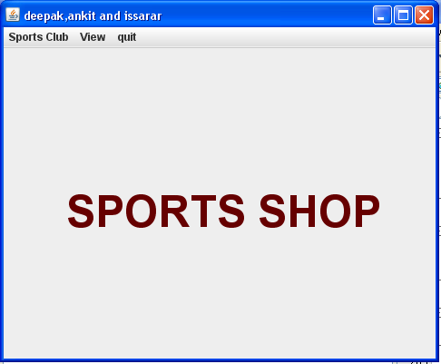

**Coding for MainUi.java**

public class MainMenuUI extends javax.swing.JFrame {

/** Creates new form MainMenuUI */

public MainMenuUI() {

initComponents();

}

private void mnuCustAddActionPerformed(java.awt.event.ActionEvent evt) {

this.setVisible(false);

new ShopINUI().setVisible(true);

}

private void mnuItemAddActionPerformed(java.awt.event.ActionEvent evt) {

this.setVisible(false);

new ItemINUI().setVisible(true);

}

private void mnuOrderActionPerformed(java.awt.event.ActionEvent evt) {

this.setVisible(false);

new OrderINUI().setVisible(true);

}

private void jMenu1ActionPerformed(java.awt.event.ActionEvent evt) {

// TODO add your handling code here:

}

private void jMenu2ActionPerformed(java.awt.event.ActionEvent evt) {

}

private void ListCustActionPerformed(java.awt.event.ActionEvent evt) {

this.setVisible(false);

new CustListUI().setVisible(true);

}

private void ListItemActionPerformed(java.awt.event.ActionEvent evt) {

this.setVisible(false);

new ItemListUI().setVisible(true);

}

private void ListOrderActionPerformed(java.awt.event.ActionEvent evt) {

this.setVisible(false);

new OrdListUI().setVisible(true);

}

private void jMenu3ActionPerformed(java.awt.event.ActionEvent evt) {

// TODO add your handling code here:

}

private void jMenuItem1ActionPerformed(java.awt.event.ActionEvent evt) {

System.exit(0); // TODO add your handling code here:

}

/**

* @param args the command line arguments

*/

public static void main(String args[]) {

java.awt.EventQueue.invokeLater(new Runnable() {

public void run() {

new MainMenuUI().setVisible(true);

}

});

}

**Frame: SHOPINUI**

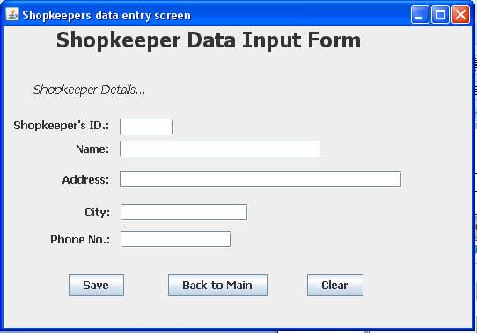

**Coding of ShopINUI**

**import java.sql.*;**

**import javax.swing.JOptionPane;**

**public class ShopINUI extends javax.swing.JFrame {**

**/** Creates new form ShopINUI */**

**public ShopINUI() {**

**initComponents();**

**}**

**private void btnBackActionPerformed(java.awt.event.ActionEvent evt) {**

**this.setVisible(false);**

**new MainMenuUI().setVisible(true);**

**}**

**private void btnSaveActionPerformed(java.awt.event.ActionEvent evt) {**

**try {**

**Class.forName("com.mysql.jdbc.Driver");**

**Connection con = (Connection)**

**DriverManager.getConnection("jdbc:mysql://localhost:3306/shopkeeper","root","kvuc");**

**Statement stmt = null;**

**ResultSet rs = null; // ResultSet for SHOPKEEPER table.**

**String SQL = "SELECT * FROM shopkeeper";**

**stmt = con.createStatement(); // Connection string for ResultSet - rs.**

**rs = stmt.executeQuery(SQL);**

**// Data transfer from JTextField control to variables**

**String shno = txtSHno.getText().trim();**

**String shname = txtSHName.getText();**

**String shadd = txtSHAddress.getText();**

**String shcity = txtSHCity.getText();**

**double shphone = Double.parseDouble(txtSHPhone.getText());**

**if (shno.length() <= 4) {**

**String strSQL = "INSERT INTO shopkeeper(Shopper_id, Name, Address, City, Phone) VALUES ('"+(shno)+"','"+(shname)+"','"+(shadd)+"','"+(shcity)+"',"+(shphone)+")";**

**JOptionPane.showMessageDialog(this, "Record successfully inserted");**

**int rowsEffected = stmt.executeUpdate(strSQL);**

**System.out.println(rowsEffected + " rows effected");**

**}**

**else {**

**JOptionPane.showMessageDialog(this, "Customer ID should not more than 4 character.");**

**}**

**con.close();**

**} catch (Exception e) {**

**JOptionPane.showMessageDialog(this,e.getMessage());**

**e.printStackTrace();**

**}**

**}**

**private void btnClearActionPerformed(java.awt.event.ActionEvent evt) {**

**// TODO add your handling code here:**

**txtSHno.setText("");**

**txtSHName.setText("");**

**txtSHAddress.setText("");**

**txtSHCity.setText("");**

**txtSHPhone.setText("");**

**}**

**/\*\***

**\* @param args the command line arguments**

**\*/**

**public static void main(String args[]) {**

**java.awt.EventQueue.invokeLater(new Runnable() {**

**public void run() {**

**new ShopINUI().setVisible(true);**

**}**

**});**

**}**

**Frame: ItemINUI.java**

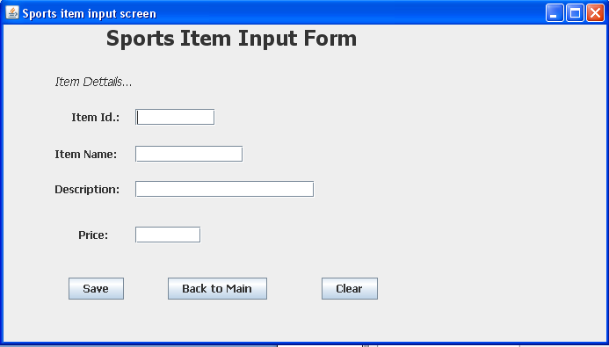

**Coding for ItemINUI.java**

**import java.sql.*;**

**import javax.swing.JOptionPane;**

**public class ItemINUI extends javax.swing.JFrame {**

**/** Creates new form ItemINUI */**

**public ItemINUI() {**

**initComponents();**

**}**

**private void btnClearActionPerformed(java.awt.event.ActionEvent evt) {**

**// TODO add your handling code here:**

**txtItemno.setText("");**

**txtItemName.setText("");**

**txtItemDesc.setText("");**

**txtItemPrice.setText("");**

**}**

**private void btnSaveActionPerformed(java.awt.event.ActionEvent evt) {**

**try {**

**Class.forName("com.mysql.jdbc.Driver");**

**Connection con = (Connection)**

**DriverManager.getConnection("jdbc:mysql://localhost:3306/shopkeeper","root","kvuc");**

**Statement stmt = null;**

**ResultSet rs = null; // ResultSet for SHOPKEEPER table.**

**String SQL = "SELECT * FROM item";**

**stmt = con.createStatement(); // Connection string for ResultSet - rs.**

**rs = stmt.executeQuery(SQL);**

**// Data transfer from JTextField control to variables**

**String itemno = txtItemno.getText();**

**String itemname = txtItemName.getText();**

**String desc = txtItemDesc.getText();**

**double itemprice = Double.parseDouble(txtItemPrice.getText());**

**String strSQL = "INSERT INTO item(Item_Id, Item_Name, Description, Price) VALUES ('"+(itemno)+"','"+(itemname)+"','"+(desc)+"',"+(itemprice)+")";**

**JOptionPane.showMessageDialog(this, "Record successfully inserted");**

**int rowsEffected = stmt.executeUpdate(strSQL);**

**System.out.println(rowsEffected + " rows effected");**

**con.close();**

**} catch (Exception e) {**

**JOptionPane.showMessageDialog(this,e.getMessage());**

**e.printStackTrace();**

**}**

**}**

**private void btnBackActionPerformed(java.awt.event.ActionEvent evt) {**

**this.setVisible(false);**

**new MainMenuUI().setVisible(true);**

**}**

**/\*\***

**\* @param args the command line arguments**

**\*/**

**public static void main(String args[]) {**

**java.awt.EventQueue.invokeLater(new Runnable() {**

**public void run() {**

**new ItemINUI().setVisible(true);**

**}**

**});**

**}**

**Frame: OrderINUI.java**

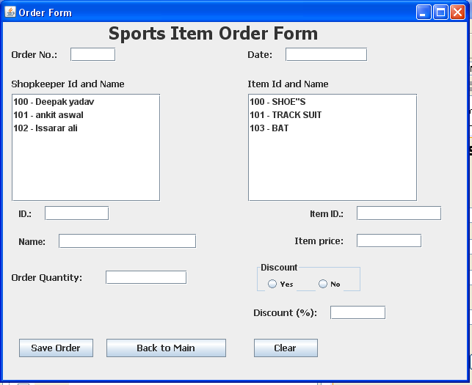

**Coding for OrderINUI.Java**

**import javax.swing.DefaultListModel;**

**import java.sql.*;**

**import javax.swing.JOptionPane;**

**public class OrderINUI extends javax.swing.JFrame {**

**/** Creates new form OrderINUI */**

**public OrderINUI() {**

**initComponents();**

**}**

**private void btnClearActionPerformed(java.awt.event.ActionEvent evt) {**

**// TODO add your handling code here:**

**txtOrdno.setText("");**

**txtOrdDate.setText("");**

**txtSID.setText("");**

**txtItemID.setText("");**

**txtSName.setText("");**

**txtItemPrice.setText("");**

**txtOrdQty.setText("");**

**}**

**private void btnBackActionPerformed(java.awt.event.ActionEvent evt) {**

**this.setVisible(false);**

**new MainMenuUI().setVisible(true);**

**}**

**private void btnSaveActionPerformed(java.awt.event.ActionEvent evt) {**

**try {**

**Class.forName("com.mysql.jdbc.Driver");**

**Connection con = (Connection)**

**DriverManager.getConnection("jdbc:mysql://localhost:3306/shopkeeper","root","kvuc");**

**Statement stmt = null;**

**ResultSet rs = null; // ResultSet for SHOPKEEPER table.**

**String SQL = "SELECT * FROM orderitem";**

**stmt = con.createStatement(); // Connection string for ResultSet - rs.**

**rs = stmt.executeQuery(SQL);**

**float discP = 0; // Discount**

**// Data transfer from JTextField control to variables**

**String Ordno = txtOrdno.getText();**

**String OrdDate = txtOrdDate.getText();**

**String ItemID = txtItemID.getText();**

**String ShopID = txtSID.getText();**

**String ItemPrice = txtItemPrice.getText();**

**double iPrice = Double.parseDouble(txtItemPrice.getText());**

**String ordQty = txtOrdQty.getText();**

**if (rdYes.isSelected()) {**

**discP = Float.parseFloat(txtDisc.getText());**

**}**

**else {**

**discP=0;**

**}**

**double amt = (Integer.parseInt(txtOrdQty.getText()) * Double.parseDouble(txtItemPrice.getText())) - (Integer.parseInt(txtOrdQty.getText()) * Double.parseDouble(txtItemPrice.getText()))*(discP*0.01);**

**String strSQL = "INSERT INTO orderitem(orderno, OrderDate, Item_Id, Shopper_Id, Quantity, price, discount, Amount ) VALUES ('"+(Ordno)+"','"+(OrdDate)+"','"+(ItemID)+"','"+(ShopID)+"',"+(ordQty)+","+iPrice+","+ discP+","+(amt)+")";**

**JOptionPane.showMessageDialog(this, "Order successfully placed");**

**int rowsEffected = stmt.executeUpdate(strSQL);**

**System.out.println(rowsEffected + " rows effected");**

**con.close();**

**} catch (Exception e) {**

**JOptionPane.showMessageDialog(this,e.getMessage());**

**e.printStackTrace();**

**}**

**}**

**private void formWindowGainedFocus(java.awt.event.WindowEvent evt) {**

**// Creating a ListModel object sModel to perform DefaultListModel**

**// method operations for Shopkeeper list**

**DefaultListModel sModel = (DefaultListModel) jList1.getModel();**

**// Creating a ListModel object iModel to perform DefaultComboBoxModel**

**// method operations for Item list**

**DefaultListModel iModel = (DefaultListModel) jList2.getModel();**

**sModel.clear();**

**iModel.clear();**

**try {**

**Class.forName("com.mysql.jdbc.Driver");**

**Connection con = (Connection)**

**DriverManager.getConnection("jdbc:mysql://localhost:3306/shopkeeper","root","kvuc");**

**Statement stmt = null;**

**ResultSet rs = null;**

**ResultSet rs1 = null;**

**String SQL = "SELECT * FROM shopkeeper";**

**String SQL1 = "SELECT * FROM item";**

**stmt = con.createStatement();**

**// Steps to extract shopkeepers id and name**

**rs = stmt.executeQuery(SQL);**

**while (rs.next()) {**

**String sID = rs.getString("Shopper_id");**

**String Sname = rs.getString("Name");**

**sModel.addElement(sID + " - " + Sname);**

**}**

**jList1.setModel(sModel);**

**// Steps to extract item id and name**

**rs1 = stmt.executeQuery(SQL1);**

**while (rs1.next()) {**

**String iID = rs1.getString("Item_Id");**

**String Iname = rs1.getString("Item_Name");**

**iModel.addElement(iID + " - " + Iname);**

**}**

**jList2.setModel(iModel);**

**con.close();**

**} catch (Exception e) {**

**JOptionPane.showMessageDialog(this,e.getMessage());**

**e.printStackTrace();**

**}**

**}**

**private void jList1MouseClicked(java.awt.event.MouseEvent evt) {**

**// Extracting supplier id and name into a variable SidName**

**String SidName = (String) jList1.getSelectedValue();**

**String Sid = SidName.substring(0, 3);**

**String Sname= SidName.substring(6);**

**// Displays ID and name from ComboBox1**

**txtSID.setText(Sid);**

**txtSName.setText(Sname);**

**}**

**private void jList2MouseClicked(java.awt.event.MouseEvent evt) {**

**try {**

**Class.forName("com.mysql.jdbc.Driver");**

**Connection con = (Connection)**

**DriverManager.getConnection("jdbc:mysql://localhost:3306/shopkeeper","root","kvuc");**

**Statement stmt = null;**

**ResultSet rs = null;**

**// Extracting item id and item name into a variable ItemIDName**

**String ItemIDName = (String) jList2.getSelectedValue();**

**String ItemID = ItemIDName.substring(0, 3);**

**String Iame= ItemIDName.substring(7);**

**txtItemID.setText(ItemID);**

**String SQL = "SELECT * FROM item where Item_Id = '"+(ItemID)+"'";**

**stmt = con.createStatement();**

**rs = stmt.executeQuery(SQL);**

**while (rs.next()) {**

**double iprice = rs.getDouble("Price");**

**txtItemPrice.setText(Double.toString(iprice));**

**}**

**con.close();**

**} catch (Exception e) {**

**JOptionPane.showMessageDialog(this,e.getMessage());**

**e.printStackTrace();**

**}**

**}**

**/\*\***

**\* @param args the command line arguments**

**\*/**

**public static void main(String args[]) {**

**java.awt.EventQueue.invokeLater(new Runnable() {**

**public void run() {**

**new OrderINUI().setVisible(true);**

**}**

**});**

**}**

**Frame: CustListUI.java**

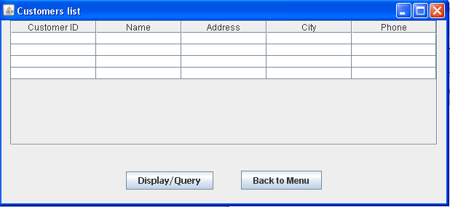

**Coding of CustListUI.java**

**import javax.swing.table.*;**

**import java.sql.*;**

**import javax.swing.JOptionPane;**

**/\***

**\* To change this template, choose Tools | Templates**

**\* and open the template in the editor.**

**\*/**

**/\***

**\* CustListUI.java**

**\***

**\* Created on Mar 18, 2010, 1:24:42 PM**

**\*/**

**/\*\***

**\***

**\* @author gagan**

**\*/**

**public class CustListUI extends javax.swing.JFrame {**

**/** Creates new form CustListUI */**

**public CustListUI() {**

**initComponents();**

**}**

**/** This method is called from within the constructor to**

**\* initialize the form.**

**\* WARNING: Do NOT modify this code. The content of this method is**

**\* always regenerated by the Form Editor.**

**\*/**

**@SuppressWarnings("unchecked")**

**// <editor-fold defaultstate="collapsed" desc="Generated Code">**

**private void initComponents() {**

**jButton1 = new javax.swing.JButton();**

**jButton2 = new javax.swing.JButton();**

**jScrollPane1 = new javax.swing.JScrollPane();**

**jTable1 = new javax.swing.JTable();**

**setDefaultCloseOperation(javax.swing.WindowConstants.EXIT_ON_CLOSE);**

**setTitle("Customers list");**

**jButton1.setFont(new java.awt.Font("Tahoma", 1, 12)); // NOI18N**

**jButton1.setText("Display/Query");**

**jButton1.addActionListener(new java.awt.event.ActionListener() {**

**public void actionPerformed(java.awt.event.ActionEvent evt) {**

**jButton1ActionPerformed(evt);**

**}**

**});**

**jButton2.setText("Back to Menu");**

**jButton2.addActionListener(new java.awt.event.ActionListener() {**

**public void actionPerformed(java.awt.event.ActionEvent evt) {**

**jButton2ActionPerformed(evt);**

**}**

**});**

**jTable1.setModel(new javax.swing.table.DefaultTableModel(**

**new Object [][] {**

**{null, null, null, null, null},**

**{null, null, null, null, null},**

**{null, null, null, null, null},**

**{null, null, null, null, null}**

**},**

**new String [] {**

**"Customer ID", "Name", "Address", "City", "Phone"**

**}**

**));**

**jScrollPane1.setViewportView(jTable1);**

**javax.swing.GroupLayout layout = new javax.swing.GroupLayout(getContentPane());**

**getContentPane().setLayout(layout);**

**layout.setHorizontalGroup(**

**layout.createParallelGroup(javax.swing.GroupLayout.Alignment.LEADING)**

**.addGroup(layout.createSequentialGroup()**

**.addGroup(layout.createParallelGroup(javax.swing.GroupLayout.Alignment.LEADING)**

**.addGroup(layout.createSequentialGroup()**

**.addContainerGap()**

**.addComponent(jScrollPane1, javax.swing.GroupLayout.DEFAULT_SIZE, 587, Short.MAX_VALUE))**

**.addGroup(layout.createSequentialGroup()**

**.addGap(171, 171, 171)**

**.addComponent(jButton1)**

**.addGap(38, 38, 38)**

**.addComponent(jButton2)))**

**.addContainerGap())**

**);**

**layout.setVerticalGroup(**

**layout.createParallelGroup(javax.swing.GroupLayout.Alignment.LEADING)**

**.addGroup(layout.createSequentialGroup()**

**.addComponent(jScrollPane1, javax.swing.GroupLayout.PREFERRED_SIZE, 172, javax.swing.GroupLayout.PREFERRED_SIZE)**

**.addGap(35, 35, 35)**

**.addGroup(layout.createParallelGroup(javax.swing.GroupLayout.Alignment.BASELINE)**

**.addComponent(jButton1)**

**.addComponent(jButton2))**

**.addContainerGap(19, Short.MAX_VALUE))**

**);**

**pack();**

**}// </editor-fold>**

**private void jButton1ActionPerformed(java.awt.event.ActionEvent evt) {**

**// Before writting the followng line, you should import the line:**

**// import javax.swing.table.*; at the top of your application**

**DefaultTableModel model = (DefaultTableModel) jTable1.getModel();**

**// Clear the existing table**

**int rows = model.getRowCount();**

**if (rows > 0) {**

**for (int i = 0; i < rows; i++) {**

**model.removeRow(0);**

**}**

**}**

**// SQL Query**

**String query = "SELECT * FROM shopkeeper";**

**try {**

**// Connect to MySQL database**

**Class.forName("com.mysql.jdbc.Driver").newInstance();**

**Connection con = (Connection) DriverManager.getConnection("jdbc:mysql://localhost:3306/shopkeeper","root","kvuc");**

**// Create SQL statement and execute query.**

**Statement stmt = con.createStatement();**

**ResultSet rs = stmt.executeQuery(query);**

**// Iterate through the result and display on screen**

**while (rs.next()) {**

**String Sid = rs.getString("Shopper_id");**

**String SName = rs.getString("Name");**

**String SAddress = rs.getString("Address");**

**String SCity = rs.getString("City");**

**String SPhone = rs.getString("Phone");**

**System.out.println(Sid + "|" + SName + "|" + SAddress + "|" + SCity + "|" + SPhone);**

**model.addRow(new Object[] {Sid, SName, SAddress, SCity, SPhone});**

**}**

**} catch (Exception e) {**

**JOptionPane.showMessageDialog(this, e.getMessage());**

**}**

**}**

**private void jButton2ActionPerformed(java.awt.event.ActionEvent evt) {**

**this.setVisible(false);**

**new MainMenuUI().setVisible(true);**

**}**

**/\*\***

**\* @param args the command line arguments**

**\*/**

**public static void main(String args[]) {**

**java.awt.EventQueue.invokeLater(new Runnable() {**

**public void run() {**

**new CustListUI().setVisible(true);**

**}**

**});**

**}**

**Frame: ItemListUI.java**

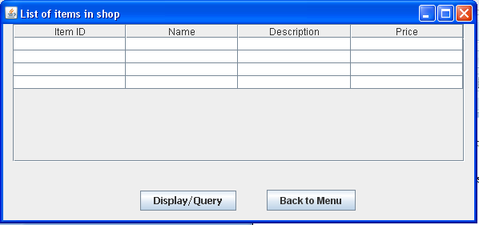

**Coding for ItemListUI.java**

**import javax.swing.table.*;**

**import java.sql.*;**

**import javax.swing.JOptionPane;**

**/\***

**\* To change this template, choose Tools | Templates**

**\* and open the template in the editor.**

**\*/**

**/\***

**\* ItemListUI.java**

**\***

**\* Created on Mar 18, 2010, 1:45:12 PM**

**\*/**

**/\*\***

**\***

**\* @author gagan**

**\*/**

**public class ItemListUI extends javax.swing.JFrame {**

**/** Creates new form ItemListUI */**

**public ItemListUI() {**

**initComponents();**

**}**

**/** This method is called from within the constructor to**

**\* initialize the form.**

**\* WARNING: Do NOT modify this code. The content of this method is**

**\* always regenerated by the Form Editor.**

**\*/**

**@SuppressWarnings("unchecked")**

**// <editor-fold defaultstate="collapsed" desc="Generated Code">**

**private void initComponents() {**

**jButton2 = new javax.swing.JButton();**

**jButton1 = new javax.swing.JButton();**

**jScrollPane1 = new javax.swing.JScrollPane();**

**jTable1 = new javax.swing.JTable();**

**setDefaultCloseOperation(javax.swing.WindowConstants.EXIT_ON_CLOSE);**

**setTitle("List of items in shop");**

**jButton2.setText("Back to Menu");**

**jButton2.addActionListener(new java.awt.event.ActionListener() {**

**public void actionPerformed(java.awt.event.ActionEvent evt) {**

**jButton2ActionPerformed(evt);**

**}**

**});**

**jButton1.setFont(new java.awt.Font("Tahoma", 1, 12));**

**jButton1.setText("Display/Query");**

**jButton1.addActionListener(new java.awt.event.ActionListener() {**

**public void actionPerformed(java.awt.event.ActionEvent evt) {**

**jButton1ActionPerformed(evt);**

**}**

**});**

**jTable1.setModel(new javax.swing.table.DefaultTableModel(**

**new Object [][] {**

**{null, null, null, null},**

**{null, null, null, null},**

**{null, null, null, null},**

**{null, null, null, null}**

**},**

**new String [] {**

**"Item ID", "Name", "Description", "Price"**

**}**

**));**

**jScrollPane1.setViewportView(jTable1);**

**javax.swing.GroupLayout layout = new javax.swing.GroupLayout(getContentPane());**

**getContentPane().setLayout(layout);**

**layout.setHorizontalGroup(**

**layout.createParallelGroup(javax.swing.GroupLayout.Alignment.LEADING)**

**.addGroup(layout.createSequentialGroup()**

**.addGroup(layout.createParallelGroup(javax.swing.GroupLayout.Alignment.LEADING)**

**.addGroup(layout.createSequentialGroup()**

**.addContainerGap()**

**.addComponent(jScrollPane1, javax.swing.GroupLayout.DEFAULT_SIZE, 564, Short.MAX_VALUE))**

**.addGroup(layout.createSequentialGroup()**

**.addGap(171, 171, 171)**

**.addComponent(jButton1)**

**.addGap(38, 38, 38)**

**.addComponent(jButton2)))**

**.addContainerGap())**

**);**

**layout.setVerticalGroup(**

**layout.createParallelGroup(javax.swing.GroupLayout.Alignment.LEADING)**

**.addGroup(layout.createSequentialGroup()**

**.addComponent(jScrollPane1, javax.swing.GroupLayout.PREFERRED_SIZE, 172, javax.swing.GroupLayout.PREFERRED_SIZE)**

**.addGap(35, 35, 35)**

**.addGroup(layout.createParallelGroup(javax.swing.GroupLayout.Alignment.BASELINE)**

**.addComponent(jButton1)**

**.addComponent(jButton2))**

**.addContainerGap(javax.swing.GroupLayout.DEFAULT_SIZE, Short.MAX_VALUE))**

**);**

**pack();**

**}// </editor-fold>**

**private void jButton2ActionPerformed(java.awt.event.ActionEvent evt) {**

**this.setVisible(false);**

**new MainMenuUI().setVisible(true);**

**}**

**private void jButton1ActionPerformed(java.awt.event.ActionEvent evt) {**

**// Before writting the followng line, you should import the line:**

**// import javax.swing.table.*; at the top of your application**

**DefaultTableModel model = (DefaultTableModel) jTable1.getModel();**

**// Clear the existing table**

**int rows = model.getRowCount();**

**if (rows > 0) {**

**for (int i = 0; i < rows; i++) {**

**model.removeRow(0);**

**}**

**}**

**// SQL Query**

**String query = "SELECT * FROM Item";**

**try {**

**// Connect to MySQL database**

**Class.forName("com.mysql.jdbc.Driver").newInstance();**

**Connection con = (Connection) DriverManager.getConnection("jdbc:mysql://localhost:3306/shopkeeper","root","kvuc");**

**// Create SQL statement and execute query.**

**Statement stmt = con.createStatement();**

**ResultSet rs = stmt.executeQuery(query);**

**// Iterate through the result and display on screen**

**while (rs.next()) {**

**String ITid = rs.getString("Item_id");**

**String IName = rs.getString("Item_Name");**

**String IDesc = rs.getString("Description");**

**String IPrice = rs.getString("Price");**

**System.out.println(ITid + "|" + IName + "|" + IDesc + "|" + IPrice);**

**model.addRow(new Object[] {ITid, IName, IDesc, IPrice});**

**}**

**} catch (Exception e) {**

**JOptionPane.showMessageDialog(this, e.getMessage());**

**}**

**}**

**/\*\***

**\* @param args the command line arguments**

**\*/**

**public static void main(String args[]) {**

**java.awt.EventQueue.invokeLater(new Runnable() {**

**public void run() {**

**new ItemListUI().setVisible(true);**

**}**

**});}**

**Frame: OrdListUI.java**

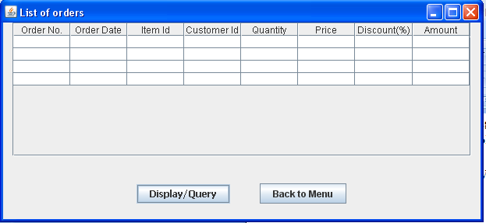

**Coding for OrdListUI.java**

**import javax.swing.table.*;**

**import java.sql.*;**

**import javax.swing.JOptionPane;**

**/\***

**\* To change this template, choose Tools | Templates**

**\* and open the template in the editor.**

**\*/**

**/\***

**\* OrdListUI.java**

**\***

**\* Created on Mar 18, 2010, 1:50:20 PM**

**\*/**

**/\*\***

**\***

**\* @author gagan**

**\*/**

**public class OrdListUI extends javax.swing.JFrame {**

**/** Creates new form OrdListUI */**

**public OrdListUI() {**

**initComponents();**

**}**

**/** This method is called from within the constructor to**

**\* initialize the form.**

**\* WARNING: Do NOT modify this code. The content of this method is**

**\* always regenerated by the Form Editor.**

**\*/**

**@SuppressWarnings("unchecked")**

**// <editor-fold defaultstate="collapsed" desc="Generated Code">**

**private void initComponents() {**

**jButton2 = new javax.swing.JButton();**

**jButton1 = new javax.swing.JButton();**

**jScrollPane1 = new javax.swing.JScrollPane();**

**jTable1 = new javax.swing.JTable();**

**setDefaultCloseOperation(javax.swing.WindowConstants.EXIT_ON_CLOSE);**

**setTitle("List of orders");**

**jButton2.setText("Back to Menu");**

**jButton2.addActionListener(new java.awt.event.ActionListener() {**

**public void actionPerformed(java.awt.event.ActionEvent evt) {**

**jButton2ActionPerformed(evt);**

**}**

**});**

**jButton1.setFont(new java.awt.Font("Tahoma", 1, 12)); // NOI18N**

**jButton1.setText("Display/Query");**

**jButton1.addActionListener(new java.awt.event.ActionListener() {**

**public void actionPerformed(java.awt.event.ActionEvent evt) {**

**jButton1ActionPerformed(evt);**

**}**

**});**

**jTable1.setModel(new javax.swing.table.DefaultTableModel(**

**new Object [][] {**

**{null, null, null, null, null, null, null, null},**

**{null, null, null, null, null, null, null, null},**

**{null, null, null, null, null, null, null, null},**

**{null, null, null, null, null, null, null, null}**

**},**

**new String [] {**

**"Order No.", "Order Date", "Item Id", "Customer Id", "Quantity", "Price", "Discount(%)", "Amount"**

**}**

**));**

**jScrollPane1.setViewportView(jTable1);**

**javax.swing.GroupLayout layout = new javax.swing.GroupLayout(getContentPane());**

**getContentPane().setLayout(layout);**

**layout.setHorizontalGroup(**

**layout.createParallelGroup(javax.swing.GroupLayout.Alignment.LEADING)**

**.addGroup(layout.createSequentialGroup()**

**.addGroup(layout.createParallelGroup(javax.swing.GroupLayout.Alignment.LEADING)**

**.addGroup(layout.createSequentialGroup()**

**.addContainerGap()**

**.addComponent(jScrollPane1, javax.swing.GroupLayout.DEFAULT_SIZE, 588, Short.MAX_VALUE))**

**.addGroup(layout.createSequentialGroup()**

**.addGap(171, 171, 171)**

**.addComponent(jButton1)**

**.addGap(38, 38, 38)**

**.addComponent(jButton2)))**

**.addContainerGap())**

**);**

**layout.setVerticalGroup(**

**layout.createParallelGroup(javax.swing.GroupLayout.Alignment.LEADING)**

**.addGroup(layout.createSequentialGroup()**

**.addComponent(jScrollPane1, javax.swing.GroupLayout.PREFERRED_SIZE, 172, javax.swing.GroupLayout.PREFERRED_SIZE)**

**.addGap(35, 35, 35)**

**.addGroup(layout.createParallelGroup(javax.swing.GroupLayout.Alignment.BASELINE)**

**.addComponent(jButton1)**

**.addComponent(jButton2))**

**.addContainerGap(20, Short.MAX_VALUE))**

**);**

**pack();**

**}// </editor-fold>**

**private void jButton2ActionPerformed(java.awt.event.ActionEvent evt) {**

**this.setVisible(false);**

**new MainMenuUI().setVisible(true);**

**}**

**private void jButton1ActionPerformed(java.awt.event.ActionEvent evt) {**

**// Before writting the followng line, you should import the line:**

**// import javax.swing.table.*; at the top of your application**

**DefaultTableModel model = (DefaultTableModel) jTable1.getModel();**

**// Clear the existing table**

**int rows = model.getRowCount();**

**if (rows > 0) {**

**for (int i = 0; i < rows; i++) {**

**model.removeRow(0);**

**}**

**}**

**// SQL Query**

**String query = "SELECT * FROM orderitem";**

**try {**

**// Connect to MySQL database**

**Class.forName("com.mysql.jdbc.Driver").newInstance();**

**Connection con = (Connection) DriverManager.getConnection("jdbc:mysql://localhost:3306/shopkeeper","root","kvuc");**

**// Create SQL statement and execute query.**

**Statement stmt = con.createStatement();**

**ResultSet rs = stmt.executeQuery(query);**

**// Iterate through the result and display on screen**

**while (rs.next()) {**

**String Ordno = rs.getString("Orderno");**

**String Ordd = rs.getString("OrderDate");**

**String OItemid = rs.getString("Item_Id");**

**String OSid = rs.getString("Shopper_Id");**

**String OQty = rs.getString("Quantity");**

**String IPrice = rs.getString("price");**

**String Disc = rs.getString("discount");**

**String OAmount = rs.getString("Amount");**

**System.out.println(Ordno + "|" + Ordd + "|" +OItemid + "|" + OSid + "|" + OQty + "|" + IPrice + "|" + Disc + "|" + OAmount);**

**model.addRow(new Object[] {Ordno, Ordd, OItemid, OSid, OQty, IPrice, Disc, OAmount});**

**}**

**} catch (Exception e) {**

**JOptionPane.showMessageDialog(this, e.getMessage());**

**}**

**}**

**/\*\***

**\* @param args the command line arguments**

**\*/**

**public static void main(String args[]) {**

**java.awt.EventQueue.invokeLater(new Runnable() {**

**public void run() {**

**new OrdListUI().setVisible(true);**

**}**

**});**

**}**

**QUIT**

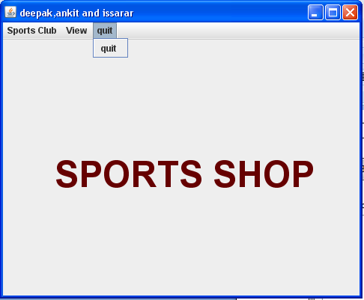

**Coding of QUIT**

**private void jMenuItem1ActionPerformed(java.awt.event.ActionEvent evt) {**

**System.exit(0); // TODO add your handling code here:**

**}**