MVC Pattern

Project Title - UCab – Cab Booking System
Introduction
The UCAB Cab Booking System follows the Model-View-Controller (MVC) architectural pattern.
MVC helps separate the application into three main components:
- Model (Data Layer)
- View (Presentation Layer)
- Controller (Business Logic Layer)
This separation improves:
- maintainability
- scalability
- code organization
- debugging efficiency

Model Layer
Location
server/src/models/
Models Used
- user.model.js
- ride.model.js
- payment.model.js
Responsibilities
The Model layer is responsible for managing the application's data.
Key responsibilities include:
- Defining database schemas
- Performing database operations
- Validating stored data
- Defining relationships between entities
- Providing reusable methods for controllers
Example
User Model
Ride Model
Payment Model
These models interact directly with MongoDB using Mongoose ODM.

View Layer
Location
client/src/
Responsibilities
The View layer represents the user interface of the application.
Responsibilities include:
- Rendering UI components
- Displaying ride information
- Showing user dashboards
- Handling user interactions
- Sending requests to backend APIs
- Updating UI based on responses
Technologies Used
- React.js
- React Router
- Context API
- Axios
- TailwindCSS
The frontend functions as a Single Page Application (SPA).

Controller Layer
Location
server/src/controllers/
Controllers Used
- user.controller.js
- ride.controller.js
- payment.controller.js
Responsibilities
Controllers act as the bridge between the View and the Model layers.
Key responsibilities include:
- Receiving HTTP requests from the client
- Validating input data
- Executing business logic
- Communicating with database models
- Sending structured JSON responses to the client
Controllers ensure that application logic remains separate from database logic and UI rendering.

MVC Flow
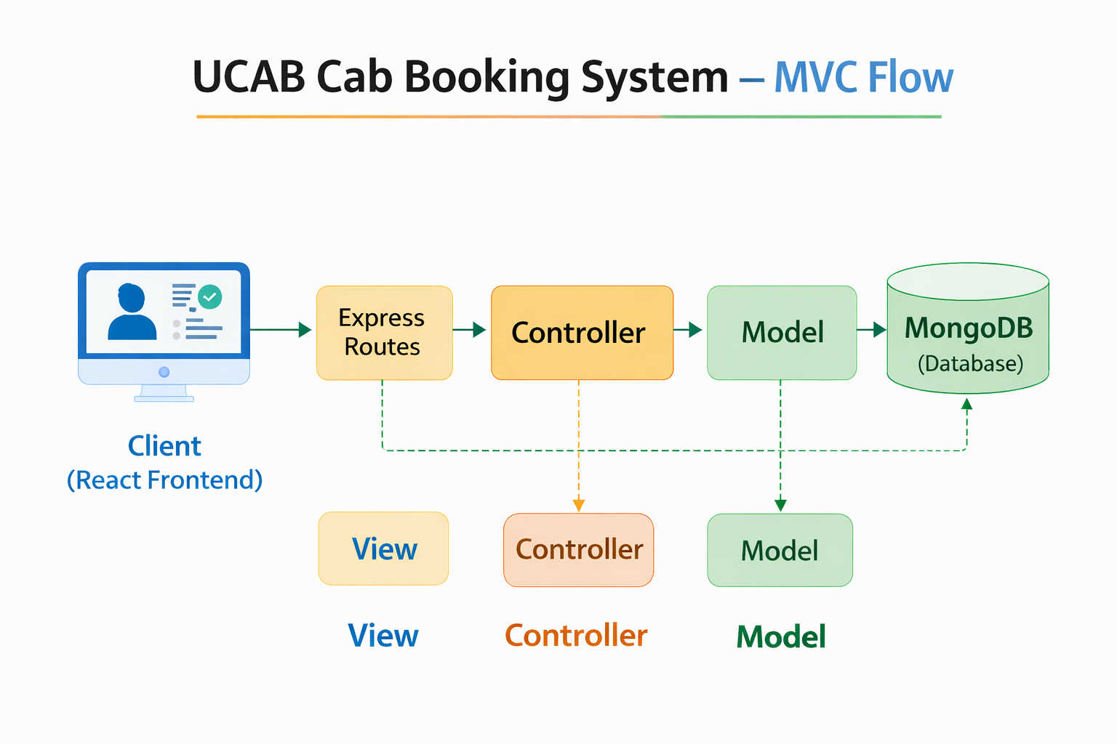
Step-by-Step Process
- The client (React frontend) sends a request to the backend API.
- The request first reaches the Express route handler.
- The route forwards the request to the appropriate controller.
- The controller processes the request and interacts with the model.
- The model performs database operations with MongoDB.
- The result is returned to the controller.
- The controller sends the response back to the client view.

Conclusion
The MVC architecture used in the UCAB Cab Booking System ensures a clear separation between:
- data management
- application logic
- user interface
This architecture improves system organization and makes the application easier to maintain, scale, and extend in the future.

