Technical Architecture

Project Title - UCab – Cab Booking System
Introduction
The UCAB Cab Booking System is developed using the MERN Stack (MongoDB, Express.js, React.js, Node.js).
The system follows a three-tier architecture consisting of the frontend layer, backend layer, and database layer.

Technology Stack
Layer | Technology
Frontend | React.js, Vite, React Router
Backend | Node.js, Express.js
Database | MongoDB with Mongoose
Authentication | JWT (JSON Web Tokens)
Security | Bcrypt Password Hashing
Maps | React Leaflet with OpenStreetMap
API Communication | Axios

System Architecture
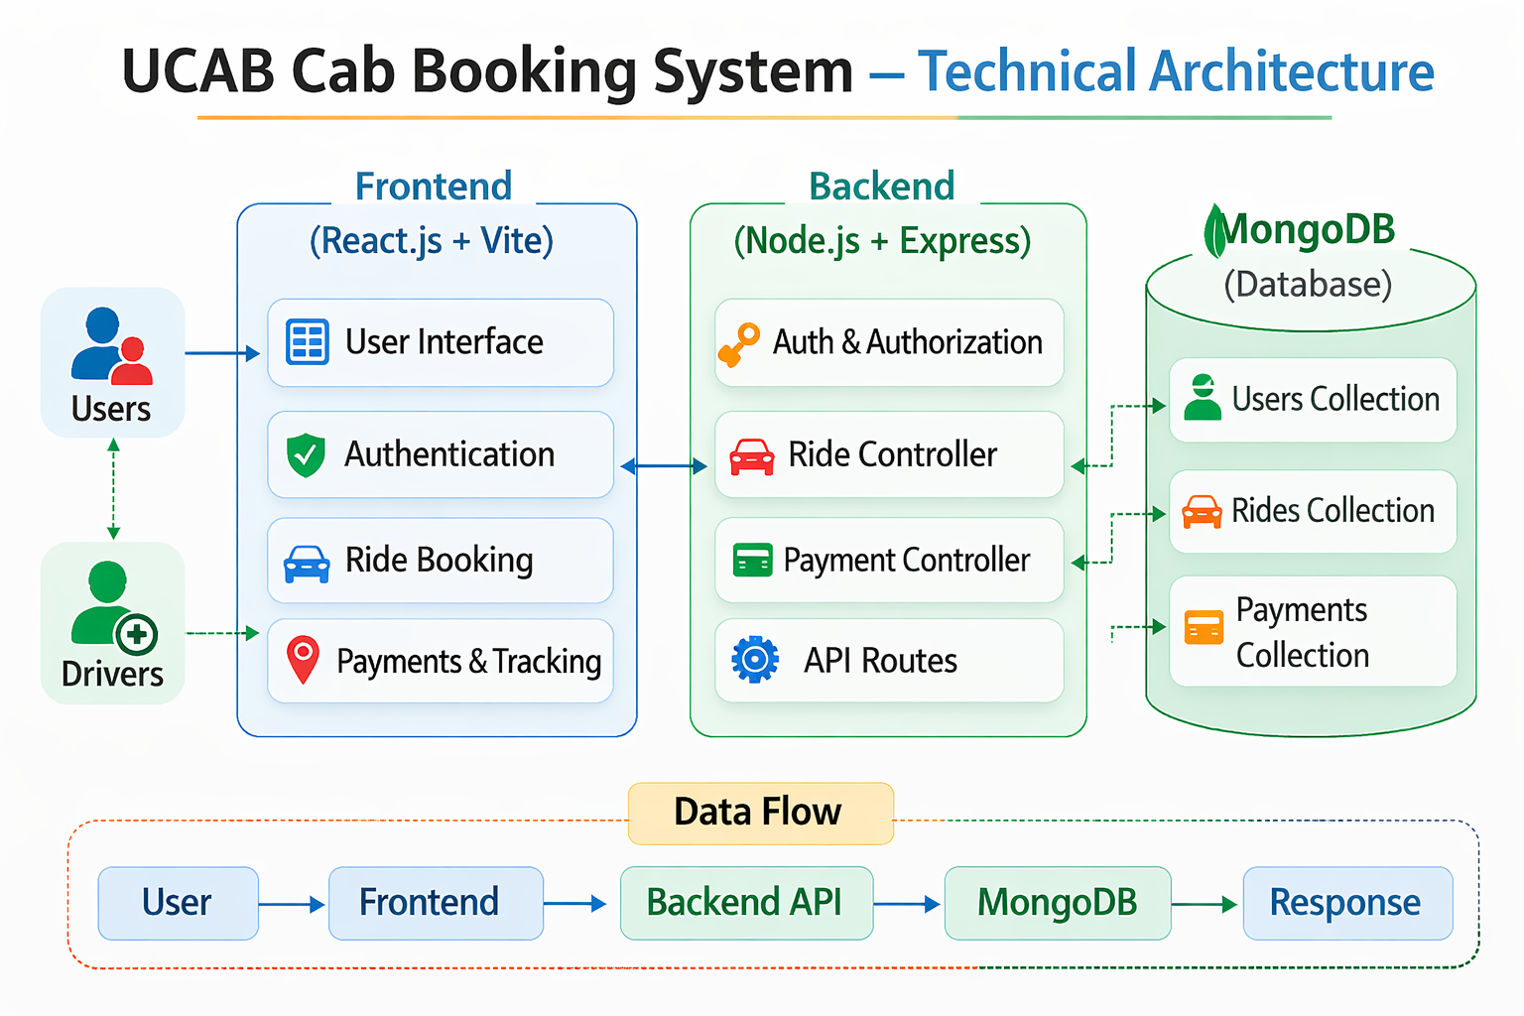
Frontend Layer (Client)
The frontend is developed using React.js with Vite and functions as a Single Page Application (SPA).
Responsibilities include:
- Rendering user interface components
- Handling user interactions
- Managing authentication state
- Sending API requests to the backend
- Displaying ride and payment information

Key Technologies:
React.js, React Router DOM, Context API, Axios/Fetch

Backend Layer (Server)
The backend is built using Node.js and Express.js.
Responsibilities include:
- Authentication and authorization
- Processing ride booking logic
- Managing ride lifecycle
- Handling payments
- Validating requests
- Communicating with MongoDB

Security Features:
- JWT Authentication
- Password hashing using bcrypt
- Protected API routes
- Refresh token system

Database Layer
MongoDB is used as the primary database with Mongoose ODM.
Collections:
- Users
- Rides
- Payments

Data Flow
- The user interacts with the React frontend.
- The frontend sends an HTTP request to the Express backend API.
- The backend validates the request and processes business logic.
- The backend communicates with MongoDB to store or retrieve data.
- The backend sends the response back to the frontend.
- The frontend updates the user interface accordingly.

