User Flow
Project Title - UCab – Cab Booking System

This document describes the complete end-to-end user journey through the application, for both Riders and Drivers.

Flow Diagram
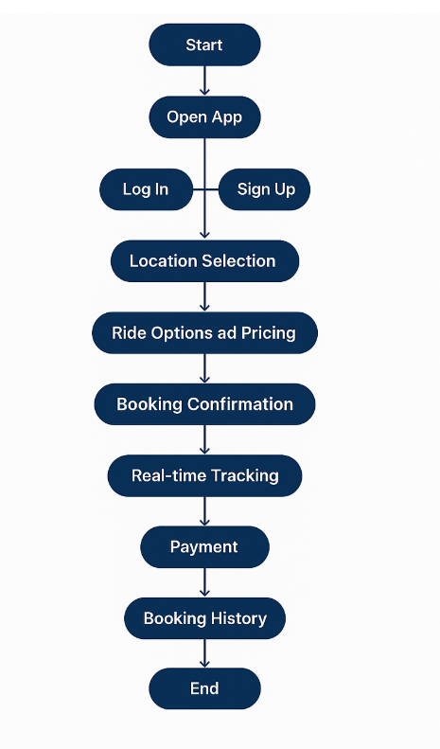

Step-by-Step Breakdown
1. Start → Open App
Detail | Value
URL | http://localhost:5173
Page | Landing Page (/)
The user opens the app and lands on the Landing Page, which presents:
- A hero section with "Book a Ride" and "Learn More" call-to-action buttons.
- Feature highlights: Fast Pickup, Safe & Secure, Eco Friendly.
- Service categories: Daily Commute, Business Travel, Airport Transfers.
- Navigation links to Log In and Sign Up.

2. Log In / Sign Up
Sign Up (New Users) — Route: /register
Users choose a role:
Role | Form Fields
Rider | Full Name, Email, Phone Number, Password, Confirm Password
Driver | All Rider fields + Vehicle Type, Vehicle Number, License Number
On successful registration → redirected to /login.
Log In (Returning Users) — Route: /login
Field | Required
Email | Yes
Password | Yes
After login, the app reads the user's role and redirects:
Role | Redirect To
Rider | /user/dashboard
Driver | /driver/dashboard

3. Location Selection — Route: /user/book
From the User Dashboard, the rider taps "Book a Ride".
The booking page has a split layout:
- Left panel: Form to enter Pickup and Drop-off locations.
- Right panel: Interactive map (React Leaflet / OpenStreetMap) where locations can be selected by clicking.
Addresses are geocoded via the Nominatim API to obtain latitude/longitude coordinates.

4. Ride Options and Pricing
After both locations are set, the rider taps "Get Fare Estimate".
The app calculates:
Component | Value
Base Fare | ₹50
Per KM Rate | ₹15
Formula | fare = 50 + (distance × 15)
Est. Duration | distance × 3 minutes
An estimate card is displayed showing Distance, Duration, and Estimated Fare.

5. Booking Confirmation
The rider reviews the estimate and taps "BOOK NOW".
The app sends a ride request to the server with:
- Pickup location (lat, lng, address)
- Drop location (lat, lng, address)
- Calculated fare
- Calculated distance
The ride is created with status REQUESTED and appears on the Driver Dashboard for available drivers to accept.
Driver side: The driver sees the ride request on their dashboard and can tap "Accept Ride". The ride status changes to ACCEPTED.

6. Real-time Tracking — Route: /user/ride/:rideId
Once a ride is accepted, the rider can track it from the User Dashboard or directly via the tracking page.
Left panel displays:
- Ride status badge (animated pulse for active rides)
- Pickup and drop-off locations
- Driver details: name, vehicle info, phone number (with call button)
- Distance and fare
- Cancel button (available only while status is REQUESTED or ACCEPTED)
Right panel displays:
- Full interactive map with pickup and drop-off markers
Polling: The page auto-refreshes ride data every 5 seconds.
Ride lifecycle managed by the driver:
Driver Action | Status Change
Accept Ride | REQUESTED → ACCEPTED
Start Ride | ACCEPTED → ONGOING
Complete Ride | ONGOING → COMPLETED

7. Payment — Route: /user/history
When a ride is COMPLETED, payment is processed from the User History page.
Payment Detail | Value
Method | Cash (default, mock system)
Flow | POST /payments/create → POST /payments/complete/:paymentId
Unpaid completed rides are highlighted with a red border and a "Pay Now" button at the top of the history list.

8. Booking History — Route: /user/history
The rider can view all past rides with filter options:
Filter | Shows
ALL | Every ride
COMPLETED | Only completed rides
CANCELLED | Only cancelled rides
Each ride card displays:
- Date and time
- Pickup and drop-off locations
- Ride status badge
- Fare amount
- Payment status
Rides are sorted with unpaid rides first, then by date (newest first).

9. End
The rider can log out at any time from the header navigation. The session is cleared and cookies are removed.

Driver Flow Summary
Drivers follow a parallel flow after login:
Step | Route | Action
Dashboard | /driver/dashboard | View ride requests and active ride
Accept | Dashboard | Tap "Accept Ride" on a requested ride
Start | /driver/ride/:rideId | Tap "Start Ride" when passenger is picked up
Complete | /driver/ride/:rideId | Tap "Complete Ride" at destination
History | /driver/history | View all past rides
Profile | /profile | Manage account details

Route Map
Public Routes (No Login Required)
Route | Page
/ | Landing Page
/login | Login Page
/register | Register Page
Protected Rider Routes
Route | Page
/user/dashboard | User Dashboard
/user/book | Book Ride
/user/ride/:rideId | Ride Tracking
/user/history | Ride History
/profile | Profile
Protected Driver Routes
Route | Page
/driver/dashboard | Driver Dashboard
/driver/ride/:rideId | Driver Ride
/driver/history | Driver History
/profile | Profile

Ride Status Lifecycle
REQUESTED ──► ACCEPTED ──► ONGOING ──► COMPLETED
│ │
│ CANCELLED ◄──────────────┘
└──────────► CANCELLED (only before ONGOING)
Status | Color | Description
REQUESTED | Yellow | Ride created, waiting for a driver
ACCEPTED | Blue | Driver accepted, heading to pickup
ONGOING | Green | Passenger picked up, ride in progress
COMPLETED | Yellow | Ride finished, payment may be pending
CANCELLED | Red | Ride cancelled by rider or driver

