Sanskar Srivastava

193332930

The Body Max Index (**BMI**) calculator measures your body size based on your weight and height. The excel worksheet displays the table starting at 5 ft and ending at 6’4 ft. The table starts at 5 ft and ends at 6+ feet since that is the most common height range amongst individuals across age groups. There is a button on the top left corner, labeled “**Run BMI Calculator**”. After that button is clicked, the information is displayed in which the user must input the corresponding values: **Name**, **Date** (Format is MM/DD/YYYY), **Height** (in meters) and **Weight** (in KGs). After the user has input the data, clicking “**Calculate BMI”** on the bottom left displays the users BMI based on the users input. “**Generate Chart**” displays the information and color codes the chart according to the legend. “**Add to Database**” displays the information on an empty table on ACCESS file which displays the data and calculates inputs for multiple users. Finally, “**Generate Report**” creates a report on a word document from all the data input in a table.

I chose to do the BMI calculator option as I felt it was the easiest code to execute amongst the given choices. After looking online for help, I was able to work through the challenges that I was facing. Since we were given a long time to complete this assignment, I first started doing the other options, but I found myself getting stuck in between and my code was having trouble executing. In addition, there were a few labs that were like the BMI calculator and so I was able to get started and work accordingly. Finally, I feel this assignment was an important way to incorporate all the important tools I learned in the course. I feel like the BMI calculator was a good choice as it could be further extended in assisting for future projects/work.

**Explanation of the Application**

Sanskar Srivastava

193332930

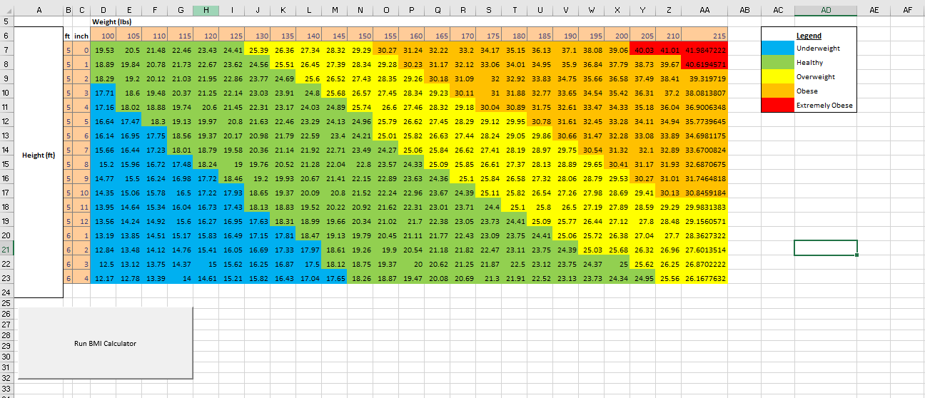

**This is what the excel looks like before any program is executed**

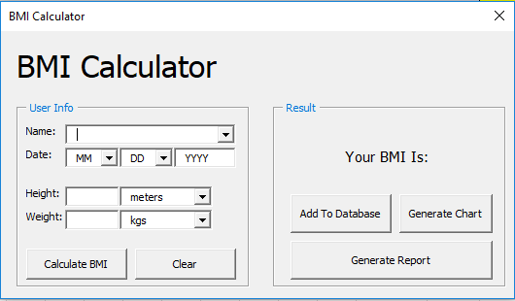

**After clicking Run BMI calculator, this is displayed on the screen. (Input the data accordingly)**

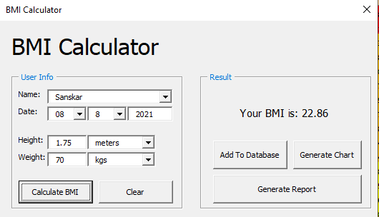

**Calculates the BMI (After inputting the data)**

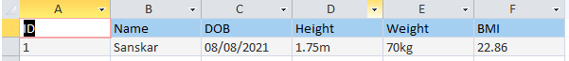

**Added to database**

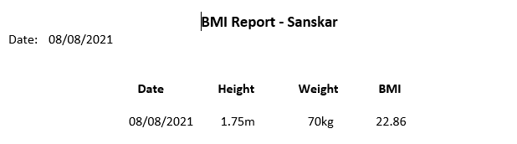

**Report Generated**