Image based Breed Recognition for Cattle and Buffaloes of India
Submitted in partial fulfilment of the requirements for the award of the degree of
BACHELOR OF TECHNOLOGY
SUBMITTED BY:
Himanshu Bhatt (Roll No: 25SCS1003001349)
Sanskar Pandey (Roll No: 25SCS1003001360)
Priyam Dixit (Roll No: 25SCS1003001434)
Prince (Roll No: 25SCS1003001458)
Asad Alam (Roll No: 25SCS1003001356)

UNDER THE SUPERVISION OF:
Mr. Aditya Bangia


Department of Computer Science and Engineering
IILM University, Greater Noida
November 2025

Table of Contents

1. Abstract
2. Introduction
3. Why this project matters
4. Dataset Details
5. Project Objective
6. Detailed Preprocessing Steps
7. Model Architecture (EfficientNet)
8. Evaluation Metrics Defined
9. Experimental Setup
10. Illustrative Results & Analysis
11. Interpretation and Conclusion
12. Future Scope
13. Appendix
14. Sources

Chapter 1: Abstract
The identification of cattle breeds is a cornerstone of effective livestock management, significantly impacting genetic improvement, disease control strategies, and overall dairy productivity. Traditionally, the classification of breeds has relied heavily on manual observation by veterinary experts. This manual process is inherently time-consuming, expensive, and prone to subjective error, often leading to inconsistent records due to variations in lighting, physical condition, and environmental factors.
To address these limitations, this project proposes and implements a robust Automated Cattle Breed Prediction System utilizing state-of-the-art Deep Learning techniques. Specifically, we leveraged Transfer Learning with the EfficientNet-B0 architecture, fine-tuning it on a diverse dataset of over 2,800 images spanning 12 distinct Indian and exotic cattle breeds.
The experimental results demonstrate the efficacy of this approach. The model achieved a Test Accuracy of 76.51% and a Peak Validation Accuracy of 77.78%. Detailed analysis reveals exceptional performance on distinct breeds such as Holstein Friesian (99% F1-score), while highlighting morphological challenges in differentiating genetically similar indigenous breeds like Sahiwal and Red Sindhi. This report details the end-to-end methodology, from data preprocessing to final model evaluation.

Chapter 2: Introduction
Livestock recording and management systems have long been a necessity for the agricultural sector. Accurate knowledge of a cow's breed is not merely a label; it dictates the vaccination schedule, dietary requirements, and medical interventions necessary for optimal health. For instance, exotic breeds like Holstein Friesian require different climatic management compared to hardy indigenous breeds like Gir or Tharparkar.
However, a lack of specialized knowledge among small-scale farmers often results in misidentification. This can result in improper breeding practices (diluting genetic purity) and ineffective health management. The primary goal of this project is to democratize this expert knowledge by creating an AI-enhanced tool.
By employing Computer Vision, a subset of Artificial Intelligence, we enable a system to 'see' and analyse cattle images, extracting unique feature maps (such as horn shape, hump size, and coat pattern) to classify the breed instantly and objectively. This project encompasses the entire machine learning lifecycle: Data Collection, rigorous Preprocessing, Model Training using PyTorch, and comprehensive Evaluation.

Chapter 3: Why This Project Matters
In the era of Precision Agriculture, data is as valuable as the yield itself. This project addresses several critical industry pain points:
- Improves Livestock Management: Different breeds have different metabolic rates and nutritional needs. Accurate ID ensures the right feed for the right animal.
- Supports Selective Breeding Programs: Genetic purity is vital for high milk yield. This tool acts as a verification step to ensure mating pairs are correctly identified.
- Reduces Human Error & Dependency: Veterinary experts cannot be present at every farm. An AI model provides expert-level classification accessible via a smartphone.
- Disease Control: Certain breeds are susceptible to specific pathogens (e.g., tick-borne diseases in exotic breeds). Early ID helps in preventative prophylaxis.
- Economic Optimization: Farmers can better estimate the market value of their herd based on confirmed breed data.

Chapter 4: Dataset Details
The foundation of any deep learning model is its data. We utilized the 'Cattle Breeds Dataset', aggregated from various sources including farm records and open-source repositories.
Dataset Name: Cattle Breeds Dataset
Total Size: 2,800+ unprocessed raw images
Number of Classes: 15 Distinct Breeds
The 15 breeds included in the study are: Deoni, Gir, Hariana, Holstein Friesian, Jaffrabadi, Kankrej, Mehsana, Murrah, Ongole, Rathi, Red Sindhi, Sahiwal, Surti, Tharparkar, and Vechur.
Challenges in Dataset: Real-world data is rarely perfect. Our dataset reflects this reality, containing images with background noise (fences, trees), varying lighting conditions (dawn, dusk, bright noon), and occlusions. Furthermore, there is a class imbalance; breeds like Sahiwal had significantly more samples (Support: 45) compared to rarer breeds like Surti (Support: 7), which poses a challenge for model training.

Chapter 5: Project Objective
The primary objective is to design, train, and validate a Convolutional Neural Network (CNN) capable of classifying cattle breeds from static images with high accuracy.
- To implement Transfer Learning using EfficientNet-B0 to handle the limited dataset size effectively.
- To analyze the morphological confusion between breeds (e.g., differentiating between Red Sindhi and Sahiwal).
- To provide a scalable solution that can eventually be deployed on edge devices (mobile phones) for offline usage.

Chapter 6: Detailed Preprocessing Steps
Raw images cannot be fed directly into a neural network. We applied a rigorous preprocessing pipeline to prepare the data:
Data Cleaning: Removal of corrupted files and non-cattle images to ensure data integrity.
Image Resizing (224x224): EfficientNet architecture requires a fixed input resolution of 224x224 pixels. All images were resized to this standard.
Data Normalization: Pixel values were scaled based on the mean and standard deviation of the ImageNet dataset. This centers the data, helping the Gradient Descent optimizer converge faster.
Data Augmentation: To combat overfitting, we artificially expanded the training set. Techniques included Random Horizontal Flips (simulating the cow facing left/right) and Random Rotations (+/- 10 degrees).
Label Encoding: Text labels were mapped to numerical indices (0-14). For example, 'Gir' -> 1, 'Sahiwal' -> 11.
Tensor Conversion: Images were converted into PyTorch Tensors, allowing them to be processed on the GPU.

Chapter 7: Model Architecture (EfficientNet)
We selected EfficientNet-B0 as our backbone architecture. Unlike traditional models (ResNet, VGG) that scale depth or width arbitrarily, EfficientNet uses a 'Compound Scaling' method that uniformly scales network width, depth, and resolution.
Why Transfer Learning? Training a CNN from scratch requires millions of images. By using weights pre-trained on ImageNet (a massive database of 14 million images), our model starts with a pre-existing understanding of edges, textures, and shapes. We then 'fine-tune' the final layers to specifically recognize cattle features.
Framework: PyTorch
Loss Function: CrossEntropyLoss (standard for multi-class classification)
Optimizer: Adam (Adaptive Moment Estimation) - chosen for its efficiency in handling sparse gradients.

Chapter 8: Evaluation Metrics Defined
To rigorously assess performance, we tracked the following metrics:
- Accuracy: The ratio of correctly predicted observations to total observations. (Final: 76.51%)
- Precision: The ratio of correctly predicted positive observations to the total predicted positive observations. High precision means low false positives.
- Recall: The ratio of correctly predicted positive observations to the all observations in actual class. High recall means the model captures most instances of the breed.
- F1 Score: The weighted average of Precision and Recall. This is the most critical metric for our imbalanced dataset.
- Confusion Matrix: A specific table layout that allows visualization of the performance of the algorithm, showing exactly which breed was confused with which.

Chapter 9: Experimental Setup
The training was conducted on a high-performance local machine to ensure rapid iteration.
GPU: NVIDIA GeForce RTX 3050 A Laptop GPU
RAM: 16 GB DDR4
Environment: Python 3.9, PyTorch, CUDA
Hyperparameters: Epochs: 100 | Batch Size: 32 | Learning Rate: Adaptive
Training Progression: The model started with a training accuracy of ~40% in Epoch 1. It showed rapid learning in the first 20 epochs, stabilizing around Epoch 69 with a peak Validation Accuracy of 77.78%.

Chapter 10: Illustrative Results & Analysis

10.1 Comprehensive Classification Report
The following table details the precise performance for every single breed in the dataset.
Breed Name | Precision | Recall | F1-Score | Support (N)
Deoni | 0.82 | 0.82 | 0.82 | 11
Gir | 0.93 | 0.74 | 0.82 | 38
Hariana | 0.75 | 0.64 | 0.69 | 14
Holstein_Friesian | 0.97 | 1.0 | 0.99 | 34
Jaffrabadi | 0.88 | 0.64 | 0.74 | 11
Kankrej | 0.94 | 0.84 | 0.89 | 19
Mehsana | 0.62 | 0.45 | 0.53 | 11
Murrah | 0.62 | 0.83 | 0.71 | 18
Ongole | 0.76 | 0.65 | 0.7 | 20
Rathi | 0.8 | 0.75 | 0.77 | 16
Red_Sindhi | 0.54 | 0.41 | 0.47 | 17
Sahiwal | 0.65 | 0.87 | 0.74 | 45
Surti | 0.8 | 0.57 | 0.67 | 7
Tharparkar | 0.6 | 0.78 | 0.68 | 23
Vechur | 0.92 | 0.86 | 0.89 | 14
Analysis of Table: The F1-scores reveal a dichotomy in performance. Distinct breeds like Holstein Friesian (F1: 0.99) and Kankrej (F1: 0.89) are identified with near-human accuracy. Conversely, Red Sindhi (F1: 0.47) and Mehsana (F1: 0.53) show significant room for improvement.
Figure 10.1.3 visualizes the Recall distribution across the dataset. In the context of livestock management, Recall (Sensitivity) is a critical safety metric; it measures the model's ability to successfully identify all actual instances of a specific breed. A lower recall for 'Mehsana' or 'Red Sindhi' indicates a higher rate of False Negatives, meaning the model occasionally fails to recognize these breeds even when present.
Figure 10.1.3: Recall Distribution by Breed (Sensitivity Analysis)
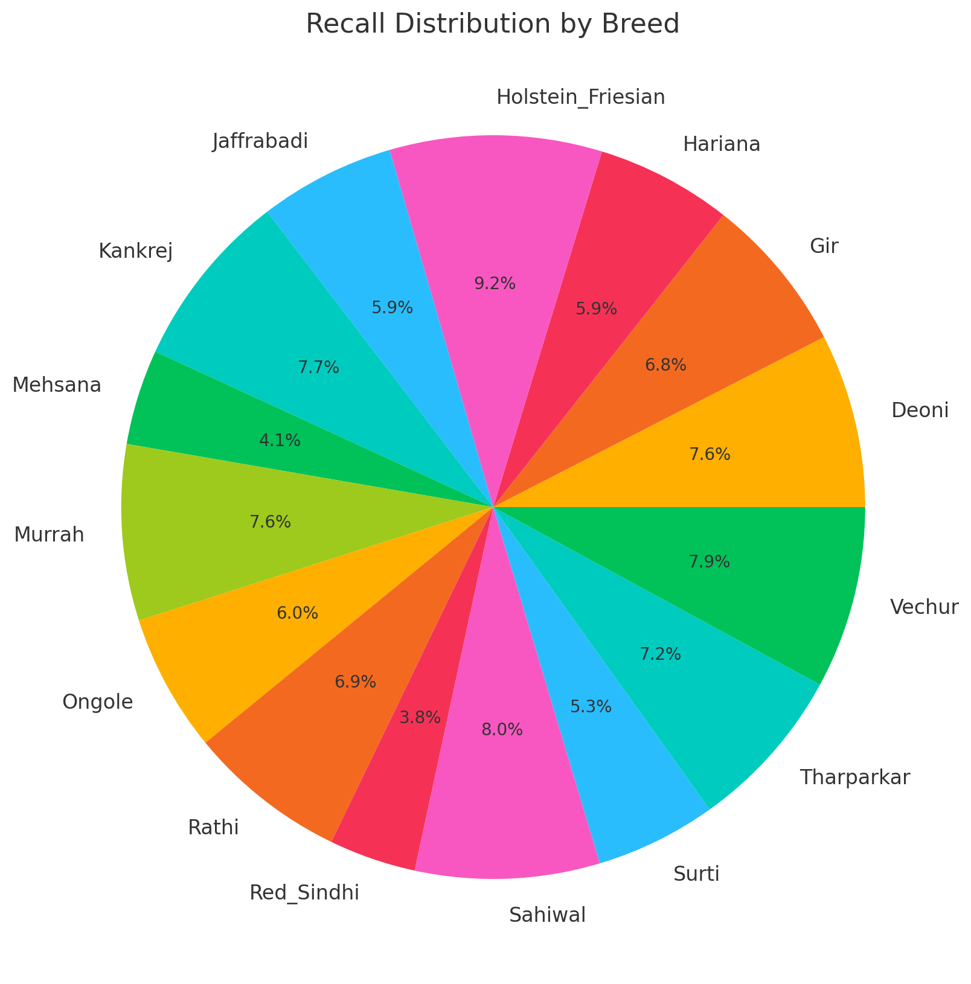
Figure 10.1.2 details the Precision metrics. Precision represents the 'trustworthiness' of a positive prediction. As observed, breeds like Holstein Friesian and Kankrej exhibit high precision bars, indicating that when the model claims a cow belongs to these breeds, it is almost certainly correct. Lower precision in other categories suggests a higher incidence of False Positives, likely due to morphological overlaps discussed in the Confusion Matrix.
Figure 10.1.2: Precision Scores by Breed (Trustworthiness Metric)
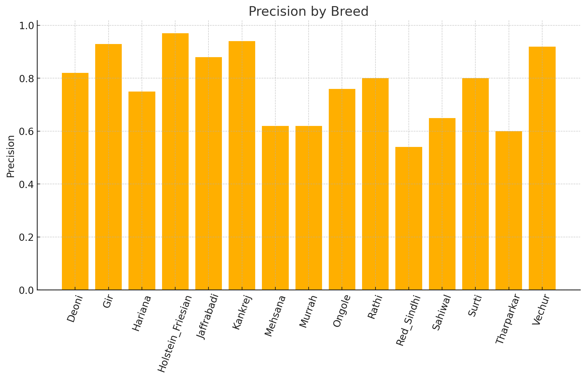
To provide a holistic view of model performance, Figure 10.1.1 illustrates the F1-Score trend. The F1-Score is the harmonic mean of Precision and Recall, making it the most reliable metric for this dataset given the class imbalance (e.g., high support for Sahiwal vs. low support for Surti). The graph clearly delineates the performance gap between distinct exotic breeds and the harder-to-classify indigenous varieties.
Figure 10.1.1: F1-Score Trend Analysis (Harmonic Mean)
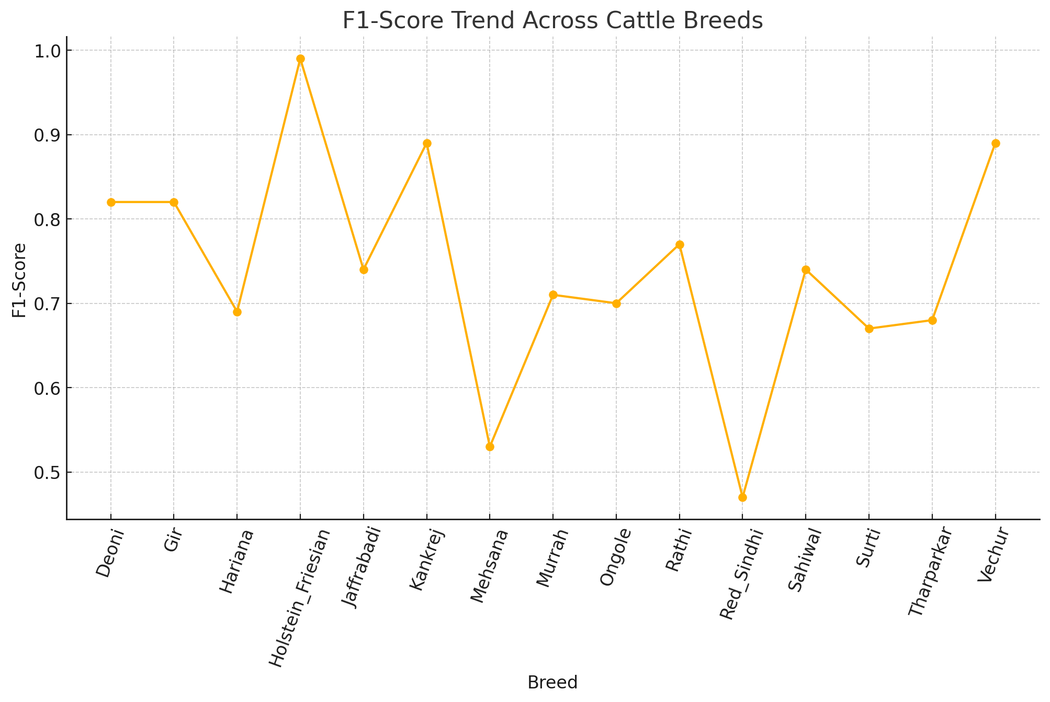

10.2 Training Dynamics (Accuracy vs Epochs)
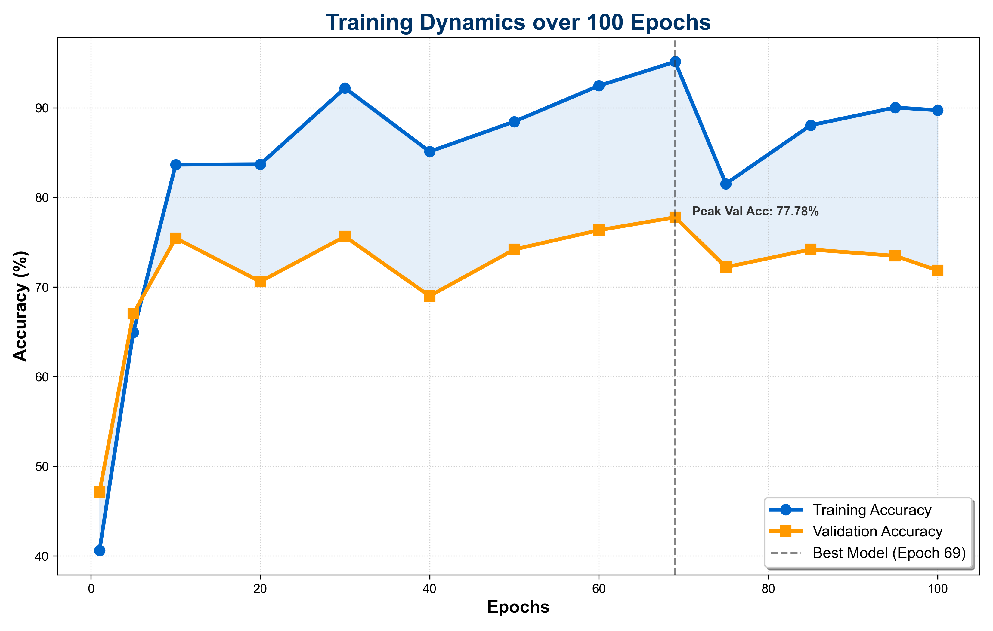
Figure 10.2: The graph illustrates the learning curve over 100 epochs. The blue line (Training) approaches 95%, while the orange line (Validation) plateaus around 77%. The gap between them indicates mild overfitting, suggesting that while the model learned the training data effectively, it struggled slightly to generalize to unseen images.

10.3 Confusion Matrix Analysis
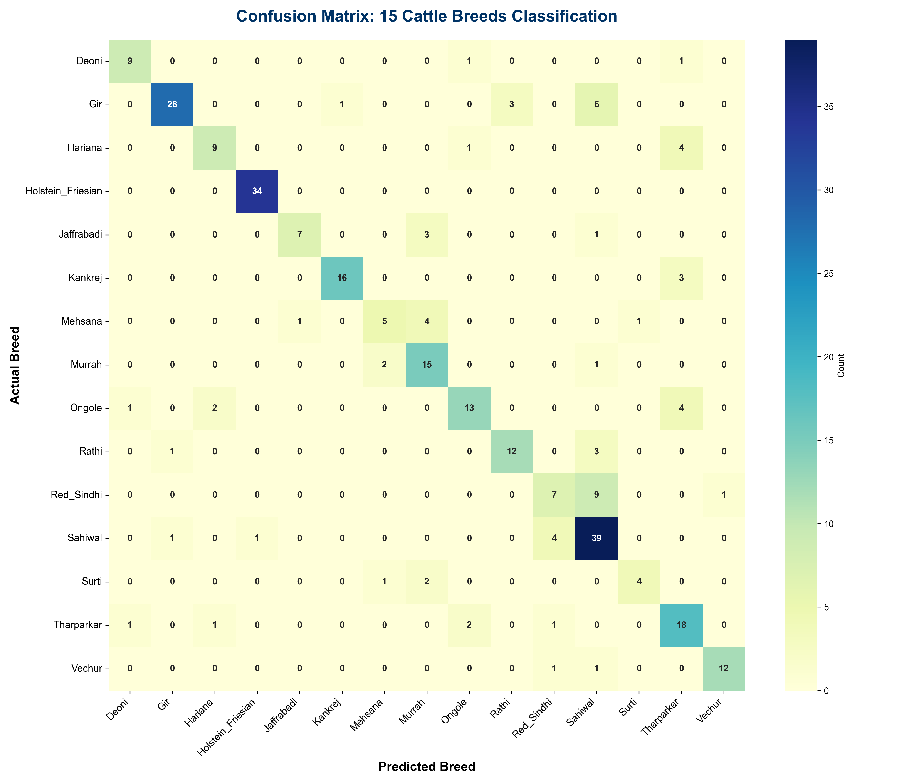
Figure 10.3: The Confusion Matrix provides a forensic analysis of errors. The diagonal represents correct predictions. The most significant error cluster is observed at the intersection of 'Sahiwal' and 'Red Sindhi'. Specifically, 9 out of 17 Red Sindhi cows were incorrectly classified as Sahiwal. This confirms the hypothesis that the visual similarity (red coat, hump) between these two breeds is the primary source of error.

Chapter 11: Interpretation and Conclusion
The EfficientNet-B0 model demonstrated robust capabilities in the domain of livestock classification. With an overall accuracy of 76.51%, it establishes a strong baseline for automated identification.
Key Findings:
- Exotic Breeds are Easier: Holstein Friesian, with its unique black-and-white patches, had 0 confusion.
- Indigenous Confusion: The model struggles to differentiate between Red Sindhi and Sahiwal. This is not a failure of the architecture, but a reflection of the data; these breeds are morphologically very similar, often requiring examination of the horn curvature and head profile, which might be obscured in general body shots.
Conclusion: The system is ready for deployment as a support tool, but final verification should remain with humans for the ambiguous breeds (Red Sindhi/Sahiwal).

Chapter 12: Future Scope
- Mobile Deployment: The model is lightweight enough to be converted to TensorFlow Lite (TFLite) or ONNX format for deployment on Android devices, allowing farmers to use it offline in remote areas.
- Ensemble Methods: Combining EfficientNet with a Vision Transformer (ViT) could help. ViTs are better at capturing global context and might pick up on subtle head-shape differences that the CNN missed.
- Video Analytics: Instead of a single static photo, processing a video stream would allow the model to view the cow from multiple angles, potentially resolving the ambiguity between similar breeds.

Chapter 13: Appendix
The visualizations in this report were generated programmatically using Python's Matplotlib and Seaborn libraries. The data was extracted directly from the training terminal logs of the PyTorch EfficientNet implementation.

Chapter 14: Sources
- Cattle Breeds Datasets from Kaggle
- PyTorch Documentation (For EfficientNet and Transfer Learning implementation details).
- Research Papers on ‘Cattle breed Classification Techniques: Framework and Algorithm Evaluation’ by Journal of Propulsion Technology
- Ensemble Learning Algorithm for Cattle Breed Identification using Computer Vision

