MANAGING CLOUD SOLUTIONS PROJECT REPORT
(Project Semester January-April 2025)

AWS Cloud Solution for Home Automation and Security

Submitted by

SANSKAR SAINIK

Registration No: 12315897

Programme and Section: Btech CSE and KM059
Course Code: INT 330

Under the Guidance of

Mrs. Madhuri , UID - 23525

Discipline of CSE/IT

Lovely School of Computer Science and Engineering

Lovely Professional University, Phagwara

CERTIFICATE

This is to certify that Sanskar Sainik, bearing Registration No. 12315897, has successfully completed the project titled, “AWS Cloud Solution for Home Automation and Security”, under my guidance and supervision. To the best of my knowledge, the present work is the result of his original development, effort, and study.

Signature and Name of the Supervisor
Designation of the Supervisor
School of Computer Science & Engineering
Lovely Professional University
Phagwara, Punjab
Date:

DECLARATION

I, Sanskar Sainik student of BTech under CSE/IT Discipline at, Lovely Professional University, Punjab, hereby declare that all the information furnished in this project report is based on my own intensive work and is genuine.

Date: Signature
Registration No. 12315897 Name of the student

Acknowledgement

I would like to express my sincere gratitude to Mrs. Madhuri for her valuable guidance, encouragement, and continuous support throughout the development of this project, "AWS Cloud Solution for Home Automation and Security". Her insights and suggestions have been instrumental in shaping this project.
I also extend my heartfelt thanks to Lovely Professional University and the faculty of the School of Computer Science & Engineering for providing the necessary infrastructure, resources, and a conducive learning environment.
Lastly, I would like to thank everyone who directly or indirectly supported and encouraged me during the successful completion of this project.

Table of Contents

- Scenario
- Problem Statement
- Objective
- Outcomes
- Proposed AWS Components
- Solution : implementation plan
- Conclusion
- Future Scope
- References

Scenario

In a smart home system, environmental sensors like temperature and motion are crucial for monitoring conditions. However, unexpected events such as temperature exceeding 50°C or motion detected when no one is home can indicate potential hazards or security breaches. The system must detect these anomalies in real-time and send immediate alerts to the homeowner. For scalability and performance, the solution is built on AWS services like Lambda for processing sensor data, SNS for sending email alerts, and IoT Core for managing sensor connections. The system needs to be highly available, secure, and cost-effective, while scaling to handle more devices over time. Additionally, the solution must ensure quick response times and efficient handling of large amounts of data, providing continuous monitoring with minimal latency. This architecture ensures the smart home remains secure, efficient, and responsive, keeping the homeowner informed of any unusual conditions.

Problem Statement
The AWS architecture for real-time sensor monitoring starts with AWS IoT Core, which securely collects sensor data from devices in the home. The data is then processed by AWS Lambda functions, which analyze the sensor readings and trigger alerts if unusual conditions, like high temperature or unexpected motion, are detected. Amazon SNS is used to send immediate notifications to the homeowner via email or SMS. For secure, scalable storage of sensor logs, the system uses Amazon S3, ensuring that data is easily accessible and durable. Additionally, AWS CloudWatch monitors and logs Lambda executions and system health, providing real-time insights into the performance of the architecture and enabling quick troubleshooting.

Objective
- Real-Time Sensor Data Processing: The system should continuously monitor temperature and motion sensor data and detect abnormal conditions.
- Automated Alerts: Upon detecting unusual conditions (e.g., temperature > 50°C or motion when home mode is away), the system should automatically send email notifications.
- Scalability and High Availability: The architecture should scale automatically and remain highly available even during high traffic or large data volumes.
- Efficient Cost Management: Minimize operational costs using serverless technologies and cost-effective AWS services.
- Secure Data Storage: Ensure that all sensor data is securely stored and can be retrieved for further analysis.

Outcomes
- The system automatically processes real-time sensor data and detects anomalies like high temperature or motion detection when the house is set to "away."
- Alerts are automatically triggered via SNS and sent to the homeowner’s email.
- The architecture scales automatically to handle varying amounts of data or load, ensuring high availability and minimal downtime.
- The solution efficiently uses AWS services like Lambda, S3, and SNS to minimize costs.
- Data is securely stored in Amazon S3, ensuring both security and easy access for future analysis.

Proposed AWS Components
- Amazon S3: Stores sensor data, motion images, and logs.
- AWS Lambda: Executes the logic for processing sensor data (e.g., temperature checks, motion detection).
- Amazon SNS: Sends email notifications when unusual conditions are detected.
- API Gateway / Function URL: Receives data from the sensors securely and forwards it to the Lambda function.
- AWS IAM: Manages access permissions and secures the system.
- Amazon CloudWatch: Monitors Lambda execution and logs for troubleshooting.
- Amazon DynamoDB (optional): Could be used for maintaining status logs or house mode (home/away).
- AWS WAF: Protects APIs from malicious traffic.
Solution
Implementation Plan:

Amazon S3 Bucket – Sensor Data Storage
- Purpose: Store motion images, logs, and other sensor data.
- Implementation:
  - Create an S3 bucket named home-automation-security.
  - Configure appropriate permissions to allow Lambda functions to write data.
  - Enable versioning and logging for data integrity and auditing.
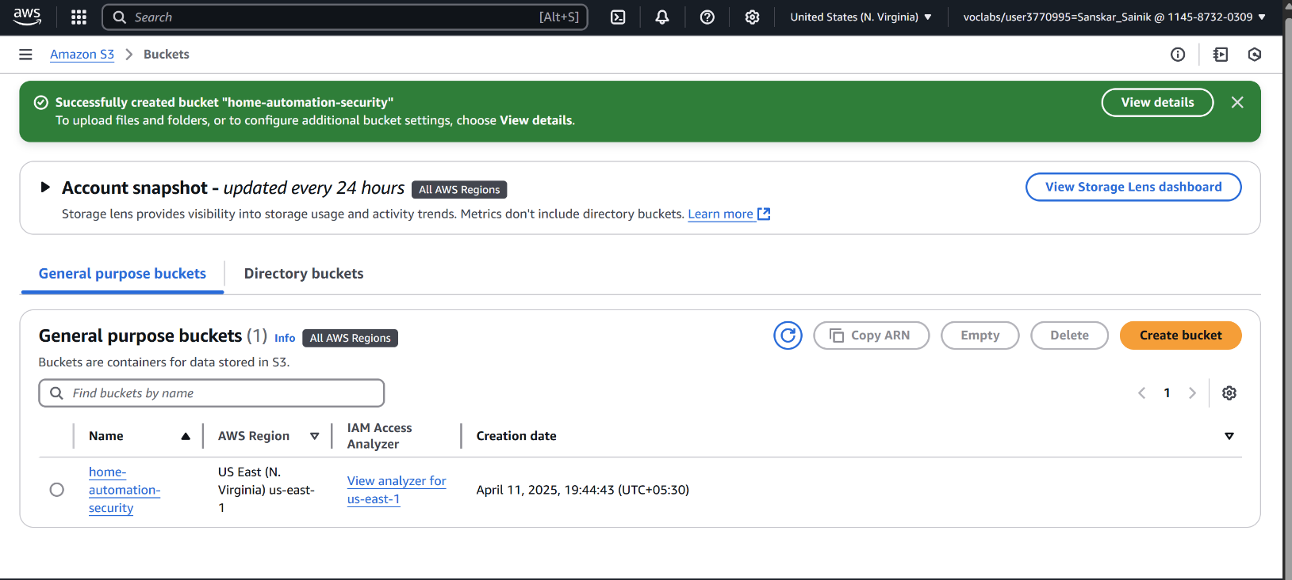

AWS Lambda Function – Data Processing Logic
- Purpose: Process incoming sensor data and trigger alerts.
- Implementation:
  - Create a Lambda function named LogSensorDataFunction.
  - Implement logic to:
    - Parse incoming data (e.g., temperature, motion).
    - Check if temperature > 50°C or if motion is detected when the house is in 'away' mode.
    - Trigger an SNS notification if conditions are met.
  - Assign necessary IAM roles and permNissions for S3 and SNS access.
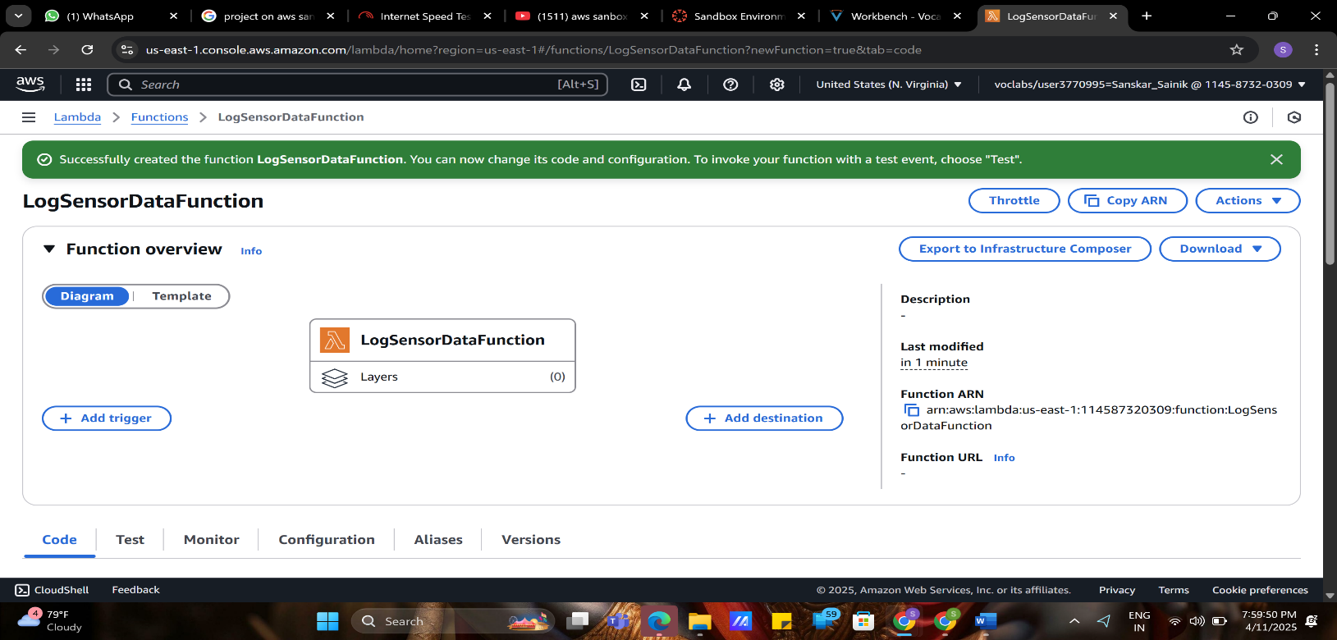
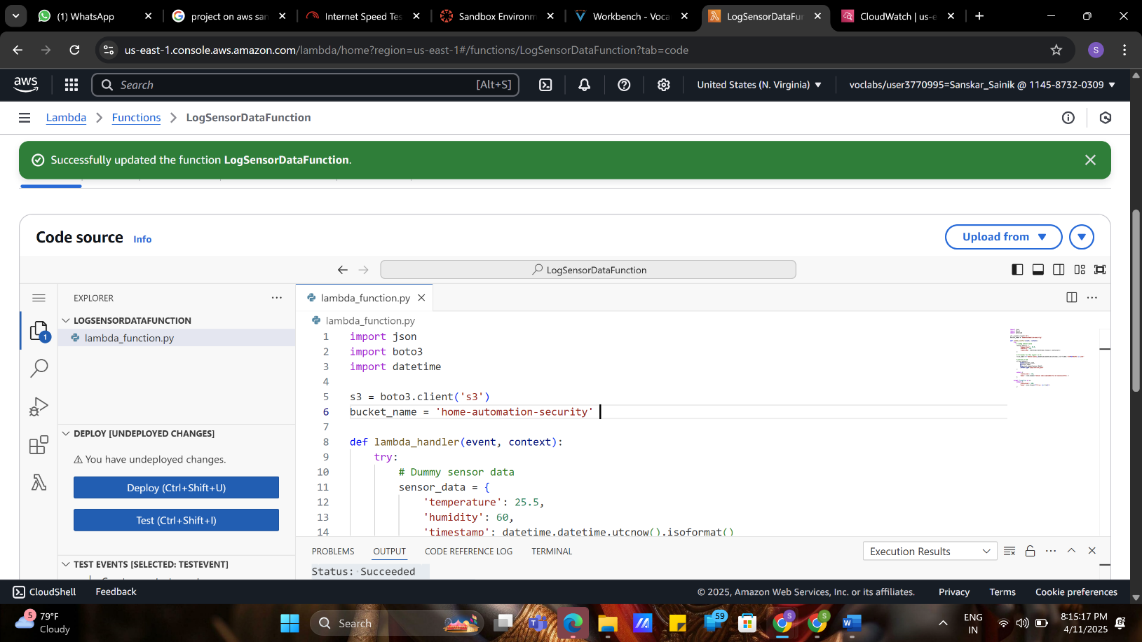
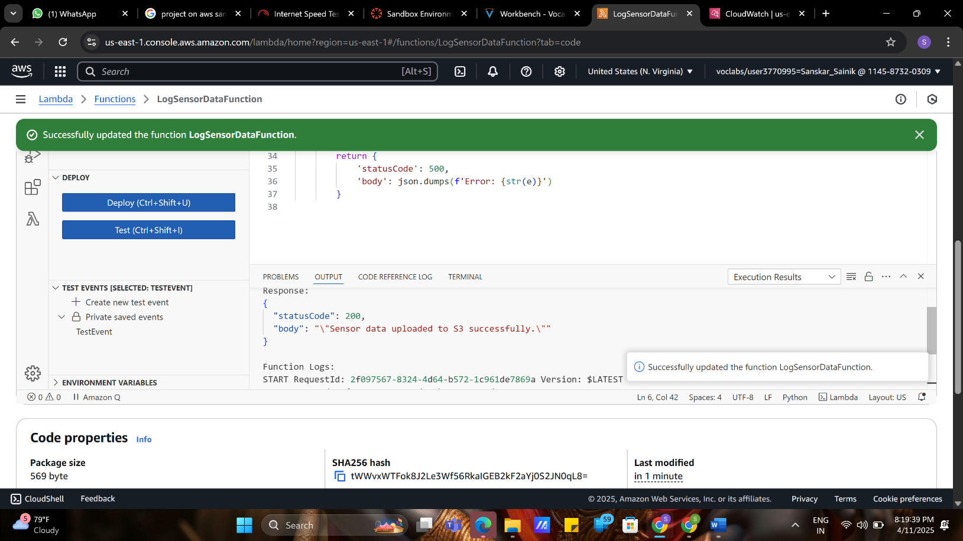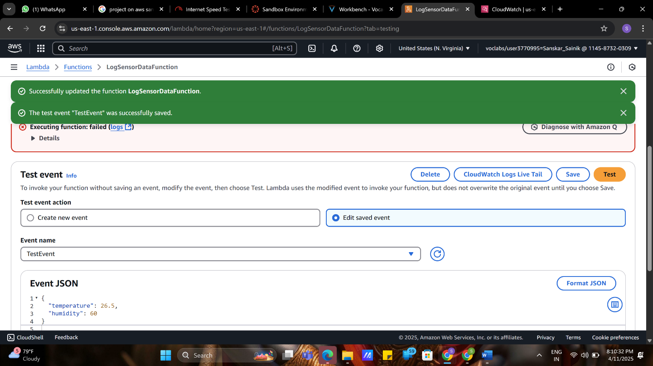

API Gateway / Function URL – Data Ingestion Endpoint
- Purpose: Provide a secure endpoint for sensor data submission.
- Implementation:
  - Since API Gateway setup faced permission issues, use Lambda's built-in Function URL:
    - Enable Function URL for LogSensorDataFunction.
    - Configure security settings (e.g., authentication method).
    - Provide the generated URL to sensor devices for data submission

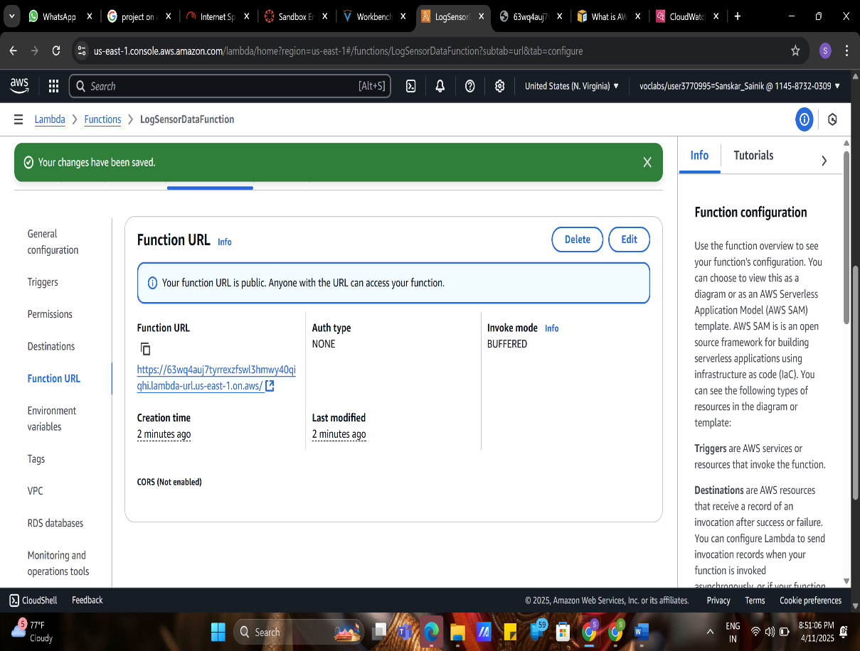

Amazon SNS – Alert Notification Service
- Purpose: Send email notifications upon detecting anomalies.
- Implementation:
  - Create an SNS topic named HomeSecurityAlerts.
  - Subscribe an email endpoint (e.g., your email address) to the topic.
  - In the Lambda function, integrate SNS to publish messages to the topic when conditions are met.

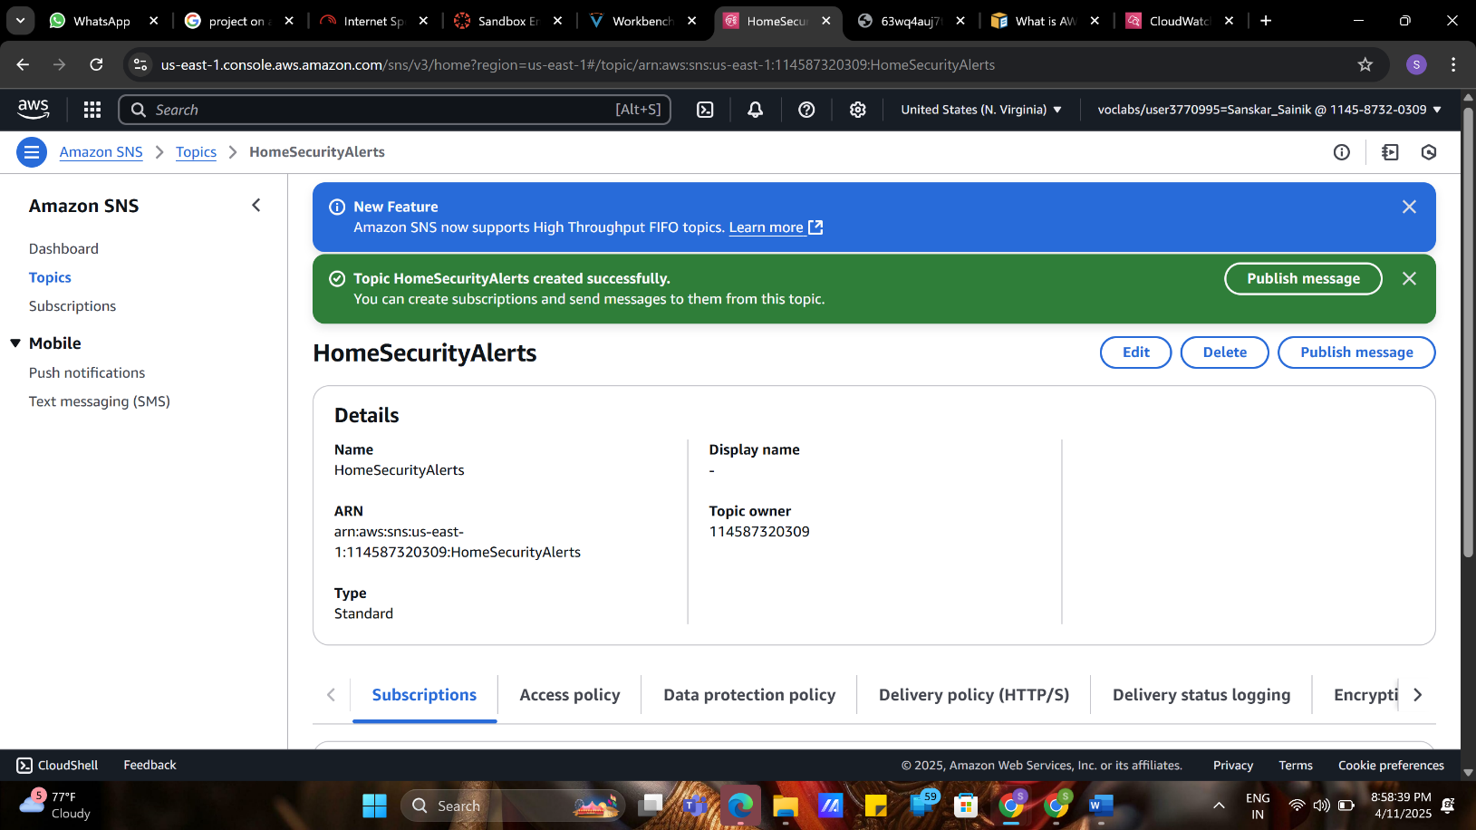
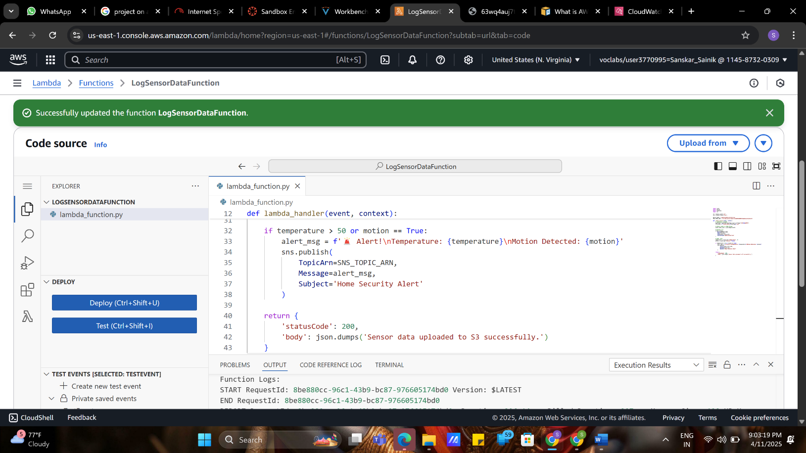
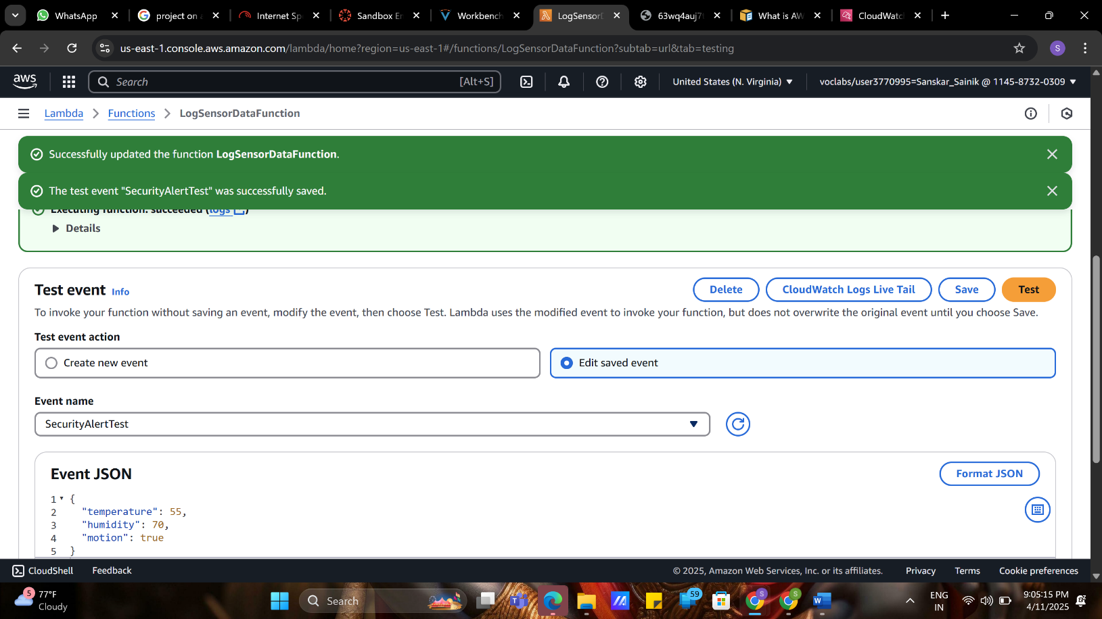
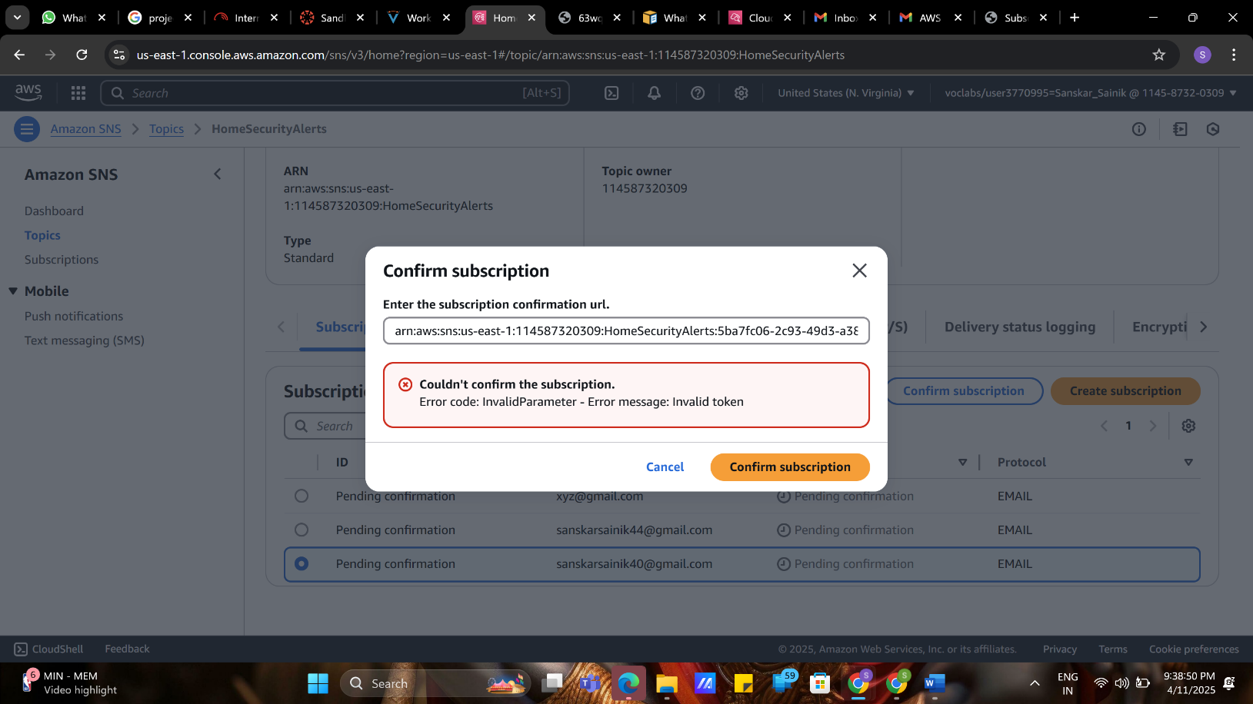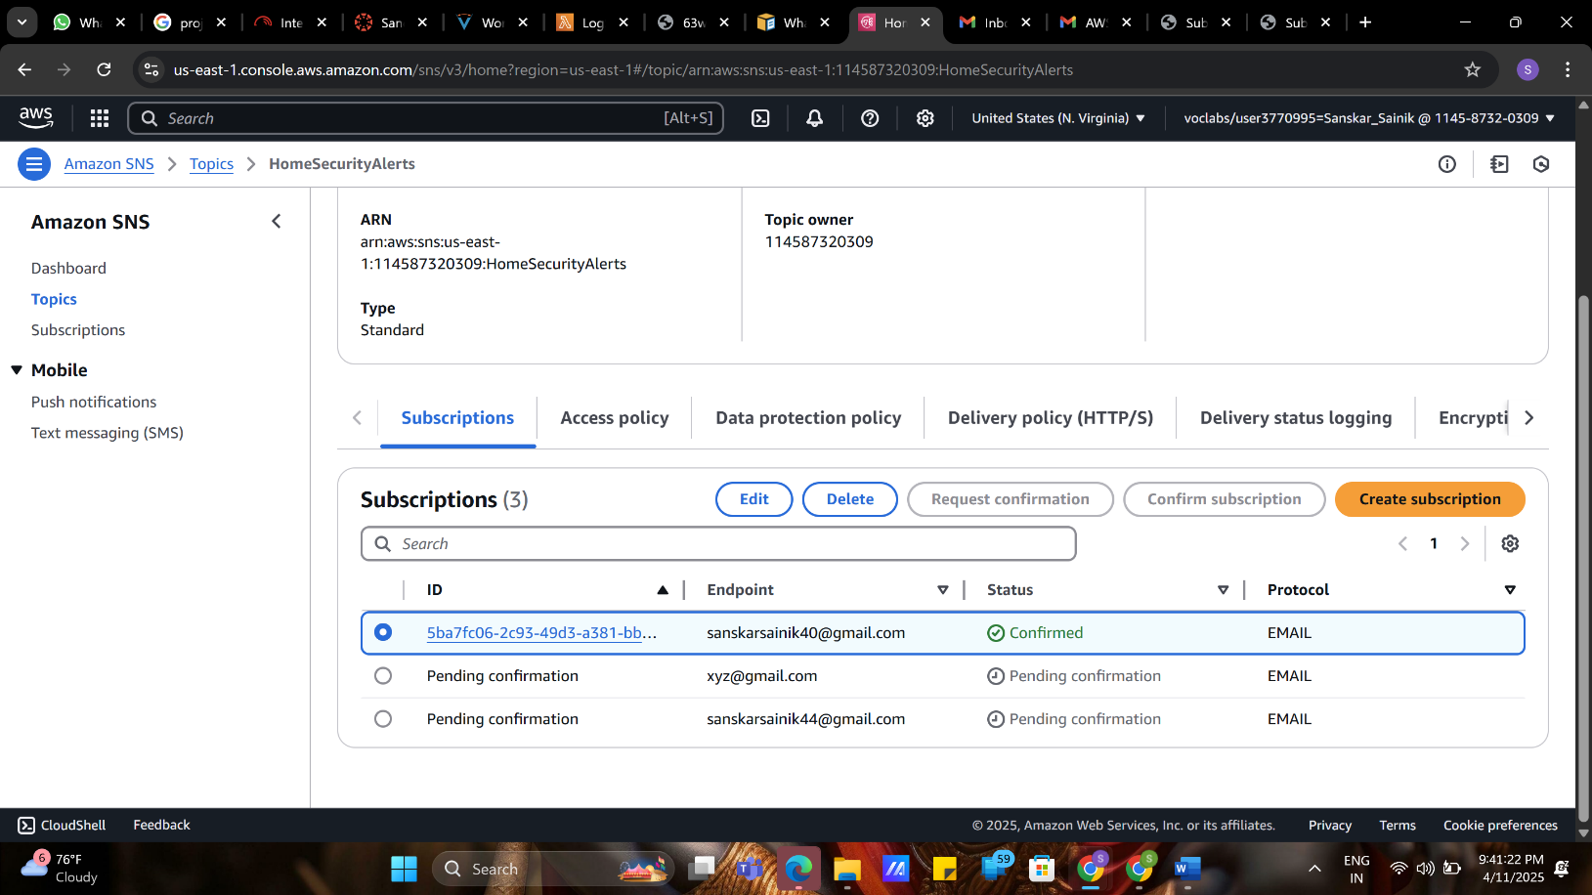
Email Notification – Alert Delivery
- Purpose: Receive alerts when anomalies are detected.
- Implementation:
  - Ensure the email subscription to the SNS topic is confirmed.
  - Test the system by simulating conditions (e.g., setting temperature > 50°C) and verify email receipt
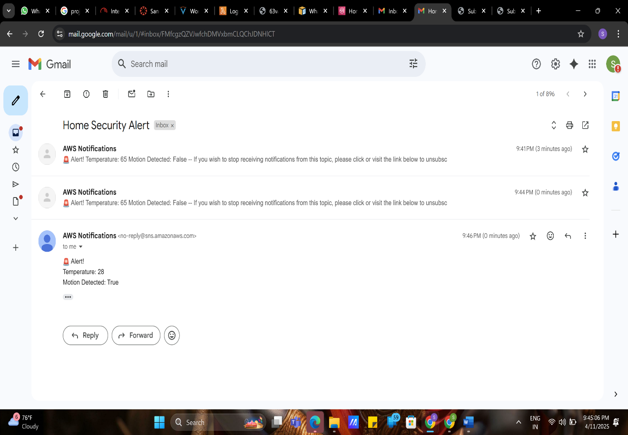

Conclusion

The integration of AWS services has enabled the development of a robust, scalable, and cost-effective smart home automation and security system. By leveraging AWS Lambda for serverless computing, Amazon S3 for secure data storage, and Amazon SNS for real-time notifications, the system ensures efficient monitoring and prompt alerts for unusual activities. The use of Function URLs provides a simplified approach to data ingestion, especially in scenarios with permission constraints. Overall, this architecture demonstrates the effectiveness of AWS in facilitating real-time, automated responses to environmental changes within a smart home setting
Future Scope

The current implementation lays a solid foundation for further enhancements:​
- IoT Device Integration: Incorporate a wider range of IoT devices, such as smart locks, lights, and thermostats, to expand automation capabilities.​
- Mobile Application Development: Develop user-friendly mobile applications to provide homeowners with real-time control and monitoring of their smart home systems.​
- Machine Learning Integration: Utilize AWS services like Amazon SageMaker to analyze historical data and predict potential security threats or system failures.​
- Advanced Analytics: Implement Amazon Athena and AWS Glue for more sophisticated data analysis and reporting.​
- Enhanced Security Measures: Adopt AWS WAF and AWS Shield for improved protection against cyber threats.

References

• AWS IoT for the Connected Home
An overview of AWS IoT services tailored for building scalable and secure smart home applications.
https://aws.amazon.com/iot/solutions/connected-home/​
• Smart Homes | AWS Solutions IoT
Provides insights into AWS's smart home accelerators and connectivity protocols for rapid development.
https://aws.amazon.com/solutions/iot/smart-homes/​
• AWS IoT Core
Details on AWS IoT Core, enabling secure device connectivity and management for IoT applications.
https://aws.amazon.com/iot-core/​
• Home Automation Made Easy: AWS IoT Architecture - Silicon Labs
A comprehensive review of AWS IoT architecture for home automation, including device and data services.
https://www.silabs.com/support/training/works-with-2020-home-automation-made-easy/works-with-2020-home-automation-made-easy-aws​
• Connected Homes with AWS IoT (PDF)
A detailed guide on building responsive, secure, and intelligent devices using AWS IoT services.
https://pages.awscloud.com/rs/112-TZM-766/images/AWS_Home%20Automation_DES_07.20.18_V4.pdf

