SLE-2: Profiling Report
Course: 02AML204 – Introduction to Artificial Intelligence
PRN: 25UAM126
Name: Sanskar Gorave
Division: B
Date: 20/09/2026
GitHub Link (optional): https://github.com/SanskarG-09/SLE--AI.git
───────────────────────────────────────────────────────────────────
1. Algorithms / Versions Profiled
Algorithm A: Breadth-First Search (BFS)
Algorithm B: Depth-First Search (DFS)
Problem used: Finding a Quality Inspection Station on a Textile Factory Floor
The same 6 × 6 factory-floor layout was used for both algorithms. S represents the Main Control Room, G represents the Quality Inspection Station, and # represents blocked or restricted areas.
Figure 1: Factory-floor layout used for the experiment.
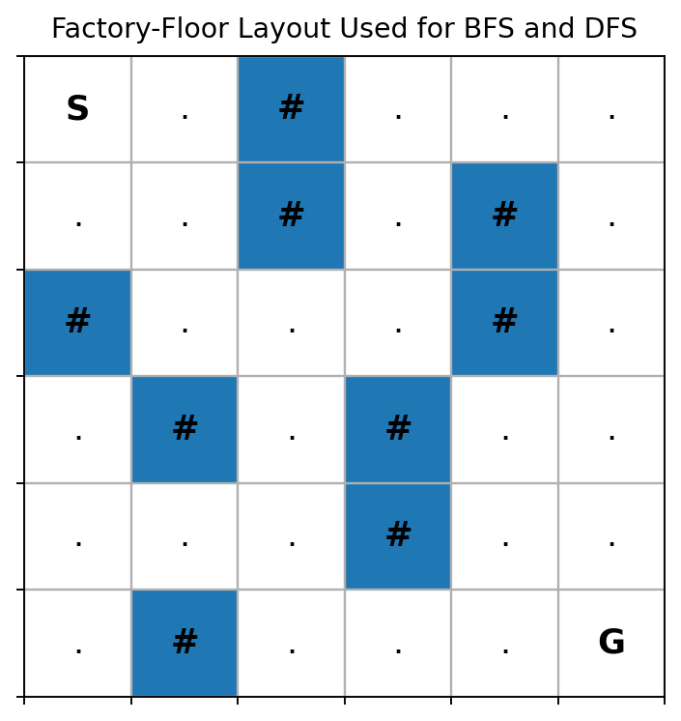
2. Profiling Method
Tool used: py-spy + Python perf_counter()
How I measured: Used the same factory-floor layout for BFS and DFS; generated separate py-spy flame graphs; executed each algorithm 3 times; each timing run repeated the algorithm 10,000 times; counted nodes explored during the search.
Number of runs: 3
Profiling Evidence – py-spy Flame Graphs
Separate py-spy flame graphs were generated for BFS and DFS. The graphs visualize sampled stack activity during execution.
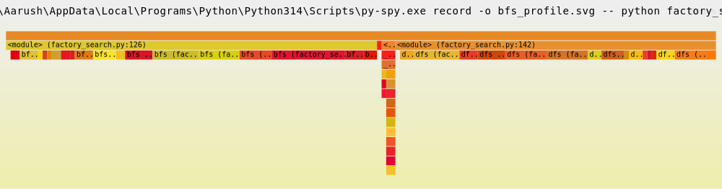 | 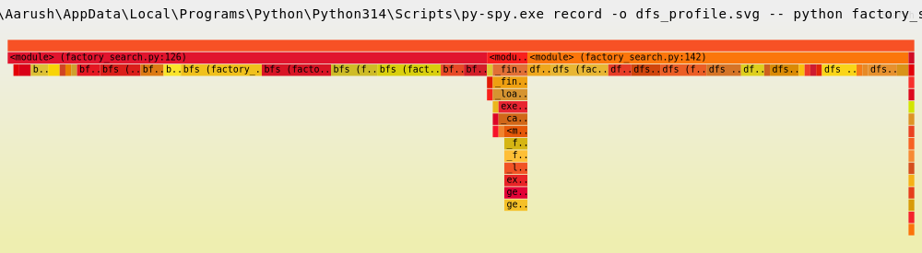
Figure 2: BFS py-spy flame graph. | Figure 3: DFS py-spy flame graph.
3. Results
Metric | Algorithm A  (BFS) | Algorithm B  (DFS) | Better?
Run 1 Time (ms / 10,000 runs) | 285.9454 | 145.2534 | DFS
Run 2 Time (ms / 10,000 runs) | 207.8587 | 142.8757 | DFS
Run 3 Time (ms / 10,000 runs) | 185.3564 | 136.0209 | DFS
Average Time (ms / 10,000 runs) | 226.3868 | 141.3833 | DFS
Nodes Expanded / Explored | 22 | 17 | DFS
Short observation: On this particular factory-floor layout, DFS had a lower average execution time and explored fewer nodes than BFS. The timing was measured over 10,000 searches per run to obtain a clearly measurable workload. The result is specific to this input layout and traversal order and does not mean DFS will always be faster.
4. Justification & Analysis
Based on the measured results, DFS performed better on this particular test case. DFS explored 17 nodes, whereas BFS explored 22 nodes, and its average execution time was 141.3833 ms per 10,000 searches compared with 226.3868 ms per 10,000 searches for BFS. The lower node count and shorter execution time are linked: because DFS explored fewer nodes before reaching the goal, it also did less work overall, which is reflected directly in its lower measured time. This result is broadly consistent with theory: BFS explores the search space level by level and must expand every node at a given depth before moving deeper, so on a layout where the goal lies along a path DFS reaches directly, DFS can expand fewer nodes and run faster. However, this outcome is not guaranteed by theory -- DFS has no optimality guarantee and can perform much worse than BFS on a layout where its expansion order leads it away from the goal first. BFS, by contrast, is guaranteed to find the shortest path in an unweighted grid such as this one, which DFS does not guarantee. So while DFS performed better here, it is not fundamentally the superior algorithm -- the result depends on this specific layout and start/goal placement rather than on DFS being better in general. As the problem size becomes larger, the number of explored states and execution time can increase for both algorithms, and the gap between them can widen or narrow depending on how the branching and goal position scale with the layout, so measuring the algorithms on larger inputs would give a more complete comparison.
5. AI Contribution Note
AI tools used: ChatGPT
What AI helped with: Understanding the SLE-2 requirements, preparing the BFS and DFS code structure, explaining py-spy commands, and explaining the comparison results.
What I did myself: Created and ran the experiment in VS Code, executed BFS and DFS, generated the py-spy flame graphs, collected the performance numbers, and compared the results.
6. Conclusion
This profiling exercise helped me understand how theoretical algorithm behavior can be compared with actual experimental performance. I learned to use py-spy to profile a Python program and generate flame graphs. For the selected factory-floor problem, DFS explored fewer nodes and had a lower average execution time than BFS. I also learned that experimental results depend on the input problem and should be supported by measured data.
Profiling evidence: Separate py-spy flame graphs were generated as bfs_profile.svg and dfs_profile.svg.

